LCMB7003- STRATEGIC MANAGEMENT ASSESSMENT 100%
SUBMITID BY -Kulwinder Kaur

STUDENT NAME: Kulwinder Kaur
STUDENT ID NUMBER: 2125861
MODULE: STRATEGIC MANAGEMENT 100%
LECTURER: Gladious Kulothungan
COURSE: Masters Of Business Administration General
SUBMISSION DATE: 5TH JAN 2023

PAGES: 22

Table of Contents
Introduction 3
External context of an organization 3
Internal context of the organization 5
Understanding the context-based strategy of Netflix 7
Evaluating the environment of India for Netflix 10
Contemporary strategic management issues 11
Strategical Recommendations 13
Conclusion 15
References 17

Introduction
Netflix has been a successful video streaming platform and is a dominant player in the SVOD platform. In this assignment, the strategic analysis of Central issues faced by Netflix Company has been discussed using a variety of skills for the analysis of the Case Study on Netflix Goes to Bollywood has been presented in this report. Netflix explains the evolution of the company from a DVD rental shop to a major SVOD platform with a global reach of more than 190 countries. The main objective of this assignment was to comprehend the fundamental problems the organization has with the use of models, theories, and emergent tactics.
This assignment outlines the organizational internal and external contexts that have an impact on Netflix's performance and management. The test strategic management issues faced by the Netflix company and the solution with the competitive and development strategies have been discussed in detail. External factors like technological, competitive, and economic factors that indirectly affect the company's success, as well as internal factors like organizational structure, value system, etc., that are under the control of the Netflix company have been discussed (Bengali, 2018). The assignment analyses and explains why India is the ideal market for Netflix's audience, as well as the elements that should be taken into account while implementing plans and market entry tactics. This paper analyses Netflix's culture and growth plan in India to reach its next 100 million subscribers. India is a huge country, and numerous Netflix competitors have made an effort to split the market share of the industry. There are many obstacles to overcome, and players have employed a variety of strategies to win the SVOD war in India. This report about the Netflix company includes many questions and answers about these strategies.

External context of an organization
An organization's external context is related to external factors that happen outside of the business, adhesive an effect on it that is beyond its control. Because it has stayed up to speed with market trends and adopted creative business techniques, Netflix has transformed from a DVD rental store to an online video streaming platform. The reach and target audience of Netflix is its main priorities because they can directly contribute to the company's goals being met (Wang, 2014). The success of Netflix can be attributed to its adept environment scanning, which enables the business to accommodate future opportunities and thread the market for competition. It is done both internally and externally to scan the environment. Internal environmental scanning allowed Netflix to assess its inefficiency and improve organizational efficiency. While external environmental scanning is more complex and out of the company's control, many external factors affect the company and its performance. A few significant external factors that have had an impact on Netflix in its journey are discussed below. In 2001, Netflix was forced to lay off one-third of its workforce, but it still managed to complete its task with a much smaller workforce.

Technological factor
The State of technology is always changing. Technology progress made it feasible for Netflix to launch video streaming and a subscription model for users, which has been a key element in the company's success. The advancement of technology allows viewers to stream their preferred movies and television programs anytime and wherever they desire. By 2019, Netflix had 167 million paid subscribers worldwide, making it the leading SVOD platform. It indirectly expanded the Netflix company's audience. Because of the buying habits and practices of the Indian audience, Netflix struggled when attempting to enter the Indian market. As a result, the company offered viewers the lowest possible price and a variety of entertainment options (Bengali, 2018). The primary reason was that Indians used mobile plans to watch and stream shows, and mobile data was more expensive in 2016. However, in late 2016, Reliance Industries launched Jio 4G and broadband services at a rate that was up to 75% less expensive than that of incumbent carriers, giving millions of Indian consumers access to the fastest data at the lowest prices, which indirectly benefited Netflix.

Competitive factors
Another important issue that has an impact on how the firm is managed, i.e., competition, competes in this market. Netflix started to release its own produced and original series, like its first major original series, "House of Cards," and then continued to invest in producing original series and movies. Netflix faced tough competition from Disney, Amazon Prime, HBO, and many other providers of streaming video with a large library of content. With 1.3 billion people, Netflix expects India's population to make up its next "100 million" subscribers. To gain market share in India, Netflix introduced the country's cheapest and mobile-only subscription plans, which cost just $ 2.85 per month, significantly less than its rivals.
Price reduction tactics used by competitors also affect Netflix's pricing methods.

Demographic factors
Netflix emphasized the demographics of the Indian audience. Netflix is aware that language preferences for online video streaming vary from one State to another. Due to the availability of Netflix series in English and Hindi through 2020, Netflix primarily targeted well-educated, wealthy urban consumers who could afford a Netflix subscription and who mostly viewed international material in English and Hindi. And Netflix reviewed its strategic decisions to appeal to the Indian population, which preferred local language programming. People from various social classes and educational levels utilize video streaming platforms for leisure. Netflix mostly targets young people who are more interested in watching episodes and series. The younger generation has a significant impact on the Netflix business. Netflix has become the go-to option for weekend plans that include Netflix and chills, and it has been utilized to generate ideas and binge plans that have greatly benefited the business.

Economic Factor
Normal economic downturns are difficult for many businesses, but the global financial crisis has been especially advantageous for video streaming services like Netflix. The covid-19 pandemic saw more people watch episodes and series than at any other time, which had a positive impact on Netflix's expansion. With the ability to share screens with friends and family under a single subscription plan, Netflix has increased audience engagement and view time. As a result, many external factors have an effect on the performance and strategies of the company.

Internal context of the organization
The internal context of an organization is the relationships that an internal organization aspect that it can control and that have an impact on its operations, management, and strategies. The company values integrity, excellence, respect for inclusivity, and collaboration, according to the Netflix culture overview. Internal Netflix elements, including the caliber of the firm's people resources, organizational structure, value system, and Netflix culture, are some important ones that have an impact on the performance and management of the company. Internal organizational contexts are more crucial to concentrate on as they are within the control of the company and can be improved a reorganized to improve the performance of the company. Netflix places a lot of emphasis on developing a scaled culture for the company (Wang, 2014). The following are significant internal factors that affect the business or have a significant impact on management and have led to Netflix's success.

Quality of human resource
When Netflix had to fire one-third of its workforce in 2001, it concentrated on keeping only the most talented and highly effective workers for the business. With this approach, Netflix was able to meet its goal with fewer workers who were more devoted to their work and expertise, and Netflix encouraged this business model, which is more flexible for the company. Instead of hiring underperformers who hurt the performance of their leaders and coworkers, Netflix focuses on keeping the best employees who are more productive (Mitter, 2018). Netflix places a strong emphasis on assembling "dream teams" that work well together and benefit the firm. To maintain the caliber of its human resources, Netflix not only selects the best candidates but also periodically evaluates its workforce using the "keeper test."
To foster a sense of trust and to belong among its employees, the Netflix firm makes sure that the human resources in its organization are of a high caliber. The top management of the Netflix company welcomes employee input. Netflix is cognizant of the value of its valuable employees and bases retention efforts on providing them with as many opportunities as possible. Employees have a direct impact on the company's growth.

Corporate culture & style of functioning of top managers
With its employees, Netflix creates an honest and open work environment that encourages people to contribute their ideas and opinions to group decisions for the company. To create decisions that are effective for the firm, Netflix encourages the discussion to incorporate the opinions and ideas of every employee (Blumenthal, 2019). This Netflix company policy fostered the development of original and unique concepts. The Netflix culture places a strong emphasis on providing regular, honest criticism about their coworkers, which helps to resolve disagreements inside the company. To resolve problems and keep peace in the workplace so that management may continue its functions uninterrupted, executives and senior managers expand their practice.
The organizational culture at Netflix supports employee participation and open lines of communication between upper and lower management, which helps to guide workers and fosters a motivating work environment.

Value system
An organization's value system is a crucial internal component that helps the organization achieve its objectives and goals by providing a moral compass and guiding principles (Bureau, 2017). Netflix disbelieves in enforcing regulations that are not necessary and avoids regulations that impede the company's expansion. All of the Netflix companies adopted a "no rules approach" to improve organizational efficiency, but the firm has rigorous exception policies for some things, such as harassment, insider trading, and protecting user information. The Netflix values system inspires its staff and management to think creatively and without restrictions, and the corporation prides itself on being the finest workplace for employee growth and development. For the Netflix Company, this business strategy is more advantageous.

Organizational structure
Organizational structure is a crucial internal element for any company. It needs to be efficient and streamlined so that the business can make decisions quickly and correctly. Netflix gives its employees the freedom to make decisions without being constrained by structure, procedure, or management. The freedom to make decisions with accountability and responsibility that Netflix gives its employees fosters a positive work atmosphere (Madhavan, 2017). Netflix thinks that a corporate strategy where employees make their own decisions using the most creative and innovative methods possible is superior to a top-down approach that tries to prevent Netflix approaches from creating a flexible organizational structure for productive and quality performance can be a strong influence in the growth and success of the Netflix company.

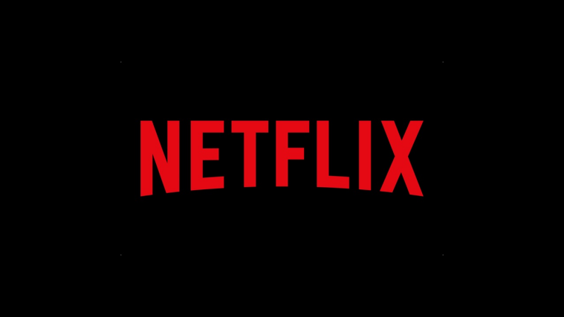
Figure 1: Netflix

Understanding the context-based strategy of Netflix
In the early 2000s, Netflix was a fledgling company that threatened Blockbuster's business model. Netflix is not the same fledgling business it once was. It was able to successfully change into the market-leading service of content streaming while maintaining its "nimble and successful throughout, giving it a superb example of strategic agility." The CEO, Reed Hastings, concluded that the company's DVD subscription service was flawed and that Internet-based operations may have provided greater leverage. This insight prompted the development of this novel competitive advantage. A similar failure plagued the company's 2011 trial with Qwikster, prompting a pivotal decision that will ultimately alter the company's strategic focus. The decision was made to separate the mail service from the internet distribution. In the same year that it revised its approach and apologized to its members, Netflix went deeply into the world of online content development and streaming to replace HBO (Weerasundara, 2021).
Before making the switch from DVD subscriptions to the new format, the company gave serious consideration to market demands and trends as well as customer needs. Success at Netflix can be primarily attributable to the company's strategic agility, which allowed management to take charge of carrying out the company's planned strategic direction (Rahman, 2018). Therefore, Netflix's management took the initiative to assume ownership of their actions to build a corporate climate that provided employees the opportunity to make swift judgments that enhanced the company's strategic agility. These results show that a company's culture significantly influenced Netflix's success and kept it on track. The inability of an organization to successfully implement new initiatives may be attributable, in part, to a culture in which employees feel their judgment is not trusted by management.
Netflix's strategic agility is the "anti-apple" of Apple in that, while Apple is focused on the compartmentalization of projects and products, Netflix offers its employees the flexibility and trust to make their own strategic decisions, allowing them to take on a more autonomous and innovative role. Furthermore, Netflix disseminates all company information across the whole organization, ensuring that every employee is active. Therefore, the success of the company's shift to streaming services is based on the creation of an innovative policy that gives employees some say in major company matters. Netflix's dedication to the notion of context rather than control explains why the corporation prioritizes characteristics such as strategic agility, the clear delineation of duties, transparency, and knowledge of the stakes. When compared to other sorts of businesses, Netflix has shown that it is not interested in the kind of stringent management and top-down decision-making that is commonplace.
When discussing Netflix's strategic decision, it's important to note that the company is a prime example of how ineffective a strategy can be if it's not put into practice effectively in organizations that can adjust their methods on the fly to achieve their goals (Pelts, 2017). Netflix's global success is unprecedented because the firm has redirected resources while putting strategic decisions into action, reorganized its workforce, and responded to emerging threats and opportunities. The ultimate decision to enter the internet content streaming business was made by Netflix's top executives. Through strategic agility and the cultivation of a unique corporate culture, however, the company has been able to capitalize on its advantages and build a strategy that is unique to it.

Lessons Learned
Companies can take multiple cues from Netflix's strategic agility and distinctive organizational culture. This includes strategies for continuing to thrive in the face of stiff competition. The company's founders saw early on that a sizeable portion of their clientele would hold on to the rented recordings for far longer than expected, costing the business a lot of money. Their response was the idea for a company that would allow customers to rent movies and TV shows for an unlimited amount of time for a set monthly fee. Netflix was successful because it developed a simple business strategy that satisfied customers' needs in a way that had previously gone unfulfilled.
Netflix has not only closed gaps in the market but also established a network of strategic alliances that point to the company's philosophy toward the mutual benefit of collaboration between companies. In forming a strategic alliance with Apple, Netflix increased the platform's visibility, which benefited both companies. The ability to sign up for Netflix directly through the Apple TV, iPad, and iPhone applications proved convenient for the company and its customers who watch the film on Apple's portable and non-portable devices. The potential to reach Apple's loyal customer base with high-quality, diverse content in a familiar environment was another perk of the cooperation with the industry leader (Singh, 2018).
Netflix has learned four key lessons from its practice of strategic agility, and one of these is the significance of value addition. One of the key factors in the company's spectacular rise to the top of the business is its ability to give exactly what the customers desire. Reed Hastings, CEO of Netflix, claims that the service's success is predicated on Netflix's ability to meet the needs and preferences of its users. For instance, the streaming service's website and apps feature a recommendation engine that has been trained to make predictions about the types of TV shows and movies that viewers are most likely to enjoy. The Netflix recommendation engine is responsible for providing about 60% of the service's available material. As a result, the company offers its customers, not just a rental service but also a platform through which they may discover programming that will pique their interest.

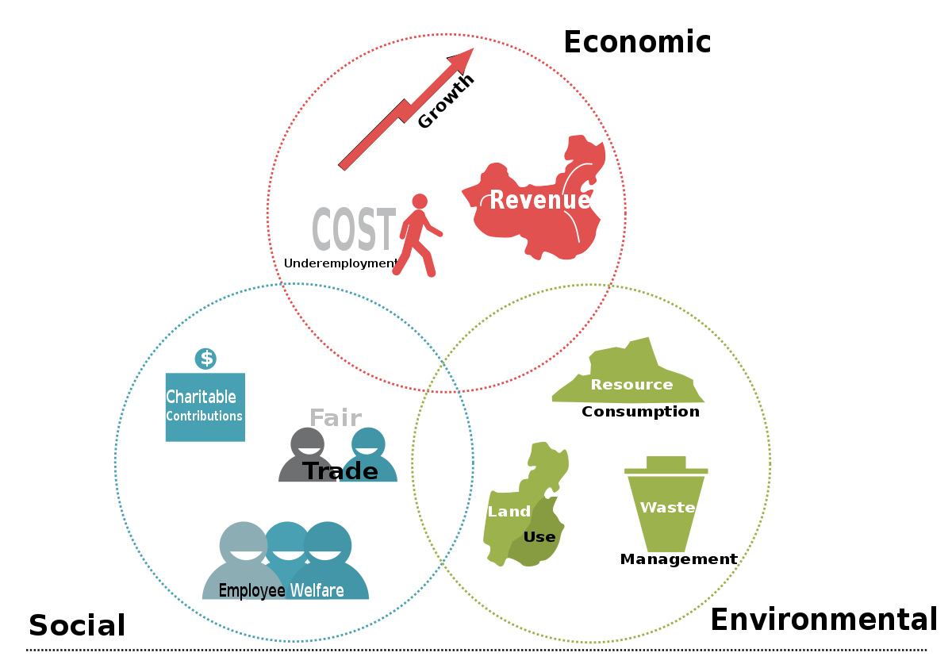
Figure 2: Bottom Line Approach

The Bottom Line
Netflix's top brass predicted accurately that the streaming media market would expand. After abandoning Blockbuster Movie's outdated business strategy, the company adapted to the changes in the market by providing a unique selling proposition. Focusing on the right business approach and the company's corporate culture led to the development of a set of practices that enabled Netflix to deal with a wide variety of complex procedures that could have put the company at risk. To formalize these procedures. This suggests that the company's digital transformation was the result of both a strategic decision and the preexisting procedures, which placed the onus of decision-making on all employees.
It's important to cite this phrase. Companies that refuse to change, like Kodak, which decided not to compete in the digital photography market, are finding it increasingly difficult to meet the needs of today's consumers. While the company has been profoundly altered by Netflix's technological development, the effects on customers have not been as noticeable as they have been on staff. As a company that has grown and changed in response to consumer demand, Netflix is a model of technological progress. Therefore, Netflix is the most effective illustration of technology development. For instance, Netflix listened to its users and adapted its business model to provide online entertainment when it became apparent that this was something they wanted.
One of the most important outcomes of Netflix's shift to online programming is the company's elevated status as a pioneer in the sector (Lewis, 2016). Because technological progress alone would not ensure the company's survival, a suitable response to the ongoing digital disruption was required. Existing services and goods were put to the test as technology advanced at a rapid clip, and Netflix needed to adjust to changes in online advertising prices, marketing campaign standards, and available networks if it wanted to keep its disruptive edge in the media sector. The company's clientele and its collection of works were expanding at a measured but consistent pace. With the help of its relationships with major studios like MGM, Lions Gate Entertainment, and Paramount Pictures, Netflix was able to set itself apart from its competitors in the online video streaming industry.

Evaluating the environment of India for Netflix
In recent years, digital video streaming has risen to prominence as a popular medium in India. By year's end, more than 200 million people had used the internet to watch videos for the first time in 2014. This appears to be the wave of the future in India since the digital video market is expected to grow to 35-40 billion users by 2020. This prediction suggests that Netflix and its rivals were wise to put in the time and money required to become a major presence in the streaming industry. Since Indians are more interested in digital internet media, Netflix and other streaming services have made it a top priority to provide a mobile app for watching their material on the go (Baxi, 2017). As a result, there is a greater need for these streaming services in the Indian economy. Netflix's mobile app is available on a wider variety of devices than those of its competitors. The Netflix streaming service stands apart from its competitors in part because of this.

The popularity of video streaming has increased in India in recent years. Over 60 million individuals in India regularly use YouTube as their primary source of entertainment due to the lack of alternatives before the rise of services like Netflix and Hulu. A "strong predilection for movies" was found "across age groups, genders, and geographies." As a result, individuals began to recognize the need for content streaming services that also included movies and television programs that users could access without charge and whenever they pleased. Consequently, businesses like Netflix and Hulu could begin operating. The advent of Netflix coincided with a growing demand for convenient, on-demand forms of entertainment that could be accessible at the touch of a button.
The Indian film industry, or Bollywood, is a cultural phenomenon with far-reaching effects on contemporary India. In India, the market is expected to grow from its current $2.1 billion to $3.7 billion by 2020. India has the largest film production pace in the world, with 1,500 to 2,000 films being made annually in more than 20 different languages. Despite these numbers, India's annual revenues still fall far short of the $11 billion produced in the US and Canada. India is highly popular for supplying its country with original content; thus, Netflix needs to boost its game if it wants to offer the same diverse original movies that Bollywood in India is not currently adjusting to the country's tastes. Adding the rights to stream films starring iconic Bollywood actor Shah Rukh Khan is a positive development for Netflix. Netflix has taken a positive step in the right direction with the release of a new series titled "Scared Games" in India. The fact that Netflix is trying so hard to give Indians what they want is undeniably promising for the company's future in the country.

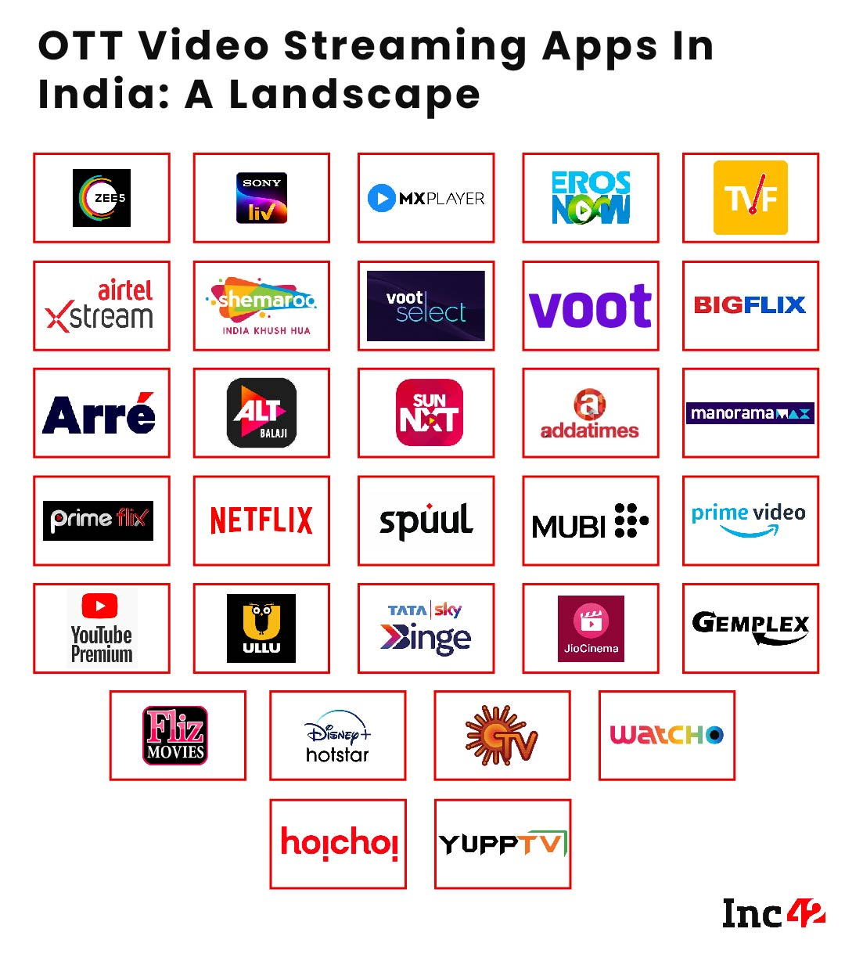
Figure 3: Netflix Failure in India

Contemporary strategic management issues
Netflix's international subscriber base surpassed its domestic one by the middle of 2017. However, not all international markets were given equal priority by the company (Mitter, 2018). Previous studies by the company indicated that growth in the population's internet connection was a leading indicator of the potential audience size for live video streaming.
That's why Netflix didn't launch in India until 2016 after initially planning to do so during its 2012 global rollout. When the service first debuted in India, it featured not only the company's original programming but also hundreds of Hollywood and Bollywood films and television episodes. CEO Reed Hastings and a large contingent of Netflix employees have been frequent visitors to India ever since the company's initial launch there.
According to Hastings, India is "the most spectacular example anywhere in the world of low Internet costs and expansion of 4G," and the country is home to "the next 100 million for us."
Due in large part to the "Jio effect," Netflix has decided against expanding into the Indian market. Jio Platforms, a subsidiary of Reliance Industries, introduced Jio 4G and broadband services at the end of 2016 at pricing that was up to 75% less than those offered by the incumbent carriers. In addition to lowering pricing across the board, this gave millions of Indian consumers access to speedier data for the first time. With a market share of 24% and more than 280 million customers by the end of 2018, Jio overtook the second-largest telecom operator in India (Bhattacharya, 2018).
At the end of 2017, analysts estimated that Netflix had slightly over half a million Indian customers, 2.6 million Australian and New Zealand users, and roughly 2.4 million subscribers across the rest of Asia and the Pacific. Even though Netflix didn't share its subscriber numbers globally, it has over 500,000 Indian customers. According to the company, there are 16 million paying subscribers in the Asia-Pacific region as of 2019, with an estimated 2 million of those clients residing in India alone.
Hastings claims that " what it would cost to buy a movie ticket" is how much Indian Netflix subscribers spend each month. After explaining, he said, "We would like people to compare it with that with what they spend on cable TV." It was estimated in 2017 that 155 million Indians would have paid to watch television. Netflix said in the second quarter of 2019 that it would begin selling a $2.85 monthly mobile-only subscription package in India. Only residents of India will be able to sign up for this plan.
Customers were unable to use their computers or televisions to gain access, and the standard definition quality was the only option.
For Netflix to realize its full potential in India, two major hurdles must first be cleared. The price difference between Netflix and its competitors is the first issue that needs fixing. Netflix's first target audience in India was the country's affluent, but the company eventually hoped to broaden its appeal to the country's middle class as well. Netflix's failure to diversify its customer base was a direct result of the company's failure to anticipate the level of interest that other customers would have had in their product. Due to the monthly subscription nature of the service, the membership fee ranges from $7.50 to $12 per month. While the most expensive plan available through Hotstar costs over $3 per month, the most expensive plan available through Eros Now is around $1.50 per month. Due to its pricing structure, Eros Now has attracted an estimated 8 million paying customers. In today's society, it's common to practice looking at the pricing of related goods and services and making a comparison to others in the market. Netflix needs to be more cost-conscious to win in the United States. This is essential if the company is to offer its customers the finest service possible (Weerasundara, 2021).
In the next two to four years, Netflix will also have to face a significant challenge: satisfying the demand from the Indian audience for more original material made exclusively for that market. If Netflix wants to keep catering to the Indian market, which places a premium on and feeds off of the desire for original content, it needs to step up its game and give the people what they want. Given Bollywood's popularity and the number of new films being made there each year, Netflix just can't compete with this offering. They have only created one original television series and eight films since they entered the Indian market. Netflix needs to invest in the production of more original films if it is to compete with other streaming services on a level comparable to Bollywood.

Strategical Recommendations
The company should strive for a cost leadership strategy in the Indian market. Since there are so many other competitors out there offering lower costs for streaming services, Netflix is more likely to be ignored while providing a product that is differentiated from its competitors. The market is so saturated with rival businesses for this reason. Since Netflix's offering is already distinct from the competition, it makes sense for the company to compete with cheaper costs. The competition has the edge over Netflix because of this feature.
Another recommendation that I think would be helpful to the company in terms of pricing is for Netflix to solely offer to stream on mobile devices in India. Since digital consumption and streaming on mobile devices have become so popular in India, it makes sense for companies to save costs in this way. If Netflix were successful in eliminating the need for consumers to pay for the data required to stream their material, I think more people would opt to watch Netflix on their mobile devices rather than on their desktops or televisions. Because modern society is more mobile, it makes sense to cater to the desires and expectations of the Indian populace by focusing on mobile streaming. That's why we're a nomadic, always-on-the-go culture.
High costs, severe rivalry, and a lack of appropriate control over the copying of material are often cited as reasons for Netflix's lack of success in India. First, let's analyze the various ways in which Netflix could enhance them.

Modifying the Pricing Strategy
When taking into account Netflix's outrageous pricing, there's no denying that the service isn't cheap. In addition to these increased fees, Netflix has also introduced new device restrictions, such as restricting access to mobile devices only or increasing the maximum number of users at once. Four out of five customers in India have admitted to giving away their credentials for over-the-top services to other people, per the study "Indian OTT Landscape" by Vidooly. Sharing Netflix IDs is simple, which compounds the problem in a highly competitive market.
However, Netflix may not be the first service that springs to mind when thinking about shelling out cash for a subscription. Donating 200 rupees was a good idea in theory, but there is no way to tell if it helped. While the digital markets in India are notoriously crowded, bargains abound. Companies like Amazon and Flipkart have relied heavily on promotional pricing and cash-back incentives to build their market dominance in India. Discounting is a surefire winner when it comes to market strategies in India (Weprin, 2022). Perhaps Netflix will use advertisements that make viewers feel pressured to make a purchase immediately.

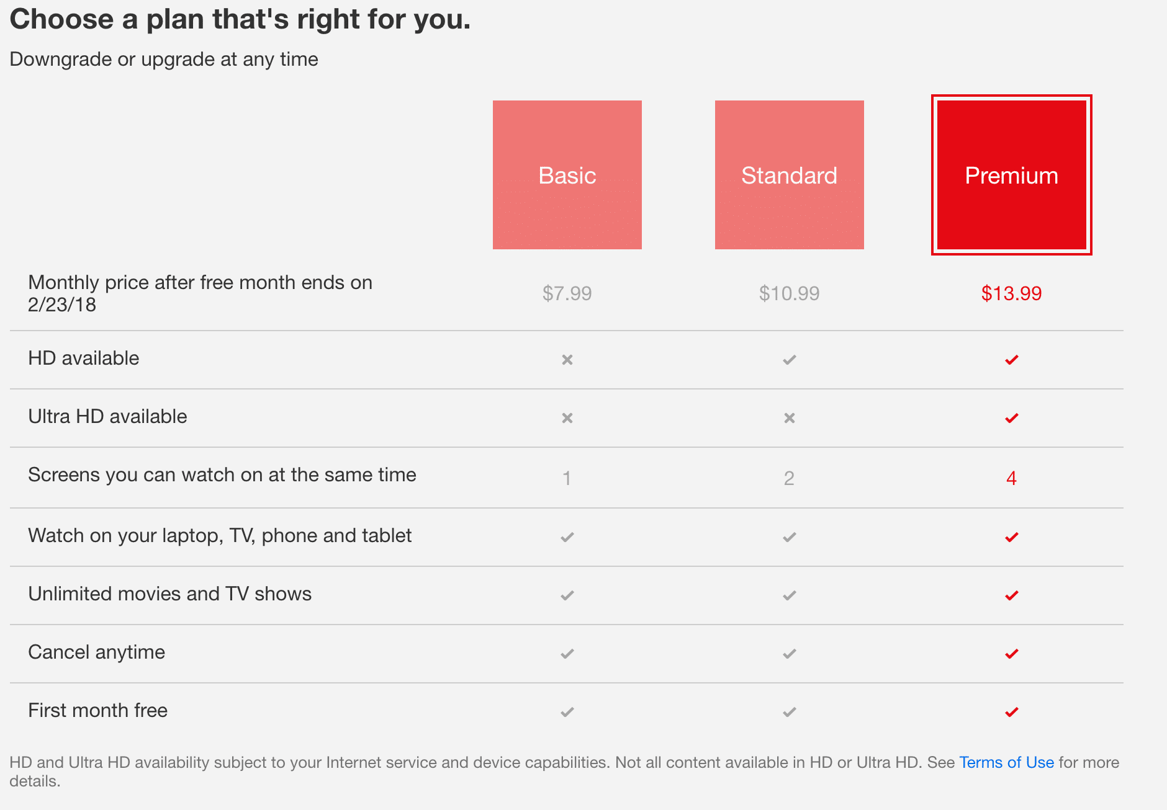
Figure 4: Pricing Strategy

Stopping Piracy
Not only is Netflix's selection limited by its high price, but its programming is also easily downloadable from other video-sharing websites. In the face of stringent device-based limits, it is hard to enable even basic content replication. When content can be accessed through a variety of free and paid channels, the value of a Netflix subscription declines. Netflix was able to exert influence over the content's replication because of the severe checks it had set up. Using a video that could be obtained through torrenting services, the Bollywood film "URI: The Surgical Strike" did set a good example of how to tackle piracy. They hoped that showing pirated content that had been obtained through BitTorrent would send a message to would-be pirates.

Understanding Ethical Behavior behind
Netflix has faced ethical issues like being sued for copyright violations and breaking license agreements for numerous shows because it does not control all of the content it transmits. As an example, consider the uproar that followed the release of the 1948 picture "Bicycle Thief" (Cullins, 2019). Since no one ever submitted a renewal request for the copyrights, it was assumed that the public had had access to this film for nearly three decades. An ethical dilemma was revealed when it was found that while the film itself might not have been copyright protected, the version with subtitles might still be. As a result of this issue, it is clear that Netflix must prioritize the creation of its original content over the renewal of licensing agreements and copyrights. If the company did this, they would have ownership of the great bulk of the site's content and wouldn't have to worry about the onslaught of legal challenges they're now seeing.
The increasing cost of Netflix subscriptions is a concern that can be used to further institutionalize racial prejudice. Netflix's $7.99 monthly charge has been stable for a long time, and the majority of customers have been assured that it will remain stable for the rest of their life. Within a specific window of time, Netflix promised subscribers that their $7.99 monthly fee would always be locked in so long as they remained active members. George Keratosis is one of the people who were told their monthly fee would be $7.99 but who then had their cost increased to $8.68 without warning. As a bonus, he received an email informing him that the monthly fee for his subscription would amount to $9.99 (Blumenthal, 2019). This person decided to sue Netflix for breach of contract because they lied to him and then went back on a promise they had made to him. Telling them one thing and doing another is neither fair nor moral. The illegal steps Netflix has taken and the way they have misled its customers in this regard need to be explained. They have to own up to the consequences of their actions. Customers' ability to trust Netflix and maintain loyalty to the firm may have been damaged as a result of this behavior.

Conclusion
The Netflix company's conclusion is drawn in this study. The biggest provider of online entertainment, Netflix, struggled to build its culture and continued operations. The external and internal organizational context of a firm does have an impact on its success, but the research above highlights the major leadership challenges the Netflix company is currently experiencing. To outperform rivals, Netflix employed a variety of techniques, such as membership plans and investments in original material for weavers. Netflix offered viewers a selection of high-quality video that was both diverse and appealing.
Bollywood is a platform that offers the preferred movies and shows for Indian audiences, for which Netflix faced issues alongside the Indian audience. Additionally, other competitive platforms and video streaming players like ZEE5, ALT Balaji, Amazon prime, Hotstar, and many more have divided the audience and caused options for viewers. Indian audiences prefer their local languages and Hindi for most Netflix shows and movies. The telecommunications companies that offered mobile data and broadband connections for streaming videos, as well as launched content for viewers for streaming videos, increased competition and management problems for Netflix. This report explains the strategic management and factors that Netflix took into account when implementing its strategies.
Netflix faces a variety of challenges and factors that must be addressed if it is to be successful in its growth in India. They need to learn more about what their American clients want and need and then use it as the sole criterion for what they produce and sell in the country. Both the price and the availability of distinctive components are crucial to winning over the majority of Indians. While Netflix has successfully dominated the US market, its success has not translated into global dominance just yet. After lowering their prices to compete with other streaming services in India and after creating more original content tailored to their Indian audience, they would have a solid foundation on which to build their streaming business.

References
Baxi, A. 2017. India's Video Streaming Market Is Bigger Than Ever, And Here's Who You Should Watch. [online]. Available at: https://www.forbes.com/sites/baxiabhishek/2017/09/30/indias-video-streaming-market-is-bigger-than-ever-and-heres-who-you-should-watch/#60a2c4217cda
Bengali, S. 2018. Big-budget TV meets Bollywood as Amazon and Netflix battle in India. [online]. Available at: https://www.latimes.com/world/asia/la-fg-india-netflix-amazon-2018-story.html
Bhattacharya, A. 2018. A 40-year-old film company has a plan to beat Netflix and Amazon in India. [online]. Available at: https://qz.com/india/1319005/inside-eros-nows-plan-to-take-on-netflix-and-amazon-in-india/
Blumenthal, E. 2019. Netflix raises monthly prices on all of its US plans; here's how much you'll pay. [online]. Available at: https://www.usatoday.com/story/tech/2019/01/15/netflix-raising-prices-all-its-plans/2578957002/
Bradshaw, T. 2017. Netflix boosted as viewers outside the US tune in. [online]. Available at: https://www.ft.com/content/e8c742f2-6b34-11e7-b9c7-15af748b60d0
Bureau, E. 2017. Film industry in India to hit $3.7 billion by 2020, says report. [online]. Available at: https://economictimes.indiatimes.com/industry/media/entertainment/media/film-industry-in-india-to-hit-3-7-billion-by-2020-says-report/articleshow/60998458.cms
Cullins, A. 2019. Netflix User Sues Over Rising Subscription Fees. [online]. Available at: https://www.hollywoodreporter.com/thr-esq/netflix-price-increase-user-sues-907613
Gardner, E. 2019. Netflix Hit With Copyright Lawsuit Over Classic Italian Film' Bicycle Thief'. [online]. Available at: https://www.hollywoodreporter.com/thr-esq/netflix-hit-copyright-lawsuit-classic-833908
Lewis, D. 2016. Will the internet of things sacrifice or save the environment? [online]. Available at: https://www.theguardian.com/sustainable-business/2016/dec/12/will-the-internet-of-things-sacrifice-or-save-the-environment
Madhavan, A. 2017. How Netflix Lost Big to Amazon in India | Backchannel. [online]. Available at: https://www.wired.com/2017/01/how-netflix-lost-big-to-amazon-in-india/
Mitter, S. 2018. Netflix announces 9 new originals from India, brings focus on regional content. [online]. Available at: https://yourstory.com/2018/11/netflix-announces-9-new-originals-india-brings-focus-regional-content
Pathak, P. 2019. Netflix increases prices in US, if India is next you may have to pay over Rs 900 per month for it here. [online]. Available at: https://www.indiatoday.in/technology/news/story/netflix-increases-prices-in-us-if-india-is-next-you-may-have-to-pay-over-rs-900-per-month-for-it-here-1431956-2019-01-16
Pelts, S. 2017. A Look at Netflix's Strategy in Developing Markets Like India. [online]. Available at: https://articles.marketrealist.com/2017/04/a-look-at-netflixs-strategy-in-developing-markets-like-india/
Rahman, M. 2018. SWOT analysis of Netflix. [online]. Available at: https://www.howandwhat.net/swot-analysis-netflix/
Singh, M. 2018. Netflix and Amazon are struggling to win over the world's second-largest internet market. [online]. Available at: https://www.cnbc.com/2018/07/05/netflix-and-amazon-are-struggling-to-win-over-indian-viewers.html
Wang, U. 2014. How the Netflix model impacts the environment, economy and society. [online] the Guardian. Available at: https://www.theguardian.com/sustainable-business/2014/feb/06/how-the-netflix-model-impacts-the-environment-economy-and-society
Weerasundara, R. 2021. See What's NEXT... Overview of NETFLIX Strategy. [online] www.linkedin.com. Available at: https://www.linkedin.com/pulse/see-whats-nextoverview-netflix-strategy-ruwan-weerasundara
Weprin, A. 2022. Netflix Dominates Subscription Streaming Video Market. [online]. Available at: https://www.mediapost.com/publications/article/334116/netflix-dominates-subscription-streaming-video-mar.html

‌
‌

