Awa Ceesay
Student ID: 2129819
Programme: Health and Social care
Module code: LCHS4002
Lecturer: Rebecca Stewart

MODULE: DIGITAL SKILLS AND RESEARCH METHODS

MODULE CODE: LCHS4002 DIGITAL SKILLS AND RESEARCH METHODS

Report – “Why is digital technology important when working with people in health and social care?”

Executive summary
Digital technology in the health and social care sector has led to faster communication systems which had a positive effect on maintaining medical records. This particular report has signified the importance of digital technology in the health and social care sector when working with people. It has given detailed knowledge about the specific digital technology that is used for making improvements in the service of Health and social care. This report has also highlighted the advantages and disadvantages of using digital technology in the health and social care field.
Table of Contents
Introduction 4
Overview of different types of digital technology in the healthcare workplace 5
Big data 5
Artificial intelligence 5
Blockchain 5
Health apps 6
Increase of using technology in health and social care due to covid-19 6
Benefits 7
Sustainable and responsive healthcare 8
Providing authentic emergency services and allocating staff 8
Disadvantages 9
Cyber security threats 9
The frustration associated with complacency 10
Lack of empathy 10
Conclusion 10
References 12

Introduction
Digital technology is referred to as utilizing advanced information and technology of communication to share, analyse, store and collect physical information along with the market information in every link associated with the value chain of a product. It provides the necessary support of technical categories for any kind of innovation in different fields. On the other hand, digital transformation is the latest trend in the sector of Healthcare where people have initiated leveraging the effects of the digital category. It is generally considered as the process which involves the introduction of digital technology in all the areas of the Healthcare business such as member interactions, operations for the providers and payer operations.
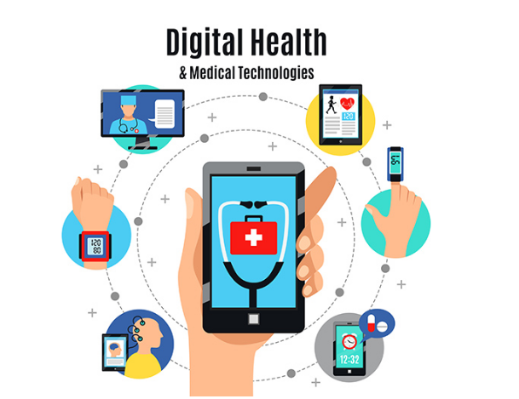
Figure 1: Digital Healthcare
(Source: The healthcare insights, 2022).
Artificial intelligence, blockchain, big data and health apps are some kinds of digital technology, which are used highly nowadays, in the Healthcare sector for tackling different conditions such as the covid-19 pandemic or other serious health complications. An overview of various digital technologies in the workplace of Healthcare will be provided in this particular report in detail. However, the increasing usage of digital technologies during the covid-19 pandemic will be highlighted in this report. The report will also specify the advantages and disadvantages of digital technology in the healthcare sector when working with people.

Overview of different types of digital technology in the healthcare workplace

Big data
Big data generally help in aggregating information about a particular business through different formats such as financial transactions, online transactions, social media and e-commerce along with identifying the patterns and trends for future usage (Shil et al. 2020). For the industry of Healthcare, big data has different uses such as lowering the errors in medication through analysing the record of the patient in detail. Through big data, preventive care can be facilitated and preventive plans can be created for making patients comfortable in emergencies. Big data is also influential in making clinicians gather huge amounts of data in minimum time. For conducting epidemiological studies, digital technology can help in collecting data from a large and diverse category of the population instantly.

Artificial intelligence
Artificial Intelligence can be considered as more than just the trend of digital transformation in the healthcare sector. The main aspect of medical innovation is represented by Artificial Intelligence and the players in the industry are eager for investing in this particular area. Chatbots and virtual assistance of health can be considered as technology based on artificial intelligence and patients are using it on a higher level (Randhawa and Jackson, 2020). The real power of Artificial Intelligence can be observed in a better way for the areas such as genomics, the discovery of drugs, precision medicine and medical imaging.

Blockchain
Blockchain is a kind of digital ledger or a database of transactions, which is computerized. It is shared within a network of computers and makes the customers capable of exchanging some financial information with the suppliers in a safe way without requiring a third party such as the bank (Odeh et al. 2022). In the healthcare sector, blockchain has been proven to be an efficient tool for the prevention of data breaches, making improvements in medical record accuracy and the procedure of cutting extra costs.

Health apps
The revolution in the digital aspect has resulted in the development of different kinds of Health Apps. These types of apps have made patients capable of monitoring their complications and helping and providing them with authentic medical information (Kumar and Singh, 2018). It also allows the patients to access their test results and make them remember their time of check-up. This is quite fruitful for the workers in the Healthcare sector to check the test results quickly along with recommendations of medicine dosage and other required information.

Increase of using technology in health and social care due to covid-19
Covid-19 is a respiratory illness caused due to the virus SARS-CoV-2 and was declared a Global pandemic by the World Health Organisation within 3 months after its first case was detected. New procedures and technologies are being researched and developed for strengthening the main capacities during this outbreak of the pandemic and innovation become a necessity. During the period of Public Health emergency, massive amounts of daily data on the internet can be utilized for tracking the progression of the pandemic or epidemic and the public concerns for monitoring the crisis. A huge level of data is required for predicting the tendencies of the pandemic in advance along with providing early warnings. During the pandemic, the usage of big data increased highly as through this the data associated with the confirmed and active cases of covid-19 can be collected quickly (Anthony Jnr, 2021).
This digital technology can also help organizations in storing high amounts of data for future usage. The tools and techniques of artificial intelligence have helped in accessing the data of molecular modelling, bioinformatics and epidemiology, the challenge associated with covid-19. Chatbots and virtual assistants have been implemented for supporting the Healthcare organization for example in the United, States England, Canada and France by the American Red Cross. These tools have helped triage specific people dependent on their observed symptoms (Morrow-Howell et al. 2020). The Centre for Disease Control and Prevention along with Microsoft in the United States tried to develop a self-checker service with the help of artificial intelligence for covid-19 to provide help for its users. It has been done to make them capable of self-assessment of covid-19 recommend particular preventive measures.
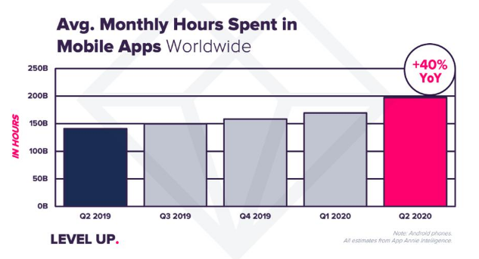
Figure 2: Monthly hours spent in mobile apps on the global aspect
(Source: Natanson, 2020)
On the other hand, it has been reported that the use of Health Apps has surged by around 40% during the scenario of covid-19 and reached an all-time high period of 200 billion hours in the timing April 2020 (Natanson, 2020). This is a global trend although the statistics are different in individual countries. For example, in the US, the time spent on health apps increased by 15%. In the second quarter, 27 billion dollars have been spent by customers on health Apps (Natanson, 2020). It can be stated that covid-19 has increased the urgency of people to use digital technology in order to get health services and care services comfortably (Xie et al. 2020). During the time of covid-19, which was full of stress, digital Technology has been a sigh of relief for people.

Benefits
Digital health technologies involve using sensors, connectivity, software and computing platforms that help in supporting the monitoring of parameters associated with health while providing the scope for other associated usage (Urbinati et al. 2020). This technology generally provides effective assessment of medical products such as biologics, devices and drugs which are commonly utilized for managing patients suffering from different kinds of acute or chronic complicated health problems.

Sustainable and responsive healthcare
With the improvement in life expectancy, the population suffering from chronic diseases increased steadily way which led to the rise of significant costs associated with healthcare services. These types of changes in the sector of Healthcare have contributed to the shift towards the process of digital health for receiving some treatments (Lee and Yoon, 2021). Different technological advancements are providing scope for introducing smart care and different wearable. Digital platforms can provide help patients receive access to the services of healthcare more quickly thereby making improvements in the treatment quality received by them along with the prognosis of health issues. This type of platform has been helpful for the reduction of burden for the health care professionals along with the facilities such as the clinics and the hospitals by introducing the concept associated with self-care taken by the patients themselves.

Providing authentic emergency services and allocating staff
Digital technology such as big data can help in analysing the records of patients and detect any type of inconsistencies between the drug prescriptions and the disease of a patient (Akpan et al. 2022). This can help make the health professionals and the patients alert when there is a risk of medication error. There are frequent fliers, which means a high population of people entering the emergency rooms. Big data analysis can help in identifying this kind of person and create plans of prevention to remove their chances of returning. On the other hand, big data predictive analysis can help Healthcare and social care organizations for estimation of rates associated with future admission. This leads to the allocation of authentic staff for dealing with the complications of the patients. It can help in saving money and reducing the wait times in emergency rooms.

Disadvantages
Digital technology is an important step towards securing the future for the Healthcare and social care sector although it has some advantages. In digital technology, there is security and privacy concern for consumers. The biggest difficulty of the digital Healthcare industry is processing the data as hospitals and similar kinds of platforms use delicate data. Cyber security is also a major issue in the sector of digital Health Care along with the inefficiency of the health care professionals in adopting digital health technologies.

Cyber security threats
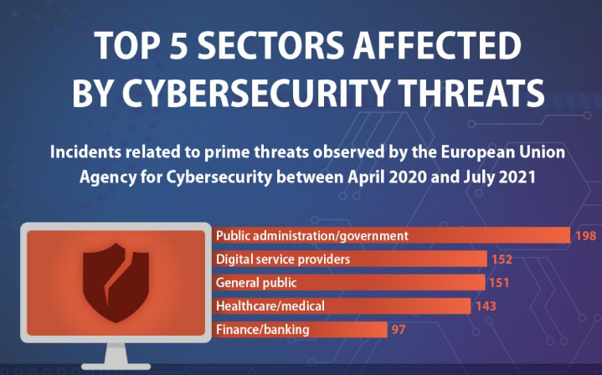
Figure 3: Sectors affected by cyber security threats
(Source: European Parliament, 2022)
In the present day, huge volumes of data are generated and it is difficult to handle that data. There are some risks involved with the accessibility of this data easily by third parties. If any kind of data breach occurs due to hacking or leakage then the personal information of the patients might be at high risk (Fleming et al. 2020). Today, healthcare professionals are dependent upon this kind of device to relay the data sets in an accurate way for treatment planning and prescribing medicine. It needs to be noted that this reliance on cloud connectivity devices can cause damage to a lot of personal information if a single breach of data occurs.

The frustration associated with complacency
Healthcare is an industry where the life and death of people matter highly. It is quite critical that the technology involved in the Healthcare sector needs to work authentically and accurately without any kind of glitches for making improvements in the quality of care provided to the patients (Ortega et al. 2020). However, technologies such as Artificial Intelligence and machine learning are dependent highly on historical data and might struggle to adapt to different kinds of operational data thereby leading to observable mismatches. Complacency may lead to the failure to cross-check the predictions of the system with any kind of alternative.

Lack of empathy
Telehealth has allowed the connection between physicians and patients to run smoothly despite the long distance although it has some disadvantages. Here, the technology acts as a proper mediator and it can save costs highly with authentic efficiency although it lacks the touch of empathy between the doctor and the patient. The connected devices and different types of dashboards cannot provide the personal touch of an empathetic human, which is craved by patients. This is especially in the cases of elderly people who are vulnerable as they face complications in gaming knowledge about their plan of treatment and any confusion can arise for their diagnosis of diseases (Shareef et al. 2021).

Conclusion
Therefore, it can be concluded that the important usage of big data in the Healthcare sector is associated with the area of e-commerce social media financial transactions and different kinds of online transactions. Preventive care can be provided with the help of big data in the fast possible manner by maintaining the efficiency of the service. It also allows the collection of huge data volumes of the patient and stores it safely. On the other one, it can also be said that artificial intelligence has provided the scope of maintaining a proper connection between patients and health care professionals.
Health apps and blockchain can be considered among the greatest revolutions in the digital Healthcare sector. During the covid-19 pandemic, the connection between patients and doctors has been maintained through the above digital technology safely and accurately. The main disadvantages associated with digital technology implementation in the healthcare sector are cyber security threats, difficulties linked to complacency and lack of empathy due to the lack of physical interaction between patients and doctors.

References
Akpan, I.J., Udoh, E.A.P. and Adebisi, B., 2022. Small business awareness and adoption of state-of-the-art technologies in emerging and developing markets, and lessons from the COVID-19 pandemic. Journal of Small Business & Entrepreneurship, 34(2), pp.123-140.
Anthony Jnr, B., 2021. Implications of telehealth and digital care solutions during COVID-19 pandemic: a qualitative literature review. Informatics for Health and Social Care, 46(1), pp.68-83.
Cybersecurity: Main and emerging threats in 2021 (infographic): News: European Parliament (2022) Cybersecurity: main and emerging threats in 2021 (infographic) | News | European Parliament. Available at: https://www.europarl.europa.eu/news/en/headlines/society/20220120STO21428/cybersecurity-main-and-emerging-threats-in-2021-infographic (Accessed: November 26, 2022).
Fleming, G.A., Petrie, J.R., Bergenstal, R.M., Holl, R.W., Peters, A.L. and Heinemann, L., 2020. Diabetes digital app technology: benefits, challenges, and recommendations. A consensus report by the European Association for the Study of Diabetes (EASD) and the American Diabetes Association (ADA) Diabetes Technology Working Group. Diabetes care, 43(1), pp.250-260.
Kumar, S. and Singh, M., 2018. Big data analytics for healthcare industry: impact, applications, and tools. Big data mining and analytics, 2(1), pp.48-57.
Lee, D. and Yoon, S.N., 2021. Application of artificial intelligence-based technologies in the healthcare industry: Opportunities and challenges. International Journal of Environmental Research and Public Health, 18(1), p.271.
Morrow-Howell, N., Galucia, N. and Swinford, E., 2020. Recovering from the COVID-19 pandemic: a focus on older adults. Journal of aging & social policy, 32(4-5), pp.526-535.
Natanson, E. (2020). Healthcare apps: A Boon, Today and Tomorrow, Forbes. Forbes Magazine. Available at: https://www.forbes.com/sites/eladnatanson/2020/07/21/healthcare-apps-a-boon-today-and-tomorrow/?sh=12fe83501bb9 (Accessed: November 26, 2022).
Odeh, A., Keshta, I. and Al-Haija, Q.A., 2022. Analysis of Blockchain in the Healthcare Sector: Application and Issues. Symmetry, 14(9), p.1760.
Ortega, G., Rodriguez, J.A., Maurer, L.R., Witt, E.E., Perez, N., Reich, A. and Bates, D.W., 2020. Telemedicine, COVID-19, and disparities: policy implications. Health policy and technology, 9(3), pp.368-371.
Randhawa, G.K. and Jackson, M., 2020, January. The role of artificial intelligence in learning and professional development for healthcare professionals. In Healthcare management forum (Vol. 33, No. 1, pp. 19-24). Sage CA: Los Angeles, CA: SAGE Publications.
Shareef, M.A., Kumar, V., Dwivedi, Y.K., Kumar, U., Akram, M.S. and Raman, R., 2021. A new health care system enabled by machine intelligence: Elderly people's trust or losing self control. Technological Forecasting and Social Change, 162, p.120334.
Shilo, S., Rossman, H. and Segal, E., 2020. Axes of a revolution: challenges and promises of big data in healthcare. Nature medicine, 26(1), pp.29-38.
The healthcare insights (2022). Minsait: The digital technologies to build the future of Healthcare, The healthcare insights. Available at: https://thehealthcareinsights.com/minsait-the-digital-technologies-to-build-the-future-of-healthcare/ (Accessed: November 26, 2022).
Urbinati, A., Chiaroni, D., Chiesa, V. and Frattini, F., 2020. The role of digital technologies in open innovation processes: an exploratory multiple case study analysis. R&D Management, 50(1), pp.136-160.
Xie, B., Charness, N., Fingerman, K., Kaye, J., Kim, M.T. and Khurshid, A., 2020. When going digital becomes a necessity: Ensuring older adults’ needs for information, services, and social inclusion during COVID-19. Journal of Aging & Social Policy, 32(4-5), pp.460-470.

