Understanding Transition in Early Years |  | Sam Founds  1503540  Human Development  EAEE4003/C
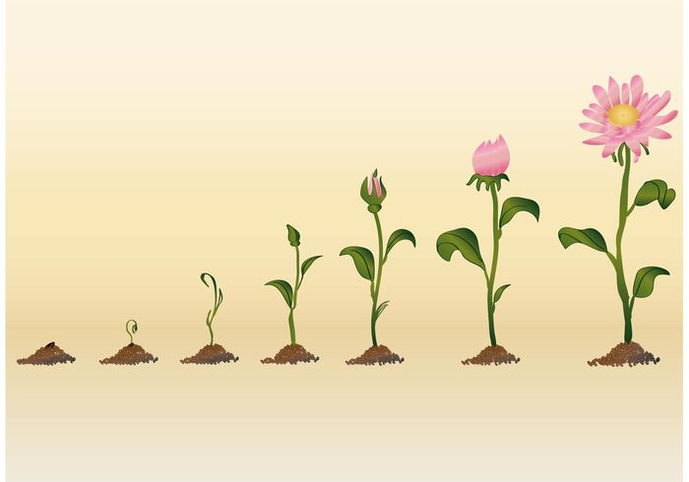
(Source: WeLoveSoLo, 2016)

There are several moments within a child’s life when things will change for them. Some of these changes can be positive while others may be difficult and can have an influence the child’s development. (Bleith, Bulman et a, 2010)

Contents Page

What is Transition? – Page 1-2

The Role of The Adult – Page 3-5

The Needs of The Child – Page 6-10

What is Transition?

Firstly,The term transition is applied to many disserent situations in which children and young people go through a period of change. Some of these transitions occor when starting school,changing classes, moving through the key stages or transitioning to secondary school. Children and young people also go through other periods of transition that can be long term or short term and these inlude these indlude changes on personal circumstances, experiences, going through puberty or just changing a seat or activity wwithin the classroom (Burnham,Baker, 2010)

One of the most important transitions a child will go through is often one of the first forms of transition they will experience and that is education. Children can access school education from as young as 3 years old.

Preparation for transition should start early and providers of childcare should try to develop a positive relationship with schools to aid the process. Good practice involves:
• Liaising with the new school.
• Organising a visit from school Reception staff and introduce them to children in their new provision.
• Talk to children about how they feel starting school and offer opportunities to share their feelings, such as at circle time.
• Encouraging independence throughout the day.
• Providing the new school with children’s records of development, interests, special needs, etc.
• Consider the children who are not old enough to transition to school and how they are feeling regarding their peers leaving.

The Role of The Adult

Early years practitioners must always make sure the child is supported fully throughout the whole transitional process. The practitioner must ensure that they are honest with the children about what is happening. They must give the children the time to ask any questions they might have, as well giving hem the opportunities to express their feelings. It is important for the practitioner to be the role model for the children, this can be done by showing them how to play with the different activities, the importants of listening and siting on the carpet and also role modeling good communication skills, to ensure they are able to form friendships (Sponsored Post, 2016). The practitioner needs to ensure they plan appropriately for the childs transition, always looking for ways of helping the children and keep in contact with everyone else that is involived (Beith, Bulman,et al, 2010).
The role of the adult does not stop at the children, they must also ensure they support the whole family through the whole process. One of the main ways this could be done is to give the pupil and families the opportunity to visit the new setting prior to the transition, this gives them the opportunity to ask any questions they need regarding the new setting and to also see the environment before they start (Burham, Baker, 2010).
All transitions that children encounter can have positive or negative affects and this usally is impacted by the support that is offered by the parents/carers and childcare workers. It needs to be remembered that any move to a new setting is going to cause concern for the child. The important thing for the childcare worker to understand is the concerns that the child might have this could be:
- What will the staff be like
- Will I like the teachers at the school
- What will the other children be like
- Will I have friends
- Will understand everything
- Where will the toilets be
- What will the food be like
As long as the childcare worker understands that these are some of the thoughts the children has, these can be worked on and apporached either before the child starts by having a tour of the setting, pictures sent home or showen and talked about on their first day (Martinelli, 2020; City and Guilds, 2019).
Once the child starts the transition process it is suggested by Bowlby (1958), the cope better if the adult:
- respons to the children’s needs to develop a strong trustworthy relationships
- ensures that every child within in the setting is supported
- is a positive role model, modeling social behaviour
- ensures that routines and clear experctations are established
- begings to work on how children conrtol and express their feelings
- encourages children to develop different strategies to deal with certain suituations effectively
- is sensitive to the childrens communication and developmental needs (City and Guilds, 2019; McLeod, 2017).
When the child has started the gradual setting process within their transition, paractioners must ensure they remember their role within this process, they must:
- remember to be good role model
- remember to follow all safeguarding policies to support the children and their families
- ensure they support and reassure the parent and the child through the proccess
- always ensure they are working within a welcoming, inviting environment
- meet the childrens physical, social and emotional needs
- take out assessments, observations and planning
- disscuss any concerns with the appropriate person (Allingham, 2011).

Mini conclusion saying if all these factors are considered and put into place then it will lead to a smooth ransition and will have a positive impact on them during future transitions.

The needs of the child

All children should be included and not at a disadvantage due to home language, family background, ethnicity, culture, religion, speical educational needs, gender or ability. All children going through transition need to be included within the process and they should be cared for in a secure and loving environment. One of The most important things to consider when a child is going through transition is to make sure they are able to form secure attachments with a key worker, because this will ensure they feel safe, secure and happy within their new environment. To ensure that the transition is as smooth as possiable it is important for the childcare workers to have the communication with parents as well as doing observations when meeting the child, to understand their likes and dislikes, this helps the childcare worker to ensure activities and toys are avliable for the child, to help them feel safe and secure also giving them a comfortable, enjoyable environment and experiences. All of these things help to ensure the child has a smooth tranisiton and it also helps to support their well-being as well as their development (Smidt, 1998, Beith, Bulman, et al, 2010).
Any transition can have an effect on the children:
- Emotional, this could be due to personal experiences, such as seperation anxiety. Some children can also find it hard to mix with others and make friends. Some children might also find it hard to form relationships with other adults as a result of something they might have seen or been subject to.
- Physical, this could be due to moving school and/or home having a lot of change within environment, feeling unsettled. The child’s physical development could also be affected, because they may not being sleeping or eating properly due to the transitions, which can led to an affect on their growth.
- Physiological, this can be having long-term health conditions, having a family member with health conditions or having problems with puberty.
- Intellectual, due to the changes some children might become withdraw and aviod social contact with peers, or adults. This can also affect the child regarding their school work because they might not be able concentrate or they might not be interested with school work (City and Guilds, 2019; Beith, Bulman, et al, 2010).

The child-centred approach looks at the child's development in a holistic approach. Its aim is to enable children to make decisions and solve problems. It also allows the child to become confident and independent. A child-centred approach gives the key workers a chance to observe the children, which support their planning because they are able to reflect on the things that the child enjoys and dislikes. By observing the children it gives the key workers the opportunity to take this into consideration and incoraporate the things the child likes within further learning activities, helping to support the childrens development, learning which in turn help the child to settle (Ford, Sankey, Crisp, 2007).
Throughout many different theories it is showen that happy, well settled children learn better and their wellbeing is higher. Children need to be supported when they are adjusting to transition this, includes moving from place from place or person to person. It is very important that we ensure children are the highest priority when it comes to their needs and the transition proccess. By doing this keyworkers ensure that children are able to build on their confidence, self-esteem, social skills learning and development ( Gopnik, 2016).
The importance of play helps children make sense of the world, it gives them the opportunity to discover things from themselves and develop cognitively, socially, physically and emotionally. Play has been studied by many psychologists Piaget (1962) was one of the first psychologist and Piaget viewed play as an integral to the development of children intelligence. His theory of play was that as the child matures, their environment and play should be encouaged to develop further langauge and cognitive development. This supports children throughout their transistion as they move through the school, the learning through play changes throughout key stages. Although accourding to his theory children should be able to cope with this transistion because they will have had the correct support for their maturaity (Hamid, 2018). Bruner and Vygotsky (1978) have also played an important role in shaping the educational practices of today by sharing their theory of adults playing an active role in assisting the child’s learning and development. Their theory links to supporting the child by simplifying task, encouraging and motivating the child and giving them models that can be imitated (Wood, Bruner, Ross, 1976). As well as these theories shaping how key workers support transistion, play, learning and development for children, they should also consider and support the child’s individual needs. Maslows hierarchy of needs highlighs the needs of the children and what they need to achieve before they are able to move onto the next stage and gain self-actualization.

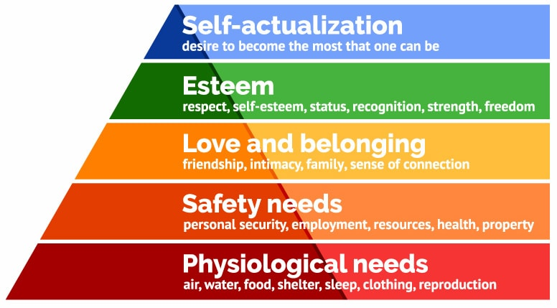
(Source; McLeod, 2020)
As well as the key worker implementing the importance of play to support the child the schools and nursery also follow The Foundation Phase Framework. This includes the important seven learning outcomes for children. Within in this the outcomes are set out to ensure that the child is gaining a variet of play opportunities to support and enable them to achieve the outcomes in the following areas:
- Well-Being and Cultural Diversity
- Personal and Social Development
- Language, Literacy and Communication
- Welsh Language Development
- Creative Development
- Knowledge and Understanding of the World
- Mathematical Development.
Having these in place ensure that setting are following the inclusion policies giving every child the opportunity to learn and develop (Welsh Government, 2015; UNICEF, No date).

It is important that all core skills are taught in fun ways, this can be done through role play, artwork, singing, small world, sand and water and other activities outdoors. This helps them to create a deeoer understanding of the world around them as well as themsleves. Giving them fun stimulating ways to learn supports their development and can encourage them them to take lead of their own learning. Through giving them different ways to explore develop and learn, it supports their confidence and self-esteem, which supports them through the different forms of transition that they may experience throughout their home life, or different stages of school (Patel, 2020).
Put a mini conclusion within this section this, pulling out the most important bits to support the needs.

Partnerships and Communication

One of the most important partnerships to develop is a parent/carer partnership because they know and understand the child more than anyone. Taking the time to listen and build a respectful relationship based upon trust is essential, as it will ensure parents/carers can trust the carer and share important information about their child or children, and make it is easier for you to approach the childs carer and discuss any developmental concerns you might have too. From there you can provide appropriate support, especially for those parents/carers who may feel isolated or excluded. Contact can be made with carers/parent via numerous ways such as:
- Email
- Phone call
- Home school diary
- Face to face appointments.

This will increase the effectiveness of the partnership by making information more accessable as well as building relationships which help to support their children because there can be clear goals and targets set where the childs best intrests are the priority
(Parentkind, 2018). Being able to communicate with parents through different forms can also help support them through transitions because you are able to let them know how everything is going, whether or not the child is settling. Having a strong partnership also supports the parents if they are struggling, for example filling in the application forms, gaining access to other forms of communication throughout the school, if the parents have their own needs or English is a second langauge to them. Having the partenships and the chance to build on relationships, supports them giving them the additional support they might require, ensuring a smooth transition for the parent as well as the child (Croner-i, 2019).

It is also important to have a partnership between the childcare provider, Parent/carer and external agencies such as:
- Health visitor
- General Practioner (GP)
- Education psycologist
- Speech language theropist
- Physiotherapist
- School Additional Learning Needs Coordinator (ALNCO) ( If applicable)
Depending on the child’s curcimstances you might have to contact such agencies to impliment a smooth transition by catering for the childs needs and ensuring the environment is also suitable (City and Guilds, 2019).

Effective communication is essential in achieving success and maintaining strong working relationships at all levels of a learning organisation. Leaders who invest time and energy into delivering clear lines of communication will build trust among staff, pupils and parensts leading to greater levels of acheivment within the school community.
Communication with parents is very important throughout the child’s school life. However, it has a huge throughout their time in the Early Years Foundation Stage, this is due to this being the first time the communication and partnerships between the parents and the settings happen. It helps to create postivite relationships and also helps to support the transition between home life and school for the children, as well as ensuring their development and well-being is being supported throughout. Communcation between parents help because they are able to be kept up to date with how their child is settling as well as their progress. It also supportst their development, because targets that need to be worked on at home and within in school can be addressed, relating to any assessments that are carried out (Nursery Resources, 2019). It is important that assessments and observations are carried out all children to help support their development, throughout any transition that they maybe going throught, this ensures that tasks and activities being set will help support the child in the correct way and help them feel secure and enjoy the activities (Drake, 2006).
Assessments that are carried out when a child transitions into Nursery and into Reception are the Wellcomm which is a speech, language and communication assessment that is carried out with children aged 6 months to 6 years. The Wellcomm assessment supports childrens understanding as well as speech, language and communication and it important that work is done within the setting as well as home. The Wellcomm assessment ensures there is good communication links between the care giver and parents/carers. The Wellcomm assessments support the child ensure they are working at their cronilogical age regarding speech, it also supports the transition into the different environment because they have got the time to build relationships with the member of staff delivering the assessments as well as the interventions if any are needed (GL Assessments, 2017). The Foundation Phase Profile is also another important assessment for children between the age of 3-7. The Profile is set out to support early identification of possible developmental delay, giving the practitior the opportunity to talk to the children’s parents about any conserns as well as the schools (ALNCo) to further support the children. This could be support by providing tasks to do at home, intervention acivities within the setting or being referred to correct support. The assessments are gathered on the Foundation Phase Baseline Profile and this provides all the useful information for everyone supporting the child’s learning and development as well as supporting the child between transisitons between different settings, year groups and schools (Early Years Wales, 2020; Welsh Government, 2015).
Not only does their need to be strong communication between the adutls the adults and key workers need to have strong communication with the children. The children and the key workers need to build a strong relationship in order for the child to feel safe and secure. Communication is paramount and key workers need to be able to communicate using veral and non-verbal skills, to be able to build strong relationships, which has a huge impact on the child (Daly, Byers, Taylor, 2004).

CONCLUSION: IMPORTANCE OF SMOOTH TRANSITION- HOW DOES THIS SUPPORT CHILDS DEVELOPMENT - HOW DOES TRANSITION IMPACT CHILDS DEVELOPMENT.

Interventions

In order for children to thrive and develop throughout their time within childcare settings, early identification and intervention is important. It is suggests that early years and pre-school interventions have positive impact on the child’s development (Early Years Interventions, 2018).
It is important that when interventions are being deliveried they are with the same key worker or a key worker that they are familiar with and that they feel comfortable with. The environment also needs to be considered when delivering an intervention, it needs to be somewhere, quite, comfortable and with minimal distractions. Having all of these things in place support the child and create higher outcomes (House of Commons, 2018).
Interventions are used as way to support children and help give them the opportunities to close the gaps that they might have within certain aspects of their learning and development. Keyworkers are then able to assess how they are doing and if there are any further concerns, they will be able to make a refferal to the approprite team, and communicate these outcomes to the child’s parent/carer (Early Intervention Foundation, 2020).

Proposed outcomes
Im not 100% about this section but what I have looked at looks like a conclusion but double check

Reference list

McLeod, S. (2020). Maslow’s Hierarchy of Needs. Available at: Maslow's Hierarchy of Needs | Simply Psychology (Accessed: 20/11/2020)

Early Years Interventions. (2018). Early Years Interventions. Available at: https://educationendowmentfoundation.org.uk/evidence-summaries/teaching-learning-toolkit/early-years-intervention/ (Accessed: 20/11/2020)

House of Commons. (2018). Evidence-based Early Years Intervention. Available at: https://publications.parliament.uk/pa/cm201719/cmselect/cmsctech/506/506.pdf (Accessed: 20/11/2020)

UNICEF, (No date). How We Proctect Children’s Rights: With the UN Convention on the Rights of the Child. Available at: https://www.unicef.org.uk/what-we-do/un-convention-child-rights/ (Accessed: 20/11/2020)

Wood, D.J, Bruner, J.S, Ross, G. (1976) ‘The role of tutoring in problem solving. Journal of Child Psychiatry and Psychology. 17(2) 89-100

Hamid, K. (2018). Psychology Behind Learning Through Play. Available at: https://www.pentagonplay.co.uk/news-and-info/psychology-learning-through-play#:~:text=Piaget%20viewed%20play%20as%20integral,further%20cognitive%20and%20language%20development. (Accessed: 20/11/2020)

Early Intervention Foundation, (2020). What is Early Intervention? Available at: https://www.eif.org.uk/why-it-matters/what-is-early-intervention#:~:text=Early%20intervention%20means%20identifying%20and,do%2C%20before%20problems%20get%20worse. (Accessed: 20/11/2020)

Gopnik, A. (2016). The Gardener and the Carpenter. London: The Bodely Head.

Ford, K, Sankey, J, Crisp, J. (2007) ‘Development of Children’s Assent documents using a Child-Centred Approach’ Journal of Child Health Care. 11(March 1, 2007) 19-28

Patel, A. (2020). Supporting Transitions in the Early Years. Available at: https://www.teachearlyyears.com/a-unique-child/view/supporting-transitions-in-the-early-years (Accessed: 20/11/2020)

Daly, M, Byers, E, Taylor, W. (2009). Early Years Management in Practice. 2nd Ed. Essex: Heinmann

Allingham, S. (2011) Transitions in the Early Years. London: Practical Pre-School Books

McLeod, S. (2017) Attachment Theory. Available at: https://www.simplypsychology.org/attachment.html (Accessed: 20/11/2020)

Sponsored Post. (2016) The Importance of Positive Role Models for Children. Available at: https://educationandbehavior.com/importance-of-positive-role-models-for-children/ (Accessed: 20/11/2020)

Martinelli, K. (2020) How can we help Kids with Transitions? Available at: https://childmind.org/article/how-can-we-help-kids-with-transitions/ (Accessed: 20/11/2020)

Welsh Government. (2015) Curriculum for Wales. Available at: https://gov.wales/sites/default/files/publications/2018-02/foundation-phase-framework-revised-2015.pdf (Accessed: 20/11/2020)

Early Years Wales. (2020) Foundation Phase. Available at: https://www.earlyyears.wales/en/foundation-phase (Accessed: 20/11/2020)

Nursery Resources. (2019) The Importance of Communication with Parents in EYFS. Available at: https://www.nurseryresources.org/articles/parents-as-partners/communication-with-parents/ (Accessed: 20/11/20)

Drake, J. (2006) Assessment for Learning. Available at: https://www.nurseryworld.co.uk/News/article/assessment-for-learning#:~:text=Having%20made%20assessments%20to%20identify,and%20practise%20the%20same%20skills. (Accessed: 20/11/20)

Croner-i. (2019). Managing Transitions in Early Years Provisions. Available at: https://app.croneri.co.uk/feature-articles/managing-transitions-early-years-provisions (Accessed: 20/11/2020)

Parentkind. (2018) How schools communicate with parents. Avaliable at: https://www.parentkind.org.uk/Parents/How-schools-communicate-with-parents (Accessed 20/11/2020)

Smidt, S. (1998) A Guide to Early Years Practice. 3rd Ed. Oxon: Routledge

Burnham, L, Baker, B. (2010) Supporting Teaching and Learning in Schools: Primary. Essex: Heinemann

Beith, K, Bulman, K, Forbes, S, Griffin, S, Tassoni, P. (2010) Children and Young People’s Workforce. Essex: Heinemann

City and Guilds, (2019) Principles and Values of Children’s Care, Play, Learning and Developmnet (0-19 years of age): How change and transitions impact upon children. Avaliable at: http://resource.download.wjec.co.uk.s3.amazonaws.com/vtc/2018-19/HSC18-19_3-1/_multi-lang/unit11/01-change-and-transitions.html (Accessed: 20/11/2020)

GL Assessments, (2017) Wellcomm Early Years and Wellcomm Primary: The Complete Speech and Langauge Toolkit. Avaliable at: https://www.gl-assessment.co.uk/products/wellcomm/ (Accessed: 20/11/2020)

