Name: Izabella Bristowe-Casey
Student Number: 1702665
BA Course: Photography in the Arts
Word Count: 2292
Tutor Name: Paul Duerinckx
Title: Using at least 3 examples consider how image makers have utilised digital technology to explore at least one of the following: conflict, identity, the surveillance state, the technological world?

In today’s modern society digital technology is part of everyday life, to capture images at a moment’s notice you don’t need to drag around bulky cameras and wait a day to see the final outcome, you can burst at ten frames per second and have them stored all in one location. The digital world is getting a bigger following day by day and needs to keep up with the high demands expected from it. Being an image maker myself I rely on having my phone, camera and laptop everywhere I go with also the catch of expecting free WIFI along the way. As I use a digital camera for my work planning and executing a shoot can be done relatively fast with limited equipment. I have decided to base this essay on Identity as it seems to be the bases around a lot of my work, most of my inspiration and role models in photography have used elements of identity in their projects from the likes of Cindy Sherman and Nan Goldin. To me, identity is what defies you and makes you your own, most artists have their favoured ways of working whether it be painting, making or photographing but putting your own stamp on everything is what makes it true to yourself. By adding your own individuality to all of your work is what makes it stand out and have people know that it is yours just by the small details you have included. In this growing technological world there are so many opportunities for artists and makers to improve on their work by faster ways to research, helping them to develop ideas and being cost effective, it can be a big competition for individuals to get noticed. If back in the day artists like Van Gogh had social media platforms to promote their work to thousands of people, then maybe in today's society he wouldn’t have been as iconic due to everyone using the same techniques and developing the same amount of fame. I will be looking into the works of artists such as Nan Goldin, Mario Testino and Zoe Grossman, who I think capture identity in the best way of my interests but each with their individual touches.

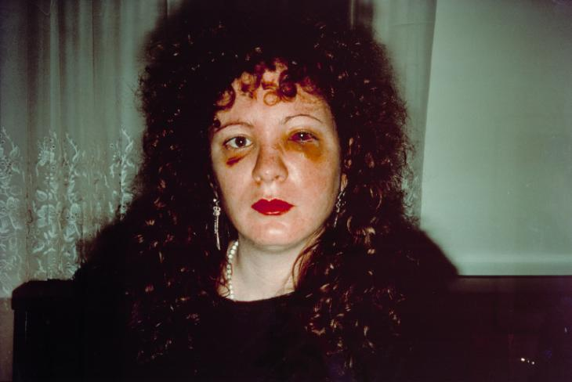Fig. 1
I chose to write about Nan Goldin, although her work isn’t always based on herself I think that by turning the camera on others and documenting the people that she loves makes it even greater. When I look at how distinctive and deep her self-portraits can be you get to see sides to her that normally a person wouldn’t share. ‘Nan, one month after being battered’ is a solid piece of work to look at, by almost feeling the pain she endured just by looking into her bloodshot eyes. “Her portrait after the event reflects Goldin's honest approach, which she never avoided showing personal trauma.” (Gallery label, 2019) We as the watchers and readers get to depict our own imagination into their personalities just by looking at the images. “Send love to each person that’s dead” (Rena Silverman, 2017) In an article for The New York Times Rena Silverman looks closely into Goldin's friendships made after moving to New York and how her past life traumas are shown throughout her work. How being an artist in the 80’s and the types of friendships she made caused her to lose the close people that surrounded her which she chose to be her fake family. When looking at her work you see that she is not afraid of challenging the ordinary and does not hesitate in the work that she shows. Goldin's Taboo style photographs explore hugely into the early LGBT community along with visually documenting her life as a city hoping photographer.

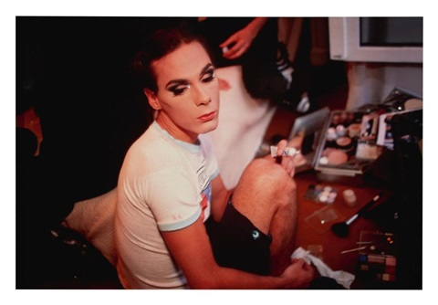Fig. 2
Out of all Goldin’s work which I have studied her images of the LGBT community stuck out the most to me, these are people who have hidden their full identities for so long that by seeing them be their true selves is a good example of why photography can be so rewarding, having these images circulating the creative world helps normalise these people and gives them a chance in the spotlight after years of hiding. When these images were first made they would not have made such an impact on the digital world as it was just getting started but today Nan Goldin’s work is still being displayed all over the globe and by social media popularity will be shared everywhere letting a new and more understanding generation make their mind up on them. “I don’t think we’d be here now in this amazing sexual and gender revolution without the online space where young people can see and share other versions of identity and sexuality.” (Charlotte Cotton, 2016) One of the many extraordinary things about using the internet is discovering fresh artists who use platforms to be found, using their profiles as digital scrapbooks piecing together their own online identities which open them up to new opportunities and being discovered in the creative world. In the same interview Cotton is asked how artists manage to keep three aspects of life balanced, private, public and secret, she responds “More platform - sensitive generations will make distinctions between online and in person intimacy” (Charlotte Cotton 2016) I think that the importance of keeping real life and online balance can determine how your art can be viewed or you will be judged as an artist and that when it comes to identity other people's perspective will never be the correct version. As an artist I think my online profile is perceived in a different way I see myself, many thinking I can be self-obsessed when it is just an alto ego filtering out the raw details. Getting to Photograph people can be such a satisfying feeling when you see your final products and show them back, I always find it so interesting getting to find out how somebody else sees you or if you are only giving them a version of yourself you’d like them to see.

Mario Testino, profoundly known as one of the most iconic fashion photographers of our time. From shooting Fashion House campaigns like Versace, Gucci, Tom Ford and Chanel but also getting to work with everyone from Princess Diana to Jay- Z he is one to say been there, done that. Testino's work can also be boundary breaking just like Goldin’s, but within his own means, covering topics like sexuality and nudity in an artistic form.
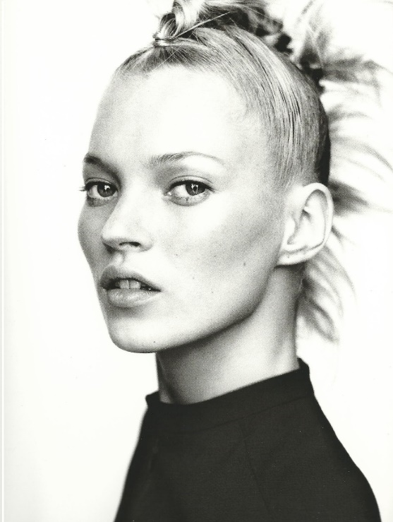Fig. 3

With his international coverage Testinos’ work inspires all from exhibitions, to his social accounts he shares his experiences to the world passing on his most memorable tips to help new artists thrive. He has also created his own agency ‘Testino+’ where he offers creative direction in digital marketing, development and branding to help new and aspiring artists and photographers on how to grow their own platforms. Much of his images which have been shot digitally prove how he manages to work so fast “I spend, maximum four or five days in a place at a time.” (Mario Testino, 2012) With the boom of having an Insta obsession no other medium unlike photography beats all, with millions of people scrolling through millions of images day by day no other art form gets this amount of coverage unless you were to tour all the museums around Europe. Social media creates an online community space so that artists can connect and learn from each other for free, inspiring and recontextualizing their work all on one device. Sometimes there can be a negative effect on getting to see so many people’s work so quickly, by not stopping and praising the details or scrolling down too fast without even catching the name of the artist. “Cartier - Bresson’s work is perhaps the most emblematic example of what used to be called straight photography: An example of the art of going out into the world with a camera to take a great photograph. Now, though, photography tends to be made - and remade, remixed or recontextualized rather than taken.” (Sean O’Hagan, 2016) When mixing art and photography together recontextualizing isn't a bad thing, I think that being able to find pieces of work that balance each other out to make new meanings but still seeing essences of the original definition is the future of the artistic world. When working digitally you are able to piece together work from so many unknown artists and broaden the context of their work then sharing it among your own followers makes them become more noticeable. When it comes down to Identity, Mario Testino’s famous portraits bring the person out within them, reflecting new and upcoming beauty standards and showing how masculine and feminine identities are developing inside the Fashion Photography kingdom.

Zoe Grossman’s passion is shown throughout all of her images, as we watch her grow into the newest generation of famous Fashion Photographers she is catching up with the best and always setting herself new goals. As she grew up in LA she is in one of the finest locations to get some famous faces into her portfolio. Since finally getting established as a well-known fashion photographer she has been lucky enough to work with Bella Hadid and Christina Aguilera creating stunning imagery to feature in all types of magazines. As fashion is so fast changing it isn't always the most currently on trend photographers who’s images stand out the most and sticking to your means is what gets people looking, But, by Grossman having such good connections with today's supermodels her online profiles are where a lot of her work will be shared. If someone like Bella Hadid is to upload images from a recent photoshoot with Grossman and mentions her it could be the best type of publicity to keep her growing as an artists and gaining more followers.
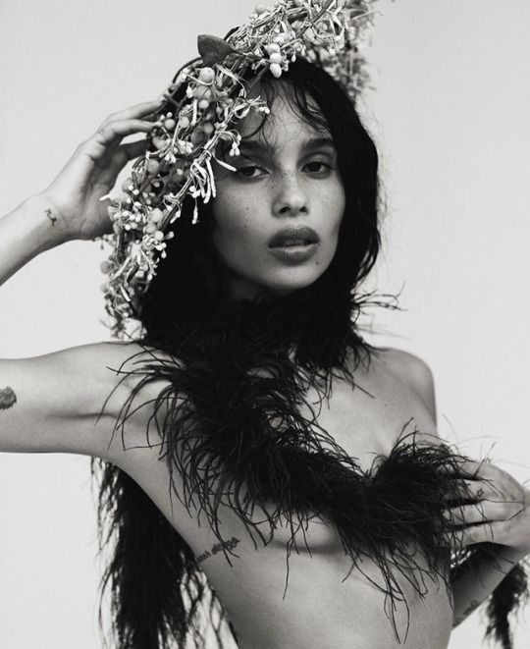Fig. 4
I think in the subject of fashion photography there is huge stigma whether it can be viewed in a positive or negative light and if it makes women in particular feel empowered or not. Now times are changing you aren’t seeing as many skinny, white females on the Front Covers as diversity in fashion is finally making a breakthrough, but as it is eventually making coverage it almost feels forced and as if certain brands are having to push themselves out of choosing the ‘traditional’ looking model to represent their clothes, which I think can make their images look flat and almost like they all share the same boring qualities. “Fashion Photography speaks both reality and illusion of garments and of bodies, and in deconstructing how these elements are organised and presented a new language and system emerges from the photographic work.” (Roland Bath, 1967) Bath’s explanation on how the photographers planning of a shoot to create visually appealing shapes and colours and their way of showing off the most important part, the garment, is great words to work by for any upcoming fashion photographer who seems more focused on other people's opinions rather than their own work. By using more diverse models in magazines and advertisements can create a turning point on how women see themselves instead of comparing each other to what is thrown in their faces online. Social media's negative side can be such a depressing space when all we do is wish we looked like somebody else. It is so easy to access and puts more and more pressures on young women who grow up seeing the idealised ways of looking. I think that by the power high end fashion brands, photographers and artists hold is the best way of getting through to growing girls by changing the way advertisements are shown.

In conclusion to the points made on how image makers have utilised digital technology by exploring identity I have discovered that having a high social following, being diverse, current and open to exploring topics you might not have covered before will make you the better type of Photographer, and that the odd self-portrait here and there never hurt anybody. You have to understand yourself before moving onto others and capturing really raw and true images is the preferred way of showing who you really are. In an interview with Zoey Grossman she explains how researching the models she is about to photograph helps her get the best understanding of what they are comfortable doing and how genuine they are as a person. Or like Nan Goldin, she uses they people who surround her that she knows best is her way of storing their identities in her photographs and keeping it personal. In this digital revolution how you are seen online can determine peoples ways of hiring you into jobs, secretly viewing how somebody looks before deciding to photograph them or deciding if their social followings are worth your time to gain more for yourself, but remembering that not everyone's opinions of yourself matters and it isn’t always about how you capture other people's identities but keeping your own will make your work stand out more and be remembered for your personal ways of working. Competition is so high in the photographic world that adding more high-profile names and faces into your portfolio will also do wonders in your creative career. For me I find that growing up in such a digitally empowered generation can be inspiring and that is why getting to assess such a vast number of upcoming artists is what keeps me inspired. As a photographer I think identity is one of the key topics every artist should cover as each piece of work will come out differently, whether you are studying by yourself or others no style of work will be the same.

Bibliography

https://lens.blogs.nytimes.com/2017/12/05/nan-goldin-looks-back-at-friends-and-lovers/
https://www.guernicamag.com/surveillance-revisited/
https://www.theguardian.com/artanddesign/2012/oct/21/mario-testino-interview-fashion-photography
https://www.theguardian.com/artanddesign/2016/jul/02/photography-no-longer-just-prints-on-the-wall
https://www.tate.org.uk/art/artworks/goldin-nan-one-month-after-being-battered-p78045
https://www.ukessays.com/essays/cultural-studies/positive-construction-of-identity-through-photography-cultural-studies-essay.php

List of Illustrations

Fig .1 - Nan, one month after being battered
Fig .2 - Misty, doing her makeup
Fig. 3 - Kate moss
Fig. 4 - Zoe Kravitz

