First light on Archaic petroglyphs in east central Utah as solstice markers.
Iza Steiner
Dissertation submitted in partial fulfilment
of a Master of Arts in Cultural Astronomy and Astrology
University of Wales Trinity Saint David
2022

Master’s Degrees by Examination and Dissertation
Declaration Form
1. This work has not previously been accepted in substance for any degree and is not being concurrently submitted in candidature for any degree.
Name..…….Iza B. Steiner…………………………………...
Date ………April 23, 2022…………………………………………………...

2. This dissertation is being submitted in partial fulfilment of the requirements for the degree of Master’s Degree in Cultural Astrology and Astronomy
Name… Iza B. Steiner……………………………………………….
Date …April 23, 2022…………………………….…………..…………...

3. This dissertation is the result of my own independent work/investigation, except where otherwise stated.
Other sources are acknowledged by footnotes giving explicit references.
A bibliography is appended.
Name………Iza B. Steiner
Date: ……April 23, 2022………………………...……………………….

4. I hereby give consent for my dissertation, if accepted, to be available for photocopying, inter- library loan, and for deposit in the University’s digital repository
Name………Iza B. Steiner………………………………………….
Date………April 23, 2022………….……………………………..
Supervisor’s Declaration.
I am satisfied that this work is the result of the student’s own efforts.
Signed: …………………………………………………………………………...
Date: …………………………………………………………………………..

Table of Contents

Abstract 7
Introduction 8
The Study Area 10
Cultural Prehistory 13
Paleo-Indians 13
Archaic Era 14
Ancestral Puebloan (AP) 16
The Fremont 19
Numic Tribes 21
Literature Review 22
Rock Art 22
Solstice-observations in Emerging Societies 29
Paleolithic and Archaic Rock Art 29
Sedentarism and Megaliths 30
Petroglyphs and Solstice among Southwestern Agriculturalists 34
Solstice Ethnology among Hunter Gatherers 36
Skyscape Archaeology 39
The Method 42
Results 46
Discussion 50
Issues 50
Rock Art in the Landscape 56
Hunter-Gatherer Ethnology 62
Relationship with the Sun 62
Time and Space 65
Animism and Shamanism 67
Phenomenology of the Desert 71
Conclusion 79
Appendix A: Summary of Site Data 82
Bibliography 90

Table of Figures
Figure 1 Map of Study Area and Region…………………………………………………….………………….12
Figure 2 Ingold’s Exhabitants and Inhabitants……………………………………………………………….73
Figure 3 Canyonland’s Inhabitants………………………………………………………………………...........74

Table of Tables
Table 2 Scatter Plot of Low Points on the Eastern Horizon from Petroglyph Sites……….47
Table 1 Percentages and Numbers of Solstice Petroglyph Sites……………………… ………….48
Table 3 Scatter Plot of Low Points on the Western Horizon from Petroglyph Sites….….48
Table 4 Scatter Plot of All Low Points on the Horizon from Non-Rock Art Sites……………49
Table 5 Degrees of Diffusion from Exact Solar Trajectory…………………………………………….50

Table of Plates
Plate 1 Barrier Canyon Style Rock Art…………………………………………………………..……………..23
Plate 2 Repatinated Petroglyphs………………………………………………………………………………….24
Plate 3 Western Archaic Tradition Rock Art………………………………………..……………………….28
Plate 4 Sunrise on Winter Solstice Sunrise Petroglyph Site………………………………………….43
Plate 5 Geographic Distribution of Sites within the Study Area……………………………………46
Plate 6 Summer Solstice Sunrise in Canyonlands with Mesa and Cliff Edges….……….…..52
Plate 7 Winter Solstice Sunrise over Kane Creek Road…………………………………………………53
Plate 8 Bundling of Petroglyph Sites along Millcreek……………………………………………………54
Plate 9 Bundling of Petroglyph Sites in the Kane Creek Area...………………….………………...56
Plate 10 Mountain View from Millcreek Petroglyph Site………………………………………………57
Plate 11 Handprint Petroglyph in Millcreek………………………………………………………………….75
Plate 12 Footprint Petroglyphs at Courthouse Panel……………………………………………………76
Plate 13 Spire near to Petroglyphs……………………………………………………………………………….77

Acknowledgments
I am grateful to the encouragement and support of J. McKim Malville as Dissertation Supervisor, the Sophia Centre’s Programme Director Nicholas Campion and my Dissertation Module Tutor Bernadette Brady. Greg Nunn, Christopher Prentice, and Rory Tyler were invaluable informants. I appreciate the assistance of Tom Spruil, Lori Hunsaker, and Kris Westrum in accessing resources.

Abstract
This research questions whether the Archaic and prehistoric hunter-gatherer peoples of east central Utah created rock art markers at locations for viewing solstice sunrise and sunset, where first light of dawn and last light of dusk fell on the landscape. Nomadic people required fixed locations to track the turning points of the sun. While the sedentary agriculturalist’s need for calendars and solar tracking is well-established, this research tested the frequency of petroglyphs for viewing solar events to determine a relative value of solstices to hunter-gatherers in an inventory of all the known petroglyphs in the study area.

Introduction
This study investigated whether Archaic rock art of eastern central Utah was situated to receive first light on the solstice sunrise or last light at solstice sunset. Clive Ruggles confirmed Alexander Thom’s conclusion that Stonehenge was oriented to solstices. Since then other megalithic structures have been documented to be oriented to solstices in prehistoric agricultural societies by Robert Hensey at Newgrange, Tore Lomsdalen at the Mnajdra temples of Malta, and Anthony Aveni at Cuzco. Aveni, Gregory Feist, Tom Condit and Gabriel Cooney have argued that emerging agricultural societies needed to track solar movements for calendars and planting. There are certainly multiple purposes for the placement of Archaic rock art, yet the percentage of sites oriented to solstices offers insight into the value placed on solar turning points by hunters and gathers, for whom Elizabeth and Paul Barber argued time ‘would be largely irrelevant’.
Hunters and gathers, who relied on keen observation of their environment for survival, according to Ekkehart Malotki and Ellen Dissanayake, could hardly have failed to notice the seasonal differences in the path of the sun. To accurately determine whether the sun was at its most northerly or southerly point along the horizon, nomadic, Archaic people needed a reference point from which to view sunrise and sunset, according to the Barbers. It is proposed that among the simplest and earliest means of establishing a reference point for solstice-viewing was to inscribe the rocks with petroglyphs, where the first light occurred in a landscape. The Barbers contended Archaic people relied on seasonal floral and faunal indicators for their calendrical needs. This research proposes that Archaic groups tracked and commemorated solar movements as part of a sacred relationship to the sky rather than a subsistence motivated need for a calendar. The sky realm is featured as the home of supernatural beings in many Native American cosmologies including the Chumash of California, the Iroquois of New York, the Pawnee of Nebraska, Osage of Arkansas and Missouri, Muskogee in Florida, and Classic Mayan myths, according to George Sabo III and Jan F. Simek . While no ethnologies have survived from the desert Archaic people who once occupied the study area, an abundance of sky beings in myth across Native American peoples indicate the sky was sacred to their ancestors.

The Study Area
This section begins with the geology of the study area, including its impact on people who inhabited it and their rock art, followed by the geographic influences and the cultural history.
The study area lies in east central Utah, centered around Delicate Arch in Arches National Park with a radius of 35 km, covering 3848 km², including the towns of Moab, Castle Valley, and Thompson Springs. The Colorado River bisects the study area, from the Dolores River confluence to the west end of Highway 279. Thompson Springs and Pack Creek are the north and south perimeters, respectively. Arches National Park lies completely within the study area, as do the Millcreek Wilderness Study Area (WSA), Behind the Rocks WSA, Negro Bill Canyon WSA, and Lost Springs Canyon WSA. The northwestern half of the La Sal Mountains in the Manti-La Sal National Forest is within the study area, while a large portion of the remaining lands are under management of the Bureau of Land Management (BLM). Most of the study area is in Grand County, although some sites at the southern end are in San Juan County. Grand County is 87% public land, and the study area is representative of that distribution.
The surface geology of the study area ranges from Cretaceous Mancos Shale to the Pennsylvanian limestone and Paradox salt layer, according to Hellmut Doelling. Entrada and Navaho sandstone (Jurassic) formed the iconic fins and arches of Arches National Park and ubiquitous Wingate Sandstone cliffs (Triassic) have eroded into a maze of high-walled canyons, mesas and buttes in the surrounding Canyonlands, according to Doelling. These sandstones have manganese and iron oxides, which interact with rainwater to form a dark patina called ‘desert varnish’, which was the preferred canvas for petroglyphs in the Southwest, according to Sally Cole. Basalt was occasionally pecked with petroglyphs, where it remains from laccolithic volcanic intrusions like the La Sal Mountains. Suitable surfaces for rock art are abundant in the study area and the choice of canvas is unlikely to have determined the location of rock art.
The second geological factor influencing the research question is the orientation of many of the large features of the landscape. The Paradox Formation is a soft semi-fluid subterranean salt layer up to 4250 m thick, which created collapsed salt dome valleys lying along the southeast to northwest axis, as do local fault lines, according to Doelling. The long salt valleys have high walls to the northeast and southwest, but low horizons in the southeast and northwest, predisposing local skyscapes to winter solstice sunrise and summer solstice sunset views. See Figure 1.
Geography also played a key role in the cultural development of the study area. The intrusion of the La Sal Mountains (max. 3879 m) amongst the deep canyons and sage plains (1160 m) added multiple zones of vegetation, which early hunter-gathers were able to
Figure 1 Map of the region includes black fault lines, stippled salt valleys, black areas of laccolithic mountains. The study area is outlined by the blue circle. Map: Utah Geological and Mineral Survey, 1985.
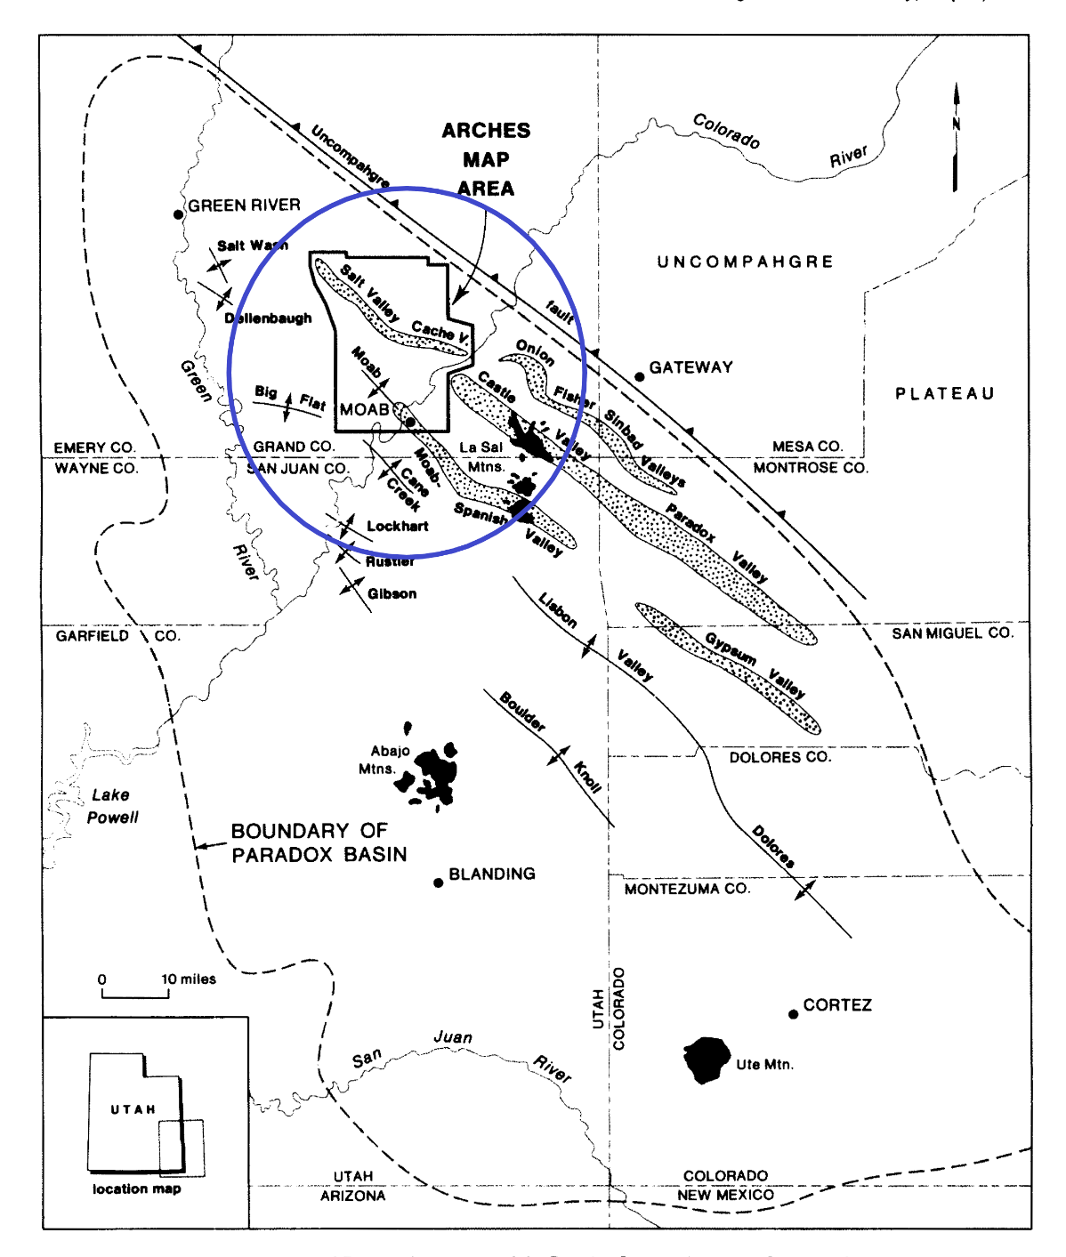

exploit, according to Jesse Jennings. Annual precipitation on the slopes of the La Sal mountains is over 1000 mm/yr., going down to 222 mm/yr. in Arches National Park. Native American sites and rock art are found along the Colorado River and its tributaries, where there is enough water to support a diverse ecosystem, while the surrounding high desert shrubland was sparsely inhabited. Much of the study area is Canyonlands formed of wind and rain sculpted stone deeply incised into canyons, mesas, and fins forming barriers to travel that have left the region isolated.

Cultural Prehistory
The cultural prehistory of the study area began with Paleo-Indians around 10,000 BCE, who adapted to environmental conditions by developing Archaic cultures and lifestyles which persisted among various groups into historic times. Incursions of sedentary agriculturalists from the south were sparse during the Pueblo II expansion and the dated evidence in the study region is limited to several centuries from around 900-1150 CE.

Paleo-Indians
David Stuart assessed that during Paleolithic times, from 10,000 – 5,000 BCE, Utah was inhabited by Paleo-Indians who hunted megafauna, including mammoths, with Clovis spears. According to Mary Prasciunas, Clovis points were found across all the southern states (excluding California), including all of Utah. The Museum of Moab has a mammoth tusk displayed as part of a Clovis kill within the study area. Ekkehart Malotki has documented a Clovis site at Sand Island, UT 150 km south of the study area, where mammoths are depicted in the rock art. Greg Nunn attested to the use of quarries within the study area to produce Clovis points. The Paleo-Indians ranged broadly, considering large regions ‘home’ according to Stuart, which reinforces the conclusion that Paleo-Indians lived in the study area.

Archaic Era
After the megafauna died out and a drier, more seasonal climate prevailed, the Native Americans shifted to an Archaic lifestyle, which included hunting smaller game such as deer and bighorn sheep and adding seeds, roots, and other wild plants processed by grinding tools to their diet, according to Stuart. Archaic artifacts, including textiles and baskets were excavated by Phil Geib and Edward Jolie at Cowboy Cave, just west of the study area. Stuart assessed the Archaic phase lasted from 5,000 -2,000 BCE in the Four Corners area. Closer to the study area, Kevin Black, et al. concluded that in Lisbon Valley just south of the La Sal Mountains, ‘Hunting and gathering activities dominated the cultural scene for most of the prehistoric era,’ and listed a single ‘Anasazi incursion into the area in the tenth century.’ Betsy Tipps summarized that ‘local people were practicing a hunting and gathering lifeway… continuing as late as A.D. 710-1010,’ in the Squaw Butte region of the Needles District of Canyonlands National Park. Stuart depicted the Archaic period as a time when the population grew slowly, people remained highly mobile, had a healthy, diversified diet and used naturally occurring rock shelters. Jennings suggested the term ‘Desert Archaic’ to unify the eastern and western branches of the Great Basin Archaic culture, the keynotes of which are the millstone and basketry, use of a broad range of flora and fauna and residential use of caves. Jennings concluded that Utah had
… a widespread, but thin Archaic population geared to a mobile hunting-collecting way of life in an essentially unchanged environment over the study area for some 10,000 or 11,000 years, to about A. D. 1850 – 1900.’

James Aton more recently argued that the Archaic era along the Green River, directly north of the study area, ended around 600 CE, after which the area was depopulated for three hundred years.
Aton contended that both corn and the bow and arrow were introduced in that region between 50 BCE and 200 CE during the late Archaic. The shift toward agriculture was not one way: Stuart reported that ‘a few, scattered Archaic- style sites (as late as 1000 CE) indicate some families drifted back toward more traditional hunting and gathering’ even in the centre of Four Corners region, where early agriculture flourished. In the study area, the archaic lifestyle was maintained in the deserts and most of Canyonlands, even while agriculturists occupied the valleys, according to Alice Hunt. Hunt asserted that over 90% of the sites she discovered in a 500 square mile (1300 km²) survey of the La Sal Mountains were campsites, not dwellings, indicating that hunting and gathering was the preferred subsistence in this montane and canyon environment. The salient feature of the Desert Archaic for the purposes of this study is nomadism. Because the temporal definition of ‘Archaic era’ varies regionally, this study only distinguishes between sedentary agriculturalists and ‘Archaic’ people who led a nomadic lifestyle of seasonal migration to optimize a hunting and gathering subsistence, regardless of timeframe.

Ancestral Puebloan (AP)
Francis Smiley argued that nomadic, Archaic peoples shared traits and behaviors across broad regional areas, but cultural traits became regionalized as people became sedentary and more isolated. In the Four Corners region (bottom right in Figure 1), Ancestral Puebloans (AP) mastered maize agriculture and villages emerged, beginning with small unit pueblos of surface masonry, which culminated between 900 – 1200 CE in the Chaco culture with magnificent core and veneer masonry in multistory pueblos large enough to house thousands of residents, yet mysteriously only housing a few hundred, according to Kathy Durand. Chaco outliers extended northward to the San Juan Basin in southeastern Utah, where small farmsteads and villages supported the city of Chaco with corn, according to Stephen Lekson. At the Pecos Conference in 1927, archaeologists agreed upon eight phases of development for the Chaco culture, including Basketmaker (BM) I-III and Ancestral Pueblo (AP) I-V. While ‘Basketmaker’ generally meant pre-ceramic and was associated with initial steps toward maize agriculture, BM I was considered Archaic, according to Smiley. Pit houses and agriculture were common by BM III, but only rudimentary ceramics were produced, as Jennings explained. Near Four Corners, the Pecos classification BM III ended around 750 CE, but according to Jennings, both the cultural traits and the temporal designations of the Pecos classification rapidly fade as the culture extended into the Northern Periphery of the Colorado Plateau, in which the study area is centered.
The AP, whose cultural epicentre was Chaco, NM and later Mesa Verde, CO reached the Colorado River near Moab during the Pueblo II expansion phase, where a ‘very sparse’ AP population pursued farming in the valleys of the study area, according to Lloyd Pierson. Based on ceramic evidence summarized by David Breternitz et al., the AP occupation around Moab lasted from 900 -1075 BCE, although potentially to 1282 BCE. For Pierson, ‘the cultural norms for the period as described from the large centres, never quite seem to fit the local situation, and one wonders if one really dealing with the same culture.’ Western Basketmakers of Uto-Aztecan (Mesoamerican) descent preceded the AP with a preceramic, agricultural lifestyle living in small hamlets of pit houses in southeastern Utah, according to Steven LeBlanc, yet Pierson described a transfer of ideas into Archaic populations rather than a Basketmaker migration into the Moab area. The architectural first stage of AP, known as the unit pueblo, was discontinued about 75 km south of the study area, on maps from William Ferguson and Arthur Rohn. The rich ceramic culture of the Four Corners is found in trade goods, but local manufacture appears to have not progressed beyond rudimentary grayware, according to Pierson.
According to Black et al., who conducted a pedestrian survey of the Lisbon Valley south of the La Sal Mountains, shifting climate and thin soils made, ‘the northern periphery marginal for societies dependent on maize agriculture.’ In contrast to the agriculturists of the San Juan basin, whose diet consisted of around 70% corn, according to Stuart, AP near Moab may have been opportunistic horticulturists. Annual precipitation in Moab is 240 mm/yr. Maize is a tropical plant which requires 635 mm/yr. rainfall, according to Lekson, and 120 frost-free days to reach maturity. West of the La Sals, there may have been enough frost-free days to ripen corn, but irrigation was required to supplement rainfall, while in the valleys north of the La Sals, early frosts descend from snowy slopes shortening the already marginal frost-free season for corn, according to Jennings. Within the study area, attempts at agriculture and sedentary lifestyles were sparse, short-lived, and continued to rely heavily on hunting and gathering to supplement the diet, in Pierson’s assessment.

The Fremont
Jennings delineated the Colorado River as the boundary between the AP to the south and the Fremont to the north. The Fremont are a second agricultural group, who emerged from Archaic peoples in the region north and east of the Colorado River around 500 -1200 CE, according to Jennings. David Madsen described the Fremont as ‘variable’ in their subsistence strategies, fluctuating between sedentary agricultural lives in pit houses to hunting and gathering and living in rock shelters, and for whom only four minor cultural traits were distinctive. Based on genetic mitochondrial DNA and linguistic evidence, Carol Patterson argued in 2018 that the Fremont north of the study area were AP, who colonized and farmed river valleys and side streams throughout eastern Utah to the Wyoming border, then eventually migrated to the Hopi mesas. Patterson argued that AP created masonry structures along the Green River and farmed its tributaries. Connie Mulligan questioned whether Fremont are genetically linked to the AP and modern Pueblo groups. The early regional archaeologist Hunt labeled the farmers in the valleys of the study area as ‘prehistoric Hopi’ and the hunter-gatherers in the mountains as ‘Fremont?’ While Hunt’s terms are no longer used, Pierson concluded that there was an ‘interfingering’ of two groups that used different ecosystems in the study area. Contrary to Jennings’s assertion of the Colorado River as a regional border between the Fremont and AP, a more complex map of riverine farming communities surrounded by hunter-gatherer peoples emerged, which may extend across North America, according to Lekson.
Whether these groups were maintaining territories along the river or crossing it for trade and intermarriage, neither the Fremont nor the AP retained the classic traits of their cultural epicentres and both had adopted adaptable lifestyles, often mixing horticulture with hunting and gathering, leaving their cultures almost indistinguishable according to Pierson. The architecture never progressed beyond pit houses and using R. G. Matson, et al.’s formula for estimating sedentary population, the fifty known pit house ruins, generously multiplied by four would only yield a population of 66 on average over 150 years of occupancy in the study area. Aton described a depopulated region from 600-900 CE leaving only a couple of centuries during which a small group of settlers attempted farming in the valleys of the study area. The rock art left by the AP and/or Fremont forms a timestamp of younger rock art superimposed over older elements, which can then be associated with people leading an archaic lifestyle.

Numic Tribes
The study area was culturally uniform in the protohistoric ~1200-1800 CE phase during which the Numic-speaking Utes and Southern Paiutes led a nomadic hunter-gatherer lifestyle, mostly using wickiup brush shelters, according to Pierson. The Utes flourished with the introduction of the horse and were primarily a mountain people, whose petroglyphs are often identifiable by the depictions of horses and other European introductions, according to Patterson. The importance of identifying the local rock art as part of the AP, Fremont or even Ute traditions was solely used to recognize that it is of a significantly younger creation than Archaic elements, which are the subject of this study. Due to the extended time frame in which Ute rock art was produced, panels containing Ute elements are not included in this study.
In summary, the geologic and geographic attributes of the study area have favored the versatile approach of hunter-gathers. It remained remote from cultural centres and distinctions between groups seem more responsive to environmental conditions than cultural legacies. After a relatively short period of trying to pursue maize agriculture in a marginal environment, those who had once come from the south returned and hunting and gathering tribes from Western Great Basin took over the region to exploit the resources effectively into protohistoric times.

Literature Review
This study sought to understand the importance of solstitial horizon events to Archaic hunter and gathers, by applying skyscape archaeology methods to the placement of their rock art within the canyon landscapes. The academic context begins with definitions of rock art, proceeds with the role of solstice tracking in emerging societies and concludes with the method of skyscape archaeology and means of applying it to the local rock art.

Rock Art
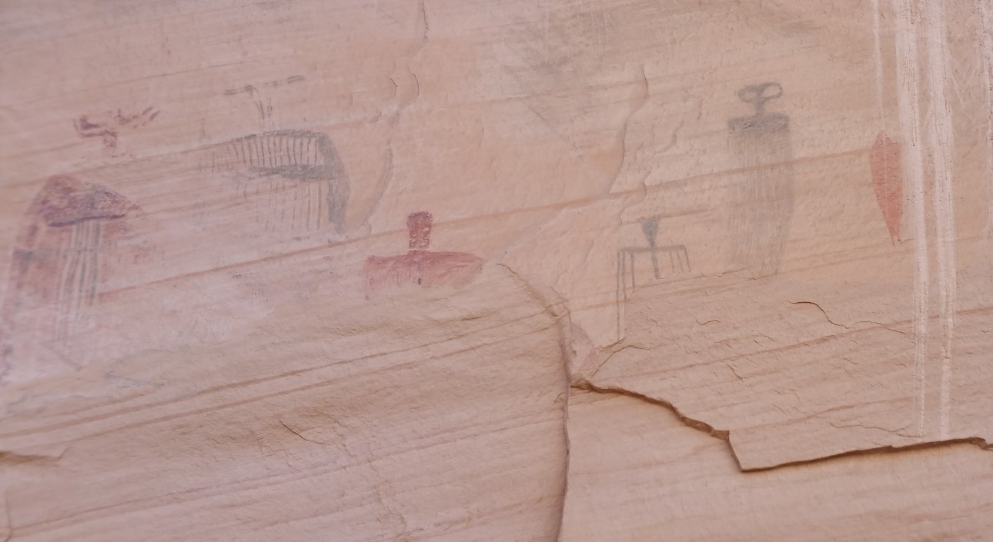
The term ‘rock art’ is still in widespread use by researchers, such as Cole, who defined it as ‘A body of pictorial data (images, marks, forms, technologies and their relationships) as well as to specific groups of imagery displayed on natural rock surfaces.’ Both Native descendants and researchers like Cole, Dissanayake and Malotki agree that the term ‘art’ conjures misleading Western concepts of ‘art’. Yet Malotki disputed the concept that rock art is a form of proto-writing; by contrast LaVan Martineau and Patterson correlated the imagery to Indian sign language. Dissanayake and Malotki seek to redefine rock art as a form of artification or ‘making something ordinary extraordinary,’ which is considered a universal human trait. Artification is a particularly useful term in this study, where the question is not concerned with the meaning of the rock art figures but to determine why an ordinary place was made extraordinary.
Plate 1 Barlett Panel has Barrier Canyon Style pictographs. Photo: Author.
Cole defined the basic rock art categories by technique, where petroglyphs are ‘pecked, incised, abraded, gouged, etched or scratched’ into the rock and pictographs, or rock paintings, are painted onto the stone using pigments. Pictographs are highly vulnerable to weathering and generally only survive in protected locations. See Plate 1. Because erosion skews the sampling by location, pictographs have been excluded from the study. The collective term ‘element’ is used to refer to individual figures subdivided by researchers like Polly Schaafsma and Cole into ‘types’ such as anthropomorphs (human-like figures), zoomorphs (animal-like figures), and geometric or abstract figures. Both Schaafsma and Cole have distinguished themselves on the classification of rock art styles. Differentiating between styles in the study region was challenging because many elements recurred during different eras of deposition, as seen in Plate 2.

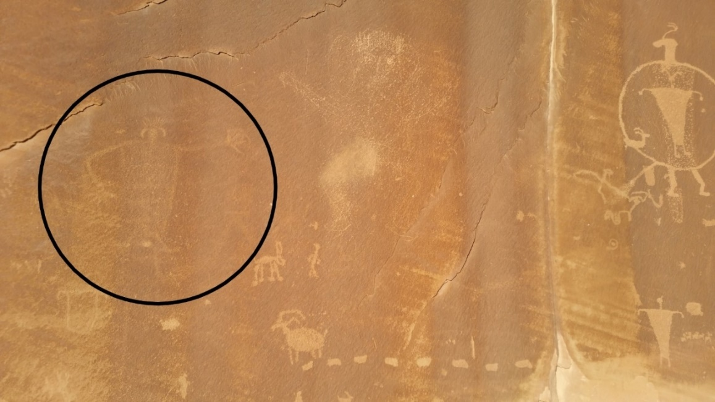
Plate 2 Hidden Valley petroglyph showing repatination of the older circled figure in contrast to the newer potentially AP figure on the right. Photo: Author

Prehistoric rock art is ‘notoriously difficult’ to date chronologically, according to Phil Geib and Helen Fairley. Even where the distinctive Barrier Canyon Style (BCS) pictographs such as in the Great Gallery of Horseshoe Canyon have provided an opportunity for dating the results have been inconclusive with 1880-1520 BCE reported by Marvin Rowe using accelerator mass spectrometry (AMS) radiocarbon dating, while Pederson et al. concluded the same panels date between 1-1000 CE based on OSL dating (optically stimulated luminescence) making the argument that BCS is Fremont and not late Archaic.
Malotki agrees on the difficulty of objective chronological dating of petroglyphs in 2018 but concluded that ‘traditional archaeological methods of estimating rock art age’ still include, ‘degree of patination and weathering; superimposition; and the use of style and manufacturing technique.’ Within the study area, AP petroglyphs are frequently superimposed over earlier petroglyphs which show repatination. Repatination is the degree to which pecked petroglyphs have received a fresh ‘desert varnish’ patina since their creation, which takes 900-1,200 years to form in the nearby Glen Canyon area, according to Christy G. Turner II. David Whitley considered the presence of repatination an indicator that rock art was at least 2000 years old. Repatination is only reliable on individual panels, where the environmental conditions are a constant. In a study of Paleo-Indian rock art dating, Middleton, et al. concluded:
At least 47 of the 55 GBCA [Great Basin Carved Abstract] (~85%) sites also contain other styles of rock are that are both superimposed on and less revarnished than the GBCA panels, suggesting that those styles postdate the GBCA style and the sites were revisited over many millennia.

Chester Liwosz used three levels of repatination (none, partial, and complete) to assign relative dates to petroglyph elements in a Mojave canyon while ascertaining the prevalence of broad stylistic developments in rock art. Liwosz showed that the oldest elements were exclusively abstract, including curvilinear and rectilinear styles; figurative or representational elements were added subsequently and geometric figures were the youngest elements added to the repertoire, while none of the styles were discontinued. Don Laylander included ‘limitation of access’, such as sedimentary burial, water erosion, ramps and ceiling collapses that leave the rock art in awkwardly high, low or in inaccessible positions relative to more recent panels as an additional means of relative chronological dating. Differential repatination and weathering of elements compared to younger elements was the primary determinant for archaic dating in this study. See Plate 2.
Regional archaeological surveys by Hunt, Tipps, Black, et al., and Pierson established that Paleo-Indian, Archaic, and Ute Indians hunted and gathered in Canyonlands and the mountains around Arches National Park for twelve millennia. Dated evidence of sedentary agriculturalists either AP or Fremont was limited to the valleys and basins from about 900 – 1150 CE, according to Pierson, Hunt, Black, and Tipps. The short term occupation of the study area by sedentary agricultural peoples allowed differential depositions of rock art to be attributed initially to archaic groups with later superimpositions by sedentary peoples.
Two petroglyph sites within the study area belonged to the Western Archaic Tradition (WAT), which was documented by Dissanayake and Malotki as, ‘Long-lived and widespread body of archetypal geometric rock markings that originated with hunter-gatherer immigrants in western North America. This tradition includes the subdivisions of Rectilinear Abstract and Great Basin Curvilinear Abstract, defined in the Heizer-Baumhoff model as
The circle, in one context or another, is the common element of this style but perhaps a more characteristic element is the curvilinear meander. These meanders have a vague sort of composition in that they tend to fill an area defined by the outline of a single boulder.

Sites within the study area evidencing WAT imagery were included in the Archaic panels, even where no younger rock is present. See Plate 3.
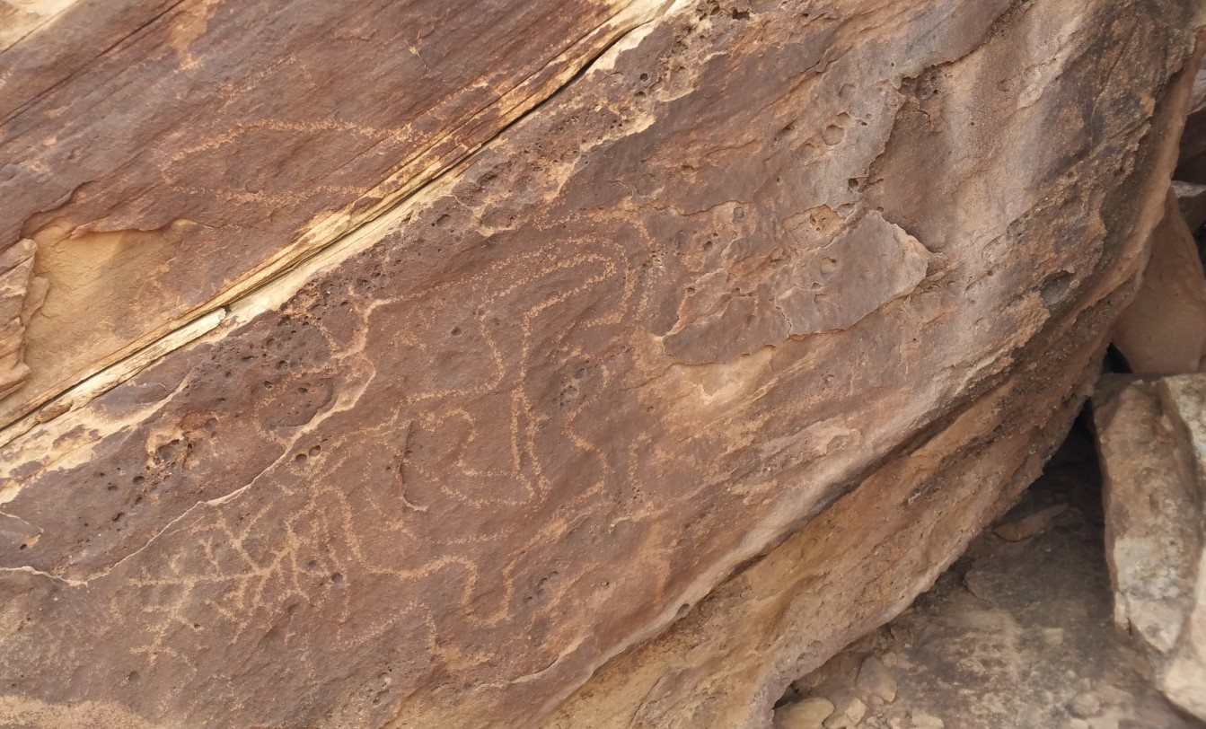
Plate 3 Example of WAT style petroglyph with abstract curvilinear elements in addition to significant repatination and weathering. Photo: Author.

Rock art is one of the rarest phenomena left by ancient Native Americans. In a pedestrian survey of the Squaw Flat region of the Needles District of Canyonlands National Park, Tipps found one rock art site out of eighty sites in an area of 355 ha. In Black’s survey of 5500 ha in Lisbon Valley, two out of 539 sites included rock art, and Hunt’s survey of 1300 km² of the La Sal Mountains found 350 sites of which about twenty contained rock art. Henry Wallace and James Holmlund estimated that one element was produced every year, in the Picacho mountains in Arizona between 3000 BCE and 1450 CE. The rarity of the petroglyphs and pictographs relative to other Native American sites, implies that there is significance to the location and type of rock art created.
In short, rock art was a rare form of ‘artification’ used for marking locations in the landscape. To determine if the petroglyph sites originally marked locations for astronomical viewing for early hunter-gatherer peoples, the archaic sites were distinguished from more recent panels that could have been created by agricultural peoples using relative dating methods of superimposition, weathering, and repatination, since chronometric dating is not available for petroglyphs. Because the AP occupation was short-term in this area, the presence of two cultural layers implied the original layer belongs to the Archaic, or those leading a hunter-gatherer lifestyle.

Solstice-observations in Emerging Societies
This section discusses the observation and celebration of solstices in emerging societies, including the debate of whether pre-agricultural societies had the need or inclination to watch and celebrate solar turning points. Beginning with Paleolithic and Archaic sites, the documentation becomes increasingly rugged as it applies to agricultural, sedentary societies, who used megalithic structures as fixed points to measure celestial movements.

Paleolithic and Archaic Rock Art
Evidence for pre-agricultural solstice-watching is sparse. Villeneuve and Hayden cited Chantal Jeguès-Wolkiewiez’s documentation of painted caves in southern France, such as Lascaux (17,000 BP), where sunset on winter or summer solstice penetrated the caves’ entrance chambers. The Spout Run site in Virginia included three concentric stone rings on the ground and petroglyphs on two adjacent boulders, which, according to Wm. Jack Hranicky, were aligned to summer solstice and the equinox sunrises and contained a lithic tool and hearth charcoal dating to 11,200 -11,500 BP. Paleolithic solstice-viewing sites are considered controversial by Hayden and Villeneuve.
In the New World, ten rock art sites used as observatories for solstice-viewing were documented among Californian hunter-gatherer tribes by Travis Hudson et al. Cole cited two Barrier Canyon Style pictographs (2000 BCE- 400 CE) where on the solstice sunrise, ‘bursts of light extend from the “mouths,”’ of anthropomorphs.

Sedentarism and Megaliths
The oldest known solstice sunrise viewing ceremonial centre in the Old World was documented by Malville in the Nabta Playa of southern Egypt, where prehistoric pastoralists aligned megaliths to summer solstice and important stars between 7500-6500 BP. According to Malville, the seasonal filling of the desert lake drew a nomadic population, which displayed symbolic thinking in ceremonial structures prior to the manifestation of the religious and political institutions of sedentarism. Ulrich Boser considered the wooden henge enclosure in Goseck, Germany among the oldest sites in Europe oriented to solstices, used ceremonially by Neolithic farmers between 4800- 4600 BCE. According to Clive Ruggles, Alexander Thom established that Stonehenge (3000 -1600 BCE) was erected by Neolithic farmers to mark alignments to solstice sunrise and sunset along the rolling hills of the English horizon. Orientations of megalithic structures have continued to be discovered in the Old and New World among agricultural peoples, but solstice observations prior to sedentarism are rare and suggest non-subsistence motivation.
In the New World, the solstice orientations in the architecture of the Torreon at Machu Picchu were established by Malville; that of Mesoamerican pyramids by Ivan Šprajc and Alonso Mendez, et al.; and that of Chaco, New Mexico by Malville. Due to the organized labor force required to build megalithic structures, they were considered evidence of advanced village formation and agricultural development by V. Gordon Childe (1892-1957).
The rise of astronomically oriented buildings in ancient civilizations was often concurrent with the development of calendars, which were also based on celestial cycles, according to Ronald Faulseit and Šprajc. Calendars were cited by Šprajc as a prerequisite for the timing of agricultural tasks. Barber and Barber entertained the possibility that Paleolithic people watched moon cycles or other astronomical phenomena, but concluded that it was the rise of agriculture when, ‘time changed its significance and the observation of celestial cycles had to begin in earnest.’ M. Jane Young noted that, ‘as is common with agriculturalists, the Zunis devote most of their attention to the apparent recurrent motion of the sun.’ While the archaeological record shows many cultures in which agriculture, calendars, and megalithic structures based on astronomical orientations arose simultaneously, Lewis Binford’s processual approach of linking subsistence to societal patterns may not explain all cultural phenomena. The observation and celebration of solar cycles among Archaic people may represent a part of the ritual fabric of their societies.
The association of astronomically oriented megalithic buildings with calendars and agriculture conflates these phenomena unnecessarily. In the Southwest, corn was a cultigen introduced onto the Colorado Plateau by at least 3000 BP, according to Smiley. As a cultigen, it can’t grow without human cultivation. Yet Smiley found that corn was grown around the Four Corners region for a thousand years before the local people became sedentary and began to build open air dwellings (i.e., pit houses, instead of using rock shelters). Sedentarism is a watershed decision that shifts from a minimalist material existence to the production of material goods and claims on territory, according to Robert Heizer and Albert Elsasser. In the study region, indigenous peoples used rock shelters or slept in open campsites for millennia, according to Hunt, Black et al., and Pierson. Archaic values of traditional conservatism and economy of effort, resulting in less than 500 hours of work per year, according to Stuart, are inconsistent with large-scale megalithic projects. As Šprajc noted, ‘The simple objective of timekeeping by means of solar observations could have been achieved without monumental constructions, even without archaeologically recoverable artifacts.’ Sedentarism divided the archaeological record between the obvious and the elusive.
Among sedentary peoples the oral tradition sufficed to maintain the fixed point of reference for viewing astronomical events. Among the Hopi, Florence Hawley Ellis’ documented ‘horizon calendars’, where remarkable horizon features were aligned to sunrise or sunset on sacred dates, as viewed from a fixed location. Šprajc attested that such horizon calendars were used in Mesoamerican even after temples with astronomical alignments were in use. The Desert Archaic culture predated the Mesoamerican migrations who became the Hopi, so the two ethnologies can’t be directly linked, but may share a generalized Native American pattern of sky watching and worship. The rugged landscape of Canyonlands, highlighted by mountains, canyon walls and deep ravines, can easily be used as horizon calendars. Ellis stated, that the Hopi, simply had ‘a stone slab’ on the north side of the village to view sunrise. Smiley concluded the desert Archaic had high mobility and large ranges across the Colorado Plateau based on the stylistic uniformity of rock art across the region. According to Smiley, nomadic Archaic groups followed the pine nut mast hundreds of kilometers from year to year, making it more of a challenge to find the same solstice-viewing location when years had passed between visitations.

Petroglyphs and Solstice among Southwestern Agriculturalists
Among agricultural Southwestern cultures the connection between petroglyphs and solstice-watching is evident from the Hohokam in southern Arizona to the AP around Chaco and the Four Corners region. Todd Bostwick concluded that ‘four years of sunrise and sunset observations have revealed that several rock art sites exhibit deliberate solar interactions during the winter and summer solstices,’ in the Hohokam region of South Mountain.
Malville and Dennis Doxtater noted several petroglyph sites with solstice interactions, in addition to the astronomical alignments at the foundation of the buildings and between cities in the monumental architecture of Chaco Canyon. Malville discussed the bundling in Chaco Canyon of the Piedra del Sol and Headquarters petroglyph sites with the ‘Sun Dagger’, discovered by Anna Sofaer et al., where a shaft of light enters between fallen slabs to bisect a spiral petroglyph around summer solstice. Malville described how Piedra del Sol petroglyphs allow views of summer solstice sunrise in a notch in the horizon, while the December solstice sunrise is directly above Fajada Butte from the Great Kiva (29SJ1253) in Marcia’s Rincon. Holly House at Hovenweep is the site of another solstitial light and shadow interaction on spirals, according to Malville. The first illumination of petroglyphs, including anthropomorphs and zoomorphs in addition to the more common spirals, circles, and crosses, on solstice and equinox has been documented at an additional eighteen sites in the Four Corners area by the Robert and Anne Preston. According to Smiley, the Hohokam and Ancestral Puebloans were agricultural societies, which brought corn from Mesoamerica. Michael Mathiowetz et. al. noticed headdresses and katsina myths, which showed broad similarities in winter solstice ceremonies between the Hopi and Mesoamerica, indicating astronomy migrated too. The astronomy of Southwestern agricultural societies may be as Mesoamerican as the corn.
In summary, evidence of solstice watching is not as well documented among nomadic groups as the megalithic and calendric methods of sedentary agriculturalists, but Nabta Playa indicates that solstice was ritually honored by nomadic pastoralists by 7500 BP. Claims of Paleolithic solstice-viewing sites are considered speculative. Petroglyphs were used for solstice-viewing on rare occasions in Archaic rock art and more frequently among agricultural Southwestern societies. This research hypothesized that where hunters and gathers lived intermittently, artification of stone anchored viewing locations for solstices.

Solstice Ethnology among Hunter Gatherers
This section reviews ethnologies of solstice-viewing or ceremonies among nomadic, hunter-gather traditional peoples with a discussion of how they engaged the sky and sun as an interactive aspect of their world.
Hudson et al. determined in a cross-cultural study of Californian hunter-gatherers that thirty-four out of forty-nine tribes observed and celebrated one or both solstices, with only two cultures denying solstice observances and seven lacking information on the subject. Among the Chumash, solstices were critical times when priests needed to ‘”encourage” or “pull” the sun back again’ on its solar path, according to Hudson et al. In cross-cultural study of settlement patterns of 197 cultures by George Murdoch and Suzanne Wilson the data showed that prominent community ceremonials were calendrical in 64% of the cultures with permanent settlements. Yet that metric went up to 100% in cultures with rotating settlements, while 57% of impermanent, 41% of semi-nomadic, 34% of migratory, and 43% of semi-sedentary cultures held prominent calendrical ceremonies. This data indicates that time, solstices and potentially calendars, were celebrated among many nomadic, migratory, and non-agricultural peoples.
Ubiquitous beliefs across North American tribes, potentially reaching back to Siberia may reveal core attitudes of early Native Americans toward the sky and solstices. Roslyn Frank noted for the indigenous people of Siberia, ‘their skylore is not viewed as a separate conceptual sphere, but rather one that is intimately connected to their overall belief system: their lived cosmovision.’ The sky was not only part of the landscape, but that landscape was living and interactive in the ‘animic ontologies’ characteristic of hunter-gatherers, according to Robert Wallis. E. B. Tylor’s (1832-1917) term animism, or ‘belief in spiritual beings’ is fraught with imperialist overtones but was so important to Tylor’s theories that he saw it as a universal first step in religious thought, according to David Chidester, who went on to offer updated revisions of the theory as ‘the basic animistic propensity to project human characteristics of life, thought, and feeling onto the natural world’.
When Native Americans address the world as ‘all my relations’ they are referring to the inanimate, as well as animate world, according to David Posthumus. A world rife with seen and unseen entities requires actors so Whitley concluded ‘shamanism was the religious system that underlies almost all Native American hunter-gatherer religions.’ Whitley introduced the concept of poha, which translates to supernatural power among the Numa of the Great Basin, where shamans are ‘man having supernatural power’ and rock art represents ‘house of supernatural power’. Shamans served as specialists of interactions with the supernatural world.
In stark contrast to Cartesian and Enlightenment ideologies, ‘the specific perception of the environment as filled with people, only some of whom are human, is not uncommon’ among traditional societies according to Wallis. Malville considered this a ‘relational ontology’, where ‘people can be involved in reciprocal relationships with things that we would normally identify as inanimate: stones, mountain, rivers, mummies, the sun, moon, planets, and stars.’ In such a living landscape, the entanglement of earth and sun at solstice sunrise constitutes a theophany, a gate between earth and sky, according to Malville. Mircea Eliade (1907-1986) went one step further to say that ‘whatever is “cosmicized”, whatever resembles a Cosmos,— is sacred.’
As the solar turning point of winter solstice approaches in the northern hemisphere, the days become shorter, the sun rises in the southeast and sets in the southwest passing lower in the sky and providing less warmth and energy for growth. The correlation between solar movements and the seasonal variation could hardly have been missed by peoples who lived outside. The diminished light produced by the low trajectory of the sun in winter and the shorter days are recognized today as the cause of Seasonal Affective Disorder (SAD), a form of depression, by Simon Harrison who concludes that, ‘the ritual and symbolism connected with seasonality in some societies may be partly motivated by neurophysiology’.
In summary, deep-seated beliefs in relational ontologies, animism and shamanism, the evidence of calendrical ceremonies even among nomadic cultures and a wealth of cosmologies among traditional cultures about the sacred beings in the sky and ritual interaction with those beings indicate solar movements were included in Archaic cosmologies.

Skyscape Archaeology
Fabio Silva’s definition of archaeoastronomy contextualized the discipline within the applicable culture:
Archaeoastronomy is the study of how people have understood, conceptualized, and used the phenomena in the sky and what role the sky played in their cultures, by analysing their material remains.

For Silva the practice of skyscape archaeology included three facets: pattern repetition, observing the horizon as the ‘mediator’ between earth and sky, and to ‘understand how they relate back down to human beliefs and practices, to their notions of time and space, to their structures and material remains.’ The essence of skyscape archaeology as conceptualized by Malville, is, ‘utilizing strong archaeological contextualization combined with Geertzian thick descriptions… to develop hypotheses about the meaning and intent in these cultures.’ Clifford Geertz employed ‘thick description’ as an analytical tool for understanding ontology by using the repeated symbols of the language and behavior as the syntax for culture and beliefs. According to Timothy Darvill, moving away from the earlier archaeoastronomical practice of relying solely on measurements, required understanding how the builders conceptualized their world. Following David Whitley’s approach with shamanism and early rock art, this research relied on the most universal principles found among hunter gatherers and Native Americans, such as animism, shamanism, and a belief in sky gods to contextualize the data, because there were no documented ethnologies or language remaining from the Desert Archaic.
The skyscape perspective is well-suited to the study region, where the Desert Archaic people literally lived in the sky. According to Hunt most of the sites in La Sal mountains were Archaic campsites. Using natural shelters and having few material goods, means that the experience of an ‘Archaic’ environment is still available in wilderness areas. Christopher Tilley’s phenomenology of the landscape, or the science of a subjective experience of walking through a region, contributed valuable insights into the nomads whose lives revolved around walking through the same environment. Tilley pointed out, ‘Features of the natural landscape may be held to have provided a symbolic resource of the utmost significance to prehistoric populations.’ What is significant in the unique high desert environment may be different from commonly held beliefs, such as watching sunrise over a sacred mountain, as noted by Malville and Bostwick. In the high desert, where diurnal temperature variation can be up to 25˚C, getting into the first light on winter solstice, when nighttime lows are frequently -15˚C, was a physical as well as spiritual relief, especially if the cliff face bearing petroglyphs blocked the north wind. Only in summer would the additional shade of waiting for sunrise over a mountain peak have been welcome or pragmatic.
In summary this research is designed to look for repetitive patterns in the placement of petroglyphs relative to the canyon skyscape, focus on the interaction between sky and earth at the horizon and use ‘thick description’ gleaned from common Native American ontologies augmented by some phenomenological perceptions of the high desert as the most effective means of applying skyscape archaeology to the understanding of the placement of Archaic petroglyphs.

The Method
The research question is whether petroglyphs were used to mark optimal locations for viewing solstitial sunrise and sunset, while equinoctial events were also noted. ‘Sites’ are defined as rock art that is separated from other rock art by a gap of 10 m, or more. Panels were counted to emphasize the relative size of sites. ‘Panels’ were distinguished by a 2 m separation between groups of elements or by location on different faces of the rock. The azimuth and altitude of the lowest points on the horizon were measured from about 1m height and 2m in front of the panel using a Suunto Tandem compass/clinometer. Due to erratic horizon lines, between one to five low points were measured from any observation point. After adjusting for magnetic declination of 9.90˚E, rounded off to 10, the positions of the low horizon points were plotted as deviation from the solstice sunrise and sunset positions modeled in Stellarium, whenever actual observation was not possible.
Solstice sunrise or sunset were photo-documented by looking at the horizon from a point directly in front of the panel or by viewing the panel from below during solstice sunrise to ascertain where first light fell. See Plate 4. Time permitted viewing only a few sites on the solstices, the remainder have been modeled using Stellaruim. Azimuths within five degrees of the actual sunrise or sunset locations have been recorded as a positive result, where the horizon remained low in the direction of exact sunrise. Where cliffs or mesas occluded views of the sunrise, the result was negative even if it was within the margin of error.

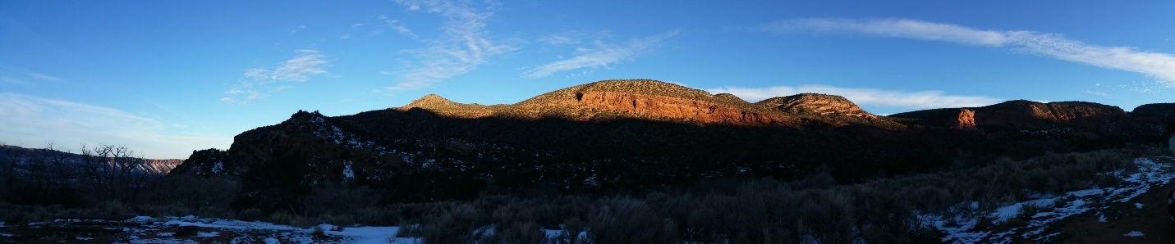
Plate 4 View from below of WSSR (winter solstice sunrise) on a sandstone cliff with petroglyphs scattered along 600 m. Photo: Author.
Stellarium software was used to model every degree of the sun’s ascent/descent on the solstices in terrestrial coordinates. Along horizontal lines, such as a horizon, the discrepancy between the modeled sunrise azimuth and the low point on the horizon was measured in azimuth degrees. In the few instances, where a vertical crack exposed the sunrise or sunset the deviation was measured in altitude degrees. Where a broader gap occurred on the horizon the breadth of the gap was considered for potential sunrise or sunset, but in practice, actual sunrise typically occurred on one side of the gap. See Plate 6.
Skyscape measurements were made at 157 Native American rock art sites and 22 non-rock art sites within the study area. The test sample included 115 petroglyph sites, which met the criteria of having two periods of deposition of petroglyphs. The 22 non-rock art sites used as a control group included habitations, indicated by dry laid rock walls or lithic tools in rock shelters, and limited activity sites such as lithic scatter. Sites which failed to meet the test criteria included 13 pictographs panels, two Ute petroglyph sites and 26 petroglyph sites which appeared to have a singular time of creation, rendering no comparison for repatination. Only two sites easily identified as Archaic abstract petroglyphs (WAT) and showing significant repatination were included, based on stylistic dating. A couple of sites with petroglyphs showing the atlatl (a throwing spear) were included because atlatl use was discontinued around 400 CE with the introduction of the bow and arrow which dated the petroglyph before sedentary agriculture in the study area.
Photos of the panels were used to show variable levels of repatination between elements, indicating where Archaic, or ‘archaic lifestyle’ groups had originally chosen the site for rock art. In the study area, Archaic conditions prevailed for 12,000 years except for several centuries of scattered farming attempts in this region between 900- 1150 CE. Younger petroglyph elements have been associated with the AP or Fremont, but they could represent multiple layers of Archaic deposition. The high number of sites that are assessed with AP or Fremont superimposed over older elements would indicate that it had been a priority for the AP to add to or overwrite older rock art for ceremonial or territorial reasons.
Federal agencies do not disclose locations of archaeological sites to the public. Many sites in the study area probably remain undiscovered or undisclosed, but the publicly known sites in the study area have been measured, with few exceptions. Given the amount of private land, statistically about 1500 archaeological sites of the 5300 in Grand County could be expected to be within the study area. Many of these may be historical settler sites. About 10% (179 sites) of this total were measured in this research of which 157 were rock art sites. Pedestrian studies in the adjacent Needles District of Canyonlands National Park by Tipps and Lisbon Valley by Black et al. yielded rock art in about 1% of the sites. This survey has measured ten times that expected relative number of rock art sites in the study area. Three sites were not found, one was in an inaccessible acrolocation (high on a cliff) and another two known sites are on private land. Geographical distribution of sites can be seen in Plate 5.
The results were tabulated among the 250 panels at 115 eligible sites, according to whether they were in locations to view early sunrise on winter solstice (WSSR), or summer solstice (SSSR). Sunset locations for winter solstice (WSSS) and summer solstice (SSSS) were also calculated as were equinoctial sun rise and sunset labeled EQSR and EQSS, respectively. Results are summarized as percentages since nearly 100% of the publicly known rock art sites within the study area were visited. See Table 1.
In summary, petroglyphs were measured for their positioning relative to low points in the horizon. Due to time constraints most of the sites were tested for solstice viewing using Stellarium modeling. Pictographs and petroglyphs to which relative dating methods could not be applied with confidence were excluded from the test group. All rock art that could be found within the study has been measured with few exceptions. A total of 179 sites were measured for horizon features, including 22 non-rock art sites used as a control, and 42 rock art sites, which were not included because they did not meet test criteria. See Appendix A.

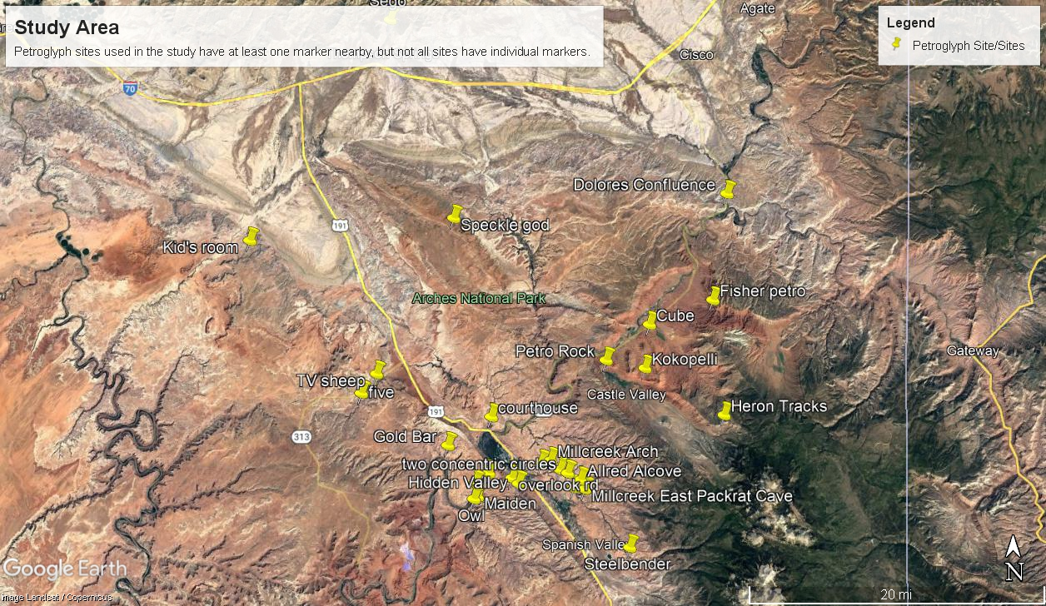
Plate 5 Geographic distribution of sites using arbitrary names. Rock art frequently occurs along the river or tributaries. Image: Google Earth Pro.

Results
The research indicated that Archaic and hunter-gatherer petroglyphs, as determined by relative repatination and weathering, were placed in locations for viewing the first light of winter solstice sunrise at a much higher rate than would have occurred at randomly. The random chances of a low point falling within five degrees of the exact sunrise azimuth degree is 2.7%. Eighty-two of the 250 panels (32.8%) were in WSSR observation locations, and 60 panels (24%) in WSSS locations, 24 panels (9.6%) were in SSSR locations and 26 panels (10.4%) in SSSS positions. Of the 115 eligible petroglyph sites, 65% had views of first or last light on one of the solstices. By contrast, less than 10% of the 22 non-rock art sites were in any solstice viewing locations. In the control group, only two sites had views of first or last light on the solstices and another two witnessed first or last light on equinox. See Table 1.
 | WSSR | WSSS | SSSR | SSSS | EQSR | EQSS | RANDOM
Archaic  petroglyphs | 32.8% | 24% | 9.6% | 10.4% | 15.6% | 2% | 2.7%
N=115 | 82 | 60 | 24 | 26 | 39 | 5
Non-rock art sites | 4.5% | 0% | 0% | 4.5% | 4.5% | 4.5% | 2.7%
N=22 | 1 | 0 | 0 | 1 | 1 | 1
Sites in good locations for viewing the solstice sunrise or sunsets tended to have multiple ages of rock art deposition and to have multiple panels spread along a cliff face or on boulders. Some sites had low horizon points for viewing more than one of the solstice events. The number of panels at either WSSR or WSSS locations was 143 (57.2%). Cumulative values for solstice viewing panels (WSSR, WSSS, SSSR and SSSS) was 166 of 250 (66%). Randomly only 11% horizon low points would have fallen into selected 40˚ of the compass directions. See Table 1.
Table 1 Percentages and numbers of viewing solstice locations among the sites.
By contrast, two non-rock art sites such as habitations and limited activity sites were in any solstice viewing locations (WSSR, WSSS, SSSR and SSSS) comprising 9%. Cardinal orientations were not sought out, but due north appeared frequently (46%) among the pictograph panels, potentially because that is the most protected orientation from the wind and rain. The concern that the orientation of geologic faults would predispose views of WSSS and SSSS was allayed by the high frequency of WSSS, which was not geologically predisposed. Also, the similar frequency between SSSR to SSSS viewing locations was not geologically predicated. Geologic predisposition predicted low WSSS and SSSR values and high WSSR and SSSS values in valleys along the southeast to northwest axis.
Each of the 157 rock art sites had between one and five measured recesses in the horizon. The scatter plots in Tables 2 and 3 show all the random data points of the 115 test sites in addition to the clusters and trendlines, which are colour-coded where they met the criteria for an observation site.
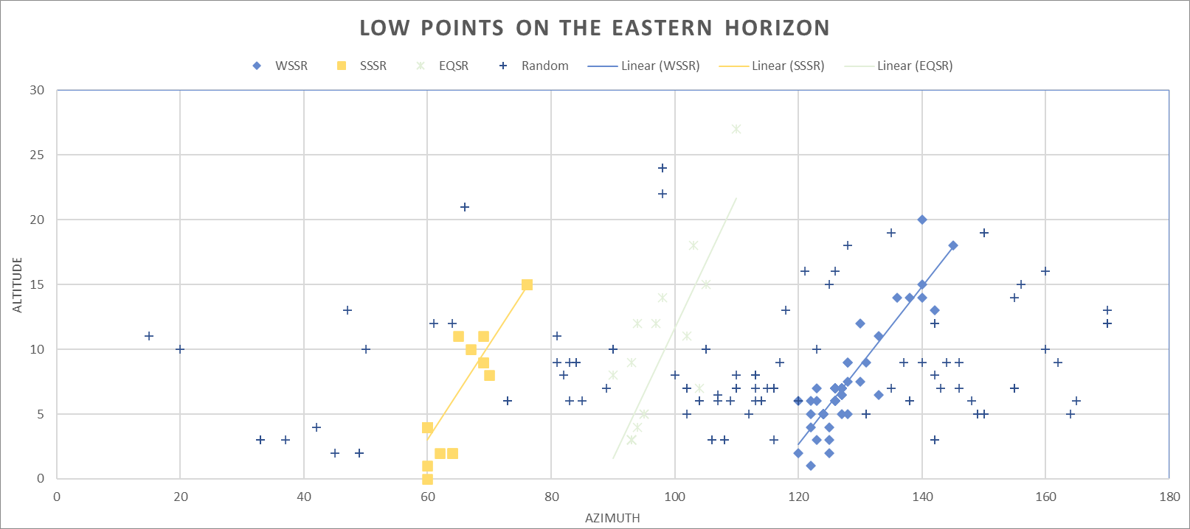
Table 2 Scatter plot of the petroglyph views of the eastern horizon low points.
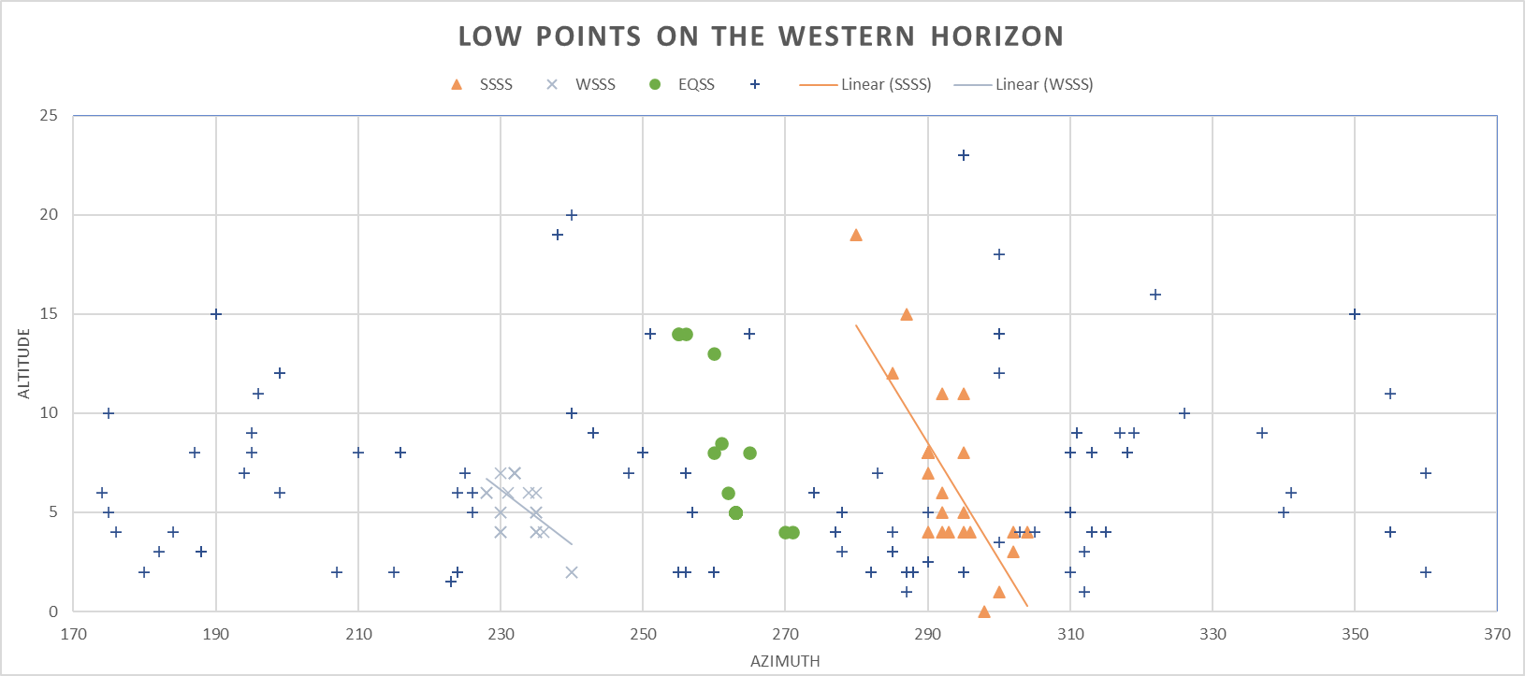
Table 3 Scatter plot of the petroglyph views of the western horizon.
By comparison the random and matching coordinates for the non-rock art sites (control group) are plotted in Table 4.
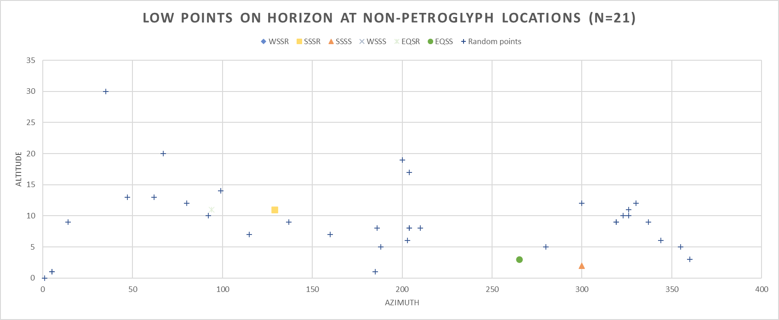
Table 4 Scatter plot of control group horizon points across 360˚.

In Moab solstice sunrise at 0˚ altitude occurs at 58˚azimuth in the summer and 120˚ azimuth in the winter. Solstice sunset in summer is 301˚ azimuth and 239˚ in winter at 0˚ altitude. The sun rises and sets at an angle resulting in the oblique trendlines that correspond to sunrise and sunset as the horizon line rises. Where the horizon altitude is above 0˚, the azimuth must be adjusted. (For example, at 5˚ altitude, WSSR occurs at 126˚ azimuth.) The graph in Table 5 depicts the total number of sites with the low horizon point aligned to the exact degree of WSSR relative to the number of sites that deviated from exact by up to five degrees in the margin of error.

Table 5 Numbers of sites with exact matches to sunrise/sunset relative to sites within the 5˚ margin of error. Numbered bars are the total of exact matches.

Detailed information on the sites is in Appendix A.

Discussion
The discussion of the research findings proceeds in three parts, starting with the issues. The second section relates the findings to previous research including contextualizing solstice-viewing into archaic lifestyles and ontologies of Native Americans. The third section explores the phenomenology of the sun and sky in Canyonlands.

Issues
Several issues arose in taking measurements. The first was where to stand. In many instances the rock art is several meters above a feasible location to stand, in which case the closest feasible location was used. In some instances, only a meter or less was level before the cliff ledge or talus slopes fell away from the site. Unlike orientations of buildings or even stone circles, the rock art was placed on rocks in situ, which do not dictate a specific view or orientation. Using tighter tolerances for the viewing locations of solstitial events would have been inconsistent with the vagaries of the natural environment.
The question of specificity framed every measurement. Although five degrees of azimuth on either side of exact sunrise locations seemed generous, especially compared to measurements of buildings taken with theodolites, the ability to take very accurate measurements using a compass and clinometer was compounded by the inability to access the same vantage point for all the panels and the precarious footing in many locations with narrow ledges, no ledges, or steep talus slopes abutting the panels. An additional challenge was to match the compass, which must be held level, with horizon points over altitudes of twenty degrees, as tilting the compass halts its free movement and accuracy.
When it became clear that larger palimpsest panels were in positions to gain first light on solstices, it seemed logical that these sites were used for the celebration of solar turning points. If larger groups aggregated for ritual celebrations, where did they stand or dance? Some of the long panels could accommodate a crowd, but many could not, and the participants may have been many meters below or off to the side, on leveler ground. Where petroglyphs occur on cliff faces, the horizon low points are often where the cliff face meets the side of the valley, stepping even a few meters into the valley frequently opens the horizon quickly, or bypasses a rock that occludes views along the cliff line. To achieve consistency in this wild environment was unattainable.
The horizon in canyonlands is classically shaped as a mesa that slopes down to another level plane. Mesa edges are a logical place to look for the emergence of first light, but it is hard to gauge what part of the sloped edge was used as the location for sunrise. Although the range along the low section of the horizon was measured, solstice events most often occurred on one side, where the slope up the mesa begins, as seen in Plate 6. This research measured direct observation locations only, where the sun is seen cresting the horizon. While opportunities for indirect measurements of solstice, such as the ‘Sun Dagger’ light and shadow interactions were abundant, few were apparent, and their measurement was beyond the scope of this work.
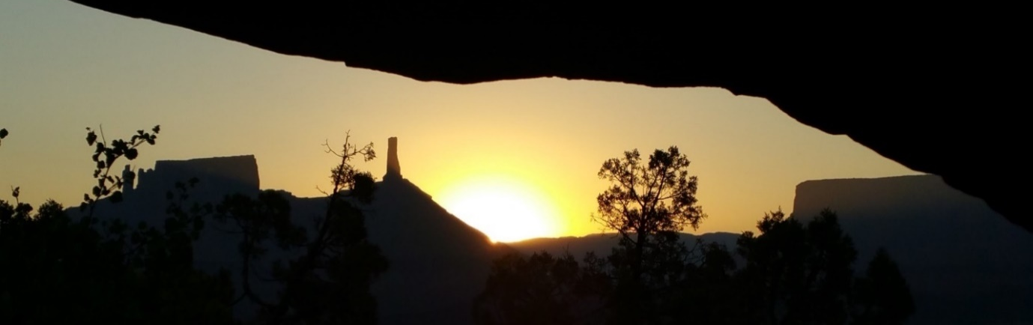
Plate 6 A Castle Valley SSSR from a petroglyph site with iconic mesa forms. Photo: Author.
The research targeted narrow solstice-viewings between fins, and canyon cracks in the horizon, but while watching winter sunrise over the Colorado River (Plate 7) it was evident that a full kilometer of the cliff wall received first light within a few minutes, where the eastern horizon varied between 5 – 8˚ altitude. Petroglyphs line this section of Highway 279, known as Wall Str. Both upstream and downstream of this section where the petroglyphs are no longer present, the opposing cliff wall was between 22–33˚ altitude. It appeared that broad swaths of lower horizon were reason to locate petroglyphs in that area, yet only the panels that met the criteria for sunrise at the lowest point between fins of sandstone were counted as WSSR sites.
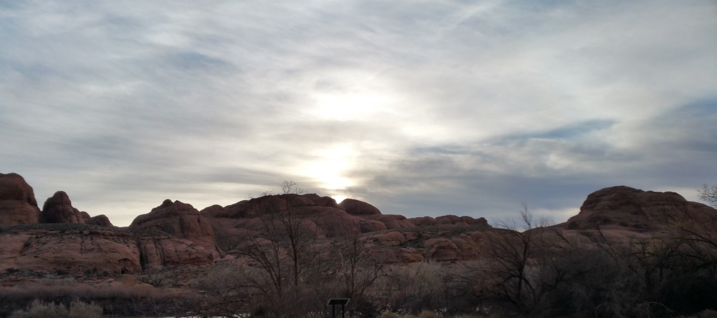
Plate 7 Sunrise over Back of Beyond Dec 16, 2022. The horizon line varies between 5-8 degrees altitude and illuminates 1 km of petroglyphs on the cliff face abutting Highway 279. Photo: Author

Another section of petroglyphs was scattered along the eastern cliff face in Millcreek, a narrow canyon that runs southeast to northwest. See Plate 8, between ‘Diamond Edge’ and ‘two concentric circles.’ There are no views of SSSR and views of WSSR are rare, but low winter sun skims the western rim all afternoon just reaching the petroglyphs at the base of the eastern wall. Eastern cliffs may have provided smoother sandstone with stronger patination, but late winter sun may have been motivation enough for their placement in this heavily populated canyon. Again, most of the panels on the eastern cliff face failed to meet the solstice viewing criteria.
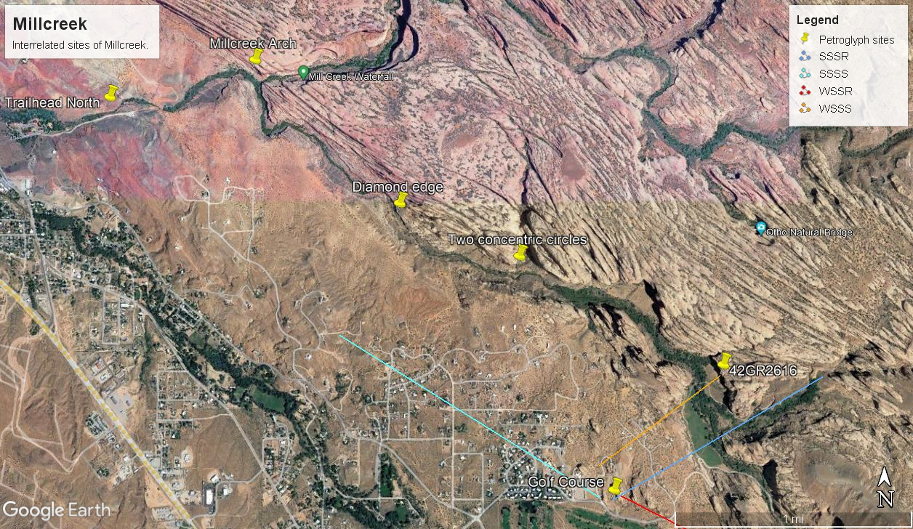
Plate 8 Map of Millcreek showing relationship between 42GR2616 and Golf Course Panel and their WSSS (orange) and WSSR (red). Blue lines are SSSR and SSSS for the Golf Course site. There are 20 sites on the eastern cliff between 'Diamond Edge' and "Two concentric circles.' Map: Google Earth Pro.
One of the largest palimpsest panels in Millcreek (42GR2616) is on the eastern cliff face in a WSSS location. Opposite this panel is a rare egress from Millcreek canyon where it is a short walk to the ‘Golf Course’ site with good views of WSSR. These WWSR and WSSS sites may have been paired with one another. See Plate 8. Malville referred to this phenomenon as ‘bundling’ when he discovered related sites for observing solstices in Chaco Canyon.
Another potential implementation of bundling was observed in the Kane Creek area. In a hanging valley above the confluence of Kane Creek and the Colorado River six to twelve pit houses were located where views to the east were occluded by surrounding cliffs. The nearest WSSR site is ‘Birthing Stone’, but there is a network of petroglyph sites sharing sightlines, which connect the sites, including the ‘Owl Panel’, where a broad bench has views of ‘False Kiva’, and the ‘Maiden’ on the ridge overlooking the pit house village. The sightlines continue from ‘Maiden’ to ‘Kane Creek Road Petroglyphs’ and the ‘Colorado Overlook’ panel with further sightlines across the Colorado river to ‘Poison Spider Trailhead’ panels. Therefore, while only the ‘Birthing Stone’ meets the criteria for WSSR, the notification of sunrise could have been communicated through a network of petroglyph sites, which are unusually densely placed in this area and all within sightlines. See Plate 9. There are numerous petroglyphs along both sides of this shallow section of the Colorado, which seem to be stylistically and culturally connected.
The issues that affected the research related to maintaining consistency of measurements under inconsistent environmental conditions. There were also questions of how specific rock artists were in their criteria.
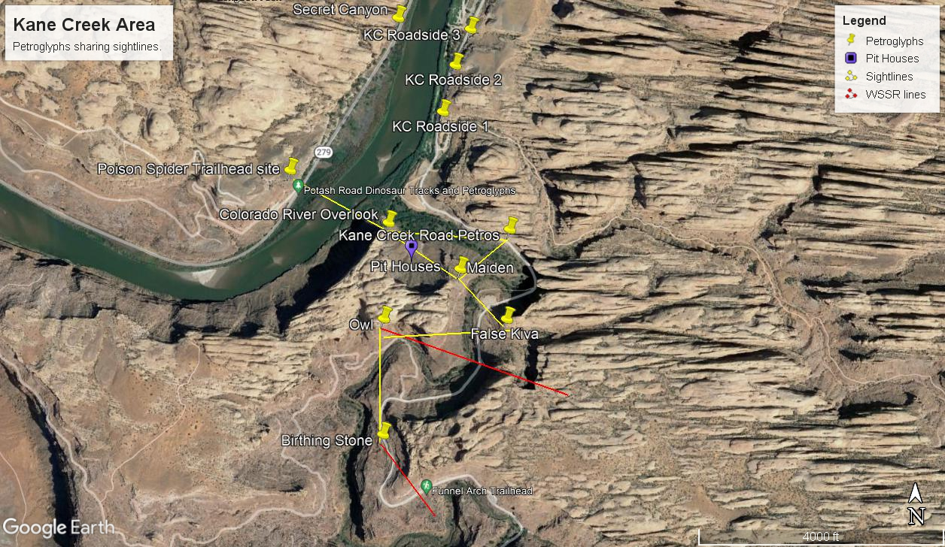
Plate 9 Map of Kane Creek petroglyphs showing sightlines that could have connected watchers across an occluded landscape to communicate first light on the ‘Birthing Stone’ in the bottom of the photo. The red line is the angle of WSSR. Image: Google Earth Pro.

Rock Art in the Landscape
It was anticipated that the location of rock art sites would have been motivated by multiple factors. This section discusses the conditions that may have influenced the placement of rock art in the Canyonlands landscape.
J. D. Lewis-Williams stated, ‘North American rock art research is, fundamentally, a study of the archaeology of religion,’ because, according to Whitley, there is a ‘consensus among Native Americans that rock art sites are sacred.’ In many parts of the world the low point on the horizon would not have been considered as sacred as high points. In Mesoamerica, Mendez et al. documented sunrise over a sacred mountain from the Temple of the Sun in Palenque on winter solstice, while Šprajc documented the Temple of the Sun oriented to the peak of Cerro Gordo in Teotihuacan. Utes in the study area considered mountains sacred, according to Patterson. Some of the large WSSR sites exhibited solstice sunrise just east of the La Sal Mountains, so that the sun appeared to ascend the mountains, a view which was geologically predisposed by the Paradox layer faulting in the study area as displayed in Figure 1. But the skyline in Canyonlands is dynamic and many different highpoints challenge the natural logic of high places, specifically mountains, being closer to sky gods. See Plate 10. Overall, it did not appear that rock art highlighted views of solstice sunrise over the mountains.
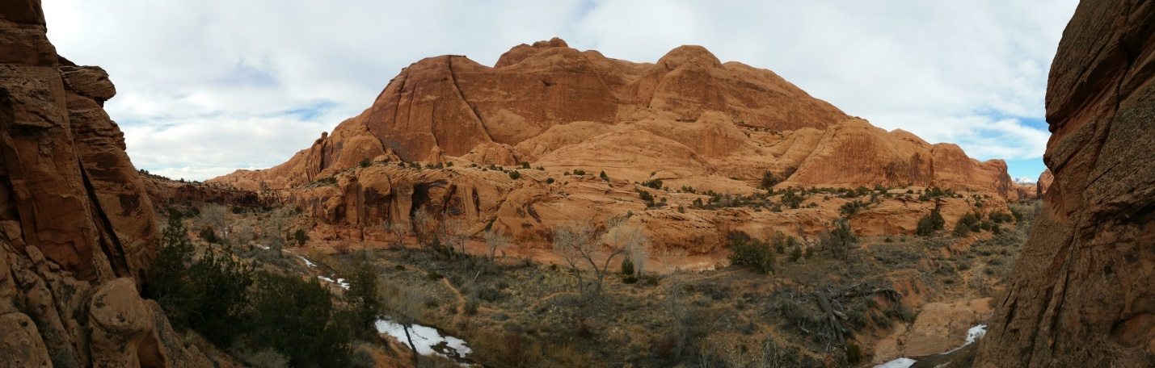
Plate 10 A panoramic image of Millcreek from a petroglyph with a rare view of the La Sal Mountains, which are in the green circle. Photo: Author.
Many of the largest sites were in optimal viewing locations for WSSR. Few cultures have valued low points in the horizon. The decision to research that aspect of the skyscape is borne of witnessing solstice sunrise at various sites. If WSSR sites were places for gatherings and rituals, the low points were of pragmatic value. The low humidity of the desert translates into immediate temperature shifts when moving from shade into sun. In many instances, the petroglyph sites seem to celebrate the winter sun, not necessarily in their imagery, but in locations where the sun first appears or lingers. Although some petroglyphs are as high as possible on the cliffs, where the morning sun first reaches, many more were accessible to all members of the community.
The largest site was in an alcove cave about 100 m above the creek with a view of WSSS and had evidence of habitation, but most of the sites were located away from habitations, as Malotki and Weaver have argued is common. In this study, petroglyphs were found in only three habitation caves and the artwork was concealed from distant views. In other words, petroglyphs were not used to announce locations of habitation. Pictographs, on the other hand, especially the large Barrier Canyon Style, were frequently found in habitation caves which may be attributable to better preservation in those locations.
Many sites were proximal to water sources. It seems unlikely that the petroglyphs were used to mark water sources as creeks, rivers, springs, and the associated vegetation are more obvious than rock art. Alex Carroll et al. cited the three essential elements of locations for Numic peoples (to which the Ute belong) to hold ritual performances as: a water source, a salient landform or rock outcropping, and rock art. Most of the sites were near a water source, which correlates with Whitley’s findings in California where he found rock art (a male activity) was located in feminine gendered landscapes, such as deep canyons and by springs, while masculine landscapes such as mountains tops were visited during female puberty rituals in a counterbalancing or ‘inversion’ of male/female in landscapes and rituals.
The four largest WSSR sites were about an hour walk away from water. In effect, they required a pilgrimage. At winter solstice, these sites probably had snow on the ground, so water may not have been an issue as it would have been while visiting these sites in summer. According to Smiley, winters were the time of year that late Archaic people aggregated and held rituals or celebrations. In Iceland disparate and isolated bands of Vikings developed a calendar to time their assemblies, where ‘Þing [name of the assembly] in its earliest form meant both ‘time’ and ‘meeting’ and it can therefore be translated as a “gathering at a fixed time”’. While not a calendar, petroglyph sites set to witness winter solstice may have served as a time and place for hunter-gatherer reunions, in an environment where annual time markers were scarce and communication between bands was sparse.
Malotki and Weaver argued that ‘hunting magic must be included as one of the probable functions of rock art.’ The description of game movement patterns and hunting strategies may have included elements of sympathetic magic in the Archaic mind, but were pragmatic in Canyonlands, where both hunter and prey had limited routes for exiting box canyons. At least four large sites were placed in good locations for watching game movements and hunting, such as canyons with springs. Three of these sites (Amasa Canyon, Poison Spider Trailhead, and Millcreek) did not have orientations to solstices, while one did.
Margarita Dìaz-Andreu et al., have provided evidence that rock art in the Mediterranean area was placed where landscape acoustics are enhanced. Whitley considered Waller’s study of echoes at rock art sites in Horseshoe Canyon, UT as some of the strongest scientific evidence for site distribution. At two sites in this study area there were cupules and grinding areas on vertical or tilted stone faces, which could have been used to produce echoes against the opposing canyon wall. Because side-by-side canyon walls are prevalent in Canyonlands, about 95% of the rock art sites in this study had an opposing cliff wall or mountain face with good echo potential.
Malotki and Weaver argued that positioning rock art away from habitation and ordinary activity sites, may have been a prerequisite for shamanic activities by providing secrecy and to protect supernatural places and beings. Seclusion is an important element in vision quests and initiation rites, which according to Whitley et al. have been used among Native Americans for up to 10,000 years. The shamanic theory originally proposed by Lewis-Williams and Thomas Dowson that rock art records and facilitates shamanic activities and that the motifs are derived from entopic (neurologically produced) images seen during altered states of consciousness, has been embraced by researchers like Malotki, Schaafsma, Young, and Whitley. Whitley concluded rock art served to document shamanic journeys, which are later difficult to recall. Sites used for vision quests or similar rituals over many generations would explain the frequent occurrence of palimpsest panels. Because shamanism is ‘the initial New World religion’ in Native America, according to Whitley, it should be considered as a potential motivation for some of the rock art locations in the study area.
In summary, given all the potential motivations for placing rock art in the landscape, the strong correlation between solstice-viewing sites and petroglyphs indicates that the Archaic peoples of the study area were tracking the sun’s annual journey. Even while recognizing the imprecision with which natural landscapes can be measured and the range of solar events that might have interested hunter and gatherers, it can be concluded that Archaic people considered the sun a part of their sacred landscape and celebrated or at least measured its movements with rock art.

Hunter-Gatherer Ethnology
The following discussion provides ‘thick description’ of solstice-viewing derived from ethnologies of Native American hunter-gatherers, beginning with the relationship to sky or sky gods. Potential cultural aspects of the Desert Archaic shared by other traditional groups are animism, shamanism, and a ‘reciprocal ontology’.

Relationship with the Sun
Whitley argued that historical beliefs among traditional societies can reflect Archaic beliefs due to the extreme conservative nature of those belief systems and their adaptability. Especially in models based on ‘invariant principles, uniformitarian laws, and timeless characteristics’ of natural phenomena, Whitley felt that these perspectives can be applied even in the absence of ethnographic information. The annual solar cycle may be such a process. Archaic peoples were keen observers of natural processes. While the slow path of the sun between the turning points in the northeast and southeast, may be somewhat harder to track among migratory people, the fact of the days being shorter and the sun lower in winter in contrast to the long hot days of summer was an unmistakable fact of life in the northern hemisphere. While the sun’s path along the horizon goes stationary (rises in the same location for three consecutive days) at both the southernmost WSSR location and the northernmost SSSR location, it is understandably the winter solstice that feels most threatening and has resulted more consistently in large ceremonies among Native Americans, such as the Hopi, where ceremonies to pull the sun back were one of the most important, according to Ellis. This research indicates that knowing the turning point of the sun at winter solstice was important enough to Archaic peoples in the study area that they marked the locations for viewing solstices with petroglyphs. It is likely that the interaction of those tribes with the sun included ritual and ceremony.
The inscription of petroglyphs at solstice viewing locations appears to be a mnemonic device for nomadic peoples, but it may have also been part of the ritual exchange with the sun being. The WSSR sites were often notably large sites, where one palimpsest panel of images from many generations comprised the central or focal point of the site. Additional smaller panels trailed along the cliff face for hundreds of meters. This phenomenon implies that large groups may have held ceremonies at these sites and that the production of rock art may have been a shared activity. Alternatively subsequent generations chose to establish related sites rather than superimpose on older elements.
Malotki and Dissanayake attested cupules were among the oldest forms of artification of stone. Although not common in the study area, stones which have cupules, or pecked basins appear at viewing locations for solstices, similar to those described by Malville at Chimney Rock and Mesa Verde, CO, where they may have been used for offerings. Malotki and Dissanayake contended that the considerable work of creating a pecked basin lent deep symbolic meaning to places where they are found. Cupules may have served as anchors to the wanderings of the sun. Holes in rock are linked to the feminine, considered a portal for supernatural beings, and symbolize openings to the underworld, according to Whitley. Scott Ortman described the shipapu of AP kivas, the ritual holes in the earthen floor, as symbolizing points of emergence from the underworld into this world. Pecked basins and cupules placed at solstice positions, not only link sky and earth, but also symbolize access to all three of the ‘worlds’, including the underworld, typically found in Native American worldviews. By contrast, the narrative nature of petroglyphs encultured viewing locations with stories. Regardless of whether the meaning of the petroglyphs can be deciphered, the Archaic people wove the movements of the sun together with terrestrial activities and underworld influences through human stories and rituals. These petroglyphs and cupules, situated in the encultured landscape, united the sky beings with the earth beings and potentially those below, as might be implied by drilling a hole in stone.
While Cartesian dualism and modern science make a distinction between the cosmos and the terrestrial world, there is no reason to believe that Archaic people did not perceive the sun, moon, and stars as part of ‘everything else in the world.’ In myths throughout North America, animals and humans interact with the sun as an equal member of the community of life, such as the Ajumawi (northern California) myth, retold by E.C. Krupp, in which Sun and Moon were an old married couple who lived in the east and provided light to the world.

Time and Space
The marking of solstices as spatial-temporal horizon events delineates the framework of the time and space perceived by a culture. Features that distinguish the traditional (hunter-gatherer) concepts of space and time from modern concepts are, according to R. A. Rundstrom:
...the principle of the ubiquity of relatedness; non-anthropocentricity; a cyclical concept of time; a more synthetic than analytic view of the construction of geographical knowledge; non-binary thinking; the idea that facts cannot be dissociated from values; that precise ambiguity exists and can be advantageous; an emphasis on oral performance and other non-inscriptive means of representation; and the presence of morality in all actions.

This long list implies that modern scientists must rethink many of the basic premises of time and space to enter the mindset of traditional peoples. Any system which measured time or space needed a fixed reference point. For time, the solstices are the most remarkable annual celestial event. A fixed location may have been more elusive to nomadic people than a fixed time.
The stable homeland of sedentary tribes is frequently marked by a centre place, which, according to Eliade, becomes their axis mundi and distinguishes between the sacred and the profane. Whitley claimed that the ‘segregation of sacred and profane’ is non-existent in the ‘western North American ethnohistorical record,’ because ‘the sacred inhered everywhere.’ According to Stuart, for contemporary hunter-gatherers ‘home’ included their entire range and is considered simply ‘earth’ or ‘the land’ without a centre place. Could they have held an oral tradition to large enough to define specific rocks across hundreds of miles of territory? Was the ‘artification’ of stone necessary to find solstitial viewing locations that were only visited every few years?
Nomadism also questions the importance of an axis mundi. The Navaho are among the groups that believe that all land is sacred, according to Emily Cousins. Is there a ‘center place’ sacred to nomads, if they do not delineate ‘home’? Lekson described the Hopi migration and search for the centre place defined the history of an agricultural people looking for a new home, where they could grow their tropical ‘mother corn.’ The Desert Archaic, may have revisited favorite hunting or gathering grounds, but the priority for their survival was to exploit a wide range of desert environments, which ultimately proved the most successful strategy in the study area. In such a society could a perception of all land as ‘home’, seated in a moving cosmos, have provided the sacred rootedness that Archaic people desired, without planting themselves at the centre of the universe with an axis mundus?
The Chumash like many other coastal Californian hunter-gatherer tribes had rich land and sea resources which allowed for a sedentary lifestyle within tribal territories, according to Heizer and Elsasser, who contrasted them to Great Basin tribes, who followed the pinyon mast across hundreds of kilometers, resulting in small nomadic groups. Steles and large megalithic markers are rarely found in highly mobile groups, which makes Nabta Playa so unusual, according to Malville. Maps are useful, especially in places which were cyclically revisited and Patterson showed that some rock art among the Utes were maps. The marking of solstice-viewing locations may have provided a spatial and temporal map, in otherwise chaotic landscape of infinite stone and sky.

Animism and Shamanism
Rock art may have accessed celestial, terrestrial and chthonic elements in the Native American supernatural world. This section considers the animism found in North America and the concomitant form of shamanism, founded in relational ontologies, needed to navigate that supernatural world.
In Native America, all aspects of the environment were considered sacred, alive and with agency, according to Cousins, who described the Native American perspective as, ‘Every particular form of the land is the locus of qualitatively different spirit beings.’ According to Heizer and Elsasser, the natives of California understood the animals to have intelligence and intention equal to that of humans. The non-human beings that dwell in or manifest as rocks and springs were frequently malevolent in Native American stories and need to be treated with respect. It is unsurprising that specialists would become mediators with the unseen, spirit world. As Susan Hector noted among Californian hunter-gatherers, rock art sites are ‘sacred places, where power is concentrated’ and which must, ‘be maintained and managed,’ presumably by shamans.
Cousins summarized, ‘most Native American traditions stress interrelatedness among all things.’ In an animic ontology, where all aspects are alive and related, it follows that life is perceived as the reciprocal interactions between those living entities, both the seen and unseen. The oft-cited relationship between hunter and prey, which is honored through prayer and ritual is easier for the Western mind to grasp because animals and humans are both considered living beings. Cousins gave an example of the reciprocal relationship between the land and people, ‘The Lochsa River in Idaho, for instance, gives the Salish sacred songs they perform in their ceremonies.’ Tilley quoted the Apache woman Annie Peaches, ‘the land is always stalking people. The land makes people live right.’ The land may not have been the only predator perceived in the landscape of Archaic people. John Loftin included solar movements among the natural cycles that the Hopi must ‘compel’, in the words of J. Walter Fewkes (1850-1930), with their prayers and rites. One Hopi quoted by Loftin said:
A true Hopi is a part of the universe and must keep himself in balance. ... All things, animate and inanimate, have life and being. A true Hopi tries to be aware of the deep spiritual essence that is at the heart of all things. All things have inner meaning and form and power. The Hopi must reach into nature and help it move forward in its cycles, harmoniously and beautifully.

According to Whitley, ‘In traditional societies and thought, order is largely associated with human actions and interactions.’ Whitley contrasted this perspective with the modern, positivistic view where order stems from mechanistic physical laws.
The animism of Native America included stone and rock art, according to Whitley, who claimed that cracks, caves, and holes in rock were used by California’s traditional shamans as openings to the underworld or other worlds. Hector noted that ‘the rock itself is often part of the sacred quality of a place’ and gave several examples of unmodified stones that were part of the cultural landscape, associated with stories or considered the manifestation of the spiritual being it represented, such as Toad Rock, where water flowed after an earthquake. Young described how the sacred ‘raw beings’ of the Zuni are often seen as rocks that embody animals or supernatural beings. According to Young, ‘rawness’ implies ‘closeness to the world of myth’ and the supernatural ‘ability to affect change in the physical world’, in contrast to humans, who are ‘finished beings’, among the least effective beings and reliant on the intervention of ‘raw beings’ as mediators.
Rocks and rock art are considered supernatural beings worldwide. In Australia, natural pits in rock were considered portals for spirit beings, according to O. Winston Hampton and Bill Harney. Lewis-Williams and Dowson, described the rock inscribed with petroglyphs as a living being through which the beings of petroglyphs emerge and subside in the San worldview, where the paint used in pictographs also has non-human personhood and agency. Among Australian aborigines the ‘ancestors’ who created or simply became petroglyphs were non-human persons, according to Martin Porr and Hannah Bell. Similarly, Malville called the huacas of Peru, sacred, natural and shaped monoliths, ‘lithified ancestors’ from the prehistoric mythologies.
Western researchers can continue to rationalize this ontology as long as it called myth or beliefs, but to allow an animic ontology equal footing with rationalism requires suspending beliefs in Cartesian dualities, the inanimate nature of matter and the intellectual superiority of humans. This research was based on the premise that Archaic people placed petroglyphs in the landscape at locations sacred to them due to the intersection of celestial and terrestrial dynamics, such as a solstice sunrise. An animic worldview sees sky and rock beings inhabiting or creating the petroglyphs, probably at the time of creation to mark the mythic event of the sun being coaxed to return, often by an animal.
The relative rarity of rock art compared to habitation and task sites could be explained if the creation of rock art was restricted to shamans for their sacred rites. The relative abundance of rock art within the study area, which is otherwise sparsely marked by material cultural remains, suggests the region was considered a place of concentrated power.
In summary, through a process of shedding modern preconceptions of time, space, and the nature of reality, the animism, shamanism, and relational ontologies expressed by contemporary and historic Native Americans can be used to contextualize Archaic rock art. In a worldview of interrelated and interactive, seen, and unseen beings, the encultured landscape was defined and maintained through the oral tradition and ritual action. The stories of the hunter-gatherers of the study region may be lost, but the engravings made in the process of ritual, or simply as landmarks for viewing solstice attest to the value afforded to the sun among Archaic, nomadic peoples. Rock art probably had multiple functions, yet the relatively high percentage of sites with early morning light on the solstice, indicate that this was one way the traditional people tracked annual celestial events and that the turning of the sun’s path along the horizon was reason to celebrate among the Archaic people.

Phenomenology of the Desert
The essence of the desert has not changed since hunter-gatherers roamed this area. It is comprised of sky and stone, laid bare to sun, rain, and wind. This section considers the experience of living between sun and stone, the lifestyle of walking, and the sacred aspects that spires may have had to Archaic peoples.
The sun defines life in the desert. With 244 days of sunshine in Moab annually, the sky may have been the only ceiling Archaic people needed on many nights. The high desert is a land of extremes. In winter the sun’s warmth is the most precious commodity, in summer it’s water and shade. Stone collects and stores temperatures and sometimes water. It is one of few things that moderates the seasonal and daily swings between light and darkness, warmth and cold. For the Archaic people stone was shelter, tool, and canvas. In a world where everything was inhabited with life forces, the touching of sun on stone during a solstice sunrise united two of the most essential beings in their universe.
Tim Ingold introduced the concept of dwelling in the weather world, a place of moving weather in contrast to ‘exhabitants’ acting out their lives in empty space above the flat plane of the earth. See Figure 2. A weather-world would not have been a new concept to those living an archaic lifestyle in the desert. Canyonlands are, by definition, not a flat surface. Even while traversing a slope, one must cross deep ravines between every cliff-lined ridge. Hiking is more akin to navigating a three-dimensional maze than walking across a field. Without trees and buildings winds gain speed across the open land and the sun is relentless. The image of a man walking in the vibrant waves of Ingold’s weather world take on deadly force and are inescapable in the desert. But the Archaic people would have felt another dimension in this ‘weather-world’, which are the currents and activities of the unseen world we call supernatural, as illustrated in Figure 3.
Figure 2 Ingold's depictions of A: Exhabitant of the earth. B: Inhabitant of the weather-world. Source: Tim Ingold, ‘Earth, Sky, Wind, and Weather’, p. S35.

William Stafford stated, ‘The Navaho world is made of verbs.’ For ‘solstice’ and even ‘sun’ to be experienced as processes instead of things requires an ontological ground shift for modern Westerners. In a lifestyle where humans moved constantly, did they perceive anything around them as static? Was the sun a being that walked back and forth along the horizon?
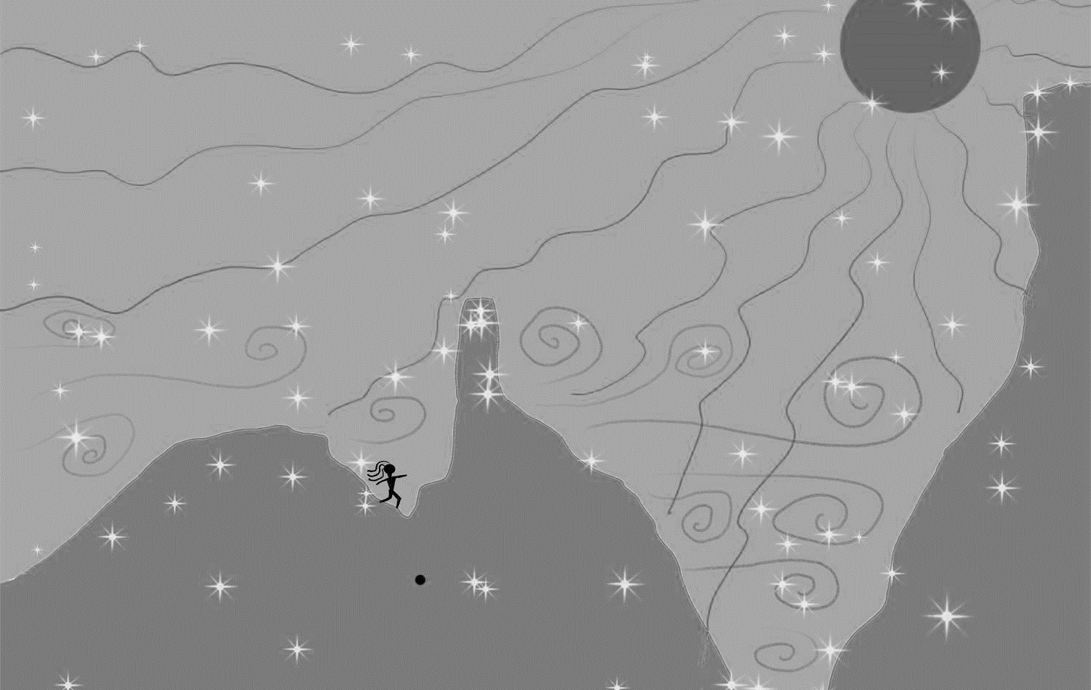
Figure 3 Canyonland’s world includes earth, wind (swirls), sun, and unseen beings (stars). Illustration: Author.

It could be argued that the primary technology of Archaic people was walking. The petroglyphs in the study area, defined by Mona Charles and Cole as the La Sal Mountain style of rock art with a preponderance of tracks and bear ‘paw prints’ frequently included images of footprints. By contrast the AP regions of sedentary farmers around Four Corners had a keynote of ‘the ubiquitous handprint’, according to Schaafsma. The sedentary agriculturalists to the south were ‘makers’, makers of pottery, architecture, and ornamentation and they left their handprints in the rock art as well as in the wall mortar and pottery. See Plate 11. By contrast, the hunter-gatherers were walkers, who lived by tracking animals and wild plant harvests and left little but footprints, including in their rock art as seen in Plate 12. Comfort was navigated by seeking out micro-environments to moderate weather conditions: a deep pool in summer, a sunny alcove in winter.
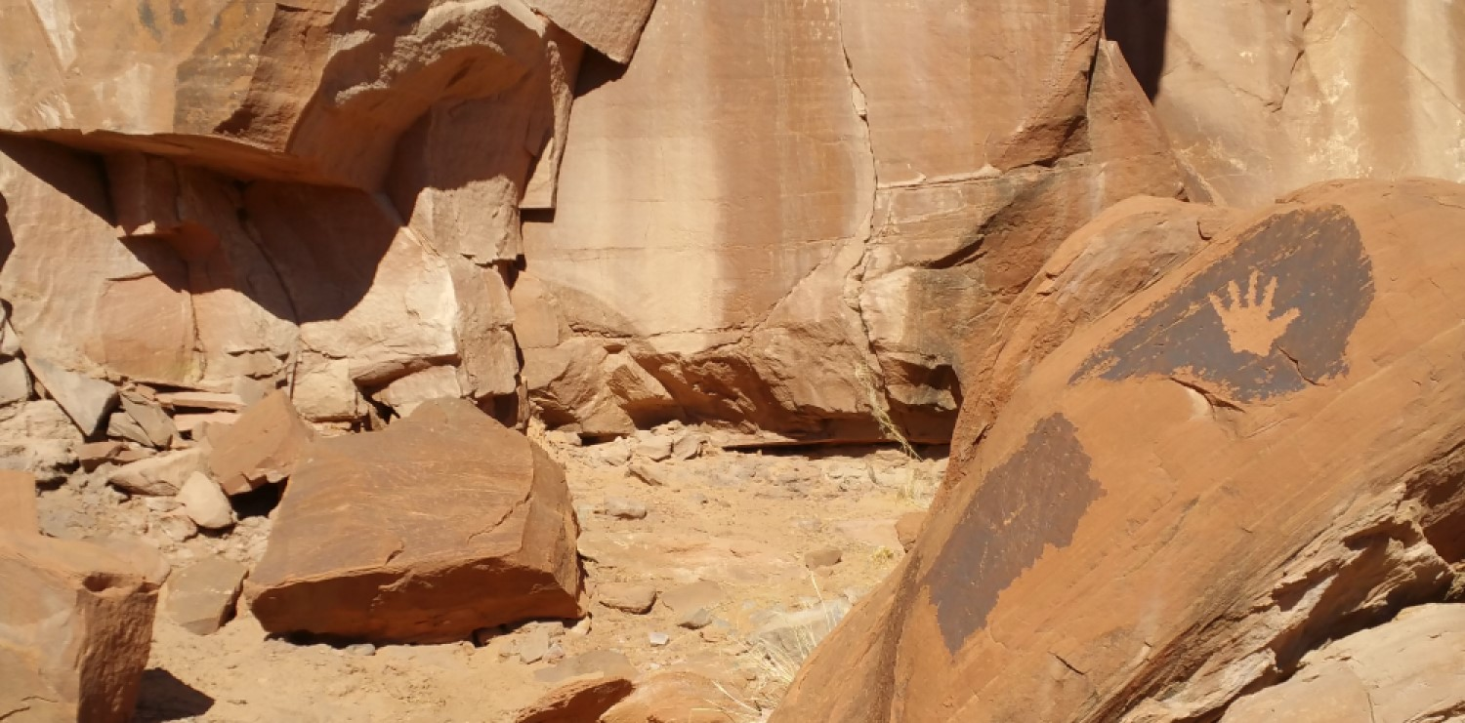 Plate 11 Handprints are more common south of the study area. This hand petroglyph in Millcreek is in front of an older panel of very faded zoomorphs on the half-light/half-dark cliff face in the centre of the photo. Photo: Author.
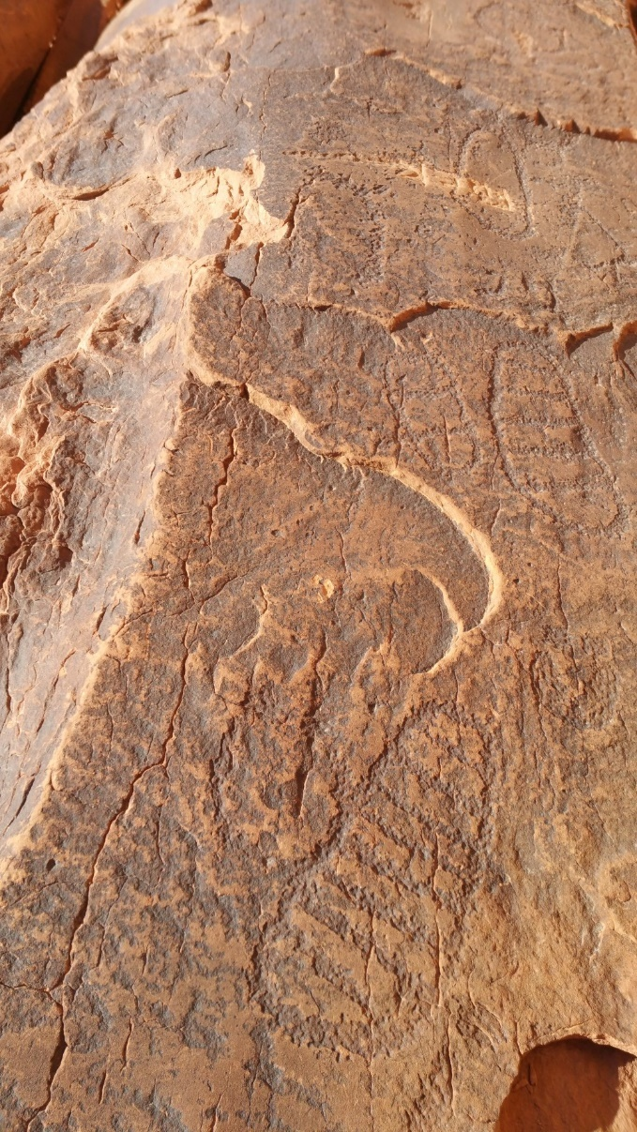
Tilley made a science of walking through the landscape, as an ‘appropriation of the topographical system’ to understand the anthropology of a place. Walking, hiking, climbing, and falling in Canyonlands instills a sense of movement that is life in the desert, the intimacy of sky and stone and the sacredness that is never quite benign. Footprints from an ancient past linger in the dry soil, and the rock art still beckons unseen beings.
Plate 12 Sandal prints are among the petroglyphs at the palimpsest panel at Courthouse Wash near Moab. Photo: Author.

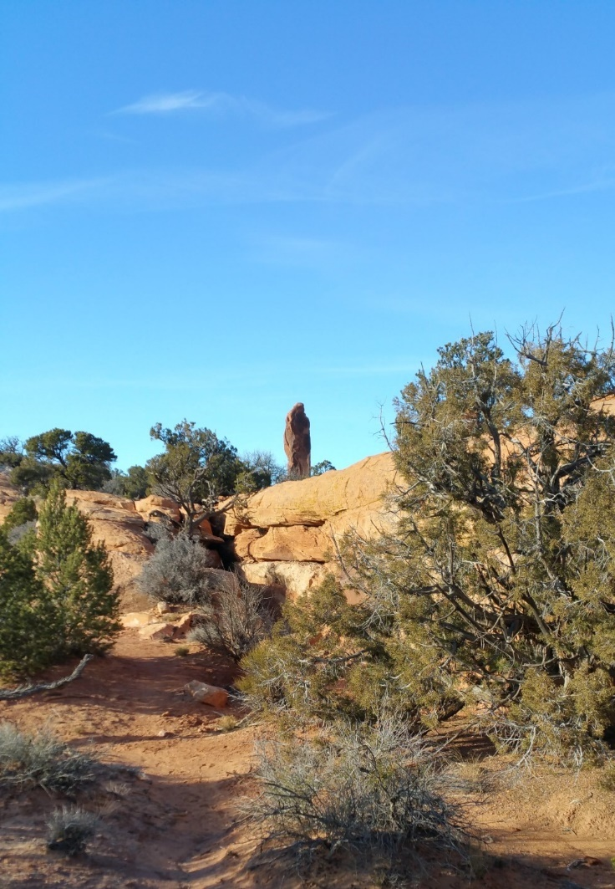
The emptiness is as important in the desert as what is present. Wind rivals stone and the dead heat of the air is as powerful a flashflood. Vast expanses of sandstone cliffs remain unmarked by rock art. Panels are clustered along waterways or in high hanging valleys, while the mesas and badlands between remain free of rock art. In Whitley’s ritualized counterbalancing of energies in the gendered landscape, the male-associated pecking of petroglyphs occurred in female watery places. In an apparent refutation of this gender inversion large petroglyph sites were sometimes located next to iconic monoliths jutting up into the sky. The smooth patinated faces of sandstone flanking the base of spires was unmarked. If these stone needles were axes mundi, were they so sacred that they were left unmodified? Or are they lightning rods, which connect literally with thunderstorms throughout the summer? Did nearby rock art panels commune with thunder gods without risking lightning strikes? H. R. Bell told the story of Lightning Brothers in Australia, who charge the earth with energy that ‘fills up everything with power’ and ‘Trees know how to grow in the right place because of that energy,’ which travels underground and connects everything. In southern California, Merle Walker found that

Plate 13 Spires are found near many sites, but none of the bases of spires have petroglyphs that were found in the study. Photo: Author.

a lightning struck boulder was subsequently adorned with petroglyphs, aligned to the magnetic traces.
The sun was only one of the sacred sky beings in traditional societies and prayers for rain in the desert are echoed today. The sedentary Hopi prayed for rain in the desert to water their crops, but migratory bands may have simply moved up the mountain, where berries and rain were abundant. Regardless of the subsistence responses to the presence or absence of rain among Archaic people, the awe and wonder of watching water fall from the sky in the desert has not changed over the millennia. Rain transforms the desert, while petrichor fills the air, the plants and soil swell with life. Thunderstorms are among the most powerful manifestations of supernatural beings; the land and sky reverberate with energy even before lightning strikes and in their wake are flashfloods and burning trees. The petroglyphs in high, dry valleys may have been sites for rituals of calling home the rain gods to their anchoring spires. See Plate 13.
The phenomenology of the desert indicated that the nexus of stone and sun would have been particularly salient to desert people who lived between those two elements. Ingold’s weather-world was probably infused with supernatural forces as is common among hunter-gatherers, while the walking perception of the landscape, that was so informative to Tilley, was a way of life to early nomadic peoples. Petroglyphs in proximity to spires may have been dedicated to rain gods who struck those towers regularly with the blessing of lightning and rain.

Conclusion
The study area has offered a unique opportunity to address the question of whether Archaic people of east central Utah tracked the movement of the sun along the horizon and recognized the turning points of solstices. The positioning of petroglyphs within the landscape to receive first light, through low points along the horizon was used as the measure of the frequency with which the nomadic Archaic people anchored viewing points for solstice observations. Because sedentary, agriculturalist, ancestral Puebloans only occupied the study area for about 250 years (based on dateable evidence), older petroglyph elements can be considered belonging to the nomadic groups leading an ‘archaic lifestyle’. Repatination, weathering and iconic Western Archaic Tradition abstract curvilinear styles were the criteria for recognizing multiple ages of rock art on individual panels.
Skyscape measurements were analysed for 179 Native American sites, including almost all the publicly known rock art sites in the study area. Pictographs and Ute petroglyphs were excluded from the test, as were petroglyph panels with one date of creation. Non-rock sites, such as habitations and limited activity sites were used a control group. Stellarium software was used to model solstice horizon events against low points in the horizon. Winter solstice sunrise falls on 32% of the petroglyph panels in the test group, while only 4.5% of the control group was situated to see first light on winter solstice. Winter solstice sunset also showed a marked increase over the control group and the anticipated random distribution with 24% of the panels seeing last light on winter solstice. Some sites had low horizons at the point of more than one solar event. About 65% of the petroglyph panels had an orientation to one of the solstice sunrises or sunsets. In the control group 9% of the non-rock art sites had viewing locations for any of the four solstice orientations. Based on this research it was concluded that hunter-gatherers created some petroglyphs at optimal solstice-viewing locations for ritual or time-keeping purposes.
In contrast to other studies, this research measured the relative value of solstice sunrise and sunset to non-agricultural people. It has been argued that tracking the sun and creating calendars only became a priority for earlier peoples when they needed the information for planting their crops. While Hudson at al. established that the Chumash of California were hunter-gathers who tracked the solstices and held ceremonies to call the sun back, the California Indians were relatively sedentary hunter-gatherers. The Hohokam and Chacoans also tracked solstices but were both groups of Uto-Aztecan agriculturalist Southwestern tribes with strong influence from Mesoamerican farming and astronomy. Among the Chumash, the Hohokam, and ancestral Puebloans several studies have revealed patterns of using petroglyphs to mark solstice sunrise or sunset, but none of the previous studies attempted to measure all available rock art for orientation to solstice sunrise or sunset. This research sought to establish a percentage, or measurement of value placed on each orientation by migratory, hunter-gatherer peoples.
Using a skyscape archaeology approach, the intention has been to establish repetition, back it up with ‘thick description’ and pertinent ethnological information and understand the relationship of the horizon to the cosmology of the Archaic peoples. Repetition was evidenced by the high percentage of Archaic petroglyph sites in locations for viewing the first light and last light of the winter solstice. Ethnologies of the Chumash, Hohokam, and Hopi affirm that winter solstice was an important ritual event in those groups. ‘Thick description’ was derived from ubiquitous beliefs among Native American peoples in animism, shamanism, and the interrelatedness of the animate and inanimate entities in the world, which led to the possibility of participation of the non-human beings in the creation of rock art. The horizon as a mediator between sky and earth was intrinsically an aspect of watching solstice sunrise and sunset, but cupules and petroglyphs add access to the underworld and the unseen world in an enculturated landscape. Alternate motivations for the placement of rock art were also considered.
Finally, the desert’s contribution to the Archaic experience through exposure to the elements, walking as a lifestyle and the potential meaning of spires as lightning beings was considered through Tilley’s phenomenology of landscape approach and the perspective of Ingold’s ‘weather-world.’

Appendix A: Summary of Site Data
Column 1: Site numbers are assigned for this research. Colour codes are where the site matches criteria for WSSR (dark blue), WSSS (light blue), SSSR (light yellow, SSSS (light orange). See also columns 12-15.
Column 2: Site names are mnemonics assigned for this research, except for the nine publicly known and named sites, where their common names are used. Magenta cells were used as the test group. Teal cells were excluded because they were single deposition sites. Orange sites were pictographs and excluded. White cells with site numbers beginning with ‘A’ are non-rock sites used as a control group and are all in the fifth spreadsheet.
Column 3: Artifacts described the artifacts found at the site.
Column 4: Styles are based on repatination and weathering only, or dateable elements such atlatl, which were used to determine whether the site met test criteria. Assignation of a culture is not definitive and beyond the scope of this work.
Column 5: Panels lists the number of panels at a site. Panels < 2m apart are considered contiguous. Panels > 10m apart are considered separate sites. All the panels within one site are considered to share the same horizon low points.
Column 6: First event is the closest low point match to a solstice sunrise or sunset observation point along the horizon. Exact matches, such as winter solstice sunrise, are WSSR+0. If the match is not exact, the degrees of azimuth required to meet the solar path is notated, i.e., SSSR+3 means the low point is three degrees north of SSSR. This information is graphed in Table 5: Degrees of Diffusion.
Column 7: Second Event is either a second solstice orientation, an equinox viewing location (EQSR, EQSS), or in a few instances an orientation to a low point that is due north (N).
Column 8: Setting is a description of the geologic and geographic features used for the rock art.
Column 9: Water describes the proximity to a water source. Sites over 45 min walk from a water source were considered ‘no’, not proximal to water.
Column 10: Habitation indicates whether any dwellings were adjacent to the rock art.
Column 11: Acoustics are not tested but a notation of the proximity of cliff walls and mountains with potential acoustical properties.
Columns 12-15: WSSR lists the number of panels at the site that meet the criteria for winter solstice sunrise and is colour-coded dark blue. The same method is used in the next five columns.
Column 16: Location describes the canyons and valleys in which the sites were found. Publicly undisclosed (PU)sites have restrictions on location disclosures due to risk of vandalization. Publicly known sites are described in further detail in the sixth table of this appendix.

Table of Publicly Known Sites and their Locations

Common Name | Trinomial | Latitude | Longitude | Research Site Number
Birthing Stone |  | 38˚31’21.61” N | 109˚36’09.67” W | Site 18
Moonflower Canyon |  | 38˚33’14.51” N | 109˚35’14.23” W | Site 10
Wall Street Petroglyphs |  | 38˚32’39.85” N | 109˚36’00.38” W | Site 31
Poison Spider Trail Head |  | 38˚32’02.40” N | 109˚36’29.20” W | Site 35
Courthouse Wash |  | 38˚36’25.46” N | 109˚34’53.40” W | Site 81
Golf Course Panel |  | 38˚32’19.40” N | 109˚28’43.18” W | Site 82
Steelbender Panel |  | 38˚32’22.10” N | 109˚28’05.90” W | Site 139
Millcreek Panel ‘Allred’ | 42GR2616 | 38˚32’46.54” N | 109˚28’10.79” W | Site 75
‘Old Shamans’ | 42GR3008 (PU) |  |  | Site 45
Sego Canyon |  | 38˚59’54.91” N | 109˚42’29.46” W | Site 93
Trinomials are derived from Legacy on Stone, Sally J. Cole.

Bibliography

Aton, James M., ‘Walls of Rock Art: Unfolding the Native Story’ in The River Knows Everything: Desolation Canyon and the Green (Boulder: University Press of Colorado, 2009)

Aveni, Anthony, ‘Horizon Astronomy in Incaic Cuzco’ in Foundations of New World Cultural Astronomy: A Reader with Commentary, ed. by Anthony Aveni (Boulder: University Press of Colorado, 2008), pp. 109-123.

Basso, Keith H., ‘Stalking with stories: names, places and moral narratives among the western Apache’, in Text, Play and Story, ed. by E. Bruner (Prospect Heights, IL: Waveland Press, 1984)

Barber, Elizabeth Wayland and Paul T. Barber, When They Severed Earth from Sky: How the Human Mind Shapes Myth (Princeton: Princeton University Press, 2006)

Bell, H. R., Storymen (Cambridge: Cambridge University, 2009) cited in Martin Porr and Hannah Rachel Bell, ‘” Rock-art”, “Animism” and Two-way Thinking: Towards a Complementary Epistemology in the Understanding of Material Culture and “Rock-art” of Hunting and Gathering People’, Journal of Archaeological Method and Theory, Vol. 19, No. 1 (March 2012), pp. 161-205.

Bestplaces.net https://www.bestplaces.net/climate/city/utah/moab#:~:text=On%20average%2C%20there%20are%20244%20sunny%20days%20per%20year%20in%20Moab.&text=Precipitation%20is%20rain%2C%20snow%2C%20sleet,that%20falls%20to%20the%20ground. [Accessed March 3, 2022]

Binford, Lewis R., ‘Mobility, Housing, and Environment: A Comparative Study’, Journal of Anthropological Research, Vol. 46, No. 2 (Summer, 1990), pp. 119-152.

Black, Kevin D., James M. Copeland and Steven M. Horvath, Jr., An Archaeological Survey of the Lisbon Valley Study Tract of the Moab District of San Juan County, Utah (Montrose, Colorado: Centuries Research, Inc., 1981)

Boser, Ulrich, ‘Solar Circle’, Archaeology, Vol. 59, No. 4 (July/August 2006), pp. 30-35.

Bostwick, Todd W., ‘Saluting the Sun: A Hohokam Calendar’, in Landscape of the Spirits: Hohokam Rock Art at South Mountain Park (Tucson: University of Arizona Press, 2002)

Breternitz, David, Arthur H. Rohn, and Elizabeth A. Morris, ‘Prehistoric Ceramics of the Mesa Verde Region.’, Museum of Northern Arizona Ceramics Series, No. 5 (Flagstaff: Museum of Northern Arizona, 1974) cited in Pierson, East Central, p. 62.

Carroll, Alex K., M. Nieves Zedeño and Richard W. Stoffle, ‘Landscapes of the Ghost Dance: A Cartography of Numic Ritual’, Journal of Archaeological Method and Theory, Vol. 11, No. 2,
Recent Advances in the Archaeology of Place, Part 2 (Jun. 2004), pp. 127-156.
Castleton, Kenneth B., Petroglyphs and Pictographs of Utah, Vol. Two (Salt Lake City: Museum of Natural History, 1979)

Charles, Mona C., and Sally J. Cole, ‘Chronology and Cultural Variation in Basketmaker II’, Kiva, Vol. 72, No. 2, Symposium: Basketmaker II: A View from the Colorado Plateau (Winter, 2006), pp. 167-216.

Chérieau, Fabien, Stellarium v. 01.21.1, 2001, Linux, Windows, MacOS. https://stellarium.org/release/2021/06/24/stellarium-0.21.1.html

Chidester, David, ‘Animism’ in Religion: Material Dynamics (Oakland: University of California Press, 2018), pp. 23-29.

Childe, V. G., ‘The Birth of Civilisation’ Past & Present, No. 2 (Nov. 1952), pp. 1-10.

Cole, Sally J., Legacy on Stone: Rock Art of the Colorado Plateau and Four Corners Region, Revised and Updated (Boulder: Johnson Books, 2009)

Condit, Tom and Gabriel Cooney, ‘Heritage Guide No. 8: Newgrange, Co. Meath: Neolithic religion and the mid-winter sunrise’, Archaeology Ireland, November (1999)

Cousins, Emily, ‘Mountains Made Alive: Native American Relationships with Sacred Land’ CrossCurrents, Vol. 46, No. 4, Spiritualities in a Post-Einsteinian Universe, (Winter 1996/1997), pp. 497-509.

Darvill, Timothy, ‘Afterword: Dances Beneath a Diamond Sky’, in Skyscapes: The Role and Importance of the Sky in Archaeology, ed. by Fabio Silva and Nicholas Campion (Oxford: Oxbow Books, 2015), pp. 140-148.

Dìaz-Andreu, Margarita, Angelo Farina, Enrico Armelloni, Laura Coltofean, Mathieu Picas and Tommaso Mattioli, ‘Acoustic effects at prehistoric landscapes: an archaeoacoustics analysis of rock art sites from the Western Mediterranean’, Proceedings of the 23rd International Congress on Acoustics, (Sept. 2019), pp. 281-287.

Doelling, Hellmut H., The Geology of Arches National Park: To Accompany Map 74 (Salt Lake City: Utah Geological and Mineral Survey, 1985)

Doxtater, Dennis, ‘A Hypothetical Layout of Chaco Canyon Structures via Large-Scale Alignments between Significant Natural Features’, Kiva, Vol. 68, No. 1 (Fall, 2002), pp. 23-47.

Durand, Kathy Roler, ‘Function of Chaco-Era Great Houses’, Kiva, Vol. 69, No. 2, The Chaco World (Winter, 2003), pp. 141-169.

Eliade, Mircea, The Sacred and the Profane: The Nature of Religion, trans. by Willard R. Trask (New York: Harcourt, Brace and world, Inc., 1957)

Eliade, Mircea, Myth and Reality (New York: Harper and Row, 1962)

Ellis, Florence Hawley, ‘A Thousand Years of the Pueblo Sun-Moon-Star Calendar’ in Foundations of New World Cultural Astronomy: A Reader with Commentary, ed. by Anthony Aveni (Boulder: University Press of Colorado, 2008), pp. 647-668.

Faulseit, Ronald F., ‘Mountain of Sustenance: Site Organization at Dainzú-Macuilxóchitl and Mesoamerican Concepts of Space and Time’ in Cosmology, Calendars, and Horizon-Based Astronomy in Ancient Mesoamerica, eds. Anne S. Dowd and Susan Milbrath (Boulder, University Press of Colorado, 2015)

Feist, Gregory J., ‘Origins of the Scientific Thinking’ in The Psychology of Science and the Origins of the Scientific Mind (New Haven: Yale University Press, 2008)

Ferguson, William M. and Arthur H. Rohn, Anasazi Ruins of the Southwest in Color (Albuquerque: University of New Mexico Press, 1987)

Fewkes, J. Walter, ‘Sun Worship of the Hopi Indians.’, in Smithsonian Report (Washington: Government Printing, 1918), pp. 493-526.

Frank, Roslyn. M., ‘Skylore of the Indigenous People of Northern Eurasia’, in Handbook of Archaeoastronomy and Ethnoastronomy, ed. Clive L. N. Ruggles (New York: Springer Science+Business Media, 2015), pp. 1679-1686.

Geertz, Clifford, ‘Deep Play: Notes on the Balinese Cockfight’, Daedalus, Vol. 101, No. 1, Myth, Symbol, and Culture (Winter, 1972), pp. 1-37.

Geib, Phil R. and Helen C. Fairley, ‘Radiocarbon Dating of Fremont Anthropomorphic Rock Art in Glen Canyon, South Central Utah’, Journal of Field Archaeology, Vol. 19, No. 2, (Summer, 1992), pp. 155-168.

Geib, Phil R. and Edward A. Jolie, ‘The Role of Basketry in Early Holocene Small Seed Exploitation: Implications of a Ca. 9,000 Year-Old Basket from Cowboy Cave, Utah’, American Antiquity, Vol. 73, No. 1 (Jan. 2008), pp. 83-102.

Gunnerson, James H., ‘The Fremont Culture: Internal Dimensions and External Relationships’ American Antiquity, Vol. 25, No. 3 (Jan. 1960), pp. 373-380.

Hampton, O. Winston, and Bill Harney, 2000 ‘Mixed Media Dimensions of Dreamtime Painting, Abraded Grooves, and Sacred Rock in the Northern Territory, Australia’, Rock Art Papers, Vol. 15, (2000), pp. 1-15, cited in Susan M. Hector, ‘Cupule Petroglyphs as Elements of the Cultural Landscape’ Journal of California and Great Basin Anthropology, Vol. 29, No. 1 (2009), pp. 68-76.

Harrison, Simon, ‘Emotional Climates: Ritual, Seasonality and Affective Disorders’, The Journal of the Royal Anthropological Institute, Vol. 10, No. 3 (Sep. 2004), pp. 583-602.

Heizer, Robert F. and Martin A. Baumhoff, Prehistoric Rock Art of Nevada and Eastern California (Berkley and Los Angeles: University of California Press, 1962), cited by Kenneth B. Castleton, Petroglyphs and Pictographs of Utah, Vol. Two (Salt Lake City: Museum of Natural History,1979)

Heizer, Robert F. and Albert B. Elsasser, The Natural World of the California Indians (Berkley, Los Angeles, London: University of California Press, 1980)

Ingold, Tim, ‘Earth, Sky, Wind, and Weather’, The Journal of the Royal Anthropological Institute, Vol. 13, Wind, Life, Health: Anthropological and Historical Perspectives (2007), pp. S19-S38.

Hensey, Robert, First Light: The Origins of Newgrange (Oxford: Oxbow Books, 2015)

Headwaters Economics, https://headwaterseconomics.org/economic-development/economic-grand-county/#:~:text=Grand%20County%20consists%20largely%20of,47%20percent%20of%20private%20employment. [Accessed Jan. 22, 2022]

Hector, Susan M., ‘Cupule Petroglyphs as Elements of the Cultural Landscape’ Journal of California and Great Basin Anthropology, Vol. 29, No. 1 (2009), pp. 68-76.

Hranicky, Wm Jack, ‘The Oldest Above Ground Site in North America’, Central States Archaeological Journal, Vol. 59, No. 2 (April 2012), pp. 82-86.

Hudson, Travis, Georgia Lee, and Ken Hedges, ‘Solstice Observers and Observatories in Native California’, Journal of California and Great Basin Anthropology, Vol. 1, No. 1 (Summer, 1979), pp. 38-63.

Hunt, Alice, Archaeological Survey of the La Sal Mountains Area, Utah (Salt Lake City: University of Utah Press, 1955)

Jeguès-Wolkiewiez, Chantal, ‘Lascaux, vision du ciel des Magdalénien’, in Arte preistorica e tribale: conservazione e salvaguardia dei messaggi. Presentation at Symposium 2000 d’Art Rupestre, Val Camonica, 2000, http://www.archeociel.com/lascaux.htm; ‘Cro-Magnon: premier astronome de l’humanité?’, Science et vie (Nov. 2007), pp. 93–101; ‘Lascaux et les astres.’ Les dossiers d’archaeologie (Hors Série) 15, 2008, pp. 22–9, cited by Brian Hayden and Suzanne Villeneuve, ‘Astronomy in the Upper Paleolithic?’, Cambridge Archaeological Journal Vol. 21, No. 3, (2011), pp. 331–55. https://www.cambridge.org/core [Accessed February 20, 2022].

Jennings, Jesse D., Prehistory of Utah and the Eastern Great Basin (Salt Lake City: University of Utah Press, 1973)

Kolm, Kenneth E., Hydrologic Systems Analysis, LLC., Golden, Colorado and Paul K.M. van der Heijde, Heath Hydrology, Inc., Boulder, Colorado, ‘Hydrologic Assessment of the Surface Water and Groundwater Resources of Castle Valley, Utah: Part 1: Hydrologic and Environmental Analysis (HESA) and Preliminary Water Budget’, prepared for the Town of Castle Valley, March 2016

Krupp, E. C., Beyond the Blue Horizon: Myths and Legends of the Sun, Moon, Stars and Planets (New York: Harper Collins Publishers, 1991)

Laylander, Don, ‘Preemptive Positioning and Relative Chronology in Rock Art’ Proceedings of the Society for California Archaeology, Vol. 24 (2010), pp. 1-3.

LeBlanc, Steven A., ‘The Case for an Early Farmer Migration into the Greater American Southwest’ in Archaeology without Borders: Contact, Commerce, and Change in the U.S. Southwest and Northwestern Mexico, ed. by Laurie D. Webster, Maxine E. McBrinn and Eduardo Gamboa Carrera (Boulder: University Press of Colorado, 2008)

Lekson, Stephen H., A History of the Ancient Southwest (Santa Fe: School for Advanced Research, 2008)

Lewis-Williams, J. David and Thomas A. Dowson, ‘Through the Veil: San Rock Paintings and the Rock Face’, The South African Archaeological Bulletin, Vol. 45, No. 151 (Jun. 1990), pp. 5-16.

Lewis-Williams, J. D., ‘ACRA: a retrospect’, in Perceiving Rock Art: Social and Political Perspectives, by K. Helskog and B. Olsen (Oslo: Novus forlag, 1995), cited by David S. Whitley, ‘Science and the sacred: interpretive theory in U. S. rock art research’, in Theoretical Perspectives on Rock Art Research, ed. by Knut Helskog (Oslo: Novus forlag, 2001), pp. 124-151.

Liwosz, Chester R., ‘Synesthetic Petroglyphs: A Vision Quest Perspective on the Significance of a Mohave Desert Slot Canyon Rock Art Site’ Society for California Archaeology Proceedings, Vol. 28, (2014), pp. 426-437.

Loftin, John D., ‘Supplication and Participation: The Distance and Relation of the Sacred in Hopi Prayer Rites’, Anthropos, Bd. 81, H 1./3. (1986), pp. 177-201.

Lomsdalen, Tore, ‘Can Archaeoastronomy Inform Archaeology on the Building Chronology of the Mnajdra Neolithic Temple in Malta?’, in Skyscapes: The Role and Importance of the Sky in Archaeology, ed. by Fabio Silva and Nicholas Campion (Oxford: Oxbow Books, 2015), pp. 59-75.

Mackenzie, Kierin, Willington Siabato, Femke Reitsma and Christophe Claramunt, ‘Spatio-temporal Visualisation and Data Exploration of Traditional Ecological Knowledge/Indigenous Knowledge’, Conservation & Society, Vol. 15, No. 1 (2017), pp. 41-58.

Madsen, David B., Exploring the Fremont (Salt Lake City: Utah Museum of Natural History, 1989)

Malotki, Ekkehart and Dennis E. Weaver, Jr., Stone Chisel and Yucca Brush: Colorado Plateau Rock Art, (Walnut, CA: Kiva Publishing, 2002)

Malotki, Ekkehart, ‘Early rock art at the Upper Sand Island Site near Bluff, Utah, United States: addenda et corrigenda’, Rock Art Research, Vol. 29, No. 2, (2012), pp. 234-238.

Malotki, Ekkehart and Ellen Dissanayake, Early Rock Art of the American West: The Geometric Enigma (Seattle: University of Washington Press, 2018)

Malville, J. McKim, ‘Astronomy and Social Integration Among the Anasazi’ in Proceedings of the Anasazi Symposium 1991, compiled by Art Hutchinson and Jack E. Smith (Mesa Verde: Mesa Verde Museum Association, 1991), pp. 149-156.

Malville, J. McKim, ‘Enigmas of Fajada Butte Chaco Canyon’ (unpublished).

Malville, J. McKim, Guide to Prehistoric Astronomy in the Southwest, Revised and Updated (Boulder: Johnson Books, 2008)

Malville, J. McKim, ‘Climate Change, Nomadic Pastoralism and Astronomy at Nabta Playa, Southern Egypt’, (unpublished, 2011)

Malville, J. McKim, ‘Machu Picchu’ in Handbook of Archaeoastronomy and Ethnoastronomy, ed. Clive L. N. Ruggles (New York: Springer Science+Business Media, 2015), pp. 884-888.

Malville, J. McKim, ‘Preface: The Meaning and Intent in Ancient Skyscapes – An Andean Perspective’, in Skyscapes: The Role and Importance of the Sky in Archaeology, ed. by Fabio Silva and Nicholas Campion (Oxford: Oxbow Books, 2015)

Malville, J McKim, ‘Animism, Reciprocity and Entanglement’, Mediterranean Archaeology and Archaeometry, Vol. 16, No. 4, (2016), pp. 51-58.

Malville, J. McKim, ‘Entangling the Cosmos: Astronomy of the Ancestral Pueblos – Sacred Skyscapes and Medicine Bundles’ (2021, unpublished)

Martineau, LaVan, The Rocks Begin to Speak (Las Vegas: KC Publications, 1973)

Matson, R. G., William D. Lipe and William R. Haase IV, ‘Adaptational Continuities and Occupational Discontinuities: The Cedar Mesa Anasazi’ Journal of Field Archaeology, Vol. 15, No. 3 (Autumn, 1988), pp. 245-264.

Mathiowetz, Michael, Polly Schaafsma, Jeremy Coltman and Karl Taube, ‘The Darts of Dawn: The Tlahuizcalpantecuhtli Venus Complex in the Iconography of Mesoamerica and the American Southwest’, Journal of the Southwest, Vol. 57, No. 1 (Spring 2015), pp. 1-102.

Mendez, Alonso, Edwin L. Barnhart, Christopher Powell, and Carol Karasik, ‘Astronomical Observations from the Temple of the Sun’ in Foundations of New World Cultural Astronomy: A Reader with Commentary, ed. by Anthony Aveni (Boulder: University Press of Colorado, 2008), pp. 305-346.

Mendez, Alonso, Carol Karasik, Edwin L. Barnhart and Christopher Powell, ‘The astronomical architecture of Palenque’s Temple of the Sun’, in Archaeoastronomy and the Maya, (eds.) Gerardo Aldana, Gerardo Villalobos and Edwin L. Barnhart (Oxford: Oxbow Books, 2014)

Middleton, Emily S., Geoffrey M. Smith, William J. Cannon, Mary F. Ricks, ‘Paleoindian rock art: establishing the antiquity of Great Basin Carved Abstract petroglyphs in the northern Great Basin’, Journal of Archaeological Science, Vol. 43, (2014), pp. 21-30.

Mulligan, Connie J., ‘Anthropological Applications of Ancient DNA: Problems and Prospects’, American Antiquity, Vol. 71, No. 2 (Apr. 2006), pp. 365-380.

Murdock, George P., and Suzanne F. Wilson, ‘Settlement Patterns and Community Organization: Cross-Cultural Codes 3’, Ethnology, Vol. 11, No. 3 (Jul. 1972), pp. 254-295.

Nunn, Greg, personal communication, 2021

Ortman, Scott G., ‘Architectural Metaphor and Chacoan Influence in the Northern San Juan’, in Archaeology without Borders: Contact, Commerce, and Change in the U.S. Southwest and Northwestern Mexico, eds. Laurie D. Webster, Maxine E. McBrinn and Eduardo Gamboa Carrera (Boulder: University Press of Colorado, 2008)

Patterson, Carol, ‘Ute Indian Rock Art Maps and Game Drives in Western Colorado: A Preliminary Study of Ute Rock Art Maps in Gunnison Gorge National Conservation Area and Dominguez-Escalante National Conservation Area’, IFRAO 2013 Proceedings, American Indian Rock Art, Vol. 40, (2013), pp #-#, ed. by Mavis Greer Session and Peggy Whitehead. https://www.academia.edu/4925944/Ute_Indian_Rock_Art_Maps_and_Game_Drives_in_Western_Colorado_A_Preliminary_Study_of_Ute_Rock_Art_Maps_in_Gunnison_Gorge_National_Conservation_Area_and_Dominguez_Escalante_National_Conservation_Area, [Accessed February 25, 2022].

Patterson, Carol, ‘Petroglyphs of Western Colorado and the Northern Ute Indian Reservation as Interpreted by Clifford Duncan’, Transactions of the American Philosophical Society, New Series, Vol. 105, No. 5 (2015), pp. i-151.

Patterson, Carol, ‘The Mu:kwitsi/Hopi (Fremont) and Numic Immigrants Depicted in Nine Mile Canyon Rock Art.’ (2018), https://www.academia.edu/36439563/The_Mu_kwitsi_Hopi_Fremont_abandonment_and_Numic_Immigrants_into_Nine_Mile_Canyon_as_Depicted_in_the_Rock_Art [Accessed Mar. 5, 2022]

Patterson, Carol, ‘What Can Be Learnt from Body Postures and Gestures of Anthropomorphic Figures in Petroglyphs of the Southwest USA’ in Anthropomorphic Images in Rock Art Paintings and Rock Carvings, ed. by Terence Meaden and Herman Bender (Oxford: Archaeopress, 2020), pp. 179-199.

Pederson, Joel L., Melissa S. Chapot, Steven R. Simms, Reza Sohbati, Tammy M. Rittenour, Andrew S. Murray, and Gary Cox, ‘Age of Barrier Canyon-Style Rock Art Constrained by Cross-Cutting Relations and Luminescence Dating Techniques’, Proceedings of the National Academy of Sciences of the United States of America, Vol. 111, no. 36, (2014), pp. 12986–12991.
Pierson, Lloyd M., Cultural Resource Summary for the East Central Portion of Moab District, Bureau of Land Management Cultural Resource Series, Vol. 10, (Salt Lake City: Bureau of Land Management, 1980)

Porr, Martin and Hannah Rachel Bell, ‘” Rock-art”, “Animism” and Two-way Thinking: Towards a Complementary Epistemology in the Understanding of Material Culture and “Rock-art” of Hunting and Gathering People’, Journal of Archaeological Method and Theory, Vol. 19, No. 1 (March 2012), pp. 161-205.

Posthumus, David C., ‘The Living Rock, Grandfather of All Things’ in All My Relatives: Exploring Lakota Ontology, Belief, and Ritual (Lincoln: University of Nebraska Press, 2018), pp. 73-91.

Prasciunas, Mary M., ‘Mapping Clovis: Projectile Points, Behavior and Bias’, American Antiquity, Vol. 76, No. 1, (2011), pp. 107-127.

Rowe, Marvin, in a letter to Dr. Nancy Coulam, Canyonlands National Park, cited in Tipps, Holocene, p.156

Ruggles, Clive, Astronomy in Prehistoric Britain and Ireland (New Haven and London: Yale University Press, 1999)

Ruggles, Clive L.N., ‘Stonehenge and its Landscape’, in Handbook of Archaeoastronomy and Ethnoastronomy, ed. Clive L. N. Ruggles (New York: Springer Science+Business Media, 2015), pp. 1223-1238.

Rundstrom, R.A., ‘Mapping, the white man’s burden.’ The common property resource digest, Vol. 45, (1998), pp. 1–9, cited by Kierin Mackenzie, Willington Siabato, Femke Reitsma and Christophe Claramunt, ‘Spatio-temporal Visualisation and Data Exploration of Traditional Ecological Knowledge/Indigenous Knowledge’, Conservation & Society, Vol. 15, No. 1 (2017), pp. 41-58.

Sabo III, George and Jan F. Simek, ‘Materiality and cultural landscapes in Native America’ Transforming the Landscape: Rock Art and the Mississippian Cosmos, ed. by Carol Diaz-Granados, Jan Simek, George Sabo III and Mark Wagner (Oxford: Oxbow Books, Limited, 2018)

Sanmark, Alexandra, ‘Assembly Research: Past and Present’, in Viking Law and Order: Places and Rituals of Assembly in the Medieval North (Edinburgh: Edinburgh University Press, 2019)

Schaafsma, Polly, Indian Rock Art of the Southwest (Santa Fe and Albuquerque: School of American Research and University of New Mexico Press, 1980)

Schaafsma, Polly, ‘Form, Content, and Function: Theory and Method in North American Rock Art Studies’, Advances in Archaeological Method and Theory, Vol. 8 (1985), pp. 237-277.

Schaafsma, Polly and M. Jane Young, ‘Rock Art of the Zuni Region: Cultural-Historical Implications’ in Zuni Origins: Toward a New Synthesis of Southwestern Archaeology, eds. David A. Gregory and David R. Wilcox (Tucson: Published by: University of Arizona Press, 2007)

Silva, Fabio, ‘The Role and Importance of the Sky in Archaeology: An Introduction’ in Skyscapes: The Role and Importance of the Sky in Archaeology, eds. Fabio Silva and Nicholas Campion (Oxford and Philadelphia: Oxbow Books, 2015)

Smiley, Francis E., ‘The Agricultural Transition in the Northern Southwest: Patterns in the Current Chronometric Data’, Kiva, Vol. 60, No. 2, Anasazi Origins: Recent Research on the Basketmaker II (Winter, 1994), pp. 165-189.

Smiley, Francis E., ‘Kayenta Farmers and Villagers’ in Prehistoric Culture Change on the Colorado Plateau: Ten Thousand Years on Black Mesa, eds. Shirley Powell and Francis E. Smiley (Tucson: University of Arizona Press, 2002)

Sofaer, Anna, Volker Zinser and Rolf M. Sinclair, ‘A Unique Solar Marking Construct’, Science, New Series, Vol. 206, No. 4416 (Oct. 19, 1979), pp. 283-291.

Šprajc, Ivan, ‘Astronomical Alignments at Teotihuacan, Mexico’, Latin American Antiquity, Vol. 11, No. 4 (Dec. 2000), pp. 403-415.

Šprajc, Ivan, ‘Astronomical Alignments at the Templo Mayor of Tenochtitlan, Mexico’ in Foundations of New World Cultural Astronomy: A Reader with Commentary, ed. Anthony Aveni (Boulder: University Press of Colorado, 2008), pp. 273-303.

Šprajc, Ivan, ‘Astronomy, Architecture, and Landscape in Prehispanic Mesoamerica’, Journal of Archaeological Research, Vol. 26, No. 2 (June 2018), pp. 197-251.

Stafford, William, ‘In the All-Verbs Navaho World’, Rhetoric Review, Vol. 10, No. 1 (Autumn, 1991), p. 70.

Stuart, David E., Anasazi America: Seventeen Centuries on the Road from Center Place, Second Edition (Albuquerque: University of New Mexico Press, 2014)

Thomsen, Dietrick E., ‘Sunwatchers of the American Southwest’, Science News, Vol. 123, No. 25 (Jun. 18, 1983), pp. 394-395.

Tilley, Christopher, A Phenomenology of Landscape: Places, Paths and Monuments (Explorations in Anthropology) (Oxford: Berg Publishers, 1997)

Tipps, Betsy L., Holocene Archeology Near Squaw Butte, Canyonlands National Park, Utah, Cultural Resources Report 411-04-9102 (Denver: National Park Service, 1995)

Turner, II, Christy G., Petroglyphs of the Glen Canyon Area, Bulletin 38, Glen Canyon Series 4, (Flagstaff: Museum of Northern Arizona, 1963), cited in Cole, Legacy, p. 4

USCLimatedata.com https://www.usclimatedata.com/climate/moab/utah/united-states/usut0165 [Accessed Feb. 15, 2022]

Weather Atlas https://www.weather-us.com/en/utah-usa/arches-national-park-climate [Accessed Jan. 23, 2022]

Walker, Merle E., ‘Petroglyphs, Lightning, and Magnetism’, Journal of California and Great Basin Anthropology, Vol. 27, No. 1 (2007), pp. 52-71.

Wallace, Henry D., and James P. Holmlund, ‘Petroglyphs of the Picacho Mountains, South
Central Arizona’, Anthropological Papers, No. 6. (Tucson, AZ: Institute for American
Research, 1986)

Waller, Steven, ‘Spatial Correlation of Rock Art and Acoustics Exemplified in Horseshoe Canyon.’
American Indian Rock Art, Vol. 24, (2000), pp. 85-94.

Wallis, Robert J., ‘Re-enchanting Rock Art Landscapes: Animic Ontologies, Non-Human Agency, and Rhizomatic Personhood’, Time and Mind: The Journal of Archaeology, Consciousness and Culture, Vol. 2, No. 1, (March 2009), pp.47-70.

Whitley, David S., ‘Finding rain in the desert: landscape, gender and far Western North American rock art’, (1998) https://www.academia.edu/3170207/Finding_rain_in_the_desert_landscape_gender_and_far_western_North_American_rock_art [Accessed March 2, 2022].

Whitley, David S., Joseph M. Simon and Ronald I. Dorn, ‘The Vision Quest in Coso Range’, American Indian Rock Art, Vol. 25, (1999), pp. 1-31.

Whitley, David S., ‘Issues in Archaeoastronomy and Rock Art’, International Council on Monuments and Sites, Comite Internationale de Arte Rupestre, (2006), pp. 85-102.

Whitley, David S., ‘Science and the sacred: interpretive theory in U. S. rock art research’, in Theoretical Perspectives on Rock Art Research, ed. by Knut Helskog (Oslo: Novus forlag, 2001), pp 124-151.

Whitley, David S., The Art of the Shaman: Rock Art of California. (Salt Lake City: University of Utah Press, 2000), pp. 82-82, cited by Susan M. Hector, ‘Cupule Petroglyphs as Elements of the Cultural Landscape’ Journal of California and Great Basin Anthropology, Vol. 29, No. 1 (2009), pp. 68-76.

David S. Whitley, ‘Rock Art, Religion and Ritual’, pp. 307-327. https://www.academia.edu/14548487/Rock_Art_Religion_and_Ritual [accessed April 5, 2022].

Wikipedia: Diurnal Temperature Variation https://en.wikipedia.org/wiki/Diurnal_air_temperature_variation [Accessed Mar. 9, 2022].

Young, M. Jane, Signs from the Zuni Cultural Symbolism and Perceptions of Rock Art (Albuquerque: University of New Mexico Press, 1988)

Clive L.N. Ruggles, ‘Stonehenge and its Landscape’, in Handbook of Archaeoastronomy and Ethnoastronomy, ed. Clive L. N. Ruggles (New York: Springer Science+Business Media, 2015), pp. 1224, 1229, 1236.
Robert Hensey, First Light: The Origins of Newgrange (Oxford: Oxbow Books, 2015), p. 66; Tore Lomsdalen, ‘Can Archaeoastronomy Inform Archaeology on the Building Chronology of the Mnajdra Neolithic Temple in Malta?’, in Skyscapes: The Role and Importance of the Sky in Archaeology, ed. by Fabio Silva and Nicholas Campion (Oxford: Oxbow Books, 2015), pp. 59-75; Anthony Aveni, ‘Horizon Astronomy in Incaic Cuzco’ in Foundations of New World Cultural Astronomy: A Reader with Commentary, ed. by Anthony Aveni (Boulder: University Press of Colorado, 2008), pp. 110, 122.
Aveni, Horizon, p. 110; Gregory J. Feist, ‘Origins of the Scientific Thinking’ in The Psychology of Science and the Origins of the Scientific Mind (New Haven: Yale University Press, 2008), p. 199. Tom Condit and Gabriel Cooney, ‘Heritage Guide No. 8: Newgrange, Co. Meath: Neolithic religion and the mid-winter sunrise’, Archaeology Ireland, November (1999), p. 4.
Elizabeth Wayland Barber and Paul T. Barber, When They Severed Earth from Sky: How the Human Mind Shapes Myth (Princeton: Princeton University Press, 2006), p. 178.
Ekkehart Malotki and Ellen Dissanayake, Early Rock Art of the American West: The Geometric Enigma (Seattle: University of Washington Press, 2018), p. 41.
Barbers, Severed Earth, p. 180.
Barbers, Severed Earth, p. 178.
George Sabo III and Jan F. Simek, ‘Materiality and cultural landscapes in Native America’, in Transforming the Landscape: Rock Art and the Mississippian Cosmos, ed. by Carol Diaz-Granados, Jan Simek, George Sabo III, and Mark Wagner (Oxford: Oxbow Books, Limited, 2018), pp. 5-25.
Headwaters Economics, https://headwaterseconomics.org/economic-development/economic-grand-county/#:~:text=Grand%20County%20consists%20largely%20of,47%20percent%20of%20private%20employment. [Accessed Jan. 22, 2022]
Hellmut H. Doelling, The Geology of Arches National Park: To Accompany Map 74 (Salt Lake City: Utah Geological and Mineral Survey, 1985), pp. 1-9.
Doelling, Geology of Arches, p. 6.
Sally J. Cole, Legacy on Stone: Rock Art of the Colorado Plateau and Four Corners Region, Revised and Updated (Boulder: Johnson Books, 2009), p. 4.
Doelling, Geology of Arches, pp. 1, 9-11.
Jesse D. Jennings, Prehistory of Utah and the Eastern Great Basin (Salt Lake City: University of Utah Press, 1973), p. 9.
Dr. Kenneth E. Kolm, Hydrologic Systems Analysis, LLC., Golden, Colorado and Paul K.M. van der Heijde, Heath Hydrology, Inc., Boulder, Colorado, ‘Hydrologic Assessment of the Surface Water and Groundwater Resources of Castle Valley, Utah: Part 1: Hydrologic and Environmental Analysis (HESA) and Preliminary Water Budget’, prepared for the Town of Castle Valley, March, 2016, p. 6.; Weather Atlas https://www.weather-us.com/en/utah-usa/arches-national-park-climate [Accessed Jan. 23, 2022].
David E. Stuart, Anasazi America: Seventeen Centuries on the Road from Center Place, Second Edition (Albuquerque: University of New Mexico Press, 2014), pp. 8-11.
Mary M. Prasciunas, ‘Mapping Clovis: Projectile Points, Behavior and Bias’, American Antiquity, Vol. 76, No. 1, (2011), pp. 119-121.
Ekkehart Malotki, ‘Early rock art at the Upper Sand Island Site near Bluff, Utah, United States: addenda et corrigenda’, Rock Art Research, Vol. 29, No. 2, (2012), pp. 234-238.
Greg Nunn, personal communication, 2021.
Stuart, Anasazi America, p. 9.
Stuart, Anasazi America, pp. 11-18.
Phil R. Geib and Edward A. Jolie, ‘The Role of Basketry in Early Holocene Small Seed Exploitation: Implications of a Ca. 9,000 Year-Old Basket from Cowboy Cave, Utah’, American Antiquity, Vol. 73, No. 1 (Jan., 2008), pp. 83-102.
Stuart, Anasazi America, pp. 11-18.
Kevin D. Black, James M. Copeland and Steven M. Horvath, Jr., An Archaeological Survey of the Lisbon Valley Study Tract of the Moab District of San Juan County, Utah (Montrose, Colorado: Centuries Research, Inc., 1981), p. 149.
Betsy L. Tipps, Holocene Archeology Near Squaw Butte, Canyonlands National Park, Utah, Cultural Resources Report 411-04-9102 (Denver: National Park Service, 1995), p. 184.
Stuart, Anasazi America, pp. 11-18.
Jennings, Prehistory of Utah, pp. 29-93.
Jennings, Prehistory of Utah, p. 92.
James M. Aton, ‘Walls of Rock Art: Unfolding the Native Story’ in The River Knows Everything: Desolation Canyon and the Green (Boulder: University Press of Colorado, 2009), pp. 42-43.
Aton, River Knows, p. 43.
Stuart, Anasazi America, p. 36.
Alice Hunt, Archaeological Survey of the La Sal Mountains Area, Utah (Salt Lake City: University of Utah Press, 1955) pp. 1-240.
Hunt, La Sal Mountains, p. 8.
Francis E. Smiley, ‘Kayenta Farmers and Villagers’ in Prehistoric Culture Change on the Colorado Plateau: Ten Thousand Years on Black Mesa, eds. Shirley Powell and Francis E. Smiley (Tucson: University of Arizona Press, 2002), pp. 47, 63.
Kathy Roler Durand, ‘Function of Chaco-Era Great Houses’, Kiva, Vol. 69, No. 2, The Chaco World (Winter, 2003), pp. 141-169.
Stephen H. Lekson, A History of the Ancient Southwest (Santa Fe: School for Advanced Research, 2008), p. 128.
Jennings, Prehistory of Utah, p. 97.
Smiley, Kayenta, pp. 42-48.
Jennings, Prehistory of Utah, p. 107.
Jennings, Prehistory of Utah, p. 98.
Lloyd M. Pierson, Cultural Resource Summary for the East Central Portion of Moab District, Bureau of Land Management Cultural Resource Series, Vol. 10, (Salt Lake City: Bureau of Land Management, 1980), pp. 55-64.
David Breternitz, Arthur H. Rohn, and Elizabeth A. Morris, ‘Prehistoric Ceramics of the Mesa Verde Region.’, Museum of Northern Arizona Ceramics Series, No. 5 (Flagstaff: Museum of Northern Arizona, 1974) cited in Pierson, East Central, p. 62.
Pierson, East Central, p. 64.
Steven A. LeBlanc, ‘The Case for an Early Farmer Migration into the Greater American Southwest’ in Archaeology without Borders: Contact, Commerce, and Change in the U.S. Southwest and Northwestern Mexico, ed. by Laurie D. Webster, Maxine E. McBrinn and Eduardo Gamboa Carrera (Boulder: University Press of Colorado, 2008), p. 108; Pierson, East Central, pp. 107-108.
William M. Ferguson and Arthur H. Rohn, Anasazi Ruins of the Southwest in Color (Albuquerque: University of New Mexico Press, 1987), pp. 8-15.
Pierson, East Central, p. 64.
Black, Lisbon Valley, p. 37.
Stuart, Anasazi America, p. 103.
https://www.usclimatedata.com/climate/moab/utah/united-states/usut0165 [Accessed Feb. 15, 2022]
Lekson, History of the Ancient Southwest, p. 16; Pierson, East Central, p. 62.
Jennings, Prehistory of Utah, p. 8.
Pierson, East Central, pp. 55-64.
Jennings, Prehistory of Utah, p. 155.
Jennings, Prehistory of Utah, p. 98; James H. Gunnerson, ‘The Fremont Culture: Internal Dimensions and External Relationships’ American Antiquity, Vol. 25, No. 3 (Jan. 1960), p. 379.
David B. Madsen, Exploring the Fremont (Salt Lake City: Utah Museum of Natural History, 1989), pp. 2-3.
Carol Patterson, ‘The Mu:kwitsi/Hopi (Fremont) and Numic Immigrants Depicted in Nine Mile Canyon Rock Art.’ (2018), https://www.academia.edu/36439563/The_Mu_kwitsi_Hopi_Fremont_abandonment_and_Numic_Immigrants_into_Nine_Mile_Canyon_as_Depicted_in_the_Rock_Art [Accessed Mar. 5, 2022]
Patterson, ‘Mu:kwitsi/Hopi’, pp. 1-52.
Connie J. Mulligan, ‘Anthropological Applications of Ancient DNA: Problems and Prospects’, American Antiquity, Vol. 71, No. 2 (Apr. 2006), pp. 371-372.
Hunt, La Sal Mountains, pp. 17-21.
Pierson, East Central, p. 45.
Lekson, History of the Ancient Southwest, p. 226.
Pierson, East Central, pp. 64-65.
R. G. Matson, William D. Lipe and William R. Haase IV, ‘Adaptational Continuities and Occupational Discontinuities: The Cedar Mesa Anasazi’ Journal of Field Archaeology, Vol. 15, No. 3 (Autumn, 1988), p. 250.
Aton, River Knows, pp. 42-43.
Pierson, East Central, pp. 65-71.
Carol Patterson, ‘Petroglyphs of Western Colorado and the Northern Ute Indian Reservation as Interpreted by Clifford Duncan’, Transactions of the American Philosophical Society, New Series, Vol. 105, No. 5 (2015), p. 14.
Cole, Legacy, p. 1; Malotki and Dissanayake, Early Rock Art, pp. 23-45.
Cole, Legacy, p. 1-2; Malotki and Dissanayake, Early Rock Art, pp. 176-179.
LaVan Martineau, The Rocks Begin to Speak (Las Vegas: KC Publications, 1973), pp. 3-11; Carol Patterson, ‘What Can Be Learnt from Body Postures and Gestures of Anthropomorphic Figures in Petroglyphs of the Southwest USA’ in Anthropomorphic Images in Rock Art Paintings and Rock Carvings, ed. by Terence Meaden and Herman Bender (Oxford: Archaeopress, 2020), pp. 179-199.
Malotki and Dissanayake, Early Rock Art, pp. 23-45.
Cole, Legacy, pp. 3-5.
Polly Schaafsma, ‘Form, Content, and Function: Theory and Method in North American Rock Art Studies’, Advances in Archaeological Method and Theory, Vol. 8 (1985), p. 247; Cole, Legacy, pp. 42-43.
Phil R. Geib and Helen C. Fairley, ‘Radiocarbon Dating of Fremont Anthropomorphic Rock Art in Glen Canyon, South Central Utah’, Journal of Field Archaeology, Vol. 19, No. 2, (Summer, 1992), pp. 155-168.
Marvin Rowe, in a letter to Dr. Nancy Coulam, Canyonlands National Park, cited in Tipps, Holocene, p. 156; Joel L. Pederson, Melissa S. Chapot, Steven R. Simms, Reza Sohbati, Tammy M. Rittenour, Andrew S. Murray, and Gary Cox, ‘Age of Barrier Canyon-Style Rock Art Constrained by Cross-Cutting Relations and Luminescence Dating Techniques’, Proceedings of the National Academy of Sciences of the United States of America, Vol. 111, No. 36, (2014), pp. 12986–91.
Malotki and Dissanayake, Early Rock Art, pp. 56-57.
Christy G. Turner, II, Petroglyphs of the Glen Canyon Area, Bulletin 38, Glen Canyon Series 4, (Flagstaff: Museum of Northern Arizona, 1963), cited in Cole, Legacy, p. 4.
David S. Whitley, ‘Finding rain in the desert: landscape, gender and far Western North American rock art’, (1998), p.14. https://www.academia.edu/3170207/Finding_rain_in_the_desert_landscape_gender_and_far_western_North_American_rock_art [Accessed March 2, 2022].
Emily S. Middleton, Geoffrey M. Smith, William J. Cannon, Mary F. Ricks, ‘Paleoindian rock art: establishing the antiquity of Great Basin Carved Abstract petroglyphs in the northern Great Basin’, Journal of Archaeological Science, Vol. 43, (2014), pp. 21-30.
Chester R. Liwosz, ‘Synesthetic Petroglyphs: A Vision Quest Perspective on the Significance of a Mohave Desert Slot Canyon Rock Art Site’ Society for California Archaeology Proceedings, Vol. 28, (2014), pp. 426-437.
Liwosz, ‘Synesthetic Petroglyphs’, pp. 431-433.
Don Laylander, ‘Preemptive Positioning and Relative Chronology in Rock Art’ Proceedings of the Society for California Archaeology, Vol. 24 (2010), p. 1.
Hunt, La Sal Mountains, pp. 1-240; Black et al., Lisbon Valley, pp. 1-153; Pierson, East Central, pp. 3-133.
Pierson, East Central, pp. 108-109; Hunt, La Sal Mountains, pp. 1, 20; Black et al., Lisbon Valley, p. 149; Tipps, Holocene, pp. 146-147, 178-183.
Malotki and Dassanayake, Early Rock Art, pp. 46-50, 260.
Robert F. Heizer and Martin A. Baumhoff, Prehistoric Rock Art of Nevada and Eastern California (Berkley and Los Angeles: University of California Press, 1962), p. 205, cited by Kenneth B. Castleton, Petroglyphs and Pictographs of Utah, Vol. Two (Salt Lake City: Museum of Natural History, 1979), p. 5.
Tipps, Holocene, p. 171.
Black et al., Lisbon Valley, p. 149; Hunt, La Sal Mountains, p. 179.
Henry D. Wallace and James P. Holmlund, ‘Petroglyphs of the Picacho Mountains, South Central Arizona’, Anthropological Papers, No. 6. (Tucson, AZ: Institute for American Research 1986), p. 221, cited in Malotki and Dissanayake, Early Rock Art, p. 149.
Chantal Jeguès-Wolkiewiez, ‘Lascaux, vision du ciel des Magdalénien’, in Arte preistorica e tribale: conservazione e salvaguardia dei messaggi. Presentation at Symposium 2000 d’Art Rupestre, Val Camonica, 2000, http://www.archeociel.com/lascaux.htm; ‘Cro-Magnon: premier astronome de l’humanité?’, Science et vie (Nov. 2007), pp. 93–101; ‘Lascaux et les astres.’ Les dossiers d’archaeologie (Hors Série) 15, 2008, pp. 22–9, cited by Brian Hayden and Suzanne Villeneuve, ‘Astronomy in the Upper Paleolithic?’, Cambridge Archaeological Journal Vol. 21, No. 3, (2011), p. 332. https://www.cambridge.org/core [Accessed February 20, 2022].
Wm Jack Hranicky, ‘The Oldest Above Ground Site in North America’, Central States Archaeological Journal, Vol. 59, No. 2 (April 2012), pp. 82-86.
Hayden and Villeneuve, ‘Upper Paleolithic’, p. 334.
Travis Hudson, Georgia Lee, and Ken Hedges, ‘Solstice Observers and Observatories in Native California’, Journal of California and Great Basin Anthropology, Vol. 1, No. 1 (Summer 1979), pp.45-47.
Cole, Legacy, pp. 60, 66.
J. McKim Malville, ‘Climate Change, Nomadic Pastoralism and Astronomy at Nabta Playa, Southern Egypt’, (unpublished, 2011).
Malville, ‘Nabta Playa’, unpublished
Ulrich Boser, ‘Solar Circle’, Archaeology, Vol. 59, No. 4 (July/August 2006), pp. 30, 32-34.
Ruggles, Astronomy in Prehistoric Britain, pp. 1-11, 44-45.
J. McKim Malville, ‘Machu Picchu’ in Handbook of Archaeoastronomy and Ethnoastronomy, ed. Clive L. N. Ruggles (New York: Springer Science+Business Media, 2015), pp. 884-888; Ivan Šprajc, ‘Astronomical Alignments at the Templo Mayor of Tenochtitlan, Mexico’ in Foundations of New World Cultural Astronomy: A Reader with Commentary, ed. Anthony Aveni (Boulder: University Press of Colorado, 2008), pp. 273-303; Alonso Mendez, Edwin L. Barnhart, Christopher Powell, and Carol Karasik, ‘Astronomical Observations from the Temple of the Sun’ in Foundations of New World Cultural Astronomy: A Reader with Commentary, ed. by Anthony Aveni (Boulder: University Press of Colorado, 2008), pp. 305-346; J. McKim Malville, Guide to Prehistoric Astronomy in the Southwest, Revised and Updated (Boulder: Johnson Books, 2008), pp. 49-79.
V. G. Childe, ‘The Birth of Civilisation’ Past & Present, No. 2 (Nov. 1952), pp. 1-10.
Ronald F. Faulseit, ‘Mountain of Sustenance: Site Organization at Dainzú-Macuilxóchitl and Mesoamerican Concepts of Space and Time’ in Cosmology, Calendars, and Horizon-Based Astronomy in Ancient Mesoamerica, eds. Anne S. Dowd and Susan Milbrath (Boulder, University Press of Colorado, 2015), p. 88; Ivan Šprajc, ‘Astronomy, Architecture, and Landscape in Prehispanic Mesoamerica’, Journal of Archaeological Research, Vol. 26, No. 2 (June 2018), p. 197.
Šprajc, Cosmology, p. 197.
Barbers, Severed Earth, p. 179.
M. Jane Young, Signs from the Zuni Cultural Symbolism and Perceptions of Rock Art (Albuquerque: University of New Mexico Press, 1988), p. 95.
Lewis R. Binford, ‘Mobility, Housing, and Environment: A Comparative Study’, Journal of Anthropological Research, Vol. 46, No. 2 (Summer, 1990), p. 119.
Smiley, Kayenta, p. 40.
Smiley, Kayenta, pp. 37-48.
Robert F. Heizer and Albert B. Elsasser, The Natural World of the California Indians (Berkley, Los Angeles, London: University of California Press, 1980), p. 74.
Hunt, La Sal Mountains, pp. 1-21; Black, Lisbon Valley, pp. 28-31, 88-110; Pierson, East Central, pp. 22-44.
Stuart, Anasazi America, p. 9.
Šprajc, ‘Astronomy’, p. 227.
Florence Hawley Ellis, ‘A Thousand Years of the Pueblo Sun-Moon-Star Calendar’ in Foundations of New World Cultural Astronomy: A Reader with Commentary, ed. by Anthony Aveni (Boulder: University Press of Colorado, 2008), pp. 650, 660-664.
Šprajc, ‘Astronomy’, p. 218.
Ellis, ‘Pueblo’, p. 663.
Smiley, Kayenta, pp. 46-47.
Smiley, Kayenta, pp. 46-47.
Todd W. Bostwick, ‘Saluting the Sun: A Hohokam Calendar’, in Landscape of the Spirits: Hohokam Rock Art at South Mountain Park (Tucson: University of Arizona Press, 2002), p. 32.
Malville, Prehistoric Astronomy of the Southwest, pp. 49-64; Dennis Doxtater, ‘A Hypothetical Layout of Chaco Canyon Structures via Large-Scale Alignments between Significant Natural Features’, Kiva, Vol. 68, No. 1 (Fall, 2002), pp. 23-47.
J. McKim Malville, ‘Entangling the Cosmos: Astronomy of the Ancestral Pueblos – Sacred Skyscapes and Medicine Bundles’ (2021, unpublished), pp. 8-17; Malville, Prehistoric Astronomy of the Southwest, pp. 64-70; Anna Sofaer, Volker Zinser and Rolf M. Sinclair, ‘A Unique Solar Marking Construct’, Science, New Series, Vol. 206, No. 4416 (Oct. 19, 1979), pp. 283-291.
J. McKim Malville, ‘Enigmas of Fajada Butte Chaco Canyon’ (unpublished).
Malville, Prehistoric Astronomy of the Southwest, pp. 64-70, 142-145.
Dietrick E. Thomsen, ‘Sunwatchers of the American Southwest’, Science News, Vol. 123, No. 25 (Jun. 18, 1983), pp. 394-395.
Francis E. Smiley, ‘The Agricultural Transition in the Northern Southwest: Patterns in the Current Chronometric Data’, Kiva, Vol. 60, No. 2, Anasazi Origins: Recent Research on the Basketmaker II (Winter, 1994), p. 176.
Michael Mathiowetz, Polly Schaafsma, Jeremy Coltman and Karl Taube, ‘The Darts of Dawn: The Tlahuizcalpantecuhtli Venus Complex in the Iconography of Mesoamerica and the American Southwest’, Journal of the Southwest, Vol. 57, No. 1 (Spring 2015), pp. 34-36.
Hudson, ‘Solstice Observers’, pp. 39-45.
Hudson, ‘Solstice Observers’, p. 40.
George P. Murdock and Suzanne F. Wilson, ‘Settlement Patterns and Community Organization: Cross-Cultural Codes 3’, Ethnology, Vol. 11, No. 3 (Jul. 1972), pp. 254-295.
Murdock, Settlement Patterns’, pp. 254-295.
Roslyn. M. Frank, ‘Skylore of the Indigenous People of Northern Eurasia’, in Handbook of Archaeoastronomy and Ethnoastronomy, ed. Clive L. N. Ruggles (New York: Springer Science+Business Media, 2015), p. 1680.
Robert J. Wallis, ‘Re-enchanting Rock Art Landscapes: Animic Ontologies, Non-Human Agency, and Rhizomatic Personhood’, Time and Mind: The Journal of Archaeology, Consciousness and Culture, Vol. 2, No. 1, (March 2009), p. 53.
David Chidester, ‘Animism’ in Religion: Material Dynamics (Oakland: University of California Press, 2018), pp. 23, 29.
David C. Posthumus, ‘The Living Rock, Grandfather of All Things’ in All My Relatives: Exploring Lakota Ontology, Belief, and Ritual (Lincoln: University of Nebraska Press, 2018), pp. 73-91.
Whitley, ‘Science and the sacred’, p. 125.
Whitley, ‘Science and the sacred’, p. 125.
Wallis, ‘Re-enchanting Rock Art’, p. 53.
J McKim Malville, ‘Animism, Reciprocity and Entanglement’, Mediterranean Archaeology and Archaeometry, Vol. 16, No. 4, (2016), p. 53.
Malville, ‘Animism’, p. 53.
Mircea Eliade, Myth and Reality (New York: Harper and Row, 1962), p. 32.
Simon Harrison, ‘Emotional Climates: Ritual, Seasonality and Affective Disorders’, The Journal of the Royal Anthropological Institute, Vol. 10, No. 3 (Sep. 2004), p. 583.
Fabio Silva, ‘The Role and Importance of the Sky in Archaeology: An Introduction’ in Skyscapes: The Role and Importance of the Sky in Archaeology, eds. Fabio Silva and Nicholas Campion (Oxford and Philadelphia: Oxbow Books, 2015), p. 2.
Silva, ‘Introduction’, pp. 3, 6.
J. McKim Malville, ‘Preface: The Meaning and Intent in Ancient Skyscapes – An Andean Perspective’, in Skyscapes: The Role and Importance of the Sky in Archaeology, ed. by Fabio Silva and Nicholas Campion (Oxford: Oxbow Books, 2015), p. xv.
Clifford Geertz, ‘Deep Play: Notes on the Balinese Cockfight’, Daedalus, Vol. 101, No. 1, Myth, Symbol, and Culture (Winter, 1972), pp. 1-37.
Timothy Darvill, ‘Afterword: Dances Beneath a Diamond Sky’, in Skyscapes: The Role and Importance of the Sky in Archaeology, ed. by Fabio Silva and Nicholas Campion (Oxford: Oxbow Books, 2015), pp. 140-148.
David S. Whitley, ‘Science and the sacred: interpretive theory in U. S. rock art research’, in Theoretical Perspectives on Rock Art Research, ed. by Knut Helskog (Oslo: Novus forlag, 2001), pp. 124-151.
Hunt, La Sal Mountains, p. 8.
Christopher Tilley, A Phenomenology of Landscape: Places, Paths and Monuments (Explorations in Anthropology) (Oxford: Berg Publishers, 1997), pp. 12-13.
Tilley, Phenomenology, p. 25.
Malville, ‘Enigmas’; Bostwick, ‘Saluting the Sun’, p. 195.
https://en.wikipedia.org/wiki/Diurnal_air_temperature_variation [Accessed Mar. 9, 2022].
Fabien Chérieau, Stellarium v. 01.21.1, 2001, Linux, Windows, MacOS.
Tipps, Holocene, p. 95; Black, Lisbon Valley, p. 114.
Malville, ‘Entangling the Cosmos’, pp. 8-17.
J. D. Lewis-Williams, ‘ACRA: a retrospect’, in Perceiving Rock Art: Social and Political Perspectives, by K. Helskog and B. Olsen (Oslo: Novus forlag, 1995), pp. 409-415, cited by David S. Whitley, ‘Science and the sacred: interpretive theory in U. S. rock art research’, in Theoretical Perspectives on Rock Art Research, ed. by Knut Helskog (Oslo: Novus forlag, 2001), p. 124; Whitley, ‘Science and the sacred’, p. 125.
Alonso Mendez, Carol Karasik, Edwin L. Barnhart and Christopher Powell, ‘The astronomical architecture of Palenque’s Temple of the Sun’, in Archaeoastronomy and the Maya, (eds.) Gerardo Aldana, Gerardo Villalobos and Edwin L. Barnhart (Oxford: Oxbow Books, 2014), pp. 59-61; Ivan Šprajc, ‘Astronomical Alignments at Teotihuacan, Mexico’, Latin American Antiquity, Vol. 11, No. 4 (Dec. 2000), pp. 405-408.
Patterson, ‘Petroglyphs of Western Colorado’, p. 5.
Ekkehart Malotki and Dennis E. Weaver, Jr., Stone Chisel and Yucca Brush: Colorado Plateau Rock Art, (Walnut, CA: Kiva Publishing, 2002), p. 90.
Alex K. Carroll, M. Nieves Zedeño and Richard W. Stoffle, ‘Landscapes of the Ghost Dance: A Cartography of Numic Ritual’, Journal of Archaeological Method and Theory, Vol. 11, No. 2, Recent Advances in the Archaeology of Place, Part 2 (Jun. 2004), p. 132.
Whitley, ‘Finding Rain’, pp. 18-26.
Smiley, Kayenta, p. 59.
Alexandra Sanmark, ‘Assembly Research: Past and Present’, in Viking Law and Order: Places and Rituals of Assembly in the Medieval North (Edinburgh: Edinburgh University Press, 2019), p. 4.
Malotki and Weaver, Stone Chisel, p. 61.
Margarita Dìaz-Andreu, Angelo Farina, Enrico Armelloni, Laura Coltofean, Mathieu Picas and Tommaso Mattioli, ‘Acoustic effects at prehistoric landscapes: an archaeoacoustics analysis of rock art sites from the Western Mediterranean’, Proceedings of the 23rd International Congress on Acoustics, (Sept. 2019), pp. 281-287.
Steven Waller, ‘Spatial Correlation of Rock Art and Acoustics Exemplified in Horseshoe Canyon.’ American Indian Rock Art, Vol. 24, (2000), pp. 85–94, cited by David S. Whitley, ‘Issues in Archaeoastronomy and Rock Art’, International Council on Monuments and Sites, Comite Internationale de Arte Rupestre, (2006), p. 90.
Malotki and Weaver, Stone Chisel, p. 65.
David S. Whitley, Joseph M. Simon and Ronald I. Dorn, ‘The Vision Quest in Coso Range’, American Indian Rock Art, Vol. 25, (1999), pp. 1-31.
J. David Lewis-Williams and Thomas A. Dowson, ‘Through the Veil: San Rock Paintings and the Rock Face’, The South African Archaeological Bulletin, Vol. 45, No. 151 (Jun., 1990), pp. 5-16; Polly Schaafsma and M. Jane Young, ‘Rock Art of the Zuni Region: Cultural-Historical Implications’ in Zuni Origins: Toward a New Synthesis of Southwestern Archaeology, ed. by David A. Gregory and David R. Wilcox (Tucson: Published by: University of Arizona Press, 2007), p. 254; Malotki and Dissanayake, Early Rock Art, pp. 169-176; David S. Whitley, ‘Rock Art, Religion and Ritual’, pp. 307-327. https://www.academia.edu/14548487/Rock_Art_Religion_and_Ritual [accessed April 5, 2022].
Whitley, ‘Science and the sacred’, p. 139.
Whitley, ‘Rock Art, Religion and Ritual’, p. 321.
Whitley, ‘Science and the sacred’, pp. 132-133.
Whitley, ‘Science and the sacred’, p. 133.
Ellis, ‘Pueblo’, p. 6511.
Malotki, Early Rock Art, p. 68.
J. McKim Malville, ‘Astronomy and Social Integration Among the Anasazi’ in Proceedings of the Anasazi Symposium 1991, compiled by Art Hutchinson and Jack E. Smith (Mesa Verde: Mesa Verde Museum Association, 1991), pp. 149-156.
Malotki and Dissanayake, Early Rock Art, p. 110.
Whitley, ‘Finding Rain’, pp. 18-27.
Scott G. Ortman, ‘Architectural Metaphor and Chacoan Influence in the Northern San Juan’, in ‘Archaeology without Borders: Contact, Commerce, and Change in the U.S. Southwest and Northwestern Mexico’, eds. Laurie D. Webster, Maxine E. McBrinn and Eduardo Gamboa Carrera (Boulder: University Press of Colorado, 2008), p. 228.
E. C. Krupp, Beyond the Blue Horizon: Myths and Legends of the Sun, Moon, Stars and Planets (New York: Harper Collins Publishers, 1991), p. 13.
R.A. Rundstrom, ‘Mapping, the white man’s burden.’ The common property resource digest, Vol. 45, (1998), pp. 1–9, p. 8, cited by Kierin Mackenzie, Willington Siabato, Femke Reitsma and Christophe Claramunt, ‘Spatio-temporal Visualisation and Data Exploration of Traditional Ecological Knowledge/Indigenous Knowledge’, Conservation & Society, Vol. 15, No. 1 (2017), p. 42.
Mircea Eliade, The Sacred and the Profane: The Nature of Religion, trans. by Willard R. Trask (New York: Harcourt, Brace and world, Inc., 1957), pp. 20-44.
Whitley, ‘Finding Rain’, p. 25.
Stuart, Anasazi America, p. 9.
Emily Cousins, ‘Mountains Made Alive: Native American Relationships with Sacred Land’ CrossCurrents, Vol. 46, No. 4, Spiritualities in a Post-Einsteinian Universe, (Winter 1996/1997), p. 504.
Lekson, A History of the Ancient Southwest, p. 39.
Heizer, California Indians, pp. 60-64, 74.
Malville, ‘Nabta Playa’, p. 3.
Carol Patterson, ‘Ute Indian Rock Art Maps and Game Drives in Western Colorado: A Preliminary Study of Ute Rock Art Maps in Gunnison Gorge National Conservation Area and Dominguez-Escalante National Conservation Area’, IFRAO 2013 Proceedings, American Indian Rock Art, Vol. 40, (2013), pp #-#, ed. by Mavis Greer Session and Peggy Whitehead. https://www.academia.edu/4925944/Ute_Indian_Rock_Art_Maps_and_Game_Drives_in_Western_Colorado_A_Preliminary_Study_of_Ute_Rock_Art_Maps_in_Gunnison_Gorge_National_Conservation_Area_and_Dominguez_Escalante_National_Conservation_Area, [Accessed February 25, 2022].
Cousins, ‘Mountains Made Alive’, p. 500.
Heizer, California Indians, p. 209.
Susan M. Hector, ‘Cupule Petroglyphs as Elements of the Cultural Landscape’ Journal of California and Great Basin Anthropology, Vol. 29, No. 1 (2009), p. 68.
Cousins, ‘Mountains Made Alive’, p. 501.
Cousins, ‘Mountains Made Alive’, p. 501.
Annie Peaches, cited by Keith H. Basso, ‘Stalking with stories: names, places and moral narratives among the western Apache’, in Text, Play and Story, ed. by E. Bruner (Prospect Heights, IL: Waveland Press, 1984), p. 21, cited in Tilley, Phenomenology, p. 33.
J. Walter Fewkes, ‘Sun Worship of the Hopi Indians.’, in Smithsonian Report (Washington: Government Printing, 1918), pp. 493-526, cited by John D. Loftin, ‘Supplication and Participation: The Distance and Relation of the Sacred in Hopi Prayer Rites’, Anthropos, Bd. 81, H 1. / 3. (1986), p. 179.
Loftin, ‘Supplication and Participation’, p. 183
Whitley, ‘Science and the sacred’, p. 130.
Whitley, ‘Science and the sacred’, p. 130.
David S. Whitley, The Art of the Shaman: Rock Art of California. (Salt Lake City: University of Utah Press, 2000), pp. 82-82, cited by Susan M. Hector, ‘Cupule Petroglyphs as Elements of the Cultural Landscape’ Journal of California and Great Basin Anthropology, Vol. 29, No. 1 (2009), pp. 68-76.
Hector, ‘Cupule Petroglyphs’, p. 69.
Young, Signs from the Ancestors, pp. 125-128.
Young, Signs from the Ancestors, p. 128
O. Winston Hampton and Bill Harney, 2000 ‘Mixed Media Dimensions of Dreamtime Painting, Abraded Grooves, and Sacred Rock in the Northern Territory, Australia’, Rock Art Papers, Vol. 15, (2000), pp. 1-15, cited in Susan M. Hector, ‘Cupule Petroglyphs as Elements of the Cultural Landscape’ Journal of California and Great Basin Anthropology, Vol. 29, No. 1 (2009), p. 70.
Lewis-Williams, ‘Through the Veil’, pp. 5-16.
Martin Porr and Hannah Rachel Bell, ‘” Rock-art”, “Animism” and Two-way Thinking: Towards a Complementary Epistemology in the Understanding of Material Culture and “Rock-art” of Hunting and Gathering People’, Journal of Archaeological Method and Theory, Vol. 19, No. 1 (March 2012), p. 183.
Malville, ‘Animism’, p 55.
https://www.bestplaces.net/climate/city/utah/moab#:~:text=On%20average%2C%20there%20are%20244%20sunny%20days%20per%20year%20in%20Moab.&text=Precipitation%20is%20rain%2C%20snow%2C%20sleet,that%20falls%20to%20the%20ground. [Accessed March 3, 2022]
Tim Ingold, ‘Earth, Sky, Wind, and Weather’, The Journal of the Royal Anthropological Institute, Vol. 13, Wind, Life, Health: Anthropological and Historical Perspectives (2007), pp. S32-S37.
William Stafford, ‘In the All-Verbs Navaho World’, Rhetoric Review, Vol. 10, No. 1 (Autumn, 1991), p. 70.
Mona C. Charles and Sally J. Cole, ‘Chronology and Cultural Variation in Basketmaker II’, Kiva, Vol. 72, No. 2, Symposium: Basketmaker II: A View from the Colorado Plateau (Winter, 2006), pp. 194-195.
Polly Schaafsma, Indian Rock Art of the Southwest (Santa Fe and Albuquerque: School of American Research and University of New Mexico Press, 1980), p. 126.
Tilley, Phenomenology of Landscape, p. 28.
Whitley, ‘Finding Rain’, pp. 18-26.
H. R. Bell, Storymen (Cambridge: Cambridge University, 2009), p. 115 cited in Porr and Bell, ‘Animism’, p. 192.
Merle E. Walker, ‘Petroglyphs, Lightning, and Magnetism’, Journal of California and Great Basin Anthropology, Vol. 27, No. 1 (2007), pp. 57-71.
Hudson, ‘Solstice Observers’, pp. 40-41.

