Contributor Fitness to Participate

Programme Type Summary – Outdoor Production

Activity Level – Level 2

Health Clearance Required – Crew and cast of production will need a self-declaration of fitness. We require you to fill out a form to ensure you will be able to carry out the work needed to complete the production.

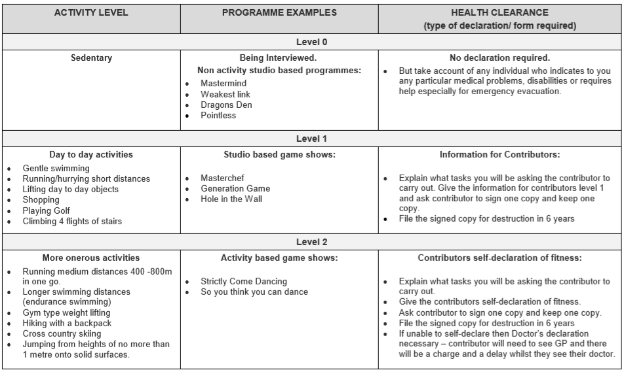
Please read the table below for further information on the fitness requirements for this production:


