Week 6 – Working Capital Management
  - Reference
Atrill, P., & McLaney, E. (2018). Chapter 12. Accounting and finance for non-specialists (10th ed., pp. 456–503). Pearson Education, Limited.

  - Exercise 1
What costs might a business incur as a result of holding too high a level of inventories?
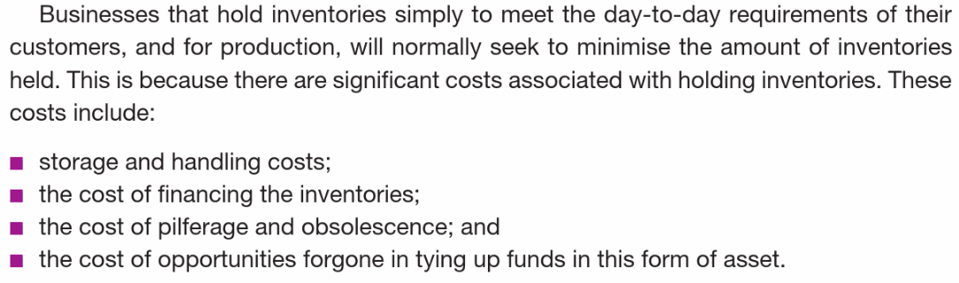

  - Exercise 2
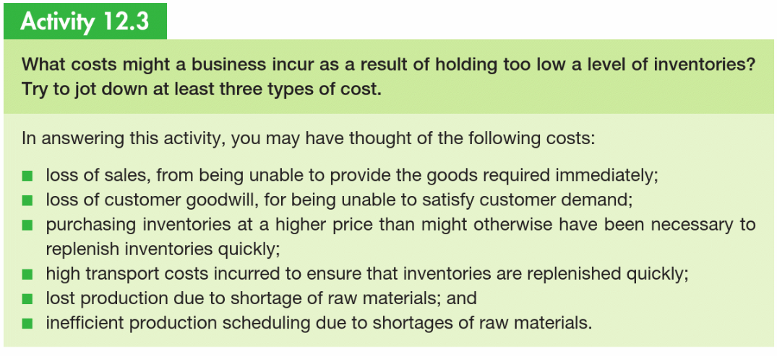

  - Exercise 3


