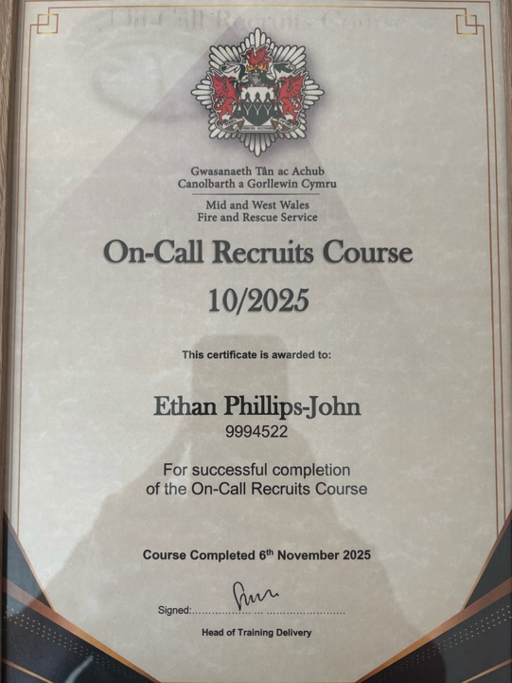
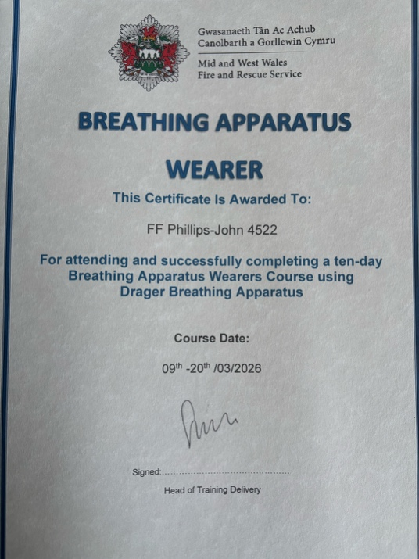
BMFR4001-Practical Placement
Ethan Phillips-John
2508897

The images here show my certificates for attending and completing my on-call initial course and my breathing apparatus wearer initial course. I have also attended and successfully passed a fire trauma initial course, but I don't have a certificate for it.

