DS 1 Template

My Screenshots/Photos
- Please add 4–6 screenshots or photos of your digital life.
- You can use your phone or laptop.
- For each screenshot, write one or two sentences explaining what it shows.

Screenshot/Photo 1
[Insert Photo/Screenshot below]
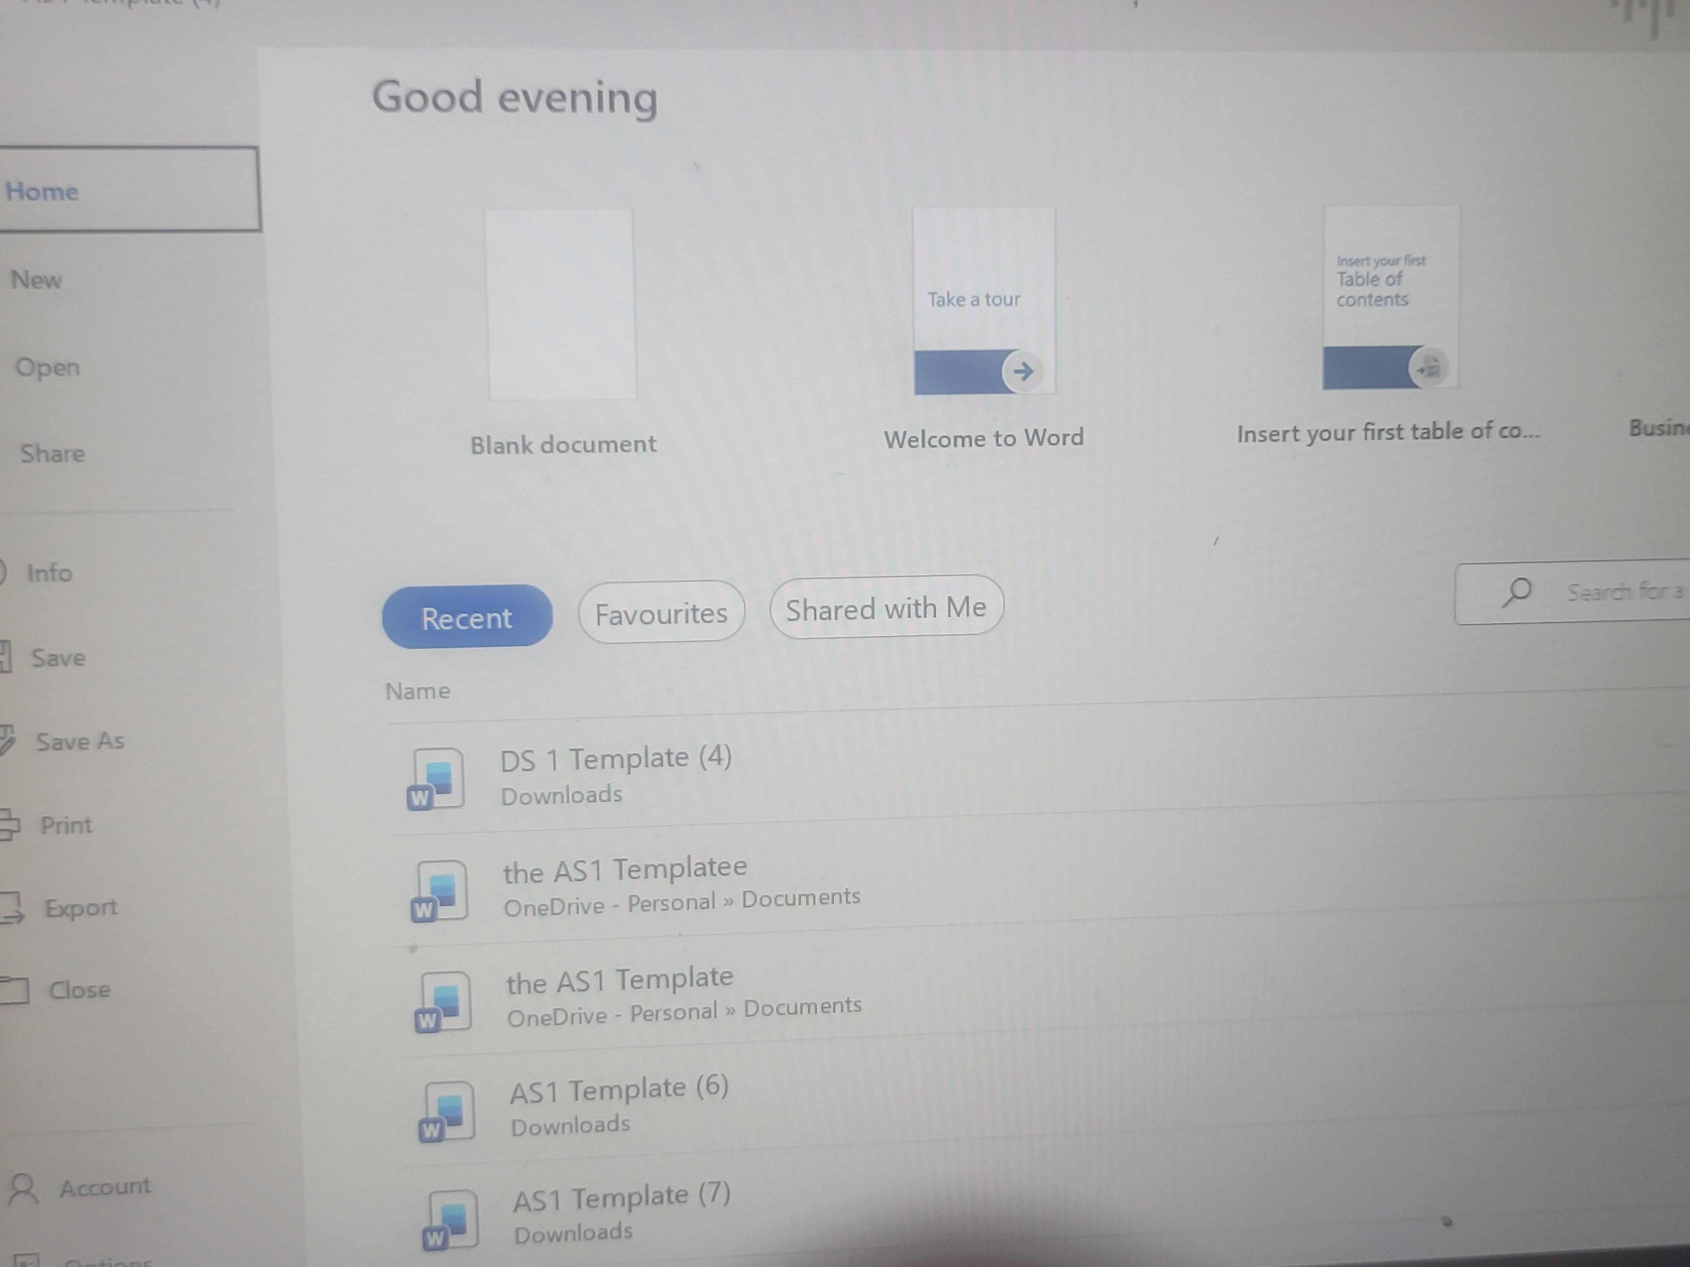
[Write what this shows of your digital life]
This image shows me utilising Microsoft word to create and download documents to complete assignments. I use word to organise information and complete or edit work.

Screenshot/Photo 2
[Insert Photo/Screenshot below]
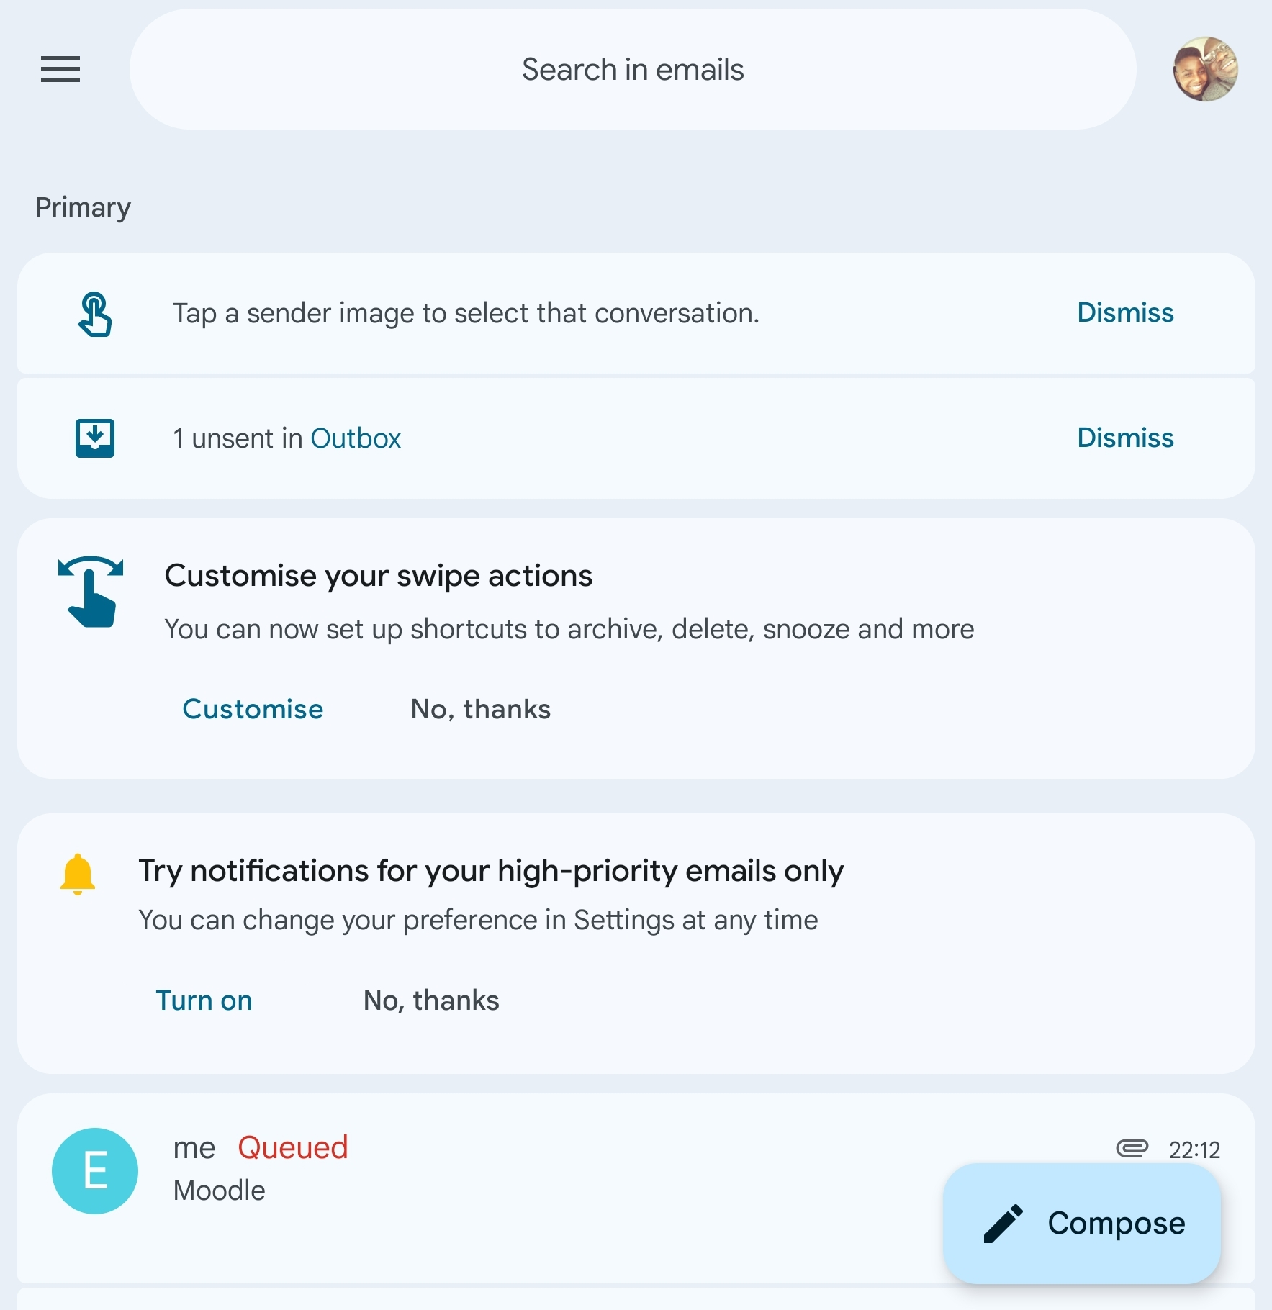
[Write what this shows of your digital life]
This screenshot shows my email that I use to talk with tutors, get important updates, and send assignments and documents when needed.

Screenshot/Photo 3
[Insert Photo/Screenshot below]
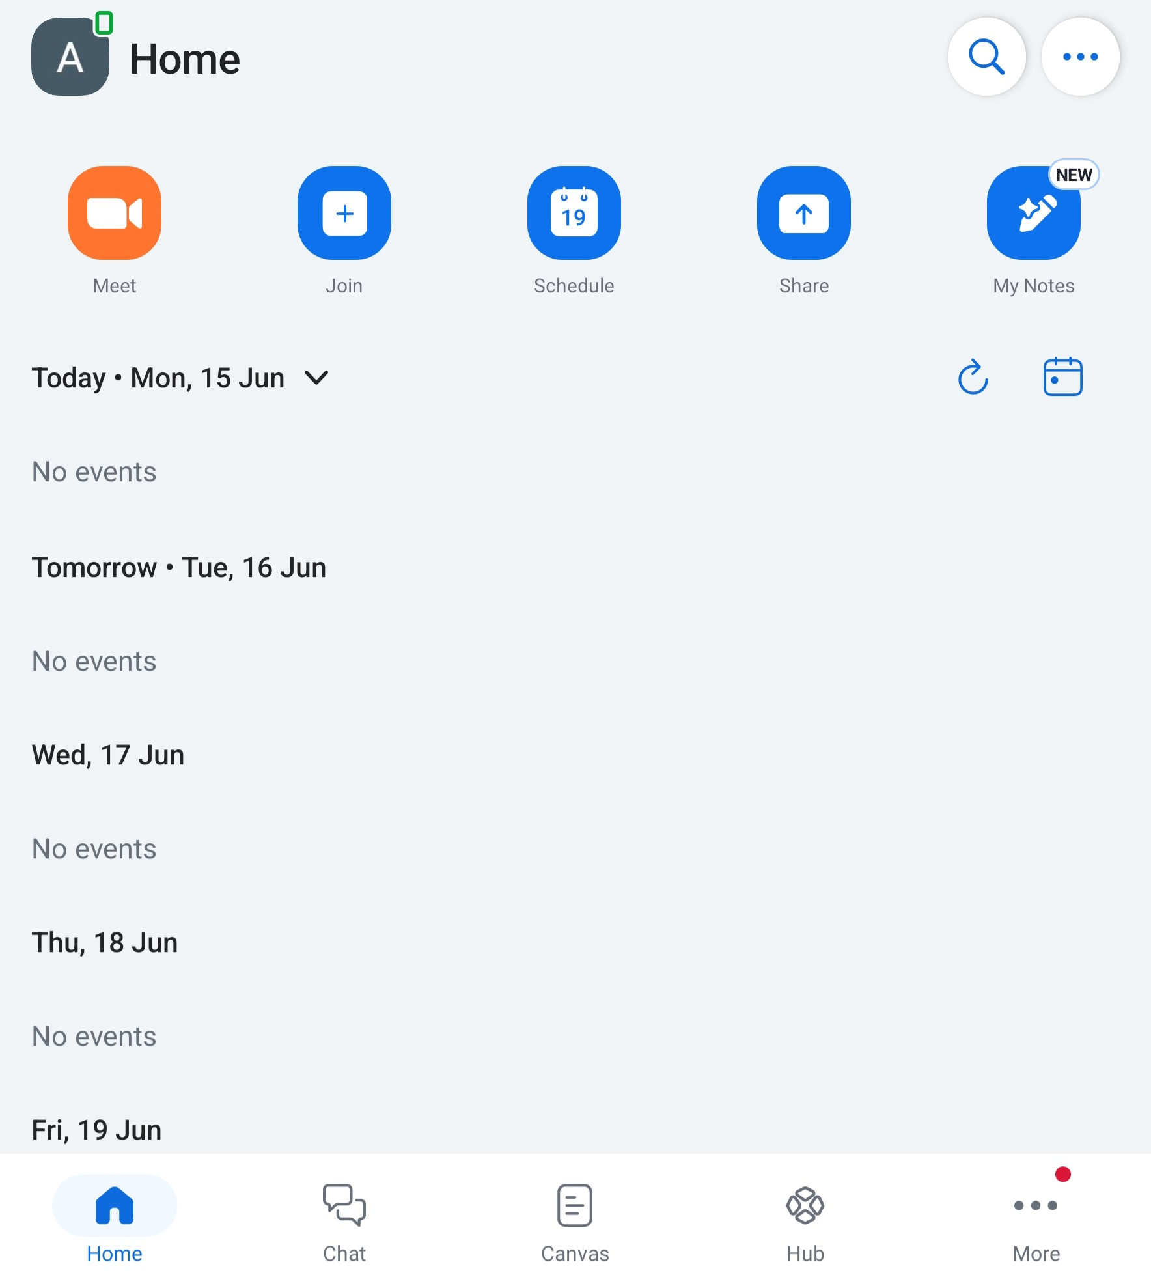
[Write what this shows of your digital life]
This screenshot is showing an online communication platform that I use for classes or group work. It helps with my digital life by allowing me to communicate and work with others remotely.

Screenshot/Photo 4
[Insert Photo/Screenshot below]
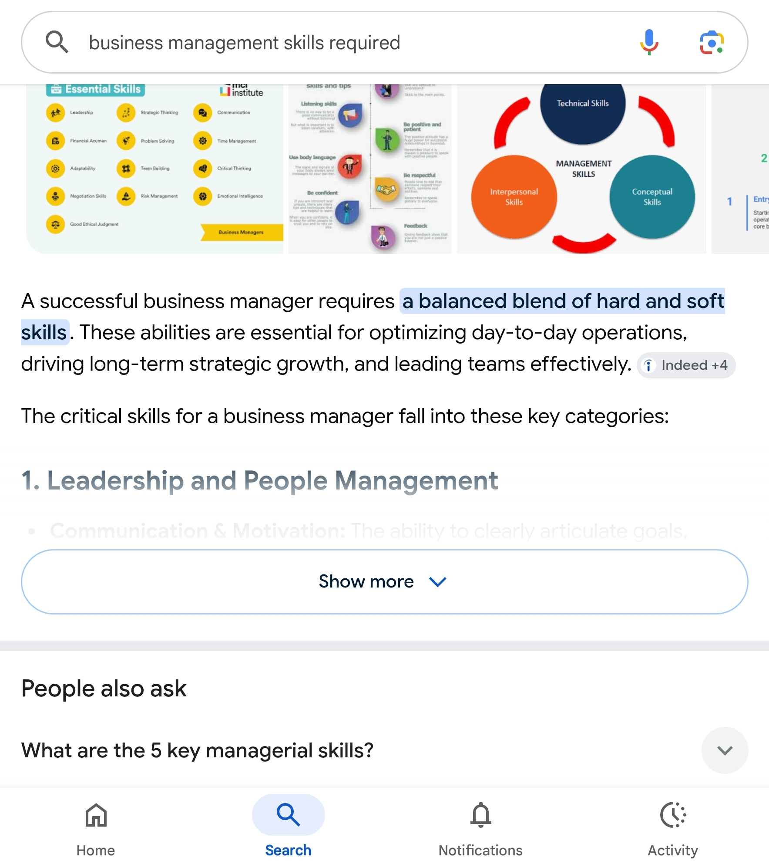
[Write what this shows of your digital life]
This photo is showing me using the internet to find out information for assignments. Online research helps me find trustworthy sources and learn new things.

Screenshot/Photo 5
[Insert Photo/Screenshot below]
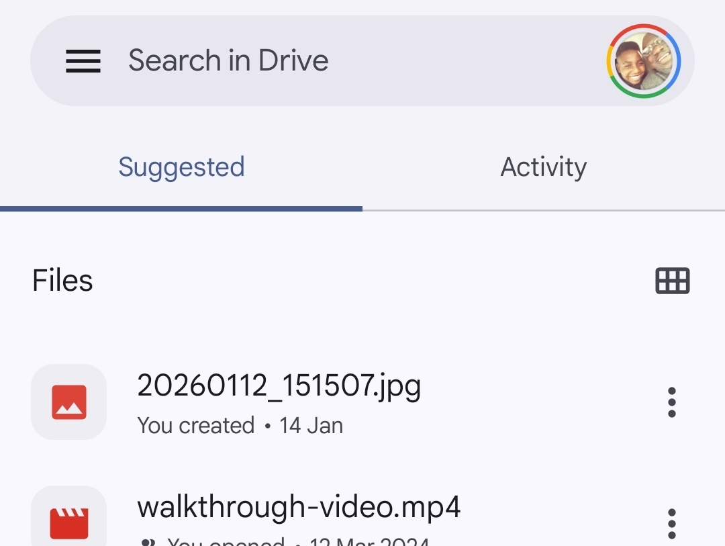
[Write what this shows of your digital life]
This photo is showing my google drive that I sometimes use to save and retrieve my files. It helps to keep my work organised and backed up over different devices.

Screenshot/Photo 6
[Insert Photo/Screenshot below]
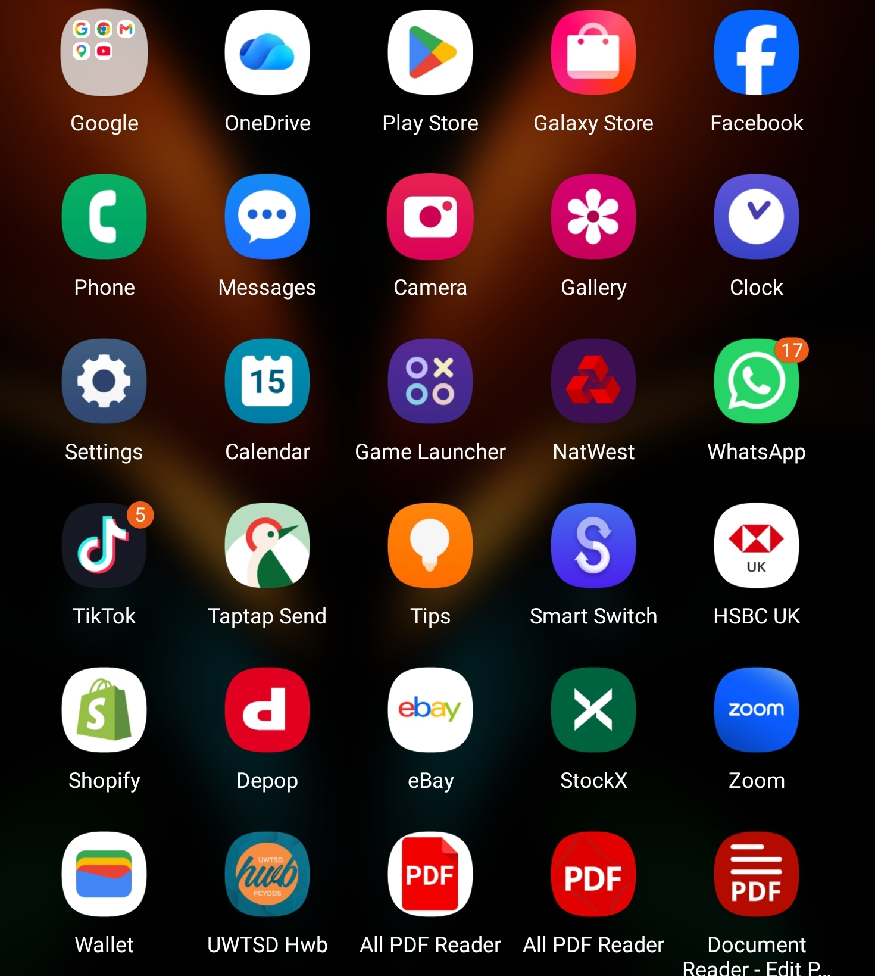
[Write what this shows of your digital life]
This screenshot is showing apps that I use regularly on my phone. Digital apps aid me in staying controlled and in order, communicating with others and managing my studies.

My Short Reflection
- Write 5–8 simple sentences about your digital life.
- You can use the sentence starters below if helpful.

Sentence starters
- I use digital tools to …
- I feel confident when I …
- I want to improve …
- I often use these tools: …
- I sometimes feel nervous about …
- I hope this module will help me …
- Digital skills are important for me because …
You can write more if you want.

Submission Checklist
Before you submit, please check:
​​​ ☐ I added 4–6 screenshots
☐ I wrote short sentences for each screenshot
☐ I wrote my short reflection
☐ My work is my own
☐ My file opens correctly
​​☐ My file opens correctly

