Full Business Plan - Moving Masala Financial Aspects
Katarzyna Kolowrocka 1805961

2019
BMSK4006 Newport

02.07.2019

Spis treści
1.0 Introduction 2
2.0 Financial Plan Section 2
2.1 Business expenses 2
2.2 Sales forecast 10
2.3 Income statement 11
2.4 The cash flow projection 12
3.0 Conclusion 13
4.0 References: 14

FINANCIAL ASPECTS OF THE BUSINESS PLAN
MOVING MASALA

Introduction
The researcher’s section of the presentation is the financial aspect of the food van business. The financial analysis shows, from the beginning of the plan period, how finances will be used to achieve success (Lamb, 2006).
It is difficult to know what realistic financial projections are when the business is from scratch. In order to allocate funds efficiently, it is important to analyse the target market and set clear financial goals. This paper suggest how to estimate expenditures, discusses sale forecast, income statement and cash flow.

2.0 Financial Plan Section
In the financial section of the business plan, four financial statements should be included (Cunningham et al, 2019, p 23):
- Business expenses
- Sale forecast
- Income statement
- Cash flow projection

2.1 Business expenses
There is distinction between types of cost: (Cunningham et al, 2019, p 63)
- Capital cost
- Fixed cost
- Direct cost
Capital costs - that is the total cost needed to bring a business to a commercially operable status.
There are many expenditure overhead. The biggest expenditure is in the purchase of a food truck, equipped with the required kitchen units. Based on internet sale offer, this vehicle can be purchased at the cost £19,500 (www.ncass.org.uk). The truck we are purchasing will come with a 3 year warranty on parts and labour. This will help us manage the risks of mechanical failure. Malcom Services, our overnight storage provider, has an on-site mechanic that will be routinely checking the truck for issues and make maintenance suggestions.
Based on a supplier cost quotation (www.booker.com) and website sources, MOVING MASALA can obtain additional equipment for £1,100 and will purchase initial food at a cost £1,100 .
All businesses are required to register the business prior to operating. Insurance, licenses and health and safety certificates are just a few of the areas that founders should consider. All the insurances and licenses need to be in place before the food van can open (Table 1).
Marketing promotion expenses for the grand opening of the MOVING MASALA in the amount of £1,290. This price includes flyer printing (2,000 flyers at £0.04 per copy) for the total amount of £80 and the cost for building and hosting a website- £600.
According to the researcher calculation the initial investment to run food truck business is approximately £26,000. Table 1 shows a list of the features required to start the business.

Table 1 Initial investment requirement
Required initial investment | Approximate Cost
Second hand food truck fully equipped (www.ncass.org.uk) | £19,500
Kitchen tools and equipment (Pots, Pans, and other cooking utensils)  (www.ncass.org.uk / www.booker.co.uk) | £1,300
Health and safety regulation items (fire safety equipment and first aid kits (www.ncass.org.uk) | £58
Diesel Generator with Long Run 30L Tank  www.sgs-engineering.com | £999.98
Catering BBQ (www.kdev.co.uk) | £ 450
Total Cost | £22,308
Initial food costs and inventory
Food products ( poultry, meat, veg, drinks, beverages, frying oil) first week | £1,100
napkins, plastic cups, food packaging materials (www.booker.co.uk) | £ 90
Uniforms (x5) | £100
Cleaning products (mop, detergents – www.booker.co.uk) | £65
Total cost | £1,355
Initial marketing cost
Web design and hosting (www.ncass.org.uk) | £600
Sign / posters/ menu board (www.ncass.org.uk) | £310
Flyer (2,000 flyers at £0.04 per copy - www.profitableventure.com) | £80
Other marketing activities | £800
Total Costs | £ 1, 800
Legal expenses
Professional service fees (legal consultant) | £0
Business registration fees 12 -on line, £40 -form (www.gov.uk) | £12
Legal expenses for obtaining licenses and permits prior the trading (Environmental Health department license and business license), permits (Fire department, Commercial kitchen, Commercial Vehicle Operator’s Registration for the truck, Health inspection Certificate, Air and water pollution control permit (www.profitableventure.com, www.ncass.org.uk) | £600
Online Food Hygiene Course  (www.ncass.org.uk) | £250
Gas safe (already in place) and Electrical certificates (www.global-compliance.co.uk/ www.newport.gov.uk | £120
Total Costs | £982
TOTAL required initial investment | £ 26, 445
Fixed costs are expenses that do not change with an increase or decrease in the number of sold goods (Cunningham et al, 2019, p 62). Based on internet research, can be determined that £134 per month to rent space at the Imperial Business Park and £50 covers parking costs (www.businessleader.co.uk). The insurance and road tax costs around £110 monthly. Marketing cost £120.

A considerable portion of the money will be spent on insurance. Insurance will protect the owners and the business against numerous problems, from broken equipment to liability lawsuits. Public liability insurance costs approximately £ 200 annually. Overall, recurring costs will be approximately £ 5,700 per month. The list of fix monthly expenses are included in table 2.

Table 2 Expected Monthly Expenses – fixed costs
Expected monthly outgoings | Anticipated Amount
Rental space at the Imperial Business Park in Newport  (www.businessleader.co.uk) | £134
Water cost ( based on domestic bill) | £55
Marketing /Website, social media hosting £10 -expertmarket.co.uk) /Promotions | £120
Commercial insurance (general insurance, health insurance, product liability insurance, business owner’s policy group insurance) www.ncassinsurance.co.uk  TAX | £180
Motor Vehicle Insurance, Comprehensive (VanCompare.com)  Road Tax  Petrol (www.businesswales.gov.wales)  MOT (£58 one cost – www.gov.uk) | £83  £16.70  £60
Salaries (Table 3) | £4,680
Vehicle parking storage (Malcom Services) | £50
Depreciation (table 4) | £366
Accountant fee | 0
Total Costs: | £5,744.70
Table 3 Basic Salary Calculation
Basic Salary calculation
Employee | Working hours per day (6 days a week) | Working hours per Month (26 days) | Wage/hour | Monthly salary
Owner 1 | 9 hours | 234 (include 12 hours for shopping, marketing) | £10 | £ 2,340
Owner 2 | 9 hours | 234 (include 12 hours for shopping, marketing) | £10 | £ 2,340
 |  |  | Total | £ 4, 680

Depreciation food truck, kitchen tools and equipment’s, electronic equipment’s they will lose their value over time. Therefore, researcher have set 20% depreciation value for these item Cunningham et al, 2019, p 62).
Table 4 Depreciation of assets
Depreciation a year
Food truck | £19,500
Kitchen equipment | £1,100
Generator | £1,000
Catering BBQ | £ 400
Total: | £22,000
Depreciation rate (Cunningham et al, 2019, p 62) | 20%
Depreciation amount | £ 4,400

Direct costs - those that go up and down with the level of sales (Marouli, Maroulis, 2015). These costs are included in table 5. Fuel for generator can cost around £180. Based on price quote from Euro Food and Booker suppliers, monthly costs of food and drinks would be around £4,200 dependant on sales. The vehicle maintenance, food loss (due to spoilage or unsold meals) and other invisible expenses should be factored into the finance projection this would cost the business approximately £180 per month.
Different rules apply for VAT depending on the type of food. When MOVING MASALA’s annual turnover excess of £81,000 sells hot food VAT at 20% need to be paid (www.ncass.org.uk).
Table 5 Expected Monthly Costs – direct costs.
Direct monthly costs | Expected Amount
Food (calculated accordingly to the sale forecast and prices from the Booker Wholesale and Euro food ) | £ 5,304
napkins, plastic cups, food packaging materials (www.booker.co.uk) (5p per container - nobleexpress.co.uk)  150 - average costumers a day) | £195
Diesel for generator | £180
Gas bottle - 2 a week £36,25 (flogas.co.uk) | £290
Vehicle maintenance and other unexpected expenditures | £80
Food waste | £60
Total Costs: | £6,194

2.2 Sales forecast
Sales forecasting is a process where businesses estimate their future sales based on historical sales data, economic trends, or market analysis. Sales forecasting is important because it allows the business to make decisions and predict performance. (Cunningham et al, 2019)
MOVING MASALA is a new business and does not have previous financial projections, therefore the financial plan is created based on:
- Market research - staff employed in the Imperial Business Park -1,000-1,600,
- Competitor research – Greggs
- Previous experience of running a cantina
- Assumptions
Sales data from the previous business establishment allow the researcher to make new sales forecast. Predicted figures are based on the assumptions therefore can increase or reduce while running the business.
MOVING MASALA will operate 26 days in a month and 12 months in a year. During winter, researcher predicts a drop in sales since people prefer to dine indoor. During the summer MOVING MASALA expects higher level of income since the BBQ will be in operation and attract more customers. Below table includes sale forecast, cost and price per item.
Table 6 Average sale forecast
Menu | Average daily sales  (unit) | Cost per item | Price per item
Good Morning Sandwich | 30 | 60p | £2.20
Masala Breakfast | 15 | 75 p | £3.50
Burgers/ Hot sandwiches | 15 | £1.30 | £3.40
Masala Hot Sandwich | 15 | £1.20 | £3.90
Baguettes | 12 | £1.10 | £2.80
Authentic curry | 22 | £1.40 | £6
Meal Deals (sandw + chips + drinks) | 15 | £1.70 | £6
Light snacks ( masala chips, samosas, bhajis) | 20 | 50 p | £2
Desserts (gulab jamun, gajar halwa cheesecake) gajar halwa sundae ) | 10 | 60 p | £2.50
cold drinks | 50 | 40 p | £1
Special Hot drinks ( karak chaii, garam chocolate) | 20 | 30 p | £ 1.60
Total | 154 +  70 drinks | £184 | £608

2.3 Income statement
The income statement is one of the four financial statements that need to be included in the financial section of the business plan (Cunningham et al, 2019). It shows business revenues, expenses, and profit for a particular period. Shows whether or not business is profitable. Revenue - Expenses = Profit/Loss.
Table 7 Sales revenue, Expenses, Profit/Loss
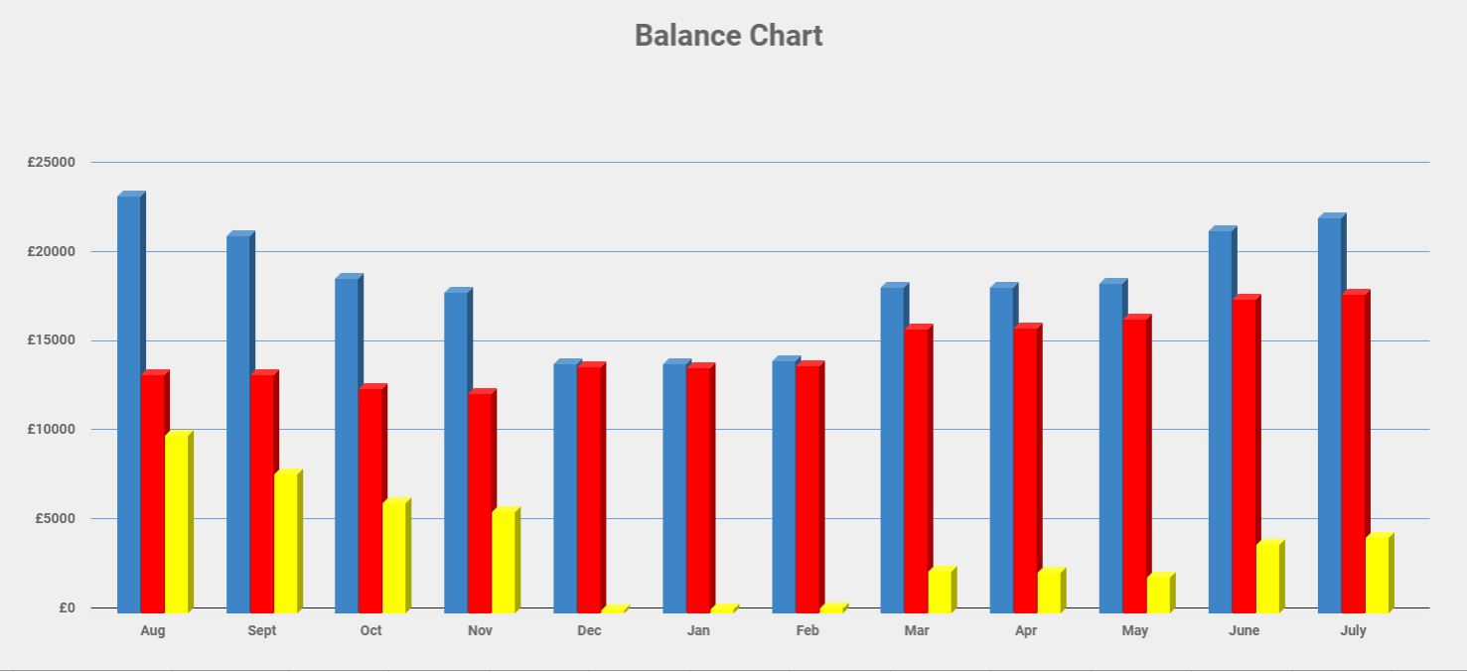
According to calculation, the projected profit is approximately £20,120 in annual sales by the end of the first year of opening. (£223,900 -£203,780=£20,120)

2.4 The cash flow projection
The cash flow projection is the last financial statement that need to be included in the financial section of the business plan.
The cash flow represents expected inflows and outflows that occurred within an accounting period and concern all the investments that the company has made. Primarily, these cash flows refer to cash received or paid for the acquisition or disposal of long term ( Kousenidis, 2006).

There are three parts to the cash flow projection:
- cash revenues (estimated sales figures for each month).
- cash disbursements ( the various expense categories for each month)
- the reconciliation of cash revenues to cash disbursements (an opening balance, which is the carryover from the previous month's operations. The current month's revenues are added to this balance; the current month's disbursements are subtracted, and the adjusted cash flow balance is carried over to the next month.)
Cash flow is shown in Appendix 1. Opening balance is 0 as £25,000 investment money and grant covers in total our Capital cost.

3.0 Conclusion

This financial plan makes use of the following assumptions:
(1) The founders are providing £50.000 equity investment in the business in cash to purchase fully equipped food truck with 3 year warranty.
(2) The food cost are an average of 28.9% of the product pricing.
(3) Sales have been adjusted for seasonality, including weather, holidays, and special events.
(4) Five of the founders will be working on MOVING MASALA full time in Year 1
(5) Ingredients and equipment will be supplied from Euro Food, Booker.
(6) Moving masala will not be using professional resources in the form of legal and accounting.

4.0 Appendix
Appendix 1 Cash flow
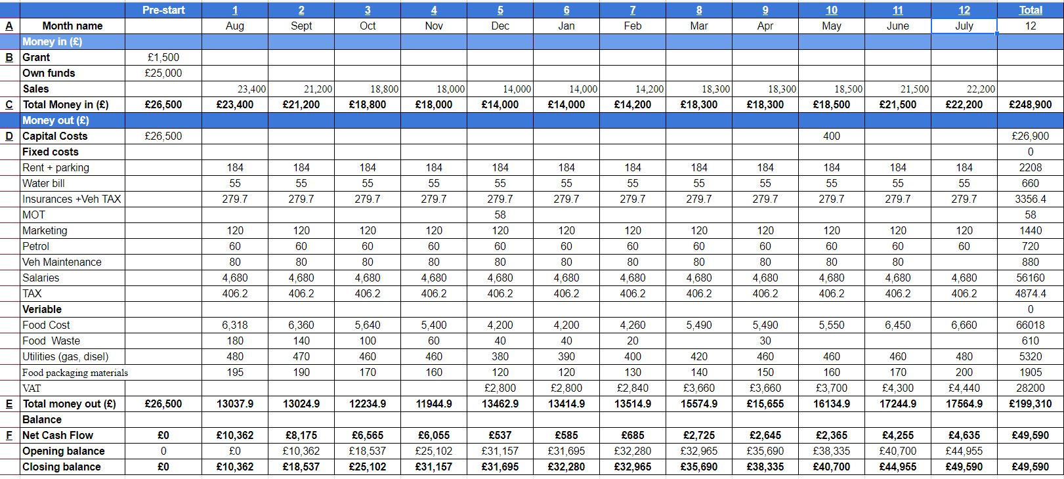

5.0 References:

Myrick, R., (2012), Running a Food Truck For Dummies, New Jersey: John Wileys & Sons, Inc Hoboken p 55
Cunningham, B., Nikolai, L. Bazley, J., Kavanagh, M., Simmons, S., (2019), Accounting: Information for Business Decisions, (3rd edition), Melbourne: CENGAGE
Baker, T. (2014). Restaurant benchmarking, Melbourne, CENGAGE
Lamb, S.,E., (2066), How to Write It: Business Plans and Reports, Vol. 53, Iss. 1, Columbia: Moore School of Business
Kousenidis, D., V., (2006) A free cash flow version of the cash flow statement, Vol. 32, Iss. 8 ,Patrington: Emerald Group Publishing Limited

https://www.sgs-engineering.com/generators/diesel accessed 16/06/2019
https://www.kdev.co.uk/proddetail.php?prod=zenith_4_catering_barbecue_grill accessed 16/06/2019
https://www.globalcompliance.co.uk/?gclid=CjwKCAjw9dboBRBUEiwA7Vrrzb0Ri9g0nz11_bio7WM3xZUriSMK3D_idHPw9l9FeDgEcQKen6SBSRoC2dIQAvD_BwE accessed 15/06/2019
https://www.ncass.org.uk/training-area/hygiene-safety-training accessed 13/06/2019
https://www.profitableventure.com/cost-start-food-truck-business/ accessed 16/06/2019
https://www.ncassinsurance.co.uk/mobile-catering/mobilers-insurance/ accessed 04/06/2019
https://www.ncass.org.uk/mobile-catering-home/content/get-legal/start-up-legal-checklist accessed 18/06/2019
https://www.ncass.org.uk/mobile-catering-home/content/starting-up/how-much-does-it-cost-to-start- accessed 18/06/2019
https://www.businessleader.co.uk/how-to-start-a-food-truck-business-start-up-and-running-costs/65973/ - accessed 18/06/2019
https://www.ncass.org.uk/mobile-catering-home/articles/vat-regulations-for-hot-and-cold-food accessed 18/06/2019
http://www.newport.gov.uk/en/Business/Food-safety/Starting-a-food-business.aspx accessed 18/06/2019

