I confirm that I have not used any AI tools in the research and creation of this assignment. I confirm that I have not presented any AI-generated materials as my own work. I confirm I have copies of my drafts, notes, and other resources I used, which I may be asked to provide in evidence.

Part 1- Article summary
“How music makes you feel”, written by Zoe Nendick in September 2022, discusses the link between music and emotion. Nendick (2022) states that music typically plays a significant part in most people's everyday lives, whether it is being intentionally chosen or heard in public establishments.
The author reminisces about her interest in the link between music and emotion started whilst she was studying music at A-Level. She continued to complete a degree in music, but it wasn’t until her final year that she immersed herself in the subject.
Nendick’s (2022) focuses on the effect music has on emotions and how it can differentiate between individuals, such as how one song can evoke different memories and emotions attached to it depending on their personal association. However, not everyone experiences a positive association with music; in fact, some incite anger and strong negative responses. Additionally, a minority of people have musical anhedonia, which is the inability to derive pleasure from music.
Nendick references Leonard Meyer's book on emotion and meaning in music (1956) as one of the most vital earlier pieces of evidence. Meyers proposed that we “feel emotions in response to the harmonic progressions of the music” (Meyer, L. (1956)).
Nendick states that music is powerful! And explores the ability to use music for therapeutic benefits. Major music can be effective in reducing stress compared to minor music (Suda et al, 2008). Additionally, Music can also help improve memory recall in those suffering from Alzheimer's disease (Fraile et al, 2019).
Nendick then discusses “BRECVEMA” framework (Juslin & Vastfjäll, 2008; Juslin,2013), which is an acronym for psychological mechanisms and how they have been theorised to develop progressively throughout the years.
The author discusses how technology has developed and altered how music is listened to. Purchasing CDs of preferred music is no longer necessary, instant access to music apps such as Spotify or Apple Music, which offer playlists that can be chosen on a specific mood. Additionally, these apps will automatically recommend /play tracks based on one track previously played.
The extensive reference list demonstrates that there was a considerable amount of research compiled for this article; however, some of the sources are outdated. Nendick did not conduct her own study to support the subject further alternatively relies on data and findings from previously published studies.

Part 2- Reference list
Davis, E.R. & Clarke, M.J. (2022). Modern marketing strategies. Business Books Publishing.
Department for Environment, Food and Rural Affairs (DEFRA). (2020). Uk climate change risk assessment 2020. UK Government. https://www.gov.uk/government/publications/uk-climate-change-risk assessment-2020
Lee, A. M. (2020). Cognitive development in early childhood. In Brown & L. Green (Eds). Child Development Theories. (45-67). Springer.
Garcia, M.T. (2022, March 5). Climate change impacts on coastal cities. The Global Times. https://globaltimes.com/climate/coastal-impact
Hoa, N.P. (2018). Blockchain technology in finance. In R. Singh & A. Cohen (Eds.), Innovations in financial technology (eBook). (122-139). Wiley Online Library.
Kim, S. H., Patel, R., & Wilson, J. D. (2021). Virtual reality in education: A meta-analysis. Educational Technology Research and Development. 69(2). 1105-1123. https://doi.org/10.1007/s11423-020-09834-7
Martinez, S.L. (2022, October 14). Advances in renewable energy storage. International Symposium on Sustainable Energy. Berlin, Germany.
Morgan, D.S. (2021). Machine learning applications in healthcare diagnostics. (Accession No. 12345678). [University of Edinburgh]. ProQuest Dissertations & Theses Global.
Nguyen, L. T., O’Connell, M.A., Li, J.S., Rivera, P. M., Adams, F. R., Chen, F. R., Jones, A. R., Walker, C. L., & Ahmed, S. E. (2022). Cognitive flexibility and executive function in early childhood. Journal of Experimental Psychology: General. 151(4). 789-805. https://doi.org/10.1037/xge0001223
NHS Greater London Trust. (2022). Annual patient satisfaction survey report. London, UK.
Patel, S.R. (2020). The rise of digital therapy. The Psychologist. 33(6). 48-53.
Reynolds, K.M. (2023). How mindfulness improves productivity. Mindful living. https://mindfulliving.com/how-mindfulness-improves-productivity
Smith, J.A. (2019). Understanding Psychology. (3rd ed). Academic Press.
Thompson, R.E. (2018). Social media effects on adolescent mental health. Journal of Adolescent Health. 62(4). 410-417. https://doi.org/10.1016/j.jadohealth.2017.11.290
U.S. Department of Education. (2017). National Education Technology Plan 2017. (ED-ICT-17-01). https://tech.ed.gov/netp
University of Oxford. (2022). Referencing and citation guide. https://www.ox.ac.uk/students/academic/referencing
Williams, J.L. (2020). Exploring sustainable urban development [Doctoral dissertation]. University of California. https://escholarship.org/uc/item/7gp4v2cd.
World Health Organisation. (2023). Mental health and COVID-19. https://www.who.int/mental_health/covid-19
Zhao, Ling. (2019). Enhancing user experience in mobile apps. Proceedings of the International Conference on Human-Computer Interaction. 102-110. ACM Press. https://doi.org/10.1145/3313831.3376310

Part 3-Essay plan- Discuss how trait theories of personality account of individual differences in behaviour
To start developing my essay plan, I am going to create a brainstorm with ideas on what to include in my essay plan and start to compile a reference list of information I believe is relevant. I will conduct the necessary research to help support me whilst planning my essay, and will ensure that my essay plan is clearly structured to make writing the essay as seamless as possible.
Brainstorm for an essay plan
- Introduction- What is trait theory?
- Main body- research and briefly describe 3 different models
- Conclusion- what have I learned throughout researching for the essay
- When was the first trait theory developed, and who by?

Introduction (200 words)
-Trait theories show differences in behaviour by suggesting that people differ based on their strength and intensity of fundamental personality traits, which have to be stable and consistent patterns of thought, feeling and behaviour. The first trait theory was proposed by Gordon Allport in 1936. Allport (1936) suggested the English language dictionary contained 4000+ words that could describe different personality traits. Other theories have then developed from this.

Main body (600-800 words)
Socio economic
-sees personality as a system containing traits, states, environments and biological factors. Suggests that the environment can affect the expression of DNA-coded information.
-Major issues traits can be long-term patterns in an individual, and the changes in the individual can cause changes in personality traits.
-Predicts that an individual's personal stability is genetic and can be affected by the environment.
Whole Trait Theory
-Whole trait theory can help provide a specific perspective on how personality can affect someone's daily behaviour
-The description of individual differences in behaviour and why those differences occur.
-Whole trait theory aims to be broken up into two separate compartments, those being a social cognitive approach and the trait approach
-assumptions: two parts of traits (explanatory and descriptive), explanatory output is behaviour or state, whereas descriptive is a causal consequence resulting from the explanatory part.
-Major theme is density distribution, which is state levels formed over time
-The major issue accounts for stability and variability.
Predicts that the density distribution model can allow dynamic processes via the characteristic part of traits, and the variety in density distributions can let the dynamic processes be the explanatory part.
THE BIG 5 / five-factor model
-John et al. (1991). Personality has 5 major traits. Openness, Conscientiousness, Extraversion, Agreeableness and Neuroticism. (can be memorised as OCEAN).
-Openness can be planned and practical in comparison to imaginative and impulsive. Conscientiousness can be impulsivity and disorganised compared to self-discipline and caution. Extraversion is shy and compassionate or confident and outgoing. Agreeableness is cautious and always anticipating a negative outcome, versus faith in humanity and a positive outlook. Neuroticism is placid and confident or anxious and pessimistic
- The higher levels of extraversion and neuroticism in an individual, the more likely they are to display negative emotional and psychological responses throughout life. (Ikizer et al.,2022). (Similar studies have been conducted and could be useful at gathering more information (Liu et al., 2021; Schmiedeberg & Thonnissen, 2021).
- Two main pieces of evidence for Big 5 include strong cross-questionnaire (Costa & McCrae, 2006) and cross-cultural replicability (Saucier,2009).
-Cattell (1965) and Eysenck (1947 & 1966) said to have too many or too few traits, which then resulted in “the big 5” theory. (Eysenck developed a model that originally had two traits (1947), consisting of Introversion/Extraversion, Neuroticism/ Emotional stability and later added Psychoticism (1966)). (Cattell condensed Allport's (1936) list from 4000 to 171, then used a sample group and reduced his list to 16 key personality traits).
Conclusion (200ish words)
-There have been a lot of different theories developed and a significant amount of analysis relating to trait theories of personality
-The first theory developed by Allport (1936) dates back 89 years
-Throughout my research, I have discovered that the whole trait theory and Big 5 theory/five-factor model can link together
Screenshots
On the University of Wales Trinity St David's Hwb page, I clicked the library tile and initially typed into the search bar “Discuss how trait theories of personality account of individual differences in behaviour”. This showed me the first article, “Whole trait theory: an integrative approach to examining personality structure and process. Personality and individual differences”. I deemed this a reliable source as it had a large reference list, suggesting that research had been conducted thoroughly. I then used other keywords in the library search to help find any other information that I needed, along with using Google for any information that I could not locate, which encouraged me to locate a reliable source, such as .org or .ac as opposed to .com.
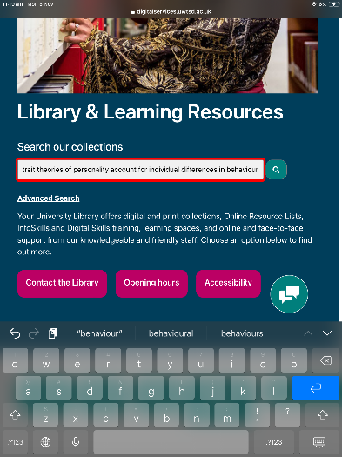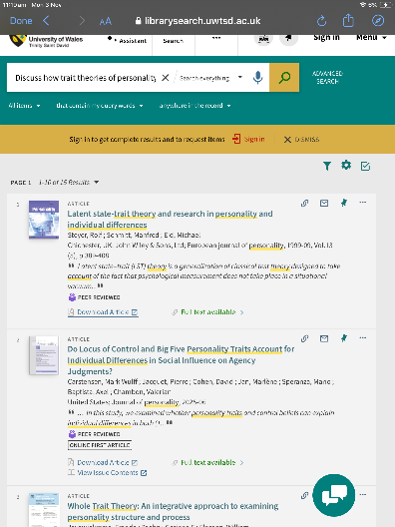
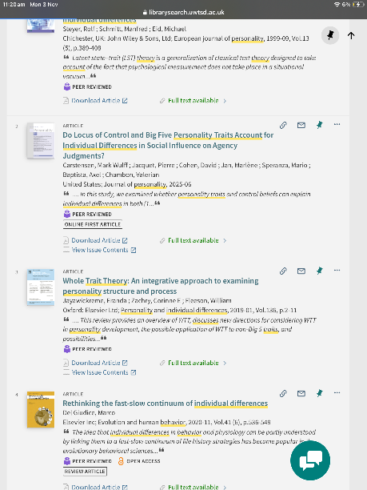

Reference list
Nendick, Z. (2022). How does music make you feel? The British Psychological Society.
Meyer, L. (1956). Emotion and Meaning in Music. University of Chicago Press.
Jayawickreme, E., Zachry, C. E., & Fleeson, W. (2019). Whole Trait Theory: An integrative approach to examining personality structure and process. Personality and Individual Differences. 136, 2–11. https://doi.org/10.1016/j.paid.2018.06.045
Chakraborty, S., & Sadachar, A. (2025). Applying reactance theory in exploring the relationship between the Big 5 personality traits and shopping intentions post-pandemic. International Journal of Fashion Design, Technology and Education, 18(3), 310–320. https://doi.org/10.1080/17543266.2024.2409889
Fleeson, W., & Jayawickreme, E. (2015). Whole Trait Theory. Journal of Research in Personality, 56, 82–92. https://doi.org/10.1016/j.jrp.2014.10.009
Lim, A. G. Y. (2025, March 20). Big Five Personality Traits: The 5-Factor Model Of Personality. Simply Psychology. Big 5 Personality Traits: The 5-Factor Model of Personality
Cherry, K. (2024, June 26). What the Trait Theory Says About Our Personality. Very Well Mind. The Trait Theory of Personality
McLeod, S. (2024, January 29). Theories of personality: Hans Eysenck, Gordon Allport & Raymond Cattell. Simply Psychology. Theories of Personality: Hans Eysenck, Cattell & Allport

