

Title of the Dissertation:
The effect of technology on public transportation in terms of increasing customer satisfaction

Student Name: MINODORA-VIOLETA DULUMAN
Student Number: 1919047
Module Name: DISSERTATION
Module Number: LCBB6000
Lecturer Name: Dr Mohammed Chowdhury

Table of Contents
Chapter 1: Introduction 3
Research Topic 3
Significance of the Research Topic 3
Purpose of the research 3
Research aim 3
Research objective 4
Research Questions 4
Chapter 2: Literature Review 5
Chapter 3: Research Methods and Methodology 6
Research Philosophy 6
Research Approach 7
Research methodology 8
Research strategy 8
Sampling methods 8
Data collection method 9
Data analysis 9
Research Time Horizon 9
Ethical Considerations 10
Chapter 4: Conclusion 10
Chapter 5: References and Bibliography 10

INTRODUCTION
Public transportation is a type of travel offered locally that enables more people to travel together along designated routes. Buses, trains, and trams are some examples of public transportation. High-speed airlines, rails, and coaches dominate public transportation between cities. With the growing prevalence of smart, connected transportation technology, the way people live, move, and interact with mass transit systems has fundamentally changed. Emerging technology in public transportation provides a potential solution for overburdened city and metro traffic systems as well as a safer, better rider experience (Hong, Choi, and Chae, 2020). The new and emerging technologies, such as artificial intelligence and high-performing 5G mobile routers, as well as the increasing availability of edge computing solutions, help transportation agencies meet their multiple goals. These advanced technologies help transportation agencies to simplify their infrastructure and manage their backhaul and on-board systems cost-effectively and seamlessly. By connecting IoT devices with transportation technology, smart cities can easily develop sophisticated data collection and processing systems that provide a better public transportation experience to customers. Current research is being conducted to analyse the impact of technology on public transportation and improve customer satisfaction. The current study is based on data from Transport for London, a local government body that is responsible for many aspects of the transport system in Greater London.

Research Aim and objectives

Research Aim:
To analyse the impact of technology on public transportation for improving customer satisfaction.

Research Objectives:
- To understand the concept of public transportation and customer satisfaction
- To determine the technology used by Transport for London to improve customer satisfaction
- To examine the impact of technology on Transport for London while improving their customer satisfaction

Research Questions

- What is the concept of public transportation and customer satisfaction?
- What are the technologies used by Transport for London to improve customer satisfaction?
- What is the impact of technology on Transport for London while improving their customer satisfaction?

4. LITERATURE REVIEW

4.1 Research Gap
With the help of this study, it will be easier to have the in-depth knowledge of public transportation and customer satisfaction. Also, the impact of the technology will also be outlined in relation to improve their customer satisfaction.

Concept of public transportation and customer satisfaction
According to the view of Mugion and Sebathu (2018) public transportation systems include trains, buses, trolleybuses, trams, ferries, or rapid transit that are easily available and use by the public as well as run on a scheduled timetable. Most of the public transportation is operated and funded by local government authorities. Basically, it is designed as an alternative method of automobile travel as well as help in reducing unnecessary walking time. These vehicles may work within a city or connect one city to other cities. There are many benefits can avail by the people through public transportation. It includes improving community health, economic benefits to the community, improving fuel efficiency, reducing air pollution, improving road congestion, improving community mobility and many more.
As per the view of customer satisfaction de Chardon (2019) refers as a measurement that determines how happy the customers are from company’s products, services, and capabilities. With the help of information regarding customer satisfaction can help company to determine the best way for improving their products and services. The focus of the company is to satisfy their customers. If the company wants to retain more customers as well as increase customer lifetime value, they need to keep their customer satisfaction high. Because customers do not hesitate to switch to a competitor that provide better quality product and services in reasonable prices including better customer service interactions.

Technology used by Transport for London to improve customer satisfaction
In the perspective of Fukuda (2020) there are numerous of technologies that can help public transport to adjusts themselves to a new era of travel behaviour. These technologies may help public transportation agencies to improve their overall system to provide better service to their customers. It will help in improving satisfaction towards public transportation. The technologies used by public transportation include Mobility- as- a-service, artificial intelligence, tackling data silos with the cloud, internet of things, real time decision making, better means of communication and many more. In today’s public transportation systems, customers purchase tickets for the mode of transport. But with the help of MaaS system, they can purchase tickets based on their destination as technology will find the best route, which is most efficient, cost effective, timely and safe. Artificial Intelligence can be used for smart route planning that help passengers and transport providers to select most efficient routes (Green, 2019). Cloud technology can help transportation agencies to store all their information, because it easily breaks down the silos as well as share information among different departments. IoT sensors can help public transportation to collect large amount of information about everything from the temperature of their trains to the usage levels of roads, or to the vehicles’ health or to the drivers’ stress level. Through this information, transport provider can improve their services as well as maintain proper safety and staff well-being.

Impact of technology on Transport for London while improving their customer satisfaction
In the perspective of Utriainen and Pöllänen (2018) there are positive impact of technology on public transportation while improving customer satisfaction. With the help of different innovative and new technologies, public transportation can provide accessible, intelligent, and cost-effective transportation services to their customers. Use of Artificial Intelligence for routing autonomous public transportation can help in reducing risk to human drivers, improves efficiency and safety as well as allow the coordinated rerouting of overlapping routes during emergency. Zero-emission busses can help in improving the public transportation system efficiency as well as reducing the carbon output. Smart traffic management enable centralised traffic control, allow transportation authorities to smartly manage traffic cameras, light, emergency routing as well as public transportation routes (Adnan and Ali, 2018). MaaS is also an effective technology for public transportation agencies that, can provide passenger app to their customers as it supports in mobile ticketing. With the help of advance technologies, public transportation can improve the passenger experience by providing better reliable service as well as responsible information updates about the availability, capacity, and service of transport.

5.RESEARCH METHODOLOGY
Research methodology is an important part of research because it allows readers to critically evaluate the reliability and validity of research. There are many methods and techniques are used by the researcher to conduct this research (Knottnerus and Tugwell, 2018). It is also defined as the whole process about the collection, evaluation analysis of data in a systematized manner. Furthermore, it is the set of various methods which are helpful in the process of performing in a better manner. As there are various techniques and features will be involved in the process of the data in a proper way. In relation to this study, this chapter of research methodology is considered as a main element.
5.1 Research Philosophy- It is described as the set of beliefs that concern about the nature of the reliability which will being investigated. It is divided in three parts that are defined as positivism, interpretivism and realism (Ndlovu-Gatsheni, 2019). In the current research, researcher will use realism research philosophy because it allows researcher to understand the social world in both objective and subjective manner.
5.2 Research Paradigm
The term research paradigm is explained as the framework which comprises the pattern of proper understanding in relation to the theories and various practises. It comprises of various that is ontology, epistemology, and research methodology. In relation to the present study the researcher will select the realism research. As it will help the researcher to have proper understanding about the social world in both objective and subjective manner.
5.3 Research Approach- The two important types of approaches are deductive and inductive approach. In the present research, researcher will use deductive approach as it helps researcher to develops the hypotheses based upon pre-existing theory and then formulated research approach to test it. This approach uses questionnaire to create understanding of observation that allows researcher to compare different understanding of the people through empirical data (Ullah and Rafiq, 2022). The researcher also inductive approach in this research also to generate new theory from the pre-existing data.
5.4 Methodology
The methodology comprehends the overall ways through which researcher intend to carry out their research. The main purpose of research methodology is to explain the reason behind the approach of the research that researcher will need to support their collection methods, methods of analysis as well as other key points of their work.
5.5 Research Design
It comprises of the information with the data in an organised way and there are various factors which are involved in the research design. Such as the accurate statement, timeline, analysis, setting for study and many more. In the existing research, the researcher will make use of mixed method as it will aid the researcher to combine both quantitative and qualitative methods.
Research Strategy- There are many types of strategies in research that are defined as survey, observation, case study, systematic literature review, focus group and many more. The researcher will use survey monkey and systematic literature review for collecting the relevant data in present research (Ledford and Gast, 2018). Survey monkey is one of the finest and economical strategies for research. It allows researcher to collect reliable and rich data related to the topic. Systematic literature review help researcher to gain insight, opinion and ideas of other authors related to the topic.
Research Choice- There are three outlined choices in the research that are defined as Mixed, Mono, and multi method. In the present research, researcher will use mixed method because it allows researcher to combine both quantitative and qualitative methods for creating a precise set of data. Quantitative and qualitative methods allow researcher to collect and analyse numerical and in-depth information related to the topic (Tayebi Abolhasani, 2019).
Time horizon- The time horizon refers as the required time for the completion of the research project. Two types of time horizons are specified within the research onion that are defined as cross sectional and longitudinal. In the current research, researcher will use cross sectional time horizon because it concerned with the study of a particular phenomenon at a specific time (Barnes, 2018).
5.6 Sampling- There are mainly two types of sampling methods in research that are defined as probability sampling and non-probability sampling. In this research, researcher will use probability sampling for selecting respondents randomly from the large population. Therefore, researcher will use simple random method for selecting 20 respondents for the current research. The selected respondents are the regular customers of Transport for London to gain accurate and reliable information for the research (Staron, 2020).
5.7 Data Collection- It refers to the process of collecting accurate data for the study. There are two important data collection method that are defined as primary and secondary data collection. In the present research, researcher will use both primary and secondary data collection for collecting a large set of data related to the topic. Primary data collection provides first-hand data through survey (Psomas, 2021). On the other hand, secondary data collection provides work or opinions of other researcher through books, journals, and scholarly articles.
5.8 Ways of interpreting data -There are many types of data analysis techniques that used for conducting research. These are frequency distribution, regression, thematic and correlation and many more. In this research, researcher will use SPSS software for analysing quantitative information. On the other hand, researcher will use thematic analysing for analysing raw collected information in the research through discussion (VanKooten, 2019).
5.9 Gantt Chart
The term Gantt Chart is defined as the graphical projection of the project which is known to support in the process of managing, scheduling, and monitoring specific tasks and resources in the project.

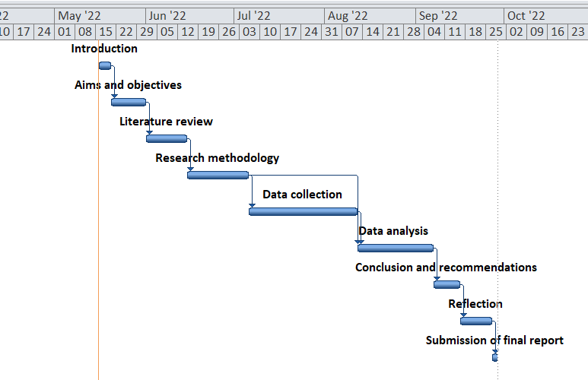
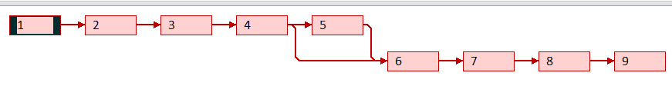

5.10 Statistical technique
Statistical techniques are known to be involved in the process of carrying out the study. It comprises of designing, planning, collecting the data, analysing, and bringing meaningful interpretation of the data. Due to which it will be easy to have the statistical analysis which provides meaning to the various numbers of the data.
6.Research ethics- It consist of the application of fundamental ethical principles to research activities. These principles govern how researcher should carry out their work. It is crucial to adhere the ethical principles for protecting the rights, dignity, and welfare of the participants in research. The ethical principle that are followed in the research are anonymity, confidentiality, voluntary participations, result communication as well as potential for harm (Coombes and Ryder, 2019).
7.Conclusion
From the above information, it can be outlined that due to the help of research methodology it was easy to carry out the research. As the main target of the research methodology was mainly to explain the overall reason behind research and its methods. In that process that researcher got the information about the collection methods, methods of analysis and the other key points of the work. Along with it, it was an important part of research as it allows the readers to favourably evaluate the overall reliability and validity of research. In addition to this, there are many methods and techniques which were utilised by the researcher to conduct the research.

REFERENCES
Books and Journals:
Hong, S.J., Choi, D. and Chae, J., 2020. Exploring different airport users’ service quality satisfaction between service providers and air travellers. Journal of Retailing and Consumer Services, 52, p.101917.
Tang, C.S. and Veelenturf, L.P., 2019. The strategic role of logistics in the industry 4.0 era. Transportation Research Part E: Logistics and Transportation Review, 129, pp.1-11.
Mugion, R.G. and Sebathu, S.P., 2018. Does the service quality of urban public transport enhance sustainable mobility? Journal of cleaner production, 174, pp.1566-1587.
de Chardon, C.M., 2019. The contradictions of bike-share benefits, purposes, and outcomes. Transportation research part A: policy and practice, 121, pp.401-419.
Fukuda, K., 2020. Science, technology, and innovation ecosystem transformation toward society 5.0. International journal of production economics, 220, p.107460.
Green, B., 2019. The smart enough city: putting technology in its place to reclaim our urban future. MIT Press.
Utriainen, R. and Pöllänen, M., 2018. Review on mobility as a service in scientific publications. Research in Transportation Business & Management, 27, pp.15-23.
Adnan, N. and Ali, M., 2018. How can trust drive forward the user acceptance to the technology? In-vehicle technology for autonomous vehicle. Transportation research part A: policy and practice, 118, pp.819-836.
Knottnerus, J.A. and Tugwell, P., 2018. Ethics of research methodology requires a methodology of research ethics. Journal of Clinical Epidemiology, 100, pp.-vi.
Ndlovu-Gatsheni, S.J., 2019. Provisional notes on decolonizing research methodology and undoing its dirty history. Journal of Developing Societies, 35(4), pp.481-492.
Ullah, A. and Rafiq, M., 2022. Education and learning about research methodology: Views of LIS authors in Pakistan. Information Development, 38(4), pp.688-703.
Ledford, J.R. and Gast, D.L. eds., 2018. Single case research methodology (p. 377). New York, NY: Routledge.
Tayebi Abolhasani, A., 2019. Introduction to research methodology: Standard procedures for qualitative data analysis. Science and Technology Policy Letters, 9(2), pp.67-96.
Barnes, B.R., 2018. Decolonising research methodologies: Opportunity and caution. South African Journal of Psychology, 48(3), pp.379-387.
Psomas, E., 2021. Future research methodologies of lean manufacturing: a systematic literature review. International Journal of Lean Six Sigma.
VanKooten, C., 2019. A research methodology of interdependence through video as method. Computers and Composition, 54, p.102514.
Staron, M., 2020. Action research as research methodology in software engineering. In Action Research in Software Engineering (pp. 15-36). Springer, Cham.
Coombes, J. and Ryder, C., 2019. Walking together to create harmony in research: A Murri woman’s approach to Indigenous research methodology. Qualitative Research in Organizations and Management: An International Journal.

