

Methods and Search Strategy Academic Poster

Student name: Eunice-Naomi Labou
Student ID: 2322368

Module name: Independent Project
Module code: BMHP6020

The Influence of Social Media on Body Image and Self-Esteem Among Young Adults in the UK
01 Introduction and Research Aim  This dissertation has a structured secondary literature review to investigate how social media affects body image as well as self-esteem amongst young adults in the UK. According to Snyder(2019),the analyst studies the existing evidence in secondary research and gaps. The purpose of this research is to critically examine the positive and negative psychological impacts of social media while also identifying ways to promote healthier digital use. | 02 Search Strategy  Searching is the art of constructing a methodology to identify relevant academic evidence via databases, keywords and selection criteria (Snyder, 2019). The study identifies four key databases for locating research: PubMed, PsycINFO, CINAHL and Google Scholar. Search terms may be combined with the Boolean operators AND and OR to increase relevance.
03 Searching for Information  The structured search process involves:  1. Identifying keywords: social media, body image, self-esteem and young adults. 2. Combining terms, for instance, ‘social media’ and ‘body dissatisfaction’. 3. Assessment of titles, abstracts and full texts against eligibility criteria 4. Listing the relevant studies in a literature tracking workbook. We give priority to works from the years 2016 to 2026, but are open to significant theoretical papers published before 2016. Structured Searching Enhances Openness and Consistency 1. A structured search process enhances transparency. In addition, a structured search process helps ensure consistent identification and selection of relevant evidence (Booth, Sutton and Papaioannou, 2016). 2. Evaluating the evidence, document and select sources for further analysis. Research primarily published between the years 2015 and 2025 was prioritized. | 04 Picture / Graph / Visual Aid / Statistics  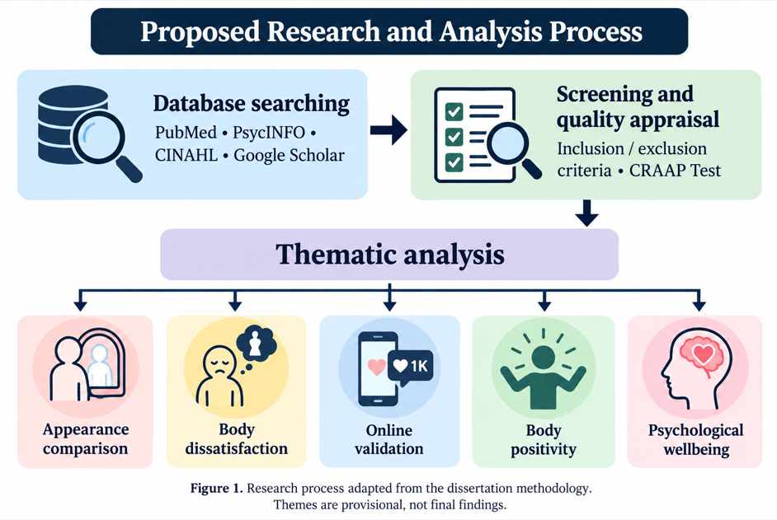
05 Research Validation and Analysis
Research validation means determining how credible, relevant and reliable published evidence is. This test checks currency, relevance, authority, accuracy and purpose (Blakeslee, 2004). While selecting sources is supported, attention must also be paid to methodological quality. Braun and Clarke (2006) argue that thematic analysis seeks patterns by familiarizing, coding, developing themes and interpretation. Results from studies will be reproduced by taking into consideration differences in populations, platforms and research designs.
06 Inclusion Criteria  Most of the research was published between 2016 and 2026. Studies involving young adults, aged preferably 18–25. Studies involving social media, self-esteem and body image. Publications which went through peer review and reports of reliable institutions. Evidence from UK or international sources. | 07 Exclusion Criteria  Outdated publications that are not relevant theoretically. Research focusing solely on children or elderly. Studies not related to appearance or mental effects. Websites without verification, opinion pieces, and claims are not supported. The evidence is either unavailable in English or irrelevant.
08 Ethical Considerations
Secondary research refers to the responsible use of evidence. Participants not being recruited and primary data not being collected. Ethical responsibilities include correct Harvard referencing, no plagiarism, recognition of research limitations and no unsupported cause claims. It is essential to ensure a research integrity, transparency and respect in reporting.

References
1. Blakeslee, S. (2004) ‘The CRAAP test’, LOEX Quarterly, 31(3), Article 4.
2. Braun, V. and Clarke, V. (2006) ‘Using thematic analysis in psychology’, Qualitative Research in Psychology, 3(2), pp. 77–101. Available at: https://doi.org/10.1191/1478088706qp063oa.
3. British Educational Research Association (BERA) (2018) Ethical Guidelines for Educational Research. 4th edn. London: BERA.
4. Creswell, J.W. and Creswell, J.D. (2018) Research Design: Qualitative, Quantitative, and Mixed Methods Approaches. 5th edn. Thousand Oaks, CA: SAGE Publications.
5. Fardouly, J. and Vartanian, L.R. (2016) ‘Social media and body image concerns: Current research and future directions’, Current Opinion in Psychology, 9, pp. 1–5. Available at: https://doi.org/10.1016/j.copsyc.2015.09.005.
6. Snyder, H. (2019) ‘Literature review as a research methodology: An overview and guidelines’, Journal of Business Research, 104, pp. 333–339. Available at: https://doi.org/10.1016/j.jbusres.2019.07.039.

