
Certificate for Higher Education Skills for the
Workplace

(weekend) Group 2
Lecturer name: Joanna Walsh
Module: BMSW4001
Student ID: Shenay Ulanova
Student number: 2121082

Content
- Introduction (p.1)
- Time management (p.2,3)
- Reflection (p.3.4)
- Paraphrasing (p.,5,6,7)
- References (p.6,7)
Introduction
With ACE we learn many important skills, how we teach ourselves more efficiently and how to present ourselves with academic knowledge. In my assignment I explain three of topic with Kolb reflective cycle.

Time management (TOPIC 1)
(Levin, 31/12/2007) Time management I heard for the first time in the Academic and Employability skills class and had interested me right away, because my reflection was: how I can manage the time, as it flies. Also, I want to absorb all knowledge like the sponge that absorbs the water. I learnt that managing time effectively is helpful to have success in my education process, also in my life, because according to Peter Levin Time management it’s a strategic thinking ahead, which includes knowledge on how to control my time effectively, without wasting time. When I don’t get organised and approach the day carelessly with many tasks, or compulsively take decisions I hinder our success. Levin strategy says: when you use time-use strategy, you can be a happy person and will have quality results, because an ambitious person can look critically ahead and organises his purposes to achieve it.
The lecturer explained to us how to apply Time management skills in our lives with the effective taught process of the Kolb cycle. At beginning It was difficult to make it, because I never do it, but according to the Kolb reflective cycle we learn from our experience and when we think carefully, we are able to assimilate the new skills and apply them. We considered Eisenhower quadrant in class on the first lesson and applied a personal frame with an Urgent/Not urgent and Important/Not important scheme, where I classified my daily tasks that showed me which task, I should focus on first, what it’s possible to do late and what I can delegate more time to.
(Levin, 31/12/2007) On the Skilful Time Management educational developer Peter Levin said when the student regularly plans his daily routine, they feel more confidence and have better results with high estimates. Another best point of view about time wasting of P. Levin is using travel time with reading a book or lesson notice.
(L&D, 2021;) In the final stage considered with learning, the Kolb cycle is an experimentation phase, where I apply the new knowledge in the experience about my education and try my personal theories in new or similar occurrences. According to David Kolb theory we enrich our individual skills and experience about successfully managing time and result in new concrete experiences. After all, life frequently gives us new challenges and we learn from our experimental cycle.
(Tony, n.d.) SMART is another helpful organisation skills in Time management, planning to achieve the goals in reasonable planning time, when the purposes are allocated in the right criteria with their specific needs: Specific-focused on a specific area where I want to develop; Measurable- track the progress through of the time, whatever we achieve the purposes.
Attainable- the purposes are achievable, when I have the necessary experience and knowledge to achieve the purposes in reasonable time, only I need to improve my topical habits. Relevant- the purposes take time- we should give the necessary time to achieve it. SMART tool is a useful key mostly at business purposes also is helpful in improving our personal life education and finance goals
In conclusion, I acquired skills about Time management from class discussion, University library and internet. At first it was difficult for me because I heard new things in different languages, which inspired me to first enrich my language skills. I realise Time planning is very helpful for me to complete my task and reduce stress, so I feel positive and more inspired.

Reflection (TOPIC 2)
(Cottrell, 2017-03-14) Reflection is a method of critical thinking used in professional and academic fields, to estimate our skill in a certain situation and how we appreciate new experience. Reflection thinking is helpful, when we have a challenging experience, it helps us to make the best decision and develop our skills, it helps us know ourselves, because critically thinking is purposeful at the end of a situation to develop our perception.
(L&D, 2021;) Theorist D. Kolb believed that the important ability to useful learning is our or foreign experience. An Effective education method according to Kolb is participation during education, he notes that the social experience comes with advantage.
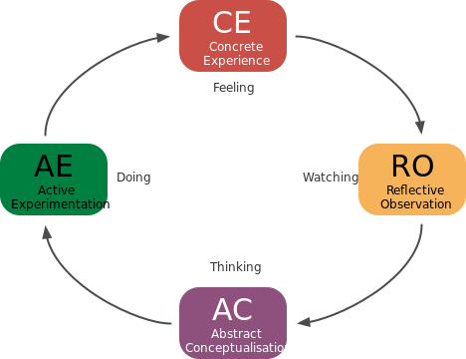
This Photo , CC BY-SA-NC
I reviewed my concrete experience with myself after academic writing because I was confused, how can I apply the new skills in my learning process because I was confused about the all-new information about structuring the sentences. According to Kolb, the learning cycle is an experimental and practical style of learning, everyone learns in different ways and reflective thinking is a chance to find my way for easy learning.
(L&D, 2021;) Second stage of reflective observation assumes we think to ask questions ourselves or such as lesson time, ask the lecturer for more information and exchange the knowledge between colleges. My reflective observation for academic writing experience was advancing to ask myself: how to achieve it? How to remember more information? What is working well and what will help me to do it? I categorised my skills from the lesson, which I saw at class and was difficult for me. I watched more videos about them, took notice and next day, I checked what I remember.
Thinking stages followed by abstract conceptualization is time to apply new knowledge, which allows us to see how they work with concrete experience and whatever we can apply to our last learned skills in future.
This all leads us to the last stage of active experimentation where I can apply new skills in different situations and how to associate in new experiences. An example from my experience about academic writing for me is when I apply my new language skills when I communicate with people.
(Malthouse) After 4years Graham Gibbs provided extensively strategy with six stages describes: situations → feelings (how I feel) → evaluations (classify what was good and bag) → analysis (evaluate what learnt from experience) → conclusion (rethink what I can change to do better) → action plan (how we will react again in the same event).
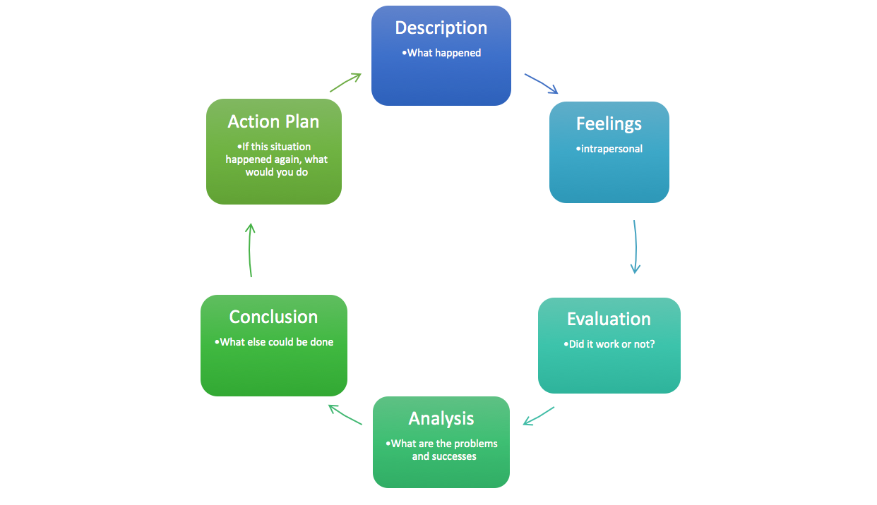
This Photo , CC BY-NC
In conclusion, reflective thinking is effectively improving myself, because now I see when I cease challenging myself, I immobilise my development. But when I analyse critically the experience and reconsider different perspectives, evaluate my goals for future and practise them, I realise, I develop from my experience.

Paraphrasing Topic 3
(Kletzien, 2009) Paraphrasing is a teaching technique as reflection, because it is experimental learning to educate the students how to understand and explain foreign information, and to enrich our vocabulary with more knowledge about grammar.
Sharon Kletzien described the paraphrasing strategy as encouraging the students to associate the prior skills with current reading information, according to Kintsch (1998) that helps to integrate the readers previous and new skills. Kletzien shared his experience from reading centre, where the readers with Roehler and Duffy (1984) methodology begin to teach how to paraphrase efficiently, as first important things we able to understand the meaning of the reading information, if we feel lost in the sense, rereading is helping to understand and remember what we read. The students in the reading centre began with short descriptions of the story and regularly they practised paraphrasing, after a few sessions they were able to paraphrase. Paraphrasing is learning tools which we, the students, use for completing our assignment, also it is useful from bloggers, publicists, and lecturers. Methodology of different explanations, which make the same sense for something read or heard from elsewhere, also the example of our paraphrasing mind should said with other different words and sentences. We discuss in class and consider the strategies on how we can paraphrase our mind successfully, such as avoiding plagiarism, because the key point of the paraphrasing is to abstain from using the foreign explanation of the information in our work.
At the beginning when we get a task to paraphrase some text, we think it is easy, but when I understood we should to be considerate to describe the text with our thought, to describe without using the same words for our expression. Then we understand the difficulties about efficient writing paraphrase and found ourselves in Kolb reflective cycle. But we are already adapting quickly to the challenges, and I know that I am learning from my experience, and I check my notice from lessons and look for additional information, which improves my skills and gives me more confidence. The lecturer explains helping methods to improve our writing with efficient paraphrasing, how it is important to explain the same things in another way, without changing the meaning of the sentences, key methods which I reinforced from AWEJ.
(Polat, Bajak & Zhumaeva, 2021)In AWEJ is described key point according Larson strategy for paraphrases we can use synonyms to exchange the word with another word, which make same sense or when we do not have synonym, we can replace with short definition, like example “without'' replace with “free from.” Another helpful type of paraphrase exchanges the specific sense with generic as not differentiate the significance of the phrase, like example “Labrador Retrievers” we can replace with “dog,” also generic with specific, like example: boots, canvas, trainers, we can exchange with shoes. Changing word form verbs to nouns that retain the same sense, like Paraphrasing-paraphrase, or exchange word arrangement like- Ana increased the clause– the clause extended by her. In AWEJ American polyglot Noam Chomsky provided another type of writing paraphrase with simplifying the sentences from active to passive or inversely, is good option because the verb changes the forms and the subject change the space, like example: (active) My sister cooks pancake every Saturday-> (passive) The pancake is cooks from my sister every Saturday.
(Polat, 2021, p. 7)Also, Larson (2012) recommended the students to wear a dictionary, because sometimes translation can divert our mind and change the meaning or make a wrong sense. To avoid da translation skewing when paraphrasing, lecturer advised us to use dictionary only for increase the vocabulary without using the translator for all phrases. According to Kolb reflective thinking I completed the task for paraphrase given from lecturer and then with my exam preparation I find myself again in new Kolb strategy, paraphrasing the read information and apply them with my explanations and thoughts, where I applied my knowledge, as I develop my process to paraphrase with more complex tools, like combine and divide the sentences.
Paraphrasing helps us to understand the information again, it is an experimental learning strategy for me. Phrase writing is progress for me where I understand deeper into the meaning than reading. In addition, improve my language skills, because my first language is different, and help me develop my vocabulary and grammar.

References

References Topic one
Peter Levin, Skilful time management,1936-2007; Open University Press
URL: https://r4.vlereader.com/Reader?ean=9780335234929
L&D, November 2, 2021, Learning Theory, Growth Engineering LMS,
URL: https://www.growthengineering.co.uk/kolb-experiential-learning-theory/
Team Tony, Tony Robbins, Career and business,
URL: https://www.tonyrobbins.com/career-business/the-6-steps-to-a-smart-goal/

References topic two
Jodi Roffey Barentsen & Richard Malthouse, Reflective Practice in Education and Training, SAGE Publications, 2013, January 05, 2017,
URL: https://sk-sagepub-com.ezproxy.uwtsd.ac.uk/books/reflective-practice-in-education-and-training-second-edition/i82.xml
Health care profession council, 08/04/2021,
URL: https://www.hcpc-uk.org/standards/meeting-our-standards/reflective-practice/what-is-reflection/

L&D, Learning Theory, November 2, 2021, Growth Engineering LMS,
URL: https://www.growthengineering.co.uk/kolb-experiential-learning-theory/
McLeod, 2013, updated 2017, Kolb's Learning Styles and Experiential Learning Cycle.,
URL: https://www.simplypsychology.org/learning-kolb.html
by Stella Cottrell; Critical Thinking Skills, Bloomsbury Publishing, 2017-03-14,
URL: https://ebookcentral.proquest.com/lib/trinity/reader.action?docID=6234915

References Topic three

Kletzien, Sharon B, 2009-09, Paraphrasing: An Effective Comprehension Strategy, Oxford, UK: Blackwell Publishing Ltd; Article of The Reading Teacher, Vol.63 (1), P.73-77.
URL:https://web-s-ebscohost-com.ezproxy.uwtsd.ac.uk/ehost/pdfviewer/pdfviewer?vid=0&sid=aca7fad5-60d3-4ea0-8113-148e05c64e45%40redis

Polat, Yahya, Bajak, Satylmysh, Zhumaeva, Ainuska, 2021-06-15, A New Approach for Paraphrasing and Rewording a Challenging Text, Arab World English Journal, Vol.12 (2), p.158-168
URL:https://web-p-ebscohost-com.ezproxy.uwtsd.ac.uk/ehost/pdfviewer/pdfviewer?vid=0&sid=3084f2c8-2f3e-4d3e-859f-77e11084f00e%40redis

