Module Name: Foreign Languages and Cultural Awareness
Module Leader: Lisa Bassler
Presentation & Recording
Student Name: Tatiana Raileanu
Student ID: 2211942
Запись-20231027_202055.webm

Presentation
Slide 3
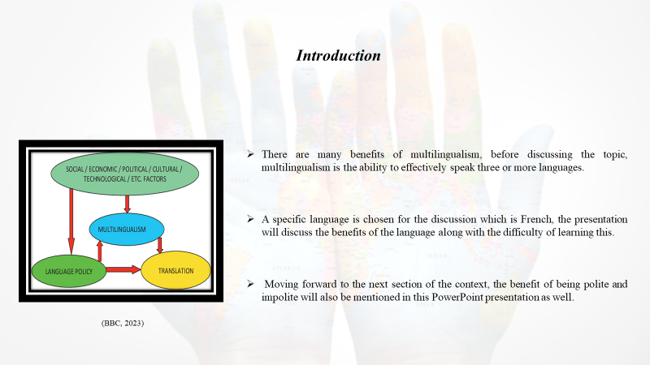
Notes

Introduction
There are many benefits of multilingualism, before discussing the topic, multilingualism is the ability to effectively speak three or more languages at the same time. The following presentation will focus on the benefits of multilingualism in detail. A specific language is chosen for the discussion which is French, the presentation will discuss the benefits of the language along with the difficulty of learning this. Moving forward to the next section of the context, the benefit of being polite and impolite will also be mentioned in this PowerPoint presentation as well.
Slide 4
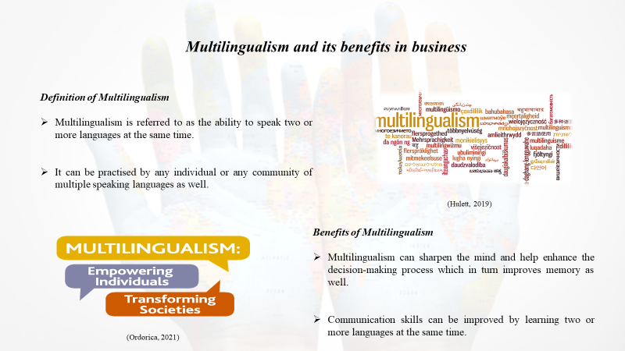
Notes

Multilingualism and its benefits in business
Definition of Multilingualism
Multilingualism is referred to as the ability to speak two or more languages at the same time. It can be practised by any individual or any community of multiple speaking languages as well. This type of speaker can maintain at least one language from their childhood which is denoted as their first language as well. Moreover, multilingualism is referred to as a common phenomenon that has received much scholarly attention in the past few years (Ordorica, 2021).
Benefits of Multilingualism
There are many benefits of multilingualism in the business aspect, which is going to be discussed. Multilingualism can sharpen the mind and help enhance the decision-making process which in turn improves memory as well. Communication skills can be improved by learning two or more languages at the same time. This can make the barriers and help in building bridges with international clients as well as partners. Career opportunities can be improved after learning multiple languages by any businessman (Hulett, 2019).
Slide 5
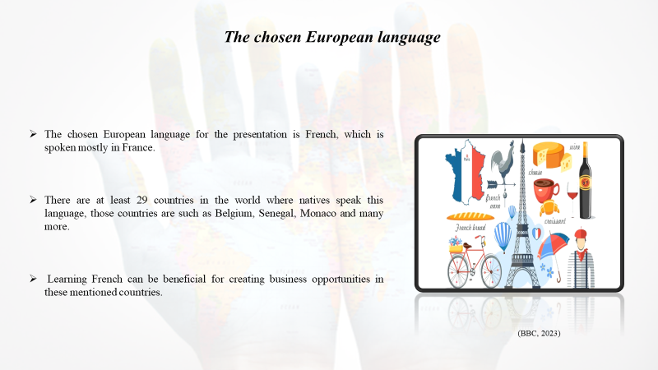
Notes

The chosen European language
The chosen European language for the presentation is French, which is spoken mostly in France. There are at least 29 countries in the world where natives speak this language, those countries are such as Belgium, Switzerland, Canada, Senegal, Monaco and many more. Learning French can be beneficial for creating business opportunities in these mentioned countries.
Slide 6
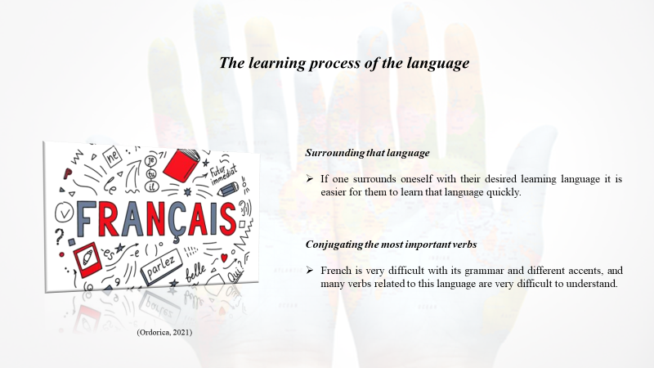
Notes

The learning process of the language
FSI or the Foreign Service Institute has listed French as one of the easiest languages for native English speakers. However, it is difficult to master in a very short period as it is a difficult language having many different accents and grammatical rules. There is a huge learning process in speaking French properly (BBC, 2023).
Surrounding that language
Studying French can involve learning proper grammar using applications, software and books. If one surrounds oneself with their desired learning language it is easier for them to learn that language quickly.
Conjugating the most important verbs
French is very difficult with its grammar and different accents, and many verbs related to this language are very difficult to understand. Using common expressions can help the learner to overcome that situation as well. Expertise hand can be very beneficial for learning anything easily, it can guide the learner properly.
Slide 7
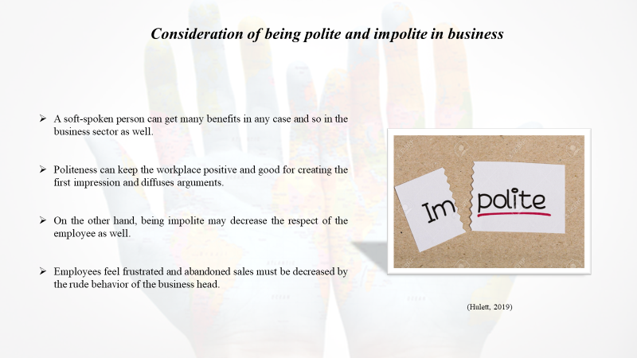
Notes

Consideration of being polite and impolite in business
A soft-spoken person can get many benefits in any case and so in the business sector as well, for instance, if an owner of any company acts politely they can instantly get respect from their employees. Politeness can keep the workplace positive and good for creating the first impression and diffuses arguments. On the other hand, being impolite may decrease the respect of the employee as well. Employees feel frustrated and abandoned sales must be decreased by the rude behavior of the business head.
Slide 8
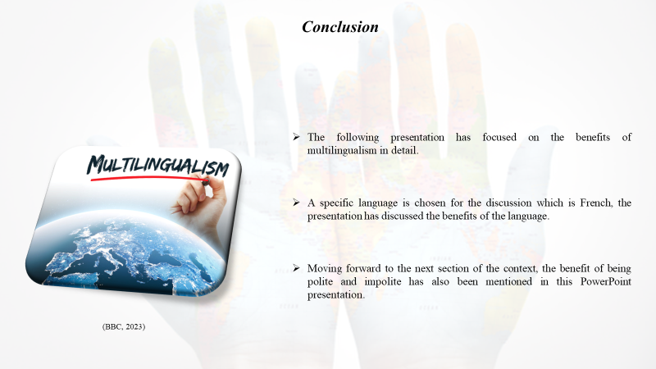
Notes

Conclusion
The following presentation has focused on the benefits of multilingualism in detail. A specific language is chosen for the discussion which is French, the presentation has discussed the benefits of the language along with the difficulty of learning this. Moving forward to the next section of the context, the benefit of being polite and impolite has also been mentioned in this PowerPoint presentation.

References
BBC, (2023). Language. [Online] Available at: https://www.bbc.co.uk/languages/learn/index.shtml#:~:text=There's%20no%20single%20universal%20foolproof,longer%20session%20once%20a%20week. [Accessed 11 October 2023].
Hulett, M., (2019). How The Power Of Language Can Grow Your Career And Business. [Online] Available at: https://forbes.com/sites/forbestechcouncil/2019/07/02/how-the-power-of-language-can-grow-your-career-and-business/?sh=1d25437270b9 [Accessed 11 October 2023].
Ordorica, S., (2021). Bilingual Organizations: The Leaders Of Global Expansion. [Online] Available at: https://www.forbes.com/sites/forbesbusinesscouncil/2021/03/23/expanding-your-business-to-a-bilingual-organization/?sh=70684bfc4f88 [Accessed 11 October 2023].

