Name: Rowshon Akter
ID Number: 1606038

Module Tile: Knowledge and Information Management Skills for the Workplace
BMSK5006
Assignment Title: Assignment 1

Lecturer’s Name: Tanja Nathan

Contents
Introduction 3
Importance of Knowledge Management 3
Relationship Between Data, Information and Knowledge 3
Individual Knowledge and Organisational Knowledge 4
Analysis for identifying Knowledge Assets 4
Evaluating actual and potential knowledge 5
The importance of creating, storing, applying and integrating knowledge 6
The benefits of having intellectual property laws 8
How do knowledge assets help make an organisation more successful 8
Knowledge management needs and application at my work 9
Bibliography 11

Introduction
In todays economy knowledge is the primary driver of growth. It is therefore important to recognise where useful knowledge is, capture it and make it available to the people who need it to carry out business activities. (Herman, 2003)
In this module we studied how knowledge is used in organisations, we studied topics such as the meaning of data, relationship between different types of knowledge, knowledge management processes, among other ways to organise and use information.
In this report I will discuss these methods while responding to the questions in the assessment guide.

Importance of Knowledge Management

Relationship Between Data, Information and Knowledge
The normal path for information is to go from data to information and then knowledge. This is generally a linear process. For example a school going child will learn that grass uses sunlight to grow, this is data in a very simple form. When the child analyses that grass needs sunlight to grow and concludes that without sunlight the grass would not grow, this would be information. (Christian, 2005)
The critical relation between data and information is that data by itself is not worth much to anyone. We can read through Wikipedia for hours and acquire lots of data, but chances it would be mostly irrelevant for anything we do. Information is the next step when data is analysed and put into a meaningful and useful context, when data presents some uses.
The next step in this chain is knowledge. Following with our grass example, knowledge would be being able to figure out that plants similarly to grass should not left in the shade otherwise they will not be able to grow healthy.
Although not asked for in the brief, this chain has one further step, wisdom. This is the ultimate stage of information. The raw facts were collected, put into perspective and given use, used to figure out other topics related to that data. This leads to ultimately being able to ask the question why yes or why not to this specific case of grass and to other related matters. In this context, wisdom would be asking why or why not allow sunlight on the grass, what do each of those options do for the user?
This hierarchy is often presented as a pyramid, with the data at the bottom and wisdom at the top.
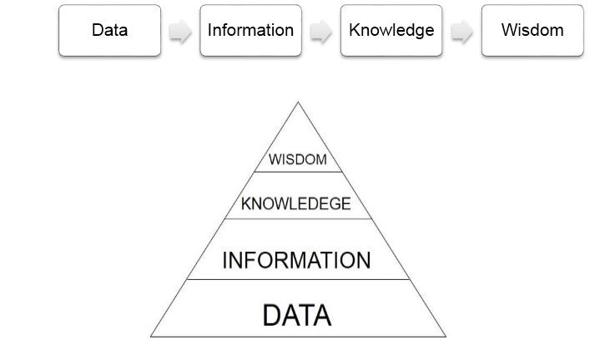
DIKW diagram pyramid (Navoni, 2018)
In the pyramid, generally data flows upwards. However, at time it can be critically analysed at the knowledge level and lead to more data being found. (Maeno, 2017)

Individual Knowledge and Organisational Knowledge
In a business information can be stored in many different ways. For example information can be stored within the individual staff members, it can be stored in handbooks that the company uses to train new employees, it can stored in the processes that are used every day.
For now we will focus on the individual knowledge. This is the knowledge within each staff member, often it is not freely available with the rest of the company. For example, a new employee joining a company may know some detailed processes from his previous job and as he joins the company this knowledge will be exclusive to himself. Another example of this could be a fresh graduate joining and brining with him the most up to date knowledge from academia, again as he joins the company only he is likely to have access to it. (Davenport, 2001)
The benefit of this kind of knowledge is that it is super easy for the person in charge to access it and often the knowledge that people trust the most. However, there are also pitfalls with basing ones work only on individual knowledge, there is not external review process. If that person holds on to some information and it is wrong, there will be no way for them to properly check it accuracy.
Now for organisational knowledge. This is the knowledge stored within the structure of the organisation. As mentioned, it can written down or knowledge that is common place through the training process. For example, this can something like a dress code: knowing to wear a shirt, even though its not written down. Or, having written down in a manual how to access and use a specialist software.
The organisational knowledge is more likely to criticized by others and thus is more likely to be more correct than individual knowledge. When basing decisions off of organisational knowledge, they can reference it to well documented protocols guides and avoid the chances of their work being questioned. (A.Noeb, 2010)
In a real business environment one would complement and improve the other. Specialist individual knowledge would in time be taught to the other staff and become part of the organisational knowledge. Individuals would also take chapters of organisational knowledge and with experience develop their own interpretations of it and use it update their existing individual knowledge.

Analysis for identifying Knowledge Assets
Knowledge exists within an organisation in many different ways, as described in this report, it can be within the employees accumulated experience, it can be in the data bases the company has, it can be in the day to day policies that every one follows. But sometimes it can be difficult to spot it, some times it can be so basic or used to so rarely that the organisation doesn’t see a particular knowledge asset clearly.
The best way to counter this is carry out a knowledge mapping activity. A knowledge map is more of a diagram that connects all the available knowledge within an organisation and points out where this knowledge is available. It assesses the interconnectivity between different knowledge assets and it can also be used to find the limitations of any knowledge assets. (Stephendale, 2017)
The list of things that are analysed during a knowledge mapping exercise include the ideas that float around the organisation, the employees them selves with the senior or more qualified employees taking a more prominent position in the map, all the different skill sets available in the organisation (the skill sets would also be mapped to their corresponding person), written out knowledge such as guide books or instruction manuals for protocols within the company which are considered explicit knowledge assets would also be mapped and the mapping might also make an attempt at mapping implicit knowledge assets such as specialized knowledge that some employees might have in their memory but which is not possible to materialize.
During the mapping exercise, as the knowledge assets are identified and catalogued it can also help reveal gaps in the knowledge map. For example it can be found that an organisation is reliant on some specialized machinery and that the department responsible has abundant employees trained in using it but they lack the ability to fix the machine should something go wrong. The knowledge to repair and maintain that equipment would be knowledge gap in that organisation. (Salmons, 2017)
In large companies mapping the full extent of their knowledge assets can be very difficult task. For example, if Microsoft tried to map the full amount of knowledge available in that company, it would take years or more to get the map completed. For this reason, despite being time consuming, during my research I found that it would be a better option to train the employees to map the knowledge assets they find in small bits as their work day goes on. Now days, their findings could be easily integrated with the organisation using software systems.

Evaluating actual and potential knowledge
There are many forms that knowledge assets can take, as discussed in the previous sections they can within people or written out clearly in books or they can locked within data bases. But two characteristics that all knowledge assets have is how they are perceived by the end user.
The benefits that a particular knowledge asset bring to an organisation or an employee are for some very clear. Lets take a few examples of this, knowledge on how to use the internet and do a quick and efficient google search for something you are writing a report on, knowledge on how to appropriate use the wireless printer at work to print that report so you can show it at a meeting, knowledge of using calendar and organiser softwares to keep track of time so you aren’t late for the meeting. These are some basic forms of knowledge, but these bring a clear benefit to the employee and thus the organisation. (Kisling, 1998)
Some organisation have such basic knowledge written down in detail in training documents or tutorials for new employees.
This adds a clear benefits, is recognised by everyone, it is knowledge that actually and visibly helps the organisation.
On the other hand there are knowledge assets within an organisation that although have the potential to be useful some day. This is not seen as being so useful by everyone at the organisation. Lets say someone at an organisation can speak both English and Hindi fluently. Most people would agree that being able to speak another language is a very beneficial skill however if the organisation does not work in translation or interpreting services or it doesn’t have any clients who speak Hindi, the skills although a nice to have will not add any immediate value to the organisation. However again, if in the future the company does do any such activity or develop business in India, the Hindi speaking employee will become a valuable asset. (Wei, 2008)
This is a basic example of knowledge that is existing within an organisation but it at the immediate present, it does not add any value to the company.
My view is that when a manager is presented with potential knowledge, she should consider retaining that knowledge within the organisation for possible use in the future. In the case used previously, retaining the ability to speak two languages is something the employee is likely to do anyway, specially if he speaks Hindi during his off work time. Retaining the knowledge adds no cost in this example. When retaining potential knowledge adds no additional cost to knowledge management system, it should be retained.

The importance of creating, storing, applying and integrating knowledge
Knowledge assets are created from various sources. In the previous sections we discussed many of these. A brief recap of them include the employees themselves through their accumulated experience, guide books and manuals that are used in the organisation, databases that are available or created by the organisation, etc. (Subramani, 2000)
The following figure provides an easy to absorb idea of what the knowledge management life cycle is at a glance.
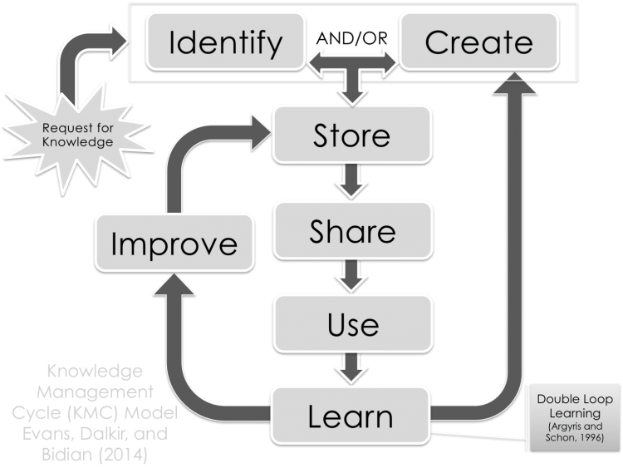
Knowledge management cycle (Know, 2014)
Knowledge is created when it is identified and the managers or employees realise that a piece of information floating in the internet or hidden in a late chapter in a tutorial book, is useful to them in the things they do. At this point that information becomes part of the organisations knowledge asset list. However, at the early stages of knowledge management life cycle, that knowledge is only available to a select few who first discovered it. (Berkes, 2009)
The next stage of the knowledge life cycle is storing that knowledge in a way that it can be easily accessed in the future. The storage should also consider how accessible the knowledge will be not just for the original knowledge creator but other members of the same organisation. For the purpose of making the knowledge more accessible to other members of the organisation it is best to store the knowledge in an organised, clear and structured way. (Fensel, 2005)
For example and employee can learn that it is possible to merge, split an manipulate pdf files using a website. That knowledge could be stored as a note on the general know how section for word documents. The knowledge, for it be clear, organised and structured, should have the link to the website that does the merging and splitting, have a small section on how to use the website and have markers such as “pdf merge” or something else that makes it easy to find the information if someone were searching the knowledge management database for information on where to manipulate pdfs.
Making knowledge assets easily accessible is likely to make it more readily usable by other members of the organisation and thus its application within the organisation becomes a bit easier to implement. After the knowledge assets have been stored and shared, employees can start to use it solve problems that they encounter in their jobs. This can involve things such as using the newly made available knowledge to help make better and more informed decisions, improve the efficiency of their policies and protocols.
It is worth mentioning that despite the knowledge being made clearly, and within a structure, available for others to use. There may still be a certain degree of background knowledge that is needed to use it. Referring back to the example of merging and splitting pdf files, for that knowledge to be useful one must know beforehand what a pdf document is and use the internet, or at an even more basic level, know how to use a computer.
The above example is a simple one to grasp, but it becomes more and more of an issue as the knowledge assets become more complex and difficult. Take an university level book for example, the knowledge assets in it are very well presented, have a structured and constant format of organising its chapters and pages. It can still be very difficult for students to decode the knowledge from it.
Modern knowledge management systems can help alleviate these bottlenecks a little bit by connecting the prerequisite background knowledge and making the connections also easily available. (Business Info, 2018)
Once the organisation has applied the knowledge successfully a few times, it is then time to integrate the knowledge within the organisation. Integration or learning means that the members of the organisation start to take the new knowledge assets as part of their routine and not the one time odd usage.
The everyday usage of the new knowledge assets leads the employees to become familiar and comfortable using it and eventually grow on that knowledge and add more further knowledge on it.
At this point two things can happen to the original knowledge. If the knowledge assets are deemed to be lacking in some form or another. The team will eventually have to recourse back to identifying or creating new knowledge assets to meet their needs and the cycle repeats.
However, on the other hand if it is deemed useful at practical for the uses it was created for, it will be further developed. The knowledge asset will undergo further iterations and be improved upon. The direction in which the iterative improvement of the knowledge asset goes will guided by the needs of the organisation. (Zack, 1999)
The last stage of the knowledge management lifecycle is improving knowledge assets that were deemed to be of good quality. At this stage all the learning that happened in the previous stages leads to a continual iterative learning process that continually improves the organisations knowledge assets.

The benefits of having intellectual property laws
Intellectual property are the laws that exist in many different countries that give some sort of protection to inventors on their inventions or ideas.
Intellectual property is generally considered to be things such as patents, copy right on things such as music, movies, pictures or other original content. Intellectual property can also be logos and trademarks.
The primary way by which it protects the original creators is by allowing the usage courts to prosecute anyone who uses their works without proper authorising to make a profit.
Further to providing legal protection and a level of guarantee of revenue from creative materials, it also gives due to credit to the original author.
All of these conditions come together to incentivise authors to publish more creative content. Be it in the entertainment industry or high tech engineering patents. Both of these fields depend on original thinking to move forward, albeit making a patent for an actual invention is more difficult then making a song. They are incentivised by the guarantee of authorship and legal guarantee of ownership of any revenue originating from their ideas. (Hogan Lovells, 2019)
An example we see regularly is companies trying to work around the loopholes in intellectual property laws. For example there are many fake knock off apple products that can be bought for cheap on ebay or other online stores or small corner shops in the high street. Often what the vendors will do is omit the actual apple logo or have a look a like logo that is undisguisable from a far. These sort of activities hurt the revenue of the original inventor, in this case the apple company.
Another intellectual property law that many of us are guilty of is watching tv shows or listening to music that was not provided to us via legitimate channels that give authorship and ownership to the original creator. This too is an offence under intellectual property laws.

How do knowledge assets help make an organisation more successful
All the things discussed in the previous sections point towards the same conclusion, knowledge assets are vital to any organisation today. So much of everything that businesses revolve around involve being able to gather information from their surrounding, be it information about their customers or information about their competitors or simply being able to gather knowledge about how to improve their own internal processes.
In addition, now days there is also an over abundance of information available and it very likely that some organisations will be overwhelmed by this. Because of this it is very important to have a good systematic approach on how to manage knowledge. As we discussed, a good knowledge management life system has a well defined structure. Some of the stages can helped and made easier by using software systems, but ultimately it is the responsibility of the organisation and its employees to make sure they use well the knowledge assets available to them.
The overall contribution of knowledge assets is that the well use of them will make the organisation work better, be able to make better decisions and ultimately be more successful. (Boisot, 1999)

Knowledge management needs and application at my work
Working in a high street retail shop, I come across many customer on a daily basis. It is a great way to get to know them and also have an enjoyable time by conversing with them. This also opens up an opportunity to do some basic market research. Some customers will chat a lot and in this they will go into a lot of detail explaining their preferences, what colours they like, what sort of design them and their friends look for these days. This is an very useful knowledge asset for any retail shop.
On our facebook page, we also have question and answer systems from where we also gather a lot of customer information.
Lately we have also been trying out platforms such as yext to integrate all these difference sources of customer data and thus be able to do more with it.
As can be seen there are many sources that constantly generate actual usable knowledge about the current market conditions. However, at the moment all our knowledge assets somewhat disperse and handled by different team members who use their own different organisation styles.
Our initial attempt uses an online business knowledge management platform called yext. The goal of using this platform was so that we could gather all of our customer data and any market status related knowledge that we gather on that platform. The main benefit of this would have been that everyone would have access to all the complete knowledge assets and would be able to make more informed decisions on things such as what to order from our suppliers, which dresses to display on the main showcase depending on what was currently popular.
However, our first starting problem is that we are all using yext in different ways. It is a situation where we need to gather knowledge on how to use the knowledge management system.
To help develop the background knowledge needed to use the knowledge management system, we took lessons from yext team on how to use their product efficiently.
The notes that we made during these lessons and anything in particular that any of us learned during the lesson, we first collected in them in a well organised dossier that would be available to all staff members should they need any further training or reminding of any particular detail from the lesson.
These two steps that I did not realise at the time, were our first attempt at having systematic knowledge management system. We standardized the way we organise knowledge and we stored in way that it could be easily shared, before we fully migrated to yext. These were the first stages of the knowledge management cycle of creating, storing and sharing.
For the first few months many of us referred back to the dossier many times to avoid making any mistakes on the online system. And during this time we found that some of the methods we were using to analyse customer data was actually very inefficient and that a lot of our work could be automated using yext. Again, I did not realise this at the time, but here we were undergoing the further stages of the knowledge management cycle, the using and learning parts of it.
As can be predicted this was a continuous and still is a incremental improvement process.
Going forward, our aim is to slowly migrate all our knowledge assets, primarily customer contact and preferences and add them onto yext in a mapped way so that we can associate brands, designs, trends, etc with the customers who appreciate it and be able to be to reach them directly when said products are available.
Being able to make accurate marketing and costumer contact like this would significantly improve the businesses reputation with our customer base and make it grow.

Bibliography
A.Noeb, S. W. (2010). Knowledge sharing: A review and directions for future research. Human Resource Management Review, 115-131.
Berkes, F. (2009). Evolution of co-management: Role of knowledge generation, bridging organizations and social learning. Journal of Environmental Management, 1692-1702.
Boisot, M. H. (1999). Knowledge Assets: Securing Competitive Advantage in the Information Economy. Oxford: Oxford University Press. Retrieved from https://medium.com/@doctusoft/how-to-identify-knowledge-assets-a80847dad8f8
Business Info. (2018). Retrieved from https://www.nibusinessinfo.co.uk/content/advantages-and-disadvantages-knowledge-management
Christian, S. (2005). Information and Knowledge Management: Dimensions and Approaches. An International Electronic Journal.
Davenport, V. G. (2001). General Perspectives on Knowledge Management: Fostering a Research Agenda. Journal of Management Information Systems.
Fensel, R. S. (2005). Knowledge Engineering: Principles and Methods. Engineering Knowledge Management Journal.
Herman, T. W. (2003). Organizing Business Knowledge: The MIT Process Handbook. London: MIT Press.
Hogan Lovells. (2019). Retrieved from https://www.hoganlovells.com/service/intellectual-property
Kisling, T. M. (1998). Potential knowledge management contributions to human performance technology research and practice. Educational Technology Research and Development, 73–89.
Know. (2014). Retrieved from https://www.knowah.com/kmc
Maeno, Y. T. (2017). Applying Design Thinking in Systems Engineering Process as an Extended Version of DIKW Model. INCOSE International Symposium.
Navoni, L. G. (2018). Retrieved from https://medium.com/@lorisnavoni/about-data-information-knowledge-relationships-and-their-representation-b1599f70130b
Salmons, J. (2017). Retrieved from https://www.methodspace.com/making-sense-knowledge-explosion-knowledge-mapping/
Stephendale. (2017). Retrieved from http://www.stephendale.com/2017/03/23/how-a-knowledge-map-can-help-to-identify-knowledge-gaps-and-needs-against-all-odds/
Subramani, J. H. (2000). A framework of knowledge management systems: issues and challenges for theory and practice. ICIS '00 Proceedings of the twenty first international conference on Information systems, 302-312 .
Wei, W. H.‐K. (2008). The role of trust in promoting organizational knowledge seeking using knowledge management systems: An empirical investigation. Journal of the association for information science and technology.
Zack, M. H. (1999). Developing a Knowledge Strategy. California Management Review.

