
Name - Gabrielle Agbenosi
Student ID -2313683
Module code – LCBB5014
Module name – Data Handling & Business Intelligence Component 2
Lecturer – Dr Said Usman
22nd December 2025

Table of Contents
Introduction
Data Cleaning and Preparation
Descriptive Statistics
Statistic analysis using SPSS
Trend analysis and visualization
Insights and recommendation
References

Introduction
Online movie services have grown, and enormous behavioural data is revealed on how individuals view, rate, and interact with movies. “Large-scale behavioural data from online movie platforms allow researchers to study how viewers evaluate films and how popularity emerges over time (Mestre et al., 2015)”. These statistics allow us to consider the relationships between content characteristics such as genre, language, and runtime, and popularity indicators such as watches, likes, and fans, as well as how these factors relate to overall audience evaluations in the form of ratings. Realizing these trends can be helpful to both industry participants who seek to maximize catalogues and marketing strategies and to scholars studying cultural consumption and recommender systems. “Prior work shows that online engagement metrics are strongly related to commercial success, for example linking social media activity with box-office performance (De Jesus, 2020).” In this project, I have analysed a sample of 10,000 movies selected from a popular film-logging platform. The dataset includes variables for film title, director, average user rating, genres, runtime, original language, watches, list appearances, likes, fans, and detailed counts of ratings at different levels, along with total ratings. “User ratings, reviews and engagement signals such as likes and followers have become central inputs for recommender systems and platform decision-making (Gupta, 2024).” The analysis is split into five objectives. I first cleaned the data and standardized the variables by ensuring that the measurement levels are correct, by checking whether the data has duplicates and missing values and creating new variables like language-standard and genres-clean. Secondly, I then did the descriptive statistics and frequency tables to summarise all the major characteristics of the sample. I then created visuals for the most important distributions and relations, such as rating distributions, variability of runtime, and popularity measures. Fourth, I used inferential methods in SPSS, such as independent- samples t -tests, Pearson correlations, and multiple regression, to test certain hypotheses on the effect of language and engagement on ratings. Finally, I incorporated these findings in larger insights and practice and research suggestions.
Data Cleaning and Preparation
In this assignment, I analysed a CSV containing 10,000 movie entries. The preliminary data cleaning and restructuring was done in Excel since Excel’s power query and find-and-replace capabilities provided an easier way to handle nested brackets and delimiters in the genres and studios columns before importing the file to the statistical programs. This allowed separating columns properly and guaranteed the existence of text fields like genres_clean, which was in a form that is easy to analyze. Statistical procedures (t-tests, correlations, regression) were then done on the SPSS, along with some visualisations, whilst corresponding charts were created in Excel as well to satisfy the need of business intelligence reporting in a spreadsheet format.The raw file initially was opened in Excel since the column with the genre in the CSV had brackets and commas within the nest (e.g., ['Drama, Comedy']), which would complicate the SPSS import. I used the Power Query “Get Data – from Text/CSV” option to load the file ensuring that the brackets do not divide columns. Then I applied Find-and-Replace (CTRL + H) to remove brackets ([‘and’]) and replace the pattern of the two quotes (‘, ‘) with a vertical line (|) to make it so that, among others, [‘Horror’, ‘Drama’] becomes Horror|Drama. I also did the same with the studios column to ensure that all things are okay. The final version was then cleaned and saved. I used the saved CSV to get into SPSS through Text Import Wizard (File-Open- Data). I set the delimiter to be a comma and the character of a decimal to be a period, and I also trimmed any preceding space or trailing space. I changed the variables to snake-case (i.e., Average rating to average_rating) in Variable View and I set runtime, fans, likes, watches, averagerating, and totalratings to a numeric data type so the statistics can work. I set the Data Identify Duplicates Condition on all variables, and I removed the duplicates (31 cases, approximately 0.3 percent). I was left with 9, 969 distinct rows.
Missing or inconsistent data can seriously harm business-intelligence outputs since essential indicators can be biased or misleading when they are calculated based on incomplete records or malformed records. As an example, when watches or likes are missing more frequently in specific genres or languages, dashboards will fail to estimate the actual popularity of those movies and therefore make poor decisions when it comes to content and marketing. Likewise, non-uniform formats like runtimes represented as text or genres interspersed in columns and, therefore, non-aligned with all records in a calculation or a model with incorrect categories, will confuse descriptive statistics, charts and predictive models. Strict cleaning, type conversion and recoding are thus needed to make sure that BI summaries and recommendations capture the underlying viewing behaviour quite well.
Running Descriptive analysis, I ensured that averagerating has a mean of approximately 3.27 (range 0-5) and runtime had an average of approximately 99 minutes and practically no missing data. My new variables were added using the SPSS syntax. The genresimple variable has string match of CHAR.INDEX of any film tag that matches to their headline genre keyword (Drama, Comedy, Action, Horror, Documentary, Thriller, Romance, Animation, Sci-Fi, Adventure, Fantasy, Crime) and anything other than that is assigned to Other. The languagestandard variable is binary: English when the originallanguage string includes the words English, Non-English otherwise. This provided me with 8,074 English titles and 1,926 non-English ones. I worked with all the syntax and saved them into files so that it could be reproduced and saved the completed dataset. “Using standard SPSS procedures for data screening, including checks for missing values and outliers, is consistent with recommended practice in applied quantitative research (Field, 2018)
Descriptive Statistics
I obtained the descriptive statistics for the main numeric variables using Analyze → Descriptive Statistics → Descriptives in SPSS. Runtime values ranged from 2 to 907 minutes (N = 10,000), with a mean of 103.17 minutes (SD = 38.07) and a median of 99.00 minutes. This indicates that most films in the dataset cluster around normal length durations, but there are a small number of extremely long works that act as outliers. Watches ranged from 2 to 5,195,503 per film, with a mean of 170,314.82, a median of 18,425.00 and a standard deviation of 458,532.92, It is exhibiting a huge positive skew and an evident disparity in the film’s exposure hits.
Likes ranged from 0 to 2,730,813, with a mean of 43,734.79, a median of 3,394.00 and a standard deviation of 151,531.43; fans ranged from 0 to 326,000, with a mean of 1,652.55, a median of 24.00 and a standard deviation of 9,368.26. These figures confirm that a small subset of films accrues extremely high engagement, while many titles receive relatively modest interaction. “The highly skewed distributions of watches, likes and fans align with evidence that online cultural markets often display winner-takes-most dynamics (Bos, 2016).” Total_ratings ranged from 0 to 4,091,037, with a mean of 106,392.30, a median of 11,823.00 and a standard deviation of 294,734.32, reinforcing this heavy-tailed pattern.​
Average_rating, measured on a roughly 0–5 scale, ranged from 1.08 to 4.71, with a mean and median both equal to 3.27 (SD = 0.53). The mean and median are nearly equal, and the SD is of moderately high value, indicating a symmetrical distribution around the central high-to-mid rating range, which is confirmed by the SPSS histogram. “The mid-range clustering of ratings around about 3.3 is similar to other large movie-rating datasets, which also show few extremely low or high scores (Mestre et al., 2015).”
You can see no trace of either hard floor or ceiling; the scores are concentrated in the middle, with narrow tails on the very high and very low sides.
Frequencies for the language_standard variable showed that English-language films make up 80.7% of the sample (n = 8,074), while Non-English films account for the remaining 19.3% (n = 1,926). For genre_simple, crime was the most common category (1523 films), followed by drama (1178), romance (1061), thriller (1008), fantasy (978), adventure (942), comedy (871), science fiction (781), horror (623), documentary (403), action (272), animation (2.2) while others were (149). This composition indicates that in general, the catalogue is spiked directly on crime and drama.
“Figure 1 demonstrates the descriptive statistics of the key numeric variables (runtime, watches, likes, fans, total_ratings and average_rating) that indicates the high right-skew in the engagement indicators as opposed to the narrow distribution of ratings. ”

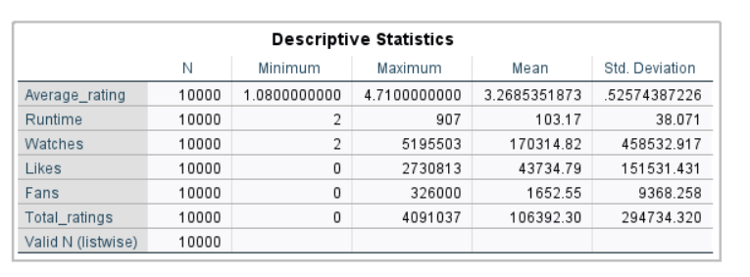
Figure 1descriptive statistics

“Figure 2 presents the frequency distribution of the language_standard variable, which demonstrates that most relevant films in the catalogue are English-language with the smaller, yet significant, non-English proportion. ”

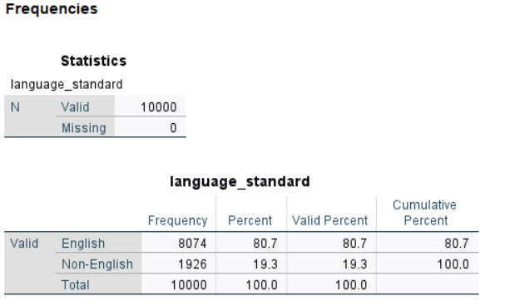

Figure 2 language standard

“Figure 3 demonstrates how the films are spread among the simplified genre categories, and it is possible to note that crime and drama take a leading position among other genres.”
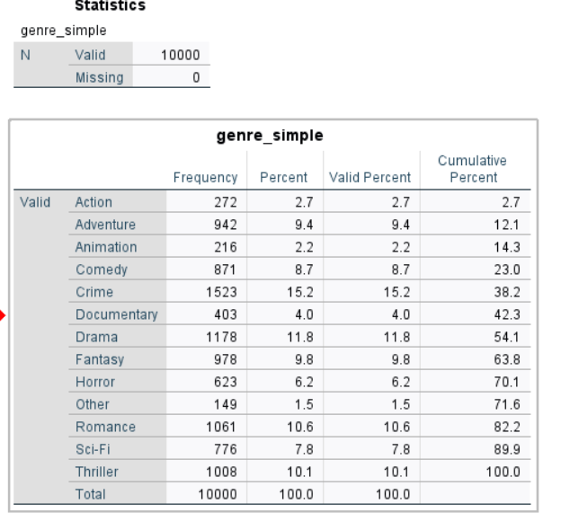
Figure 3 genres

Trend analysis and visualization
Several visualisations were produced in SPSS to explore key distributions and relationships. A histogram of average_rating (Graphs → Legacy Dialogs → Histogram) showed a unimodal, approximately symmetric distribution centred around 3.3. Most films fall between roughly 2.5 and 4.0, with fewer titles at the extreme low and high ends. This suggests that users don’t easily assign either very low or perfect scores, instead clustering evaluations near the mid-range with a slight tendency towards positive ratings.​
A boxplot of runtime (Graphs → Chart Builder → Boxplot) showed that the central tendency and spread of film lengths. The median is near 99 minutes, with the interquartile range becoming approximately 89 to 113 minutes, showing the conventions of feature-length cinema. Several points appear as high outliers, reaching up to about 900 minutes, likely representing anthologies, multi-part releases or experimental works; these cases contribute to the large standard deviation observed in the descriptive statistics.​
In order to know how the quality varies by genre, a bar chart of mean average_rating by primary_genre was generated, focusing on the main categories (e.g. action, adventure, animation, comedy, crime, documentary, drama, fantasy, horror, romance, science fiction and thriller). Differences between genres are relatively modest but systematic: some genres, such as thriller and science fiction, appear to have slightly higher mean ratings than others, whereas mass-appeal genres such as comedy and action show slightly lower means. This pattern may reflect both audience expectations and genre-specific production values, although causal interpretations require caution.​
Two scatterplots were used to explore relationships between popularity indicators. A scatterplot of likes against watches (Graphs → Legacy Dialogs → Scatter/Dot) reveals a very strong positive association: films with more watches almost always have more likes, and the points form a dense, upward-sloping cloud. This confirms the high Pearson correlation between these variables (r = 0.951) and suggests that likes are closely tied to exposure. Outliers with unusually high engagement relative to watches or vice versa represent interesting cases where audience enthusiasm diverges from pure visibility.​
A further scatterplot examined fans against runtime and genre, indicating that films span a wide range of fan counts, with most titles attracting relatively few fans and a minority developing very large fan bases. The association between runtime and fans appears weak, consistent with the small Pearson correlation between these variables (r = 0.088); thus, duration alone does not determine fan accumulation. Together, these visualisations show that while popularity measures co-move strongly, ratings and runtime exert more nuanced influences on audience engagement.​

“Figure 4 is the histogram of average_rating that demonstrates that most of the scores are around the middle-to-high range with few extreme rates. ”

Figure 4 histogram
“Figure 5 demonstrates a boxplot of runtime, which demonstrates the character of the standard feature-length interquartile and the existence of numerous very long outliers. ”

Figure 5 boxplot

“Small systematic differences in perceived quality between genres are indicated in figure 6, which averages the results by genre. ”
Figure 6 Bar chat
“Figure 7 presents a scatter plot of the likes versus watches, and it indicates that the relationship between the two measures of engagement is significantly positive. ”

Figure 7scatter plot1

“Figure 8 presents the scatterplot between the number of fans and the length of the film and indicates that film length is loosely correlated with the number of fans.”
Figure 8scatter plot 2
Statistic analysis using SPSS
Independent-samples t-test: English vs Non-English films
An independent-samples t-test was conducted to compare average ratings between English-language and non-English-language films, using language_standard as the grouping variable (English = 1, Non-English = 2). Group statistics showed that English films (n = 8,074) had a mean rating of 3.21 (SD = 0.52), whereas Non-English films (n = 1,926) had a higher mean rating of 3.51 (SD = 0.46). Levene’s test indicated a significant difference in variances, F = 27.71, p < .001, so the unequal-variances (Welch) t-test was used. The t-test revealed a large, statistically significant difference in ratings, t ≈ −24.88, p < .001, with Non-English films rated more favourably on average. “Audience reception studies indicate that viewers who actively seek foreign-language films often report particularly strong appreciation for these titles (Tsitsou, 2021).” SPSS effect-size output reported Cohen’s d ≈ −0.58, representing a medium-to-large effect. “Growing interest in geographically diverse and non-English-language content on global streaming platforms has been documented in recent work (Lobato, 2024).” These results suggest that, within this dataset, non-English films tend to be evaluated more positively by users than English-language films.

“Figure 9 presents the output of the independent-samples t-test that compares the ratings of the English and Non-English films and indicates that the mean rating of Non-English titles is significantly higher. ”
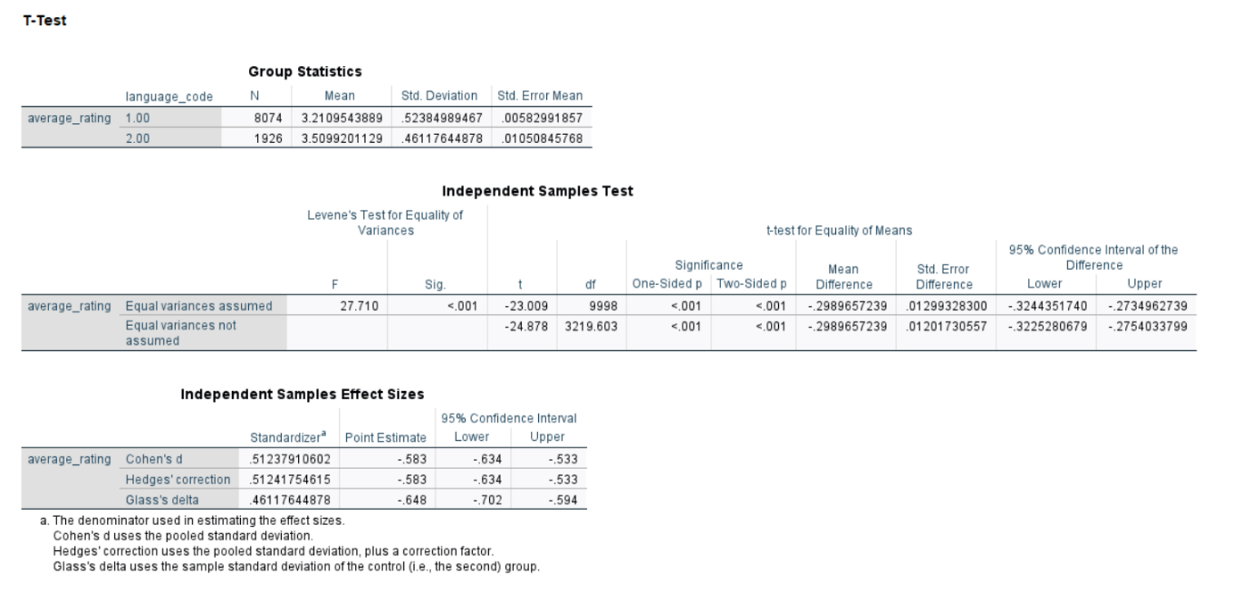
Figure 9 T-tests

Pearson Correlations
Correlations between average_rating and the engagement variables are positive but more modest in size. Average_rating correlates r = 0.290 with likes, r = 0.249 with watches and r = 0.251 with fans (all p < .001), indicating that higher-rated films tend, on average, to attract more engagement, but ratings explain only a small fraction of the variance in popularity. Runtime shows a weak positive relationship with average_rating (r = 0.187, p < .001) and small correlations with fans, likes and watches (r ≈ 0.09–0.15), suggesting that longer films are slightly more likely to be well-rated and widely watched, but that duration is far from a dominant factor.​ “Similar to other analyses of online platforms, the strong correlations among engagement metrics contrast with only moderate links between engagement and average ratings (Wang, 2018).”

“Figure 10 presents the Pearson correlation matrix, as it demonstrates that the correlation between the variables of engagement is strong, whereas the ones between engagement and average ratings are moderate. ”
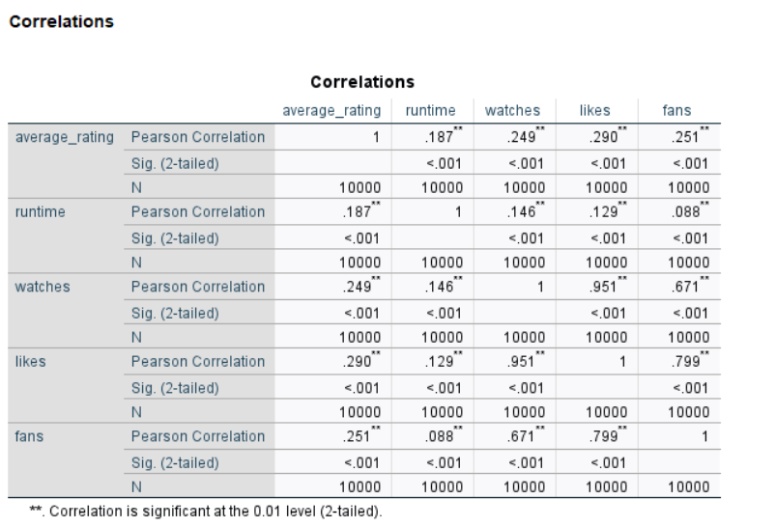
Figure 10 correlations

Regression Analysis
A multiple linear regression was fitted with average_rating as the dependent variable and runtime, likes and fans as predictors, using Analyze → Regression → Linear. The model was statistically significant, F (3, 9,996) = 403.30, p < .001, and accounted for approximately 10.8% of the variance in ratings (R = 0.329; R² = 0.108; Adjusted R² = 0.108). “Research on film branding and fan communities suggests that affective attachment to particular films or franchises can drive engagement beyond what is predicted by ratings alone (Kohli, 2021)”. Thus, while the predictors collectively contribute to explaining ratings, most of the variability in audience evaluations remains unexplained by runtime and engagement measures alone.​
The unstandardised coefficients indicate that all three predictors are positively associated with ratings when controlling for each other. The intercept was B = 3.012 (p < .001), representing the expected rating when runtime, likes and fans are at zero. Runtime had B = 0.00211 (SE ≈ 0.00015, t ≈ 13.76, p < .001), implying that each additional minute of runtime is associated with an increase of about 0.002 rating points; a 50-minute increase in length corresponds to roughly a 0.1-point higher rating, on average. Likes had B = 7.76 × 10⁻⁷ (SE ≈ 5.13 × 10⁻⁸, t ≈ 15.16, p < .001), meaning that an increase of 100,000 likes is associated with a 0.078 increase in rating, all else equal. Fans had B = 3.27 × 10⁻⁶ (SE ≈ 8.70 × 10⁻⁷, t ≈ 3.77, p < .001), so an additional 10,000 fans are linked to a 0.033 increase in rating.​
Collinearity diagnostics showed tolerances above 0.36 and VIF values of approximately 1.02 for runtime, 2.18 for likes and 2.78 for fans, indicating no serious multicollinearity among predictors. Overall, the regression suggests that more popular films (in terms of likes and fans) and slightly longer films receive somewhat higher ratings, but these effects are small in magnitude and leave substantial unexplained variance.​

“Figure 11 and figure 12 present the regression results of the model used to predict average_rating by runtime, likes and fans, which note that the above predictors are statistically significant and only account for 10.8 percent of the variance in the ratings.”
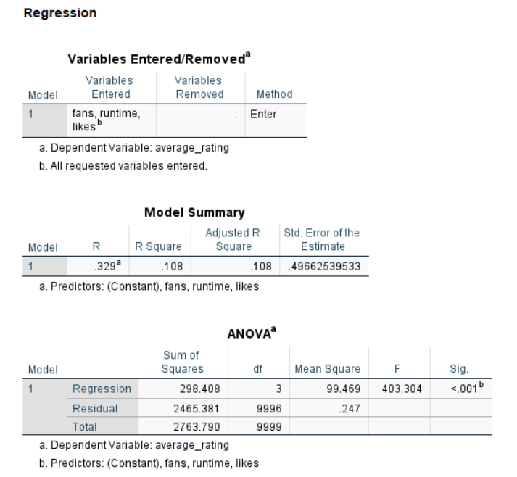
Figure 11regression 1
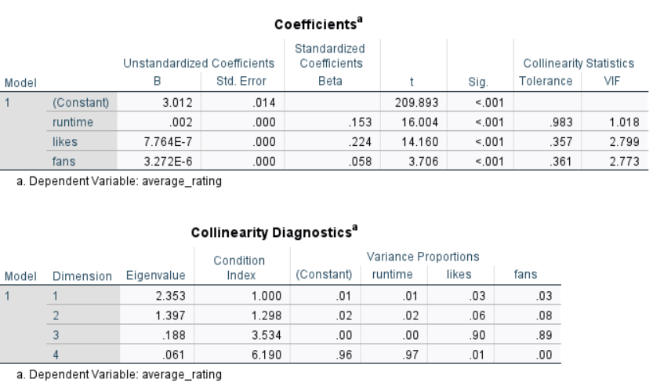
Figure 12 regression 2
Insights and recommendation

Combined, the descriptive statistics and inferential statistics indicate that there are several significant trends within the movie data. To start with, the measures of engagement are highly skewed: although only a handful of titles can get millions of watches, likes and ratings, the median film receives much more humble consideration. It implies a winner takes most dynamic which is common to cultural markets, where visibility and recommendation feedback reinforce the success of already popular titles. Second, average ratings are more evenly dispersed and centred on 3.3 on a 0-5 scale, and do not display the level of extreme inequality as is the case with engagement measures. An impressive outcome of the language analysis comes into being. Although composing less than one fifth of the catalogue (19.3%), non-English films have significantly higher average rating (M = 3.51) as compared to English language films (M = 3.21), with a medium-large effect size (d [?] [?]0.58). This implies that international or world cinema titles are rated better by the users of the platform, perhaps because the viewers have self selected to watch those films, or because of critical response, artistic approach or distribution. Platforms and distributors can hence be served by foregrounding non-English titles with curative collections, recommendation campaigns and better subtitling or localisation, by capitalizing on their high perceived standing despite their poor raw exposure. According to the engagement and regression results, views, likes as well as fans are closely connected but only weakly linked with ratings. The success of the film is therefore a multidimensional phenomenon: it is possible to have films that become very popular with only average ratings and films that have high ratings that have comparatively low exposure. “Recommender systems use signals like user ratings, watches and likes to personalise what films are shown to viewers (Ricci, 2015)”. When gauging performance therefore the decision makers should look at both quality (ratings) and reach (engagement metrics) as opposed to depending on one indicator like watches. The positive impact of runtime on ratings and engagement is very small, and it would therefore suggest that content and appeal are more crucial factors than length, given the range that it depicts. These trends drive practitioners towards delivering a wide variety of high-quality content, both non-English and less mainstream, and using multi criteria dashboards, which combine ratings, watches, likes and fans in determining catalogue value.
Conclusion
After completing a 10,000-film dataset analysis which delved into data cleaning, descriptive statistics, visualisation, and inferential modelling in SPSS. The data indicates that the engagement rates are asymmetrical, and the ratings are concentrated at a mid-to-high average of approximately 3.27. Surprisingly, non-English films receive significantly larger rating scores than English titles, and measures of popularity such as watches, likes and fans are strongly correlated but weakly related to ratings. The regression model with runtime, likes and fans accounted approximately 10.8 per cent of the variation in rating, indicating that the audience ratings rely on a more comprehensive set of variables. The results provide me with tangible, evidence-based concepts on content curation and promotion plans.
References
Bos, M. (2016). A quantitative analysis of the perceived quality for popular films. Master’s thesis. Erasmus University Rotterdam. Available at: https://thesis.eur.nl/pub/34474/Bos.pdf [Accessed 12 Dec. 2025].
De Jesus, K. (2020). Social media engagement and film box office. MMA Undergraduate Research Competition. University of Miami. Available at: https://com.miami.edu/wp-content/uploads/2021/05/mma_2020_firstplace.pdf (Accessed12December 2025).
Field, A. (2018). Discovering Statistics Using IBM SPSS Statistics. 5th ed. London: SAGE.
Gupta, S. (2024). How consumers evaluate movies on online platforms? Configurations of consumer engagement and expert signals. Journal of Business Research. Available at: https://www.sciencedirect.com/article/pii/S0148296324001176 (Accessed: 12 December 2025).
Kohli, G. (2021). Film or film brand? UK consumers’ engagement with films as brands. British Journal of Management, 32(4, pp.1100–1117. Available at: https://onlinelibrary.wiley.com/doi/10.1111/1467-8551.12401 (Accessed: 12 December 2025).
Lobato, R. (2024). Netflix’s top 10 and the popularity of geographically diverse content. Convergence. The International Journal of Research into New Media Technologies. Available at: https://journals.sagepub.com/doi/10.1177/13548565241265504 (Accessed: 12 December 2025).
Mestre, F., Gama, J. and Cortez, P. (2015). Statistical patterns in movie rating behavior. Scientific Reports, 5, 11907. Available at: https://pmc.ncbi.nlm.nih.gov/articles/PMC4555649/ (Accessed: 12 December 2025).
Ricci, F., Rokach, L. and Shapira, B. (eds.), 2015. Recommender Systems Handbook. 2nd ed. New York: Springer. [online] Available at: https://link.springer.com/book/10.1007/978-1-4899-7637-6 (Accessed 12 Dec. 2025)
Tsitsou, P. (2021). Audience engagement with foreign-to-English language film: Perceptions, emotions and experiences. Participations: Journal of Audience & Reception Studies, 18(2),, pp.243–267. Available at: https://www.participations.org/19-02-14-tsitsou.pdf (Accessed: 12 December 2025).
Wang, Z. (2018). An analysis of IMDb user participation. International Journal of Social Media and Interactive Learning Environments, 6(3), pp.213–230. Available at: https://francis-press.com/uploads/papers/8d3GOJ8jzundJsLyGhJsijW09dWk8CmyKLIcNn2u.pdf (Accessed: 12 December 2025).

