Marketing Management (LCMB7001)

Shirina Begum
Student ID 1709360
MBA- Masters of Business Administration
Marketing Management – Assessment 1
University of Wales Trinity Saint David

Contents
Introduction 3
Company Background 3
Definition of the communication 4
Shannon Weaver Model 4
Integrated Marketing Communications (IMC) 5
New Promotional Strategies to Create Awareness of Nike Jordan Brand 6
Online 7
Offline 7
Branding and Brand Equity 8
Keller's Equity Model 8
Position Strategies 9
Differentiation 10
Customers' Feedback and Response 10
Relationship, Social media, and Chats 10
Keller’s Model Advantages and Disadvantages 11
Consumer Journey 11
Stages 12
Customer Touchpoints 12
Pre-purchase 12
Post-purchase 13
Relations to Nike 13
Customer Journey Map 13
Strengths and Weaknesses of Nike's Customer Journey Map 14
Positives and Negatives of Customer Journey Map 14
Total Engagement Model 15
Conclusion 16
Recommendations 16
References 16

Introduction

Marketing Management is a crucial undertaking in an organisation aiming to increase profitability and market share of its products. Promotional messages need to be packaged in a way that can trigger consumers to develop positive convictions, emotions, and thoughts on a product. Innovative marketing strategies go a long way to deliver important messages concerning a product or service to consumers throughout the various stages of the customer's end-to-end journey. This enables a company to maximise customer satisfaction that contributes immensely towards its growth through constant cash flows. The paper provides an in-depth look at Nike's marketing management by bringing to the fore various innovative marketing strategies that Nike marketers can tap to create awareness of the Nike Jordan brand while utilising various communication channels to meet consumers' expectations throughout their end-to-end journey.

Company Background

Nike Inc. spans several countries across the world and is involved in designing, developing, manufacturing, marketing, and selling equipment and services, footwear, accessories, and apparel. The company is a multinational association based in the United States having its headquarters in the Portland Metropolitan Area. It is one of the top suppliers of athletic apparel and shoe worldwide and is one of the leading producers of sports equipment. More than seventy thousand people across the globe are working for Nike, Inc. Statistical reports depicted that Nike, Inc. has a value of nearly twenty billion U.S. dollars in 2014 (Ahmed et al., 2016). For that reason, the research labeled it as the most valuable brand in the sports business. The company began in 1964 and was known as Blue Ribbon Sports. Phil Knight and Bill Bowerman are the founders of Nike, Inc. that later changed its name from Blue Ribbon Sports to Nike in 1971. In Greeks mythology, they had several gods and goddesses who were responsible for various phenomena. The goddess of victory was referred to as "Nike." The company has several well-established and renowned brands like Air Max, Air Jordan, Nike Blazers, Nike Golf, Converse, Jordan, Nike+, Hurley Int., Nike Pro, and others. They market and sell Nike products globally. It is significant to point out that the company is always involved in sporting activities and do so by sponsoring high-profile sports teams drawn from various type of sports including football, basketball, rugby, tennis, and athletics. Also, outstanding sports personalities, notably athletics always get sponsored by Nike, Inc.

Over the years, Nike, Inc. has experienced mergers and acquisitions with multiple businesses dealing in footwear, accessories, and apparel. The period 2000s saw Nike refocusing by selling several of its subsidiaries to pay more attention to specific business lines. Today, the company only has two subsidiaries namely, Converse and Hurley, Int (Lee, 2014). The company owns a laboratory, known as Nike lab, which is responsible for innovating various Nike products through research and technology. The lab comprises highly qualified individuals drawn from various disciplines including biomedical engineering, math, physics, physiology, mechanical engineering, biomechanics, and kinesiology. Nike lab conducts testing of various ideas to ensure their products achieve high performance and possess a low injury risk.

Definition of the communication

Effective communication plays a pivotal role in marketing a product. How the message is encoded and channels utilized to relay it to consumers is crucial towards realization of desired outcomes. Every communication has a purpose that it intends to achieve and successful ads bear significant implications on their targeted audience (Funk et al., 2106). For that reason, organisations conducting marketing need to pay close attention to the type of communication models they adopt in relaying information to customers. Companies that have put in place effective communication systems will always have a competitive advantage over their rival companies because of customer satisfaction.

Shannon Weaver Model

Shannon and Weaver conceived a communication model to assist not only individuals but also organisations to transmit information more efficiently and quickly. The model takes into account six components that are essential for effective communication. First, the sender is responsible for coming up with the message that requires sharing. The encoder is the second component of the model and it involves converting the message originating from the sender into a binary form that can be electrically transmitted over the internet, video, or radio sound waves (Al-Fedaghi, 2012, p.14). The channel depicts tools that can be used to relay information between the sender and receiver. For example, one can use an email or telephone call to transmit information. The decoder unpacks the information coming from the sender enabling the receiver to understand it since it is converted from electrical signals to human language. After that, the receiver can access the information sent by the sender. It is worth noting that the receiver needs to possess technology that comprehends the sender's message. Lastly, noise is a factor that adversely affects communication since its presence may hinder the receiver from comprehending the sender's message. Therefore, marketers need to consider noise before relaying messages to customers (Al-Fedaghi, 2012, p.15).
Nike marketers can utilize the Shannon Weaver communication model to conduct marketing of their products. For instance, this model enables the company marketers to critically assess every component and put-up measures that warrant an efficient communication process. In this case, the sender is the company and the receiver is a customer. The company can select various channels such as social media considering that a huge proportion of the world's population uses social media platforms such as Facebook, Twitter, Instagram, Instagram, Tiktok, and Youtube. Nike marketers will have the opportunity to evaluate noise and adopt appropriate mechanisms to prevent the communication process from failing to achieve its purpose because of noise. The main advantage of this communication model lies in its ability to address noise, which can have a significantly negative impact on the company's marketing activities. Noise diverts the attention of customers making it difficult or impossible for them to concentrate on important issues embedded in the marketing message.
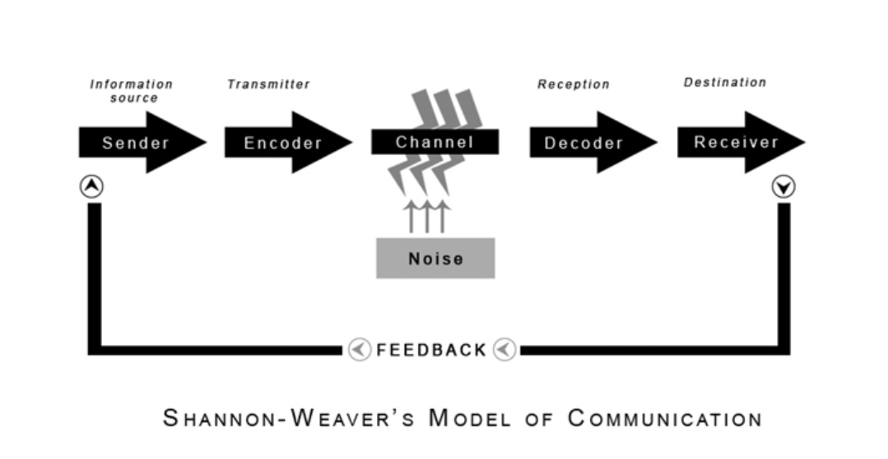
Figure 1 The Shannon-Weaver Model Source GarthBox

Integrated Marketing Communications (IMC)

Integrated Marketing Communications is an approach that enables an organisation to promote a message using a set of strategies working together and reinforcing one another. For instance, a company can create awareness concerning its new product or logo using multiple channels such as social networks, television, print media, and the web. This kind of communication enables a promotional message to reach a wider audience (Luxton, 2015). Also, the voids created by one media can be filled by another media when they are integrated leading to efficiency. Also, it enables a company to package its different promotional messages into a single unit. Today, consumers receive a lot of news from various sections making it hard for them to comprehend disjointed messages. Integrated marketing strategies go a long way to prompt organisations to deliver cohesive and clear messages to consumers (Luxton, 2015).
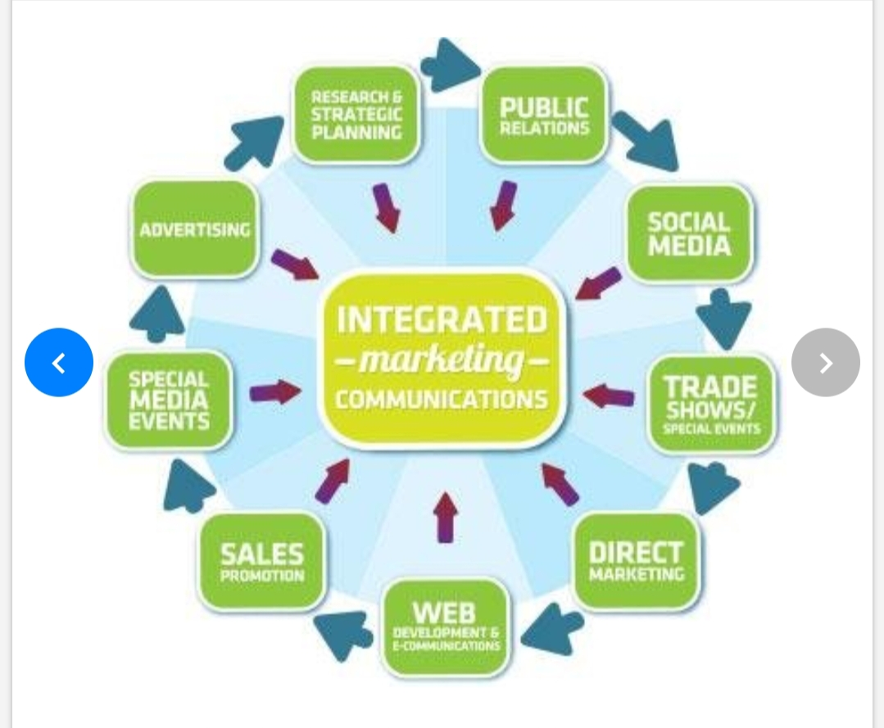
Figure 2 Integrated Marketing Communications

New Promotional Strategies to Create Awareness of Nike Jordan Brand

There are several new promotional strategies that Nike can implement to create awareness of the Nike Jordan brand. Promotional strategies will seek to position the Nike Jordan brand on the market enabling individuals to be aware of the brand and how they get to gain by purchasing it. They take into consideration the target audience, budget, and plan of action.
Nike has not always been too keen in embracing new strategies in the communications medium for marketing process instead they followed the chasing new bright ideas, they have adopted and embraced new platform since that’s what the desire of the customer are. Nike firmly believe that the more things change the more it remains the same.

Over time Nike has made sure that their brand has not lost in the current content marketing operations. They endured their brand message reached to their customers by providing quality rather than quantity. They emphasized on developing top quality material and product benefit. The focus of their branding and message remains on assisting their consumers in becoming better at what they enjoy doing and this has been done by bringing the right content market to where their customers are globally this had been succeeded through business development and fulfilling their audience demand and remaining loyal to their brand. While many of its competitors have come and gone, Nike's marketing strategy has succeeded in maintaining a global brand.

Online

Nike can implement promotional strategies like social media marketing and email marketing. Using various social media platforms, the company's marketers can draft promotional messages accompanied with photos and videos of the Nike Jordan brand to make it popular. Also, they can notify individuals, notably their loyal customers concerning the Nike Jordan brand. Furthermore, the company can use influencer marketing to create awareness of the Jordan brand. For instance, it can use highly influential and popular individuals like Christiano Ronaldo, Serena Williams, and Kanye West to encourage and motivate their fans to purchase the product.

Offline

Event sponsoring creates a platform for Nike to create awareness of the Jordan brand. Here, the company can grace huge events hosting tens of thousands of individuals and offer goodies to organisers of those events who then will grant them a platform to market and sell. Nike can decide to grace a music concert of Niki Minaj and pay for the music system for them to be allowed to put up their marketing tools like posters and banners at various strategic places within the venue of the concert. Another promotional strategy embodying great potential is promotions. Nike can avail incentives for its customers to prompt them to purchase the Jordan brand. For example, the company can offer other products for free alongside the Jordan brand to attract buyers. Customer loyalty programs will enable Nike customers to remain loyal and trust Nike's products only. Such programs prompt individuals to embody confidence and security towards Nike products.

Branding and Brand Equity

Branding refers to a process of establishing a reputation for a product that is either being launched or has been in existence. Consumer experience after utilising a product is crucial and any organisation that seeks to build a brand value for their products must consider it. Therefore, a product's reputation can affect a company's performance either positively or negatively (Les, 2014). On the other hand, brand equity denotes consumers' positive experience that prompts them to continue utilising the same brand. A company can only realise brand equity if its products appeal to consumers' desires and attitudes.

Keller's Equity Model

Keller's brand equity model provides a simple logic behind branding. According to Keller, an organisation can create a strong brand after creating a positive brand image. The right brand image is one that triggers positive convictions, emotions, and thoughts among customers after using a given product. He affirms that an enterprise that has built a brand equity can confirm presence of a brand value. Brand value compels consumers to spread their positive convictions, emotions, and thoughts to other people enabling an organisation to attract new consumers (Keller and Brexendorf, 2019). Keller reveals that brand value results from a complete journey of hierarchical four levels namely, identity, meaning, response, and relationships. The levels build a vital relationship between the buyer and the seller eventually leading to a solid brand.

Nike Jordan brand marketers can adopt Keller's equity model to realise brand equity. First, the marketers will make known Nike Jordan brand's identity to costumers. All relevant data concerning the brand will be unpacked in this level of Keller's equity model. After that, the marketers will put forward the brand's performance and imagery to depict Nike Jordan brand's meaning. Under this level, marketers will strive to reveal the Nike Jordan brand's price, style and design, primary features, reliability, efficiency, durability, empathy, and serviceability. Following the second level is response depicting consumers reactions to the brand's performance and imagery. The company marketers will then access their relationship with consumers to assist them establish how costumers perceive the brand (Lee, 2014). To assist Nike build resonance, it will implement customer loyalty programs and foster emotional connections with consumers via social media platforms.
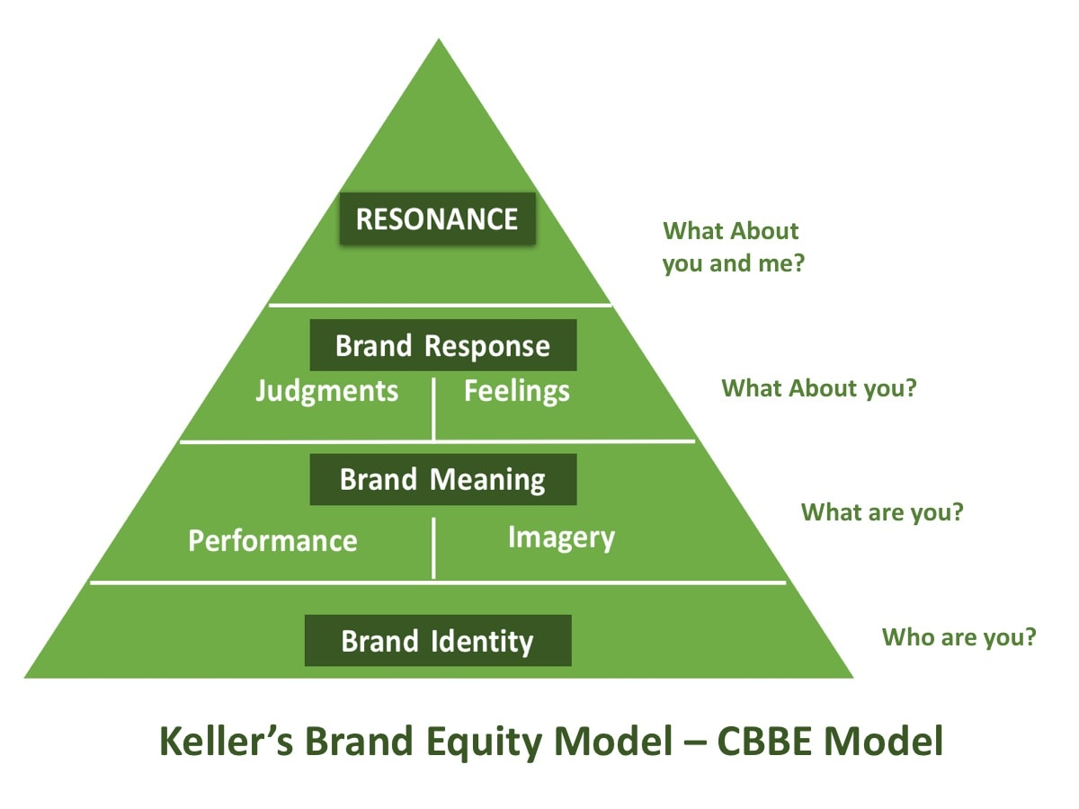
Figure 3 Kellers Brand Equity Model

Position Strategies

Nike, Inc. utilises various position strategies to market Nike Jordan. Product value has compelled customers to associate Nike Jordan with a certain value that resonates with customers' attitudes, desires, and satisfaction. Nike has created a positive imagery and performance of Nike Jordan brand on its customers domain making them to find the brand reliable. Product value is a key marketing positioning strategy. Also, Nike utilised product to position market for its Nike Jordan. The company created awareness on the brand's key unique qualities differentiating it from other similar products. Many consumers would prefer purchasing a high-quality product at exorbitant prices rather than settle on low quality but cheap products. Nike is cognizant of its customers' needs and always strive to address them. Nike Jordan brand seeks to offer solutions to costumers' problems enabling it to positively position in the market (Lee, 2014).

Differentiation

Differentiation distinguishes a product of one company from similar products of its rival companies. It is significant to note that Nike faces competition from other sports businesses and for that reason, there are several strategies the company uses to differentiate. First, Nike has a clearly defined set of values that drives its brands (Lee, 2014). These values appeal to the majority of the world population enabling Nike to be different from other sports businesses. Also, the quality associated with Nike's products is on another level altogether. The company heavily invests in innovation and research to conceive products made from supreme materials. Also, it offers ideal packages that auger well with customers desires making it to be widely embraced. This goes a long way to make Nike unique in comparison with other companies dealing in apparel, accessories, and footwear. Also, Nike pricing greatly differs with pricing of its competitors (Lee, 2014). The world population embody heterogeneous financial statuses enabling Nike to map out its target audience based on their financial capabilities.

Customers' Feedback and Response

Customers have often expressed their satisfaction and joy accompanying the utilisation of Nike's products. In many instances, the reviews from customers are positive. For example, consumers have commented in the past regarding influencers marketing. Some personalities that market Nike products are highly influential and Nike's decisions to incorporate them in marketing have always excited customers (Ahmed et al., 2016).. Also, consumers always try and imitate influencers after acquiring Nike products. In the past, several customers have imitated moves, behaviours, and speeches embodied in Nike ads done by influencers. It is worth noting that Nike products are not affordable to everyone and the majority of them can only be acquired by affluent individuals. For that reason, some consumers have always made fun of the exorbitant prices associated with certain Nike products. Some of the prices of certain Nike products do not make sense to some individuals (Les, 2014). For example, some footwear or Nike's apparel costs the same as a vehicle, and their prices have always spurred debates and left many individuals seeking answers to unending questions. In some cases, employees have experienced problems with online deliveries prompting them to castigate the company online.

Relationship, Social media, and Chats

The HR department at Nike has always depicted its commitment to ensuring customer satisfaction by encouraging consumers to constantly engage them. The company has a website that enables consumers to directly engage the company's employees at any time. Questions relating to availability of certain Nike products, discounts, and deliveries are mostly talked about by consumers engaging the customer care service team in Nike, Inc. Besides website, the company has various accounts in all social media platforms (Lee, 2014). Majority of the company's customers are young adults and youths who utilises social media to a larger extent. This has greatly assisted Nike to constantly interact with its potential consumers worldwide at affordable costs.

Keller’s Model Advantages and Disadvantages

The main disadvantage associated with the brand model is its costs. Creating a positive influence around a given product does not come for free. An organisation heavily invests in building a brand's reputation by ensuring that the product resonates with consumers' emotions, convictions, and thoughts. On the other hand, brand equity contributes immensely to a company's growth. It streamlines consumers' relationship with the company enabling them to remain loyal to the company. Their conviction is vital since loyal customers refer new individuals to buy a given company's products expanding its market share prompting growth. Another advantage of brand equity is that it enables a company to introduce new products and customers will be more willing to utilize them because already there are established positive connections between the company and customers. Also, the equity model enables an organization to have a competitive advantage over its rival firms lacking brand equity. It aids in market positioning enabling an enterprise to benefit from an established consumer base (Keller and Brexendorf, 2019).

Consumer Journey

Courtesy of e-commerce, many businesses track customer journeys to assess customers' interactions with a company's products or services periodically. Important to note is that this process is increasingly becoming problematic because of its data-intensive nature. For that reason, few enterprises manage to successfully manage and evaluate end-to-end customer journeys. It's a key area in marketing since it provides room for a business to establish positive brand equity after creating a brand value that resonates with consumers' thoughts, emotions, and convictions (Flynn, 2015).

Stages

The end-to-end customer journey comprises five stages. First, the awareness stage entails making discoveries with the help of various marketing methods. Marketers search for messages that aim to offer solutions to problems bedeviling the target audience. The second phase of the customer journey is the consideration stage where marketers examine the features and benefits of their products in comparison to their rival products (Flynn, 2015). After that, the purchase stage follows enabling customers to buy goods or services after evaluating their features and benefits. Enterprises must acknowledge and appreciate customers at this stage to enable them to progress to advance stages of customer journeys. The retention stage is the second last phase of the customer journey and arguably the most challenging one (Lee, 2014). Here, marketers maintain customer satisfaction and fulfillment by continuing to address consumers' problems. It is through constant communication that marketers achieve customer loyalty. The last stage is advocacy and entails retained consumers recommending a company's goods or services to their friends and families.

Customer Touchpoints

Doyle (2009) reveals that customer touchpoints refer to various avenues that enable customers to come in contact with enterprise goods or services. For example, consumers can come across goods and services on adverts or online, company websites, and reviews. Every brand has both pre-purchase and post-purchase points of customer contact that go a long way to influence customers' journey. Touchpoints influences consumers' emotions, thoughts, and convictions concerning a company's brand, product, service, and business.

Pre-purchase

Pre-purchase touchpoints comprises instances where potential buyers interact with a company's goods or services before arriving at purchase decisions. It is worth noting that they are an essential component of the customer's journey. Examples of pre-purchase touchpoints are social media adverts, reviews, word of mouth, social media posts, employee generated content, marketing, advertisement on websites, and content sponsorship (Funk et al., 2016). A good customer experience can be created by marketers when they examine these pre-purchase touchpoints to draft appropriate measures that warrant desirable outcomes whenever consumers interact with the company.

Post-purchase
Post-purchase touchpoints include various points of customer interaction that enables customers to interact with the company's activities after purchase. They include email, customer service, forms, social media, billing, newsletter, and loyalty programs. Business need to consider post-purchase touchpoints to enable them retain customers (Funk et al., 2016).

Relations to Nike

Nike offers customer service to its customers where they address buyers' issues emanating from sold Nike products. Also, the company effectively utilises social media to market its products and avail crucial information concerning its undertakings. The company sends emails to its online customers to appreciate them for support and bring to their attention ongoing developments within the company (Brohi et al., 2016). Reviews on Nike's products and Nike's websites offers opportunities for customers to interact with Nike's undertakings, products, culture, and structure.

Customer Journey Map

A customer journey map is a pictorial representation of various stages consumers traverse during their interaction with products or services. For example, a customer can purchase a product online and then contact the company's customer service via phone. After that, the customer can decide to review the product on social media (Rosenbaum et al., 2017, p.144). All these activities can be represented in form of diagrams. It comprises multiple components including emotions, customer touchpoints, buyers persona, and customer stages.
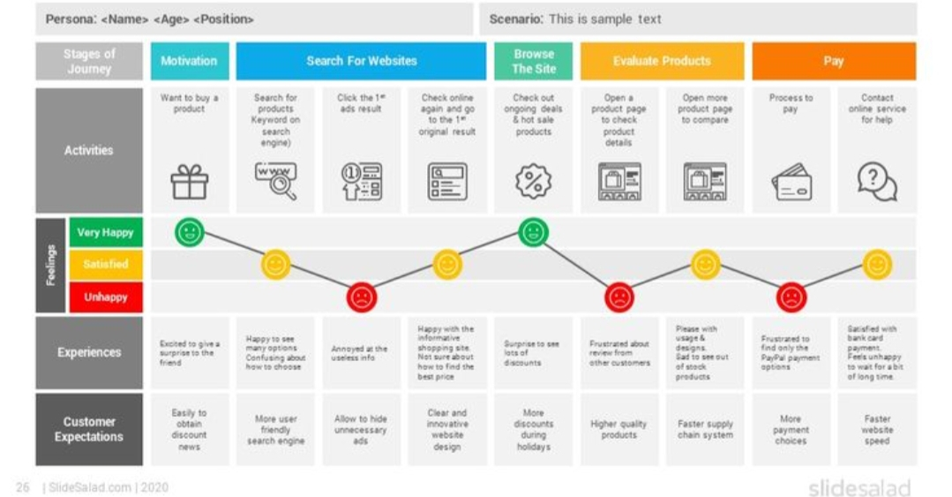
Figure 4 Customer Journey Map source Slidesalad.com

Strengths and Weaknesses of Nike's Customer Journey Map

Nike's customer journey maps avail crucial data for the company's growth and create a conducive atmosphere for consumers to realise their goals. It also enables customers to have better experiences interacting with the company. One major weakness of Nike's customer journey map is that it pays more attention to touchpoints and not customers' journeys (Ahmed et al., 2016). Also, Nike considers its customer journey map as a project yet it should be a continuous activity to reflect consumers changing needs.

Positives and Negatives of Customer Journey Map

Organisations with customer journey maps have access to insightful information that is significant to various departments of the company. Managers get to identify outlets utilised by many customers and salespeople develop ways that can enhance effective interaction with potential customers. Also, it enables a company to configure efficient ways of making the sales funnel more efficient to warrant more sales at a faster rate. Developing comprehensive consumer journey maps is tedious and data-intensive making it a challenging process (Rosenbaum et al., 2017).

Total Engagement Model

According to (Roberts and Alpert, 2010), the total Engagement model harmonises various company activities to achieve customer engagement efficiently. For example, Nike, Inc.'s total engagement model involves the company, employees, and customers. Nike employees are committed to offering consumers a unique and planned consumer experience through various practices and policies adopted by the company's HR department. Nike's corporate culture resonates with its employees' values, attitudes, beliefs, and behaviours creating a conducive atmosphere for job satisfaction and fulfillment (Ahmed et al., 2016). This goes a long way to motivate employees to go the extra mile and offer excellent services to customers. Also, the company conducts brand advertising that embodies strong consumer insights making its marketing schemes achieve the desired outcomes.
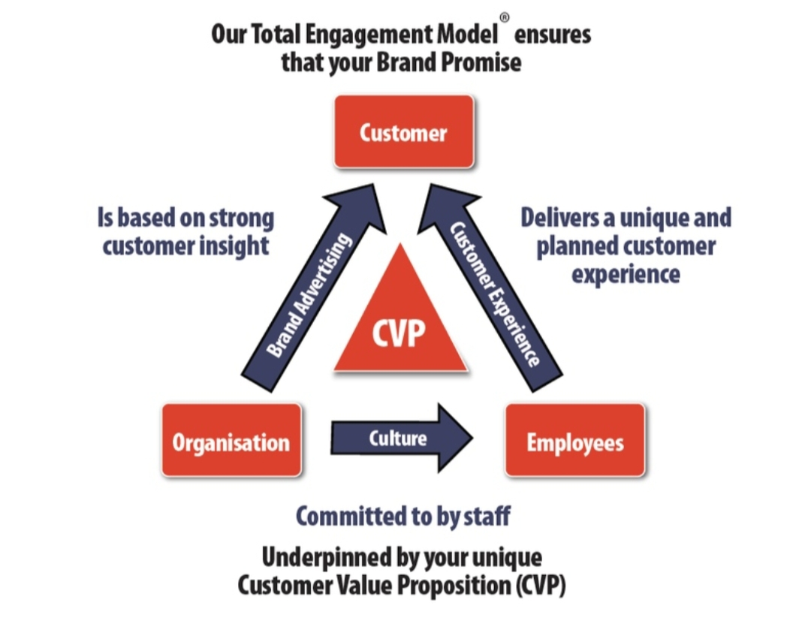
Figure 5 Total Engagement model source www.engagedstrategy.com

Conclusion

In summary, marketing management is a crucial component in business administration. Nike’s marketing strategies need to focus on customers' journeys and not necessarily the touchpoints to warrant customers' loyalty. Nike can develop innovative marketing strategies that focus on its customer's journey and not touchpoints to create awareness of Nike Jordan's brand. Customer experience is crucial for any company seeking to maintain continuous cash flows.

Recommendations

I. Nike need to focus on end-to-end customers journeys and not customers touchpoints to achieve efficient employee engagements.
II.Marketing requires comprehensive research and analysis and therefore organisations need to put aside sufficient resources, both monetary and humans for the success of the undertaking.
III. Nike need to encourage innovations among their employees to assist them to innovate marketing strategies embodying greater potential in the ever-changing today's dynamic business world.

References

Ahmed, R.R., Brohi, B., Bhutto, A.H., Prithiani, J., Khubchandani, R., Kumar, S. and Abbas, Z., 2016. „Strategic Marketing Plan of Nike “. ResearchGate, Indus Institute of Higher Education.
Al-Fedaghi, S., 2012. A conceptual foundation for the Shannon-Weaver model of communication. International Journal of Soft Computing, 7(1), pp.12-19.
Brohi, H., Prithiani, J., Abbas, Z., Bhutto, A. and Chawla, S., 2016. Strategic Marketing Plan of Nike.
Doyle, P., 2009. Value-based marketing: Marketing strategies for corporate growth and shareholder value. John Wiley & Sons.
Flynn, P., 2015. Nike Marketing Strategy: A Company to Imitate.
Funk, D., Alexandris, K. and McDonald, H., 2016. Sport consumer behaviour: Marketing strategies. Routledge.
Keller, K.L. and Brexendorf, T.O., 2019. Measuring brand equity. Handbuch Markenführung, pp.1409-1439.
lee, I., 2014. The Impact of Marketing Strategies on Building Brand Equity-A Case of Nike (Doctoral dissertation, NSYSU).
Luxton, S., Reid, M. and Mavondo, F., 2015. Integrated marketing communication capability and brand performance. Journal of Advertising, 44(1), pp.37-46.
Maechler, N., Neher, K. and Park, R., 2016. From touchpoints to journeys: Seeing the world as customers do. McKinsey Quarterly, 2, pp.2-10.
Mitchell, D.W., 2017. The Sneaker Life: A Critical Analysis of Nike and Under Armour Marketing Strategies.
Ottman, J.A., 2017. The new rules of green marketing: Strategies, tools, and inspiration for sustainable branding. Routledge.
Roberts, C. and Alpert, F., 2010. Total customer engagement: designing and aligning key strategic elements to achieve growth. Journal of Product & Brand Management.
Rosenbaum, M.S., Otalora, M.L. and Ramírez, G.C., 2017. How to create a realistic customer journey map. Business horizons, 60(1), pp.143-150.

