

EXPLORING THE ROLE OF HRM IN PROMOTING PHYSICAL AND MENTAL HEALTH POLICIES IN MODERN MNC'S OF THE UK: A CASE ANALYSIS OF TESCO PLC

Student Name: Arman Mansuri
Student ID: 2240736
Program: MBA (Human Resource Management)
Module: Dissertation
Supervisor Name: Hoang Dang Nguyen
DATE: 17/06/2024

Declaration
I hereby declare that this work is my own and original and has not been submitted before for any degree or course. I have given proper credit to all the resources that have influenced me to pursue this work and have maintained integrity and transparency in all the ways possible.

Arman 17/6/2024
Signature Date

Acknowledgement
I acknowledge that this research is purely my own work and has not been submitted before for any degree course. I have got immense support from my mentors and tutors regarding this research which has helped me in completing this study effortlessly.

Abstract
The study seeks to examine the importance of Human Resource Management (HRM) in advancing physical and mental health policies inside contemporary multinational firms in the United Kingdom. This paper examines the case study of Tesco Plc. There is a growing understanding of the importance of employee health in international firms due to the challenges workers face in balancing their personal and professional lives. This study has examined the inferential statistics approach, which involves the use of sample data. The use of this data analysis technique has enabled the researchers to derive a reliable inference and formulate a robust forecast based on a sample size of 100. In this context implementation of physical and mental health policies (IV1), employee feedback on health initiatives (IV2), enhancement of employee wellbeing (IV3), and overall organizational health of Tesco (DV) have been identified as independent and dependent variables. The age, gender, income, marital status, and experience of the participants of the surveys are included in the “analysis test". These are useful in understanding the number of participants of each type included in the study. Moreover, moderate to positive relationships have been found among the variables in this research. The major limitation of this study is that it does not focus on understanding the perspective from a quality study as well and only focuses on a quantitative study which reduces the scope of making a comparative evaluation between recent and past trends. However, this study can act as a guideline for improving the policy development for health and mental wellness for MNC employees. Due to a lack of awareness, divorce work culture, and security issues the development of policies remains ineffective. However, the HR manager can make better policies if all the HR staff can be educated more about mental health issues and stigma related to health as well. To maintain confidentiality counselling must be given. HRM directly concentrates on creating a positive work environment and addressing the concerns of the employees to further improve the employees’ mental and physical health within multinational companies (MNCs).

Table of Contents
Chapter 1. Introduction 9
1.1. Background information 9
1.2. Research problem 10
1.3. Research aims, objectives and hypothesis 11
1.3.1 Aim 11
1.3.2 Objectives 11
1.3.3 Hypothesis 11
1.4. Relevance of research 11
1.5. Theoretical framework 12
1.6. Dissertation Structure 14
Chapter 2. Literature Review 15
2.1. Introduction 15
2.2. Definitions 15
2.2.1: Robust physical health initiatives by HRM lead to fever workless injuries and illness, saving cost and boosting efficiency 15
2.2.2: Effective mental health programs driven by employee motivation reduce stress, increase job satisfaction 16
2.3.3: Proactive HRM involvement in health policies fosters trust and loyalty 17
2.2.4 Employee Motivation and Mental Health 18
2.2.5 Proactive HRM involvement 19
2.3 Hypothesis Discussion 21
2.3.1: Robust physical health initiatives by HRM lead to fever workless injuries and illness, saving cost and boosting efficiency 21
2.3.2: Effective mental health programs driven by motivation reduce stress, increase job satisfaction and retain employees 22
2.3.3: Proactive HRM involvement in health policies fosters trust and loyalty 25
2.4. Literature Gap 26
2.5. Conceptual framework 27
2.6. Theoretical underpinning 28
2.7. Summary 28
Chapter 3. Research Methodology 29
3.1. Research Philosophy 29
3.2. Research Approach 29
3.3. Types of research 29
3.4. How, when, where and what of the research was conducted 30
3.5. Data collection techniques 30
3.6. Data analysis techniques 30
3.7. Sample participants 31
3.8. Tools used for data analysis 31
3.9. Research Limitations 31
3.10. Ethical considerations 31
Chapter 4: Data analysis and findings 33
4.1 Introduction 33
4.2 Demographics 33
4.3 Descriptives Statistics 35
4.4 Reliability test 37
4.5 Validity test 38
4.6 Inferential Statistics 38
4.6.1 Correlation test 38
4.6.2 Multiple regression 40
4.6.2 Hypothesis testing 44
4.7 Discussion 45
4.8 Summary 47
Chapter 5: Conclusion and recommendations 48
5.1 Overall Summary 48
5.2 Linking with Objectives 49
5.3 Future scope of research 50
5.4 Limitations 51
5.5 Recommendations 51
References 53
Appendix: Survey Questions 59

List of Figures
Figure 2.1: Conceptual Framework 27

List of Tables
Table 4.1: Age 34
Table 4.2: Gender 35
Table 4.3: Income 35
Table 4.4: Marital status 36
Table 4.5: Experience 36
Table 4.6: Descriptive statistics 37
Table 4.7: Descriptive statistics 37
Table 4.8: Descriptive statistics 38
Table 4.9: Reliability output 38
Table 4.10: KMO and Battlers test 39
Table 4.11: Pearson correlation output 40
Table 4.12: Pearson correlation output 40
Table 4.13: Pearson correlation output 41
Table 4.14: Model summary 41
Table 4.15: ANOVA 42
Table 4.16: Coefficient 42
Table 4.17: Model summary 43
Table 4.18: ANOVA 43
Table 4.19: Coefficient 44
Table 4.20: Model summary 44
Table 4.21: ANOVA 44
Table 4.22: Coefficient 45
Table 4.23: Hypothesis testing 46

Chapter 1. Introduction

1.1. Background information
HRM concentrates on developing a positive work environment and addressing the concerns of the employees to improve the mental and physical health of the employees in multinational companies. The term HRM refers to a group of people in the organization who are accountable for the management of various aspects related to human resources (Paauwe & Boon, 2018). Their task is just not aligned with recruitment and maintenance of employee relations but also, but they are accountable to ensuring an employee feels satisfied, and comfortable during his entire tenure at the firm. HR fosters a positive work culture that is highly effective in attracting new talent and improving innovations. A positive work culture not only increases the satisfaction rates of the employees but also contributes to enhanced positive outcomes and a high level of employee satisfaction (Cooke et al. 2020). The responsibilities of HRM include enough training programs and securing active participation through the onboarding and employee development process. The management department of multinational companies offers the human resource department to develop multiple policies and give priority to the mental health of the employees. The policies include flexible work arrangements, employee assistance programs and mental health leave. All these policies offer employees enough resources and give enough support to manage mental well-being (Dickmann, 2021). HRM communicates the importance of mental and physical health in front of the employees. This department creates an environment by improving awareness and destigmatising mental health issues. As a result, employees feel highly comfortable seeking support and help.
Multinational companies are allowing HRM to organise training sessions and workshops with a clear purpose to educate the employees as well as the managers about physical and mental health and the training programs help the employees to make a detailed idea on stress management techniques (Stahl et al. 2020). Multinational companies refer to firms that have been employed in multiple countries with distinct business activities and operations (Collins, 2016). They require HRM teams to work with a diverse workforce and ensure the promotion of inclusivity. They are accountable for complying with labour laws and regulations for every country and aligning employee satisfaction as the part of procedure. It equips all the employees with enough knowledge and skills to boost mental well-being. Motivated employees are generally more satisfied with their jobs. Job satisfaction can reduce stress levels and contribute to overall mental well-being. It also improves physical well-being as Motivated employees are more likely to engage actively in their tasks, reducing feelings of fatigue and physical strain. Motivated employees often make better lifestyle choices, such as exercising regularly and eating healthily. Employee motivation plays a crucial role in reducing mental health issues and promoting mental well-being in the workplace. HRM establishes enough support systems such as confidential counselling services and employee resource groups. Both of them offer multinational companies a safe space for employees to seek enough support and guidance. All these resources contribute to maintaining a culture of care and empathy in the workplace.

1.2. Research problem
Awareness is developed about the significance of staff health and it is applicable in multinational companies because the employees are facing difficulties in managing balance between their personal life and corporate life. When MNCs started to expand their business operations throughout the world, they faced some challenges in executing physical and mental health policies that could address the regulatory requirements and the needs of the workforce (Malik et al. 2021). The research addresses the issues where employees are feeling extra stress due to high levels of work pressure in multinational companies. For that reason, it becomes very important for the human resource department to execute physical and mental health policies in the multinational companies of the UK. Within a dynamic environment of MNCs, the key well-being of employees is much important and valuable for creatively marinating productivity, fostering a positive workforce culture and reducing absenteeism. In this context, it can be further mentioned that HRM plays a specific role in implementing and developing policies that directly promote both mental and physical health. Additionally, it refers that as a popular and leading retail MNC, Tesco PLC directly examines the HRM strategies that can significantly increase the well-being of employees. However, with the enhanced awareness of the key importance of physical and mental health in the workplace, organisations are significantly investigating more in the context of comprehensive health policies (Jain et al. 2021). All these key policies have been designed to make a specific and supportive environment that addresses several health-related issues and effectively promotes the well-being of employees within this present competitive business platform. For example, Tesco that operates in competitive and diverse markets significant HRM policies are necessary for sustaining their workforces’ satisfaction, health and productivity.

1.3. Research aims, objectives and hypothesis

1.3.1 Aim
The research aims to discuss the significance of HRM in promoting physical and mental health policies in the modern multinational companies of the UK. This research analyses the case study of Tesco Plc.

1.3.2 Objectives
- To understand the basic concept of HRM and mental and physical health in an organization
- To discuss the role of employee motivation in promoting employee physical and mental well-being in Tesco
- To understand the challenges that have been faced by Tesco in executing health policies for the employees
- To recommend some suggestions to increase the responsibilities of the HRM in sustaining and promoting physical and mental health initiatives in Tesco UK.

1.3.3 Hypothesis
The hypotheses examine Tesco's organizational health and HRM practices. H1 states that HRM-led physical health efforts reduce work-related injuries and illnesses, saving money and increasing efficiency. H2 indicates that employee-motivated mental health initiatives decrease stress and boost satisfaction with work. H3 claims proactive HRM in health policy builds confidence and allegiance. Evaluating these hypotheses will reveal how HRM practises affect employee well-being and organisational health, helping Tesco improve its strategy.
H1: Robust physical health initiatives by HRM lead to fever workless injuries and illness, saving cost and boosting efficiency
H2: Effective mental health programs driven by HRM reduce stress, increase job satisfaction
H3: Proactive HRM involvement in health policies foster trust and loyalty

1.4. Relevance of research
This research is relevant since it provides a detailed idea about the importance of physical and mental health policies for HRM. It discusses how mental and physical health policies reduce stress levels of the employees and what are the benefits if HRM introduces mental and physical health policies in Tesco UK (Khor and Tan, 2023). This research provides descriptive knowledge on mental and physical health programs such as flexible work environments, employee assistance programs and mental health leaves. It provides some justifications for the practices of a flexible work environment and its impacts on the employees. A flexible work environment boosts the confidence level of the employees and this work arrangement sends a clear message in front of the employees that Tesco is only focusing on their performance levels because without them it would be not possible for them to continue the business operations in the coming future (Banks et al. 2019). With the help of this research, gives a detailed idea of how mental and physical health policy can improve the productivity and performance of employees in the workplace.
This research is highly relevant to how companies are considering mental health and physical well-being to improve high employee retention rates and when the employees feel highly valued, they are showing a high commitment level to give their best efforts in the company. This research provides detailed knowledge on how HRM minimises absenteeism rates by solving mental health issues (Dasgupta et al. 2022). As a result, the employees are available to maintain a balance between work life and personal life and achieve the objectives of Tesco UK. This report is relevant to find out the challenges that are faced by the human resource department while executing mental and physical health policies for the employees.

1.5. Theoretical framework
The HR value chain is an effective theoretical model that has given a detailed idea of how the outputs of different activities of the HR and practices contribute to the overall objectives of any company. The value chain theory of HR can be referred to as a notion to represents a series of activities in the organisation that add value to accomplish all-around business objectives (Zamora, 2016). It highlights the fact that the human resource department has a wide range of actions and processes that have generated better results and allowed the company to accomplish its goals. According to this theoretical framework, HR activities and measurements are distinguished into different categories such as HRM outcomes and activities. The HRM activities consider recruitment, compensation, planning and training.
All these activities are measured by using HR metrics (Bratton et al. 2021). On the other hand, HRM is also responsible for offering training to new employees where the main objective is to give them descriptive knowledge about their roles and responsibilities in the company. As a result, the employees started to show their dedication to achieving the goals of the business and generating a strong outcome. These outcomes consider the motivation, retention and satisfaction levels of the employees. This theory suggests that if companies are focusing on just measuring HRM activities, they can give priorities to maximize efficiency and reduce overall cost (Dasgupta et al. 2022). Meanwhile, there is a possibility of not generating the best results and strong communication between the employees and the human resource department can mitigate all the miscommunications.
The HR value chain and Harvard model of HRM offer a solid theoretical foundation for integrating HRM to business goals. HR operations including recruiting, salary, planning, and training boost employee engagement, preservation, and satisfaction, supporting corporate objectives, according to the HR value chain. Hypotheses H1 and H2 imply that physical and mental health programs minimize injuries, stress, and work satisfaction, increasing efficiency.
The Harvard HRM model provides a comprehensive approach to strategic human resource management and stakeholder interests, encompassing workers, shareholders, and governments. This model supports Hypothesis H3, that proactive HRM participation in health policy builds trust and loyalty. Effective interaction and a strategic connection between HRM practices and company objectives ensure that HR activities improve organisational health, according to both theories.
The next theoretical model is known as the Harvard model of HRM and it considers a holistic approach to HR. The Harvard model of HRM refers to the strategic approach to governing human resources. This model views employees as values and emphasises undertaking stakeholder interest to align with the company size, cultural and external network (Brunetto et al., 2011). This theoretical model suggests to pay attention to the interests of the stakeholders and the stakeholders include shareholders, government and employee groups. Situational factors make a significant impact on the impacts of the staples and it include workforce characteristics and union. Situational analysis influences HRM practices and it includes some core HR activities such as reward systems and recruitment. HRM policies lead to generate better outcomes on behalf of any company and it is highly cost-effective (Bratton et al. 2021). This theory suggests that if human resource departments continue to maintain strong communication with the employees and other stakeholders of the businesses, they will be allowed to retain the employees for a long time.

1.6. Dissertation Structure
The first chapter of this research is the introduction where the background information on the responsibilities of HRM in promoting mental and physical health policies in multinational companies has been evaluated. This chapter also provides a descriptive idea about the problems that have been addressed in this research. The introduction has also highlighted research questions and objectives. It identifies the relevance of this research. The next chapter is a literature review and, in this chapter, previous literature is reviewed and analysed in a critical manner. The thoughts and opinions of different authors are identified and it depends on the topic of the research. After that, a literature gap is identified that gives an idea of which areas the authors have not highlighted about the topic of the research. The next section is methodology where the data collection methods have been highlighted and identify data analysis methods in the best possible way. The methodology section also provides an idea of how data is collected from different sources and gives a justification for the choices of selecting the data collection method. In the fourth and fifth chapters, results and discussion, data are given and examined without modification. Based on data analysis, this section accepts or rejects hypotheses. The conclusion summarises the findings, makes suggestions, and addresses future research. This involves trying new methods based on this study's results. The final section of the research is the Conclusion where the overall summary of the research is evaluated and highlights some recommendations that will allow the research to come up with some more innovative approaches if any opportunities are provided in the future.

Chapter 2. Literature Review

2.1. Introduction
In this section of the research, it will give a descriptive idea of the thoughts and opinions of different authors about the responsibilities of HRM on physical and mental health policies in multinational companies. A critical analysis will be done to find out different HRM practices that promote physical and mental health policies. The literature review section will also give knowledge on the challenges that are encountered by multinational companies in executing mental and physical health policies for the betterment of the business.

2.2. Definitions

2.2.1: Robust physical health initiatives by HRM lead to fever workless injuries and illness, saving cost and boosting efficiency
According to Li et al. (2023), the human resource department has promoted different physical health initiatives with a clear objective to improve the health conditions of the employees. Robust physical health initiatives have been defined as practices where the HR team members have taken several approaches to improve the health conditions of the employees and also provide flexibility (Li et al 2023). It has helped the employees to maintain a strong balance between their professional life and personal life. It has led to improved mental well-being of the employees and enhanced job satisfaction rates (Rheinberg and Engeser, 2018). As a result, the overall efficiency of the employees has been improved as they are feeling highly motivated. Robust mental and physical health initiatives are necessary in the present’s competitive business platform. As per the opinion of Rodríguez-Fernández et al. (2021), an efficient HRM strategy mostly promotes the health and well-being of employees and it directly leads to the saving of operating costs associated with absenteeism and healthcare as well as enhancing overall efficiency. In this context, it can be further mentioned that through implementing safety and health protocols HRM can effectively reduce the key influence of work-related illness and injuries. On the other hand, in order to promote training and safety practices to the employees helps employees to directly maintain effective physical health and it can further mitigate the risks. According to Voordt and Jensen, (2023), healthier employees mostly need medical interventions which directly leads to healthcare costs for the organisation. Moreover, through the promotion of physical health, organisations can easily reduce the key number of sick days taken by employees and resulting in cost savings and higher productivity. HRM within Tesco PLC is directly required to promote robust physical health initiatives as it can enhance employee engagement through enhancing the sense of support and community within the workplace. Therefore, it can be further stated that evaluating a principal commitment to well-being and health can increase the organisation’s reputation as a socially responsible company.
The human resource department has also provided life insurance and health insurance opportunities to the employees. This approach has ensured that if any employee has suffered from any illness or injury, companies have taken all the responsibilities to continue the treatment process (Rheinberg and Engeser, 2018). It has given a clear message to the employees that they are the first priorities for the companies and without them, it is not possible to achieve the objectives of the research. For that reason, organisations have invested lots of money for offering treatment to the employees due to injuries or any illness. This approach has proved highly beneficial to enhance the overall productivity of the employees as they are feeling highly satisfied.

2.2.2: Effective mental health programs driven by employee motivation reduce stress, increase job satisfaction
Caligiuri et al. (2020) evaluated that mental health programs have been referred to as planning that has included specific lines of actions that have been required to improve employee satisfaction rate and ensure that the employees will be able to continue their employment with any organisation for a long time. Human resource departments of different companies have organised workshops and training programs with a clear intention to educate the employees about mental health and offer enough information on the available resources (Rheinberg and Engeser, 2018). This department has encouraged the employees to find out help and give enough support when it is required.
The HR department of different companies have provided stress management workshops where the employees have made an idea in which way they can manage high stress levels in heavy work pressure (Cavanagh et al., 2022). As a result, the employees have felt highly satisfied and they are available to continue their employment for a long time. It has been resulted to reduce the overall turnover rates of the employees and companies are able to retain a large number of employees for a long time.
Execution of mental health programs are driven by different employee motivations that include employee well-being in the work environment. Operating mental health programs have evaluated the strong commitment of organisations to support the overall health and happiness of employees (Cavanagh et al., 2022). Organisations that offer robust mental health programs have proved highly effective for new job seekers and enhance employee retention rate. Employees have given value to those companies who have respected mental health and provide enough resources to give enough support (Cavanagh et al., 2022). Highlighting mental health issues lead to enhanced productivity and performance among the employees. Mental health programs have helped to minimise absenteeism and stress in the workplace (Cavanagh et al., 2022).

2.3.3: Proactive HRM involvement in health policies fosters trust and loyalty
Obrad and Gherheș, (2018) discussed that the human resource department has communicated very effectively to make an idea on the importance of mental health and well-being of the employees. HR team members have created a healthy environment where employees are feeling highly comfortable to see help and support by raising awareness of mental health policies. The authors also believe that the human resource department has a clear objective to increase employee loyalty and gain a competitive advantage in any industry (Cavanagh et al., 2022). Establishing trust between workers and the company is also important. Trust improves interpersonal relationships, collaboration, and work satisfaction, boosting staff retention and company success. The human resource department has also restricted specific working hours for the employees. They have paid those employees who have worked for more than usual.Cooke et al. (2024) believed that HRM practices allow any company to not only gain a competitive advantage but also allow them to make some effective use of assets that have contributed to accomplishing the goals of the business. Proactive HRM within health policies is crucial for enhancing a productive, healthy and sustainable workforce. As pointed out by Gabriel et al. (2022), Proactive HRM practices mostly allow for early identification of several health issues through daily assessment and screening. Moreover, early intervention can easily prevent health-related concerns from becoming major issues. In the context of this purpose, the HRM of Tesco PLC can organise workshops and educational programs that inform employees about several kinds of “healthy lifestyle choices”. Therefore, through the address of both mental and physical health proactive HRM mostly confirms a specific and holistic approach to the well-being of employees in this common business platform. Furthermore, Johnson et al. (2020), mentioned that in order to set up support systems including employee wellness initiatives and employee assistance helps employees to directly manage stress and similarly maintain good physical and mental health. In other words, it further mentions that proactive health policies initiated by HRM can effectively lead to specific reductions in healthcare expenses by reducing the frequency, preventing chronic illness and severity of health issues within the workplace in this competitive business society. Employees within the organisation in good health are likely to perform collaboratively and efficiently. In addition, mentally and physically fit employees can easily meet their job demands. HRM is the practice of recruiting, managing and deploying the employees of any organisation. The HR department is responsible for creating and putting into effect and overseeing the policies that govern the employees and maintaining a strong relationship between the companies and the employees. HRM employs management with a strong emphasis on the employees as assets of the business. Employees are also known as human capital where the main objective of HRM is to make the best use of the employees and maximize return on investment of the business.
Cavanagh et al. (2022) contradicted that employee motivation is highly important behind the success of any business but HRM practices allow the companies to not only continue the business operations but also allow the employees to continue that employment with any organization for a long time.

2.2.4 Employee Motivation and Mental Health
Employee motivation can be defined as the internal and external factors at the organisation that steer employees to perform their tasks efficiently (Meyer et al., 2014). This is involved with the willingness and commitment of an employee to accomplish organisational goals. Increased employee loyalty and trust boost staff motivation to achieve corporate objectives. The balance of mental and physical well-being can bring in generous employee motivation which can direct towards enhanced organisational productivity (Meyer et al., 2014). In MNCs where the key workforce is often diverse and expands into several locations managing large levels of mental health and employee motivation is necessary for achieving sustainability and overall success. As per the opinion of Schaufeli, (2021), motivated employees are more committed, energetic and engaged in their individual work. However, this directly leads to better performance, larger productivity and achievement of organisational goals. Additionally, it can be further mentioned that positive health and mental well-being can easily reduce the risk of burnout which can severely impact productivity. Effective mental health decreases the likelihood of employees taking sick leave due to any kind of stress-related illness.
On the other hand, Thanem and Elraz, (2022), mentioned that employees who are mentally unfit but present at work directly have a negative impact on the overall productivity of an organisation. Therefore, it can be mentioned that maintaining mental health and employee motivation is much important and valuable for the development of the organisation. MNCs that provide priority to mental health and employee motivation are more likely to creatively retain their talent and skills for the further development of the organisation in this present business context. As researched by Ghani et al. (2022), high turnover rates are much more costly in the context of training, recruitment, and lost productivity. Moreover, this perspective, it refers that investing in motivation and mental health can reduce the cost of production and help MNCs to focus on development. A creative focus on mental health mostly makes an inclusive and supportive work environment and within the organisation employees directly feel respected and valued and effectively leading to a positive and effective organisational culture. Moreover, it can further refer that high levels of motivational power and effective mental health can directly contribute to larger employee morality. The human resource department of the companies introduces an employee motivation program where the main purpose is to satisfy the employees and identify them in the multinational companies. The human resource department recognises the fact that it is very challenging to remember all the employees in the multinational companies and for that reason, the employee recognition program allows them to stay motivated and gives the employees a message that they are the important assets of the business (Obrad and Gherheș, 2018). It proves highly beneficial for the companies because the employees provide the best contribution in achieving the goals of the business.

2.2.5 Proactive HRM involvement
A conducive work environment refers to a favourable, supportive and collaborative work environment which enriches the well-being of the employees. It consists of physical, social and psychological workplaces that contribute towards building a favourable work environment (Meyer et al. 2014). A conducive work environment has fostered loyalty and trust of the employees. Organisations are able to attract top quality of talents who have contributed their best effort to accomplish the objectives of the businesses. As a result, companies have gained a competitive advantage in any industry. According to Li et al. (2023), multinational companies recognise the fact that physical and mental stress levels are increasing at a rapid is among the employees and it results in decreasing the performance levels of the employees. For that reason, they give direction or guidance to the HR department for introducing mental and physical health programs where the main objective is to reduce the stress levels among the employees and extract the best outputs from them. Caligiuri et al. (2020) contradicted that the HR department organises training programs and workshops to educate the employees about mental health and provide enough information on some available resources. HR encourages employees to seek help and support when it is required by fostering enough open communication channels in multinational companies. HRM is responsible to develop and execute policies that prioritise mental health and welding. It considered work-life balance and flexible work arrangements. HRM creates an inclusive and supportive workplace culture in multinational companies by introducing physical and mental health programs. An inclusive and supportive work culture can be defined as an environment, where the organisation values diversity, promotes equity, and fosters a sense of belongingness (Højgaard, 2018). This environment brings well-being in the mental and physical conditions of the employees as an unbiased environment gets developed for individuals coming from diverse backgrounds.
Obrad and Gherheș, (2018) stated HRM plays an important role in developing a supportive culture that values mental health and well-being. HR professionals create an environment where the employees feel comfortable discussing mental health issues. They encourage the management department to regularly check in with the team members and create a healthy platform to discuss the work process and any challenges that have a negative impact on the mental health of the employees. HRM introduce monitoring and evaluation processes to ensure the effectiveness of the mental well-being initiative. It involves conducting employee surveys and analysing turnover data of the employees.
Proactive HRM involves anticipating and mitigate HR issues before they start to create problems. This type of HRM maintains a strong alignment with different HRM initiative with workplace objectives (Højgaard, 2018). Human resource department work very closely with senior leaders to understand strategic directions and developed strategy to give enough support to the business objective. Involve to figure out future talent requirements and execute different strategies to not only attract but also retain top quality of candidates. Proactive HRM pays attention on developing skills of the employees that meet future business requirements. It involves to offer training programs and career development opportunities (Li et al. 2023).
Proactive HRM concentrate on fostering a positive work environment where employees feel highly satisfied and motivated. It involves in conducting regular surveys of the employees and implement different recognition programs. Proactive HRM has played an important role to manage workplace changes by maintaining a strong communication and support employees with the help of transitions. It allows to minimise disruption and ensure successful change implementation (Caligiuri et al. 2020). It involves to stay abreast of making changes in employment rules and regulations and execute different policies to follow compliance. It allows businesses to mitigate legal challenges and maintain a strong reputation (Meyer et al., 2014).

2.3 Hypothesis Discussion

2.3.1: Robust physical health initiatives by HRM lead to fever workless injuries and illness, saving cost and boosting efficiency
Physical health initiatives have influenced injuries and illness by covering a health insurance policy for every employee. In this case, organisation is ready to take financial responsibilities of treatment for any injury or illness of the employees (Malik and Sanders, 2021). Meanwhile, employees must claim the insurance before getting financial help on behalf of companies. Robust physical health initiatives implemented by Human Resource Management (HRM) can significantly reduce workplace injuries and illnesses. By promoting a culture of wellness, HRM helps in cutting healthcare costs and absenteeism.
This proactive approach not only saves money but also enhances overall productivity and operational efficiency. Robust physical health initiatives by HRM significantly reduce workplace injuries and illness. These proactive measures save costs associated with medical leave and compensation, while enhancing overall employee productivity. By fostering a healthier workforce, companies experience increased efficiency and a more motivated, resilient, and satisfied team, driving long-term organizational success.
Workplace injuries depend on the nature of the work as well as industry. It can be distinguished into different types such as Musculoskeletal injuries reach include strains and overexertion from repetitive motions. This kind of injuries are very common in manufacturing and healthcare industry (Jaiswal et al. 2022). Burning can occur from contact with any hot surfaces or chemicals. It is a common injury in the construction and chemical manufacturing sector. Different measures have been considered for injuries. The first one is incident rate which has been calculated by dividing the number of workplace injuries by the total number of hours which have been work by the employees (He et al. 2019). Severity rate has considered seriousness of injuries by calculating the number of days lost or restricted for injury for the employees. It provides information on the impact of injuries on productivity and health conditions (Malik and Sanders, 2021).

2.3.2: Effective mental health programs driven by motivation reduce stress, increase job satisfaction and retain employees
Cheng, (2018) claimed that job satisfaction is the contentment that the employees are feeling with their jobs. It can be also defined as the activities that have been considered by the organization to satisfy the employees and ensure the continue their employment with any organization for a long time.
He et al. (2019) the human resource department of the companies are giving their best efforts to not only increase employee satisfaction rates but also employees feel highly motivated to stay in the companies. The human resource department has also collected the opinions of the employees to make a detailed idea about the level of expectation. The balance of mental and physical well-being can bring in generous employee motivation which can direct towards enhanced organisational productivity (Meyer et al. 2014). This approach has given a detailed idea whether the employees are feeling satisfied or not. As a result, the employees are feeling highly valued and show their commitment levels to accomplish the goals of the MNCs (Malik and Sanders, 2021). Job satisfaction can be attained in the organisation when HRM policies are framed towards enabling wellness initiatives like flexible work arrangements, salary and benefits, and promotion of work life balance. According to Herzberg’s theory, employee motivation elements are attained in the organisation through addressing the health concerns of an employee and providing resources that can ensure better employee productivity and retentions.
The role of human resource management refers to oversee various aspects of the organisation’s human capital like training, recruitment, healthy relationship management, performance management and compliance with labour laws. De Cieri and Lazarova, (2021) discussed that employees should promote the mental and physical well-being of the employees by offering rewards to the candidates. When managers appreciate all the employees, they feel highly satisfied and engaged in the regular activities and it leads to improved performance levels of the employees.
Rewards make a direct impact on the well-being and enhance mental health conditions of the organisation. It leads to a high level of job satisfaction. Jaiswal et al. (2022) added that offering rewards can provide a clear sense of accomplishment and boost the confidence and self-esteem of the employees. It leads to a high level of job security and employee satisfaction. Rewards can enhance the productivity of the employees. When employees feel rewarded and appreciated in any multinational company, they are more likely to put in some extra effort to finish the activities and meet the goals very easily. It increases the overall mental satisfaction of the employees.
Cheng, (2018) evaluated that every HR department is responsible for creating a positive work culture and positive work culture periods a healthy environment that encourages collaboration and creativity while offering the employees enough support and resources that help the companies achieve success. He et al. (2019) contradicted that HRM is promoting flexible working hours and remote working, especially after the pending because they noticed that flexible work arrangements motivate the employees to give some extra work and it is a cost-effective approach for the multinational companies. Flexible working hours as well as remote working allow the employees to have greater control over their work and life balance and allow them to manage professional and personal commitments in the best possible way.
Malik and Sanders, (2021) examined that the human resource departments of multinational companies introduce meditation and mindfulness practices to promote the mental and physical well-being of the employees. The implication of meditation and mindfulness practices has made a strong impact on both the employees and the employers. For companies, these practices can enhance productivity and creativity to reduce absenteeism rate among the employees and for the employees, meditation practices help to reduce stress levels and enhance job satisfaction rate.
Human resource department places an important role in managing stress in the workplace by executing different strategies and take several initiatives to support mental health of the employees. HR offers training session with a clear purpose to advocate employees on different stress management techniques such as time management and work-life balance strategies (Jaiswal et al. 2022). HR fosters cultures that given priority on employee well-being by encouraging open communication and promote a strong balance between work life and personal life. This functional department also provide enough resources to reduce stress for the employees. Human resource department of different industries have implemented flexible work arrangement such as flexible hours and telecommuting to accommodate all the employees based on their requirements and minimise stress which are associated with work-life conflict (Cheng, 2018). These approaches are highly significant to retain employees for a long time. Human resource department has also conducted surveys to make an idea of different sources of stress in the companies and execute any targeted interventions to address them. It includes workload adjustments and conflict resolution strategies (He et al. 2019). The human resource department allow employees to take regular breaks and use vacation time that have allowed the employees to manage stress level and improve their health conditions. HR of companies has facilitated to create peer support networks where employees have maintained a strong connection with others. This functional group has encouraged the management department to develop regular check-ins with the employees to make an idea on the load of work and stress level and offer the best strategies whenever it is required. These approaches are not only effective to maintain a strong bonding with the employees but also retain a strong number of employees for a long time. It allows companies to retain employees.
Job satisfaction as well as mental health at deeply interconnected because job satisfaction has made a significant impact on the mental well-being of employees. Job satisfaction enhanced a positive work environment where employees felt highly valued and engaged. A healthy and supportive work environment has contributed to reduce levels of stress and depression of the employees. Job satisfaction is directly related to healthy balance between work life and personal life (De Cieri and Lazarova, 2021). Companies such as Tesco and M&S have allowed all the employees to take enough time for personal activities and relationships outside of the work. A strong balance between work life and personal life is highly important to minimise stress and prevent burnout. It helps businesses to retain employees. It has been influenced by a huge level of autonomy and control employees over their activities. When the employees have a strong degree of autonomy as well as authority of decision making, they have felt highly empowered and satisfied. Job satisfaction has been influenced by perceptions of job security as well as stability (Malik and Sanders, 2021). Feeling secure in the job of an individual has reduced uncertainty and anxiety that have contributed towards a great mental health outcome.
Herzberg's two factor theory is directly associated to employee satisfaction rates. According to the analysis, motivational factors is highly associated with the research topic. According to this theoretical framework, motivational factors are associated to the actual work and opportunities for career advancement (Hamouche, 2023). It increases employee satisfaction and motivation. This theory has highlighted the fact that satisfaction and dissatisfaction are not contradicted the same continuum but they have been influenced by different factors. Companies should concentrate on improving motivational factors such as offering opportunities for achievement and personal growth to promote job satisfaction in the workplace (Moeller and Maley, 2018).

2.3.3: Proactive HRM involvement in health policies fosters trust and loyalty
Bolisetty et al. (2023) argued the human resource department has provided Health insurance opportunities are not only meet the health requirements of the employees but also their families. This department has also introduced life and disability insurance policy that has provided monetary help for professional or permanent unforeseen circumstances. All these approaches have improved that confidence level of not only the new employees but also the existing employees of companies. As a result, organizations are able to attract new talents and game a competitive advantage in different industries. It has also improved loyalty among the employees where most of the employees have shown their intention to continue their employment in the companies.
Hamouche, (2023) stated multinational companies have a strong employee base and it is a difficult task for the human resource department to manage them efficiently.
Most of the employees are complaining that immense work pressure causes them to increase stress levels and they are not able to maintain balance between work life and personal life.
In addition, the higher authorities set an expectation for the human resource department to promote mental and physical health policies in the workplace but it is observed that most of the employees of the human resource department do not have any idea about the implementation process of mental and physical health policies in the workplace.
As a result, it is very difficult for them to determine whether those policies have proved highly beneficial for them in terms of achieving growth and overcoming any difficulties. Moeller and Maley, (2018) added the higher authorities of multiple multinational companies recognise the fact that mental and physical health policies are just creating a flexible environment or healthy atmosphere but they do not communicate with the employees on whether they like the total arrangements of the HRM. A lack of communication between the HR department and employees creates huge misconception and as a result, the employee retention rates have been hampered totally.
Most multinational companies have not provided enough tools or resources to introduce mental and physical health policies in the workplace. For example, when the human resource department implements employee recognition programs in the workplace, they send a genetic mail to every employee and mention the dates and times of the programs (Mer, 2023). Few employees like this approach of the human resource department but few employees do not feel highly satisfied after receiving generic emails from the management and they feel highly humiliated. As a result, those employees have not participated in the employee recognition programs.
Cavanagh et al. (2022) evaluated that employee assistance programs are used by the human resource department of companies that are consisted of different counselling sessions as well as other resources and this fosters trust and loyalty. The main objective of using this mental health program is to find out the challenges that have been faced by the employees during their work and at home. As a result, the organisations are able to give a clear message to the employees that the management considers them as important assets of the company and they are concerned about their mental and physical health issues. The employees have felt highly valued and it increases job satisfaction rates. The employees have started to give their best efforts to accomplish the objectives of the business. Li et al. (2023) contradicted that organizations have also invested enough money in stress management and meditation workshops. It allows the employees to enjoy regular work without facing any mental stress. The managers of many multinational companies have conducted mental health training for every employee which has helped to identify burnout and stress. Regular wellness checking of direct reports by the management department has helped to detect any mental health challenges. The managers have allowed the employees to take free subscriptions to self-help content as well as AI-powered applications that have allowed the employees to stay aware of their mental health (De Cieri and Lazarova, 2021). These approaches have boosted job satisfaction rate and the employees have started to continue their employment with a particular organization for a long-time trust and loyalty. Human resource departments of different organizations have been involved in creating awareness on mental health policies with the help of different media campaigns and social events. This department has taken the responsibility to monitor and report mental health KPIs and identify the effectiveness of mental health and wellness interventions.

2.4. Literature Gap
In this literature review section, the authors have given a descriptive idea about the physical and mental health programs in multinational companies and find out their impacts on the employees on improving their performance levels in the companies. The authors have also given some ideas about the responsibilities that have been covered by the human resource department to promote the mental and physical well-being of the employees but the authors have not evaluated whether the employees recommend some alternative approaches to the management department to reduce the stress level of regular hectic activities of the multinational companies. The others have evaluated the challenges that have been encountered by the HRM department while executing mental and health policies in the multinational companies but they do not highlight any suggestions or recommendations that will help the multinational companies to welcome these challenges.

2.5. Conceptual framework

Figure 2.1: Conceptual Framework
(Source: Author’s Creation)
The conceptual framework identifies the fact that the human resource department has given their best efforts to reduce the stress levels of the employees and some additional benefits like flexible work arrangements, employee recognition programs or bonuses have been provided to the employees and the management department of the multinational companies believe that these approaches allow the employees to give their best efforts to achieve the goals of the businesses. The human resource department has also maintained strong communication with the employees and it proves highly beneficial for the companies to increase employee engagement. The organization creates a culture of respect and trust where employees are allowed to share their thoughts as well as opinions for the betterment of the company. The mental and physical health policy are highly beneficial for multinational companies to introduce an inclusive workforce where employees from different cultural, racial and religious backgrounds are welcome. All of them can give their best efforts to achieve the goals of the business.

2.6. Theoretical underpinning
The standard casual HRM model is a generalised conceptual of model that gives a clear direction to the HR department to enhance efficiency in business practices. This theory highlights that the overall strategies of the businesses depend on the top of the business structure and list strategy has given clear guidance to achieve the objective of the companies. This theory suggests that human resource strategy and these practices are the specific processes and structures in the business that have given clear guidance to the regular operations of the companies. This theory highlights that the internal performance of the employees is monitored and the adaptability skills of how the employees are performing in the existing human resource practices (Meyer and Xin, 2018). This framework discusses that financial performance is the final result of different business practices and any business cannot survive for a long time if it does not focus on the overall financial results of the companies and the results are factors into the practices as well as the outcomes to make improvements of the financial processes. This theory is applicable to the literature review section since it provides knowledge on HRM practices to extract the best performance of the employees and improve employee satisfaction rate.

2.7. Summary
The literature review section provides a detailed idea about different HRM practices to promote mental and physical health policies in multinational companies. The main objective for creating a mental and physical health policy is to reduce the stress level of the employees and maintain a healthy atmosphere in the workplace. With the help of a healthy and flexible workplace culture in multinational companies, the employees feel highly valued and empowered to share their personal thoughts and opinions for the betterment of the company. It also discusses the challenges that have been faced by the human resource department in executive mental and physical health policy in the workplace. It discusses that a lack of communication between the employees and the managers creates lots of problems while HRM is challenging to identify the expectations of the employees.

Chapter 3. Research Methodology

3.1. Research Philosophy
This research has used positivism philosophy in collecting data from sample participants. It is known as a paradigm that is based on measurement and knowledge has been revealed from a neutral and miserable observation of different activities and actions (Moises Jr, 2020). This philosophy has given the idea that if something is not measurable, it cannot be known for certain. This philosophy has concentrated on quantifiable observations that have allowed the research to make statistical analyses (Moises Jr, 2020). With the help of this research philosophy, the research has collected statistical information on the contribution of the human resource department to improving mental and physical health policy in Tesco.

3.2. Research Approach
This research has considered a deductive approach and it has allowed the research to find out numerical information on the research topic. It is a type of research where the research starts with a hypothesis and checks it through observations and data collection (Mohajan, 2020). The deductive approach has used a top-down method where the research started with a general idea of HRM policy and checked them with the help of specific observations by collecting numerical data. The deductive approach has allowed the research to depend on more quantitative analysis and create a structured and systematic method.

3.3. Types of research
This research has used quantitative methods in collecting information on the importance of HRM in promoting the wellness and mental health of the employees at Tesco. Quantitative research methods collect and analyse numerical data employing statistical in nature, mathematical, or computational techniques. Since the topic is very specific, there is not enough scope to collect descriptive information. For that reason, the research has decided to use the quantitative method instead of the qualitative method as this method has offered to collect specific information and enhance accuracy in collecting data. Quantitative data has offered the research and outcome based on numbers instead of any subjective judgement and the entire study has been to reflect data regardless of whether the outcome has maintained a strong alignment with the theoretical frameworks (Bauer et al. 2021). The quantitative method has offered a macro data set who have studied the issues that are associated with HRM. In addition, quantitative research has allowed to avoid any bias from the study. The research has used quantitative data with no outcome and if the data procedures an unexpected result, it has been noted in the final data analysis and evaluation section. This data collection method has allowed the research to compare the results with the expected outcomes which has given the research a clear idea of whether the entire process has satisfied the objectives of the research or not.

3.4. How, when, where and what of the research was conducted
The research has been conducted by using surveys where the questionnaire sets have been prepared by paying attention to the research objectives. The question sets have been sent to the participants after obtaining their consent. The main objective of making questionnaires is to collect the opinions of the participants.

3.5. Data collection techniques
Since the research has used a quantitative method to collect the opinions from the sample participants, the research has decided to use a survey method (Hou and Aryadoust, 2021). Before starting the data collection process, consent forms were sent to the sample participants individually where it has been mentioned the purpose of the research and it was also highlighted that the confidential information of the participants had been not disclosed in front of any person. After obtaining consent from the participants, a questionnaire set was sent to them through email because it is the easiest way to communicate with the participants. After taking the opinions of the sample participants, the research portrayed the data with the help of graphical representation.

3.6. Data analysis techniques
This research has considered the inferential statistics method which has included the use of sample data. This data analysis method has allowed the research to draw a valid conclusion and make a strong prediction from a large number of samples. In addition, inferential statistics has helped to suggest a strong explanation for any situation (Godwin et al. 2021). This statistics method has used a strong measurement from the sample of subjects to compare the treatment of groups and generalise a large population of subjects. This data analysis method has enabled the research to draw inferences and make predictions based on the data and it has identified trends and patterns in many numerical information which have been collected from sample participants. It has required logical reasoning to draw conclusions and it has been used to analyse the behaviour of a sample. These have included different models which have been used for hypothesis checking.

3.7. Sample participants
This research has selected 100 employees of Tesco and the research has used random sampling method while selecting the sample participants. This sampling method has allowed the research to select participants without thinking for any criteria on the experience and qualifications of the employees (Jia et al. 2022). The respondents have been selected from various parts of the UK. In March 2024, 70 staff workers and 30 managers who held different HR positions from around the UK provided data.

3.8. Tools used for data analysis
Microsoft Excel has been used to analyse the collected data as this tool has helped to display the overall data by using a graphical representation. This tool has helped the research to collect accurate information that has helped to draw a valid conclusion of the research.

3.9. Research Limitations
While collecting data, the research has faced lots of difficulties in obtaining consent from the employees of Tesco as they are not feeling comfortable sharing any information or opinions to the questionnaire. It has taken lots of time to take consent of the participants and also ensure that no personal information such as names, email IDs and contact numbers of the participants have not been disclosed. Apart from that, the research has faced a challenge in selecting the best journals to highlight data on the research topic as most of the authors have mentioned general information on HRM practices but they have not specialized on how HRM practices have improved mental health conditions of the employees in companies.

3.10. Ethical considerations
The research has mentioned to the sample participants at first that their participation is voluntary and if they have difficulties in sharing opinions, they can quit at any time. This approach has helped to not only follow ethical principles but also increase the authenticity of the collected information from the primary audience. The confidential information such as collected information from the sample participants has been uploaded to the one drive of the university and encrypted by using passwords. This approach has allowed the research to maintain confidentiality (Fox et al. 2021). The research has not forced any sample participants to share their opinions on the questionnaires. During data sourcing for the case study efforts have been taken to ensure that the data are authentic and updated from any online sources and it has maintained research integrity and upheld ethical standards in the research study process (Fox et al. 2021). Apart from that, the research has not copied any information from any secondary resources. This approach is not only effective in maintaining academic integrity but also avoids plagiarism issues and imitating discussion and conclusion chapter based on findings.

Chapter 4: Data analysis and findings

4.1 Introduction
HRM of an organisation is responsible for applying policies enlightening physical and mental health of employees. The part of study is going to be developed including data associated with the subject and its factors. Different “data analysis tests” are going to be executed in the study to analyse the effectiveness of policies of HRM and involvement of HRM in this matter. Hence, the section is considered important to evaluate the purpose of the study. “Demographic analysis”, “Descriptive analysis”, and many other analyses will be performed on the data assembled for the research work of the study. Main purpose of the study will be enlightened in the chapter.

4.2 Demographics
The analysis is performed to enlighten the properties of participants. It is salient to analyse the effects of opinions of individuals involved in certain groups that are included in a study. Evaluation of a certain group of people is done in the analysis procedure (Chen et al., 2020). Therefore, it is important to enlighten the properties of participants to study the causes of the outcomes of a study. The study will analyse age, gender, marital status, experience and many others. These are effective in understanding the causes for which the outcomes are received in the study. The analysis is essential to be o performed.
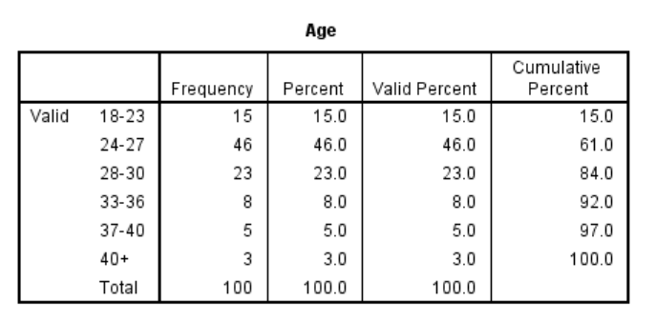

Table 4.1: Age
(Source: Self-created)
The provided figure reflects the demographic analysis depending on the age of the participants. The age groups that are involved in the study are 18-23, 24-27, 28-30, 33-36, 37-40, and 40+ years old. Individuals aged 24 to 27 years are the participants in the survey.
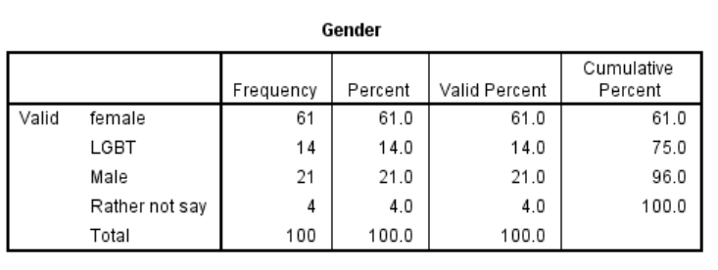

Table 4.2: Gender
(Source: Self-created)
The above figure is the outcome of the “demographic analysis” enlightening the gender of the participants. As per the data, it is noticed that females have participated most in the execution of the survey.

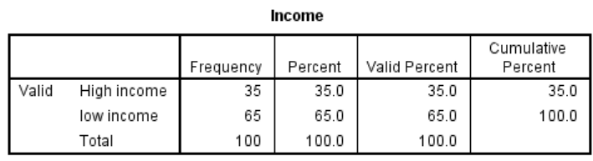Table 4.3: Income
(Source: Self-created)
The given figure reflects the outputs of the income level of the participants that are included in the surveys. The high and low levels of salary are analysed in the test. The individuals with low income mostly participated in the survey.

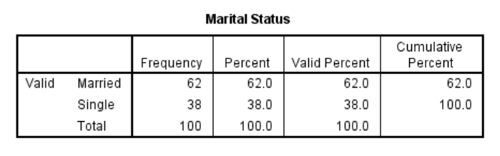Table 4.4: Marital status
(Source: Self-created)
The outcomes table; implies that most of the participants of the surveys are married, that is 62%. Therefore, the outcomes of the study are a reflection of the opinions of the married participants.
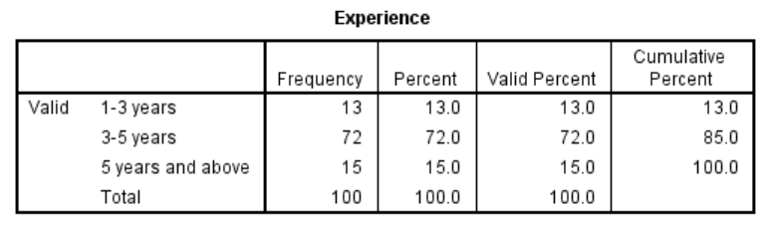

Table 4.5: Experience
(Source: Self-created)
The output table gives data associated with the experience of the participants of the survey. The data of the study shows that most of the participants are of 3 to 5 years. Hence, their responses reflect the opinions influenced by their working experience.

4.3 Descriptives Statistics
Descriptive test of H1
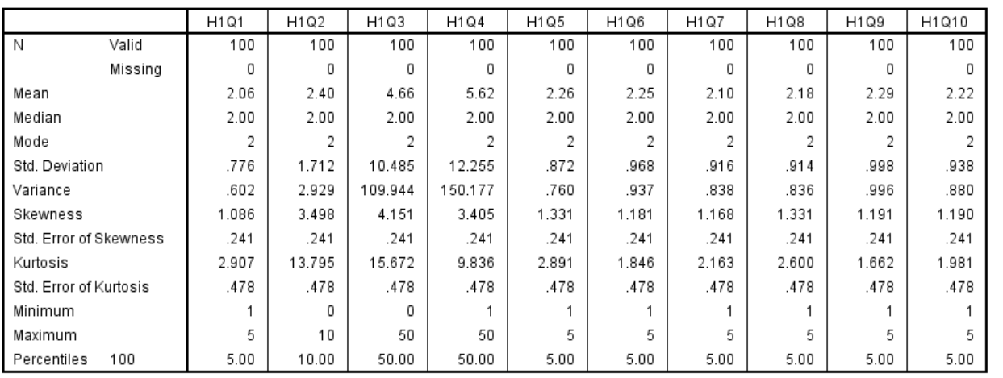

Table 4.6: Descriptive statistics
(Source: Self-created)
Table 4.6 shows a trend of “non-normal distributions” from the above output of distribution between the implementation of physical and mental health policies (IV1) and the Overall organizational health of Tesco (DV). This type of distribution range has come due to all positive skewness and larger than 1 value referring to the distribution of a “right-skewed.”
Descriptive test of H2
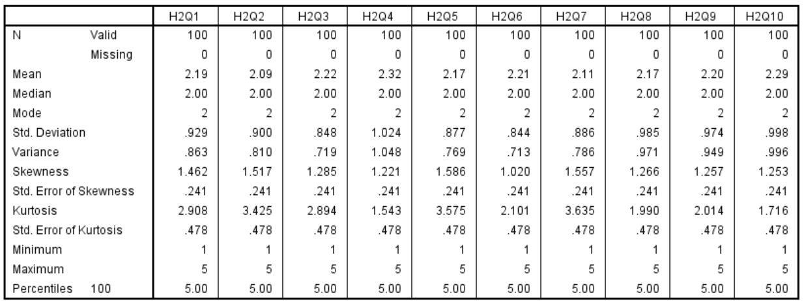

Table 4.7: Descriptive statistics
(Source: Self-created)
From the above output a trend of “leptokurtic distributions” has been found between employee feedback on health initiatives (IV2) and overall organizational health of Tesco (DV) from the data set.
Descriptive test of H3
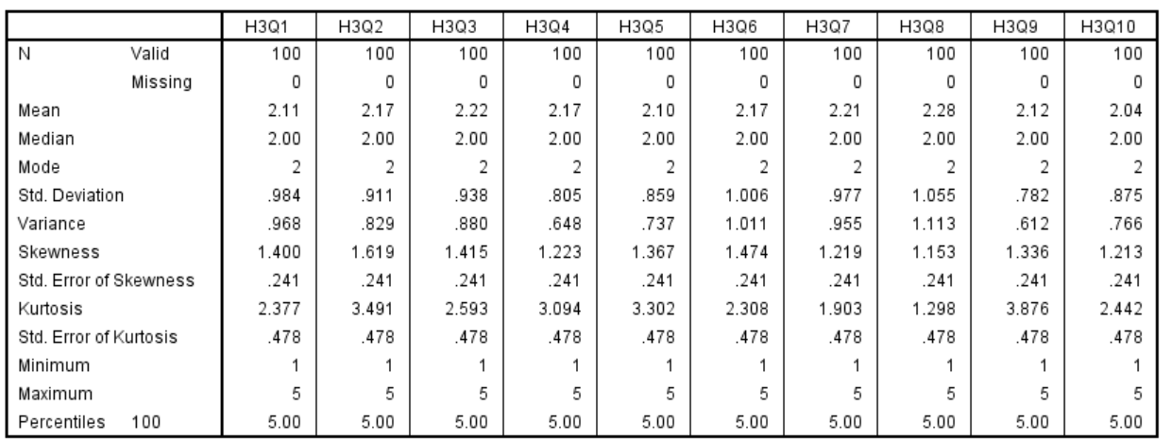

Table 4.8: Descriptive statistics
(Source: Self-created)
Table 4.8 refers to “all above 1” “skewness values” that show “leptokurtic characteristics” as the distribution range of enhancement of employee wellbeing (IV3) and overall organizational health of Tesco (DV) in this research.

4.4 Reliability test
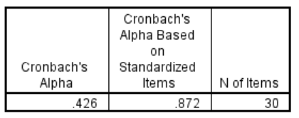

Table 4.9: Reliability output
(Source: Self-created)
Table 4.9 refers to 0.426 as ‘Cronbach's Alpha” which shows poor reliability or “internal consistency” among physical and mental health policies (IV1), employee feedback on health initiatives (IV2), enhancement of employee wellbeing (IV3), and overall organizational health of Tesco (DV) as this value was lower than the range of 0.7. On the other hand, 0.872 has become the value of “Cronbach's Alpha Based on Standardized Items” where extreme reliability has been observed among these variables due to the “standardized” nature of the items. Therefore, moderate to positive reliability has been found among the variables in this research.

4.5 Validity test
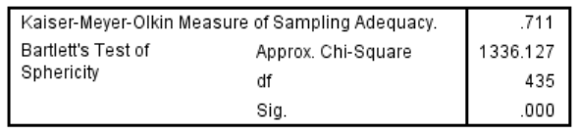

Table 4.10: KMO and Battlers test
(Source: Self-created)
Table 4.10 shows 0.711 as the “KMO measure” that refers to “middling” phases of “sampling adequacy” among the variables in this research. As these values come under the range of 0.7 to 0.9 therefore, the suitability of the data among these variables was shown from this output. 1336.127, on the other hand, has been identified as an “approximate Chi-Square” measurement. Therefore, this type of high association and positive significant value (0.000) also refers to the suitability of physical and mental health policies (IV1), employee feedback on health initiatives (IV2), enhancement of employee wellbeing (IV3), and overall organizational health of Tesco (DV) for factor analysis in this research.

4.6 Inferential Statistics

4.6.1 Correlation test
Correlation test of H1
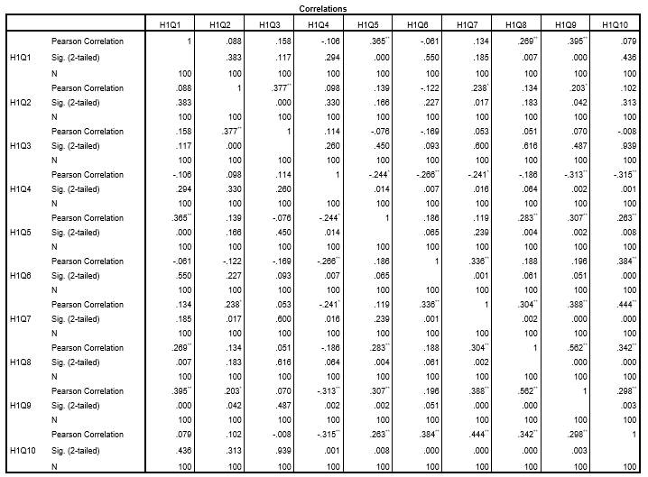

Table 4.11: Pearson correlation output
(Source: Self-created)
Table 4.11 shows that all the variables show different degrees of interdependencies along with multiple correlations demonstrating meaningful linkages. For example, 8q has a positive correlation with 9q where the r value was .562. On the other hand, 1q has positive correlations with 5q, and 8q with the R-values such as .365 and .269 in this research.
Correlation test of H2
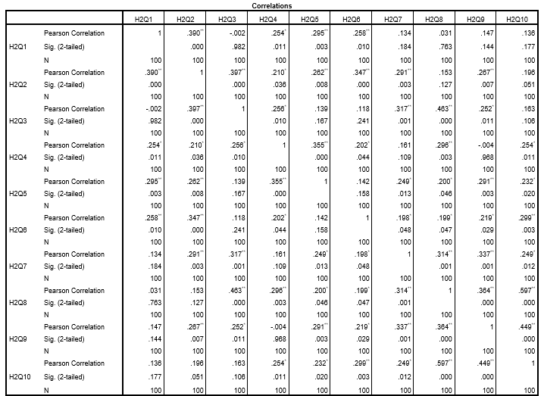

Table 4.12: Pearson correlation output
(Source: Self-created)
Table 4.12 shows Pearson correlation among 10 questions of employee feedback on health initiatives (IV2) where 1q shows a positive and effective correlation with 5q and 6q with the r values of .390 and .295. On the other hand, 3q has a positive association with q8 and the R-value became .296. Moreover, 9q shows the strongest connectivity with 10q and the R-value became .449, and this outcome refers to meaningful collaborations or associations with each other.
Correlation test of H3
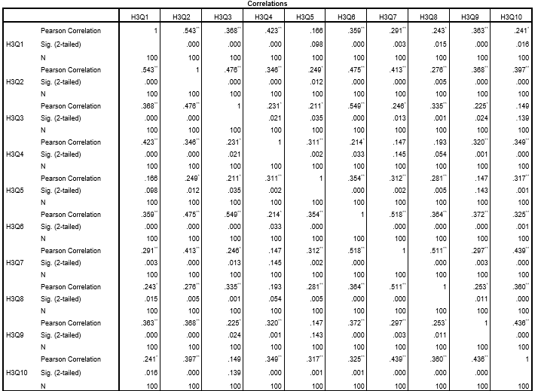

Table 4.13: Pearson correlation output
(Source: Self-created)
Table 4.13 shows the “Pearson correlation” output between the enhancement of employee wellbeing (IV3), and the Overall organizational health of Tesco (DV) where the 1q has a positive correlation with most of the other variables particularly with 1q and 2q with 543 and .423 as the R-values. On the other hand, q3 has a moderate correlation with 6q where the r value was 0.549. Moreover, all these variables of H1 were shown “varying degrees of interdependencies” with multiple affecting correlations referring to moderate to strong connectivity’s or associations.

4.6.2 Multiple regression
Multiple regression test of H1
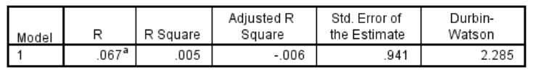

Table 4.14: Model summary
(Source: Self-created)
Table 4.14 shows 0.067 as the R-value that shows a weak correlation between the implementation of physical and mental health policies (IV1) and the overall organizational health of Tesco (DV). 0.005, on the other hand, as the “R Square value” fosters that only 0.5% of the data difference in the overall organizational health of Tesco (DV) is described by the implementation of physical and mental health policies (IV1) suggesting less explanatory ability. After that, (0.006) as the “Adjusted R Square” value refers that this “linear relationship” did not develop the anticipation of the overall organizational health of Tesco (DV) when adjusted for the number of anticipations.
0.941, as the “standard error” value shows the average distance that has highlighted values falls from the linear model. Ultimately, 2.285 as the d-w test value refers to “autocorrelation” between the implementation of physical and mental health policies (IV1) and the overall organizational health of Tesco (DV) in this research.
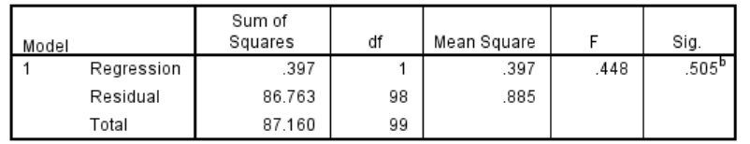

Table 4.15: ANOVA
(Source: Self-created)
Table 4.21 shows to 98.590 as a total of “regression and residual” along with 99 dfs, 29.845 F value, and 41.097 as mean square value. ANOVA test has been used to highlight and examine the difference between the means of more than two communities (Ariska et al. 2020). In this context, 0.505 has been identified as a significant value of the implementation of physical and mental health policies (IV1). Therefore, no such positive relationship between the implementation of physical and mental health policies (IV1) and the overall organizational health of Tesco (DV) has been found in this research.
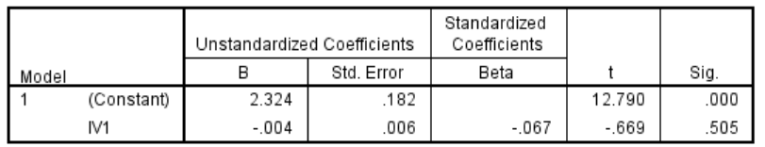

Table 4.16: Coefficient
(Source: Self-created)
Table 4.16 shows the coefficient output where 0.505 as the significant value of the implementation of physical and mental health policies (IV1) became larger than 0.05. Therefore, no such relationship between the implementation of physical and mental health policies (IV1) and the overall organizational health of Tesco (DV) has been found in this research.
Multiple regression test of H2
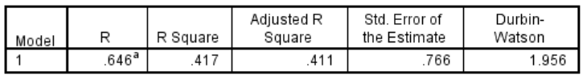

Table 4.17: Model summary
(Source: Self-created)
Table 4.17 refers to 0.064 as the R-value along with 0.417 as the “R-square” value. These values refer to the weaker correlation between employee feedback on health initiatives (IV2) and the overall organizational health of Tesco (DV). Therefore the “R Square value” highlights that only 0.4% of the data difference in the overall organizational health of Tesco (DV) was elaborated by employee feedback on health initiatives (IV2) suggesting less explanatory power. After that, 0.411 as the “Adjusted R Square” value refers that this “linear relationship” helps to develop the anticipation of the overall organizational health of Tesco (DV) when adjusted for the number of anticipations.
0.766, which has been identified as a “standard error” value shows the average distance that has reflected values fall from the linear relationship framework. Ultimately, 1.956 as the d-w test value refers to “no autocorrelation” between employee feedback on health initiatives (IV2) and the overall organizational health of Tesco (DV) in this research.
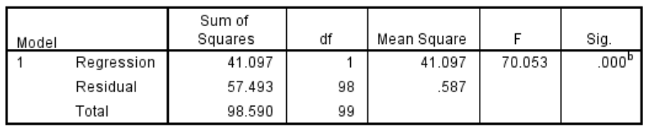

Table 4.18: ANOVA
(Source: Self-created)
Table 4.18 shows the output of ANOVA along with 41.097 as the mean square and 70.053 as the F value. On the other hand, 0.000 as F values a positive and encouraging relationship between employee feedback on health initiatives (IV2) and the overall organizational health of Tesco (DV).
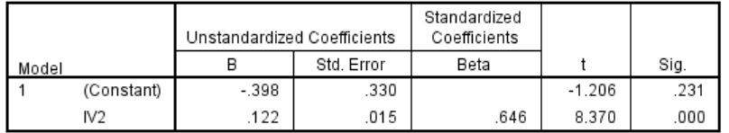

Table 4.19: Coefficient
(Source: Self-created)
The above output refers to a positive relationship between employee feedback on health initiatives (IV2) and the overall organizational health of Tesco (DV) as the significant value of IV2 was lesser than the range of 0.05.
Multiple regression test of H3
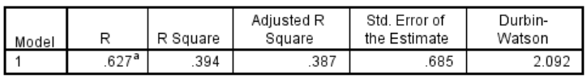

Table 4.20: Model summary
(Source: Self-created)
Table 4.20 shows a 0.627 as the “R-value” that shows a moderate to strong correlation between enhancement of employee wellbeing (IV3), and the Overall organizational health of Tesco (DV) in this research. On the other hand, 0.394 as the “R Square value” refers to around 39.4% of data differences in the Overall organizational health of Tesco (DV) and is described by enhancement of employee wellbeing (IV3) referring to an effective level of explanatory ability. However, 0.387 as the “Adjusted R Square” value was on the lower side in comparison to the “R Square” value in this model. Furthermore, 0.685 is the valuation of the “standard error of the estimate” demonstrating a moderate distance that highlights values deducted from the regression lineup.
Lastly, “autocorrelation” between enhancement of employee wellbeing (IV3), and overall organizational health of Tesco (DV) has been found in this research depending on 2.092 as the D-W test value.
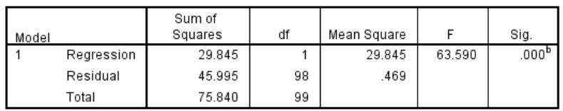

Table 4.21: ANOVA
(Source: Self-created)
Table 4.21 refers to 75.841 as a total of “regression and residual” along with 99 dfs and 29.845 F value. ANOVA has been comparing the means of two or more independent groups to determine in case there is a piece of statistical evidence that is linked to population means that are particularly different (Sadriddinovich, 2023). 0.000 has been identified as a significant value of enhancement of employee wellbeing (IV3) and this shows a positive relationship of enhancement of employee wellbeing (IV3) with the Overall organizational health of Tesco (DV).
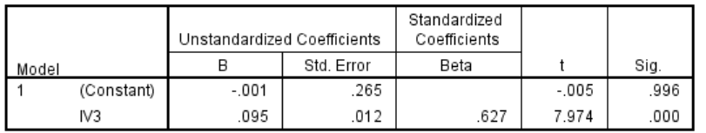

Table 4.22: Coefficient
(Source: Self-created)
Therefore, there was a positive relationship between the enhancement of employee wellbeing (IV3), and the Overall organizational health of Tesco (DV) as the significant value of IV3 was smaller than 0.05 in this research.

4.6.2 Hypothesis testing
The purpose of hypothesis testing is to test whether the null hypothesis can be approved or rejected. If the null hypothesis faces rejection, then the research hypothesis can be accepted. On the other hand, if the null hypothesis has become significant the core research objective is rejected (Afifah et al. 2022). In this context, 5% or 0.05 is the common choice for significance for the statistical tests. Therefore, hypothesis testing of the variables is presented in a table format below.
HYPOTHESIS STATEMENTS | SIGNIFICANT VALUES | OUTCOMES
H1: “Robust physical health initiatives by HRM lead to fever workless injuries and illness, saving cost and boosting efficiency.” | 0.505 | Not significant
H2: “Effective mental health programs driven by employee motivation reduce stress, and increase job satisfaction.” | 0.000 | Significant
H3: “Proactive HRM involvement in health policies fosters trust and loyalty.” | 0.000 | Significant

Table 4.23: Hypothesis testing
(Source: Self-created)
Table 23 shows hypothetical relationships among the independent and dependent variables in this research including, the implementation of physical and mental health policies (IV1), employee feedback on health initiatives (IV2), enhancement of employee wellbeing (IV3), and overall organizational health of Tesco (DV). In this context, if the significant values of the independent variables became less than 0.05 then only a positive relationship or encouragement has been found between IV and DV. However, if the significant value of IV became larger than 0.05 then no such encouragement or positive relationship has been found between the IV and DV. 0.505, 0.000, and 0.000 were the significant values of the IVs in this research. Therefore, based on the significant values of these variables modified hypothetical relationships are presented below.
H1: “Robust physical health initiatives by HRM did not lead to fever workless injuries and illness, saving cost and boosting efficiency.”
H2: “Effective mental health programs driven by employee motivation reduce stress, and increase job satisfaction.”
H3: “Proactive HRM involvement in health policies fosters trust and loyalty.”
Therefore, employee feedback on health initiatives (IV2) and enhancement of employee wellbeing (IV3) have positive relationships with the Overall organizational health of Tesco (DV) in this research as significant values of these variables are less than 0.05 (0.000). On the other hand, the implementation of physical and mental health policies (IV1) did not have any encouragement on Overall organizational health of Tesco (DV) “to discuss the significance of HRM in promoting physical and mental health policies in the modern multinational companies of the UK,” as the significant the value (0.505) was larger than 0.05.

4.7 Discussion
The study evaluates the role of HRM in the promotion purpose of physical and mental policies in MNCs in the UK that are modern. The study enlightens the data of Tesco and the employees are surveyed to analyse the orioles. "Robust physical health initiatives by HRM lead to fever, workless injuries and illness, saving cost and boosting efficiency" is the first hypothesis of the study is considered as false as no connectivity is analysed by implicating the associated data. As per the view of Li et al. (2023), promoting physical health initiatives including clear objectives by the HRM is effective in the improvement of the health conditions of the employees. The improvement is effective on the performance of the employees. On the other hand, according to Rheinberg and Engeser (2018), clear message serving by applying the organisational policies is needed as these are effective on the psychological factors of the employees. Financial investments are also done by organisations for their employees. Somehow, it is found by analysing data from the research that the mental parameters are not controlled by the initiatives of HRM. The boosting of the initiatives is not effective in the manner mentioned in the hypothesis.
The second hypothesis that is "effective mental health programs driven by employee motivation reduce stress, and increase job satisfaction" is true as the significant value is less than 0.05. The involvement of the HRM in the program for promoting mental and physical health policies is helpful to enhance the purpose of the programs. Caligiuri et al. (2020) states inclusion of “specific lines of actions” is needed in the programs. These are helpful in measuring the "employee satisfaction rate" to understand the mental condition of the employees. On the contrary, Rheinberg and Engeser (2018) enlighten the significance of HRM in providing mental support to the employees of business organisations. The purposes of the programs need to be clear to achieve adequate outcomes from programs. The programs that are most effective in the matter are "Stress management workshops" as these are helpful in analysing the parameters causing stress among employees and ways of managing the stress. Hence, the hypothesis is analysed as true as the effectiveness of the programs is noticed in the responses of the employees included in the surveys for the study.
The third hypothesis of the study "Proactive HRM involvement in health policies fosters trust and loyalty" is analysed as true as the trust and loyalty of the employee are achieved by implementing the involvement of HRM. Obrad and Gherheș, (2018) state communication with the human resource department is salient in analyzing the mental health and well-being of the employees. Help and support are served to the employees by the management of the business organisation. The mental and physical health of the employees is improved by applying support from the HRM department of the business entity. On the other hand, Cooke et al. (2024) evaluate the need for HRM practices to increase the competitive advantages of the organisation and also increase the assets of the entity to achieve the goals of the business procedure. The HRM are responsible for creating mental stress in some cases as the management is responsible for recruiting, managing and deploying the employees. The human resource department is considered as it is responsible for the creation and implication of policies in a business entity. Motivation to the employees is provided by the management of the organisation that is effective in the mental health of employees of business entity. The "employee motivation program" is influential on the performance level and causes of the performance of the employees.

4.8 Summary
This research aims to “discuss the significance of HRM in promoting physical and mental health policies in the modern multinational companies of the United Kingdom”. Thus, to achieve this aim, this chapter has incorporated a statistical analysis method with the help of SPSS software. Statistical tests such as descriptive, reliability, validity, correlation, and multiple regression have been performed. In this context, the response has become 100% as 100 out of 100 employees of Tesco Plc have recorded their responses to all the survey questions. Based on the hypothetical statements implementation of physical and mental health policies (IV1), employee feedback on health initiatives (IV2), enhancement of employee wellbeing (IV3), and overall organizational health of Tesco (DV) have been identified as independent and dependent variables where moderate to positive relationship has found among them.

Chapter 5: Conclusion and recommendations

5.1 Overall Summary
This entire research usually aims to evaluate the key significance of HRM in promoting physical and mental health policies in the modern multinational companies of the UK. From the background discussion of this entire research, it concludes that the HRM mostly concentrates on creating a significant and positive work environment and addressing the concerns of the employees to further develop the employees’ mental and physical health within the multinational companies (MNCs). Further, it concludes that a positive work culture not only enhances the satisfaction rates of the employees but similarly, it contributes to the enhancement of positive results and a large level of employee satisfaction within the workplace in this present business context. In addition, from the overall discussion, it further concludes that the MNCs are directly allowing HRM to initiate several training sessions and workshops with the effective purpose of educating the employees and the managers about the physical and mental health of employees. Moreover, it can be summarized that the training programs can easily help the employees to make a detailed idea on “stress management techniques”. Throughout the overall discussion, it further concludes that Tesco PLC is required to directly examine the HRM strategies which can effectively increase the well-being of employees. Additionally, it concludes that an effective HRM strategy directly promotes the health and well-being of employees and it significantly leads to the saving of operating costs associated with absenteeism and healthcare. Efficient HRM policies potentially lead to generating better results on behalf of any organisation and similarly, it is highly cost-effective. Proactive HRM practices directly allow for the early finding out of several health issues through daily assessment and screening. Further, it concludes that HR departments of different companies have creatively organised workshops and subsequently training programs with a clear intention to educate the employees about mental health conditions in this common business platform.
On the other hand, from problem statement analysis it concludes that continuous promotion of awareness among company’s employees’ health and it is applicable in multinational companies in view of that the employees are directly facing difficulties in managing balance between their corporate life and personal life. From the discussion of the relevance of this research, it concludes that Tesco is only focusing on their performance levels in view of that without them it would be not creatively possible for them to continue the overall business operations in future. From the outcome of the literature review, concludes that employees of Tesco are much available to directly maintain a significant balance between work life and personal life and gain the objectives of Tesco UK. In addition, as per the theoretical framework discussion, it concludes that HR activities and measurements are directly distinguished into several categories such as HRM activities and outcomes.
Additionally, several kinds of literature refer that the key execution of mental health programs has been driven by several employee motivations which include the employee well-being within the work environment. Further, it concludes that proactive and efficient HRM mostly concentrate on enhancing a positive work environment within the workplace where employees can easily feel highly satisfied and similarly motivated. The SPSS analysis refers to the overall organisational health of Tesco as a dependent variable (DV) whereas three independent variables are implementation of physical and mental health policies (IV1), employee feedback on health initiatives (IV2), and enhancement of employee wellbeing (IV3). As per the reliability moderate to positive reliability has been seen and IV1 and DV have no direct relationship. Additionally, IV2 and IV3 have a relationship with DV.

5.2 Linking with Objectives
Objective 1
From the literature review discussion, it refers that HR team members within an organisation have mostly taken several kinds of approaches to develop the health conditions of the employees and also give flexibility. However, 2.2.1 describes that life insurance and health insurance opportunities to the employees by the HRM department ensure the promotion of positive health and well-being of employees. Similarly, the findings section refers to the robust physical health initiative by the HRM significantly decreasing workplace injuries and illness. Therefore, it means that objective 1 is firmly justified with findings.
Objective 2
From the literature review discussion, it refers to “mental health programs” that have been referred to as planning which has included specific lines of actions which has been needed to develop employee satisfaction rate within the workplace. Further, 2.2.2 sections reveal that the “Operating mental health programs” have directly evaluated the strong commitment of companies to support the overall health and happiness of employees in this present business situation. Subsequently, findings state that job satisfaction is the relevant part that the employees feel much more effective with their jobs within an organisation. Additionally, it indicates that efficient health programs enhance the employee's satisfaction rates but subsequently employees feel highly motivated to stay in the companies. Therefore, it indicates that objective 2 is relevantly related to the research findings.
Objective 3
From the literature review discussion, it concludes that the HRM department recognises the fact that it is much more challenging to remember all the employees in multinational companies, in view of that reason the key “employee recognition program” mostly allows employees to stay motivated and satisfied. Additionally, 2.2.3 refers to lack of skilled HR and proactive HRM strategy is the challenge for Tesco in promoting health policy. Similarly, multinational companies have a strong and wide range of employee base and it is a difficult task for the HR department to manage them efficiently and time to time. Sometimes, these challenges obstruct the HR department from efficiently looking after the health and well-being of every employee, as Tesco as an MNC faces this issue. Therefore, it refers that objective 3 is justified with findings.
Objective 4
2.2.6 section of the literature review suggests that a proper, positive and conducive work environment has directly enhanced the loyalty and trust of the employees. Further, this section reveals that Tesco recognises the key fact that mental and physical stress levels are enhancing rapidly among employees. To avoid this proactive HRM involvement is required. Similarly, the findings section states that lack of communication between the HR department and employees creates huge misconceptions and as an outcome, the employee retention rates have been decreased totally. Therefore, employee feedback on health initiatives can enhance quality of the overall organisational health of Tesco.

5.3 Future scope of research
This study helps explain the role of HRM in promoting physical and mental health policies in modern MNCs in the UK. Therefore, as one of the promising MNCs of the UK, this study purely focuses on Tesco PLC. In modern times, the mental well-being of employees is quite the priority for a business. It is also applicable to the employees of multinational businesses who are constantly facing challenges in balancing work and life. However, the HR management team comes into play to improve approaches to dealing with employees alongside their rewards and responsibilities as well. Hence, it is the responsibility of the HRM team of MNC to understand how much stress and added pressure the employees are going through. In order to do so, the ability of HRM to conduct physical and mental health policies for betterment in MNCs of the UK is evaluated in this study. This study can act as a guideline to the HRM of different MNCs for improving their policies and approaches to improve the physical and mental health of the employees.

5.4 Limitations
Limitations of the studies usually denote the gap that has been found while conducting research and can impact the result in some way or another. However, a transparent declaration of limitations improves the reliability of the study. The first limitation of this study is the utilisation of only quantitative measures. The researcher has focused on SPSS analysis which is a quantitative form of analysis and has collected the data using Google Forms which is another quantitative measure. Even though the quantitative measures have been extremely helpful for collecting updated data, the lack of perspective or critical evaluation of past trends or data is missing which is one major limitation of this study. On top of that, the researcher has chosen the inferential statistics method for evaluating the data. The major disadvantage of inferential statistics is that it is difficult to choose appropriate statistical methods for the given problem which leads to incorrect conclusions. Therefore, it serves as another major limitation of the study.

5.5 Recommendations
In order to implement HRM policies to improve the physical and mental health of the employees in modern MNCs of the UK there are challenges such as diverse work culture, inconsistencies in the application of policy, lack of awareness of mental health issues, and stigma, improper alignment between business strategy and health initiative, and managing privacy. These challenges usually make it difficult for the HRM of MNC to create sufficient policies to improve the mental and physical well-being of the employees.
In MNCs, especially under global teams, people from different backgrounds usually work through collaboration. Therefore, diversity in culture is one of the biggest challenges as it does not support the implementation of similar policies for all (Dover et al., 2020). As it says “one size does not fit all”, similarly, the HRM department of MNCs finds it extremely difficult to properly create different perceptions of the employees from the global team. In order to overcome this challenge, and implement health as well as mental well-being policies, the HR team of MNCs such as Tesco must develop a health program that understands the sensitivity of different cultures (Reis and Molento, 2020). Besides, it is also important for the HR managers to provide proper education and training to other staff on cultural diversity to treat employees of different backgrounds quite equally.
On top of that, HR managers usually develop one policy that is implemented in different regions. However, the mental and health demands of employees of different areas can be different as well. This makes one concentrated policy effective for some and ineffective for others (Rosenberg et al., 2023). Therefore, in order to overcome this challenge, a MNC must audit the requirements of regional employees, and try to make personalized help and mental well-being policies according to regional demand. This measurement can improve the consistency of the application of policies for different areas.
On top of that, in order to create health and mental well-being programs for employees it is important for a charge to collect related data from the employees. However, the confidential nature of health data regularly challenges the HR team in terms of maintaining proper security (Thapa and Camtepe, 2021). This is one of the biggest challenges in the way of implementing proper policies for employee well-being. However, in order to overcome this specific challenge, the HR team of MNCs such as Tesco must implement a collection system that can collect data in an anonymous method. Besides collecting confidential data in an anonymous manner, it is also important for businesses to show great compliance with data protection regulations.
Apart from privacy issues, the awareness related to poor mental health and stigma is not as much known within the industry. The employees are not always comfortable talking about stigma and poor mental health conditions in an open manner due to the fear of judgment (Ong et al., 2020). Therefore, lack of judgment is extremely challenging to overcome while creating and implementing policies related to health and mental wellness. However, in order to overcome this challenge, the HRM teams of MNCs unlike Tesco must create meaningful campaigns that can help improve the awareness regarding the matter. Besides improving awareness regarding mental health issues or stigma, the employees can be also given classified solacing sessions. These sessions can be extremely helpful for the employees to open up and share their mental or physical health problems as well as a related stigma to get proper piece of advice and also medications to deal with the existing issues.

References
Afifah, S., Mudzakir, A. and Nandiyanto, A.B.D., 2022. How to calculate paired sample t-test using SPSS software: From step-by-step processing for users to the practical examples in the analysis of the effect of application anti-fire bamboo teaching materials on student learning outcomes. Indonesian Journal of Teaching in Science, 2(1), pp.81-92. https://ejournal.upi.edu/index.php/IJoTis/article/download/45895/19002
Ariska, M., Fahru, M. and Kusuma, J.W., 2020. Leverage, ukuran perusahaan dan profitabilitas dan pengaruhnya terhadap tax avoidance pada perusahaan sektor pertambangan di Bursa Efek Indonesia tahun 2014-2019. Jurnal Revenue: Jurnal Ilmiah Akuntansi, 1(1), pp.133-142. https://www.revenue.lppmbinabangsa.id/index.php/home/article/download/13/131
Banks, G.C., Woznyj, H.M., Wesslen, R.S., Frear, K.A., Berka, G., Heggestad, E.D. and Gordon, H.L., 2019. Strategic recruitment across borders: An investigation of multinational enterprises. Journal of Management, 45(2), pp.476-509.
Bauer, G.R., Churchill, S.M., Mahendran, M., Walwyn, C., Lizotte, D. and Villa-Rueda, A.A., 2021. Intersectionality in quantitative research: A systematic review of its emergence and applications of theory and methods. SSM-population health, 14, p.100798.
Bolisetty, P.K., Sharma, P. and Bhattacharya, S., 2023. Sustainable Health in the Era of Work from Anywhere. Australasian Accounting, Business and Finance Journal, 17(1), pp.51-67.
Bratton, J., Gold, J., Bratton, A. and Steele, L., 2021. Human resource management. Bloomsbury Publishing.
Brunetto, Y., Farr-Wharton, R. and Shacklock, K. (2011) ‘Using the Harvard HRM model to conceptualise the impact of changes to supervision upon HRM outcomes for different types of Australian Public Sector Employees’, The International Journal of Human Resource Management, 22(3), pp. 553–573. doi:10.1080/09585192.2011.543633.
Caligiuri, P., De Cieri, H., Minbaeva, D., Verbeke, A. and Zimmermann, A., 2020. International HRM insights for navigating the COVID-19 pandemic: Implications for future research and practice. Journal of international business studies, 51, pp.697-713.
Cavanagh, J., Wang, Y., Meacham, H., Byrne, L. and Bartram, T., 2022. Human Resource Management Challenge to Innovate to Support Employees With Disability and Mental Health Challenges. In The Emerald Handbook of Work, Workplaces and Disruptive Issues in HRM (pp. 189-205). Emerald Publishing Limited.
Chen, C.F., de Rubens, G.Z., Noel, L., Kester, J. and Sovacool, B.K., 2020. Assessing the socio-demographic, technical, economic and behavioural factors of Nordic electric vehicle adoption and the influence of vehicle-to-grid preferences. Renewable and Sustainable Energy Reviews, 121, p.109692
Cheng, C.H.I., 2018. Exploring the linkage between CSR, HRM and sustainability: a case study of a Japanese MNC in China and its transformation after the Global Financial Crisis. 立命館経営学, 56(6), pp.367-404.
Collins, M. (2016) ‘Multinational Enterprises and the global economy’, Transnational Corporations, 19(3), pp. 103–106. doi:10.18356/43ce1fe7-en.
Cooke, F.L., Dickmann, M. and Parry, E., 2024. Developing organizations’ dynamic capabilities and employee mental health in the face of heightened geopolitical tensions, polarized societies and grand societal challenges. The International Journal of Human Resource Management, 35(5), pp.767-778.
Cooke, F.L., Schuler, R. and Varma, A., 2020. Human resource management research and practice in Asia: Past, present and future. Human Resource Management Review, 30(4), p.100778.
Dasgupta, P., Carbery, R. and McDonnell, A., 2022. Human resource management in multinational corporations. In The Emerald handbook of work, workplaces and disruptive issues in HRM (pp. 67-86). Emerald Publishing Limited.
De Cieri, H. and Lazarova, M., 2021. “Your health and safety is of utmost importance to us”: a review of research on the occupational health and safety of international employees. Human Resource Management Review, 31(4), p.100790.
Dickmann, M., 2021. International human resource management–historical developments, models, policies and practices in MNCs. Contemporary human resource management: Text and cases, p.225.
Dover, T.L., Kaiser, C.R. and Major, B., (2020). Mixed signals: The unintended effects of diversity initiatives. Social Issues and Policy Review, 14(1), pp.152-181.
Fox, M.P., MacLehose, R.F. and Lash, T.L., 2021. Applying quantitative bias analysis to epidemiologic data (pp. 105-39). Cham (Switzerland): Springer.
Gabriel, A.S., Arena Jr, D.F., Calderwood, C., Campbell, J.T., Chawla, N., Corwin, E.S., Ezerins, M.E., Jones, K.P., Klotz, A.C., Larson, J.D. and Leigh, A., 2022. Building thriving workforces from the top down: A call and research agenda for organizations to proactively support employee well-being. Research in personnel and human resources management, pp.205-272.
Ghani, B., Zada, M., Memon, K.R., Ullah, R., Khattak, A., Han, H., Ariza-Montes, A. and Araya-Castillo, L., 2022. Challenges and strategies for employee retention in the hospitality industry: A review. Sustainability, 14(5), p.2885.
Godwin, A., Benedict, B., Rohde, J., Thielmeyer, A., Perkins, H., Major, J., Clements, H. and Chen, Z., 2021. New epistemological perspectives on quantitative methods: An example using topological data analysis. Studies in Engineering Education, 2(1), pp.16-34.
Hamouche, S., 2023. Human resource management and the COVID-19 crisis: Implications, challenges, opportunities, and future organizational directions. Journal of Management & Organization, 29(5), pp.799-814.
He, B., An, R. and Berry, J., 2019. Psychological adjustment and social capital: a qualitative investigation of Chinese expatriates. Cross Cultural & Strategic Management, 26(1), pp.67-92.
Højgaard, L. (2018) ‘Workplace culture, family-supportive policies and gender differences’, WOMEN, WORK AND THE FAMILY IN EUROPE, pp. 140–150. doi:10.4324/9780203442845_chapter_13.
Hooi, L.W., 2021. Leveraging human assets for MNCs performance: the role of management development, human resource system and employee engagement. The International Journal of Human Resource Management, 32(13), pp.2729-2758.
Hou, Z. and Aryadoust, V., 2021. A review of the methodological quality of quantitative mobile-assisted language learning research. System, 100, p.102568.
Jain, A., Hassard, J., Leka, S., Di Tecco, C. and Iavicoli, S., 2021. The role of occupational health services in psychosocial risk management and the promotion of mental health and well-being at work. International journal of environmental research and public health, 18(7), p.3632.
Jaiswal, A., Arun, C.J. and Varma, A., 2022. Rebooting employees: Upskilling for artificial intelligence in multinational corporations. The International Journal of Human Resource Management, 33(6), pp.1179-1208.
Jia, M., Gu, Y., Chen, Y., Tu, J., Liu, Y., Lu, H., Huang, S., Li, J. and Zhou, H., 2022. A methodological study on the combination of qualitative and quantitative methods in cognitive interviewing for cross‐cultural adaptation. Nursing open, 9(1), pp.705-713.
Johnson, A., Dey, S., Nguyen, H., Groth, M., Joyce, S., Tan, L., Glozier, N. and Harvey, S.B., 2020. A review and agenda for examining how technology-driven changes at work will impact workplace mental health and employee well-being. Australian Journal of Management, 45(3), pp.402-424.
Khor, L.K. and Tan, C.L., 2023. Workforce management in the post‐pandemic era: Evidence from multinational companies using grounded theory. Global Business and Organizational Excellence, 42(4), pp.93-104.
Li, W., Abdalla, A.A., Mohammad, T., Khassawneh, O. and Parveen, M., 2023. Towards examining the link between green hrm practices and employee green in-role behavior: spiritual leadership as a moderator. Psychology Research and Behavior Management, pp.383-396.
Malik, A. and Sanders, K., 2021. Managing human resources during a global crisis: A multilevel perspective. British Journal of Management, 32(4), pp.e1-e19.
Malik, A., Budhwar, P., Patel, C. and Laker, B., 2021. Holistic indigenous and atomistic modernity: Analyzing performance management in two Indian emerging market multinational corporations. Human Resource Management, 60(5), pp.803-823.
Mer, A., 2023. Artificial Intelligence in Human Resource Management: Recent Trends and Research Agenda. Digital Transformation, Strategic Resilience, Cyber Security and Risk Management, 111, pp.31-56.
Meyer, J.P., Becker, T.E. and Vandenberghe, C. 2014 ‘Employee commitment and motivation: A conceptual analysis and integrative model.’, Journal of Applied Psychology, 89(6), pp. 991–1007. doi:10.1037/0021-9010.89.6.991.
Meyer, K.E. and Xin, K.R., 2018. Managing talent in emerging economy multinationals: Integrating strategic management and human resource management. The International Journal of Human Resource Management, 29(11), pp.1827-1855.
Moeller, M. and Maley, J.F., 2018. MNC considerations in identifying and managing LGB expatriate stigmatization. International Journal of Management Reviews, 20(2), pp.325-342.
Mohajan, H.K., 2020. Quantitative research: A successful investigation in natural and social sciences. Journal of Economic Development, Environment and People, 9(4), pp.50-79.
Moises Jr, C., 2020. Online data collection as adaptation in conducting quantitative and qualitative research during the COVID-19 pandemic. European Journal of Education Studies, 7(11).
Obrad, C. and Gherheș, V., 2018. A human resources perspective on responsible corporate behavior. Case study: The multinational companies in western Romania. Sustainability, 10(3), p.726.
Ong, W.J., Shahwan, S., Goh, C.M.J., Tan, G.T.H., Chong, S.A. and Subramaniam, M., 2020. Daily encounters of mental illness stigma and individual strategies to reduce stigma–perspectives of people with mental illness. Frontiers in Psychology, 11, p.590844.
Paauwe, J. and Boon, C. 2018 ‘Strategic HRM’, Human Resource Management, pp. 49–73. doi:10.4324/9781315299556-3.
Reis, G.G. and Molento, C.F.M., 2020. Emerging market multinationals and international corporate social responsibility standards: bringing animals to the fore. Journal of Business Ethics, 166, pp.351-368.
Rheinberg, F. and Engeser, S. (2018) ‘Intrinsic motivation and flow’, Motivation and Action, pp. 579–622. doi:10.1007/978-3-319-65094-4_14.
Rodríguez-Fernández, M., Herrera, J. and de Las Heras-Rosas, C., 2021. Model of organizational commitment applied to health management systems. International journal of environmental research and public health, 18(9), p.4496.
Rosenberg, S., Lawson, K. and Hickie, I., 2023. Centralisation versus regionalisation: Designing the Sixth National Mental Health Plan. Australian Journal of Public Administration, 82(2), pp.290-301.
Sadriddinovich, J.T., 2023. Capabilities of SPSS Software in High Volume Data Processing Testing. American Journal of Public Diplomacy and International Studies (2993-2157), 1(9), pp.82-86. http://grnjournal.us/index.php/AJPDIS/article/download/1256/1067
Schaufeli, W., 2021. Engaging leadership: how to promote work engagement?. Frontiers in psychology, 12, p.754556.
Stahl, G.K., Brewster, C.J., Collings, D.G. and Hajro, A., 2020. Enhancing the role of human resource management in corporate sustainability and social responsibility: A multi-stakeholder, multidimensional approach to HRM. Human Resource Management Review, 30(3), p.100708.
Thanem, T. and Elraz, H., 2022. From stress to resistance: Challenging the capitalist underpinnings of mental unhealth in work and organizations. International Journal of Management Reviews, 24(4), pp.577-598.
Thapa, C. and Camtepe, S., 2021. Precision health data: Requirements, challenges and existing techniques for data security and privacy. Computers in biology and medicine, 129, p.104130.
Voordt, T.V.D. and Jensen, P.A., 2023. The impact of healthy workplaces on employee satisfaction, productivity and costs. Journal of Corporate Real Estate, 25(1), pp.29-49.
Zamora, E.A. (2016) ‘Value Chain Analysis: A brief review’, Asian Journal of Innovation and Policy, 5(2), pp. 116–128. doi:10.7545/ajip.2016.5.2.116.

Appendix: Survey Questions
Demographics
Age
- 18-23
- 24-27
- 28-30
- 33-36
- 37-40
- 40+
Gender
- Male
- female
- LGBT
- Rather not say
Income
- High income
- low income
Marital Status
- Single
- Married
Experience
- 1-3 years
- 3-5 years
- 5 years and above
H1: Robust physical health initiatives by HRM lead to fever workless injuries and illness, saving cost and boosting efficiency
- Due to robust physical health initiatives by HRM, the organisation has fewer working injuries?
- Strongly Agree
- Agree
- Neutral
- Disagree
- Strongly Disagree
- How many physical health initiatives have the company started in the last 2 years?
- 10+
- 7-10
- 4-6
- 1-3
- 0
- How many working injuries has the organisation had in the last 2 years?
- 50+
- 40-50
- 30-40 20-30
- 0-20
- 0
- How many working injuries did the organisation has from 2020-2022?
- 50+
- 40-50
- 30-40 20-30
- 0-20
- 0
5. Due to robust physical health initiatives by HRM, the organisation has fewer illness?
- Strongly Agree
- Agree
- Neutral
- Disagree
- Strongly Disagree
6. Due to robust physical health initiatives by HRM, the organisation now spends less injuries and health related expenditures?
- Strongly Agree
- Agree
- Neutral
- Disagree
- Strongly Disagree

7. Due to robust physical health initiatives by HRM, the organisation now has improved efficiency?

- Strongly Agree
- Agree
- Neutral
- Disagree
- Strongly Disagree
8. The physical health programs at Tesco Plc have contributed to a reduction in my overall illness frequency.
- Strongly Agree
- Agree
- Neutral
- Disagree
- Strongly Disagree
9. My productivity has increased due to the physical health initiatives offered by Tesco Plc
- Strongly Agree
- Agree
- Neutral
- Disagree
- Strongly Disagree

10. The physical health initiatives at Tesco Plc contribute positively to the overall work environment
- Strongly Agree
- Agree
- Neutral
- Disagree
- Strongly Disagree

H2: Effective mental health programs driven by employee motivation reduce stress, increase job satisfaction
1. The HRM executed different mental health and wellbeing policies for the employees.
- Strongly Agree
- Agree
- Neutral
- Strongly Disagree
- Disagree
2. Has the human resource department of Tesco implemented employee assistance programs?
- Strongly Agree
- Agree
- Neutral
- Strongly Disagree
- Disagree
3. The HRM offers leaves to employees to enhance mental well-being of the employees.
- Strongly Agree
- Agree
- Neutral
- Strongly Disagree
- Disagree
4. The HRM has conducted employee surveys frequently in Tesco
- Strongly Agree
- Agree
- Neutral
- Strongly Disagree
- Disagree
- I feel motivated to participate in the mental health programs offered by Tesco Plc.
- Strongly Agree
- Agree
- Neutral
- Strongly Disagree
- Disagree
- Mental health programs asked questions to the employees individually to know their stress levels
- Strongly Agree
- Agree
- Neutral
- Strongly Disagree
- Disagree
- My overall job satisfaction has improved since engaging in Tesco Plc’s mental health programs
- Strongly Agree
- Agree
- Neutral
- Strongly Disagree
- Disagree
- The mental health programs at Tesco Plc contribute positively to the overall work culture.
- Strongly Agree
- Agree
- Neutral
- Strongly Disagree
- Disagree
- I feel less stressed and more engaged at work due to the mental health support provided by Tesco Plc
- Strongly Agree
- Agree
- Neutral
- Strongly Disagree
- Disagree
- Employees are free to ask work from home in Tesco
- Strongly Agree
- Agree
- Neutral
- Strongly Disagree
- Disagree
H3: Proactive HRM involvement inhealth policies fosters trust and loyalty
1. The human resource department has organised training sessions and workshops to educate the employees on mental health awareness.
- Strongly Agree
- Agree
- Neutral
- Strongly Disagree
- Disagree
2. The HRM has offered training opportunities on stress management techniques for the employees.
- Strongly Agree
- Agree
- Neutral
- Strongly Disagree
- Disagree

3. The HRM has executed confidential counselling services in Tesco
- Strongly Agree
- Agree
- Neutral
- Strongly Disagree
- Disagree

4. The HRM is monitoring workload of the employees.

- Strongly Agree
- Agree
- Neutral
- Strongly Disagree
- Disagree
5. The HRM has advocated self-care practices such as mine fullness exercises and physical activities
- Strongly Agree
- Agree
- Neutral
- Strongly Disagree
- Disagree
6. The HRM has encouraged the employees to disconnect from work during non-working hours
- Strongly Agree
- Agree
- Neutral
- Strongly Disagree
- Disagree
7. Because of HRM’s proactive involvement in health policies, I feel a stronger sense of loyalty towards Tesco Plc.
- Strongly Agree
- Agree
- Neutral
- Strongly Disagree
- Disagree
8. The health policies at Tesco Plc make me feel valued as an employee.
- Strongly Agree
- Agree
- Neutral
- Strongly Disagree
- Disagree
9. The health initiatives by HRM increase my confidence and trust level with increased loyalty towards Tesco Plc’s
- Strongly Agree
- Agree
- Neutral
- Strongly Disagree
- Disagree
- I would recommend Tesco Plc as a great place to work due to its proactive health policies and HRM involvement.
- Strongly Agree
- Agree
- Neutral
- Strongly Disagree
- Disagree

Survey Link:
https://docs.google.com/forms/d/e/1FAIpQLSc_bvwqo0cFgN6HA8Re1ZiAMkvcr2Z6eqhxZf3oWwHw0BBR6A/viewform?usp=sharing

