3/24/2025
University of Wales Trinity Saint David
London campus
E-Portfolio Link: https://manage.wix.com/wixel-new/651a933d-2c44-4c3a-8ff8-2b6b1c91a04f/wixel-editor/ede17641-a1cf-4c74-b1ea-abb1376245bc?referralInfo=dashboard-generate&http_referrer=https%3A%2F%2Fmanage.wix.com%2Fwixel-new%2Fdashboard%3Fref%3Ddesign_agent_bm_page&selectedAssetId=e9dea66e-3eee-4186-8221-c880d8df2f1c
Module Name: Learning In the Digital Era
Module Code: ACCA 4025
Student Name: Shekhar Anant Naik.
Student ID: 2544915
Group: 1
Lecturer’s Name: Koushik Modak

LDE Assignment 1
E-Portfolio
Table of Contents
Introduction 2
Main Body 2
Task 1: Essential Academic and Employment Skills for the future career Path 2
Task 1 (a): Report on Essential Academic and Employment Skills 2
1. Introduction to Software Development Career 2
2. Essential Academic Skills for Software Developers 2
3. Essential Employment Skills for Software Developers 3
Task 1 (b): Evaluation of Task 1 (a) based on Similarity report 4
Reflection on Turnitin Similarity Report 4
Task 2: Collaborative Mind Map and Individual Poster 4
2.1 Collaborative Mind Map: Software Development Projects, Effective Teamwork Skills 4
2.2 Individual Academic Poster: The Importance of Teamwork and Collaboration for Software Development Career Success 6
Introduction 6
Importance of Teamwork 7
Real-World Application 7
Evidence required 7
Task 3: Virtual Collaboration and RefWorks 8
Report on Virtual Collaboration 8
Step-by-step process of using RefWorks with visuals 10
Task 4: E-Portfolio Creation and Evaluation 12
Task 4 (a): E-Portfolio Creation 12
Task 4 (b): Illustrative Review of E-Portfolio tool Selection 18
Conclusion 18
References 18

Introduction
The digital transformation augmented the significance of the computing professions, as software development is an important profession in the UK economy. Digital and technology jobs are listed by the UK Government as among the over-in-demand jobs, and software developers are among the most important jobs that will help the country grow digitally [1]. The World Economic Forum has listed software and application developers as some of the positions that grow fastest in the world, and technological change is likely to lead to the creation of 170 million jobs by 2030 [2]. Software development has been chosen as the future career pathway since the contemporary employers are seeking professionals with technical skills and proficiency coupled with communication, teamwork, and adaptability skills. Digital is a booming industry in the UK, with a yearly economic value of more than 150billion contributed by the industry [3]. This e-portfolio shows the ability to meet academic skills, online group work skills, and the use of digital tools as would be necessary to advance in a professional setting.

Main Body

Task 1: Essential Academic and Employment Skills for the future career Path

Task 1 (a): Report on Essential Academic and Employment Skills

1. Introduction to Software Development Career
Developing software is a valuable career path in the UK digital economy as organisations rely more and more on software-based applications, cloud computing and digital platforms. Software developers the responsible for designing, developing, testing, and maintaining digital solutions that facilitate business operations and services for the populace. Software development specialists are also in demand, and according to UK Government statistics, 561,000 programmers and software development professionals are among the largest groups of professionals within high-demand skills-based occupations who are increasing in demand to have higher-level skills [1]. Constant learning is required since the software development practices are still being modified by such technologies as artificial intelligence, cloud computing, and cybersecurity.

2. Essential Academic Skills for Software Developers

Problem-Solving and Analytical Thinking
Problem-solving is also a necessary skill because the software developers must be able to identify the needs of the user, analyse the technical issues and design solutions. Software engineering deals with logical thinking, algorithmic thought, and how to decompose complex problems into manageable steps. According to UK studies on the importance of software engineering skills, employers are starting to pay more attention to software design, planning and problem-solving skills, as well as knowledge of programming [4].

Research and Information Evaluation
To develop reliable software, software developers need to consider trustworthy technical data since digital technologies evolve quickly. Professionals gain research expertise, understand how to locate quality resources, learn new technologies, and make evidence-based decisions.

Academic Communication and Referencing
Academic communication skills aid developers in writing technical documentation, project reports and presentations. Proper referencing will also enhance professional credibility by crediting the sources of information to be credited accordingly.

3. Essential Employment Skills for Software Developers

Communication Skills
In order to communicate technical concepts to non-technical stakeholders such as clients, managers, and business users, the software developers should explain technical concepts in a manner that is clear to them. Communication will help to improve requirement gathering and reduce inaccuracies within a project.

Teamwork and Collaboration
Software projects are usually accomplished using multidisciplinary teams that consist of developers, designers, testers, as well as project managers. Teamwork facilitates the exchange of knowledge and enhances the productivity of projects. According to the UK Employer Skills Survey, employers are still faced with digital skills gaps, including gaps in application programming and development skills, underscoring the need to build workplace-ready skills [5].

Time Management and Adaptability
Developers have to deal with deadlines and adapt to the altered requirements of projects. Flexibility comes in especially when organisations embrace the emergent technologies.

Continuous Professional Development
By continually learning, software developers can remain employable. The acceleration of the development of AI and digital technologies means that specialists have to refresh their technical and transferable skills on a regular basis.

Task 1 (b): Evaluation of Task 1 (a) based on Similarity report

Reflection on Turnitin Similarity Report
The report had an estimated Turnitin similarity score of 10%, basically because of the inevitable similarities arising from reference details, technical terms, and other commonly used scholarly expressions. All these similarities were acceptable due to the fact that any idea outside was backed up with proper citations. Additional refinements, such as deeper paraphrasing, extensive application of independent assessment, and enhanced personal academic evaluation, would be incorporated in the future.
According to assessment criteria, the work would be valued at an approximate mark of 75% as it shows a clear indication of understanding the skills of developing software, presents believable evidence in the UK, and adheres to the academic conventions. Widening the research evidence and more critical discussion might further refine the findings.

Task 2: Collaborative Mind Map and Individual Poster

2.1 Collaborative Mind Map: Software Development Projects, Effective Teamwork Skills

Central Theme: Teamwork in the development of software
Efficient teamwork is important in software development projects since successful digital solutions are developed through a combination of the efforts of software developers, designers, testers and project managers. MindMeister map shows the most essential teamwork skills to enhance the performance of the project and professional collaboration.

Communication
Well-defined transmission of project information, frequent project progress and positive feedback can assist team members to achieve coordination, comprehend the requirements and enhance the overall quality of the project.

Collaboration
Collaboration helps software professionals to strive to achieve common goals by teamwork, sharing of knowledge and mutual decision-making. It promotes innovativeness and enhances the project result efficiency.

Role Management
Well-stated roles, proper distribution of tasks and individual responsibility give the members of the team a clear idea of what they need to do, and work effectively to help finish projects.

Problem Solving
By discussing the problem, coming up with ideas, and basing decisions upon the available information, teams can find a sufficient solution to identify and resolve the technical issues facing them.

Active listening
Active listening - is the practice of fully focusing on, understanding, and responding to a speaker’s message, both verbally and nonverbally, to foster empathy, trust, and effective communication.
Verbal affirmation - Contributes to increase team cohesion, motivation, and commitment, thereby improving overall team efficacy and the quality of interpersonal interactions.

Emotional intelligence
Crucial for understanding and managing emotions.

Reliability
Retest reliability - measures the consistency of results when the same test is administered to the same individuals on different occasions.
Inte-Rater reliability - assesses the degree of agreement between two or more raters or observers who are evaluating the same data or performance.
Inter-Observer Reliability - focuses on the consistency of observations made by different observers.

Accountability
Personal Accountability - focuses on individual's commitment to taking ownership of their tasks, performance and behaviour.
Ethical accountability - adherence to moral principles and professional standards in all actions and decisions.
Organizational Corporate accountability - works as responsibility of the company as a whole for its operations, impacts, and compliance with laws and regulations.
Social Accountability - refers to the responsibility of individuals and organizations to contribute positively to society and address societal needs and concern.

Conflict Resolution
Crucial for addressing technical disagreements, differing opinions on project direction, and interpersonal friction that can impede progress and innovation.

Digital Collaboration Tools
Microsoft Teams, GitHub and Jira make digital platforms, which allow software teams to work anywhere and anytime regardless of their location, underpinning communication, version control, task and project monitoring.
MindMeister
Link- https://mm.tt/map/4036041260?t=Alo9vI7JlL

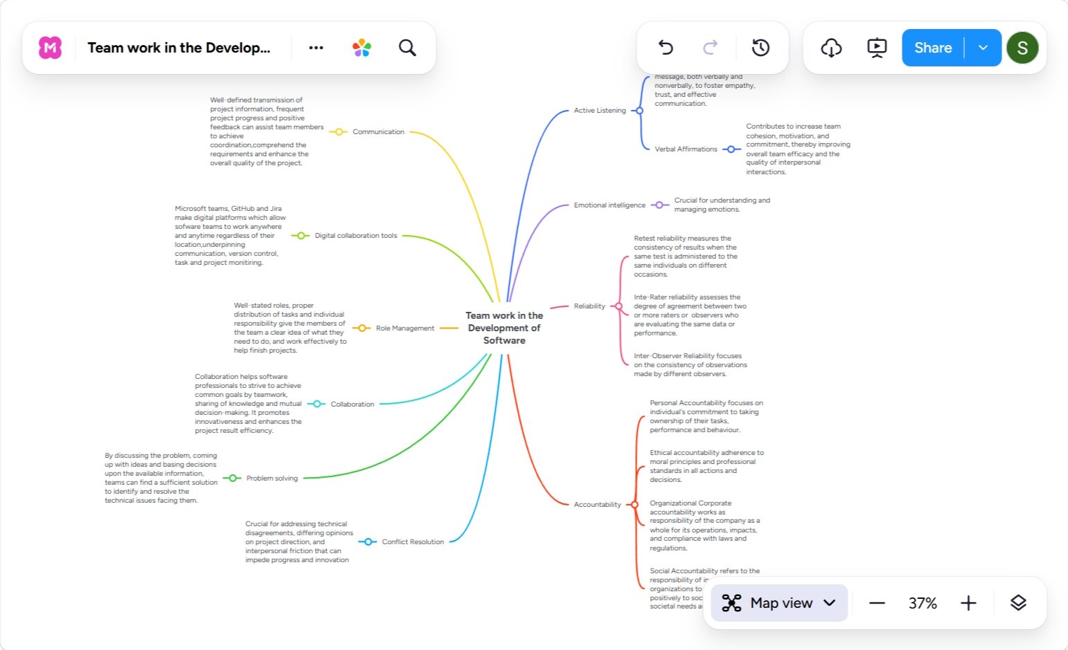
https://www.mindmeister.com/4036041260/team-work-in-the-development-of-software

2.2 Individual Academic Poster: The Importance of Teamwork and Collaboration for Software Development Career Success

Introduction
Software development is a group job that involves collaboration among developers, designers, testers and project managers. The idea of teamwork can help professionals to integrate various skills and provide high-quality digital solutions.

Importance of Teamwork
- Better Project Delivery: Teamwork enhances the coordination of a project by bringing about clear roles, good communication, and timely performance. Teamwork decreases the number of mistakes because team members can share their ideas and discuss problems at a tender age.
- Knowledge Sharing: Knowledge development will demand ongoing learning in software design because of the ever-changing technologies. Working in groups gives developers an opportunity to share their knowledge and experience and enhance their technical skills.
- Innovation and Problem-Solving: With the help of different perspectives combined, collaborative teams can create various ideas and construct solutions that are stronger. Team-problem-solving aids in creativity and effective decision making.
- Professional Development: It enhances professional skills, such as communication, leadership, and interpersonal skills; all of these are fundamentals in the advancement of a career in software development teams.

Real-World Application
Collaboration methods that are applied by agile software teams like the Scrum methodology where team members go through brief development cycles, hold frequent meetings and provide feedback to enhance the project results.

Evidence required
Link - https://canva.link/3cgd608lh3jbm64

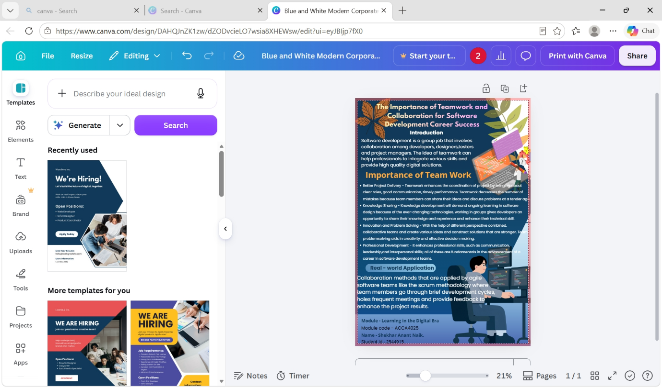

Task 3: Virtual Collaboration and RefWorks

Report on Virtual Collaboration
3.1 Report on Virtual Collaboration
The Role of Virtual Collaboration Tools in Supporting Remote Software Development Teams
Introduction
The increasing trend of remote and hybrid working has changed the way software developing is performed, where teams are now forced to use online collaboration tools to communicate and deliver a project. Hybrid working is still prevalent in the UK, with the Office for National Statistics noting that 28% of all working adults in Great Britain have worked in a hybrid format in September 2024 to January 2025 [6]. Software teams can use virtual collaboration tools to operate effectively at various locations, stay in touch, and be productive.
Virtual Collaboration Tools Used in Software Development
- Microsoft Teams helps software teams to communicate online with meetings, instant messaging, files, and real-time shared work. Such capabilities enable developers and project stakeholders to effectively communicate with each other even when they are working remotely [7].
- GitHub provides collaboration on code with version control, repository management, and communication between developers. GitHub has stated that it serves over 150 million developers across the globe, indicating its relevance in the current software development circles [8].
- Jira facilitates Agile software development by assisting teams in their task management, sprints and project monitoring [9].
Benefits of Virtual Collaboration
- The virtues of Virtual Collaboration.
- Flexibility: Remote and hybrid working.
- Global Collaboration: Enables employees in various locations to collaborate.
Quickened Knowledge Communication: Enhances communication and exchange of information.
Online teamwork is flexible and allows remote and hybrid work environments. It facilitates worldwide convergence since programmers in various places can contribute to the projects. Among the difficulties, though, are the language barrier, differences in time zones, and deprived of face-to-face communication.
Challenges of Virtual Collaboration
- Communication barriers.
- Different time zones.
- Reduced face-to-face interaction.
To enhance functioning, organisations are to develop effective communication principles, choose the right digital tools and hold frequent online conferences. In Agile software teams, mutual coordination and sharing of knowledge in teams have been found to be facilitated by collaboration platforms [10].
Recommendations
- Establish communication guidelines.
- Select suitable digital tools.
- Conduct regular online meetings.

Step-by-step process of using RefWorks with visuals
3.2 Step-by-Step Process of Using RefWorks
Step 1: Creating a RefWorks Account/Project
Screenshot 1:
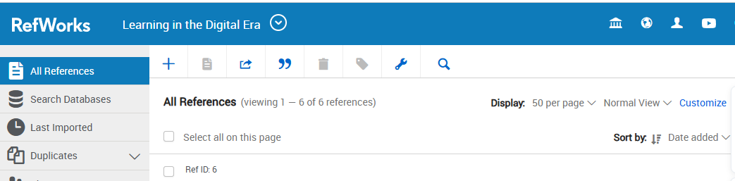
- Create a new bibliography project.
Step 2: Selecting IEEE Style
Screenshot 2:
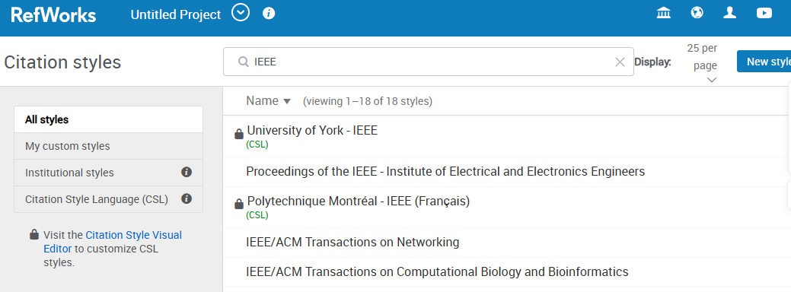
- IEEE Style
Step 3: Organising References
Screenshot 3:
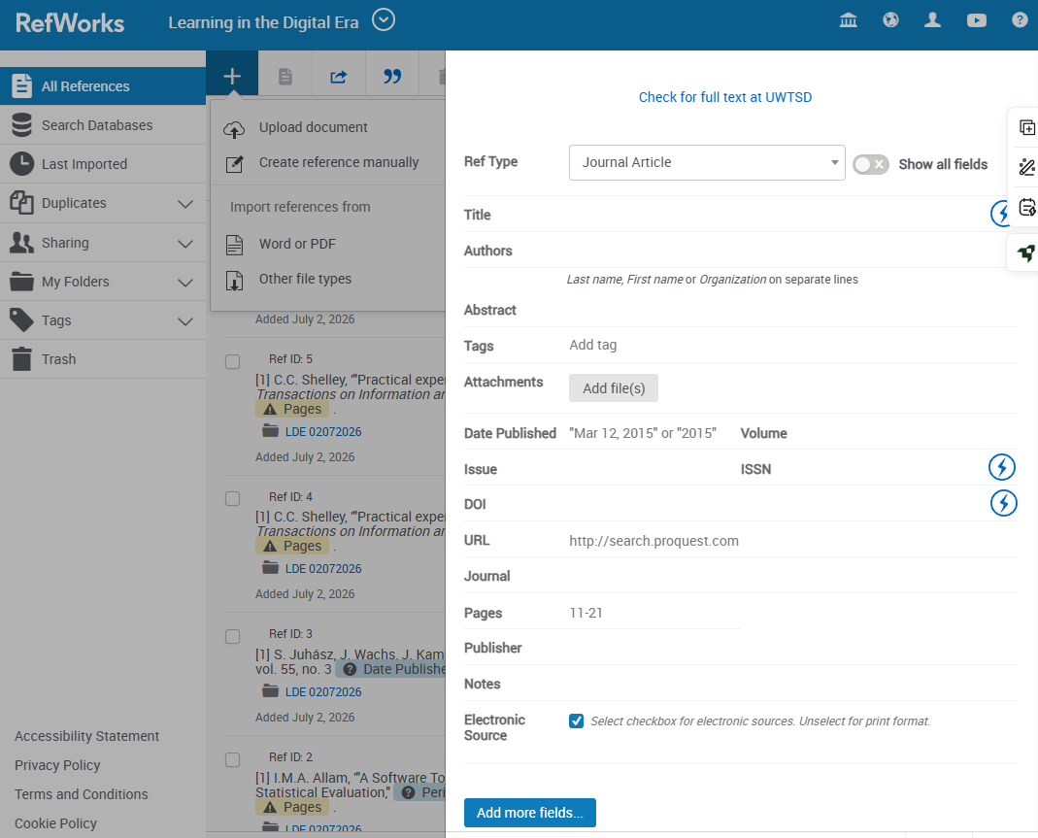
- Saved reference list.
Step 4: Generating Citations and References
Screenshot 4:
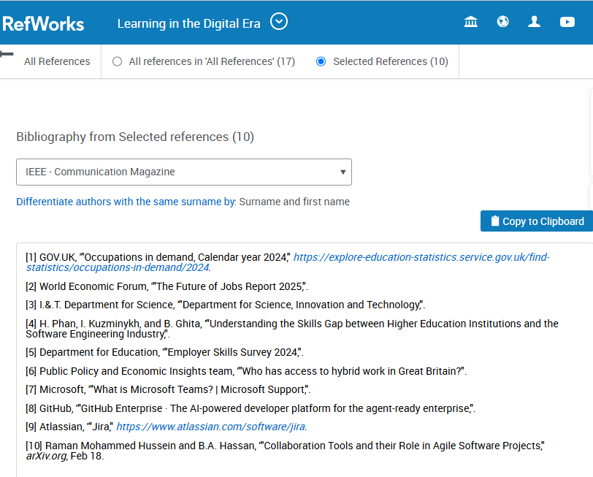
- Automatically creates citations and a reference list.
- https://refworks.proquest.com/bibliography/

Task 4: E-Portfolio Creation and Evaluation

Task 4 (a): E-Portfolio Creation
Selected Tool
Wix
The choice of Wix was determined to develop the e-portfolio as it is a platform with easy access to post academic work in a well-structured and professional manner. The site favors easy navigation, free access and simple content organisation as (it) does not need technical know-how. The homepage has career goals, a page with Task 1, where the skills report and reflection are shown, a page with Task 2, where the mind map and poster are presented, a page with Task 3, where virtual collaboration and evidence of RefWorks are shown, and a page with evaluation. There are screenshots of every page in evidence of being completed.
Portfolio pages:
Homepage
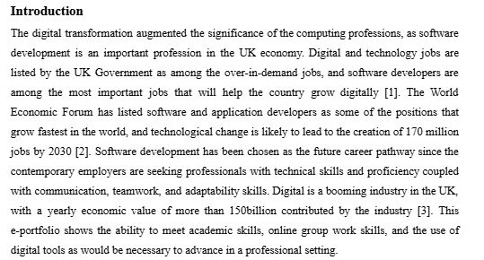
Task 1 Page
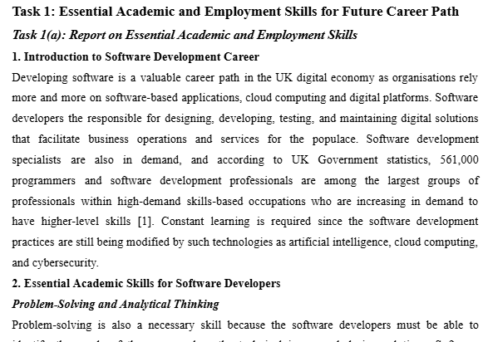
Task 2 Page

Task 3 Page
Task 4 Page
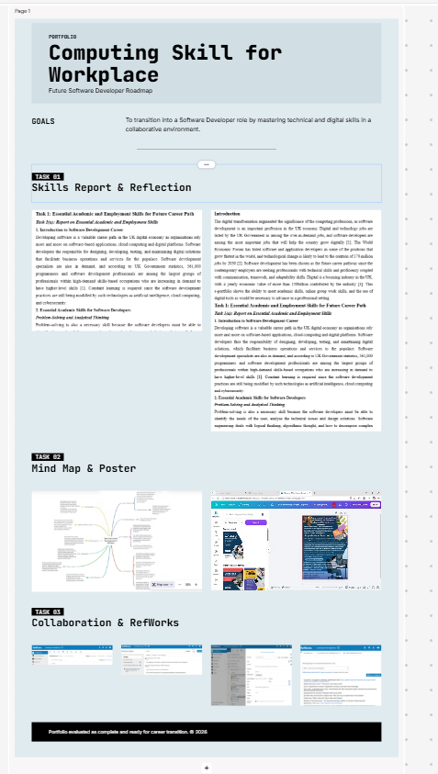

Link - https://manage.wix.com/wixel-new/651a933d-2c44-4c3a-8ff8-2b6b1c91a04f/wixel-editor/ede17641-a1cf-4c74-b1ea-abb1376245bc?referralInfo=dashboard-generate&http_referrer=https%3A%2F%2Fmanage.wix.com%2Fwixel-new%2Fdashboard%3Fref%3Ddesign_agent_bm_page&selectedAssetId=e9dea66e-3eee-4186-8221-c880d8df2f1c

Task 4 (b): Illustrative Review of E-Portfolio tool Selection
4(b) Illustrative Review of E-Portfolio Tool Selection
Wix is an option that can be applicable to developing an academic portfolio since one can develop professional websites without the need to code. The site has the capability of multimedia such as images, documents and hyperlinks inferring the presentation of academic evidence. Nevertheless, it is limited such as the lack of design customisation options and advanced features of websites as compared to the professional website builders. On the whole, Wix is a user-friendly, and reliable tool to structure and summarize academic material online.

Conclusion
Software developers should have professional and digital skills, as positive careers cannot be successful without knowledge that is technical as well as some communication, problem-solving, and adaptability. Teamwork and virtual teamwork help in the efficient delivery of projects through the sharing of knowledge and the coordination of work by professionals. Digital references (RefWorks and Wix) aid in the organisation of academic work, accuracy of references, and presentation online. This e-portfolio indicates the acquisition of the necessary skills in a work environment and shows preparation to work in the sphere of software development in the future.

References
[1] GOV.UK, '"Occupations in demand, Calendar year 2024," https://explore-education-statistics.service.gov.uk/find-statistics/occupations-in-demand/2024.
[2] World Economic Forum, '"The Future of Jobs Report 2025,".
[3] I.&.T. Department for Science, '"Department for Science, Innovation and Technology,".
[4] H. Phan, I. Kuzminykh, and B. Ghita, '"Understanding the Skills Gap between Higher Education Institutions and the Software Engineering Industry,".
[5] Department for Education, '"Employer Skills Survey 2024,".
[6] Public Policy and Economic Insights team, '"Who has access to hybrid work in Great Britain?".
[7] Microsoft, '"What is Microsoft Teams? | Microsoft Support,".
[8] GitHub, '"GitHub Enterprise · The AI-powered developer platform for the agent-ready enterprise,".
[9] Atlassian, '"Jira," https://www.atlassian.com/software/jira.
[10] Raman Mohammed Hussein and B.A. Hassan, '"Collaboration Tools and their Role in Agile Software Projects," arXiv.org, Feb 18.



