CSPB 4001 Persuasive Language:
Creativity, Copywriting & Text editing
Portfolio index

A Proof of Peer engagement: List postings under forum and date of posting (no word count)
B Written Work: indicate which three tasks completed; confirm that the single compulsory task has been completed and submitted by (the equivalent of 2000 words)

A: Engagement |  | Forum/date | Forum/date
Moodle postings of work |  | - Forum 1- 20/2/18 | - Forum 2- 2/3/18
Moodle postings of peer feedback
B: Task no. | Description |  | Word count
- 1 | Image literacy- Barbie advert analysis |  | 572 words
- 2 | Moving image literacy- Save the Children campaign analysis |  | 846 words
- 3 | The persuasion of narrative- Homelessness charity advert |  | 934 words
- Task 9 | Tick to confirm completed & submitted by hand |  |  | 500 words

Written Work: TASKS

TASK 1: Image literary; (500 words)
TASK 2: Moving image literacy (500 words)
TASK 3: The persuasion of Narrative (500 words)
TASK 4: Rhetorical Persuasion (i) (500 words)
Either 1. Write 3 pieces of copy that deploy (i) puns; (ii) alliteration; (iii) parallelism
Include self-reflection on what you are doing and why
Or 2. Develop your story by writing 2-3 pieces of copy that deploy
(i) puns; (ii) alliteration; (iii) parallelism (include self-reflection)
Or 3. write a speech for The Unbelievable Truth which full of ridiculous statements and try to blind the reader to 4 true facts
TASK 5: Proofreading/Copyediting for a house style (500 words)
TASK 6: Writing for an audience (500 words)
TASK 7: letter of complaint and demand for redress (500 words)
TASK 8: Rhetorical Persuasion (ii) (500 words)
Either 1. 3 pieces of copy that each deploy metaphor in different ways (plus self-reflection)
Or 2. write a short story that depends on developing a metaphor (plus self-reflection)
TASK 9: COMPULSORY (500 words)
Edit and correct 3 pieces of copy supplied in the class

Image Literacy
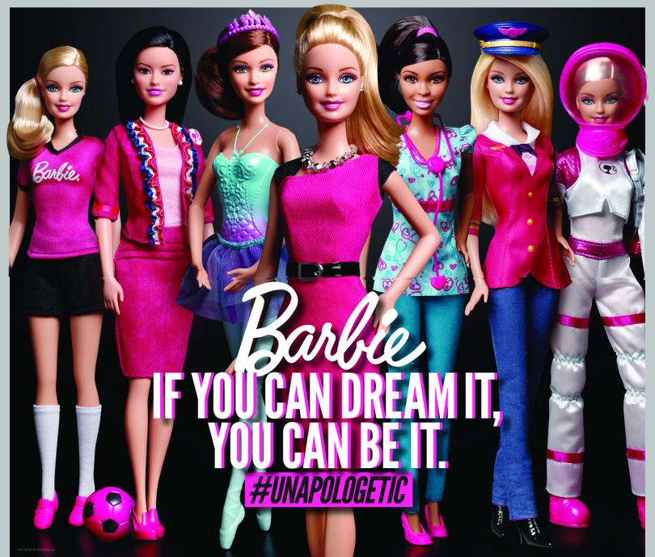
This advert for a popular children’s doll is eye catching and rich in colour, which is instantly appealing to a young consumer. The image takes up the whole background and displays seven versions of the product. This, along with the product brand in the centre in large font, make it clear what it is marketing. The large title in a bold font is quick to draw attention, and the sub-title ‘#UNAPOLOGETIC’ taps into the ‘hash tag’ and ‘sorry, not sorry’ internet trends that are so popular amongst young people, adding to the young consumer appeal.

Barbie dolls are mainly aimed at young girls and toy maker Mattel, still displaying some gender stereotyping, have used white and pink for the text to appeal to females. The image representing girls with a diverse range of careers that are not limited to the stereotypical ‘woman’s role’, and the title ‘IF YOU CAN DREAM IT, YOU CAN BE IT’, carry a message of self-belief, empowerment and gender equality. This message is reflected in the fonts they have used as the eye is drawn from the feminine, script-like Barbie brand to the masculine, capitalised title. This message would appeal to young girls as it is inspirational, empowering, and challenges the increasingly unpopular belief that girls are limited to particular career fields based on gender, whilst promoting the popular, in children’s terms- ‘girl power’ movement.
The advert attempts to persuade the perspective consumer that the product will improve their life by acting as a symbol of their aspirations and can-do attitude. That by purchasing this doll they are making a statement and taking the first step in setting an intention to follow their chosen career path. It persuades the consumer of this by using an inspirational quote along with an image of dolls representing beautiful, happy women in a range of professional roles, leading the consumer to link these desirable attributes with the product and themselves.
It tunes into and exploits the significant impact of peer pressure and young people’s (especially girls) fear of rejection or being ‘left out’ by providing an image symbolic of the ‘gang’ or ‘it crowd’, the Barbie in the foreground as the consumer with her friends behind her. This persuades the consumer that by purchasing this doll they won’t become an outcast but will be a part of a cool group of girls.
The advert hints that what buying this product says about you as a person is that not only are you part of the ‘it crowd’ but the ‘it girl’ of the ‘it crowd’. It does this by singling out one Barbie in the middle of the line of dolls, closer to the foreground, carrying a subtle message to the potential consumer that they too can be ‘leader of the pack’. The vivid colours and reference to social networking trends persuade the consumer that this product is cool and trendy and that in purchasing it they too will become cool, trendy, and most certainly worthy of even the most elite group of friends.
The advert is empowering for young girls, from footballers in training to aspiring astronauts, as it promotes self-belief and gender equality in professional roles. The product itself however, seems to suggest that although girls have a diverse range of choice in career path, to attain happiness they must be stereotypically beautiful, have a perfectly symmetrical body and face, legs that go on forever, and a tiny twenty-inch waist.

Moving Image Literacy
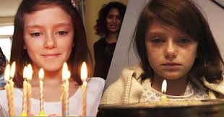
In 2014, UNIT9’s Martin Stirling partnered with Save The Children UK to create a short film to raise support for victims of war in Syria. ‘The Most Shocking Second A Day Video’ is a ninety-four second film made up of over 60 different scenes following a year in the life of a young girl in a war-torn London dystopia. It gained twenty-one million views on YouTube in five days and has gained fifty-nine million views to date. It was awarded ADWEEK’s Ad of the Week, Creative Review’s Ad of the Week, rose to the top of Ad Age Viral Chart, and was awarded Creativity Pick of The Day.
https://www.youtube.com/watch?v=RBQ-IoHfimQ
The film begins with a young girl surrounded by friends and family singing Happy Birthday. Her Mother says “Make a wish”, before the girl blows out nine candles. A succession of one second clips follow a variety of everyday scenes such as the girl practising the recorder at home, playing in the park with Dad, and Mum brushing her hair at bedtime.
After thirty seconds the narrative takes a sinister turn as it becomes clear that the city is under rising civil unrest. The power cuts out, the girl becomes unwell, the house becomes unstable, and the school is bombed. The family is forced to flee their home and are followed as they attempt to escape danger. They are seen foraging for food and the girl reluctantly eats a rotten apple before her Father is separated from the family as they’re being chased. The girl and her Mother reach a refugee camp and the girl is attended to at a Medical Centre.
The final scene is of the girl appearing shell-shocked with her Mother by her side holding a birthday cake with one candle. Her Mother sings ‘Happy Birthday’ and says “Make a wish Darling”. The girl doesn’t blow out the candle but looks up and gazes into the camera. The film ends with a white screen and the message ‘JUST BECAUSE IT ISN’T HAPPENING HERE DOESN’T MEAN IT ISN’T HAPPENING”, followed by “#SAVESYRIASCHILDREN” and the ‘Save the Children’ logo.
The film uses every day scenes at the beginning, and for thirty seconds provides no explanation of what the advert is about. The snapshots of family life make it instantly relatable to most viewers and create a relaxed atmosphere, whilst maintaining a hint of suspense by delaying revelation of the storyline to grip the viewer as they anticipate the direction of the narrative & the purpose of the advert.
The atmosphere begins to change at twenty seconds as subtle hints of all not being well are introduced in the form of news reports on the television in the background & headlines stating civil disorder. By thirty-five seconds there is clear tension in the atmosphere illustrated by scenes of unease such as plaster falling from the ceiling, followed by scenes of escalating violence and intensity, creating a sense of rising panic in the viewer. Although the scenes are the same length, they appear to gather in speed as the volume & action in each scene increase, adding to the rising sense of panic.
The advert persuades the viewer that by supporting this charity they are a compassionate person, taking action to help others in peril, and responsible as they are investing in themselves & their families receiving the same support if they found themselves in the same situation. It suggests you are compassionate by providing a raw insight into the plight of a refugee family so horrific that it suggests any person with any conscience at all would do something, if not everything they could do to help. The compassionate person is also symbolised by the doctor at the medical centre helping the girl. It suggests to the viewer that if they support the charity then they will receive help if they were in the same situation by planting a seed of fear with a strong ‘it could be you’ message. Along with the narrative, this is conveyed by helping the viewer identify with the family by using everyday family scenes at the beginning, and more strongly with each scene being mostly headshots of the girl facing the camera. This is then emphasised with the final shot of the girl looking up and directly into the camera as if making eye contact with the viewer.
The advert attempts to manipulate the viewers emotion by illustrating every parent’s worst fear- that their family could be in danger and focuses on the most vulnerable member of the family. This triggers the viewers caring nature causing, parents in particular, to want to protect the child. The increasing intensity of the scenes mirrors the emotions that would be experienced in that situation, providing a snippet of that reality, triggering an empathic reaction in the viewer. The film then links the feelings of fear to that of a Syrian family by ending with the text- JUST BECAUSE IT ISN’T HAPPENING HERE DOESN’T MEAN IT ISN’T HAPPENING #SAVESYRIASCHILDREN.
A powerful and moving film with a strong emotional selling proposition, for a very good cause.

ADVERT FOR HOMELESSNESS CHARITY CHRISTMAS DONATION APPEAL

SCENE 1
INTERIOR: LIVING ROOM.
MUM, DAD, GRANDAD & TWO YOUNG CHILDREN GATHERED AROUND BOX OF OLD PHOTOS, CHATTING AND LAUGHING. CHRISTMAS TREE IN BACKGROUND.
DAD: Well good grief, would you look at that! My old friends from Cambridge! There’s Richie, and that’s Benedict with the bowl cut.
MUM: I’ll just take the turkey out of the freezer, it’ll need a good few days with the size of it.
DAD: OK darling. And there’s Alan! Ha-ha, he wore that cap every day of the year and even in his sleep I’m sure. Anyone would think he was trying to stop his brain escaping his head!
SON: Maybe he felt the cold, or was hiding a bald patch?
DAD: Don’t be ridiculous son, he was just a tad eccentric.
CUTS TO KITCHEN
MUM REMOVES TURKEY FROM FREEZER & PLACES ON COUNTER. CAMERA ZOOMS IN ON TURKEY. FREEZE FRAME. LARGE £60 PRICE TAG GRAPHIC APPEARS IN TOP CORNER OF SCREEN, ALONG WITH SOUND OF CASH REGISTER OPENING.
VOICEOVER: 6KG-British-Free-Range-Pembrokeshire-Bronze-Turkey-just-£60!!
UNFREEZE FRAME. MUM PUTS TURKEY ON A TRAY AND PLACES IN FRIDGE. CAMERA FOLLOWS BEHIND AS SHE RETURNS TO LIVING ROOM.
DAD: Ahh, and that’s Professor Winslow… What an incredible man. He was awarded the Moseley Medal and Prize for his outstanding contribution to experimental physics, although you’d never know it to look at him…
CUTS TO FLASHBACK
LECTURE THEATRE OF STUDENTS WITH MR WINDSLOW (LOOKS LIKE EINSTEIN) MAKING EXAGERATTED ARM MOVEMENTS, EXCITEDLY TEACHING PHYSICS.
DAD VOICEOVER: He was quite possibly the most intelligent & humble man I’ve ever met. He had a real passion for science and put his whole heart & soul into teaching it…
CUTS TO LIVING ROOM
DAD: I never would’ve got to where I am today if it weren’t for Professor Winslow.
DAD POURS LAST OF CHAMPAGNE FROM BOTTLE INTO HIS GLASS. FREEZE FRAME. CAMERA ZOOMS IN ON BOTTLE. LARGE £200 PRICE TAG GRAPHIC APPEARS IN TOP CORNER OF SCREEN, ALONG WITH SOUND OF CASH REGISTER OPENING.
VOICEOVER: Six-bottles-of-Lois-Roederer-Brut-Champagne-just-£200!!
UNFREEZE FRAME. DAD DRINKS THE CHAMPAGNE.
DAUGHTER: Is he still alive, Daddy?
DAD: Well yes, I expect so, but he left in my final year at Cambridge and that was the last I saw of him.
DAUGHTER: Why did he leave?
DAD: Well he never was the same after his wife died. I suppose he needed to get away and took up teaching somewhere else…
CUTS TO FLASHBACK
EMPTY LECTURE THEATRE. PROFESSOR WINDSLOW AT HIS DESK STARING AT PHOTO OF HIS WIFE, PAUSE, STANDS SUDDENLY AND VIOLENTLY DEMOLISHES THE PHYSICS DISPLAY MODEL ON THE DESK, SLUMPS BACK DOWN IN CHAIR AND PUTS CROSSED ARMS AND HEAD ON THE DESK, SOBBING.
DAD VOICEOVER: I expect he took some time out and re-located for a fresh start…
CUTS TO HOSPITAL
TWO MEN IN WHITE COATS RESTRAIN PROFESSER WINDSLOW (LOOKING FRIGHTENED AND EVEN MORE SCRUFFY THAN BEFORE) AND LEAD HIM INTO PADDED ROOM. TWO MEN LEAVE ROOM LOCKING DOOR BEHIND THEM. SHOT OF CLOSED DOOR & PROFFESSER WINDSLOW’S EYES STARING AT CAMERA THROUGH THE TINY WINDOW.
CUTS TO LIVING ROOM
DAD: Darling we’re out of bubbly, shall we take a walk to the shops?
MUM: Well yes, we could pick up a few bits. Let me get my jacket…
CAMERA FOLLOWS MUM AS SHE RUNS UP THE STAIRS, SHE PUTS ON JACKET. FREEZE FRAME. CAMERA ZOOMS IN ON JACKET. LARGE £500 PRICE TAG GRAPHIC APPEARS IN TOP CORNER OF SCREEN, ALONG WITH SOUND OF CASH REGISTER OPENING.
VOICEOVER: Harvey-Nichols-Herno-navy-quilted-shell-coat-just-£500!!
UNFREEZE FRAME. CAMERA FOLLOWS MUM DOWNSTAIRS INTO LIVING ROOM. CHILDREN ARE PUTTING SHOES ON.
DAD: I don’t know, maybe he sold his house and bought a new one in Paris, perhaps a little villa in Rome. Now come along sweet-pea…
FAMILY LEAVE THE HOUSE. SHOT OF THE DOOR CLOSING BEHIND THEM.
CUTS TO FLASHBACK
PROFESSER WINDSLOW LEAVING HOSPITAL (LOOKING LESS SCRUFFY), MAN IN WHITE COAT PATS HIM ON THE BACK AND SHAKES HIS HAND. SHOTS OF BUS JOURNEY AND A WALK BEFORE HE ARRIVES AT HIS HOUSE.
DAUGHTER VOICEOVER: But how do you know, Daddy?
DAD VOICEOVER: I don’t know, Sweet Pea! Now come on let’s sing some Christmas songs for the walk…
HEATED EXCHANGE BETWEEN PROFESSER WINDSLOW & AN OFFICAL IN FRONT OF A REPOSESSION VAN OUTSIDE THE HOUSE. SHOT OF PROFESSER WINSLOW SITTING ON THE CURB WITH HIS HEAD IN HIS HANDS, SOBBING.
CUTS TO PRESENT DAY STREET VIEW.
SHOP ENTRANCE ON RIGHT OF SCREEN, HOMELESS MAN SITTING ON THE FLOOR AT THE CENTRE, FAMILY ENTERS SHOT FROM LEFT. CHILDREN RUN AHEAD INTO SHOP, MUM & DAD PAUSE BEFORE THEY PASS THE HOMELESS MAN.
DAD: No, Darling. I’m not giving money to hopeless, uneducated fools that clearly make no effort to help themselves…
CUTS TO CHECKOUT
DAD: Thank-you dear chap, Merry Christmas & keep the change!
SOUND OF CASH REGISTER OPENING & CLOSING.
CUTS TO STREET VIEW
FAMILY EXIT SHOP, CHILDREN RUN AHEAD OUT OF SHOT, MUM AND DAD PASS HOMELESS MAN. FREEZE FRAME. CAMERA SLOWLY ZOOMS IN ON HOMELESS MAN, REVEALING IT IS PROFESSER WINDSLOW. HE STARES AT THE CAMERA, PAUSE. UNFREEZE FRAME. CAMERA ZOOMS BACK OUT. MUM & DAD WALKING, ALMOST OUT OF SHOT.
MUM: Oh come on, it is Christmas after all.
DAD: Absolutely not, Darling. And besides, he’ll only spend it on booze.
SOUND OF BOTTLES CLINKING IN THE CARRIER BAG AS THEY WALK OUT OF SHOT.
PAUSE.
LARGE £20 PRICE TAG GRAPHIC APPEARS IN TOP CORNER OF SCREEN, ALONG WITH SOUND OF CASH REGISTER OPENING.
VOICEOVER: Survival-pack-gift-box-for-a-homeless-person-this-Christmas-just-£20!!
SCREEN GOES BLACK.
CAPITILISED TITLE- ‘IT COULD BE ANYONE’ APPEARS IN WHITE, FOLLOWED BY ‘SAVE A LIFE THIS CHRISTMAS’ & THE CHARITY’S LOGO.

