

INDIVIDUAL REPORT
Green Haven Florists: A Feasible Solution to Improve Sales Performance

Module: Problem Solving and Decision Making
Module Code: LCLM4004

Student Name: Alexandru Cristian Zamfir
Student ID: 231333

Contents
1.0 Introduction 3
2.0 Overview of the Case Study 3
3.0 Proposed Solutions 4
3.1 Solution One: Subscription Bouquet Service 4
3.2 Solution Two: Website Overhaul with Paid Digital Advertising 4
4.0 Selection of Preferred Solution 5
5.0 Risk Analysis Outcomes 5
6.0 Implementation Plan Justification 6
7.0 Monitoring and Evaluation Approach 6
8.0 Key Findings 7
9.0 Conclusion 7
References 8
Appendix 1: Grid Analysis of Proposed Solutions 10
Appendix 2: Risk Analysis Table 11
Appendix 3: Implementation Plan and Gantt Chart 12
Appendix 4: Key Performance Indicator and SMART Objectives 13

1.0 Introduction
This report is a response to a request by the owners of Green Haven Florists, Liam and Priya Patel, in Norwich to provide a viable solution to the decline in sales that has been going on. The report introduces the problem, suggests two solutions, discusses them via a Grid Analysis, selects a preferred solution, risk assessment, and establishes an implementation plan with a Key Performance Indicator. Results are based on the recent scholarly literature on small business marketing, omnichannel retailing and risk management.

2.0 Overview of the Case Study
Over a period of twelve months, Green Haven Florists has recorded a decrease in in-store sales by 30 percent and the growth in online orders has not been significant enough to counter the loss of foot traffic. An increase in the cost of inputs, a declining high street, and fierce competition with a national online chain and a fashionable boutique competitor have tightened the screws on margins and brand recognition among the business (Li et al., 2023). The tailor-made, environmentally friendly orders are appreciated by customers, but the outdated site and the lack of delivery flexibility options are condemned when the convenience has become the key in retail decisions-making. On the inside, the owners will have to depend on the word of mouth and infrequent social posts, which puts the business in an under-equipped position to protect its market share against bigger digital-first leaders. Small retailers undergoing this conglomerate cost, demand, and digital pressure usually require an intervention that is focused, preserving their differentiated brand, and provides a recurring revenue stream (Saura, Palacios-Marqués and Ribeiro-Soriano, 2023). The chart below sums up the diverging pattern in the two sales outlets and contextualises the urgency of a targeted sales reaction.
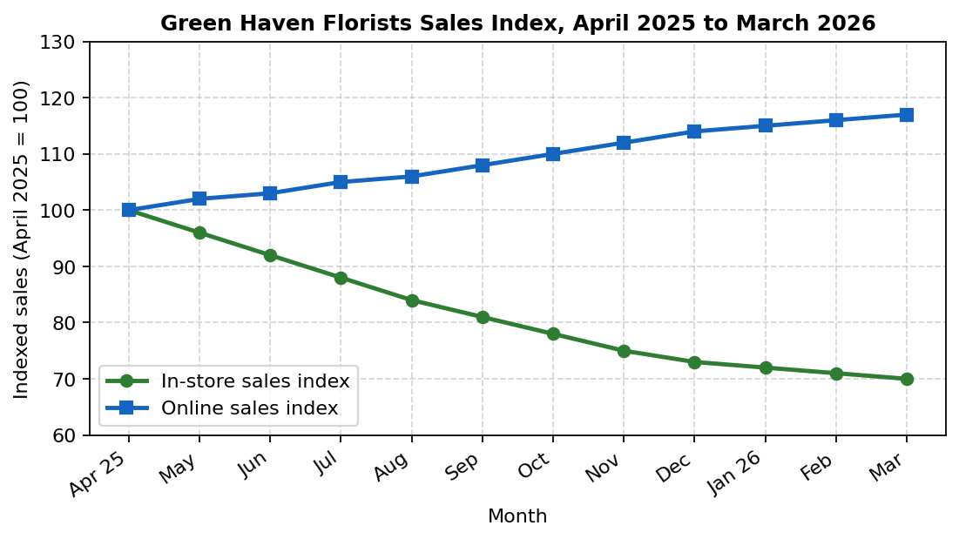
Figure 1. Sales index for Green Haven Florists, April 2025 to March 2026.

3.0 Proposed Solutions

3.1 Solution One: Subscription Bouquet Service
Green Haven would introduce a tiered weekly, fortnightly and monthly subscription where the bouquets are eco-friendly packaged and the customer has an option of selecting seasonal flowers. Subscriptions stabilise the revenue, make it easier to order suppliers, and turn one-off customers into regulars, which is essential when foot traffic is unpredictable (Nansubuga and Kowalkowski, 2024). The service is tapping into the current reputation of customized arrangements, and the service is solidifying the sustainable ethos which already makes the brand stand out. Deepening lifetime value would give priority booking of weddings and corporate orders to members. The recent retail studies associate membership and loyalty programmes with the increase in the frequency of repeating purchases and the visibility of cash flows in the owner-managed firms (Reddy et al., 2023). The model also helps to eliminate reliance on price-based national competitors, as the value proposition will be based on quality, ritual, and convenience, instead of a discount.

3.2 Solution Two: Website Overhaul with Paid Digital Advertising
The second variant is a total redesign of the site using a mobile-first navigation and in-built booking and a 6-month paid advertising campaign on Google and Instagram. An updated platform would solve the most frequent customer complaint and make the shop more like its omnichannel competitors (Both and Steinmann, 2023). Social ads would increase the discoverability over competitors with good feeds and search ads would get the local intent traffic. Findings of empirical data indicate that the amount of digital marketing allocated with a viable storefront increases conversion and brand awareness in small retailers (Sharabati et al., 2024). The trade-off is that it requires a greater initial investment, continuing agency or freelancer costs and a longer payback period, as paid media ceases to generate leads immediately the budget ceases.

4.0 Selection of Preferred Solution
In the Grid Analysis, in Appendix 1, Solution One is given a higher position over Solution Two on five of the six weighted criteria with the subscription model getting 28 points compared to 20 points in the case of the website overhaul. Subscriptions provide a predictable monthly flow of cash, quicker payback, and greater customer lock-in, which directly respond to the cash flow pressure that is brought up in the case study (Bruce et al., 2023). The subscription model also comes at less capital cost, as the current web site can accommodate a bare-bones sign-up form, whilst the model is tried out before any higher redesign investment is undertaken. According to the research on omnichannel retail, it is proven that small businesses gain the most in the case of interventions that create relational value, but not a one-time spending on paid media (Massi, Piancatelli and Vocino, 2023). Solution One is hence chosen as the preferred solution to be implemented to the Green Haven Florists with a potential upgrade of the site being introduced as a subsequent step after the subscription base offers a credible source of funding.

5.0 Risk Analysis Outcomes
The complete risk register of the subscription service is given in Appendix 2 and the heatmap is shown in Figure 2 below. The most serious risks of the top scores include delivery failure during peak weeks and reduced than anticipated subscriber uptake in the first quarter, both of which would have dire consequences in terms of revenue and reputation of an owner-managed florist (Hudáková et al., 2023). The cash flow strain at the build stage and lack of seasonal flowers supply chain are also in the medium-high band and should be monitored continuously since the first week. The mitigation measures involve a soft launch comprising of fifty test subscribers, outsourced courier, and a flexible bloom menu, which can be used to make substitutions in case imports are halted by weather or freight delays. Operational risk studies emphasise the idea that proactive controls lessen the financial effects on owner-managed companies compared to reactive actions undertaken when issues become a reality (Meiryani, 2024). The final residual risk with mitigation can be considered medium and acceptable to the estimated increase in revenue.
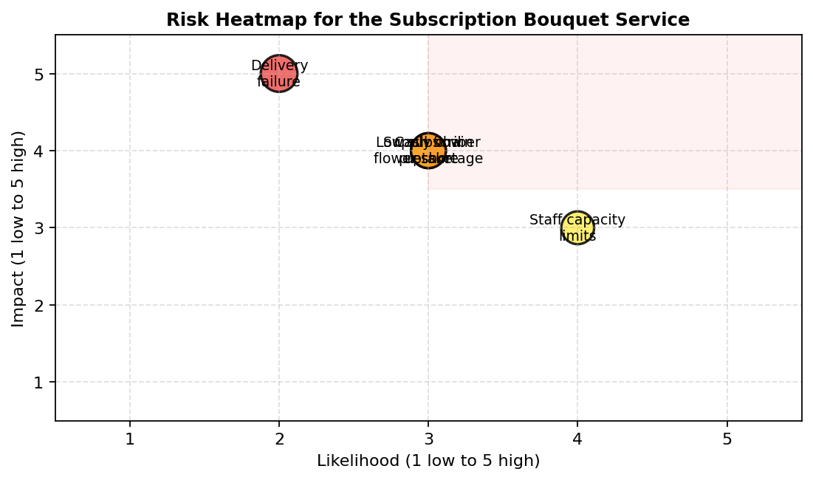
Figure 2. Risk heatmap for the subscription bouquet service.

6.0 Implementation Plan Justification
The implementation plan attached in Appendix 3 is thirteen weeks long and provides a clear ownership to Liam, Priya, and an additional part-time digital coordinator who will be hired to work during the launch period. The first two weeks will be devoted to the concept design and tier pricing, as the most frequent reason for the failure of subscription among small companies that enter the recurring revenue model is caused by the pricing errors (Nansubuga and Kowalkowski, 2024). Weeks two and three have parallel supplier contracts to secure supply of flowers prior to customer commitment or publicly pledged marketing assurances. The web sign-up module is developed between weeks three and five and a controlled soft launch of the web sign-up using fifty testers is done in the sixth week to identify fulfilment gaps in realistic conditions. The marketing campaign will begin when the operational base is demonstrated and saves money that would go to waste, as well as reputation (Thaichon et al., 2024). The entire public release in week eight is set to go hand in hand with the Mother Day demand where the team will be in a four-week monitoring and refinement period.

7.0 Monitoring and Evaluation Approach
The main Key Performance Indicator will be the monthly recurring revenue related to active subscriptions, facilitated by four SMART objectives that are presented in Appendix 4. Recurring revenue is evaluated every week in a monthly routine using a straightforward spreadsheet dashboard which will automatically import data on booking module and bank feed. The weekly review enables the owners to identify uptake stalls as early as possible and reallocate marketing expenditure or tier pricing without having to receive quarter-end results to fall (Dvorský et al., 2023). The metric set is full of customer churn rate, average order value, and net promoter score as it gives a balanced perspective of revenue, satisfaction, and customer loyalty throughout the subscription base. Empirical research also indicates that small businesses optimally enhance their performance to the extent that they combine a single headline measure with three to four operational measures instead of monitoring a long and inattentive list of measures (Sharabati et al., 2024). Failure to meet any of the thresholds leads to an action to be taken that is recorded in the operations log.

8.0 Key Findings
Scenario: Green Haven Florists is experiencing a decline in sales of thirty percent in store due to the shifting shopping patterns, the increase of prices and the presence of more formidable competitors on the web.
• A subscription bouquet service is predictable, and aligns with the established sustainable brand, and beats a website overhaul in terms of cost, speed, and customer lock-in.
The most dangerous ones are the failure to deliver and slowness of the first quarter uptake, which are reduced by a soft launch, a reserve courier, and dynamic bloom menus.
• A thirteen-week implementation plan times the supplier contracts ahead of the marketing expenditure, eliminating unnecessary money and safeguarding the brand image.
• The owners have a focused dashboard with monthly recurring revenue that will be supported by four SMART objectives to review on a weekly basis.

9.0 Conclusion
Green Haven Florists enjoys a sustainable and defensible niche in the customized and sustainable floristry, and the current operating model exposes it to web-based competition and cost increases. The most realistic way to revert to sustainable growth is a tiered subscription bouquet offering with the aid of a disciplined implementation plan and a focused KPI dashboard. Having active risk management and performance review weekly, the owners have a good chance to transform occasional shoppers into regular members, as well as to restore the revenue in twelve months.

References
Both, A.D. and Steinmann, S. (2023) 'Customer experiences in omnichannel retail environments: a thematic literature review', International Review of Retail, Distribution and Consumer Research, 33(5), pp. 445-478. Available at: https://www.tandfonline.com/doi/abs/10.1080/09593969.2023.2256491 (Accessed: 14 April 2026).
Bruce, E., Shurong, Z., Ying, D., Yaqi, M., Amoah, J. and Egala, S.B. (2023) 'The effect of digital marketing adoption on SMEs sustainable growth: Empirical evidence from Ghana', Sustainability, 15(6), 4760. Available at: https://www.mdpi.com/2071-1050/15/6/4760 (Accessed: 13 April 2026).
Dvorský, J., Olah, J., Bednarz, J. and Hudakova, M. (2023) 'Opinions of owners and managers on the business risks of SMEs sustainability: Does gender matter?', Journal of Business Economics and Management, 24(4), pp. 732-753. Available at: https://journals.vilniustech.lt/index.php/JBEM/article/view/20232 (Accessed: 16 April 2026).
Hudáková, M., Kardoš, P., Dvorský, J., Afful, C.R. and Kloudova, J. (2023) 'Management of operational risk in the context of financial performance of SMEs', Systems, 11(8), 408. Available at: https://www.mdpi.com/2079-8954/11/8/408 (Accessed: 15 April 2026).
Li, F., Rubinato, M., Zhou, T., Li, J. and Chen, C. (2023) 'Statistical analysis of small business survival under the shock of multiple COVID-19 waves: A case study from Wuhan, China', Frontiers in Environmental Science, 11, 1092768. Available at: https://www.frontiersin.org/journals/environmental-science/articles/10.3389/fenvs.2023.1092768/full (Accessed: 11 April 2026).
Massi, M., Piancatelli, C. and Vocino, A. (2023) 'Authentic omnichannel: Providing consumers with a seamless brand experience through authenticity', Psychology and Marketing, 40(7), pp. 1280-1298. Available at: https://onlinelibrary.wiley.com/doi/full/10.1002/mar.21815 (Accessed: 17 April 2026).
Meiryani, M. (2024) 'Risk management of small and medium-sized enterprises (SMEs) for upcoming research priorities', Managerial Finance, 50(9), pp. 1578-1597. Available at: https://www.emerald.com/insight/content/doi/10.1108/MF-07-2023-0459/full/html (Accessed: 12 April 2026).
Nansubuga, B. and Kowalkowski, C. (2024) 'Moving to subscriptions: Service growth through business model innovation in consumer and business markets', Journal of Service Management, 35(6), pp. 185-215. Available at: https://www.emerald.com/insight/content/doi/10.1108/JOSM-10-2023-0438/full/html (Accessed: 11 April 2026).
Reddy, K.P., Chandu, V., Srilakshmi, S., Thagaram, E., Sahyaja, C. and Osei, B. (2023) 'Consumers perception on green marketing towards eco-friendly fast moving consumer goods', International Journal of Engineering Business Management, 15. Available at: https://journals.sagepub.com/doi/10.1177/18479790231170962 (Accessed: 14 April 2026).
Saura, J.R., Palacios-Marqués, D. and Ribeiro-Soriano, D. (2023) 'Digital marketing in SMEs via data-driven strategies: Reviewing the current state of research', Journal of Small Business Management, 61(3), pp. 1278-1313. Available at: https://www.tandfonline.com/doi/abs/10.1080/00472778.2021.1955127 (Accessed: 13 April 2026).
Sharabati, A.A., Ali, A.A., Allahham, M., Hussein, A., Alheet, A. and Mohammad, A. (2024) 'The impact of digital marketing on the performance of SMEs: An analytical study in light of modern digital transformations', Sustainability, 16(19), 8667. Available at: https://www.mdpi.com/2071-1050/16/19/8667 (Accessed: 15 April 2026).
Thaichon, P., Quach, S., Barari, M. and Nguyen, M. (2024) 'Exploring the role of omnichannel retailing technologies: Future research directions', Australasian Marketing Journal, 32(2), pp. 162-177. Available at: https://journals.sagepub.com/doi/10.1177/14413582231167664 (Accessed: 17 April 2026).

Appendix 1: Grid Analysis of Proposed Solutions
The Grid Analysis below scores each solution against six weighted criteria. Scores are out of five and weights are converted into the maximum points available for each criterion. The higher total identifies the recommended option.

Criterion | Weight (out of 5) | Max points | Solution 1: Subscription | Solution 2: Web overhaul
Cost feasibility | 5 | 5 | 4 | 3
Speed of revenue impact | 5 | 5 | 5 | 3
Customer appeal | 5 | 5 | 5 | 4
Brand differentiation | 4 | 5 | 5 | 3
Long-term recurring revenue | 5 | 5 | 5 | 4
Risk level (lower is better) | 4 | 5 | 4 | 3
TOTAL | 28 | 30 | 28 | 20

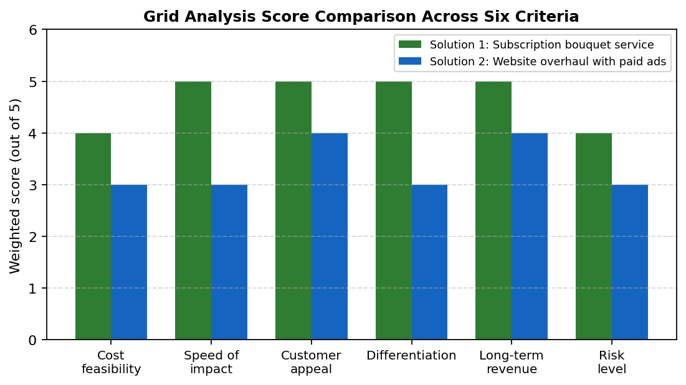
Figure A1. Bar chart comparison of weighted scores by criterion

Appendix 2: Risk Analysis Table
Risks are scored on likelihood and impact using a one to five scale. Risk score equals likelihood multiplied by impact, with mitigation actions reducing residual exposure.

Risk | Likelihood | Impact | Score | Mitigation action
Low subscriber uptake in first quarter | 3 | 4 | 12 | Targeted local social campaign, loyalty referral discount, opening week pop-up event in store.
Supply chain shortage of seasonal flowers | 3 | 4 | 12 | Dual supplier contracts and a flexible substitution policy disclosed at sign-up.
Delivery failure during peak weeks | 2 | 5 | 10 | Backup courier on standby and route planning software trial during soft launch.
Cash flow pressure during build phase | 3 | 4 | 12 | Phased capital release linked to milestones and a small business credit line as buffer.
Staff capacity limits at launch | 4 | 3 | 12 | Hire a part-time digital coordinator and cross-train one florist on packaging tasks.

Appendix 3: Implementation Plan and Gantt Chart
The plan covers thirteen weeks from approval to first quarterly review. Owners and a part-time digital coordinator share responsibility, with weekly checkpoints.

Activity | Start week | Duration | Owner
Concept design and tier pricing | 1 | 2 weeks | Liam Patel
Supplier contracts and bloom menu | 2 | 2 weeks | Priya Patel
Web subscription module build | 3 | 3 weeks | Digital coordinator
Soft launch with 50 testers | 5 | 1 week | Liam and Priya Patel
Marketing campaign on Instagram and email | 6 | 3 weeks | Digital coordinator
Full public launch on Mother's Day weekend | 8 | 1 week | All staff
Monitor performance and refine pricing | 9 | 4 weeks | Liam Patel and coordinator

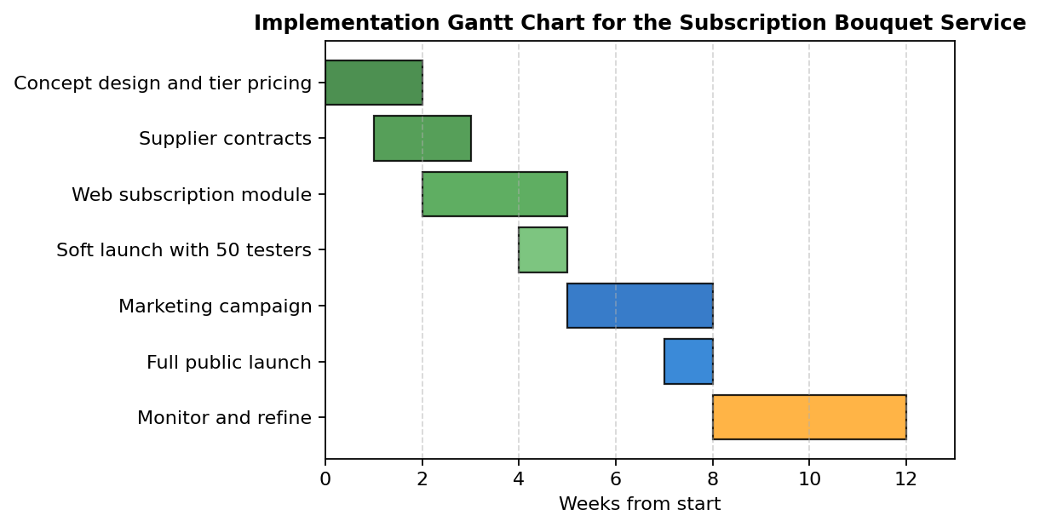
Figure A3. Gantt chart for the thirteen-week subscription rollout.

Appendix 4: Key Performance Indicator and SMART Objectives
The headline KPI for the subscription service is monthly recurring revenue. Four supporting SMART objectives are listed below.

KPI | Monthly recurring revenue (MRR) from active subscriptions
Specific | Grow paid subscribers across weekly, fortnightly, and monthly tiers in the Norwich postcode area.
Measurable | Reach 150 active subscribers and 4,500 GBP MRR by month six.
Achievable | Based on current foot traffic of around 40 weekly customers and a realistic conversion rate of 12 percent.
Relevant | Directly addresses the 30 percent in-store decline and replaces lost transactional revenue with recurring revenue.
Time-bound | Targets achieved within six months of public launch, reviewed weekly and reported monthly.

Supporting metrics tracked alongside MRR include subscriber churn rate (target below 5 percent monthly), average order value (target 30 GBP), and net promoter score (target above 40).

