Level 5 Associate Diploma in People Management: 5HR03 Reward for Performance and Contribution
Task- Slideshow with notes
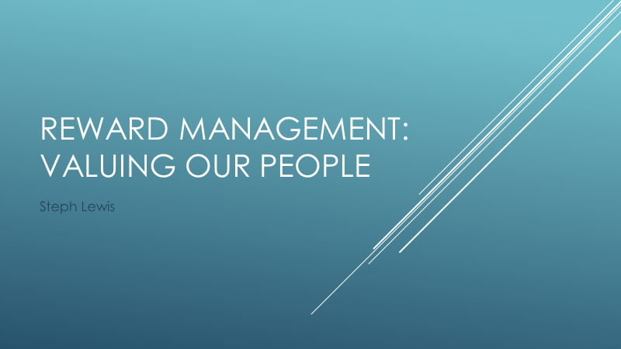Background
Worldwide we encountered unprecedented times over the last two years with the onset of the COVID-19 pandemic. The company recognises that the last couple of years has been extremely difficult for many.
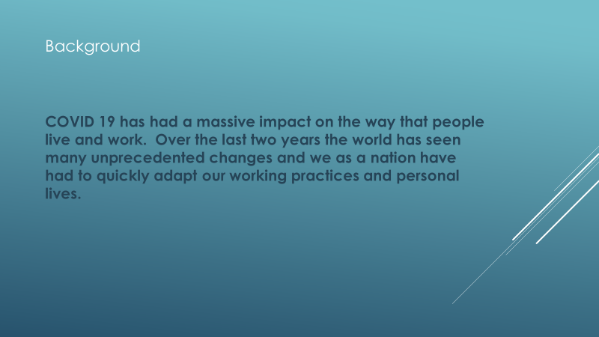
Only now are we seeing the true impact.
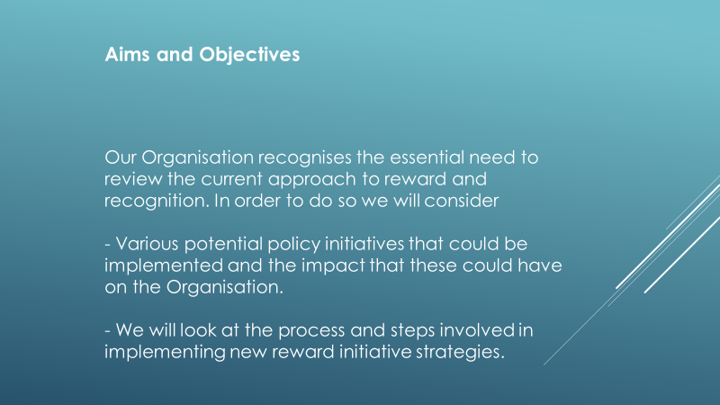
Explain what is meant by reward and the importance to organisational culture
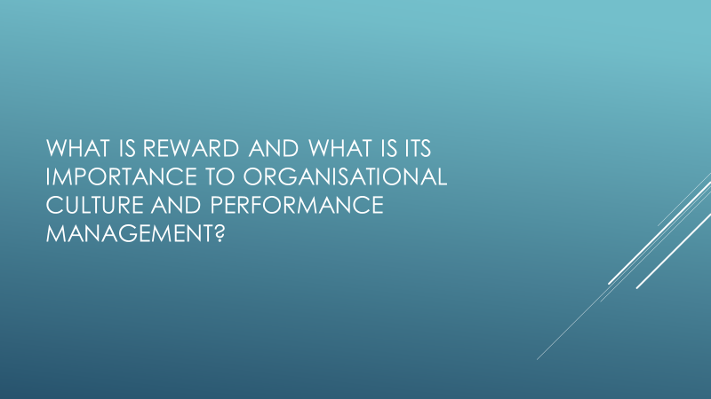

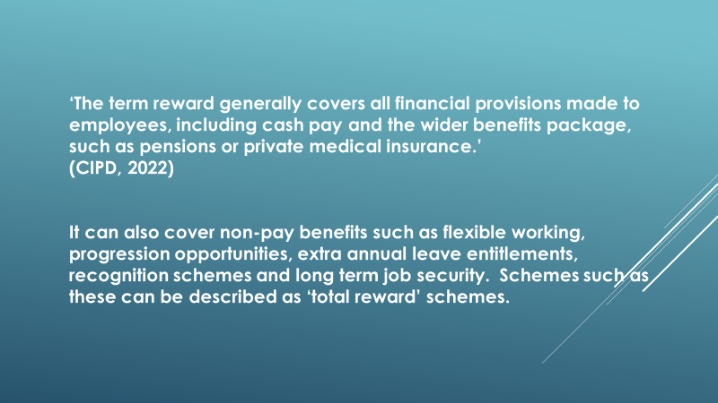

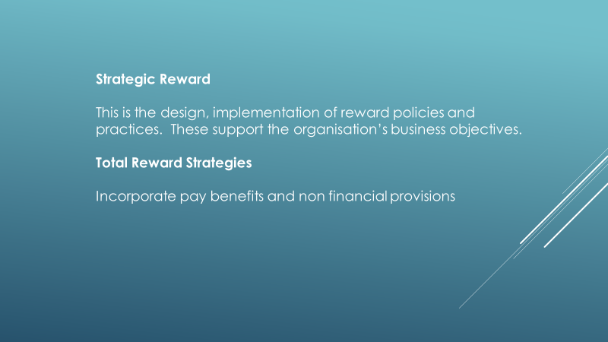
It is important to introduce the concept of strategic reward and total reward. Strategic reward focuses on the designing and implementation of reward policies/practices that support and that help advance the organisation’s people and business objectives. Armstrong (2017) suggests that there are three major objectives; performance, competitiveness, and fairness. He highlights questions such as are the strategies fit for purpose and how is it intended to be carried out. A sense of purpose should be clear. ‘The strategy is based on an understanding of the needs of the organisation and its employees and how they can be best satisfied.’ (Armstrong, 2017)
The concept of Total Reward focuses on everything that employees value within work. This would include monetary, beneficial, and development rewards. This would be given to those who have achieved specific business objectives. This could include development opportunities. The CIPD (2022) highlights that these benefits can be just as important as financial rewards to many employees.
As there are various elements to reward, it’s important to think about the appropriate mix of base to variable pay, fixed to flexible benefits, and financial to non-financial rewards to meet the needs of both the organisation and its employees. CIPD (2021)
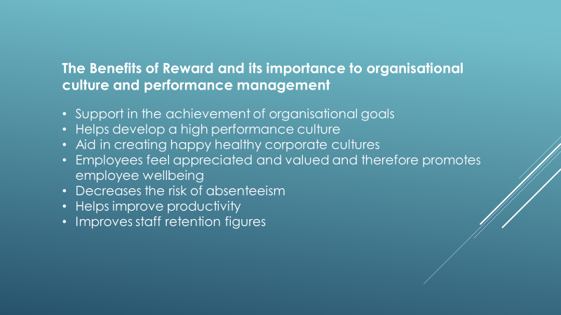
Waite el al (2021) highlights that reward plays an important role in attracting, retaining, and motivating employees. Encouraging the power of employee voice by consulting and engaging with employees to see what rewards they would like to see in place, or perhaps giving them a choice. It is important to highlight that the term reward can vary from person to person. What motivates one may not motivate another. Also attracting and retaining employees who have high-value skills. Whilst these points are important it is also key to ensure that rewards meet individual needs.
Armstrong (2020) discusses the aims of reward regarding the organisation in detail. He suggests that rewards should support the achievement of organisational goals. This is achieved by developing a high-performance culture by recognising the value of all staff who contribute, and/or according to their contribution. LSA Global (2022) supports this theory and suggests that both reward and consequences can play an important part in creating a high-performance culture if they are used correctly. However, if used incorrectly undesirable behaviours can be encouraged. It is believed that if rewards are perceived in a particular way i.e. to be fair proportionate, consistent and respectful this will help create a positive reward culture. However, LSA Global (2022) stresses that the right leaders and the correct level of motivation and engagement are needed in addition to helping employees to perform at their peak. The right behaviour should be rewarded to convey the right message.
Sutherland (2022) states that a successful organisation isn’t always determined by high salaries or profits. Some organisations are deemed as successful by creating happy, healthy corporate cultures by giving their employees that ‘something extra’ such as offering free lunches, or just being “human friendly”. For example, “Netflix” promotes a strict anti-rules philosophy and has put no limit on annual/paternal leave allowance. If employees are happy and motivated within the Organisation’s culture then they are more likely to engage them to drive performance- therefore aligning to the organisation’s goals, objectives, and strategic plan.
Compare the different types of benefits, how organisational performance can impact the approach to reward and how they can be implemented. 1.2 1.3 1.4
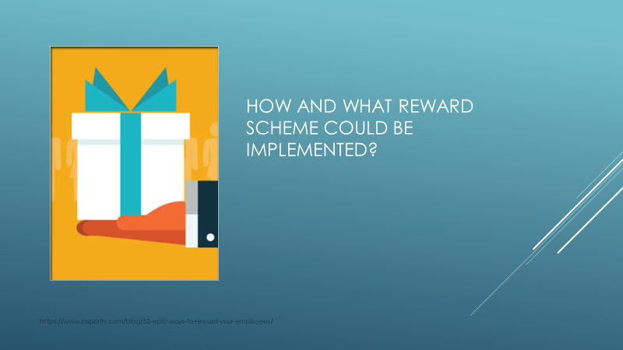
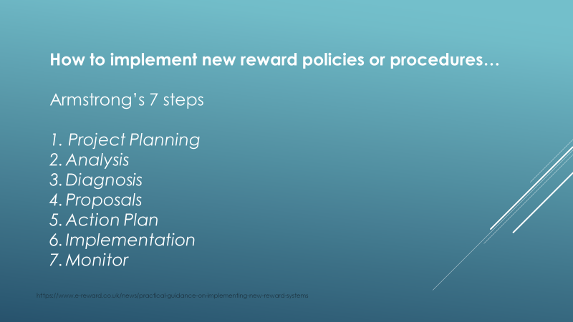
Implementing a new or revised reward system can be a difficult task for a people practitioner. According to Armstrong (2002), there are seven key steps to follow:
- Project Planning. This involves developing objectives, a brief/plan, deciding a timescale, and what exactly should be done. How will success be measured?
- Analysis. A full analysis of the organisation should be completed focusing on present reward schemes and the structure of the organisation. Analysis should include looking at internal and external factors and a SWOT. Benchmarking should be carried out. What are the current and future requirements?
- Diagnosis. Identify key issues and trends. Set goals. Identify an understanding of the employee's needs, and what motivates them. Does it encourage specific behaviours or attitudes that represent the organisation?
- Proposals. Develop and evaluate the design. What will be introduced or amended? Agreement needs to be sort from senior management. How will it be evaluated?
- Action Plan. How will the proposal be implemented? Identify what the key tasks will be.
- Implementation. Run a pilot test, communicate to all those involved (transparency is key) Train line managers, etc on the new policy/procedure.
- Monitor. Evaluate the programme to see how effective it is. Carry out surveys/focus groups. Continuous monitoring in accordance with changing business needs.

At present, the UK is experiencing a tight labour market. It has been a tough few years for the economy and it shows no sign of improving with the cost of living at an all-time high. People have re-evaluated their lives due to the impact that COVID 19 has had on them- physically, emotionally, and financially. In 2021 an unprecedented number of employees simply resigned. Many relocated to be closer to family and friends, changed jobs/careers, or if in a fortunate position- have retired early. This has been dubbed the Great Resignation and has left a shortage of skills within the UK. Now it seems that there is almost a desperation to attract and retain employees. Organisations are having to revise their reward offerings to do so. Some offering large welcome bonuses, relocation costs, and higher wages. In private sector organisations, this may be possible to carry out when business is good and profits are high, however, organisations such as public bodies cannot match these. The benefits that they can offer (such as extra annual leave) can appear to be less meaningful.
Performance-related pay has the power to both motivate and demotivate. If the employee has met all their objectives/targets they will receive a pay incentive such as an increase in salary or a bonus thus having a positive effect on motivation. However, if the employee is unfortunate enough not to have met these goals they receive no incentive. Perhaps the individual had put a great deal of effort in and these goals were not achievable due to external influences, or perhaps they were team-based- the employee could feel extremely demotivated and demoralised. This having an impact on productivity and ultimately organisational performance. If profits are not made rewards may need to be reviewed or perhaps removed if business declined.

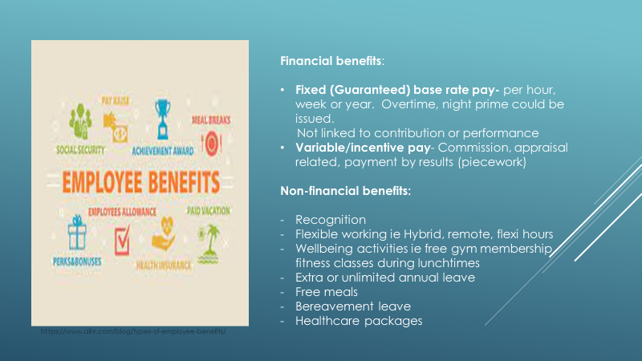
Employee benefits help attract and retain people. The CIPD (2022) highlights that they help to 'contribute towards improving wellbeing and encourage required behaviours, achievements, values and skills.'
The term reward can include both financial and non-financial benefits. These can be split into two categories; fixed (guaranteed) such as location allowances or variable which would include bonuses, overtime payments, or incentives, as these are not guaranteed and can change.
Martin and Whitling (2016) emphasise that non-pay benefits also have a part to play in retaining and motivating employees as they promote growth and development opportunities as well as recognising contribution. These benefits could include; recognition, flexible working, well-being activities, extra leave, or even allowing employees time to work on their own personal projects. For example, Google employees are encouraged to use 20% of their working week to concentrate on their projects. This type of reward is often more cost-effective as they are centred around recognition and there is no financial implication. They often have an immediate impact, whereas with a financial benefit you can be kept waiting. It can be argued that this will decrease in impact as it isn't as instant as say recognition. Benefits could also include things such as pensions, holidays, company cars, etc.
Although financial rewards are vastly important to some they are not the main motivator for everyone. It is important to point out that motivation is individual and what motivates one may not have an impact on the other. We are all driven by something different. What may attract can change over time and is dependent on circumstances in employee's lives at that time
Provide examples of how the business context, benchmarking data, and legislative requirements contribute to the design of reward strategies
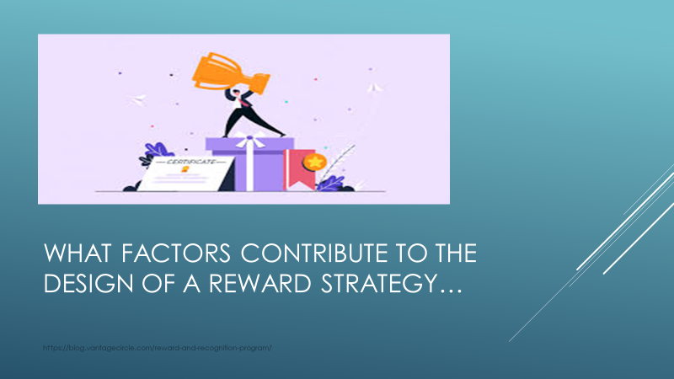
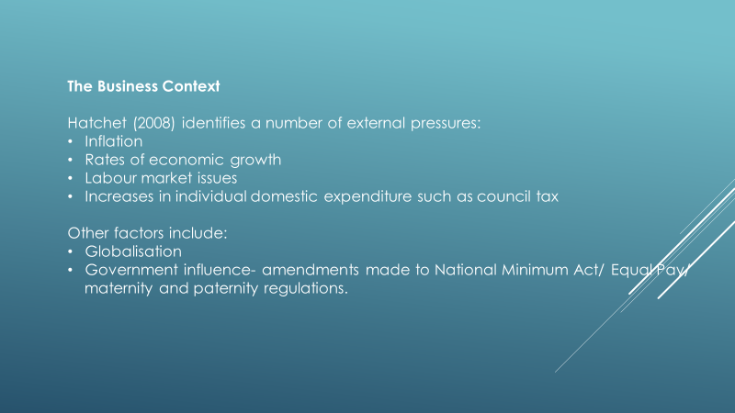
The CIPD (2022) emphasis that reward is about ‘designing and implementing strategies that workers are rewarded in line with the organisational context and culture, relative to the external market environment.’ Therefore, to have a successful reward strategy the business environment (externally and internally) should be assessed to make successful, informed decisions. Various external factors can affect the design of reward strategy, these include: inflation/ the cost of living is at an all-time high with the cost of household bills rising above the rate of inflation. Some organisations simply cannot align wages with these rates. At present, there is such concern in regards to the financial well-being of employees with many struggling to pay for the basics.
The country is currently experiencing a tight labour market and has skill shortages in various sectors despite high rates of unemployment- causing difficulties in attracting talent and retaining it. Some sectors can address the issue of low wages and rises are given to address the shortage. This can cause tensions as not every organisation can do this.
In regards to financial reward offerings, the Public sector simply cannot compete with the private sector and cannot match the pay increases that are being introduced. Therefore, in recent years there has been a focus on the non-basic pay advantages such as good pensions or work-life balance provisions to attract and retain people (CIPD, 2022) Differences such as these should be taken into consideration when benchmarking against different organisations as they do not have the opportunity to request additional funding to increase the reward offering public sectors are simply aligned to budget affordability. Public sector organisations often have very limited options when it comes to funding streams.
Internationally Globalisation can have an impact on the reward environment CIPD research has found that a ‘global pay for contribution’ approach is emerging. Legislation amendments or introductions. Organisations will need to consistently evaluate their offerings to ensure they are aligned with Government requirements (this will be discussed in detail later).
In order to gain valuable comparisons to other organisations and what they offer in terms of reward, accurate data must be gathered. It is key that we remain competitive to recruit and retain employees. This can be carried out in several different ways.
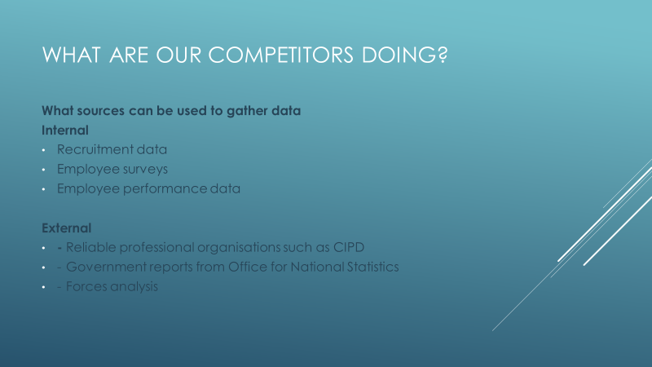
By looking at a range of the above data a fair and consistent market rate analysis can be produced to establish what competitors are offering. SWOT and PESTLE analysis can be produced. By using data from the above source employers can use various mechanisms to establish strategies such as job evaluation to ensure fair, equal, and transparent reward schemes. Taylor and Woodhams (2016) highlight that it may be easier to maintain information from the public sector as information tends to be more freely available. In this case, reports from professional bodies are a good source that is deemed reliable, fair, free from bias, and an organisational asset.
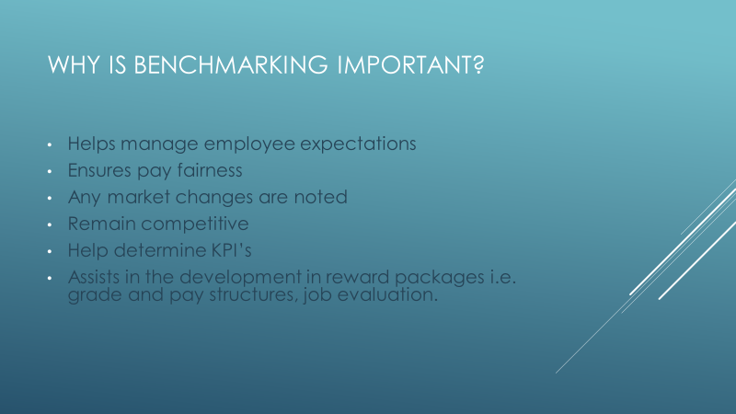
These benchmarking tools are extremely useful and almost essential when developing reward packages. They can provide the backbone when developing internal processes.
According to the CIPD (2021), ACAS defines job evaluation as ‘a method of determining on a systematic basis the relative importance of a number of different jobs’. Essentially jobs are analysed in relation to their worth to other jobs within the organisation and are ranked in order of importance. This is an internal exercise and It can ensure clear pay and grading structures. Analytical and non-analytical schemes can be used.
There are various reward policy initiatives and practices that can be implemented. These include;
Grade and pay structures; A grade structure is made up of grades or levels in which comparable jobs are placed, or a single grade that which all jobs are placed. This is usually determined by the size or complexity of the organisation. A pay structure determines the relative value of the role to the organisation by the grouping of jobs or the levels of pay for the jobs. The value of the role can be determined by conducting job evaluations or a market forces analysis. According to Taylor and Woodhams (2016), the most common grade and pay structures in operation are; narrow or broad graded, job family, career family, and pay spines. The pandemic and the recent cost of living increase crisis have seen financial rewards come to the forefront. People are generally concerned with how they and their families will survive with the cost of general day-to-day amenities rising. People would like to ensure that pay is fair and transparent. Jakubowski (2021) stresses that of late there seems to be more call for formalising pay grade structures as previously there has been a great deal of autonomy in deciding pay. ‘People feel more content with their salaries when they feel that others are not being paid unfairly by comparison.’ (Jakubowski, 2021)
To determine what pay reward practices could be implemented Job Evaluation or an external Market Pricing can be undertaken. Ultimately this is to ensure pay is fair, consistent, and competitive. These types of analyses should be carried out regularly to ensure that changes in the current climate are noted. No bias should be involved anywhere through these processes. The CIPD (2021) highlights that it 'should be based on a fair, transparent system that is effectively communicated and understood by employees.'
Market Pricing or pay benchmarking can be undertaken by looking at wider external markets to identify what rates of pay they are offering for similar roles. This data would be used by an organisation to benchmark and set their rates of pay in comparable roles. Job advertisements and surveys could be monitored to ensure the information is relevant.
All rewards must be fair and inclusive to all employees. Some legislative requirements/regulations contribute to the design of reward strategies, these include;
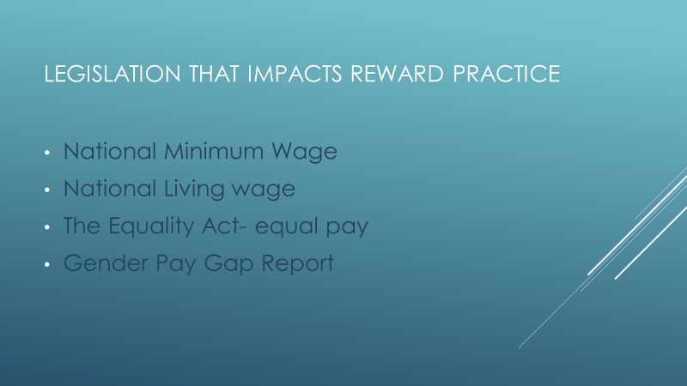
The National Minimum Wage came into effect in 1999. This determined the minimum hourly rate that employees must be paid. The rate is dependent on age and there are different rates for Apprentices. The National Living wage was introduced in 2016 however is not a legal requirement. This gave employees/workers a higher rate of pay if they were over the age of 25, this was extended to over 23-year olds in 2016. Waite et al (2021) highlight that any organisation that intentionally under pay their workers potentially will be named and shamed on Government websites. They could also gain unwanted media attention which will be brand damaging. As well as running the risk of receiving claims to the Employment Tribunals for underpayment.
The Equality Act (2010) and the Equality and Human Rights Commission's Code of Practice cover equal pay law. This states that women and men must be paid equally for carrying out equal work. The jobs do not have to be identical to determine this but they must be "substantially equal'. (ACAS, 2020) This law applies to everyone including employees, apprentices, self-employed, and agency workers. The term equal pay refers to basic pay, overtime rates, redundancy pay, access to pension schemes, benefits, etc. The terms and conditions offered must be equal to both genders and must not put any employee at a disadvantage due to a protected characteristic such as race and religion etc. Claims can be made by individuals if they feel that they are not being treated fairly in the way of pay however they must identify a comparator.
Gender pay gap reporting is an annual requirement of employers that have over 250 employees. The purpose of this is to analyse any average pay differences between women and men for equal work. If this isn’t completed then the organisation will be in breach of the Equality Act 2010. Actions should be determined to address any issues. If it is found that there is unequal pay then not only can this cause tensions but it could also affect retention within the organisation. Galvin (2017) suggests using the data to 'better understand what your employees' likely objectives, priorities and challenges are, will ensure that recruitment and benefits packages truly add value and help to attract and retain employees. Such data may also help you to understand the drivers of sickness and engagement such that action can be taken to get the best out of employees.’
To ensure that the organisation is remaining lawful in the way of equality, it can be recommended that regular Equal Pay Reviews/ job evaluations be conducted to identify any potential anomalies. Guidance has been produced by the Equalities and Human Rights Commission.

Evaluate the impact of getting a rewards strategy right to contribute to organisational performance
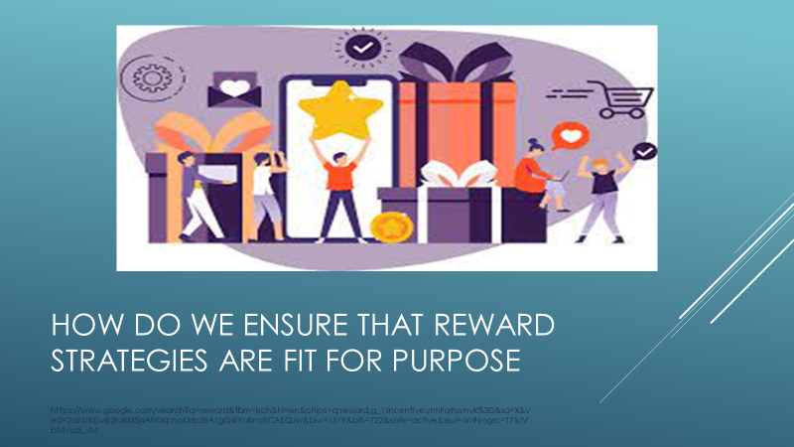
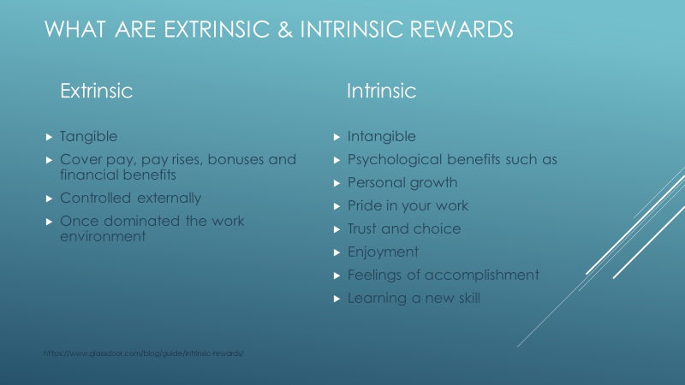
It is key to discuss intrinsic and extrinsic rewards. Hajduk (2017) describes an extrinsic reward as 'tangible' covering pay, bonuses, and benefits. Intrinsic rewards cover the psychological benefits that employees gain ‘from making a meaningful contribution through their work.’ Hajduk (2017) emphasises that although extrinsic rewards such as pay, are generally the most important factor in motivating employees. Traditionally these have dominated schemes for years however Hajduk (2017) believes there has been a cultural shift and money is no longer a motivator. Hajduk (2017) highlights that extrinsic rewards were used to motivate employees in boring and repetitive jobs however due to technological advances these roles are not as common and employers require more from employees. There has been a shift in employees' perceptions as employers are now relying on them to solve problems and use initiative.
It can also be suggested that extrinsic rewards can demotivate if it is believed to be unfair. Dan Pink (2009) highlights that if people were paid fairly, the topic of pay could be 'taken off the table'. This would encourage a culture shift and allow employees to focus on personal growth. In support of this view Waite et al (2021) emphasises that tangible rewards are easily replicable by other competitors in the labour market. She suggests that intangible rewards are not as they relate to the work environment.
Although comments such as ‘Extrinsic rewards are now less important, as day-to-day motivation is more strongly driven by intrinsic rewards.’ (Indeed, 2021) are common it is vital to remember everyone is individual and is therefore motivated by different factors. Therefore it can be argued that there is a strong place for both types of reward within organisations to encourage and motivate employees.

Compare different approaches to performance management and how these can be used by line managers to make effective reward judgments
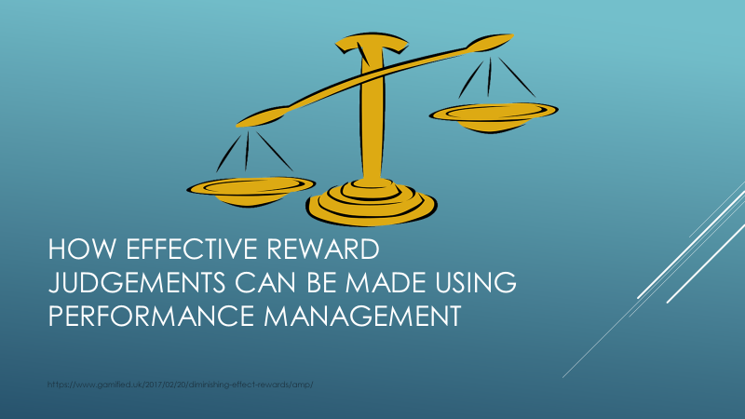
Employees must know and understand what is expected of them, to motivate, to ensure they understand their value and how they contribute to the overall business objectives. Performance management is a term that is used to include all of the above topics.
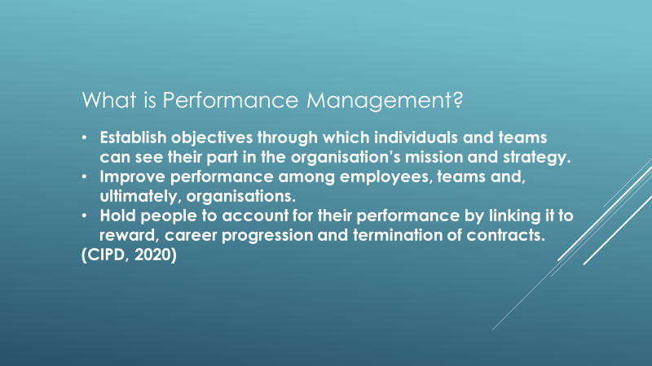
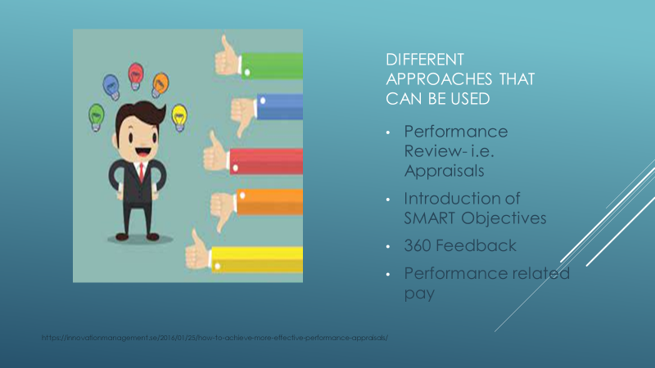There are various holistic approaches to performance management all centred around two-way discussion and feedback. these include; Performance reviews, performance-related pay, and 360-degree feedback.
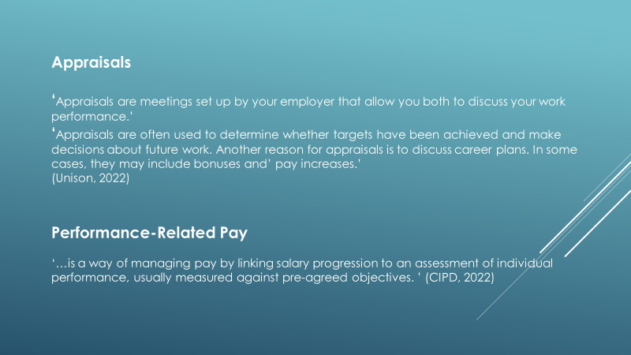
Performance reviews or appraisals traditionally have been held annually, however, this doesn't have to be the case. If held more than once a year they can help give frequent and immediate feedback. For the employee it provides the opportunity for open discussion on strengths and development areas, For the organisation, it provides an opportunity for regular communication of the organisational goals
Of late they have received much criticism. It is said that they should become more of an informal process and should be more of a regular chat providing constructive feedback rather than a formal annual process. The review process would need to be embedded into the organisation's culture for this to be excepted. The CIPD (2020) stresses that the process needs reviewing rather than getting rid of completely. Performance reviews must be fair and transparent. It has been highlighted that future performance can be influenced by the feedback that employees receive during these reviews. If they receive negative feedback this could have a negative impact on their performance going forward.
360 feedback (or ‘multisource feedback’- Armstrong, 2016) can often form part of the review. This is a process where various members offer feedback to the individual on how they are/have performed based on a series of competencies i.e. leadership, and communication. Many find these effective, however, as results are provided anonymously there is a risk of bias as the individual completing the survey can have an ‘axe to grind’. Grint (1993) quoted by Armstrong (2016) argues that it ‘merely replaces single-assessor subjectivity with multi-assessor subjectivity.’
Some organisations offer the benefit of performance-related pay. Some earlier processes weren’t successful and were revised to include linking pay to employee contribution rather than performance. Despite this the CIPD (2022) highlight that these schemes are still widespread in the private sector. This operates the notion that high performers should be rewarded with a higher pay rise than low performers. PFR can be successful if it is believed to be fair then it is likely to motivate. However, as these are generally carried out by line managers there is the risk of bias. It is up to their discretion whether or not rewards are issued.
There is great debate as to whether these incentives do motivate. The CIPD (2022) states that it has been suggested that using rewards doubles the improvements seen in performance. Herzberg (1950) believes that pay is a ‘hygiene factor’ and that poor pay demotivates, but so does higher pay. It is also suggested that financial incentives can ‘crowd out’ and reduce intrinsic motivation.
If carried out properly performance management can reward through recognition. Provide the opportunity to give feedback to motivate, encourage improvement and hold individuals to account if needed. Armstrong (2016) states that these non-financial rewards have more of a long-lasting effect and more of a powerful impact than any financial reward
It is vital to ensure that all reward judgments that are made are fair, consistent, and transparent. Line managers are central to this process. The CIPD (2020) emphasise how they reinforce the links between organisational and individual objectives. Therefore encouraging organisational performance.
Outline the nature and importance of the role that can be played by people practice professionals, in relation to supporting line managers to make appropriate judgments

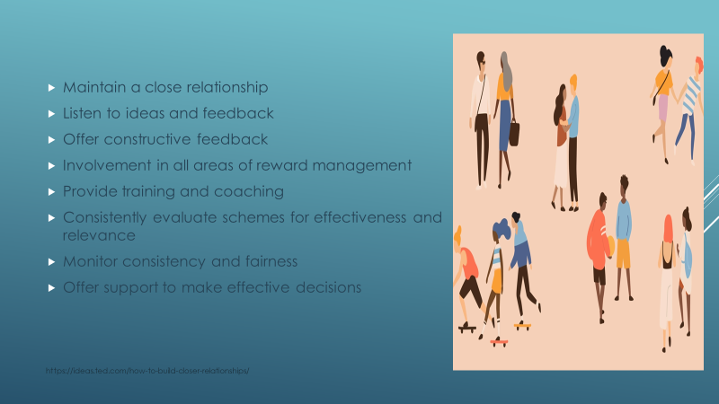
During the employee's life cycle HR and line managers must maintain a close relationship as there are there to support one another's roles.
There are various ways in which HR can support line managers- particularly in a training and coaching capability, this includes monitoring the schemes that are in place to ensure that they are fair and equitable to all. Taylor and Woodhams (2016) stress that line managers have a crucial part to play in maintaining fairness, consistency, and transparency across the organisation. It is HR's role to support to ensure this happens. If there are any difficulties in achieving this HR can identify any development areas and cater any training to meet these needs. It is HR's responsibility 'to ensure that line managers do not unfairly discriminate in the distribution of rewards, failing to recognise issues surrounding equality and diversity can quickly erode the psychological contract.’ (Taylor and Woodhams, 2016)
Although Line Managers have more contact with employees on a day-to-day basis and often make the decisions that impact reward. It is important to acknowledge that it is People practice professionals formulate, implement and maintain these policies and procedures.
As an organisation, it is key to ensure that you remain competitive, current, and the organisation of choice. Organisations not only need to offer reward initiatives that their employees want but they also need to be comparable with other organisations within the sector. To be able to do this HR need to regularly research what competitors are offering. Martin and Whiting (2016) highlight that reward is a complex/specialist area and have individuals/teams that ensure that their reward strategies and approaches are at the ‘leading edge of reward practice.’
Taylor and Woodhams (2016) state that line managers feel that they are not involved in the development of reward management, therefore it is key that HR consult with them when introducing, creating, or adapting new or existing innovations. If the line manager is not considered this can affect not only their morale and motivation but also that of the employee. Therefore, it is key that line managers' views are consulted.
Not only should line managers be trained in how reward systems work but also how decisions should be arrived at. (Taylor and Woodhams, 2016). They should understand how pay grades and structures work to be able to make effective decisions. This is even more crucial if the organisation uses a contingent pay system. Line managers are relied upon to provide information on employees' performance for an informed decision to be made for performance-related pay for example. It is important to ensure that line managers are comfortable, confident, and properly equipped with the necessary skills to conduct performance reviews such as appraisals and to deliver difficult or challenging feedback or conversations that may have an impact on reward. These are great opportunities to strengthen the employer-employee relationship and motivation,

Suggest one way of improving your organisation’s approach to reward, based on organisational data available to you

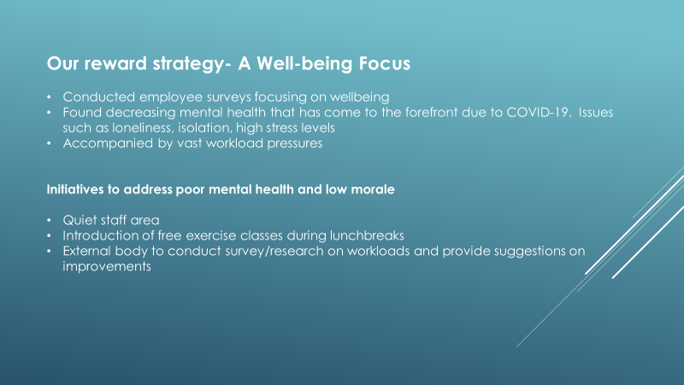
To identify ways in which my organisation can improve the overall reward package we reviewed data that was available to me, this included the Well Aware Project Report and Health and Wellbeing surveys results that were undertaken this academic year. As well as the Mental Health and Wellbeing survey results that were conducted in February 2021. Employee wellbeing has come to the forefront of all business agendas with the onset of the COVID pandemic and has made organisations consider their approaches to employee wellbeing. Pembrokeshire College was no exception. With vast workload pressures actions needed to be identified to help with the decreasing mental health issues that were evident and this became the organisation's focus.
The Mental Health survey (2021) found that 43 employees were struggling with loneliness, the lack of social contact, and face-to-face interaction. This statistic was later supported by figures in the Well Aware Report (March 2022). When looking through the free text suggestions a common theme was spotted- employees wanted a quiet space to be able to take breaks away from the busy college environment. Due to space constraints post lockdown the ‘staff café’ became a teaching space. As a result of these findings, the employees were given their staff café back with improved facilities to ensure is a comfortable and pleasant space. It was found that a large number of employees felt that they didn’t have a healthy work-life balance and as a result stress levels were high. A walking group and free fitness classes were introduced during lunch hours to encourage staff to take their breaks to help reduce stress.
Meister (2021) stresses that ‘employee wellbeing has expanded beyond physical wellbeing to focus on building a culture of holistic wellbeing including physical, emotional, financial, social, career, community, and purpose.' The CIPD (2022) highlights that promoting well-being can help prevent stress and can help create positive working environments. All line managers were consulted on these changes to gain opinion. If employees can see that there is an investment in their well-being they will feel appreciated. If they are healthy and happy a reduction in absenteeism can be anticipated. There will be an improvement in productivity, retention, and loyalty.
Through the research that was conducted, it is clear that a mixture of extrinsic and intrinsic rewards, accompanied by a fair and transparent performance review process and a mutual appreciation of the line manager and HR relationship would be most effective. However, as a public body, we don't have the funding streams to introduce a mixture of the two. The decision was made to focus on the incentives that can be controlled.


Bibliography
Armstrong, M, and Taylor, S (2020) Armstrong's Handbook of Human Resource Management Practice. London: Kogan Page.
Caboodle (2021) The 12 Best Non-Monetary Rewards that will Motivate Your Employees (Online) Available at: https://caboodle-technology.co.uk/blog_post/best-non-monetary-rewards-motivate-employees/ (Accessed: 01/05/2022)
Cappelli, P, and Tavis, A (2016) The Performance Management Revolution (Online) Available at: https://hbr.org/2016/10/the-performance-management-revolution. (Accessed: 02/06/2022)
CIPD (2022) Reward Strategy (Online) Available at: https://www.cipd.co.uk/knowledge/strategy/reward#gref (Accessed 02/05/2022)
CIPD (2022) Reward (Online) Available at: https://www.cipd.co.uk/knowledge/fundamentals/people/pay/reward-factsheet (Accessed 01/05/2022)
CIPD (2021) Strategic Reward and Total Reward (Online) Available at: https://www.cipd.co.uk/knowledge/strategy/reward/strategic-total-factsheet (Accessed: 01/05/2022)
CIPD (2022) Line Managers’ Role in Supporting the People Profession. (Online) Available at: https://www.cipd.co.uk/knowledge/fundamentals/people/hr/line-managers-factsheet#gref (Assessed 24/05/2022)
CIPD (2022) Employee Benefits: An Induction (Online) Available at: https://www.cipd.co.uk/knowledge/fundamentals/people/benefits/factsheet#gref (Accessed: 24/05/2022)
CIPD (2022) A Day in the Life of a Reward Officer (Online) Available at: https://www.cipd.co.uk/careers/career-options/reward-roles/day-in-reward-officer#gref (Accessed 29/05/2022)
CIPD (2020) Performance Management: An Introduction (Online) Available at: https://www.cipd.co.uk/knowledge/fundamentals/people/performance/factsheet (Accessed: 02/06/2022)
CIPS (2022) Benchmarking Tools (Online) Available at: https://www.cips.org/knowledge/procurement-topics-and-skills/continuous-improvement/benchmarking1/benchmarking-tools/ (Accessed: 05/06/2022)
CIPD (2022) Incentive and Recognition: An Evidence Review. (Online) Available at: https://www.cipd.co.uk/Images/incentives-recognition-practice-summary_tcm18-105466.pdf (Accessed: 05/06/2022)
Dinu, A (2021) Reward Management- Environment (Online) Available at: https://www.linkedin.com/pulse/reward-management-environment-aida-dinu (Accessed: 30/05/2022)
Galvin, J (2017) Five Ways the gender pay gap reporting can benefit business (Online) Available at: https://reba.global/resource/five-ways-the-gender-pay-gap-reporting-can-benefit-business.html (Accessed: 31/05/2022)
Glassdoor (2021) Intrinsic Rewards: Why They Matter In the Workplace (Online) Available at: https://www.glassdoor.com/blog/guide/intrinsic-rewards/ (Accessed: 05/06/2022)
Hajduk, P (2017) People Management: What’s the Real Value of Reward (Online) Available at: https://www.peoplemanagement.co.uk/article/1743866/real-value-reward#:~:text=Extrinsic%20rewards%20are%20tangible%2C%20covering,meaningful%20contribution%20through%20their%20work. (Accessed 02/05/2022)
Indeed (2021) What are Intrinsic Rewards and How to Use Them at Work? (Online) Available at: https://uk.indeed.com/career-advice/career-development/intrinsic-rewards (Accessed: 05/06/2022)
Jakubowski, J (2021) PM Insight- People Management: Three trends in employee reward strategy you can't afford to ignore. (Online) Available at: https://pminsight.cipd.co.uk/three-trends-in-employee-reward-strategy-you-cant-afford-to-ignore? (Accessed 29/05/2022)
Mandizvidza, A (2014) Rewards and Incentives (Online) Available at: https://www.linkedin.com/pulse/20140708092823-76008439-rewards-and-incentives. (Accessed: 30/05/2022)
Martin, M, and Whtling, F (2016) Human Resource Practice. London: CIPD-Kogan Page
Meister, J (2021) The Future of Work Is Employee Wellbeing (Online) Available at: https://www.forbes.com/sites/jeannemeister/2021/08/04/the-future-of-work-is-worker-well-being/?sh=3dffa3884aed (Accessed: 01/06/2022)
NHS Employers (2020) The Role of Line Managers and Total Reward (Online) Available at: https://www.nhsemployers.org/articles/role-line-managers-and-total-reward (Accessed: 24/05/2022)
LSA Global (2022) 7 Attributes of Rewards and Consequences to Shape Corporate Culture (Online) Available at: https://lsaglobal.com/blog/7-attributes-of-rewards-and-consequences-to-shape-your-corporate-culture/ (Accessed: 31/05/2022)
Perkins, S J, Jones, S and White, G (2020) Reward Management: Alternatives, Consequences, and Contexts. London. Kogan Page
Purcell, J, and Hutchinson, S (2007) Change agenda: Rewarding work - The vital role of line managers. Chartered Institute of Personnel and Development.
Sutherland, C (2022) Eight Companies with Amazing Company Culture (Online) Available at: https://www.rewardgateway.com/blog/eight-companies-with-amazing-company-culture. (Accessed: 31/05/202
Taylor, S, and Woodhams, C (2016) Human Resources Management: People and Organisations. London: CIPD-Kogan Page.
Taylor, S and Woodhams, C (2016) Studying Human Resource Management. London: CIPD- Kogan Page.
Thomas, K (2009) The Four Intrinsic Rewards that Drive Employee Engagement (Online) Available at: https://iveybusinessjournal.com/publication/the-four-intrinsic-rewards-that-drive-employee-engagement/ (Accessed: 05/06/2022)
Unison (2022) Appraisal (Online) Available at: https://www.unison.org.uk/get-help/knowledge/terminating-suspending-job/appraisal/ (Accessed: 05/06/2022)
Waite et al (2021) People Practice: A Complete Guide. London. Kogan Page

