
ACADEMIC AND EMPLOYABILITY SKILLS
ASSESSMENT 1
academic report

Certificate of Higher Education in Skills for the Workplace
Karolina Martyna Tkaczyk
ID:1916662
Lecturer’s Name: Timothy Hopkins
Date: 21/04/2020
Table of contents
- Introduction ………………………………………………………………….p.3
- Skills ……………………………………………………………………………..p.4
- Academic skills ……………………………………………………………..p.5
  - Paraphrasing and summarising …………………………….p.6
  - Effective Research and note-taking ………………..…….p.8
  - Academic essays ………………………………………………….p.9
  - Referencing and plagiarism………………………………….p.10
- Employability skills……………………………………………………….p.12
  - Time management and Eisenhower method ………p.13
  - Personal development plan………………………………..p.14
  - SWOT analysis…………………………………………………….p.15
- Conclusion…………………………………………………………………..p.17
- List of references………………………………………………………..p.18
- Appendices ……………………………………………………………….p.19

Introduction

Nowadays, studying academic and employability skills is a foundation in the employment market for young people. The education programs offered by universities are often overloaded with theoretical and practical knowledge, and as a result, students gain extensive knowledge that they can later apply to many jobs.

The main purpose of this report is to show and provide the reader with opportunities knowledge on the academic and employability skills subject. Therefore, my skills and knowledge acquired during learning will be the foundation on which I will base in this report.

The report will analyze methods such as Personal Development Plan (PDP), SWOT planning, or time management system. Additionally, this document will help the reader obtain information about Eisenhower Method, understand the goal of daily and weekly logs, and also some academic skills such as paraphrasing or summarising.

This report summarizes how academic and employability skills course from the University Of Wales Trinity Saint David program have directly, and very close expanded my scope of knowledge in this section. The report describes the learned functions, skills, and targeted exercises done during the classes. Many of the examples in this report have inserted to validate the learning process.

Skills

Why should everyone develop persona skills? Reflecting on this subject, every person, regardless of whether they are fully physically healthy or not, has smaller or more exceptional skills that they should develop because different skills can make our lives easier. Each of us has different abilities. There are so many that it is impossible to list them all. Presently, people significantly differ from each other, so do their skills. Abilities demanded in our lives usually at work or in school. They make us able to do things that become our priority, and we gain more and more knowledge, through which we enlarge to our improvement. We shape ourselves by improving our skills. We develop our imagination, we have our views on various topics, and we can demonstrate knowledge in a field that we know well, and we are interested in specially.
According to the Cambridge dictionary skills are ' a particular ability that you develop through training and experience, and that is useful in a job.' This definition supports the declaration that the skills help us expand our personal and professional skills as well as learn about our strengths, learn various curiosities, and recognition to our interests.

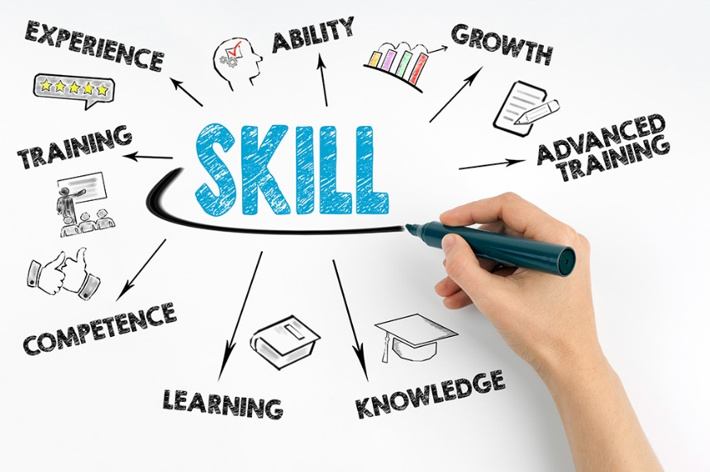
Source: Picture from presentation from the lesson.

Academic skills

Academic skills are skills and knowledge about the functioning of the educational environment (universities, regulations, course of studies) and the basics of academic skills such as paraphrasing, summarising, academic essays, research, note-taking, referencing, plagiarism.

A large number of students with excellent academic skills have a higher chance of becoming more productive students. They give students the confidence to fully participate in English courses and are invaluable outside the classroom and after graduation. These skills, including critical thinking and taking notes, are also advantageous and, therefore, essential for success in any career.

A good student who wants to improve his or her learning should know a number of these skills when he or she starts the academic level.

- Academic Discourse – skills for interacting effectively in discussions, debates, and presentations.

- Academic Discourse – skills for interacting effectively in discussions, debates, and presentations.

- Academic Text Strategies – skills for analyzing educational documents in complete detail.

- Composition – experiences for effective educational writing.

- Comprehension – skills for reading, and understanding academic texts, books, and lectures.

Paraphrasing and summarising

The paraphrase is nothing more than a repetition of what the other person said in a slightly different way, but keeping the middle of the body. When we have direct contact with another person, we simply repeat the key words of our interlocutor's own words. For example, when a student says: I am looking for books about nature that will contain illustrations, the teacher may repeat it this way: From what you said, you need a good book with illustrations about nature.
It allows us to summarize quotes and statements. Furthermore, through this technique, we also better understand certain literary texts. It allows free transfer of specific information through verbal modifications. Paraphrase is a modification of the text that does not change the sense of the body. It is used to simplify the information provided or to shorten a longer statement. In short, paraphrase and summarizing are simple ways to avoid repetition.
These are some examples of exercises from my teacher, which I have done in the lesson time.
(See appendix no 1, Paraphrase exercise)
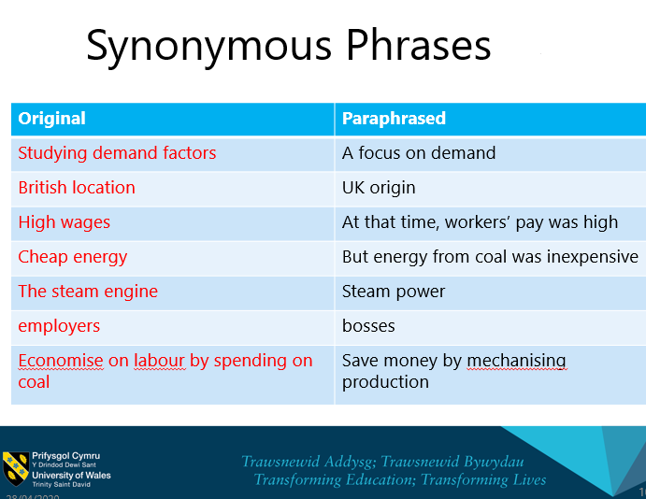
Source: Presentation from the lesson
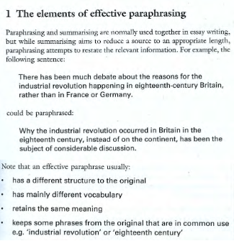
Source: Presentation from the lesson

Effective Research and note-taking

In an effective search, an important element that helps you reach the content you are looking for is the right way to create queries. How we formulate the question determines the results we find. Nowadays, we often change the way from traditional methods of searching for information, for example, before people were using the encyclopedia. Today, we search for information more often and find what we need using a search website e.g., google. Sometimes we get the right information, and sometimes we get the wrong data. Therefore we should use different sources to compare information and make selections. To sum up, in order to search for information and be sure about its reliability, we should use various sources (online, books, encyclopedias, literature) and be careful with incorrect information posted online.

Note-taking is an essential part of the road to success in business and academic life. It helps improve the way you listen and learn. Taking notes will also help you remember the key points of the meeting or training and explain them to yourself. During lectures or conversations, the notes will allow you to focus on the presented material and extract from them what is most important to us. Thanks to the habit of writing down your ideas, thoughts, and quotes, no great idea will never be lost. The habit of taking notes can be developed using a number of proven methods of effective note-taking. Making notes is the key to successfully managing projects and tasks. This habit helps you choose decisions, find solutions to problems faster, and by making a note, people can become more creative and improve their productivity. Taking notes in everyday life requires a lot of discipline, but once you find the right system for you, the benefits can be huge.
These are some examples of notes from my teacher, which I have done in the lesson time.
(See appendix no 2 and 3, Notes)

Academic essays

Typically, an essay is a publication describing the writer's perspective or story. It is often considered equivalent to a story, article, or study. Essays can be both formal and informal. Formal essays are generally academic and deal with serious topics. We can distinguish four main types of academic writing; are descriptive, analytical, persuasive, and critical.

 | ACADEMIC ESSAY
Step 1 | Analyse the topic - make sure you understand the topic and question you were asked. Define your position.
Step 2 | Collect materials for your work - read the literature on the topic, look through newspapers, watch video materials, interviews etc. Talking with people dealing with the topic can be inspiring.
Step 3 | Take notes - take notes on a regular foundation, record your observations. Your first response to a given material may be the most interesting.
Step 4 | Plan your essay - try to answer the question and arrange it into points. Check if the answer is exhaustive and if you not are moving away from the topic. Organize theses, arguments and examples.
Step 5 | Start writing - write the introduction, present the next arguments in a logical order, support the collected materials (refer to literature, research, etc.), draw conclusions and refer critically to the problem you were considering.
Source: Created by Author

Referencing and plagiarism
While we are writing a piece of work and use someone else's words or ideas, we must refer to them. That means that we must provide detailed information about all sources consulted.
in the text (quotes in the text) and at the end of the work (reference list). Referring is essential because it is critical to successful research and helps the reader find the source if he wishes. Using refinement also improves writing skills and adds authenticity to the argument.
It shows the reader that you have read a lot on a given topic so that your work looks authentic and can help you get better grades.
There are several different reference styles. Every other module/textbook, school, or university should explain which system to use. It is essential to use the appeal consistently throughout work.
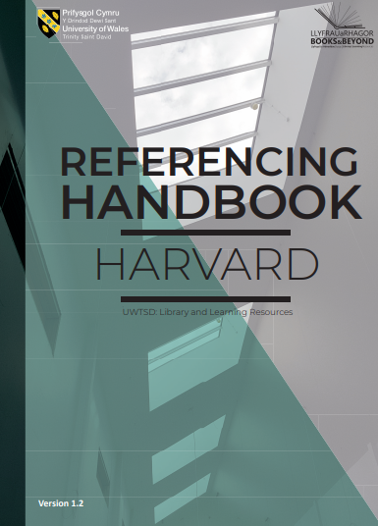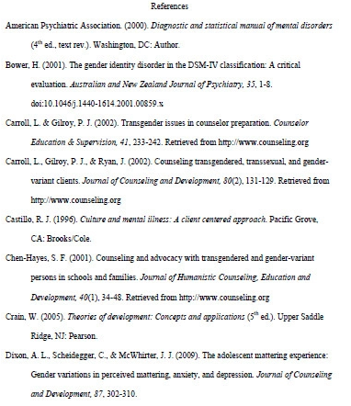

Example of a Referencing handbook as used by my university - it explains which system to use and some referencing list.

Plagiarism

According to the Cambridge dictionary, plagiarism is 'the process or practice of using another person's ideas or work and pretending that it is your own.'
Plagiarism is presentation of someone else's ideas as their own. Copying it applies not only to direct quotes but to summarized and paraphrased arguments. Plagiarism is taken very seriously and usually results in disciplinary action.
To avoid plagiarism from the section read, it is worth taking notes. This makes it easier to use your word. Saving all details about each source while working will help create a reference list or bibliography.
Taking inspiration from existing works is allowed, but we need to meet the right conditions in this regard, because accusation of plagiarism is not easy and pleasant.

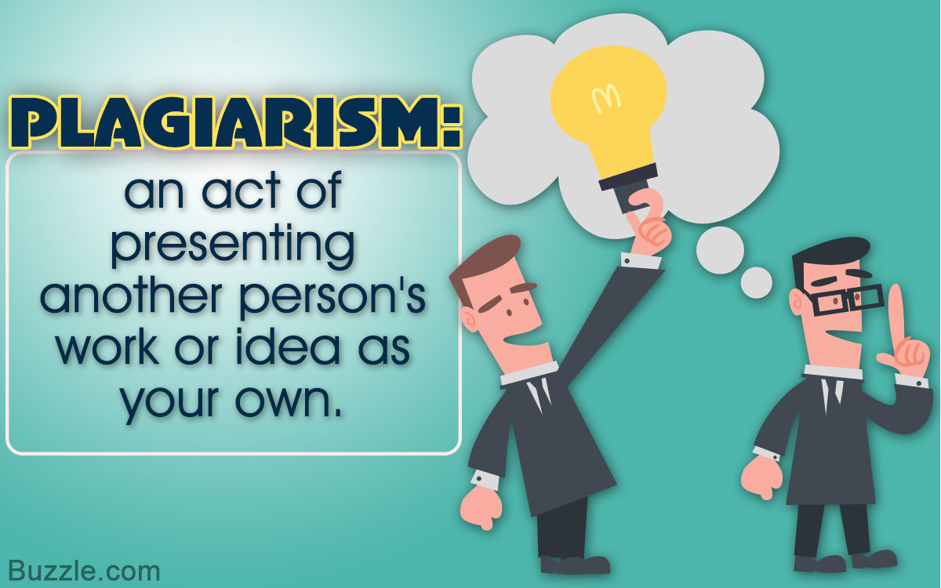
Source: Presentation from lesson

Employability skills

Employment skills are skills that may not be specific to the profession or course, but represent an important role in improving job performance and value. Employment facilities affect career, development, ability. Profession skills are transferable skills that are useful in almost any job. These include the development of specialist knowledge, a knowledge base, or a way of thinking that makes more attractive to employers or schools. Employment skills are also often referred to as employment skills, soft skills, job readiness skills, or necessary skills. They often improve performance, minimize errors, and promote collaboration with colleagues, enabling you to perform your role more efficiently.
Employers highly value employment-related skills because teaching them is much more difficult than job-specific skills. Some features related to employment appear naturally, while others can be acquired through education, work, or everyday practice.
Here are some typical employment skills that employers are looking for:

- Communication
- Teamwork
- Reliability
- Problem-solving
- Organization and planning
- Leadership
- Learning
- Technology

Time management and Eisenhower method

Time management and work organization have a lot in common, because good work organization creates conditions for the efficient use of time, while lousy work can do much damage. Even seemingly small mistakes in the organization of work can have a significant impact on reducing efficiency because can be repeated in many activities. According to the Cambridge dictionary, time management is ' the practice of using the time that you have available in a useful and effective way, especially in your work.' Eisenhower's method is one of the systems which can help with time management.
The Eisenhower Method, also known as Eisenhower Matrix or Eisenhower Box, is a method used to organize tasks and responsibilities to determine priorities. The Eisenhower method, also called Urgent-Important Matrix, helps in making decisions and prioritizing tasks according to urgency and importance, sorting less urgent and essential tasks that should be either delegated or not carried out at all.
Examples of Eisenhower method from presentation from lesson:
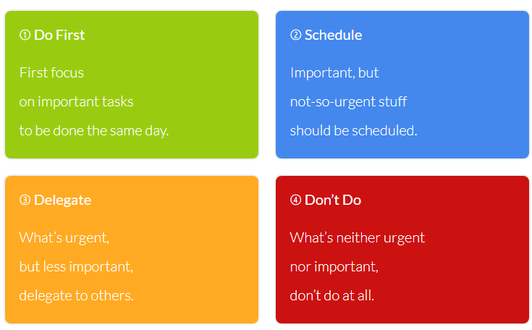

These are some examples of exercises from my teacher, which I have done in the lesson time.
(See appendix no 4 and 5, Eisenhower method exercise)
Personal Development Plan

Personal Development Plan (PDP) is the process of creating an action plan based on awareness, values, reflections, goals of personal development in the context of professional career, education, interpersonal relationships, or personal self-improvement. The PDP usually contains a statement about aspirations, strengths, and advantages, competences, previous education, and training. Besides, there are also stages showing how the plan is to implement.
A personal development plan may also contain more or less specific career priorities or a lifestyle in general.

Example of my PDP plan from lesson:
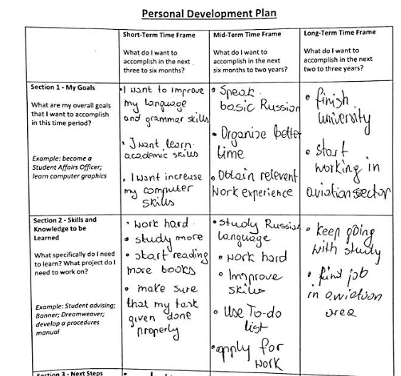
SWOT Analysis

SWOT analysis is one of the analytical methods operating in the business sector. It characterized by simplicity and speed of application. Strategic planning helps organizations be more productive by better allocating resources to achieving goals.

For the record, SWOT is an acronym of English words:
S as strengths
W as weaknesses
O as opportunities
T as threats

It is, therefore, said in a nutshell that the SWOT analysis is an analysis of the strengths, weaknesses, opportunities, and threats of an industry.


Source: Presentation from lesson

Here is an example of what the individual components of the SWOT analysis are.

SWOT ANALYSIS
Strengths  Strengths are positive internal factors. They constitute the company's internal strength. Should take care of them to keep them in the future as well. They can use for activities related to the company's expansion.  Examples of strengths are:  - high qualifications of employees  - large financial resources accumulated in the past. | Weaknesses  Weaknesses are negative internal factors. The focus should be on eliminating them so that they do not weaken their strengths. They limit the company's efficiency and inhibit their development.  Examples of weaknesses are:  - the limited production process, resulting in low product quality  - high staff turnover.
Opportunities  Opportunities are positive external phenomena and processes that can use to grow a company. They can also reduce the company's weaknesses. Focus on making the most of them.  Examples of opportunities are:  - increase in demand for products offered by the company  - opening a new market  - increase in the number of inhabitants of the city in which the company operates (more potential employees). | Threats  Threats are negative external phenomena and processes that can block a company's development. Focus on finding remedial measures so that threats do not affect business.  Examples of threats:  - increase in the number of workplaces in the town where the company operates (threat of losing employees)  - new competition importing products cheaper than their production at the company's place of business  - tax increases or other legal changes.

Source: Created by Author

Conclusion
In conclusion, my study this semester primarily based on lessons and self-study, during which I used many presentations, articles, and reports.
What's more, during my studies, I improved my experience of working in a group, my time management, and I understood that time management of other people requires development.
My academic writing skills have improved, but they can get still developed, and I believe that this will be one of my decisions. Because it will not only enhance my thinking but also improve my skills acquired at the time.

List of references:

Bailey, S. (2011) Academic Writing for International Students of Business, Abingdon: Routledge.
Cambridge Dictionary (2020) Plagiarism. Available at: https://dictionary.cambridge.org/pl/dictionary/english/plagiarism (Accessed: 28 April 2020).
Cambridge Dictionary (2020) Skills. Available at: https://dictionary.cambridge.org/pl/dictionary/english/skill?q=skills (Accessed: 28 April 2020).
Cleeve (2018) 5 academic skills to prepare your students for higher education. Available at: https://www.english.com/blog/academic-skills-for-higher-education/ (Accessed: 28 April 2020).
Cottrell, S. (2008) The Study Skills Handbook, Basingstoke: Palgrave Macmillan.
EISENHOWER (2017) Introducing the Eisenhower Matrix. . Available at: https://www.eisenhower.me/eisenhower-matrix/ (Accessed: 25 April 2020).
Indeed (2019) Employability Skills: Definition and 10 Examples. Available at:
https://www.indeed.com/career-advice/finding-a-job/employability-skills (Accessed: 27 April 2020).
Zemach, D.E. and Rumisek, L.A. (2005) Academic Writing from Paragraph to Essay, Oxford: Macmillan.

Appendices:

Appendix no 1
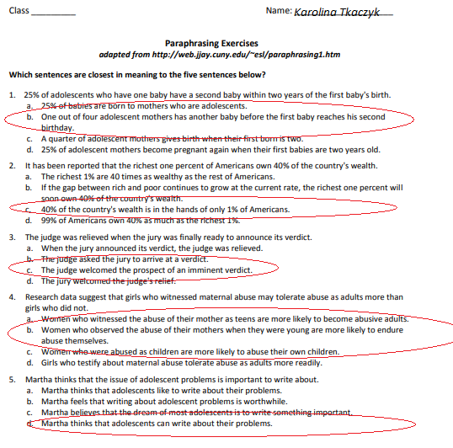

Appendix no 2
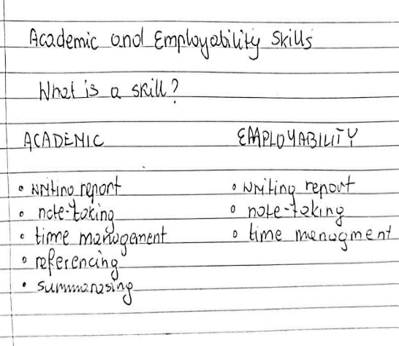

Appendix no 3
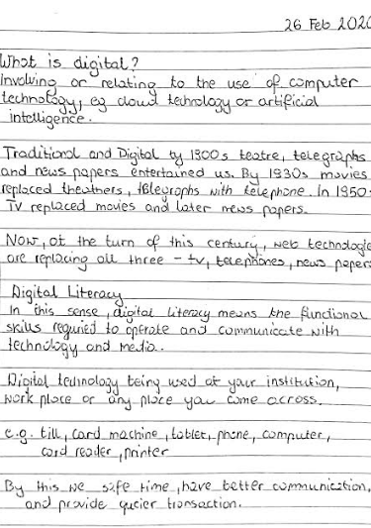
Appendix no 4
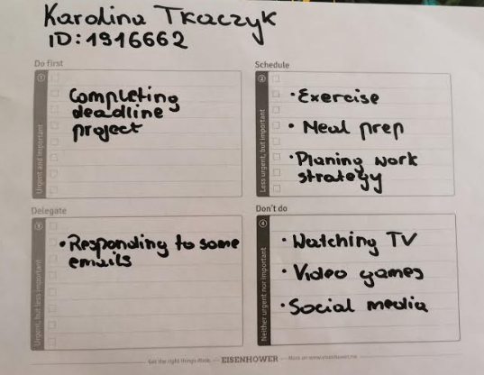

Appendix no 5


