Teach your children the SMART Rules:
S – Safe. Be careful not to give out personal information like address, passwords, school etc.
M – Meet. Never arrange to meet anyone you have only met online, it can be dangerous.
A – Accepting. Don’t accept emails or messages from people you don’t know.
R – Reliable. Not everything you see on the internet is true or real. Someone you chat to may be lying about who they are.
T – Tell. Tell your parent, carer or trusted adult if something makes you uncomfortable or if you know someone who is being bullied online.

Also, teach them to be SMART with a

Always be kind to others online and think about other users feelings.
So, how many children get bullied online?
Around 1 in 5 children aged between 10 and 15 in England and Wales experienced at least one type of online bullying behaviour last year. That’s equivalent to 764,000 children!

1 in 4 of these children didn’t report their experiences to anyone.

10% of these children experienced being called names, sworn at, being insulted and having nasty messages about them.

(ONS.gov.uk)
Help your children to be
SMART
Online!


Does your child have a phone, tablet, Ipad or laptop?


If the answer is “yes”, then you need to know how to protect them.



Look for the signs:  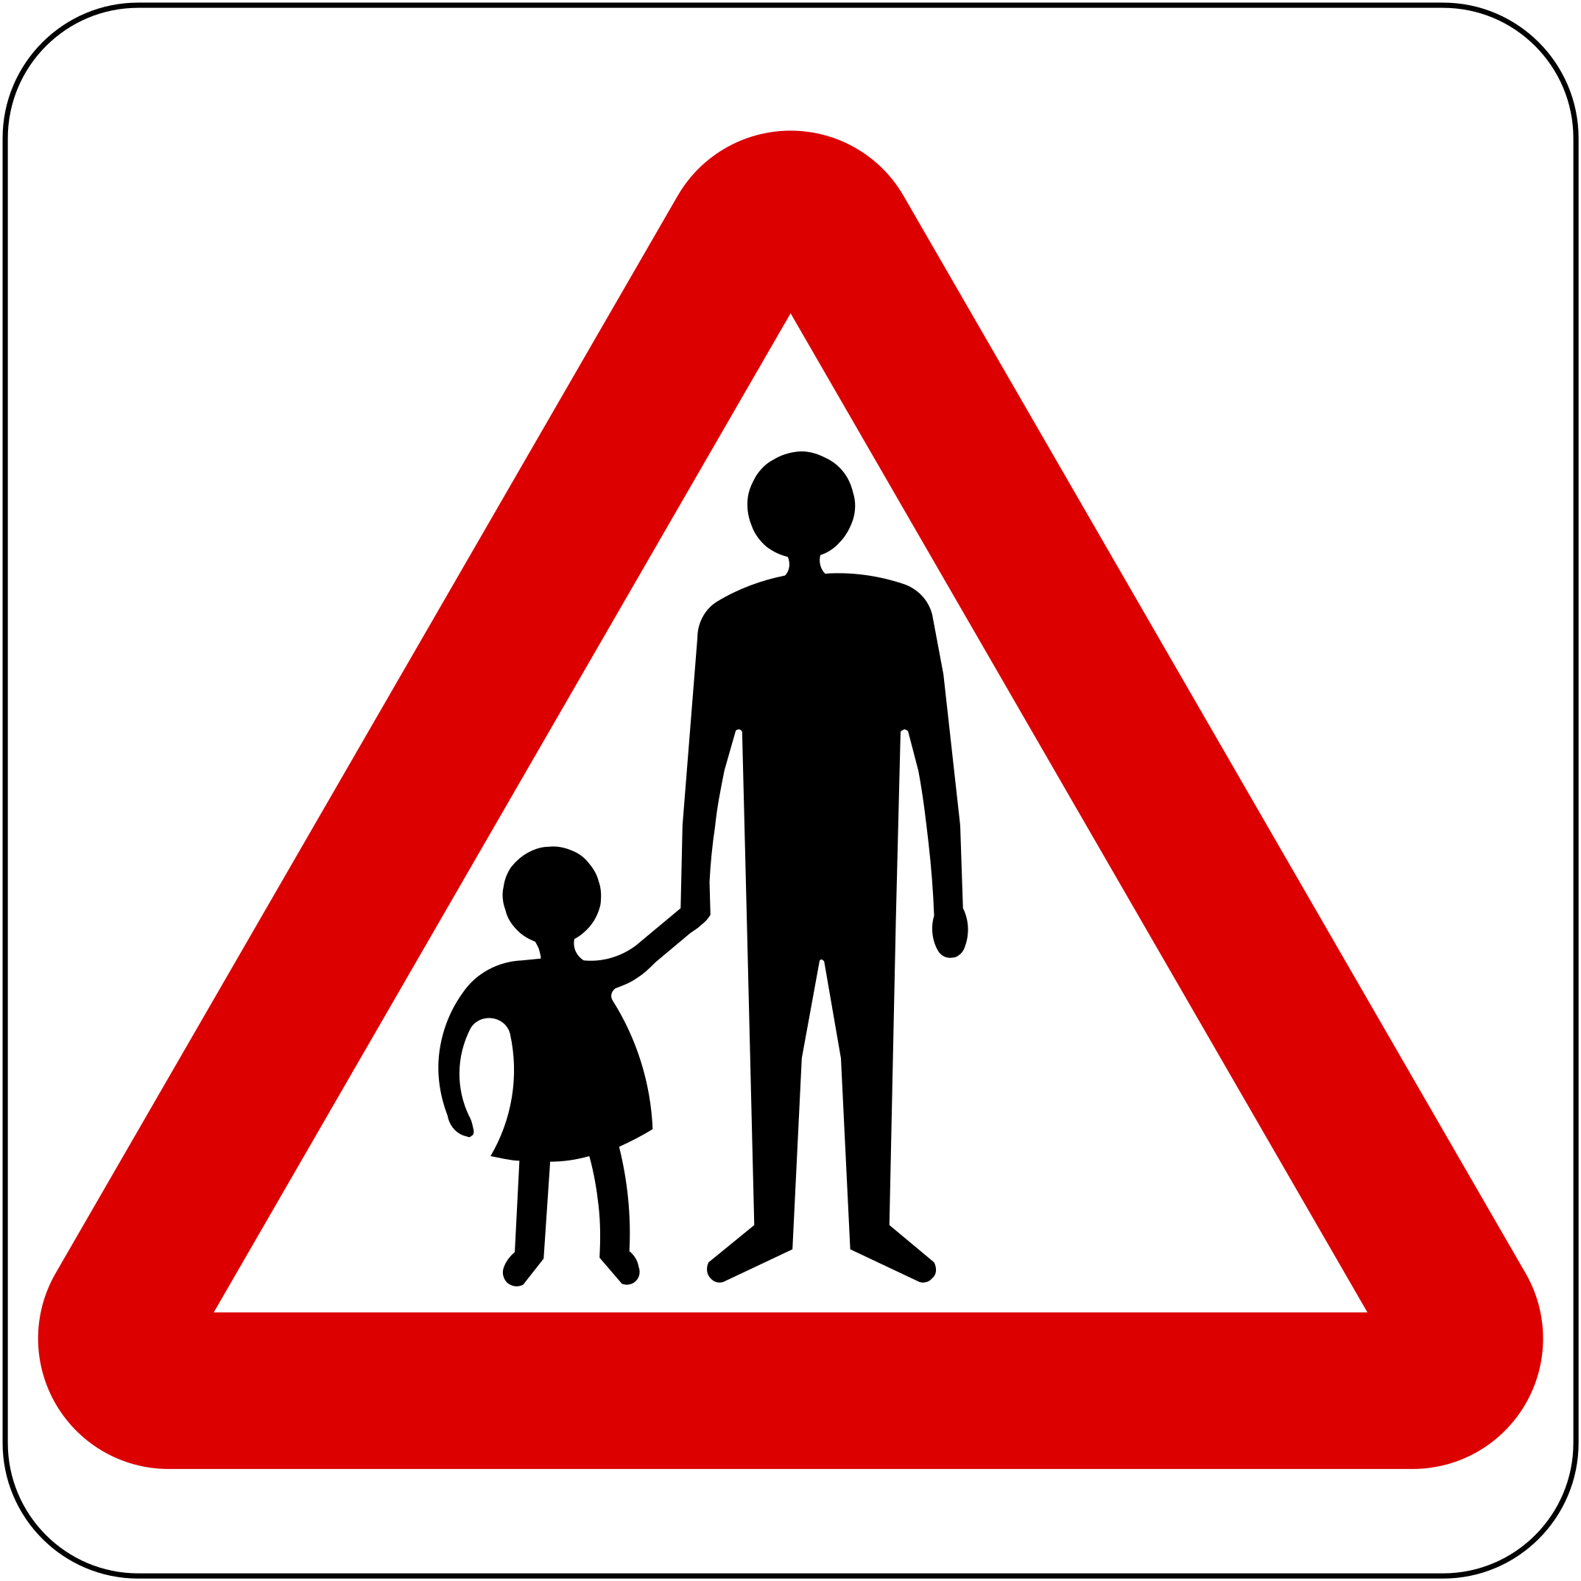
- Being emotionally upset during or after using the internet or the phone
- Being very secretive of their digital life
- Withdrawal from family members, friends and activities
- Avoiding school or group gatherings
- Becoming angry at home
- Changes in mood, behaviour, sleep patterns, or appetite
- Wanting to stop using their phone or other device
- Being nervous or jumpy when getting an instant message, text or email
- Avoiding discussions about the computer or phone activities.
(Kidshealth.org)
Here’s what to do if you think your child is being bullied:
Talk to them, Reassure them that it’s not their fault and that it’s very common. This helps them to know they’re not alone.
Encourage them not to respond to the bullying, it just fuels the fire.
Block the bully on their device
Limit online access
Ask to “Friend” or “Follow” them on social media
Keep any abusive or threatening messages or pictures to use as evidence with the bully’s parents, school or even the police.
Let someone at their school know as most schools have an anti-bullying policy.
Do all this with your child’s knowledge. They need to be able to trust you too!
What affect can bullying have on my children?
How do I know if my child is being bullied?
Sadly, any form of bullying can have a profound effect on a child. Children who are bullied often become withdrawn, lack confidence, struggle to eat and sleep and become weary and suspicious of others. Bullying can affect their ability to learn in school because of this. At its worst, bullying has driven children to self-harm or even commit suicide.  (NSPCC.org)

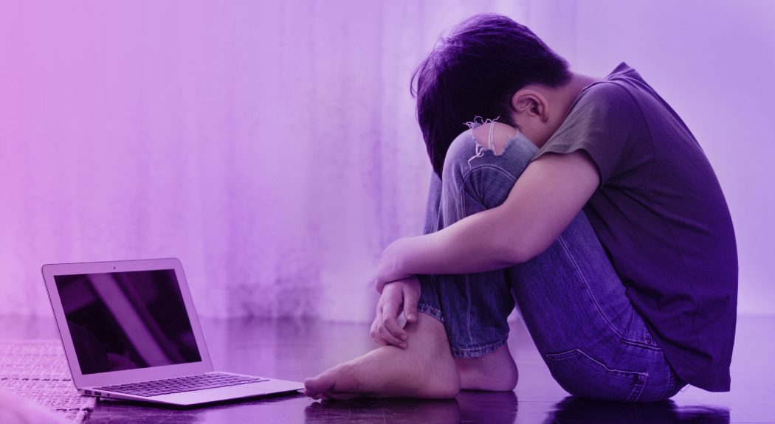

Rationale
This Rationale is linked to the Online Safety leaflet one has produced with the intention of educating parents and carers on the importance of teaching their children how to be safe online. Many children today have devices such as tablets, Ipads, Android Phones, Laptops and gaming devices (Playstations and Xbox’s). All of which have access to the internet. Children who have not yet learnt to read are able to use these devices freely and often do so without the supervision of an adult (Speilhofer, 2010).
While the internet is a considerably beneficial tool for many aspects of daily life, it can also pose a risk to children and young adults who are unaware of the dangers that freedom of the internet can have. For example, one has used the internet to gather information and evidence for this rationale and the internet is used in educational settings daily to aid teaching. However, social media, online gaming and video-sharing platforms like Youtube can all be used as a means of abuse.
Facebook was the most likely social media platform used by children aged 12 to 15 years in 2019 in the UK, closely followed by Snapchat and Instagram. Despite having minimum age limits in their terms of service, five percent of children aged 5 to 7 years had a social media account according to Ofcom (Tankovska, 2021). These social media platforms have proved to be a lifeline during the Covid-19 pandemic, enabling people to keep in touch and have a sense of access to the outside world whilst being in lockdown. Linked to Facebook, Messenger and WhatsApp have videocall capabilities to enable family and friends to speak face-to-face at a time when getting together was not an option. Unfortunately, there are accounts that have been set up on these platforms with the sole purpose of abusing children. Setting up an account with a false name, age and profile picture is all too easy for sexual predators that use these profiles in order to groom children. In the year 2019/20, there were 10,391 recorded sexual offences that involved an online element including grooming, sexual assault and rape (NSPCC, 2020).
The United Nations Convention for the Rights of The Child (UNCRC) states in Article 19 that all children have the right to be protected from abuse, violence and neglect. Parents and Carers have the responsibility to provide that protection for their children. By educating children on the dangers of being online, they are more likely to recognise the signs of attempted abuse or a false or fake account and therefore block and report it, thus protecting themselves before any serious abuse is able to take place.
Any child that suffers abuse, either physical, mental or sexual, will have their development severely affected. Adverse Childhood Experiences (or ACE’s) are known to affect a child’s mental development in many ways. Children who suffer ACE’s often go on to experience mental health problems such as depression, anxiety, behavioural disorders and suicidality (Maryland Coalition of Families, 2018).

Abraham Maslow developed the Hierarchy of Needs in 1962 to show that a child who had not had their basic needs met (like food, warmth, stability, affection, love and freedom from fear), could not then go on to develop the higher psychological aspects of self-belief, respect and self-fulfilment (Bates, 2019). This is visible in a child who has suffered ACE’s. Children that are subjected to abuse or neglect are often the pupils that require extra support with their learning. This could be in terms of anger or behaviour management, for example when children run out of class or shout at the teacher or throw equipment or furniture around the classroom. The Fight, Flight, Freeze response to everyday regular occurrences is often a sign that a child has suffered Ace’s (Nunez, 2020).
In line with the current curriculum, schools are teaching internet safety to children as young as five, by using the term the “Smart Rules”. This makes young children aware that not everything they see online is true or to be believed and that if they are to see something that causes them to be upset or scared, they must tell a trusted adult who can prevent it from happening again. It also teaches them to be respectful and kind to others online with the aim of preventing future abusive behaviour (DfE, 2019).
In 2019, Rolling Stone magazine printed an article on the “MOMO Challenge”. It was reported that children and adolescents were being challenged by the user named MOMO to perform a series of dangerous tasks including violence, self-harm and even suicide. These messages were often accompanied by frightening or gory pictures. It also reported that these videos were being inserted into Youtube and Youtube Kids videos about Peppa Pig and Fortnite, clearly with the intention of reaching young children (Dickson, 2019). This was also reiterated in the Independent newspaper the same year (O’Malley, 2019).
During the school day, primary age children are given free time to access the internet to complete tasks set by the class teacher. The schools have systems in place that block children from using Youtube to prevent any possibility of these videos or messages being seen by their pupils, but this is not always carried out at home. Sadly, blocking videos rated 18+ is not enough and is not going to protect your child from witnessing this sort of content.
In the last four years, the arguments for a change in the law seem to have been gaining ground with respects to further regulation of the internet (Strickland, Dent, 2017). Shutting down websites that do not adhere to the laws on safeguarding is a start, but this is not simple or easy to police and there is a lot more needed to be done in order to be able to fully protect children from this online threat.
Starting to teach internet safety at a young age could also discourage children from becoming online abusers in the future, so the importance of educating parents is paramount also. If children are getting the same message at home as they are getting in school, then the message is only going to be stronger. Children lead by example, mimicking others that they hold in high regard. This is not just parents or other adults, but friends and family members of the same age. Lev Vygotsky believed that knowledge and thought are developed through social interaction with family, friends, teachers and peers. He referred to the people we learn from as the “Most Knowledgeable Others” (MKO’s). He called the process of learning through social interaction as the “Zone of Proximal Development” (ZPD). If children are around adults that use abusive language, either in person or online, it is more likely that they will repeat this behaviour themselves, with the belief that it is acceptable practice (Bates, 2019). These children could then unfortunately become the abusers of tomorrow.
Kaiser Permanente’s Health Appraisal Clinic conducted a study in collaboration with a preventative disease clinic in order to highlight the risks of those exposed to psychological and physical abuse and its negative effects on an individual’s health, both physically and mentally. The study showed that children or young adults that had been previously exposed to abuse (physical, sexual or mental), witnessed substance or alcohol abuse, violence or anti-social behaviour or lived with incarceration, are more likely to engage in similar types of behaviour during their adult life. This means that the children of today’s society could go on to become anti-social drug users or alcoholics, suffer with depression and anxiety and then inevitably develop physical health issues like heart disease, liver disease or lung disease along with many more (Leitch, 2017). However, this is not the end of the story.
Children exposed to ACE’s are not beyond help and do not have to be permanently damaged by their experiences. If school staff, family members, friends or others in society spot the signs of abuse early, there are a range of interventions available to a child to help them through their difficult period to help guide and shape a more positive outcome for them. Interventions like Emotional Literacy Support (ELSA) provided in schools are pivotal in helping children in coming to terms with what has happened to them and help them to understand the feelings they are experiencing. Young children generally have problems with understanding what they feel and why and find it difficult to express themselves when they have feelings they are not used to and do not understand. This is when children develop behavioural issues and the Fight, Flight, Freeze reaction develops. ELSA sessions carried out by a familiar face in schools on a regular basis help the child to develop an understanding of their emotions and realise that what they are feeling is completely normal for someone who has faced a trauma like themselves. This helps them to build resilience and self-regulate. Adversity does not predestine children to poor outcomes. With the right support, particularly the presence of a warm, sensitive caregiver, most children, thankfully, are able to recover from their experience (Dym Bartlett, Sacks, 2019).

Reference List
- Bates, B. (2019). Abraham Maslow. Learning Theories Simplified. Second edition.
- Bates, B. (2019). Lev Vygotsky. Learning Theories Simplified. Second edition.
- Department for Education (2019). Teaching online safety in schools. Guidance supporting schools to teach their pupils how to stay safe online, within new and existing school subjects. Available at www.gov.uk. Accessed 26th March 2021.
- Dickson, EJ. (2019). What is the MOMO challenge? Rolling Stone Magazine.
- Dym Bartlett, J and Sacks, V. (2019). Adverse Childhood Experiences are different than Child Trauma, and it’s critical to understand why. Available at www.childtrends.org. accessed 26th March 2021.
- Leitch, L. (2017). Action steps using ACE’s and Trauma-Informed care: a resilience model. Leitch health and Justice.
- Maryland Coalition of Families (2018). Adverse Childhood Experiences (ACE’s) and their impact on brain development. Available at www.mdcoalition.org. Accessed 20th March 2021.
- NSPCC, (2020). Child sexual offences jump 57% in 5 years. Available at www.nspcc.org.uk. Accessed 20th March 2021.
- Nunez, K. (2020). Fight, Flight, Freeze: What this response means. Available at www.healthline.com. Accessed 26th march 2021.
- O’Malley, K. (2019). MOMO challenge appearing in Peppa Pig Youtube videos, parents are worried. The Independent.
- Speilhofer, T. (2010). Children’s online risks and safety: a review of the available evidence. Slough:NFER.
- Strickland, P and Dent, J. (2017). Online harassment and cyber bullying. House of Commons Library. Briefing paper number 07967.
- Tankovska, H. (2021). Social Media usage among children in the United Kingdom. Available at www.statista.com. Accessed 20th March 2021.

