
Student Name: | Nicollette Burrell
Student Number: | 1810427
Module No: | BMSK4002
Module Title: | Effective team working and communication
Class Lecturer: | Anupam Mazumdar
Date: | 09/01/2019
Skills for the Workplace
Module Assignment Submission

Table of Contents
Introduction: 1
1. Importance of communication: 2
2. Importance of Verbal and Non-verbal communication: 2
3. Written communication: 3
4. Relevant theories of communication in the workplace: 5
5. Example of some conflicts in the workplace for communication. 9
Conclusion: 10
Recommendation: 10
References: 11

Introduction:
Communication means the process of transferring data, view and words among peoples. The effectiveness of communication is very important for every organization. In this report I will be discussing the importance of communication. The way of communication and proper way of verbal, written communication. This report will demonstrate personal experience of effective communication in an Estate Agents, ‘Haart’. Some conflict in my organization will be discussed along with the recommendation for effective communication.

1. Importance of communication:
The importance of communication in the organization cannot be defined in short. If any organization wants to achieve its desired goal, they must bring effective communication in the workplace. Some of the importance that I observed, will be discussed in below-
Communication increase the productivity of employees- Various researches shows that, group work of the organization improves the quality of work and performances. I am a senior consultant in an Estate Agents, in my team four leaders are working. If I discuss the tasks and our projects regularly, it will create mutual understanding, they will have clear idea about the project (Doyle, A. 2018). As a result our performance will increase. Employees feels happier when they are appreciated for their work. I always appreciate them for their good works and motivate them to enhance their performance in positive manners. That is why all of my members are very happy to work with me.
Communication increases the job satisfaction- Proper communication increases the job satisfaction in the organization. Communication is the way I will approach my members. It include verbal and non-verbal communication. If the members felt that I am approaching them much roughly through verbal and non-verbal way, they will be demotivated. As a result the effectiveness of teamwork will decrease. If I always stay concern about their logical wants and needs they will feel connect with me and their performance will increase. As a management professional I always speak with my members with smile. I like to maintain professional appearances when I am talking to them (Covey, R. 2009). I give eye contact when I am talking to my staff and nod to show that I am listening. This how commination increases the team work in the organization within employment context.

2. Importance of Verbal and Non-verbal communication:
The interpersonal communication means when a person is talking to another person. Whenever a person speaks with another person, they take help of verbal communication, non-verbal communication, body language, personal presentation and awareness about the context.
Verbal communication- The most important for interpersonal communication is the verbal communication (Doyle, A. 2018). People gather information through communication in organization such as meetings, watching someone etc. As an consultant, I must have very good verbal communication skill- I have to make sure that our client understands my idea, for that I must have strong verbal communication skills. Moreover, verbal communication increase motivation. If I can speak with courage it will motivate my followers.
Non-verbal communication- Non-verbal communication most frequently used media of communication. In organization it is used very frequently as well, but most of time these are refers to as zero formality language. There are many types of nonverbal communication. For example- eye contact, expression, gestures, body posture, touch, humor, silence etc. Nonverbal communication expresses the speaker’s attitude. To present information precisely it is used and it is very helpful to communicate with handicap people as a consultant.

Body language- Body language is considered as non-verbal communication. According to the research it is found that, only 7% of any communication is purely verbal and almost 55% is non-verbal. Suppose, in the presentation I use professional body languages, using my hands to make understand the property viewers. It increases the credibility of my presentation.

3. Written communication:
Written communication is largely used in any organization from the beginning of history of organization. There are numerous types of written communication (Bown, B. and Brady, C. 2011).
Written communication for internal operations of an organization are-
- Memos
- Emails
- Instant messages
- Reports
- Bulletins
Some example of written communication for the relationship between the organization and client are-
- Emails
- Letters
- Proposals
- Faxes
- Internet website etc.
Importance of formats and structures is very large for both parties. First of all, writing with proper format and structure will save time and prevent the meandering. It will provide net and easy understandable environment for reader and make the writing more convenient. For example- if I sent mail to any of my client without, subject, name, reason, he will be confused. There are no hard and first rule for writing but some standards.
A standard structure of written communication is given below-
- Statement
- Headline
Body copy
Paragraph 1- summary of the story. Basic information that is needed to make understandable for the readers. Purpose is to gain interest of the reader.
Paragraph 2- It may include more detail about the story or report which is outlined by first paragraph.
Paragraph 3- it may include quotes from other writer’s information. It will include details about the writing etc.
Paragraph 4- it may include some additional information.
Conant information
Example of sending mail.
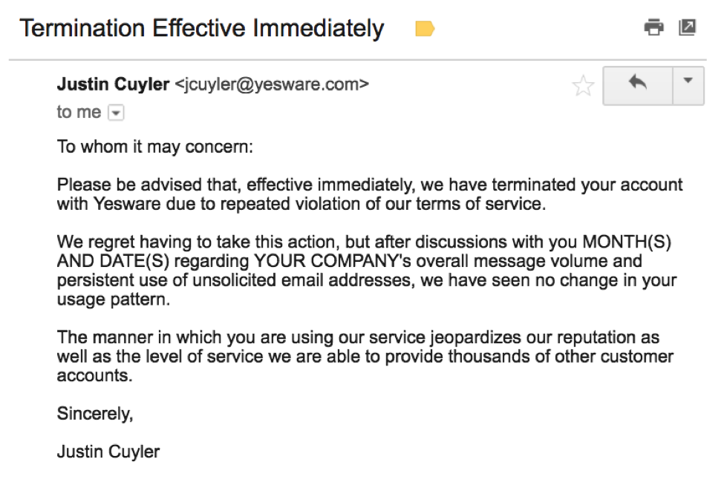
Fig: Sample Email structure.
Sourec: (Doyle, A. 2018)
Subject line- A professional mail must contain subject line, it is the purpose of writing the mail.
Greetings- all mail type of mail must contain greetings.
Length- Mail must make as concise as possible.
Font style- All kind of ornate, playful and color fronts.
Emotions- All kind of emotions symbol must not be included in professional mail.
Spelling and grammar- Writer must stay conscious about spelling mistake and grammar mistakes.
Closing – at the end writer must brief the mail through Thank you, or Best etc. words. (Bown and Brady, 2011).

4. Relevant theories of communication in the workplace:
There are many theories about the communication the workplace of an organization. In this part I will be using the theory of Shannon- weaver and Berol.

Shannon- weaver- His model was named as the mathematical theory of communication. He described his theory with 6 parts. His theory in included- sender, Encoder, Channel, Decoder (receiver), Receiver, and noise.
Sender (Source of information) - Senders is an individual who makes the message and send it to receiver through a chosen channel.
Encoder (Transmitter) Encoder is the machine that ender uses to send message. It convert the message into binary and send it.
Channel- It is the medium that is used to end the message.
Decoder – It is a machine that convert the binary data into signals for the receiver. After that that message is delivered to receiver.
Receiver- Receiver is the person who receive the message and he gives feedback according to the message.
Noise- It is the physical disturbance which occurs problem to send or receive messages. For example people, environment etc.

Fig: Shannon- weaver Communication model.
Source: (Businesstopia, 2018)
Sender sends messages through encoding to the receiver through any technological devices for example Mobile phone. The message will be converted into codes so that the machine can understand the language. Then it will be sent through a medium. The receiver will decode the codes into language and read the message. After that he will send feedback.
Berol’s Theory- His theory is known as the SMCR model of communication.
S- Sender
M- Massage
C- Channel
R- Receiver
Sender send massages with a machine that, that massage is sent through a channel and after that, that massage is received by the receiver.
Factor related to sender-
- Skills of communication
- Attitude
- Knowledge
- Social system
- Culture
All these factors can make the difference of writing massages for person to person.

Fig: Berlor’s Communication theory
Source: (Businesstopia, 2018)
Massage and factors that affect the massage-
- Content
- Elements
- Structure
- Code etc.
A massage can become professional of unprofessional due the deference’s of these factors. A writer must write message by using proper structure of writing massage that is discussed in previous part.
Channels including –
- Hearing
- Seeing
- Touching
- Smelling etc.
A receiver can receive voice massage, where he can hear the voice of sender. He can have email, or text where he only can see.
Receiver – receiving the massage depends on some factors like-
- Communication skills
- Knowledge
- Culture
- Social system.
How a receiver will accept the massage is depends on his communication skills. Knowledge, culture and social system (Blanchard, M. and Johnson, H. 2010).

5. Example of some conflicts in the workplace for communication.
In organization, conflict may arise due to lack of communication. If any organization’s communication id broke-down, the conflict will rise there. In my organization I have witnessed such inflicts due to lack of communication.
Collaborative efforts- As a leader of a project I must define roles properly to complete a teamwork. Lack of communication is a common issue for a failure teamwork in every workplace. (Belbin, R. 2010).
Unchecked Gossip- Sometime in organization rumor may arises and these rumors may cost badly for the organization. The reason of these rumor is poor communication.
Closed loops- Some time different department of the organization fails to coordinate each other. This problems is called the closed loop. Main reason of this problem is the lack of communication between the two departments (Belbin, R. 2010). The cross- department communication is poor as a result such problem raised in my organization. As a result, we were failed to complete the project in time.

Conclusion:
The communication is one of the most important part of an organization. It is seen that for having poor communication, many organization falling their tastes facing losses. By using the proper method we can solve this problem. In this report all those method are discussed. The importance of communication is briefly discussed in this report. If my organization follows the required method to solve the problem they are bound to become successful to come over of it.

Recommendation:
To improve effective communication in any organization, they may follow some simple policies. To make effective communication system my organization uses these methods.:
Open meeting- Through open meeting the communication gap can be reduced. Through this a team leader will be discussing his view with his followers and as so for the followers. To solve communication problem in my organization we can use this method. This approach is considered the best approach so far. Because leader and followers can bale to minimize the gap between them.
E-mails- the leader can send is assessment to his follower through mail and follower also can send feedback about their progress. By doing so organization will able to communicate with the members without pulling them in the office (Alvesson, W. 2012).
One on one- Leader can talk about the problem with his followers through one on one conversation. This method will help both the leader and follower to understand each other. In my organization we should use this to solve the problem now and in future.

Creating a perspective environment- Inn organization they can create perspective environment where all the member can share their ideas and thoughts without any counter. By doing so organization will be able to make the workplace friendlier and more communicative.
Communication and training- Organization can use communication through training program. Our organization used this method to solve the communication problem between me and my followers.
Use simple words- My organization should use simple words to the employees so that the members can understand the tasks and whole process.
Use presentation- using presentation is very energetic and information for all. All the person can have the idea about any tasks through presentation very easily. So, my organization must give the opportunity to presenting the followers idea to us (Alvesson, W. 2012).

References:
Alvesson, M., Willmott, H., Alvesson, (2012). Making sense of management: A critical introduction. 2nd edn. Thousand Oaks, CA: Sage Publications
Belbin, R.M. (2010). Teamroles at Work. Butterworth-Heinemann Title; 2 edition Magin, M. (2011) Making teams Work: 24 Lessons for working together successfully. McGraw-Hill Pub.
Blanchard, K.H., Hersey, P. and Johnson, D.E. (2010). Management of organizational behavior: Leading human resources. 8th edn. United Kingdom: Prentice Hal
Businesstopia. (2018). Shannon and Weaver Model Of Communication. Retrieved on 29 December from- https://www.businesstopia.net/communication/shannon-and-weaver-model-communication
Bown, G. and Brady, C. (2011). Successful manager (women in management Workbook series). Kogan Page, Limited, London, United Kingdom
Businesstopia. (2018). Berlo’s SMCR Model of Communication. Retrieved on 29 December from- https://www.businesstopia.net/communication/berlo-model-communication.
Covey, Stephen R. (2009). The 7 Habits of Highly Effective People: Powerful Lessons in Personal Change. 5th edn. New York: Simon and Schuster.
Doyle, A. (2018). How to Write and Send Professional Email Messages. Retrieved on 29 December from- https://www.thebalancecareers.com/how-to-write-and-send-professional-email-messages-2061892
Ercegovac, Z. (2008). Information Literacy, search strategies, tools & resources for high school students and college freshmen, Linworth Pub. 2nd Ed.

