DS 1 Template

My Screenshots/Photos
- Please add 4–6 screenshots or photos of your digital life.
- You can use your phone or laptop.
- For each screenshot, write one or two sentences explaining what it shows.

Screenshot/Photo 1
[Insert Photo/Screenshot below]

I use snapchat to stay connected with friends and family and promote the work I do.

Screenshot/Photo 2
[Insert Photo/Screenshot below]
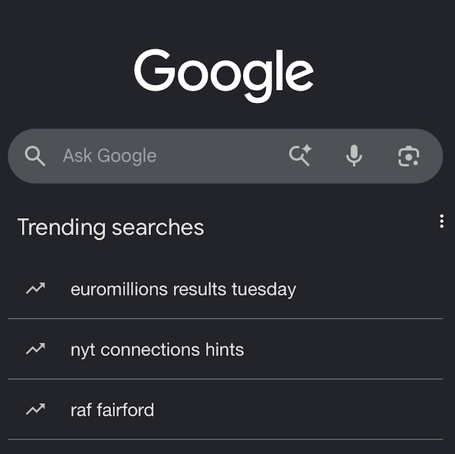
I use google to research information I like to use a trusted sorce for reliable information.

Screenshot/Photo 3
[Insert Photo/Screenshot below]

I use whatsapp business to connect with clients and also for meetings and video calls.

Screenshot/Photo 4
[Insert Photo/Screenshot below]

I use Instagram to socialise with friends and to promote work and in touch with day to day news

Screenshot/Photo 5
[Insert Photo/Screenshot below]

[Write what this shows of your digital life]

Screenshot/Photo 6
[Insert Photo/Screenshot below]
[Write what this shows of your digital life]

My Short Reflection
Write 5–8 simple sentences about your digital life.
- You can use the sentence starters below if helpful.
I use digital skills to find information and facts that our from a reliable source.
I want to improve my digital skills, so it makes my everyday tasks easier.
I feel confident when using the tools regularly that my skills will improve tenfold.
I sometimes feel nervous using word and laptops because it’s been so long.
I hope this module will help me improve my digital skills so I can use them more efficiently in the future.

Sentence starters
- I use digital tools to …
- I feel confident when I …
- I want to improve …
- I often use these tools: …
- I sometimes feel nervous about …
- I hope this module will help me …
- Digital skills are important for me because …
You can write more if you want.

Submission Checklist
Before you submit, please check:
​​​ ☐ I added 4–6 screenshots
☐ I wrote short sentences for each screenshot
☐ I wrote my short reflection
☐ My work is my own
☐ My file opens correctly
​​☐ My file opens correctly

