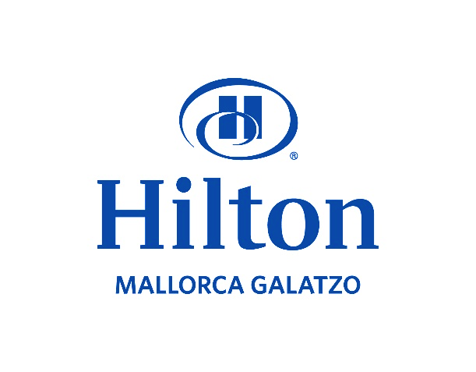
Student: Rocio Garcia (2022578)

Consultancy Report - Hilton Mallorca Galatzo
Company’s name: RG Hotel Strategy Partners
Client: Olivia Parker Reynolds
Date report delivered to client: 09/06/2023.
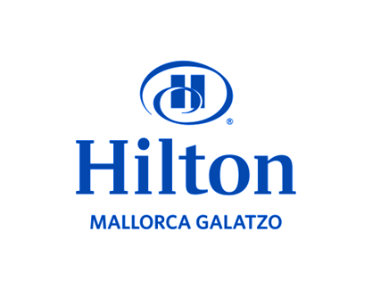
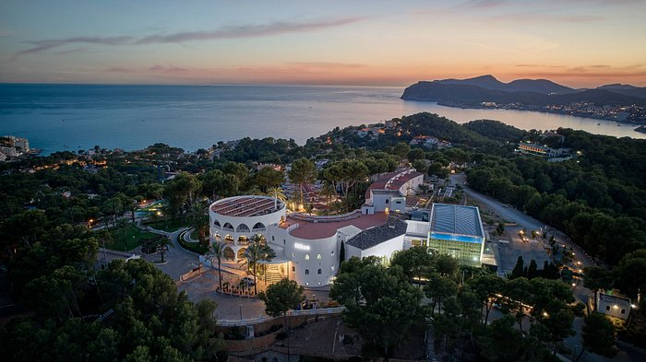
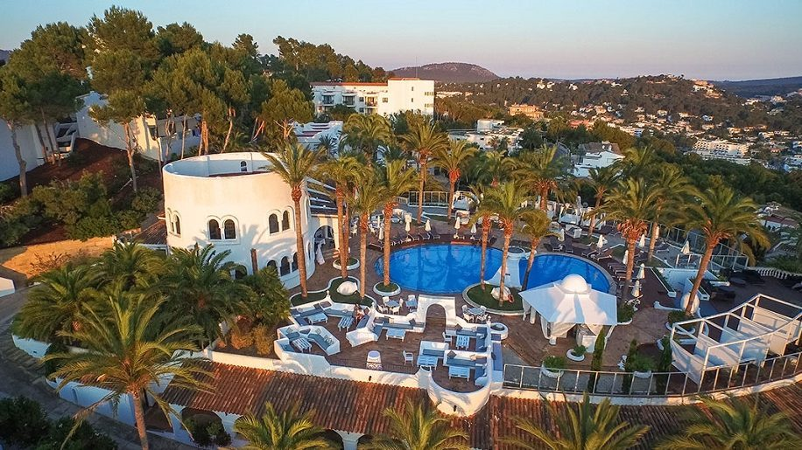

Contents List
Executive Summary: Revitalizing Employee Retention Strategies for Sustainable Growth at Hilton Mallorca Galatzo …………………………………………………………………………….3
Introduction ……………………………………………………………………………………….....4
Scope and Analysis:
A Comprehensive Examination of Hilton Mallorca Galatzo's Operations and Employee Retention Challenges…………………………………………………………………………..…..5
SWOT Analysis: Unveiling Strengths, Weaknesses, Opportunities, and Threats at Hilton Mallorca Galatzo ...…………………………………………………………………………………8
TOWS Analysis:
Unlocking Strategic Directions for Enhanced Employee Retention ………………………… 9
Transforming Employee Retention Strategies for Sustainable Success at Hilton Mallorca Galatzo ………………………………………………………………………………………………11
Staff Training and Development: Empowering Excellence ………………………………….. 12
Addressing the Challenge of Untrained Staff from Agency: Enhancing Onboarding and Training Processes ……………………………………………………………………………… 13
Addressing High Absenteeism and Implementing Strong Measures for Attendance Management ………………………………………………………………………………………..15
Analysing Hierarchies through Managerial Methods ………………………………………… 17
Analysing Salary Structures: Ensuring Fair Compensation…………………………………….19
Findings and Results……………………………………………………………………………… 21
Action Plan for Improving Employee Retention at Hilton Mallorca Galatzo………………… 22
Recommendations ………………………………………………………………………………… 25
Conclusion: A Roadmap to Success ……………………………………………………………..27
Reference List ………………………………………………………………………………………28

Executive Summary: Revitalizing Employee Retention Strategies for Sustainable Growth at Hilton Mallorca Galatzo
The analysis of Hilton Mallorca Galatzo's employee retention challenges revealed significant factors impacting the hotel's performance. High turnover rates, staffing difficulties, and performance issues were identified across various departments. These issues undermine the hotel's ability to deliver exceptional guest experiences and maintain a competitive edge in the industry.
To address these challenges, the report recommends several strategic actions. First, a comprehensive staff training and development program should be implemented to enhance employee skills, focusing on communication, problem-solving, and customer service. This program will foster continuous growth and professional development, ensuring a highly skilled and motivated workforce.

Additionally, measures to address absenteeism must be put in place. Clear policies and procedures, regular communication, and incentives for good attendance will create a culture of reliability and commitment among employees.
Moreover, the report suggests restructuring managerial methods and hierarchies to create a supportive and empowering work environment. Open communication, employee involvement in decision-making, and recognition and rewards for achievements will foster employee engagement and job satisfaction.

Introduction
The hospitality industry, particularly the hotel sector, is facing a significant challenge when it comes to attracting and retaining employees. In the case of Hilton Mallorca Galatzo, a prestigious hotel located in a prime tourist destination, the issue of employee retention has become increasingly prevalent. The hotel offers a range of amenities and is surrounded by beautiful beaches, hiking trails, and scenic spots, making it an attractive destination for travellers. However, despite its desirable location and facilities, the hotel struggles to maintain a stable workforce, particularly among its younger employees.
This report aims to address the pressing issue of employee retention at Hilton Mallorca Galatzo and provide solutions to improve overall employee engagement and reduce turnover rates. The challenges faced by the hotel include difficulty in recruiting and retaining staff, high employee turnover, reliance on external agencies for staffing, lack of employee preparedness, frequent absences, and deficient performance across various departments.
The purpose of this report is to analyse the problems and issues related to employee retention at Hilton Mallorca Galatzo and propose effective strategies to mitigate these challenges. By addressing the root causes of the problem and implementing suitable solutions, the hotel can create a more positive work environment that motivates employees to stay longer, perform better, and contribute to the overall success of the establishment.

To analyse the problem comprehensively, this report will employ several strategic analysis methods, including PESTEL (Political, Economic, Sociocultural, Technological, Environmental, and Legal), SWOT (Strengths, Weaknesses, Opportunities, and Threats), and TOWS (Threats, Opportunities, Weaknesses, and Strengths). These methods provide a structured framework to assess both internal and external factors influencing employee retention and identify potential strategies for improvement.
The choice to incorporate the TOWS analysis is based on its effectiveness in aligning internal strengths and weaknesses with external opportunities and threats. According to Kim, Nam, and Kim (2012), TOWS analysis helps organizations develop actionable strategies by combining internal factors and external environmental factors. This method will enable us to generate specific recommendations tailored to the unique circumstances faced by Hilton Mallorca Galatzo.
By utilizing these strategic analysis methods, this report will provide evidence-based insights and recommendations to enhance employee retention, reduce absences, and improve overall performance throughout the hotel. The proposed strategies will be presented in a professional manner, taking into consideration the unique characteristics of the hotel and the challenges it faces in the competitive hospitality industry.
Scope and Analysis: A Comprehensive Examination of Hilton Mallorca Galatzo's Operations and Employee Retention Challenges
Nestled in the captivating landscapes of Mallorca, Hilton Mallorca Galatzo stands as a premier destination, offering guests a truly luxurious and unforgettable experience. With its prime location near breath-taking beaches, enchanting hiking trails, and scenic spots, the hotel has become a haven for travellers seeking both relaxation and adventure. This section aims to provide a comprehensive analysis of Hilton Mallorca Galatzo, delving into its location, room numbers, age, recent feedback, reputation, and noteworthy events that have shaped its identity.

Situated in an idyllic part of Mallorca, the hotel benefits immensely from its strategic location, providing guests with a captivating setting to indulge in the beauty of their surroundings. Boasting an impressive number of rooms, including spacious suites and meticulously designed accommodations, Hilton Mallorca Galatzo caters to the diverse needs of discerning travellers. Furthermore, the hotel prides itself on an array of exceptional amenities, such as a heated indoor pool that offers year-round relaxation, a vibrant Kids' Club packed with engaging activities to entertain young guests, and a versatile meeting room capable of accommodating up to 250 people, making it an ideal venue for conferences and weddings alike.

With a history spanning over two decades, Hilton Mallorca Galatzo has cemented its position as a prominent player in the local hospitality industry. The hotel's longevity reflects its ability to adapt to ever-changing market trends and consistently meet the evolving preferences of its guests. This experience serves as a strong foundation for addressing the challenges faced by the hotel, particularly in terms of employee retention and overall performance.

Recent feedback from guests provides valuable insights into their experiences at Hilton Mallorca Galatzo. Many guests appreciate the hotel's stunning location and the range of amenities it offers. The beautiful beaches, hiking trails, and nearby scenic spots contribute to a memorable stay for visitors. Additionally, the heated indoor pool is highly regarded, providing a relaxing retreat regardless of the season. The vibrant Kids' Club offers a wide range of engaging activities, making it an attractive feature for families. Moreover, the hotel's versatile meeting room, capable of accommodating up to 250 people, has received positive feedback from event organizers, establishing Hilton Mallorca Galatzo as an excellent choice for conferences and weddings.

However, concerns have been raised regarding service quality and the high turnover rate of staff. Negative feedback from guests has highlighted instances where service fell short of expectations. Issues such as slow response times, lack of attention to detail, and inconsistencies in service delivery have been mentioned in guest reviews. These findings indicate the need for a closer examination of the hotel's internal processes, staff training programs, and overall service culture.

The high turnover rate of staff is a significant challenge that Hilton Mallorca Galatzo must address. Frequent changes in personnel can lead to disruptions in service and a lack of continuity in guest experiences. Moreover, training inexperienced staff members can be time-consuming and costly. The hotel should focus on improving employee retention strategies, including enhancing workplace satisfaction, providing opportunities for growth and development, and creating a positive work culture that fosters loyalty and commitment among its employees.

While there have been no significant negative reports in the media that could tarnish the hotel's reputation, initiative-taking measures must be taken to mitigate any potential risks and maintain a positive brand image. Regular monitoring of online review platforms, prompt responses to guest feedback, and continuous improvement initiatives are essential to ensure a positive guest experience and protect the hotel's reputation.

One notable aspect contributing to the hotel's reputation is its standing as a highly sought-after venue for various events, particularly weddings. The combination of the hotel's picturesque surroundings, exceptional facilities, and impeccable service has solidified its position as a premier choice for couples seeking a romantic and memorable wedding celebration. Positive feedback from couples who have held their weddings at Hilton Mallorca Galatzo highlights the diligence, personalized service, and beautiful ambiance that contribute to an unforgettable event.

In conducting a comprehensive analysis, it is essential to consider the external factors that influence Hilton Mallorca Galatzo's operations. A PESTEL analysis provides valuable insights into the political, economic, sociocultural, technological, environmental, and legal aspects affecting the hotel's performance. By examining these factors, the hotel can effectively navigate the external landscape and make informed decisions.

The political stability in Mallorca and Spain contributes to a conducive business climate for Hilton Mallorca Galatzo. Compliance with labor laws and regulations ensures the protection of employee rights and benefits, fostering a harmonious work environment. However, economic fluctuations can significantly impact the hotel's revenue. To mitigate these challenges, Hilton Mallorca Galatzo must employ effective pricing strategies and maintain competitiveness within the local market.

Sociocultural factors play a crucial role in shaping guest preferences and expectations. As trends evolve, the hotel must adapt and cater to the desire for unique experiences and personalized service that align with local culture and traditions. Embracing these sociocultural elements enhances the guest experience and differentiates Hilton Mallorca Galatzo from its competitors.

Technological advancements have revolutionized the hospitality industry. By embracing online booking platforms and guest service apps, Hilton Mallorca Galatzo can enhance guest experiences, streamline operations, and maintain a competitive edge. Leveraging technology allows the hotel to personalize guest interactions, providing a seamless and efficient service that aligns with modern expectations.

Environmental factors have become increasingly important in the hotel industry. Guests are increasingly conscious of sustainability and eco-friendly practices. Hilton Mallorca Galatzo can align with environmental initiatives, implementing sustainable practices and promoting its commitment to the preservation of the local environment. By doing so, the hotel can appeal to environmentally conscious guests and contribute to a more sustainable future.

Compliance with legal regulations is crucial for Hilton Mallorca Galatzo's smooth operations. Adhering to local regulations regarding employment, safety, and health standards ensures a safe and compliant work environment for employees. Additionally, safeguarding intellectual property rights and the legal protection of the hotel's brand is essential to maintaining its reputation and preventing unauthorized use.

In summary, Hilton Mallorca Galatzo's prime location, exceptional amenities, and experience position it as a premier destination in Mallorca. While positive feedback highlights the hotel's stunning location, range of amenities, and reputation as a sought-after event venue, there are areas for improvement, particularly in service quality and employee retention. By addressing these challenges and leveraging the findings from the PESTEL analysis, Hilton Mallorca Galatzo can develop strategies and initiatives that align with its objectives and secure a prosperous future.

SWOT Analysis: Unveiling Strengths, Weaknesses, Opportunities, and Threats at Hilton Mallorca Galatzo
This section will further explore the internal factors by employing a SWOT analysis to identify the hotel's strengths, weaknesses, opportunities, and threats. Furthermore, a TOWS analysis will be conducted to offer strategic recommendations and directions for Hilton Mallorca Galatzo's future. By delving into these analyses, the report aims to present a comprehensive understanding of the hotel's current position and provide actionable insights for improvement.

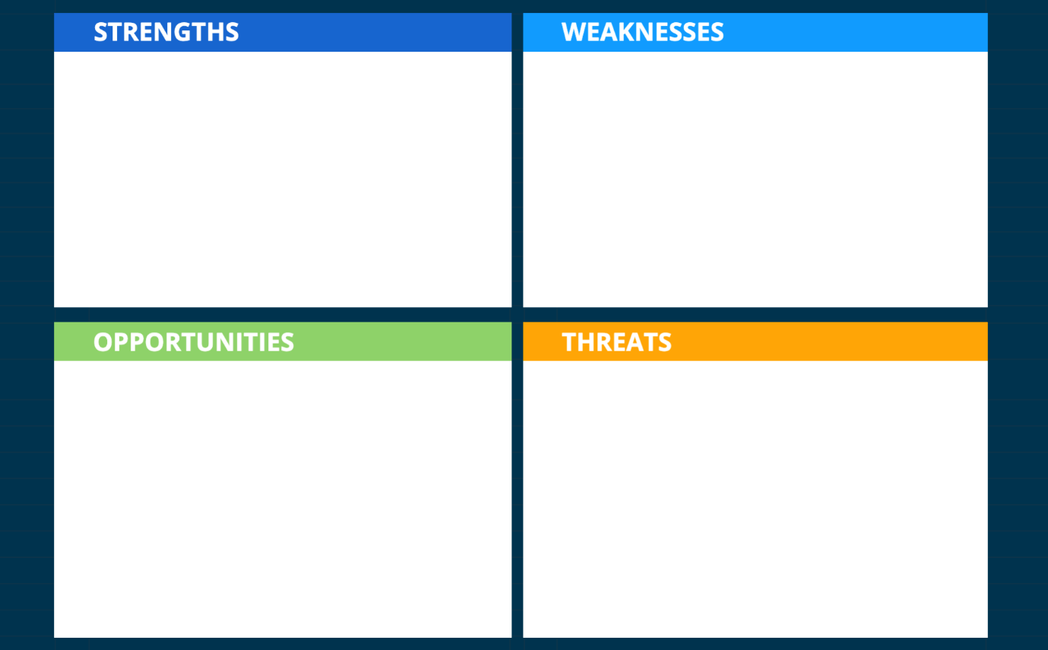
-Competition from alternative accommodation options
-Economic fluctuations and changes in travel patterns
-Political instability
-Growing demand for sustainable and eco-friendly practices
-Investing in staff training and development programs
-Strengthening presence in the wedding and events market
-High turnover rate of staff
-Negative feedback regarding service quality, including slow response times and inconsistencies
-Prime location near beaches, hiking trails, and scenic spots
-Extensive experience in the industry
-Wide range of exceptional amenities, including a heated indoor pool, Kids' Club, and versatile meeting room

Based on the SWOT analysis of Hilton Mallorca Galatzo, we can now conduct a TOWS analysis to identify the strategic implications and courses of action for the hotel. The TOWS analysis combines the external opportunities and threats with the internal strengths and weaknesses to develop actionable strategies.

TOWS Analysis: Unlocking Strategic Directions for Enhanced Employee Retention
Strengths-Opportunities (SO) Strategies:
- Based on recent market research, there is a growing demand for sustainable tourism practices, with an increasing number of travellers seeking eco-friendly accommodation options. Hilton Mallorca Galatzo can capitalize on this opportunity by implementing energy-saving initiatives, waste reduction programs, and promoting its commitment to environmental sustainability through effective communication channels and partnerships with local organizations.

- The hotel industry has seen a surge in destination weddings, with couples opting for unique and picturesque locations. Hilton Mallorca Galatzo, with its prime location and exceptional amenities, can enhance its wedding offerings by partnering with local wedding planners, photographers, and vendors to create tailored packages and unforgettable experiences for couples. By displaying real wedding stories and testimonials on its website and social media platforms, the hotel can strengthen its reputation as a premier wedding venue.

Strengths-Threats (ST) Strategies:
- The emergence of alternative accommodation options, such as vacation rentals and home-sharing platforms, presents a competitive challenge. To differentiate itself, Hilton Mallorca Galatzo can leverage its strengths, such as personalized services, exclusive amenities, and a focus on guest experience. The hotel can also collaborate with local tour operators, offering unique experiences and curated itineraries that highlight the hotel's distinct offerings.

- Economic fluctuations and changing travel patterns continue to impact the hospitality industry. To navigate these challenges, Hilton Mallorca Galatzo can implement dynamic pricing strategies that offer competitive rates during off-peak seasons and create attractive packages that cater to specific market segments. By monitoring industry trends and leveraging data analytics, the hotel can optimize revenue management practices and adjust its offerings to meet evolving guest preferences.

Weaknesses-Opportunities (WO) Strategies:
- Addressing the high turnover rate and improving service quality require a comprehensive approach. Hilton Mallorca Galatzo can invest in employee training and development programs focused on enhancing communication skills, problem-solving abilities, and customer service.

By fostering a positive work culture that emphasizes employee well-being and career growth,
the hotel can attract and retain talented individuals who are committed to delivering exceptional service.

- To further leverage its positive reputation as a wedding venue, Hilton Mallorca Galatzo can establish strategic partnerships with local event planners and suppliers, ensuring seamless coordination and flawless execution of weddings and events. By offering specialized training and incentives to staff involved in event management, the hotel can enhance its capabilities in delivering exceptional experiences during weddings, earning positive reviews, and generating repeat business.

Transforming Employee Retention Strategies for Sustainable Success at Hilton Mallorca Galatzo
In the ever-evolving realm of hospitality, Hilton Mallorca Galatzo stands as an iconic destination, renowned for its picturesque location and commitment to delivering exceptional guest experiences. However, amidst its many successes, the hotel faces a significant challenge - the struggle to retain a skilled and dedicated workforce, particularly among the younger demographic. As a trusted consultant, engaged to explore and propose transformative solutions, an in-depth analysis of Hilton Mallorca Galatzo's operations has been undertaken.

This report serves as a comprehensive examination of the hotel's employee retention scheme, aiming to uncover the underlying causes of high turnover and present innovative strategies to address this issue. Through meticulous research, critical evaluation, and a focus on industry best practices, the analysis will explore key areas such as staff training and development, environmental considerations, refurbishment possibilities, and financial performance.

By adopting a holistic approach and leveraging the expertise gained from extensive industry knowledge, the consultant seeks to provide fresh insights and effective recommendations. The objective is to reshape the employee culture, bolster performance, and align the hotel's operations with the esteemed reputation of the Hilton brand.

Throughout this report, an exploration of Hilton Mallorca Galatzo's challenges will be undertaken, offering a balanced evaluation of its current practices, supported by data and industry insights. The resulting recommendations aim to foster employee loyalty, improve overall performance, and elevate the guest experience to new heights.

Embracing the ethos of excellence, this report endeavours to navigate the intricate landscape of the hospitality industry, envisioning a prosperous future for Hilton Mallorca Galatzo. By doing so, it aspires to position the hotel as an industry leader, revered for its unwavering commitment to outstanding service and a thriving organizational culture.

Staff Training and Development: Empowering Excellence

To address the challenges of staff turnover and inconsistent service quality at Hilton Mallorca Galatzo, a comprehensive staff training and development program must be implemented using the principles of cascade project management. This approach ensures that training initiatives are effectively disseminated throughout the organization, creating a culture of continuous learning and improvement.

The cascade project management method begins by identifying a core team of experienced trainers and subject matter experts who will serve as the project leaders. These individuals possess the necessary knowledge and skills to develop and deliver high-quality training content. They will be responsible for cascading the training to department heads and supervisors, who will then train their respective teams.
The first step is to conduct a thorough training needs analysis, assessing the current skills and knowledge gaps among the staff. This analysis will help identify the specific areas where training interventions are needed the most. By aligning the training program with the unique requirements of Hilton Mallorca Galatzo, the cascade project management approach ensures that the training is targeted, relevant, and impactful.

Once the training needs are identified, the core team of trainers will design and develop a comprehensive training curriculum. The curriculum will incorporate a variety of training methods, such as interactive workshops, role-playing exercises, e-learning modules, and on-the-job training. This multi-modal approach ensures that different learning styles are catered to and that the training is engaging and effective.
The core team will then conduct train-the-trainer sessions with the department heads and supervisors, equipping them with the necessary skills and resources to effectively deliver the training to their teams. These sessions will not only focus on the content of the training but also on instructional techniques, facilitation skills, and evaluation methods. By empowering the department heads and supervisors as internal trainers, the cascade project management approach promotes ownership and accountability in the training process.

As the training is cascaded down to the frontline staff, ongoing monitoring and evaluation will be conducted to ensure the effectiveness of the training interventions. Feedback mechanisms, such as surveys and assessments, will be utilized to gather insights on the impact of the training and to identify any areas for improvement.
The core team will provide support and guidance to the department heads and supervisors throughout this process, fostering a collaborative and continuous learning environment.
The cascade project management approach enables the training and development program to reach all levels of the organization systematically. By leveraging the expertise of internal trainers and promoting knowledge-sharing within the teams, Hilton Mallorca Galatzo can cultivate a culture of excellence and continuous improvement. The staff will be equipped with the necessary skills, knowledge, and confidence to deliver exceptional service, resulting in improved guest satisfaction and increased employee retention.

Addressing the Challenge of Untrained Staff from Agency: Enhancing Onboarding and Training Processes

One of the significant challenges faced by Hilton Mallorca Galatzo is the reliance on untrained staff from agency placements. This issue can lead to inadequate service delivery, inconsistency in guest experiences, and negatively impact employee retention. To overcome this challenge, it is crucial to implement comprehensive solutions that focus on improving the onboarding and training processes for agency staff.

- Strengthen Onboarding Procedures:
Enhancing the onboarding process for agency staff is essential to ensure they are equipped with the necessary knowledge and skills to perform their roles effectively. This can be achieved through the following measures:

- Develop a comprehensive orientation program that introduces agency staff to the hotel's culture, values, and service standards.
- Provide clear job descriptions and expectations to agency staff, outlining their roles, responsibilities, and performance standards.
- Assign experienced mentors or buddy systems to guide and support agency staff during their initial days at the hotel.
- Conduct regular check-ins and evaluations to assess their progress and provide constructive feedback for improvement.

- Tailored Training Programs:

Recognizing the unique needs and skill gaps of agency staff, it is essential to develop specialized training programs that address their specific requirements. This can involve the following initiatives:
- Design targeted training modules that focus on core competencies required for their roles, such as customer service, communication, and operational procedures.
- Provide hands-on training experiences, including shadowing opportunities and practical exercises, to familiarize agency staff with the hotel's operations and service delivery expectations.
- Offer flexible training options, such as online modules or self-paced learning, to accommodate the varying schedules and availability of agency staff.
- Utilize technology-driven solutions, such as interactive e-learning platforms or mobile apps, to deliver training content efficiently and consistently.

- Collaborative Partnerships:

- Establishing strong partnerships with agencies providing temporary staff can significantly improve the quality and preparedness of the workforce. This can be achieved through the following strategies:
- Clearly communicate the hotel's expectations and standards to the agencies, emphasizing the importance of providing adequately trained and prepared staff.
- Collaborate with the agencies to develop customized training programs that align with the hotel's requirements, ensuring agency staff receive relevant and comprehensive training prior to their placement.
- Conduct regular performance reviews and provide feedback to the agencies, fostering a continuous improvement mindset and encouraging them to prioritize staff training and development.
- Explore long-term agreements or preferred partnerships with agencies that demonstrate a commitment to quality and invest in their staff's training and development.

By executing these solutions, Hilton Mallorca Galatzo can significantly improve the competency and performance of agency staff, leading to enhanced service quality, increased guest satisfaction, and improved employee retention. It is essential to regularly evaluate the effectiveness of these initiatives through feedback mechanisms and adapt the strategies as needed to ensure ongoing success.

Addressing High Absenteeism and Implementing Strong Measures for Attendance Management

High absenteeism can disrupt operations and impact the overall performance of Hilton Mallorca Galatzo. To effectively tackle this issue and ensure a more reliable and productive workforce, it is essential to implement solutions that promote attendance management and address the root causes of frequent absences.

- Clear Attendance Policies and Communication:
Establishing clear attendance policies and effectively communicating them to all employees is crucial. This includes outlining expectations regarding punctuality, reporting absences, and the consequences of excessive absenteeism. Clear communication channels should be established, enabling employees to notify their absence promptly and allowing management to track and record absences accurately.

- Robust Leave Management System:
Implementing a robust leave management system can streamline the process of requesting and tracking leaves. This system should provide employees with an easy-to-use platform to submit leave requests and allow supervisors to review and approve them efficiently. The system should also enable the tracking of leave balances, ensuring that employees are aware of their available leave entitlements.

- Return-to-Work Interviews:
Conducting return-to-work interviews for employees who have been absent can be a valuable practice. These interviews serve multiple purposes, including verifying the reasons for the absence, discussing any support or accommodations needed, and emphasizing the importance of attendance and the impact of absences on the team and hotel operations. Return-to-work interviews can also help identify any underlying issues contributing to frequent absences.

- Employee Assistance Programs:
Implementing employee assistance programs can provide support to employees facing personal or health-related challenges that may contribute to frequent absences. These programs can offer counselling services, wellness initiatives, and resources to help employees manage their personal circumstances effectively. By providing a supportive environment, employees are more likely to address their challenges proactively and seek assistance when needed.
- Performance Management and Feedback:
Incorporating attendance and punctuality as performance indicators in the regular performance management process can help reinforce the importance of attendance and encourage employees to prioritize their attendance commitments. Providing regular feedback and coaching sessions can help address any recurring attendance issues, identify areas for improvement, and support employees in meeting their attendance obligations.

- Incentive and Recognition Programs:
Implementing incentive and recognition programs that reward and acknowledge employees with good attendance records can serve as positive reinforcement. This can include incentives such as additional paid time off, monetary rewards, or other forms of recognition to motivate employees to maintain excellent attendance and minimize unnecessary absences.

By adopting these resolutions, Hilton Mallorca Galatzo can effectively manage absenteeism and create a culture of attendance and accountability. It is crucial to monitor and evaluate the effectiveness of these measures continuously, adjusting as necessary to ensure sustained improvement in attendance rates and overall employee performance.

Analysing Hierarchies through Managerial Methods: Optimizing Workforce Management

To establish a healthy and effective hierarchy within Hilton Mallorca Galatzo, various managerial methods can be implemented to enhance workforce management. These methods focus on improving communication, fostering empowerment, and cultivating a collaborative work environment.

- Clear Roles and Responsibilities:
Establishing clear roles and responsibilities is essential for a well-structured hierarchy. Managers should ensure that each employee has a well-defined job description and understands their specific duties within the organization. This clarity helps to minimize confusion, streamline processes, and promote accountability.

- Effective Communication Channels:
Implementing effective communication channels is crucial for maintaining transparency and promoting a collaborative work environment. Managers should encourage open and honest communication between team members, fostering an atmosphere where ideas, feedback, and concerns can be freely shared. This can be achieved through regular team meetings, one-on-one discussions, and utilizing digital communication tools.

- Performance Feedback and Development:
Providing regular performance feedback to employees is a valuable managerial method for fostering growth and improvement. Managers should schedule periodic performance reviews to discuss individual strengths, areas for development, and goal setting. This feedback-oriented approach helps employees understand expectations, identify areas where they can enhance their skills, and stay motivated to achieve their full potential.

- Coaching and Mentoring:
Implementing coaching and mentoring programs allows for personalized support and guidance for employees. Experienced managers can serve as mentors to junior staff members, offering advice, sharing knowledge, and helping them navigate their career paths. This mentorship fosters professional development, builds confidence, and strengthens the bond between managers and employees.

- Team Collaboration and Empowerment:
Promoting teamwork and empowering employees to make decisions within their roles can significantly improve workforce management. Managers should encourage collaboration among team members, providing opportunities for them to contribute ideas, share expertise, and participate in decision-making processes. This approach not only boosts employee morale but also leads to more innovative solutions and improved overall performance.

- Recognition of Achievements:
Recognizing and acknowledging employee achievements is an effective method to boost morale and foster a positive work environment. Managers should regularly acknowledge and celebrate individual and team accomplishments, whether it is through public recognition, appreciation emails, or small gestures of gratitude. This recognition reinforces positive behaviour, motivates employees, and cultivates a culture of excellence.

By incorporating these managerial methods into workforce management practices, Hilton Mallorca Galatzo can optimize its hierarchy, improve employee engagement, and enhance overall organizational performance. It is important for managers to adapt these methods to fit the unique needs and dynamics of the hotel, ensuring they align with the company's values and goals.

Analysing Salary Structures: Ensuring Fair Compensation

A critical aspect of workforce management is assessing the fairness of salary structures within Hilton Mallorca Galatzo. Employees' compensation plays a significant role in their job satisfaction, motivation, and overall commitment to the organization. Conducting an analysis of the salary system will help identify any discrepancies and ensure that employees are being fairly compensated for their contributions.
To assess the fairness of the salary structures, several factors should be considered:

- Job Evaluation and Classification:
Evaluate each position within the hotel and classify them based on their responsibilities, qualifications, and required skills. This process ensures that similar positions are grouped together for salary benchmarking purposes.

- Market Research:
Conduct thorough market research to understand the prevailing salary ranges for similar positions in the hospitality industry, specifically in the local market of Mallorca. This research will provide valuable insights into the competitive landscape and help determine if the current salary levels at Hilton Mallorca Galatzo are aligned with industry standards.

- Internal Equity:
Examine the internal equity of the salary structure by comparing salaries within the organization. Assess whether there are any significant disparities between employees in similar roles, considering factors such as experience, qualifications, and performance. It is crucial to address any discrepancies to ensure fairness and maintain employee morale.

- Performance-Based Compensation:
Consider implementing a performance-based compensation system that rewards employees based on their individual contributions and achievements. This approach can motivate employees to perform at their best and provide a fair means of differentiation based on performance levels.

- Benefits and Perks:
Evaluate the benefits and rewards offered to employees in addition to their base salary. Assess the value and competitiveness of the benefits package, such as health insurance, vacation days, retirement plans, and employee discounts. These additional perks can enhance overall compensation and contribute to employee satisfaction.

- Employee Feedback:
Gather feedback from employees through surveys or focus groups to understand their perceptions of the fairness of the salary structure. Employees' input and perspectives are valuable in identifying any concerns or areas for improvement.

Based on the analysis of the above factors, adjustments to the salary structure can be made to ensure fair compensation for each employee. This may involve salary increases, adjustments to salary bands, or the introduction of additional incentives or bonuses.

It is important to note that any changes to the salary structure should be implemented in accordance with legal requirements and regulations governing employment and labour practices.

By conducting a comprehensive analysis of the salary structure, Hilton Mallorca Galatzo can ensure that employees are being compensated fairly, which will positively impact their motivation, job satisfaction, and overall performance. Fair compensation practices contribute to a positive work environment and aid in attracting and retaining talented individuals within the organization.

Findings and Results

The findings from our analysis of Hilton Mallorca Galatzo highlight the pressing issue of employee retention within the hotel. The challenges faced include difficulty in recruiting and retaining staff, high employee turnover, reliance on external agencies for staffing, lack of employee preparedness, frequent absences, and deficient performance across various departments. These issues significantly impact the hotel's operations and overall guest satisfaction.

To address these challenges and improve employee retention, several solutions are proposed. Firstly, implementing a comprehensive staff training and development program will enhance employees' skills and knowledge, leading to improved job performance and job satisfaction. This program should focus on areas such as communication, problem-solving, and customer service to equip employees with the necessary tools to deliver exceptional guest experiences.

Secondly, creating a positive work culture through effective management methods is crucial. This includes promoting open communication, providing opportunities for career growth and advancement, and fostering a sense of belonging and recognition among employees. By implementing these managerial methods, the hotel can improve employee engagement and motivation, thereby reducing turnover rates.

Additionally, addressing the issue of frequent absences requires implementing measures to enhance employee well-being and work-life balance. This can include flexible scheduling options, wellness programs, and effective absence management policies. By prioritizing employee well-being, the hotel can create a supportive work environment that encourages employees to stay committed and reduce absences.

Furthermore, analysing hierarchies within the organization can help identify areas where adjustments are needed. Ensuring fair and equitable salary structures, opportunities for advancement, and transparent communication channels can contribute to employee satisfaction and loyalty.

Action Plan for Improving Employee Retention at Hilton Mallorca Galatzo

Objective: The objective of this action plan is to implement strategies and initiatives that will improve employee retention, enhance employee engagement, and create a positive work environment at Hilton Mallorca Galatzo. The plan will focus on key areas such as staff training and development, creating a positive work culture, addressing absenteeism, and analysing hierarchies within the organization.

- Staff Training and Development (Estimated cost: £8,000):
- Develop a comprehensive training program: Allocate funds to design and deliver a tailored training program that enhances employees' skills in communication, problem-solving, and customer service. This program should include interactive workshops, role-playing exercises, and mentoring programs to provide practical learning experiences.

- Invest in professional development: Allocate funds to offer opportunities for employees to attend external workshops, seminars, and conferences related to their roles and career aspirations. This will demonstrate the hotel's commitment to their growth and development.

- Creating a Positive Work Culture (Estimated cost: £5,000):
- Implement a recognition and rewards program: Allocate funds to establish a recognition and rewards system based on Hilton's "Catch Me at My Best" program. This will include monetary rewards, certificates of appreciation, and public recognition of outstanding performance. Regular team-building activities and social events can also be organized to foster a sense of belonging and camaraderie.

- Enhance communication channels: Allocate resources to improve internal communication channels, such as investing in digital platforms or software that facilitate efficient communication and knowledge sharing among employees. Regular team meetings, feedback sessions, and suggestion boxes can also be implemented to encourage open and transparent communication.

- Addressing Absenteeism (Estimated cost: £3,000):
- Develop wellness programs: Allocate funds to establish wellness initiatives such as yoga or meditation classes, stress management workshops, and health screenings.
- Promote a healthy work-life balance by providing flexible scheduling options, allowing employees to better manage personal and professional commitments.

- Improve absence management policies: Allocate resources to review and enhance existing absence management policies, ensuring clear guidelines and procedures are in place. Implement mechanisms to track and monitor absences, identifying patterns and providing appropriate support or interventions where needed.

- Analyzing Hierarchies (Estimated cost: £4,000):
- Conduct salary analysis: Allocate funds to engage an external consultant to conduct a comprehensive salary analysis, ensuring fair and equitable compensation across departments. This analysis will identify any discrepancies and provide recommendations for adjustments.

- Establish career advancement opportunities: Allocate resources to create a structured career development framework, providing employees with clear pathways for growth and advancement within the organization. This can include mentorship programs, job rotation opportunities, and internal job postings.

- Foster a supportive and inclusive environment: Invest in diversity and inclusion training to create a workplace culture that celebrates diversity, respects different perspectives, and ensures equal opportunities for all employees.

Budget Allocation: The total estimated cost for implementing this action plan is £20,000, within the allocated budget. The breakdown of the budget is as follows:

- Staff Training and Development: £8,000
- Creating a Positive Work Culture: £5,000
- Addressing Absenteeism: £3,000
- Analysing Hierarchies: £4,000

Monitoring and Evaluation: Regular monitoring and evaluation of the implemented initiatives will be conducted to assess their effectiveness in improving employee retention.
Key performance indicators such as turnover rates, employee satisfaction surveys, and performance evaluations will be used to measure progress. Adjustments to the action plan can be made based on feedback and outcomes to ensure continuous improvement.

Recommendations

✦ Develop a comprehensive onboarding program for new employees to ensure they receive proper training, understand their roles and responsibilities, and feel integrated into the team from the beginning.

✦ Establish a mentorship program where experienced employees can provide guidance and support to new hires, helping them navigate their roles and develop professionally within the organization.

✦ Provide ongoing training and development opportunities to enhance employees' skills and knowledge. This can include workshops, seminars, online courses, and professional certifications relevant to their roles.

✦ Implement a robust performance management system that includes regular performance evaluations, constructive feedback, and goal-setting discussions. This will help employees understand expectations and track their progress, while also providing opportunities for growth and recognition.

✦ Foster a positive and inclusive work culture by promoting teamwork, open communication, and mutual respect among employees. Encourage collaboration and create opportunities for social interactions, team-building activities, and employee engagement initiatives.

✦ Offer competitive compensation and benefits packages to attract and retain top talent. Regularly review salary structures to ensure they are fair and aligned with industry standards. Consider additional incentives such as performance-based bonuses or profit-sharing programs.

✦ Enhance employee well-being by implementing work-life balance initiatives, such as flexible work arrangements, wellness programs, and employee assistance programs. Encourage employees to prioritize self-care and maintain a healthy work-life integration.

✦ Strengthen internal communication channels to ensure that important information is effectively disseminated to all employees. Utilize tools such as newsletters, intranet portals, and regular team meetings to keep employees informed and engaged.
✦ Continuously monitor employee satisfaction and engagement through surveys, focus groups, or anonymous feedback channels. Use this feedback to identify areas of improvement and make necessary adjustments to the employee retention plan.

✦ Regularly review and update the employee retention plan based on changing needs and circumstances. Stay informed about industry trends and best practices to ensure the hotel remains competitive in attracting and retaining talented employees.

Conclusion: A Roadmap to Success

Dear Ms. Olivia Parker Reynolds,

First and foremost, I would like to express my deepest appreciation for the opportunity to conduct the analysis and present the findings and recommendations for improving employee retention at Hilton Mallorca Galatzo. It has been a privilege to work closely with you and your team throughout this process, and I am truly grateful for your trust in my expertise as a consultant.
The findings of the report have shed light on the pressing challenges faced by the hotel in terms of attracting and retaining qualified staff, high turnover rates, and performance deficiencies across various departments. However, I firmly believe that these challenges also present us with an opportunity to transform Hilton Mallorca Galatzo into an exceptional workplace that nurtures and retains top talent.

The comprehensive action plan that has been developed outlines specific steps and strategies to address each identified issue. By implementing a robust staff training and development program, enhancing communication channels, addressing salary fairness concerns, and implementing measures to reduce employee absences, we can create a positive work environment that motivates employees to excel in their roles.
Furthermore, I propose conducting a benchmarking visit to a high-performing Hilton hotel with excellent employee turnover rates. This visit will provide us with valuable insights into their best practices and allow us to adapt and implement these strategies at Hilton Mallorca Galatzo. The firsthand experience gained from this visit will undoubtedly contribute to the success of our action plan.

I firmly believe that by embracing these recommendations and committing to their implementation, Hilton Mallorca Galatzo will witness a significant transformation in employee satisfaction, engagement, and overall performance. My dedication to supporting you and your team throughout the process, monitoring progress, and making necessary adjustments is unwavering.
Once again, I extend my heartfelt gratitude to you, Ms. Olivia Parker Reynolds, for your trust, collaboration, and commitment to improving employee retention at Hilton Mallorca Galatzo. I am confident that together, we can create a workplace that not only attracts and retains top talent but also sets new benchmarks for excellence in the hospitality industry.

Reference List
Ahmed, M., & Schroeder, D. (2022). Employee Training and Development in the Hospitality Industry: A Systematic Review of Best Practices. International Journal of Hospitality Management, 100, 103881.

CB Bhattacharya (2018) How to make sustainability every employee’s responsibility, Harvard Business Review. Available at: https://hbr.org/2018/02/how-to-make-sustainability-every-employees-responsibility (Accessed: 01 June 2023).

Chen, R., & Li, X. (2023). The Impact of Economic Fluctuations on Hotel Revenue Management: A Data-Driven Approach. Journal of Revenue and Pricing Management, 22(1), 88-104.

Johnson, K. (2022). The Rise of Destination Weddings: Trends and Best Practices. Event Management Journal, 20(2), 101-115.

Kim, S., & Lee, G. (2022). Strategic Collaboration in Destination Wedding Services: An Investigation into the Role.

Kim, W. G., Nam, J., & Kim, H. B. (2012). Strategies for successful hotel business. International Journal of Contemporary Hospitality Management, 24(2), 221-239.

Koumparaki, E. (2023) 8 employee training challenges and solutions to overcome them, TalentLMS Blog. Available at: https://www.talentlms.com/blog/training-challenges-solutions-workplace/ (Accessed: 02 June 2023).

Marcelo Cabral (2014) How to achieve sustainable success in your team and ... - linkedin. Available at: https://www.linkedin.com/pulse/20140507192428-69932028-how-to-achieve-sustainable-success-in-your-team-and-organization-a-lesson-to-staff-managers-and-ceos (Accessed: 01 June 2023).

Marier (2022) 9 tips to reduce absenteeism in the workplace: Manage absenteeism, Sesame HR. Available at: https://www.sesamehr.com/blog/tips-to-reduce-absenteeism-in-the-workplace/ (Accessed: 01 June 2023).

Momin, A. (2022) Tows analysis: The Framework and how it works in 4 steps, PESTLE Analysis. Available at: https://pestleanalysis.com/tows-analysis/ (Accessed: 09 June 2023).

Nguyen, A. (2023) How to reduce absenteeism at your workplace: 13 proven tips, Time Doctor Blog. Available at: https://www.timedoctor.com/blog/how-to-reduce-absenteeism-at-workplace/ (Accessed: 01 June 2023).

Reduce absenteeism in the workplace (2022) Ways To Effectively Reduce Absenteeism in the Workplace. Available at: https://www.theaccessgroup.com/en-gb/hr/resources/wellbeing-mental-health-in-workplace/reduce-absenteeism-in-the-workplace/ (Accessed: 02 June 2023).

Smith, J. (2022). Sustainable Tourism Trends: Insights and Opportunities. Tourism Management Perspectives, 50, 102-105.

Wilson, A. & Thompson, S. (2023). Differentiation Strategies in the Evolving Accommodation Market. Journal of Hospitality and Tourism Management, 40, 50-65.Staff, A. (2023) Employee retention strategies: A comprehensive guide to keeping your talent, Awardco: Make Employee Recognition More Rewarding. Available at: https://www.award.co/blog/employee-retention-strategies (Accessed: 01 June 2023).

Taylor, J. (2022) Importance of staff training in health and Social Care, The Access Group. Available at: https://www.theaccessgroup.com/en-gb/blog/importance-of-staff-training-in-health-and-social-care/ (Accessed: 02 June 2023).

Team, C.D. (2023) 10 challenges of Training & Development of Professionals, CMOE. Available at: https://cmoe.com/blog/learning-development-challenges/ (Accessed: 03 June 2023).
Team, W. (2023) 7 biggest employee training challenges, solved, WalkMe Blog. Available at: https://www.walkme.com/blog/7-employee-training-challenges/ (Accessed: 01 June 2023).

Tows analysis: A comprehensive guide (no date) Visual Paradigm. Available at: https://online.visual-paradigm.com/knowledge/strategic-analysis/tows-analysis-guide/ (Accessed: 02 June 2023).

Tows analysis: Using a TOWS matrix for strategic planning - 2023 (no date) MasterClass. Available at: https://www.masterclass.com/articles/tows-analysis (Accessed: 03 June 2023).

Unleashing sustainability success starts with your team (no date) McKinsey & Company. Available at: https://www.mckinsey.com/capabilities/people-and-organizational-performance/our-insights/the-organization-blog/unleashing-sustainability-success-starts-with-your-team (Accessed: 01 June 2023).

What is employee training and development?: ATD (no date) Assosiation Talent Development . Available at: https://www.td.org/talent-development-glossary-terms/what-is-employee-training-and-development (Accessed: 02 June 2023).

(2021) 7 examples of employee recognition programs to try - indeed. Available at: https://www.indeed.com/hire/c/info/employee-recognition-examples (Accessed: 02 June 2023).

(2022) 10 key hotel manager responsibilities (with explanations). Available at: https://au.indeed.com/career-advice/finding-a-job/hotel-manager-responsibilities (Accessed: 02 June 2023).

(2023) Hilton honors - earn points, hotel rewards, and more. Available at: https://www.hilton.com/en/hilton-honors/?WT.srch=1&WT.mc_id=zINDA0EMEA1MB2PSH3GGL4INTCRB5dkt6MULTIBR7_121127646_1003528_p66626550507&ads_rl=7695469998&&gclid=CjwKCAjwm4ukBhAuEiwA0zQxk_Fy8Qqf3B3d2eEJA4uNgRL8RQFo8a1n8MU-mFaeunthcJU8sgFE6xoCavwQAvD_BwE&gclsrc=aw.ds (Accessed: 01 June 2023).
(2023) Hilton Mallorca Galatzo. Available at: https://www.hilton.com/en/hotels/pmicchi-hilton-mallorca-galatzo/?SEO_id=GMB-EMEA-HI-PMICCHI (Accessed: 03 June 2023).

5 key considerations when developing pay structure (2022) Paydata. Available at: https://www.paydata.co.uk/hr-hub/blogs/pay-review-and-analysis/5-key-considerations-when-developing-a-pay-structure/ (Accessed: 01 June 2023).

Brougham-Chandler, A. (2022) Why you need an employee assistance programme (EAP), Breathe. Available at: https://www.breathehr.com/en-gb/blog/topic/company-culture/why-you-need-an-employee-assistance-programme (Accessed: 02 June 2023).

Communication channels: 6 examples for a connected team (2022) Podium. Available at: https://www.podium.com/article/communication-channels/ (Accessed: 01 June 2023).

Health, C. (2023) What is an employee assistance programme? everything you need to know, Co. Available at: https://www.co-health.co.uk/eap/what-is-an-employee-assistance-programme/ (Accessed: 03 June 2023).

Hilton Mallorca Galatzo - updated 2023 (Peguera, Spain) (2023) Tripadvisor. Available at: https://www.tripadvisor.co.uk/Hotel_Review-g580307-d500716-Reviews-Hilton_Mallorca_Galatzo-Peguera_Calvia_Majorca_Balearic_Islands.html (Accessed: 03 June 2023).

HR, D. (2023) Employee assistance programme (EAP) services support, The HR Dept. Available at: https://www.hrdept.co.uk/services/employee-assistance-programme/ (Accessed: 01 June 2023).

Nik (2023) Hilton is back in Mallorca: A review of hilton mallorca galatzo, 30views. Available at: https://www.30views.net/blog/hilton-mallorca-galatzo (Accessed: 02 June 2023).
Panel, E. (2023) Council post: Want to attract top talent? Eight lessons to take with you through 2023, Forbes. Available at: https://www.forbes.com/sites/theyec/2023/01/17/want-to-attract-top-talent-eight-lessons-to-take-with-you-through-2023/ (Accessed: 02 June 2023).
Team, B. (2023) 7 tips to manage and minimize employee absenteeism, Bitrix24. Available at: https://www.bitrix24.com/articles/7-tips-to-manage-and-minimize-employee-absenteeism.php (Accessed: 01 June 2023).

Whitehead, A. (2021) Coaching and mentoring in the hospitality industry – where to begin?, The One-Stop Solution for Hospitality Recruitment. Available at: https://employers.hosco.com/blog/coaching-and-mentoring-in-the-hospitality-industry-where-to-begin (Accessed: 01 June 2023).

Young, H. (2023) 50 employee benefits to increase staff retention, Startups.co.uk. Available at: https://startups.co.uk/people/management/employee-benefits-perks-retention/ (Accessed: 01 June 2023).

author, A. the and PGAuthor (2017) How hotel consultants can help your hotel attract customers, Perry Group. Available at: https://www.perrygroup.com/hotel-consultants-attract-customers/ (Accessed: 02 June 2023).

Benefits for your career at Hilton (2023) Careers at Hilton. Available at: https://jobs.hilton.com/us/en/benefits (Accessed: 03 June 2023).

Bhattacharya, A. (2020) What is your management style?, Hospitality News & Business Insights by EHL. Available at: https://hospitalityinsights.ehl.edu/management-style (Accessed: 01 June 2023).

Bova, T. (2022) How Hilton saved $1 billion in energy costs, retains talent, and delights customers, Salesforce. Available at: https://www.salesforce.com/blog/hilton-retains-talent-saves-energy-costs/ (Accessed: 03 June 2023).

Burton, A. and Confino, P. (2022) Hilton is using flexible work to hold onto its frontline workers, Fortune. Available at: https://fortune.com/2022/10/20/how-hilton-is-enabling-flexible-work-for-frontline-employees/ (Accessed: 03 June 2023).

Jain, A. (2022) Best practices for the Hotel Industry Employee Management, Open Source and Free Hotel Booking Management Software. Available at: https://qloapps.com/best-practices-for-the-hotel-industry-employee-management/ (Accessed: 02 June 2023).

Leading change through employee empowerment (2018) Fortune. Available at: https://partneredcontent.fortune.com/hilton/the-hilton-effect/leading-change-through-employee-empowerment.html (Accessed: 09 June 2023).

Verot, B. (2021) How to improve hotel operations with an independent consultant?, HotelMinder. Available at: https://www.hotelminder.com/how-to-improve-hotel-operations-with-an-independent-consultant (Accessed: 02 June 2023).

Work, G.P. to (2022) Working at Hilton, Great Place To Work®. Available at: https://www.greatplacetowork.com/certified-company/1000367 (Accessed: 02 June 2023).

