

Kieran Howells

Chemistry Lab Report 1

UWTSD Swansea
OME

BEng
Academic Year: 2024 - 2029

Supervisor: Eva Kazimierska
February 2025

UWTSD
OME

BEng

Academic Year 2024 - 2029

Kieran Howells

Chemistry Lab Report 1

Supervisor: Eva Kazimierska
February 2025

This thesis is submitted in partial fulfilment of the requirements for the degree of OME
(NB. Remove if the degree award is based solely on examination of the thesis)

© UWTSD 2025. All rights reserved. No part of this publication may be reproduced without the written permission of the copyright owner.

Academic integrity declaration
I declare that:
- the thesis submitted has been written by me alone.
- the thesis submitted has not been previously submitted to this university or any other.
- that all content, including primary and/or secondary data, is true to the best of my knowledge.
- that all quotations and references have been duly acknowledged according to the requirements of academic research.
I understand that to knowingly submit work in violation of the above statement will be considered by examiners as academic misconduct.

Abstract
The flame test experiment is used to identify different metal ions within chemical compounds. In this experiment 8 different metal salts were used, and different colours should be identified. The wavelength of the colour could be estimated. The hypothesis of this experiment is that there will be 8 different results with each metal being identified along with an appropriate estimate of the wavelength. Variables to consider are contamination of samples and metal rod affecting the flame colour. Equations that will be used include:
$E=h ×f$ Eq. 1
$c=f ×$ Eq. 2

Keywords:
Photometry
Absorption
Emission

Acknowledgements
Click here to enter acknowledgement text.

Table of Contents
Academic integrity declaration i
Abstract ii
Acknowledgements iii
List of Figures v
List of Tables vi
List of Equations vii
List of Abbreviations viii
1 Introduction 1
1.1 Purpose of Experiment 1
1.2 Hypotheses 1
1.3 Variables 1
2 Results 2
2.1 Experimental Data 2
2.2 Key Findings 3
3 Discussion 4
3.1 Experimental results 4
3.2 Relationship between frequency and energy 4
3.3 Relation to OME 5
3.4 Where can this be observed 5
3.5 Limitations 5
4 Conclusions 6
5 References 11
Appendices 12
Appendix A Ethical approval letter 12
Appendix B Appendix guidance (Appendix title (use Heading 7)) 13
Appendix C Appendix title (use Heading 7) 15

List of Figures
Figure 1 Visible light spectrum 3

List of Tables
Table 1 Light emission from different metals 2
Table 2 Results taken from the experiment on the 14/02/2025. 3

List of Equations
Equation 1 E=hν [2] 4
Equation 2 (ν = 1/λ) 4

List of Abbreviations
IT  DI | Information Technology  Deionised
HCL | Hydrochloric Acid
BaCl₂ | Barium Chloride
CaCl₂ | Calcium Chloride
LiCl  SrCl₂  (Sr(NO₃)₂)  KCl  KNO₃  NaCl  CuCl₂  MTV | Lithium Chloride  Strontium Chloride  Strontium Nitrate  Potassium Chloride  Potassium Nitrate  Sodium Chloride  Copper Chloride  Magnesium Teflon Viton

Introduction

Purpose of Experiment
The Flame test experiment is used to identify different metal ions within a solution. In the experiment that was conducted on 14/02/2025 8 unknown solutions were given to the student, and they must conduct the experiment and identify each metal within the compounds. The different colours that appear during the burning of each solution allow the student to identify the metal involved.

Hypotheses
This test involves 8 unknown solutions. The student should follow the method given in where they heat up a metal salt and observe the colour of the flame. The colour of the flame should be one of those listed within Table 1. If a repeat colour is found when not expected contamination has occurred the metal cannot be determined.

Variables
The independent variable is the metal salt that is heated with the Bunsen burner. The Dependant variable is the colour of the metal salt observed. The control variable is the type of flame used to heat the metal which in this experiment is the non-luminous flame with two blue cones. Other controls include consistency with the person who observes the colour of the flame and apparatus used.

Results

Experimental Data
The student conducted the experiment on 14/02/2025 and results were recorded during the experiment. The student followed the method given and used Table 1 as a reference to identify each metal.
Metal Ion | Flame Colour | Metal Ion | Flame Colour
Barium, Ba²⁺ | Green | Potassium, K⁺ | Lavender
Calcium, Ca²⁺ | Orange | Sodium, Na⁺ | Yellow
Lithium, Li⁺ | Red/Pink | Copper, Cu²⁺ | Blue/Green
Strontium, Sr²⁺ | Red | -------- | ---------
Table 1 Light emission from different metals
Table 1 Shows the different light colours emitted from each metal ion excluding the sodium potassium mix. To find this solution the student must use the process of elimination.
The results that the student found during the experiment are shown in Table 2
Unknown Metal Salt | Colour of the flame |  | Identity of metal | Wavelength (nm)
DI water | N/A |  | ------ | ------
1 M HCL | N/A |  | ------ | ------
A | Orange | Orange | Sodium | 630
B | Lavender | Lavender | Potassium | 400
C | Red/Orange | Red/Orange | Calcium | 650
D | Red/Pink | Red/Pink | Lithium | 700
E | Blue/Green | Blue/Green | Copper | 500
F | Red | Red | Strontium | 750
G | Orange | Orange | Sodium/Potassium | 630
H | Yellow | Yellow | Barium | 570
Table 2 Results taken from the experiment on the 14/02/2025.
The wavelengths were estimated using the visible light spectrum found in figure 1.
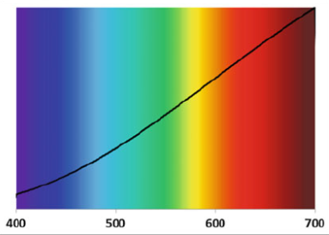 [1]
Figure 1 Visible light spectrum

2.2 Key Findings
The student’s key findings from the experiment were that the contamination of equipment was present in many of the results despite thorough cleaning of the metal rod before the test and after each solution was used. This meant that the students result had errors and the mixed solution could not be found.

Discussion

Experimental results
The results that the student collected in table 2 show the different colours that were observed and with that the metals producing them. The issue with the student’s results is that contamination was present within all results meaning that the colour change was not clear. This contamination caused most colours to appear orange where they should have been another colour present. One solution to contamination would be to use a different metal rod for each solution. This would reduce the error with contamination as samples would not be mixed during the experiment. Colours that are of the shorter wavelength than orange (<580nm) were observed more than those closer to the orange light wavelength. Potassium and Copper were the colours that were observed with ease as the colour change is substantial.

Relationship between frequency and energy
The primary equation used to describe the relation between energy and frequency is the Planck-Einstein Relation.
Equation 1 E=hν [2]
Where E is the energy required to raise the energy level of the electron (also energy of a photon) is equal to Planck constant (h) multiplied by the frequency (ν) of light. As h is a constant E and ν are directly proportional, if one value were to increase the other would have to as E = hν rearranged is E/ν = h meaning for h to remain the same they would have to increase and decrease at the same rates. On the other hand, with wavelength due to its relationship with frequency the relationship between energy and wavelength is indirectly proportional meaning as one increases the other decreases.
Equation 2 (ν = 1/λ)
This is evident within figure 1 as the higher wavelengths of light (towards infrared <700nm) have a lower frequency and less energy.

Relation to OME
The relations of the experiment to OME mainly includes fireworks and pyrotechnics. Fireworks use different metal ions in the stars to create different coloured displays. [3] This works the same way as the experiment as when the metal ions are heated, they give off vibrant colours. In OME we also have pyrotechnic compositions that are like the flame test in the way they are used. Tracer compositions for example use the heat from the burning powder to ignite the pyrotechnic composition making it burn brightly enough to be visible throughout its flight. Using different compounds containing different metals they can give off different colours most commonly being red or green.

Where can this be observed
Pyrotechnics have the capability of producing the same or similar effect as the flame test. A use of this is in illumination munitions. These types of munitions whether they be flares, mortars or artillery are used to light up a battlefield or area. Many do this by using a pyrotechnic composition [3] that burns a metal compound to create a colour of light. An example modern flares use Magnesium Teflon Viton (MTV) composition with the magnesium providing the fuel for a bright white light. [3]

Limitations
The experiment has many limitations. Human error with identifying colour, colour being subjective, contamination of both samples and metal rod and estimating the wavelength. Many of these are human error and others can be eliminated by expanding the equipment used such has having a different metal rod for each sample.

Conclusions
The findings of the experiment show that due to excessive contamination many of the results were wrong or couldn’t be determined. With the experiment being conducted where one metal rod was used the cross contamination of samples caused many of the colours to appear orange/red making it difficult to identify each metal. For future research or experiments expand the equipment available where in multiple metal rods are available so one can be used per sample and one person dictates which colour is present so there is consistency.

References

[1] | J. C. Zwinkels, “Light, Electromagnetic Spectrum,” in Encyclopedia of Colour Science and Technology, Ottawa, National Research Council Canada, 2015, pp. 1 - 8.
[2] | J. P. Ward, On the Planck-Einstein Relation, Jackson: US geological Survey retired, 2020.
[3] | K. Breitenecker, “Fireworks and Radioactivity,” Enviromental Research Letter, vol. 4, no. 3, pp. 1-3, 2009.
[4] | E.-C. Koch, V. Weiser and E. Roth, “2, 4, 6 - Trinitrotoluene: A Surprisingly Insensitive Energetic Fuel and Binder in Melt-Cast Decoy Flare Compositions,” Angewandte Chemie international edition, vol. 51, no. 40, pp. 9943-10193, 2012.
[5] | M. D. Withey, “Infrared Countermeasure Flares,” The Imaging Science Journal, vol. 5, no. 58, pp. 295-299, 2010.

Appendices
Equipment
- Bunsen burner
- Matches
- Heat-resistant mat
- Beaker with 1M HCL
- Blue cobalt glass
- Beaker with deionised water (DI water)
- Metal rod
- Samples of unknown metal salts (labelled A-H)

Method
- Equipment setup. Place Bunsen burner on heat-resistant mat. Use matches to light the Bunsen burner and ensure the flame is on safety yellow flame when not in use. Open air vent to get a blue flame with two cones.
- To clean metal rod, dip rod into 1M HCL and place over hottest part of the flame. Repeat several times until no colour is show when heating rod. If a colour change is visible contamination is present. Dip in HCL and place over hottest part of the flame again.
- Dip rod into DI water and then heat again to remove remanence of HCL. Repeat step 3 and step 4 before and after each test.
- Let wire cool before dipping into solution of unknown metal salt/mixture. Place rod into hottest part of the flame and observe colour change. Record result in the table given. Use Cobalt glass to identify mixtures containing sodium and potassium.
- Repeat steps 2 – 4 for each sample
- Record colour change of DI water and 1M HCL.

Results from experiment
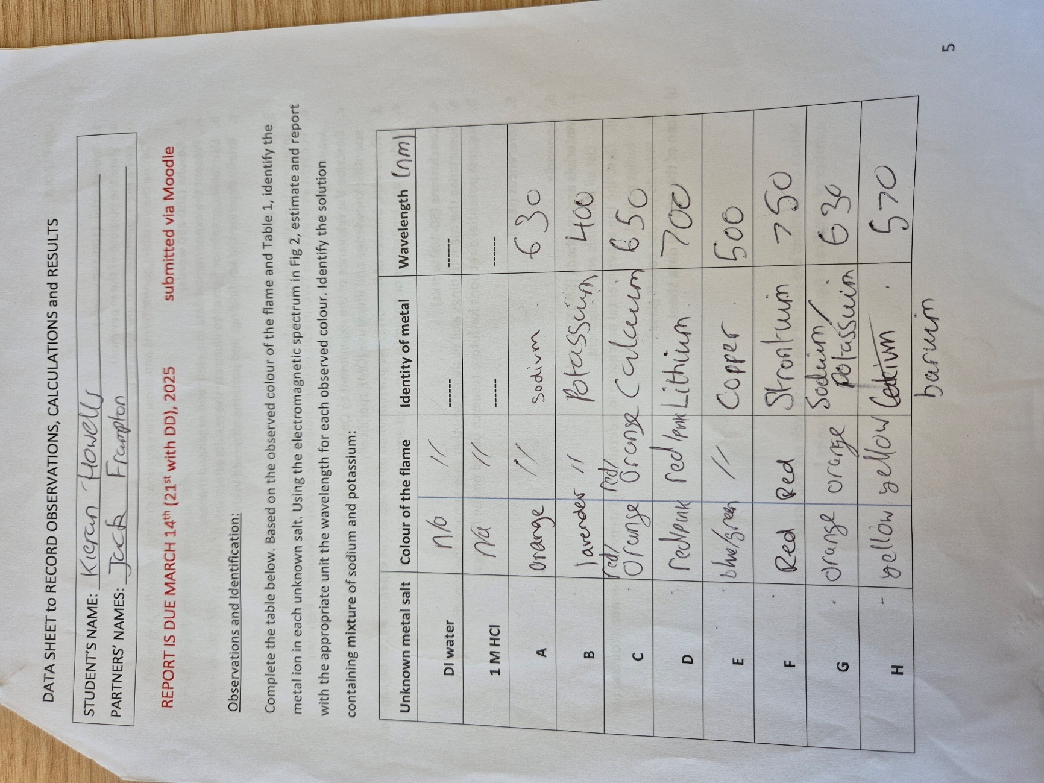

Appendix title (use Heading 7)

Appendix section (use Heading 8)

Appendix subsection (use Heading 9)

