

Undergraduate assignment feedback form
(to be completed by marker)

Student Name: Adam Johnson

Module Code: CSPB4001  Module title: Persuasive Language | Student number: 1701983
For completion by marker:
Comments:

Task 3: conspiracy
This is a great conspiracy theory but rather long. Needs editing to cut down length, remove mistakes and allow space for more build up of questions that the writer suggests can be explained in this way. More statistics. But a brilliant idea….

Task 1: Image literacy
Good but needs more work. Not clear on audience - true it’s male, but also cinema audience as this is also a poster for Skyfall. The innuendo fits with the cinema as well -a knowing humour.

Task 2: The Squatty Potty
This was such a bizarre advert! Deliberately ‘tasteless’. It plays on lots of postmodern tropes (pastiche, irony, a mashup of media genres (children’s animation and historical documentary; the personal, conversational narrator and the artificiallypink unicorn and the science lesson) , all focusing on a ‘bodiless’ body. All this stylistic playfulness gives the ad a weirdly modern atmosphere.
You only discuss this at the end but don’t spend enough time on it. In an email you said it was a healthy, utilitarian thing pretending not to be. And you’re right. Shame you couldn’t say that here.

Corrected piece 31 incorrect.
You need to spend some time looking at grammar and punctuation – look at the site I’ve linked to on moodle.

Marker’s signature: Jeni Williams |  | Date:
Provisional mark: 56
NB. All marks are provisional until confirmed by the final examination board.

ASSESSMENT CRITERIA for CREATIVE WRITING

Criteria | The portfolio demonstrates: | Mark
ORIGINALITY | imagination and originality in the production | 1
LANGUAGE | an awareness of, and the ability to deploy, appropriate language in relation to genre, form or other conventions and expectations, including pace, rhythm and shaping. | 2/3
EDITING | an awareness of the demands of, and the ability to deploy the skills required in, editing and revision at a mechanical (proof-reading), structural (length, pace, plot etc.) level | 4
SR | evidence of reading of, and reflection upon, (sub)genre or other comparables; and of awareness and deployment of ‘background’ research as appropriate to each piece | 2
ASSESS OTHERS | an understanding of the process of assessment through written assessments of the creative work of others | 2
AUDIENCE | an awareness of its intended audience and readership/ viewer and/or the market expectations relevant to the work including the conscious subverting of these expectations if appropriate. | 2/3
PROFESSIONALISM | an understanding of the presentational expectations of particular forms – here eg writing in the style of conspiracy theorists, a satirical radio programme and the use of symbolic narrative | 2/3
GUIDELINES | Adherence to guidelines | 4*

* Portfolio Index sheet missing

Complete Portfolio (Adam Johnson)
Task 3: Trump Is An Umpa Lumpa And He Is Gonna Start An Uprising With His Umpa Trumpas (Adam Johnson)

Dear friends and family, brothers and lovers, I was recently rewatching Charlie And The Chocolate Factory when I came across an awful realisation: not only were the events in that movie not a work of fiction, not only were the Umpa Lumpas not just “small fictional orange men” but America has voted one of them into the White House! Yes, as you sit here, reading this, an Umpa Lumpa has invaded the American government and has landed in the highest place of power imaginable… This master of espionage fooled you all, he claimed that the reason for his orange skin was fake tan, that his small hands were merely a birth defect, that the fact that he looked like a Willy Wonka character after he’d been attacked by a cat was ludicrous… this, my friends, was a lie of the highest magnitude, for he is, in fact, an Umpa Lumpa, now
I can see why you might be weary, I am claiming that a whole new species/type of person exists and that they have claimed power in the upper echelons of society, however, I must ask you to look carefully, look at those small childlike hands, that disgusting orange skin, that weird dusty complexion which makes him look like someone poured a pack of crushed Cheetos all over his disgusting body, and you tell me that you’re sure he isn’t one. But oh my fellow citizens, this goes way deeper than just Donald J Trump, for he, along with other Umpa Lumpas are what lead to Trumps election in the White House to begin with, they have slowly been replacing the average American, they took advantage of the electoral college, they hit multiple states, killing and replacing just enough people so as to tip the odds in Trumps favour while avoiding being caught out, but I have seen the signs! And I shall not hold my tongue any longer! I shall not let them destroy us and all we hold dear, my friends! I implore you, do not ignore these signs, do not ignore the rampant increase in xenophobia, the rampant rise in fascism, the rampant rise in deplorability in terms of the conduct of the American people! Take up arms against Trump and his Umpa Trumpas, defend your families, your friends, your siblings, it’s not too late! They may have got an Umpa Lumpa in power, but they are still greatly outnumbered, let us crush them under our boot, before Trump and his Umpa Trumpas begin their uprising, before it’s too late to stop them from enslaving us and claiming the world for themselves, before it’s too late for us to bare our arms, before it is too late for us to defend our freedom and our liberty! Take a stand for America! Take a stand for your families, but most of all take a stand for yourselves!

Rise Of The Planet Of The Umpa Trumpas: An Update With GROUNDBREAKING new evidence
Hello my fellow Americans! As many of you will have read in my last post, there is a serious threat lurking within the very walls of the great house of white! The Umpa Trumpas are coming, fuck, they’re already here! And now, I hear what some of you are saying, why? Why on Earth is this hero, this blue-blooded patriot returning to the realms of the internet once again? Why is he not out fighting against the scourge which is slowly poisoning the veins of great mother America?! Well, some battles aren’t won with guns, or protests, some battles require a silver tongue with a heavy injection of truth! And it is that truth that I plan to deliver unto you this day! For you see, my fellow countrymen, there are those who would disparage us, there are those who would laugh at us, whom read these posts and see not the danger that lies before their very eyes! Blind fools, pointing and laughing at us, the ENLIGHTENED… You are not one of those fools, those who would turn a blind eye when mother America cries out, who mock the wise and who drink up the establishment media like an alcoholic drinks up liquor! It is to you that I speak now, feast your eyes upon the truth and join us! Join the fight to reclaim America! My brothers, I’ve been scouring the internet, searching for even more proof (I’ve got lots already compiled), and what I’ve found shook me to my very core! The Umpa Trumpas transformed Trump into an Umpa Trumpa! Look at these pictures side by side:
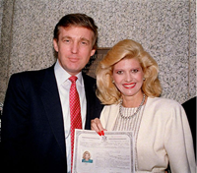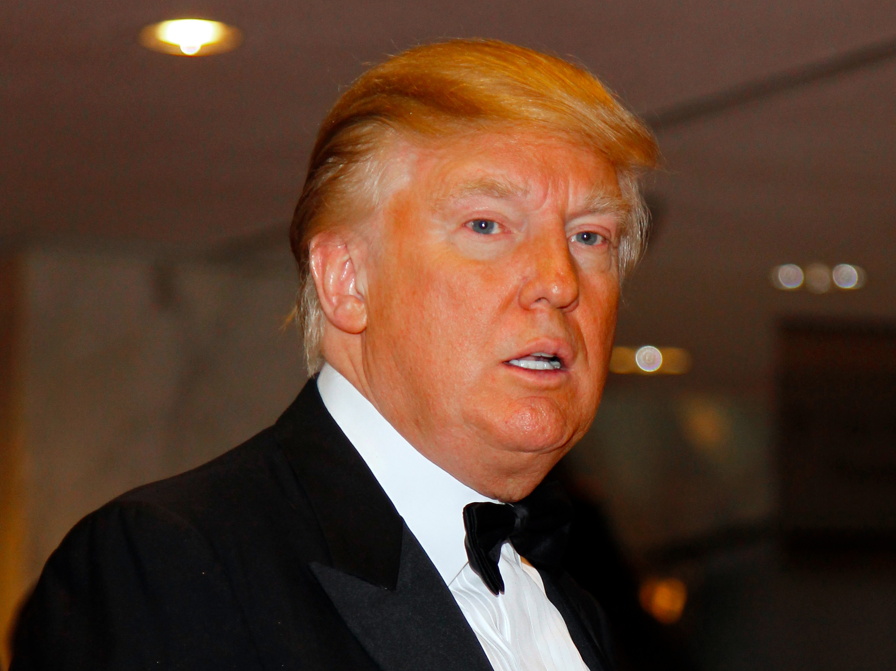

In the left picture, Trump looks like a somewhat normal human being, however, in the picture to the right, he has clearly undergone a transformation! Age you say? What kind of aging turns a man orange?! What kind of aging makes a man look like a Wotsit that has been overly seasoned? The answer, is none, it’s plain to see that this is not the same Trump, he has been changed, he has become, THE Umpa Trumpa, the one Cheeto to rule them all! And what is more my friends, I believe that he, along with the rest of his Umpa Trumpas, plan to turn us all into Umpa Trumpas as well! The sea of orange skinned people flooding into our country is no coincidence, these are people whom have been claimed by Trump and his Umpa Trumpas! What is more, is that I believe that the Umpa Trumpas were in fact the aliens that came to us in Roswell in 1947! Think about it, they need to lie low, so, they go to a chocolate factory ran by an insane man who will be mentally impaired enough to take them in, and then, they craft a horrific plan to trick the American public… They cut a lucrative movie deal with the owner of the chocolate factory, to make it look like this place is a figment of imagination and in doing so they make themselves fantasy within the minds of the American people! And, after all, whom would have the technology required to change a person’s species other than aliens who have achieved space travel?! And if this is not enough to convince you, look at all of the strange disappearances that have occurred since the Umpa Trumpas starred in Willy Wonka And The Chocolate Factory! Nick Begich + Hale Boggs (1972), Ray Robinson (1973), Thomas Leigh (1974), and MANY more have went missing since that movie aired! Nick and Hale were both U.S House Of Representatives, clearly, an attempt by the Umpa Trumpas to undermine democracy and infect our government! The disappearance of Ray Robinson was a blatant move to stir up racial tensions in America, as he was a black rights activist, his disappearance would cause ruptures in terms of race relations and keep us fighting eachother, keep us distracted while the Umpa Trumpas slaked around grasping at power wherever they could! This, my fellow Americans, my fellow patriots! Is my last blog, if you are wise, if you accept the facts and see what is happening, I implore you to take up arms with me! To liberate America of these tyrants, do not let the Umpa Trumpas bathe in the blood of our kin! Rise up and act!
Here are some links containing further evidence, as if it were not clear enough already:
https://en.wikipedia.org/wiki/Nick_Begich
https://en.wikipedia.org/wiki/Hale_Boggs
https://en.wikipedia.org/wiki/Ray_Robinson_(activist)
https://en.wikipedia.org/wiki/Light_Heart_(balloon)

Task 3: Task 1: Literary Image: Coca Cola Zero Ad (Adam Johnson)

Discuss how it seeks to persuade you as the prospective customer/consumer that buying this product:
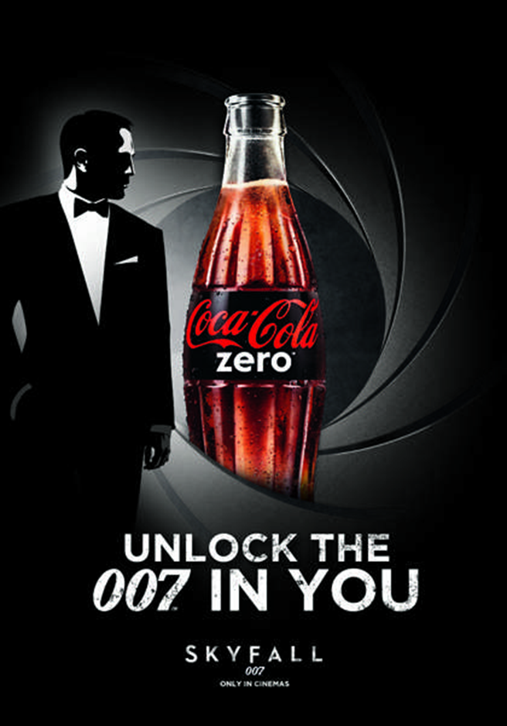
Will improve your life?
Of course, there’s the fact that they’re using the figure of 007/James Bond to sell you this product, James Bond is a secret agent, one of the best in the world if not the best, he’s also a amazing fighter, battling through waves of enemies with ease and pulling off magnificent feats with ease, he’s also a smooth talker, he’s smart, has sophisticated tech and is brimming with confidence. Therefore, it links the purchasing of Coke Zero with unlocking the best person you can be. While it obviously won’t do this, it suggests that, there is greatness within everyone, that everyone has a 007 trapped within them and that this product will somehow bring you closer to that person within and therefore will make you a better person. On top of this there are strong sexual connotations, 007 is a notorious womaniser in the James Bond movies, in almost every James Bond movie, James sleeps with an attractive woman, and due to his role in this ad, it can be perceived by the audience that by drinking this product or indulging it in any way might make them more attractive to women, therefore improving the quality (in terms of looks) that certain people are able to get (bogus, but it can suggest that). It also once again makes them associate themselves with James Bond, whom is a man brimming with confidence, as well as a high amount of class and precision in his word, James Bond is a smooth talking spy whom pulls off daring stunts and cunning espionage missions, therefore, people will drink coke zero in order to seem more sophisticated, adventurous, to perhaps try and increase their confidence, or just because it relates them to the character (007) slightly and it makes them feel more empowered, afterall, the product doesn’t have to ACTUALLY make other people think this, just the person buying it, and to this degree they may see it as improving their lives.

Will combat specific fears or anxieties?
The main demographic for this ad seems to be men, as previously mentioned, James Bond is a male role model, so his association with coke zero makes it seem like the drinking of coke is inherently masculine, in fact, to many, they may perceive anyone whom is drinking coke zero as more masculine and those who don’t drink it as less so… So in essence, the product claims to combat the anxiety of certain males who fear not being seen as masculine and/or whom hold masculine traits in high importance. The product also seems like it tackles people fears of being unexceptional in life, the tagline, “unlock the 007 in you,” suggests that you are already special, but by buying this product you shall unlock what is special within you, and that your exceptionalism will be so great that you shall match up with this legendary icon of cinema and of masculinity. Also, due to the previously mentioned sexual connotations surrounding Hames Bond as a character, it could also be said to be answering the fears and anxieties of men whom fear that they will be virgins for the rest of their lives, that by drinking coke Zero, they shall somehow be attractive enough to fulfill their sexual desires.
How is the image composed to reinforce this?
The simple uses of mainly blacks and whites help to bring focus to the product itself while keeping the association, the colour of the coke is very bright, it catches the eye, due to it being placed amongst colours with which create a strong contrast. The coke bottle is also centred where bond is usually situated, at the centre of the focus, as if to suggest that the product is the star, as opposed to putting Bond at the centre, where he usually is, which would make us lose focus on the product itself. The lines around the frame all spiral towards the coca cola, bringing yet more emphasis to the product, the reason for the colour palette seems rather simple, as the black and the white emphasise each other, the colours also refer to old bond intros in which bond would shoot the camera (not literally) and blood would come pouring down the screen. The colours also offer the sense of refined taste, more cultured perhaps. Lighting is also interesting in this image, as bond and especially the coca cola are emphasised by very bright light, highlighting them as the stars in this ad.

Task 2: The Squatty Potty (https://www.youtube.com/watch?v=YbYWhdLO43Q ) (Adam Johnson)
What specific benefit does the USP promise the consumer?
The Squatty Potty is a small stool which goes in your bathroom, when you need to go to the toilet/relieve yourself, you place the squatty potty underneath you and put your feet on top of it so that you assume a squatting position. According to the video/ad, issuing the squatting position relieves tension on a muscle, which allows your colon to align with your hole, it also reduces constipation, haemorrhaging, time spent on the toilet, and makes it easier to go to the bathroom in general. Considering that this is a much newer product, it’s USP could be said to be that it allows one to go to the toilet easier and that it is a unique product for those whom have and/or whom have had toiletry issues in the past such as constipation, however, it also has other USP’s, such as the mentioned health benefits as it theoretically prevents build up which leads to issues such as constipation, it’s also got a similar shape to your toiler t, so, once you’re done with it, it can be simply pushed back around the form of a toilet, so it takes up little to no extra room within the bathroom, stopping from becoming a discomfort.
How is the distinctiveness of the product and/or brand emphasised?
The distinctiveness of the product is emphasised through the Unicorn, most products, regarding the toilet tend not to be associated with nice things like Unicorns and ice cream, in fact, the usual distinction for toiletry products is that they’re a necessity rather than a joy. The Squatty Potty distinguishes itself since it not only gives an improvement to your toiletry needs, but it makes it so that the act of going to the toilet is allegedly pleasurable instead of painful and awkward, it is distinctive in that it makes the act enjoyable and this is emphasised by the use of ice cream (which is often considered smooth and soft) and the Unicorn, whom under the influence of the Squatty Potty is much more relaxed and a lot less backed up.
Does the advertisement rely solely upon its USP for its persuasive effect?
The advertisement does not just rely on it’s USP(s) to sell itself, in the ad, it is pointed out that multiple health organisations, doctors and The Huffington post back up the claims that the product in fact has health benefits, they use outside influences to further sell this product to you. They also use bright imagery to further sell you the product, the bright images, the unicorn, the cheesy guy in the medieval get-up, these images are drowned in colour and add easy brand recognition. The same can be said for the humour in the Squatty Potty ad, while it is juvenile, it’s sheer absurdity certainly ads a layer of memorability to it, for example, the unicorn pooping out ice cream is very absurd on its own, but the fact that there’s a conveyer belt, and the medieval guy is eating it makes it all the more memorable, the surreal nature sticks in the customers head, and therefore, since the customer associates the humour with the Squatty Potty, the absurd imagery, they’re more likely to buy it.
Posts
Task 1: Image Literacy Forum
Task 2: Moving image literacy forum
Task 3 Forum (Conspiracy)
Discussion
Task 3 Forum: Conspiracy
Student: Prithi Shukla
Comment I left: “Very well written, I love the insanity, the repetition of the term establishment is very well catered to the simpletons who will be reading it, as it gives them something to latch on to, I also love the references to the computer hackings that occurred last year, it lends your theory just enough credibility to be compelling to those who aren't smart enough to know any better. I would, however, simplify some of the language, words like "replenishments", "mandate", "obligatory", would likely be too complex for the audience that usually reads a conspiracy theory to either understand or take seriously. Same can be said with sentence structure, there are some longer sentences in there, and once again, this would likely turn the reader of a conspiracy theory off, apart from that though, it's fantastic, great job Pri”
Task 1 Forum: Image Literacy
Student: Prithi Shukla
Comment I left: “Very good Pri, although, I would argue that the statue represents more than gender inequality, in fact, I'd say, whether intentional or not, it transcends gender and works in a way to challenge corporate greed and wealth inequality as well as gender inequality, after all, wall street may be populated mainly by men, but those men are a major minority, most people in general don't work at wall street or benefit from its success, most of us, whether we like to admit it or not, are the average person facing down the bull (which, in this case, represents corporations, wall street, the status quo), I'd say that not everyone can be a bull, not everyone can be insanely wealthy... But the truth is most of us can't, and most of us (much like the statue seems to suggest and the reaction that followed) hold Wall Street (rightly so) in our most rooted suspicions. Anyway, a really good piece Pri, excellent work.”

