1

Developing an Effective Talent Acquisition Strategy in a Globalized World Assignment Title: Group Presentation
Module: Human Resource Management
Module code: LCMB7000
Lecturer: Dr Mohamed Asim
Lucien H K Yao
Student ID: 1916224
August 22, 2023
Word Count: 1290

2
Introduction
For this class group assignment, we were presented with three different presentation topics, and we decided to go with the first option: "Developing an Effective Talent Acquisition Strategy in a Globalized World." The topic of talent acquisition is crucial in today's globalized business environment. As organizations expand their operations across borders, the ability to attract and retain top talent from diverse backgrounds becomes essential for success. This report is a detailed explanation of my contribution to the group project, where I explored and explained the relevance of cultural senility, inclusion, and talent management, the process of measuring and evaluating talent acquisition success, and wrote the conclusion for the entire presentation.
Cultural Sensitivity and Talent Management
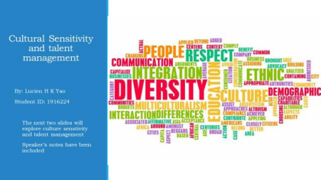
As illustrated by the above slide, I my contribution to the group began with the exploration of the relationship between cultural sensitivity and talent management. In my presentation I indicated that the symbiotic relationship between these two concepts is important
3
because they are the essential underpinnings that support achieving organisational success. Cultural sensitivity enhances talent management by creating an environment where individuals from diverse backgrounds feel valued and empowered. Consider a real-life example in the case of Marks and Spencer (M&S). By fostering an environment where different viewpoints are celebrated, M&S enhances talent management. Conversely, their well-executed talent management strategy supports and reinforces cultural sensitivity by ensuring that every individual’s unique strengths are recognised and utilised to their full potential.
Cultural Sensitivity and Inclusion
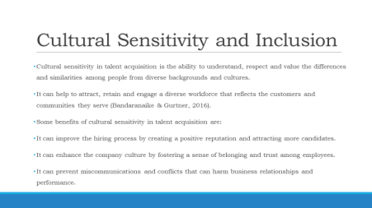
As illustrated by the slide, the next part of my contribution focused on cultural sensitivity and inclusion as a critical element of talent management. Cultural sensitivity within the framework of talent acquisition goes beyond mere acknowledgement of diversity as it encompasses a deep understanding, profound respect, and genuine appreciation for the unique differences and shared characteristics among individuals from diverse ethnic, social, and cultural backgrounds (Bitti, 2013). It transcends mere tolerance and transforms into an active and conscious embrace of the richness that this diversity brings to the fabric of our
4
organisations (Bandaranaike and Gurtner, 2016). The question arises: Why is cultural sensitivity so imperative in the modern workplace?
In a world that’s becoming increasingly interconnected, organisations that fail to embrace diversity risk becoming out of touch and disconnected from the broader global context. Consider how a culturally sensitive approach can drastically enhance the recruitment process. By embracing diversity and promoting inclusivity, Lutchman et al. (2020) show that organisations can build a reputation for welcoming and diverse workplace. This reputation, in turn, acts as a magnet, drawing a wider spectrum of candidates, each contributing their unique talents, perspectives, and experiences (O’Donovan, 2018). Besides, cultural sensitivity has the power to shape the very essence of organisational culture. When employees sense that their cultural identities are acknowledged and celebrated, a profound sense of belonging emerges. This feeling of belonging fosters trust among team members, creating a supportive environment where individuals can flourish. Hong and Minbaeva (2022) note that miscommunications and conflicts are common in a global business landscape marked by multicultural teams and cross border interactions. Here, cultural sensitivity acts as a bridge across potential communication gaps. By understanding and appreciating diverse communication styles, etiquettes, and non verbal cues, we can significantly reduce the likelihood of misunderstandings that could damage business relationships and hinder overall performance.

Talent Management
As Thunnissen (2016) illustrated, talent management refers to the strategic and comprehensive approach organisations adopt to attract, develop, retain, and optimise their workforce’s skills, knowledge, and abilities to achieve both short-term and long-term business goals. It encompasses a range of practices and processes aimed at identifying high-potential individuals, nurturing their growth, and aligning their talents with the company’s objectives
5
(Thunnissen, 2016). In essence, talent management goes beyond mere recruitment, focusing on cultivating a pool of skilled and motivated individuals who can drive the organisation forward. M&S’s talent management strategies are multi-faceted and designed to foster a culture of continuous development and growth.
Measuring and Evaluating Talent Acquisition Success
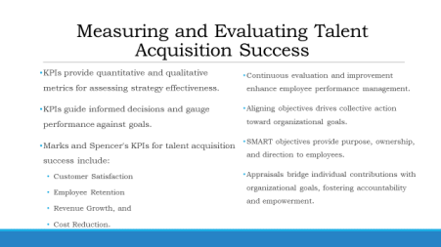
As illustrated by the slide above, I was also in charge of researching and discussing the talent acquisition evaluation process. In today’s dynamic and competitive business landscape, Ifeoma et al. (2015) argue that the ability to attract and retain top talent is a critical determinant of organisational success. However, the journey doesn’t end with recruitment as it extends to the systematic measurement and evaluation of talent acquisition efforts. This process involves the utilisation of Key Performance Indicators (KPIs) to quantitatively and qualitatively assess the effectiveness of talent acquisition strategies. KPIs enable organisations to make strategic decisions based on empirical data rather than assumptions. This approach ensures that resources are directed toward avenues that yield the highest return on investment. In this case, customer satisfaction is one of the key KPIs for talent acquisition success. High levels of
6
customer satisfaction serve as an external indicator of how well the company’s talent aligns with customer needs and expectations. This observation is in line with M&S’s recognition that the quality of acquired talent directly impacts customer experiences. The ability to retain top talent is another pivotal measure of the success of talent acquisition strategies. As noted by
Ongori (2007), high employee retention rates reflect a positive work environment and the alignment of employee aspirations with organisational opportunities. M&S also acknowledges the link between effective talent acquisition and revenue growth, making it also a key KPI. By acquiring skilled individuals who contribute to outstanding results, the company drives increased revenue generation. In addition, strategic talent acquisition practices can contribute to cost reduction, whether by streamlining the hiring process or minimising expenses related to turnover.
However, the essence of measuring success extends beyond numerical metrics as it involves cultivating a mindset of continuous evaluation and improvement. This philosophy ensures that talent management strategies evolve in tandem with the evolving business landscape. Besides, clear goal setting is pivotal in this journey. Garbellano et al. (2020) have also shown that SMART objectives (Specific, Measurable, Achievable, Relevant, and Time bound) provide employees with a roadmap for success. By applying the SMART framework to talent acquisition objectives, M&S can systematically measure their success. For instance, if M&S SMART objective is to increase female managers’ percentage by 15% within the next year, the progress can be tracked quantitatively over time. Appraisals also play a transformative role by bridging the gap between individual contributions and overarching organisational goals, nurturing a culture of accountability, motivation, and empowerment.
7
Conclusion on Global Talent Acquisition for M&S
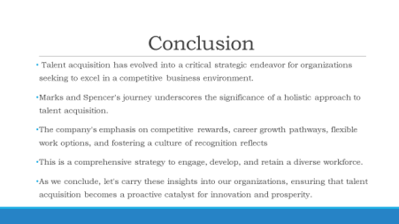
Lastly, as illustrated by the slide above, I was responsible of summarizing the entire group presentation. I showed that through our case study analysis of Marks and Spencer’s (M&S) approach, we gained valuable insights that underscore the significance of embracing a holistic perspective on talent acquisition. M&S’ commitment to competitive rewards, well
defined career pathways, flexible work options, and the cultivation of a recognition-driven culture serves as a blueprint for a comprehensive talent acquisition strategy. This strategy transcends the traditional recruitment process, extending its influence to the engagement, development, and retention of a diverse and empowered workforce. It is also evident that talent acquisition transcends the mere act of filling vacancies as it has become a dynamic catalyst for innovation and organisation success. By adopting a holistic mindset akin to Marks and Spencer’s approach, we can equip ourselves to navigate the evolving global business landscape with agility and adaptability.
In conclusion, my contributions to the group presentation focused on the vital interplay of cultural sensitivity, inclusion, and the metrics of success within talent acquisition. These
8
elements collectively impact the development of an effective talent acquisition strategy that extends beyond recruitment to encompass engagement, growth, and retention. As I look to the future, the lessons learned from this group work will shape my perspective on talent management and its role in a world where diversity and globalization continue to redefine business dynamics.

9
References
Bandaranaike, S. and Gurtner, Y., 2016. Integrating cross cultural sensitivity in the workplace: developing globally proficient professionals. In Proceedings of the 2nd International Research Symposium on Cooperative and Work-Integrated Education (pp. 13-21).
Bitti, M. T. 2013. Recruiting with cultural sensitivity will broaden the talent pool. https://financialpost.com/executive/careers/building-cultural-sensitivity-into-the recruiting-process
Garbellano, S., Ughetto, E. and Esfahani, H.D., 2020. Talent Acquisition and Development in Global Companies (based on a study on Nexans Group).
Hoare, L., 2005. Culturally sensitive human resource development in the multicultural workplace:’Western’and’Confucian heritage’experiences. Australian Association for Research in Education, pp.1-18.
Hong, H.J. and Minbaeva, D., 2022. Multiculturals as strategic human capital resources in multinational enterprises. Journal of International Business Studies, pp.1-31.
Ifeoma, O.R., Purity, N.O. and Okoye-Nebo, C., 2015. Effective talent management: Key to organisational success. Journal of Policy and Development Studies, 289(1850), pp.1- 12.
Jackson, P. and Sparks, L., 2005. Retail internationalisation: marks and spencer in Hong Kong. International Journal of Retail & Distribution Management, 33(10), pp.766- 783.
Lutchman, V., Mahlangu, I. and Lentsoane, N., 2020. Embracing diversity and inclusivity in the workplace. Civil Engineering= Siviele Ingenieurswese, 28(9), pp.4-5.
10
O’Donovan, D., 2018. Diversity and Inclusion in the Workplace. Organisational behaviour and human resource management: A guide to a specialised MBA course, pp.73-108.
Ongori, H., 2007. A review of the literature on employee turnover. African Journal of Business Management pp. 049-054
Thunnissen, M., 2016. Talent management: For what, how and how well? An empirical exploration of talent management in practice. Employee Relations, 38(1), pp.57-72.

