In this essay I will reflect upon my chosen Welsh language lesson activities which have been presented as part of a portfolio consisting of a video recording (Task 2) and related appendixes. The rationale for choosing the theme and the main aims attached the chosen activities will be outlined at the beginning of this essay (Task 1), this will be followed by a written reflection (Task 3).
My most recent Welsh as a second language session with my year 1 class involved the theme of “colour”. This theme was selected due to the pupil’s prior knowledge and understanding. When first considering the theme of the session I referred to the Welsh Second Language Scheme of Work to better understand the suggested standards and theme that this age range should be working towards. According to the Central South Consortium pupils in year 1 should have a sound understanding of language patterns relating to ‘colour’, however the theme taught over the spring term would be ‘weather and clothing’.
Communication skills are regarded as “crucial for teachers” (Silver, 2018), as sharing opinions and thoughts regarding learning can be “very rewarding and personally fulfilling” (Silver, 2018). After reflecting upon my practice and communicating with other classroom staff regarding pupils’ abilities, I decided to apply the theory of the Zone of proximal development (ZPD). The ZPD is a tool which ensures that work is not too challenging for pupils to the point that they become distressed and disengaged but also that work is not so easy that children are not challenged enough and become bored and thus disengaged in their learning. The ZPD was used to determine what parts of the Welsh language the pupils were confident in using with little “assistance” but could not yet “perform independently” (Cherry, 2019). This led to the shared thought by me and other staff that the theme of weather would prove difficult for all the class as they would need excessive support in completing any activity surrounding this theme. However, all the class had a basic understanding of the Welsh language when discussing colours but would benefit from further lessons on this theme in order to further imbed the language patterns.
According to the schools Estyn report, "pupils do not read texts fluently enough or with accurate pronunciation” (Estyn, 2017). Due to this and the school’s enthusiasm towards enquiry-based learning, I also chose to provide the class with additional continuous provisions. One of which was a pencil shop or ‘siop pensil’ (Appendix 10) as it was introduced to the class. The shop only sold coloured pencils and the pupils had to state which colour they liked or loved, to the shop keeper. This was all modelled and observed by me and the class LSA prior to the class using this area. I first considered using the strategy of implementing welsh in a play-based activity, as I believed it would “stimulate their imaginations and promote enjoyment in learning” (Donaldson, 2015:38). I also considered the beliefs of Vygotsky, who believed that “imaginary play is a precursor to abstract thinking. Through play children exercise their understanding of objects, develop relationships, mimic adult behaviour and adopt fantasy roles” Gray (2015: 98). Again, as the teaching staff had modelled the correct use of the expected language pupils were then able to mimic this and gain a better understanding in a form of “self-education” Gray (2015:98).
In using this approach, I also aimed to overcome the statement that “many pupils lack confidence in speaking Welsh in less formal situations outside Welsh lessons” (Estyn, 2017). This would then provide pupils with language they can use within multiple aspects of their day to day life both at home and in school. This is highly recommended by Donaldson (2015) who states that a “greater focus on children and young people’s ability to speak Welsh confidently in everyday settings” is needed in education. Similarly, this would also aid pupils in overcoming the barrier that “no pupils speak Welsh at home” (Estyn, 2017) as pupils are better equipped with the skills to use the Welsh language in different aspects of life.
This play-based approach was similarly used in the main activity of colour bingo as well as the continuous provisions of descriptive colouring (Appendix 1A) and sorting by colour (Appendix 2). The colouring chameleon activity was a simple and enjoyable activity in which the pupils read the brief colour description (in Welsh) and then coloured the image accordingly (Appendix 3). This activity had a simple differentiation that worked well for the pupil’s abilities. For example, the pupils were provided with a blank image of a chameleon (Appendix 1A and 1C) which was accompanied by brief instructions. The lower ability pupils had a chameleon with one colour written in welsh (Appendix 1B), they would then colour the image according to that colour. For the higher ability pupils, the chameleon images were accompanied by two or more colours written in welsh (Appendix 1C).
As a progression the MAT pupils were also given a blank image of a rainbow entitled Enfys. This image contained the written welsh word of the different colours of the rainbow (Appendix 3). The pupils’ task was to translate these words and colour the rainbow strands accordingly. This task was successful as it engaged the pupils’ and also meant the children could work independently in order to achieve the success criteria/ challenge. This activity highlighted that the pupils were able to read and understand the selected Welsh vocabulary and thus, were gaining a better understanding of the Welsh language, as reading in a second or foreign language is regarded as “excellent practice” (Tandem, 2018). By providing these additional “materials and other resources” (Donaldson, 2015:93) the learning of pupils was largely benefited. As Donaldson (2015: 48) states that reading, “will enrich” (Donaldson, 2015:48) the learning of any language.
The main activity of colour bingo was successful as all pupils were able to engage in it and deepen their knowledge and understanding of speaking and listening in Welsh. The activities success was largely due to the pupils’ enjoyment of the activity as they became more engaged. This belief is backed by the research of Willis (2007) which states “that superior learning takes place when classroom experiences are enjoyable”.
Alongside the enjoyment levels of the pupils a strong motivation for the pupils’ engagement was also the competitive element that was introduced. I chose to use this competitive element as it is believed that “competition can increase motivation, improve productivity and performance” (Evans, 2018). This proved very beneficial within the chosen class as the pupils became so engaged in what welsh colour was being called, they were unable to become distracted by any of the continuous provision going on in the surrounding learning environments. Pupils were quick to use their knowledge of the Welsh colours to complete their bingo cards in the hope of winning the game.
The bingo game was differentiated according to the pupils’ abilities. The lower ability pupils were given smaller bingo cards with less colours (3) to complete. This worked well as the pupils were able to maintain and manage a smaller number of colours on their own (examples on Appendix 4A and 4B). They were also able to become more aware of which colours (in Welsh) they were waiting for and plan their own learning. As a progression some of the lower ability pupils were able to attempt the higher ability form of the bingo. The higher ability form of bingo saw the pupils use larger bingo cards (Appendix 5) consisting of more Welsh colours (6). This of provided an additional challenge which ensured the activity remained in the zone of proximal development for the pupils. Further differentiation was provided for the MAT pupils through challenge. This challenge was for the MAT pupils to individually take on the role of the teacher and verbally state which colour was randomly selected (Appendix 6). This proved a fantastic challenge for the MAT pupils who enjoyed conducting the game and ensuring the rules were being followed. Due to its popularity, the challenge was also attempted by several of the higher ability groups, who were also successful with some support. The MAT progression was also beneficial as pupils were not only using their Welsh reading skills but were also required to use their Welsh speaking skills.
Upon further reflection of the bingo activity, I feel the activity worked well to raise the knowledge and understanding of all the pupils and was inclusive of all abilities. However, the bingo activity may have benefited from being carried out by not only myself but also an additional member of staff, this would have provided pupils with the opportunity to play multiple games of colour bingo at a quicker pace and thus access continuous provision for more time.
An additional form of bingo would have also enabled more pupils to have the chance of winning in the activity. This lack of opportunity did pose I minor issue as one of the MAT pupils became disengaged and upset during colour bingo, as she was aware of the colours that she needed, but she could not control the outcome of the game. As a direct result she refused to leave until she had won a game with her peers. This posed an issue at the time as other pupils were unable to participate as freely due to disruptive behaviour. However, if there were multiple games of colour bingo available this would provide a better opportunity for pupils to win.
However, as a second game of colour bingo was not possible due to numbers of staff (however other staff members were busy as shown in Appendix 9), I instead chose to re arranged the game so that the MAT child would support a lower ability pupil. This worked very well as the MAT child enjoyed the additional responsibility and was able to use her Welsh skills to support her peers understanding of Welsh.
While reflecting upon the differentiation used to meet the pupils’ abilities, it is also apparent that that the continuous provisions were also differentiated to meet the different learning styles of the class. For example, the continuous provision of the pencil shop role play, provided auditory learners with the opportunity to “participate in discussions and debates” (Chibana, 2018) while buying and selling different coloured pencils. This is believed to be a great strategy to aid auditory learners to “enhance retention” (Chibana, 2018) of their own learning.
Contradicting this, it is stated that Verbal learners’ strengths lay in “processing information through the use of language” (Chibana, 2018) and that they learn best when “reading, writing, listening and speaking” (Chibana, 2018). Upon reflection it is clear to see that this was provided within the main activity of colour bingo as participating pupils had to listen to the teacher/ lead who was verbally sharing the Welsh colours. The chameleon colouring pages also catered to the needs of verbal learners as they had to rely on their reading skills to decipher the Welsh colour (Appendix 1A) and colour in the chameleon accordingly. This activity was also differentiated to cater to the needs of intrapersonal learners as pupils were able to complete the activity as they wished. For example, the blank images (Appendix 1A and 1C) were placed in different areas (painting easels, creative corner and reading corner). Pupils were then able to complete the sheets while working with others or independently away from their peers. This coincides with the belief of Chibana (2018) who states that intrapersonal learners are solitary learners that benefit from and like “to use self-study and work alone”.
Upon reflection of the session, I felt that it engaged pupils of different abilities and enabled pupils to make progress through a variety of strategies. I believe the differentiation of the activities provided “pupils with the best chance at learning, regardless of their abilities, strengths and weaknesses” (ResourcEd, 2017). By using smaller groups in the colour bingo activity (Appendix 7) I was better able to support pupils if needed. This also enabled the rest of the class to enquire into the continuous provisions.
The competitive nature of the bingo activity also worked well as this ensured pupils remained motivated during the activity and focused on an end result. The pupils also responded very well to being continuously questioned in Welsh, as all the MAT pupils and the majority of the higher ability pupils were able to give a response in Welsh, using full sentences. Similarly, due the specific questions used; the lower ability pupils were also able to engage as they were able to reply with simple one-word answers in Welsh. The class also responded very well to the use of Welsh praises such as “da iawn”, in particular the whole class liked the term “bendigedig” when said with emphasis. This later led to the pupils praising each other in Welsh as they had retained this language. As a direct result, I would continue to use these techniques in my day to day practice to promote the use of Welsh across the curriculum.

Reference list
Cherry, K. (2019). What Is the Zone of Proximal Development?. Available: https://www.verywellmind.com/what-is-the-zone-of-proximal-development-2796034. Last accessed 26th May 2019.
Chibana, N. (2018). The 8 Learning Styles: Which One Works for You?.Available: https://visme.co/blog/8-learning-styles/. Last accessed 30th May 2019.
Donaldson, G (2015). Successful Futures. Cardiff: Crown. pp38.
Donaldson, G (2015). Successful Futures. Cardiff: Crown. pp48.
Donaldson, G (2015). Successful Futures. Cardiff: Crown. pp93.
Donaldson, G. (2015). Successful Futures. Available: https://gov.wales/sites/default/files/publications/2018-03/succesful-futures-a-summary-of-professor-graham-donaldsons-report.pdf. Last accessed 29th May 2019.
Estyn. (2017). A report on Cadoxton Community Primary. Available: https://www.estyn.gov.wales/sites/default/files/documents/Cadoxton%20Community%20Primary.pdf. Last accessed 26th May 2019.
Evans, L. (2018). This is how competition affects your brain, motivation, and productivity. Available: https://www.fastcompany.com/90240826/this-is-how-competition-affects-your-brain-motivation-and-productivity. Last accessed 29th May 2019.
Gray, C (2015). Learning theories in childhood. 2nd ed. London: Sage. pp98.
Gray, C (2015). Learning theories in childhood. 2nd ed. London: Sage. pp144.
ResourcEd. (2017). Differentiation in the classroom — engaging different learning profiles. Available: https://resourced.prometheanworld.com/differentiation-classroom-engaging-different-learners/. Last accessed 30th May 2019.
Silver, F. (2018). What Are the Benefits of Communication Skills to Teachers?. Available: https://work.chron.com/benefits-communication-skills-teachers-4493.html. Last accessed 26th May 2019.
Willis, J. (2007). The Neuroscience of Joyful Education. Available: https://www.psychologytoday.com/files/attachments/4141/the-neuroscience-joyful-education-judy-willis-md.pdf. Last accessed 29th May 2019.

Appendix list

Appendix 1A
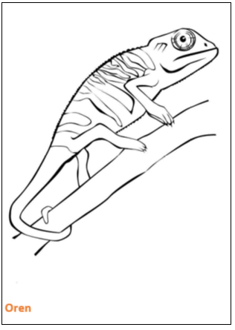 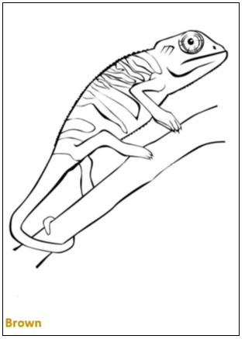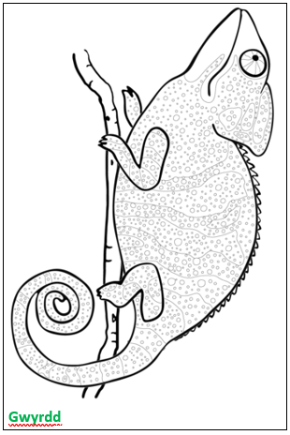 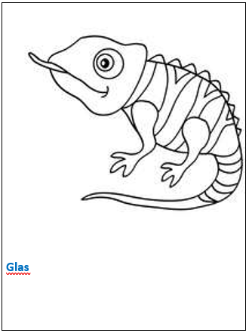
Appendix 1B
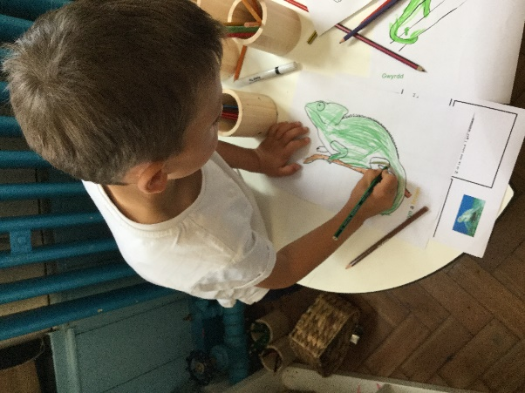 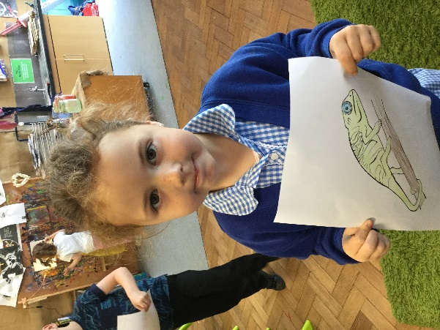
Appendix 1C
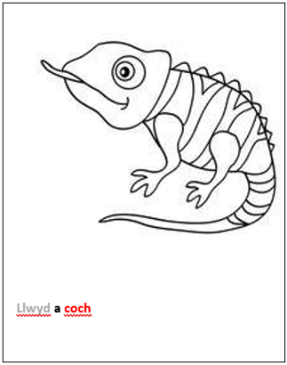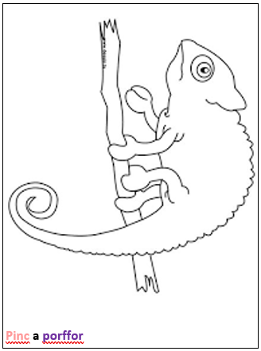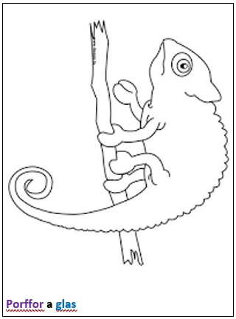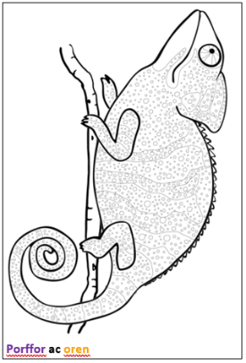
Appendix 1D
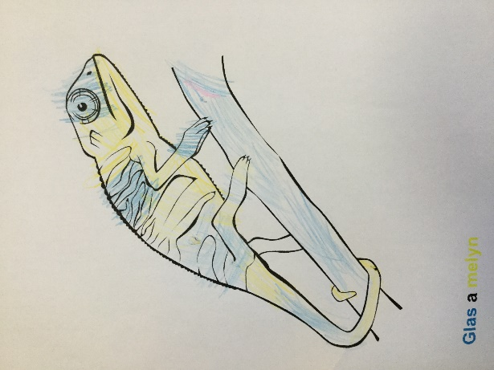 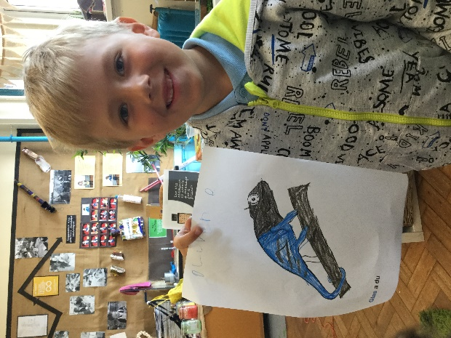

Appendix 2
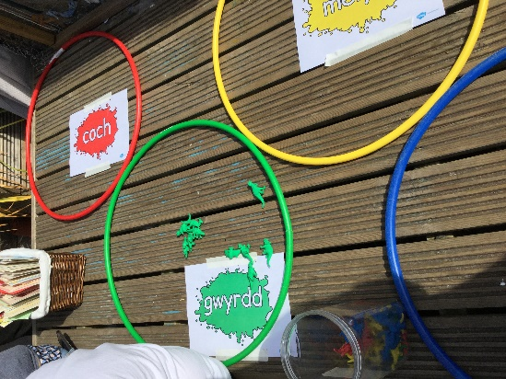 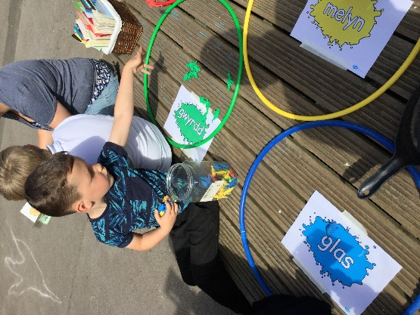 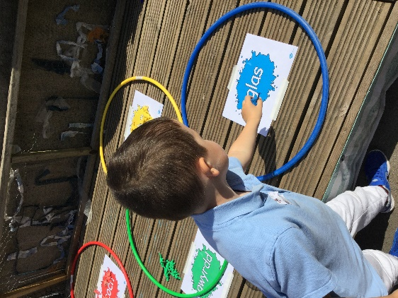

Appendix 3
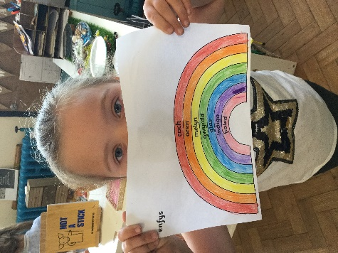 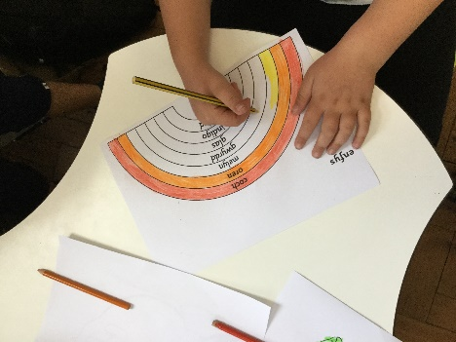 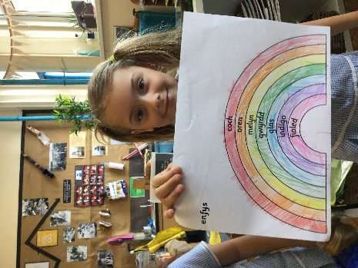

Appendix 4A
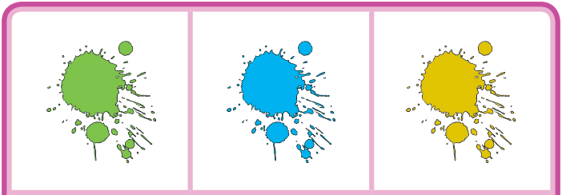
Appendix 4B
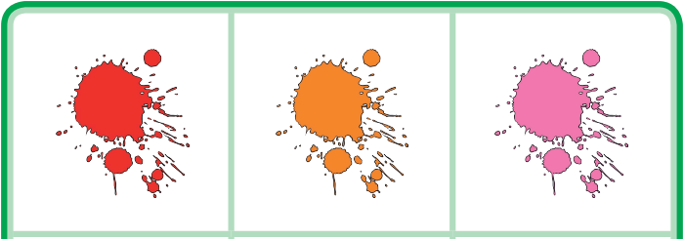
Appendix 5
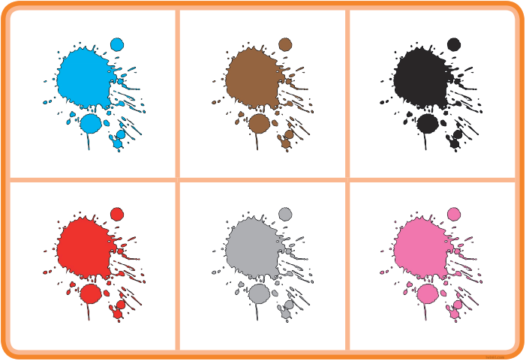
Appendix 6
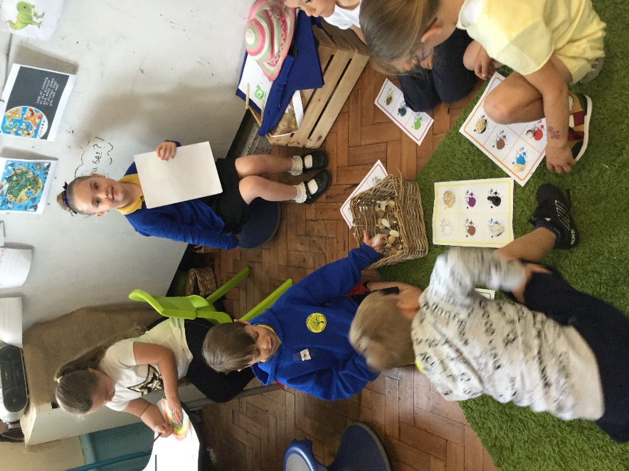 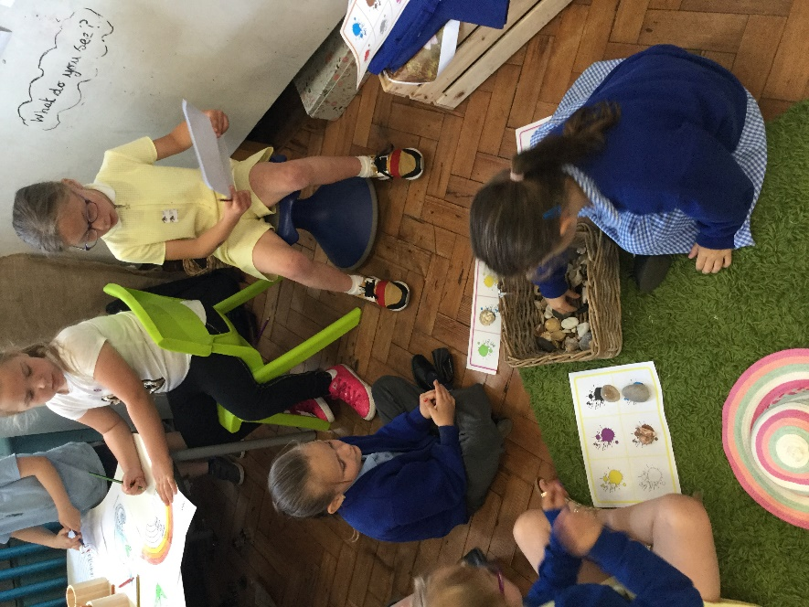
Appendix 7
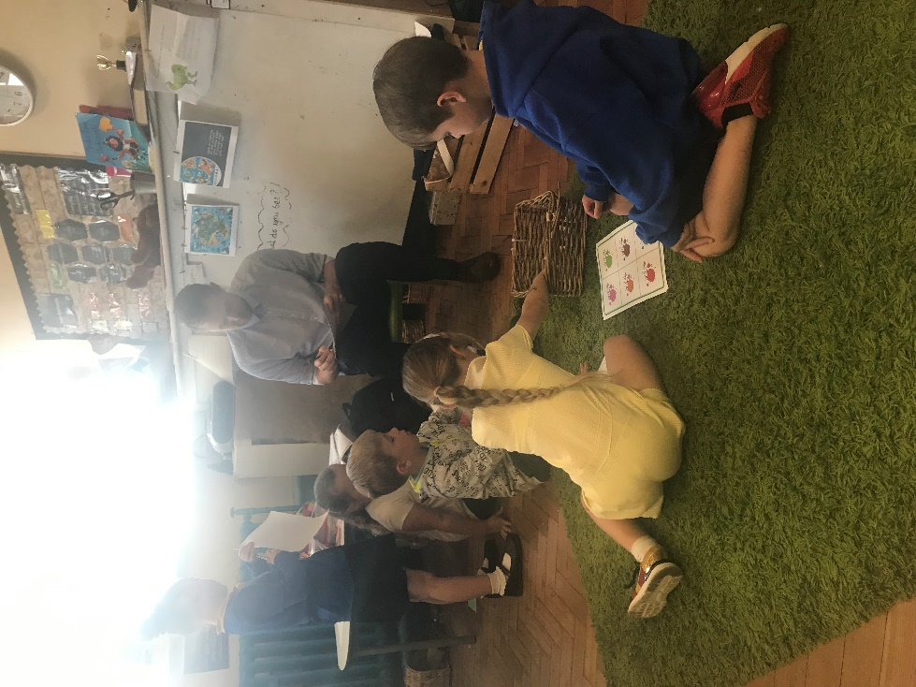

Appendix 8: Task 2
https://youtu.be/CXwhwlRySAU

Appendix 9:
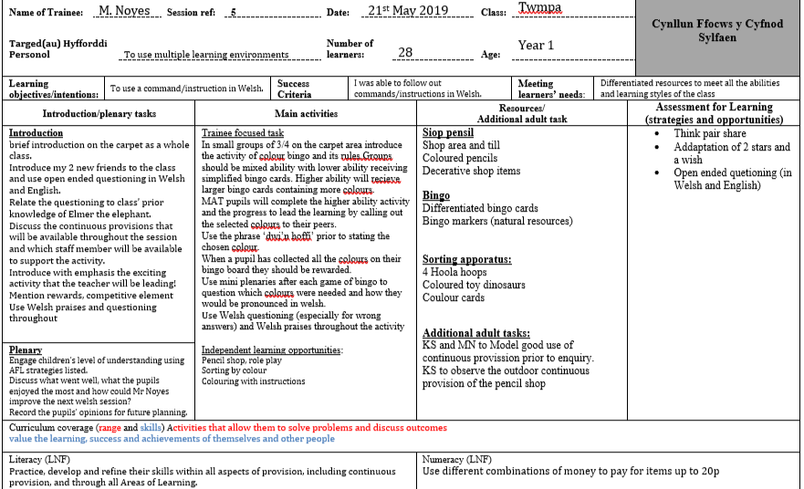
Appendix 10


