Big ol title page here

Computer Systems Practical and Computer Networking Principles Report
Rose Plumley
2218443
Introduction to Computer Systems
ACCA4021
Dr Redhwan Al-amri

Table of contents page
1. Introduction
2. Virtual Machine Practical
3. Computer Networking Principles
3.1. Network Architecture
3.2. Network Topologies
3.3. Network Communication Standards and Protocols
Architecture, Comm Standards and Protocols are required. Don’t forget a bunch of references for everything following section 3.
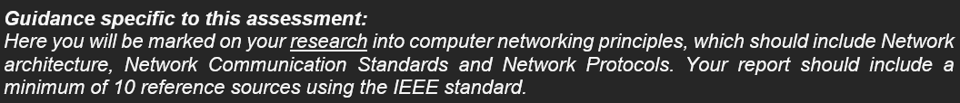

- Introduction
This report aims to cover a practical assignment, entailing the installation of a virtual machine running Windows 10, as well as a brief description and explanation of computer networking principles, understanding how this interacts and functions in tandem with computer hardware and operating systems.
- Virtual Machine Practical
A virtual machine is defined as a computational resource that runs on software, as opposed to hardware, sharing resources of a “host” computer as a “guest” [1]. Using the Oracle VM VirtualBox software, a Windows 10 ISO (an “optical disc image”) is installed and run.
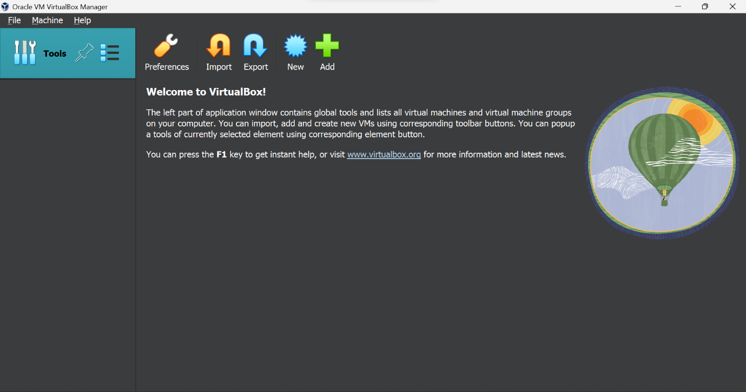
Screenshot 1 – The Oracle VM VirtualBox software, on first opening
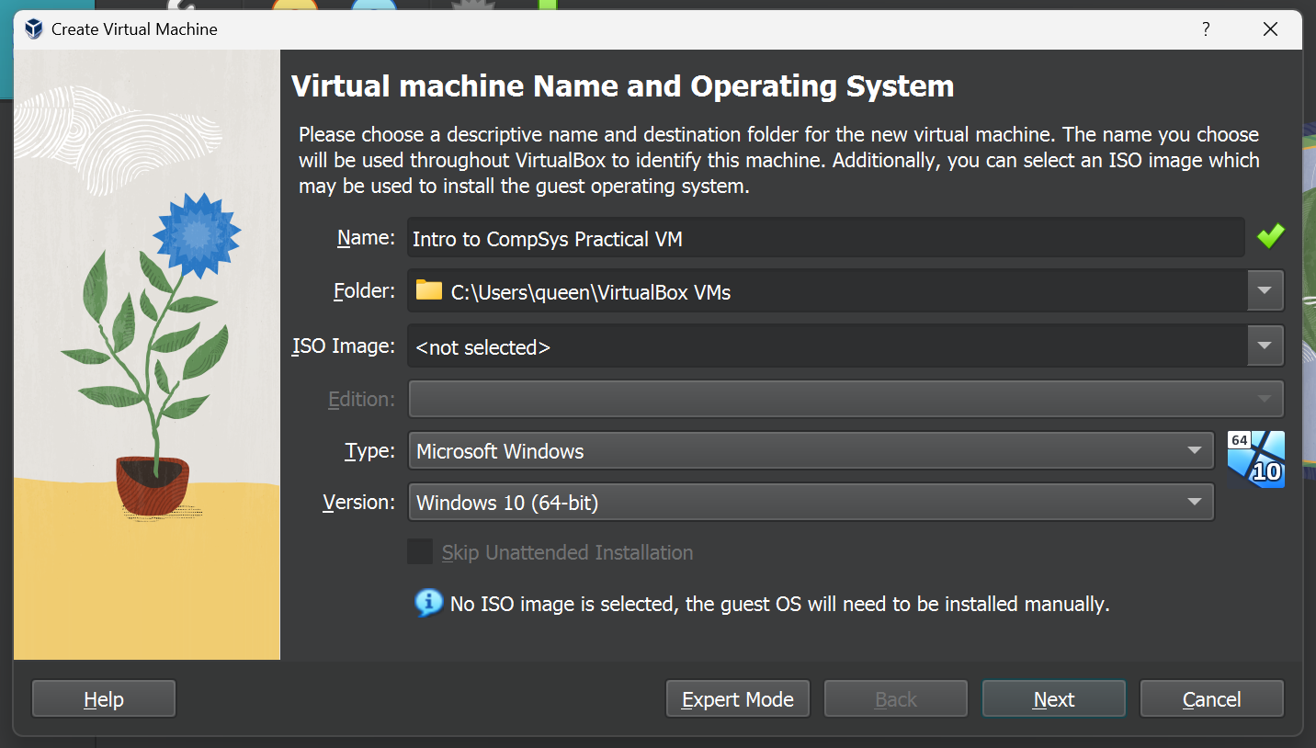
Screenshot 2 – Upon clicking the “new” button, a virtual machine (hereafter referred to as VM) is created. Here, a name can be given to the VM, it’s storage location can be selected, the ISO image can be loaded, and the type and version can be selected. Other options for type included Mac OS X, Linux, IBM OS/2, and more.
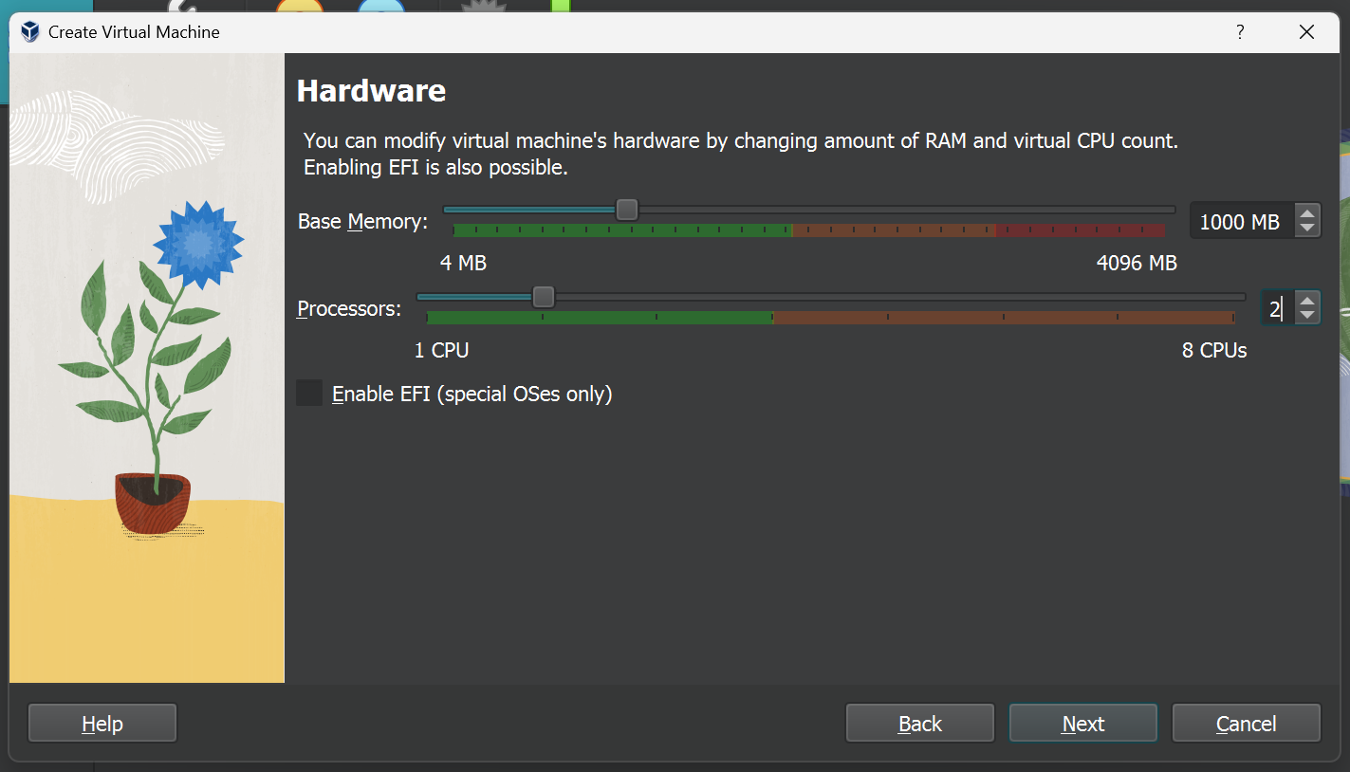
Screenshot 3 – In this screen, host system resources can be allocated to the VM. Above is the default.
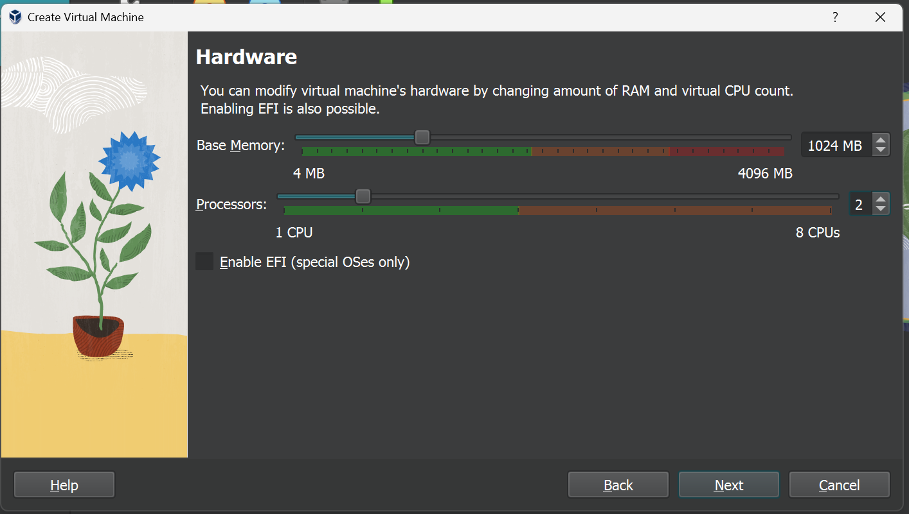
Screenshot 4 – 24MB added onto VM base memory.
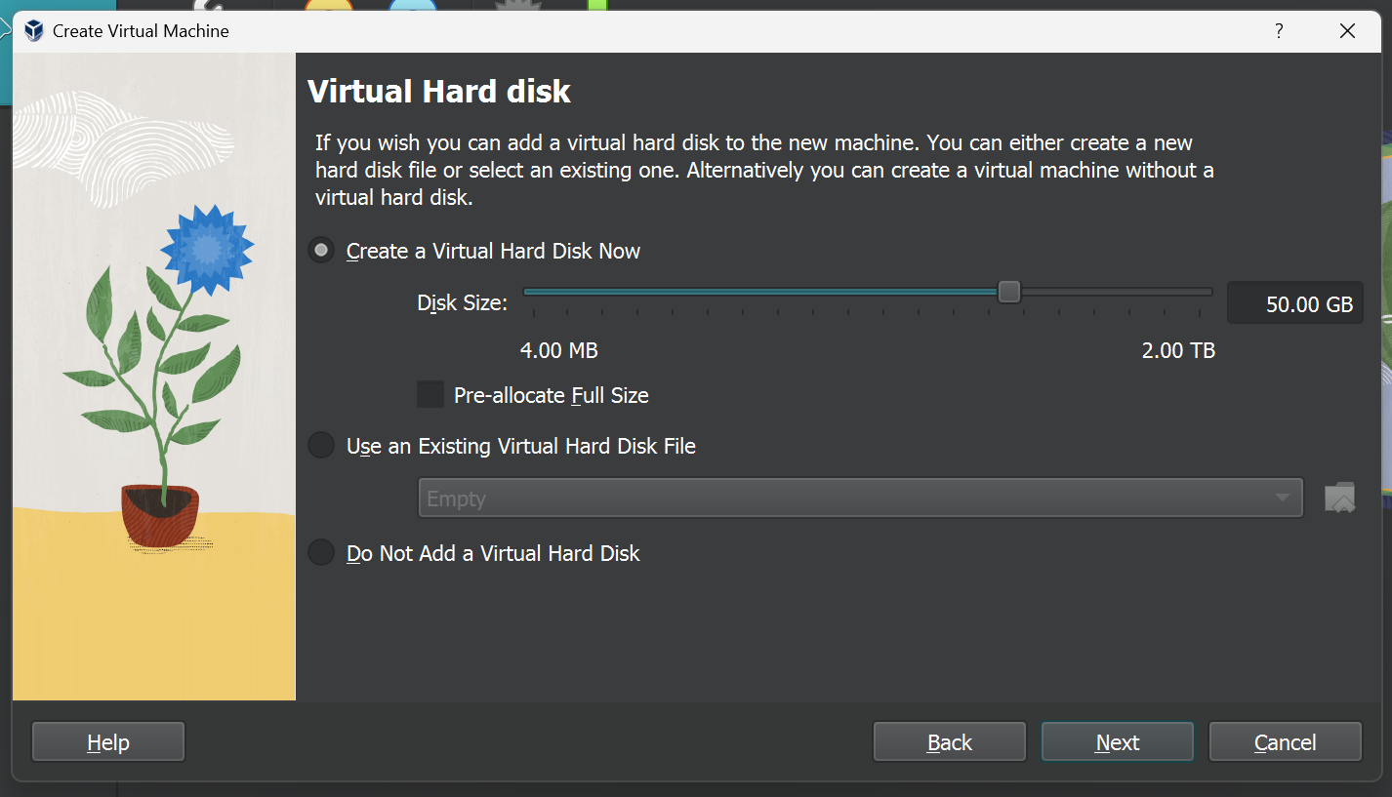
Screenshot 5 – Creation of VM hard disk drive allocates host system storage to reserve storage memory for guest system.
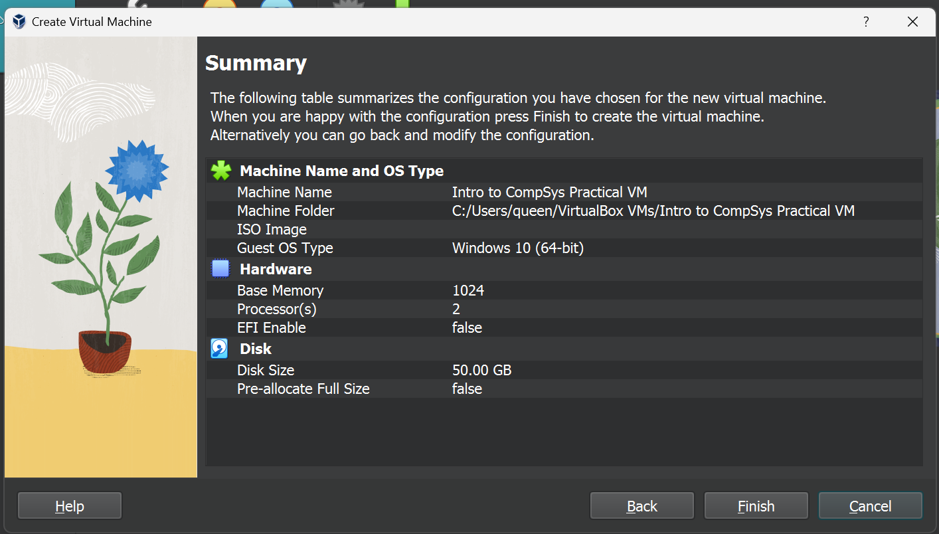
Screenshot 6 – Summary of above decisions.
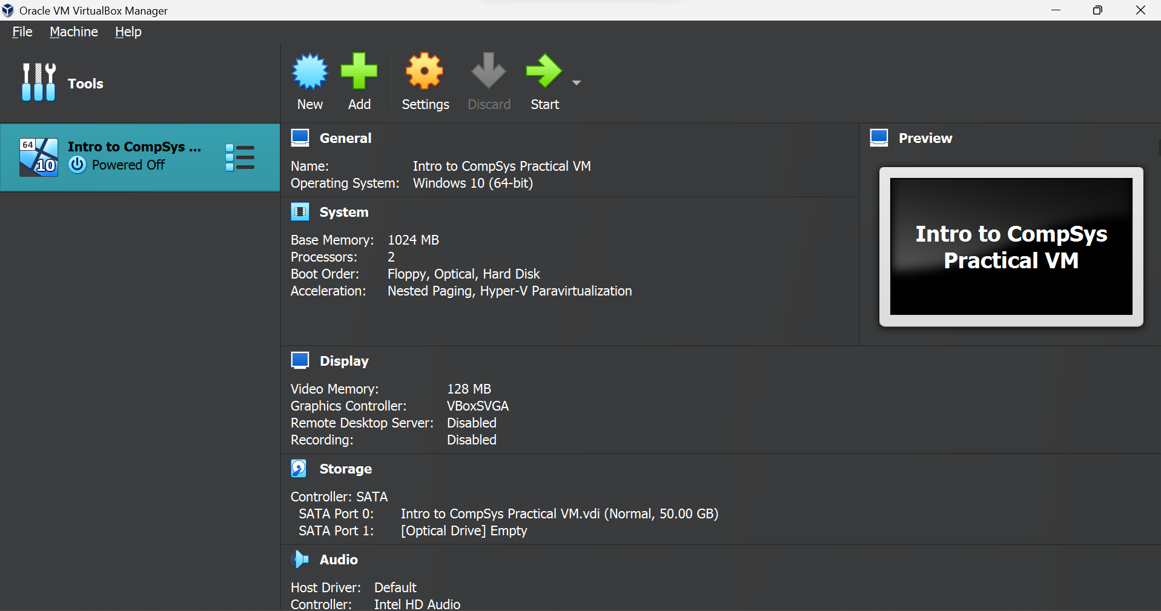
Screenshot 7 – Created VM. The screen above shows information about the VM.
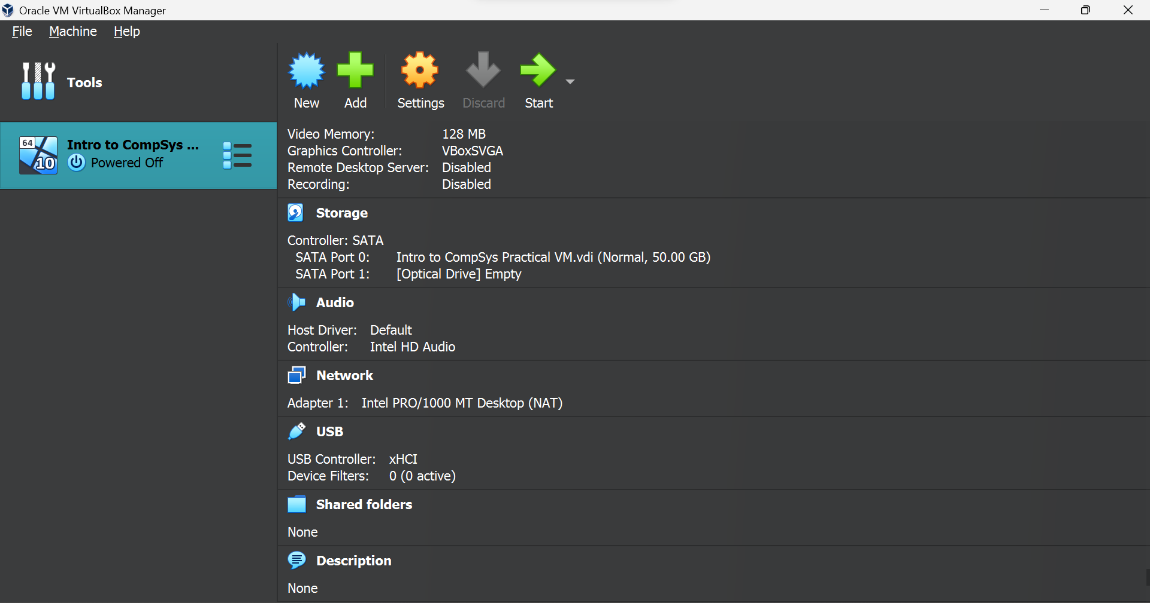
Screenshot 8 – More VM system information.
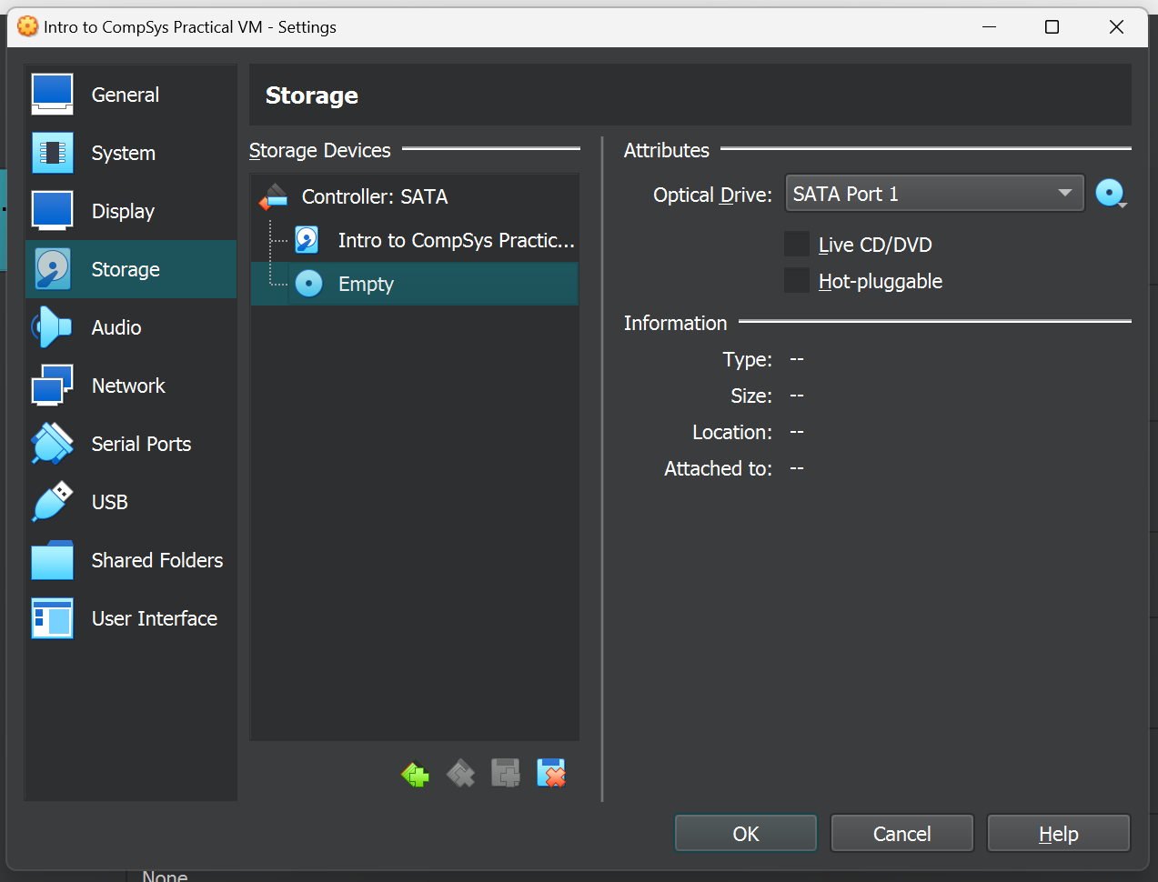
Screenshot 9 – VM settings screen. Another storage device is created to host the Windows 10 ISO.
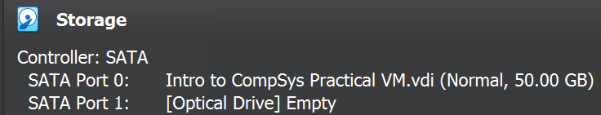
Screenshot 10 – The home VM information screen reflects this.
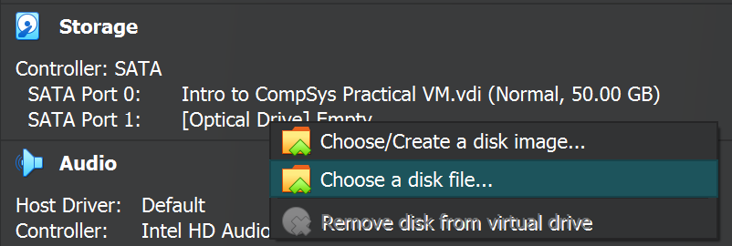
Screenshot 11 – Clicking the empty optical drive slot, the option to choose a disk file is selected.
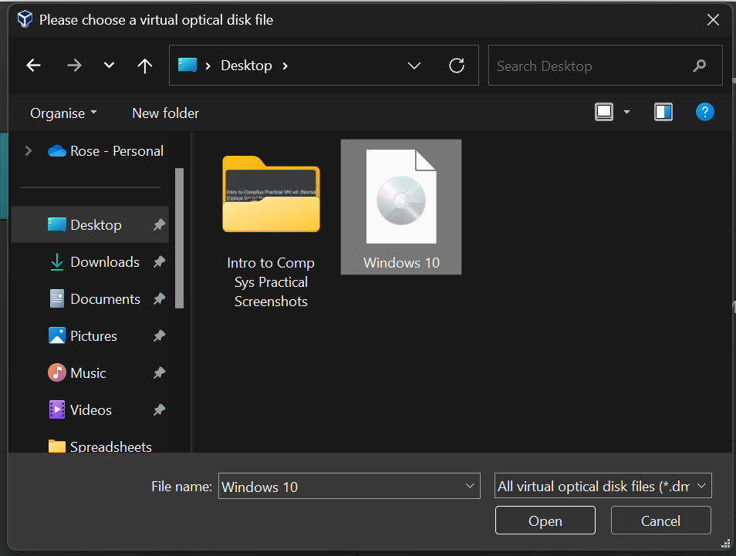
Screenshot 12 – The Windows 10 ISO is selected.
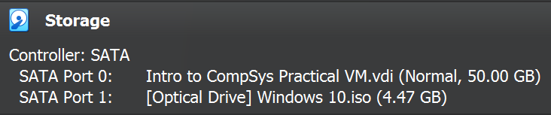
Screenshot 13 – The ISO is placed in the storage port.
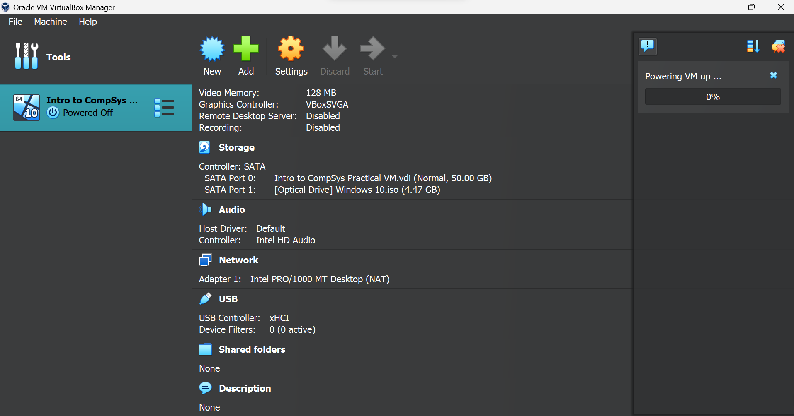
Screenshot 14 – The Start button is pressed. The right side of the screen shows progress towards initialising the VM.
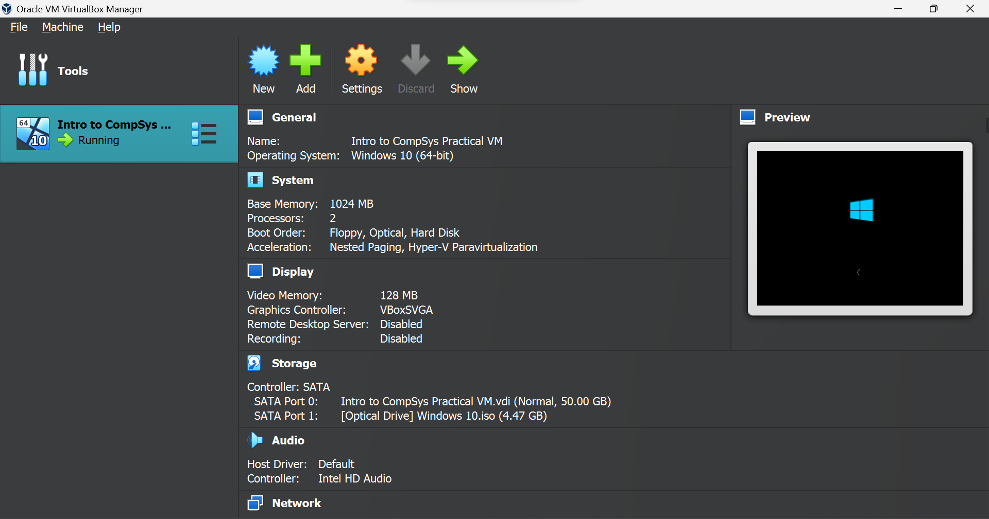
Screenshot 15 – The home VM information screen displays a preview of the VM. Another window is opened which displays the VM as it runs.
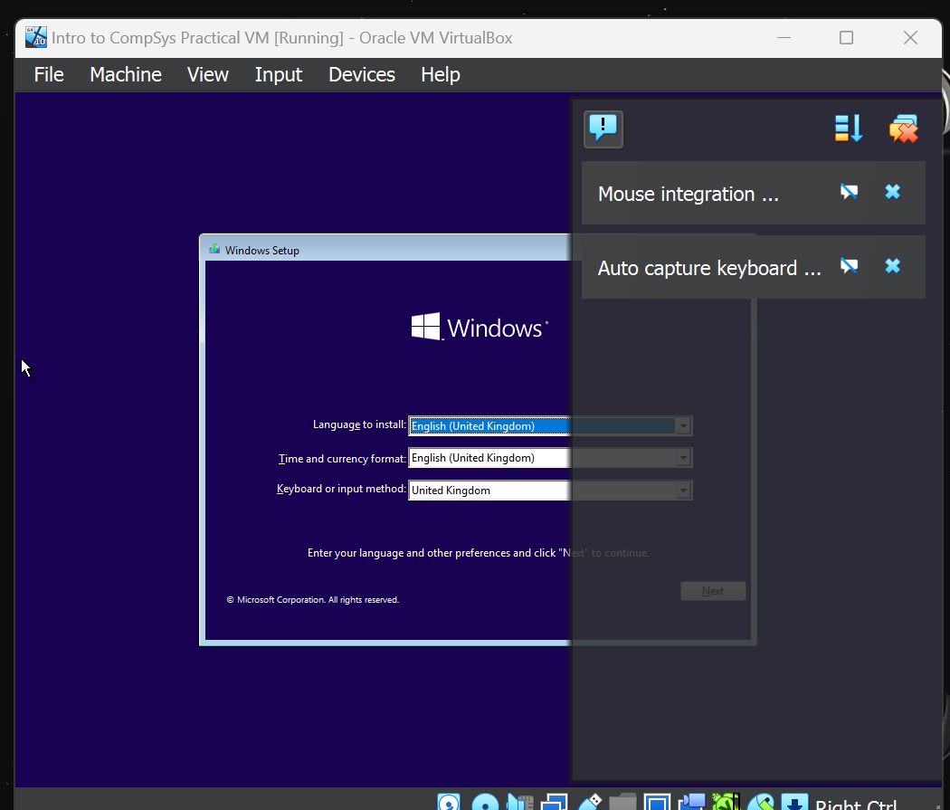
Screenshot 16 – The open VM window. After a short loading process, the following screen appears where language, time, currency, and input method can be selected.
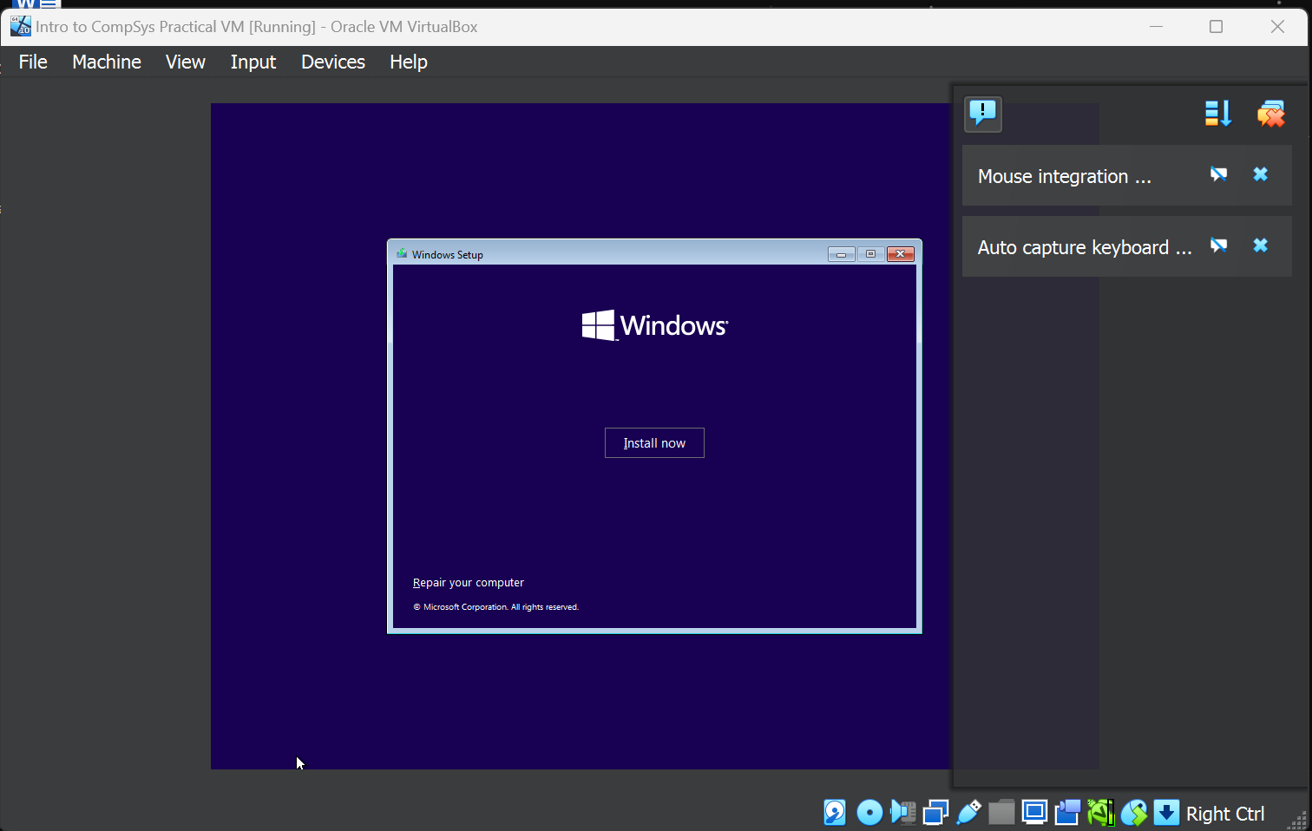
Screenshot 17 – The proceeding window.
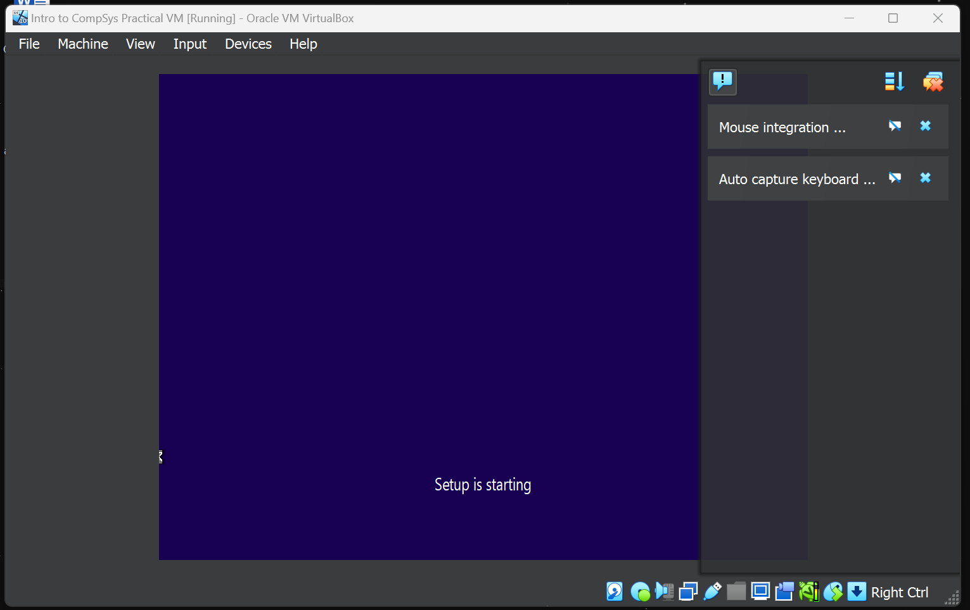
Screenshot 18 – After clicking “Install now”, setup of the operating system begins.
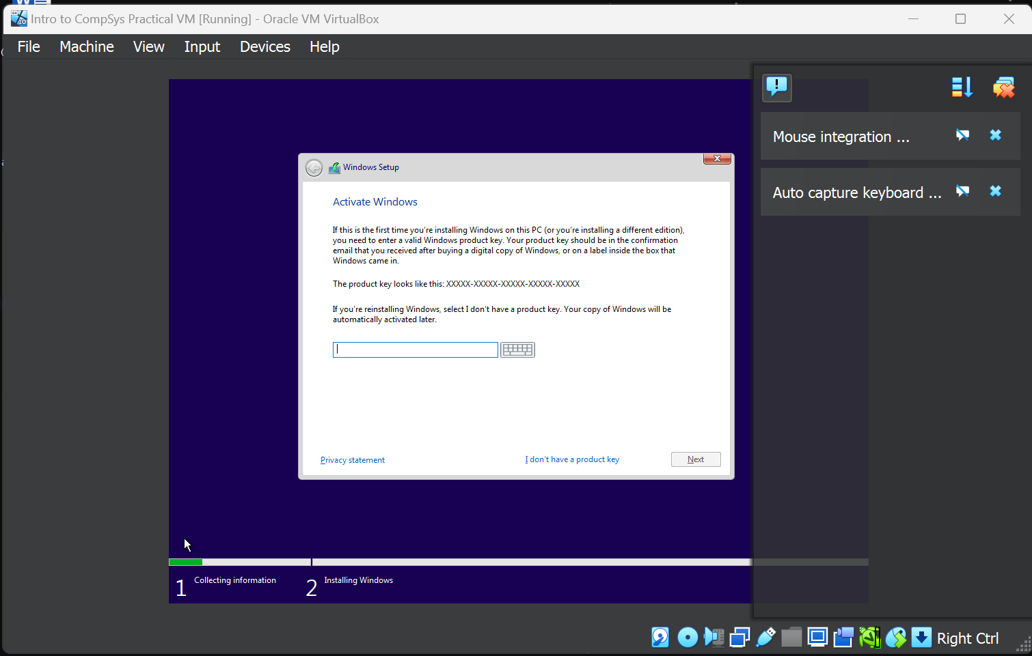
Screenshot 19 – A windows product key is requested. The “I don’t have a product key” button is clicked.
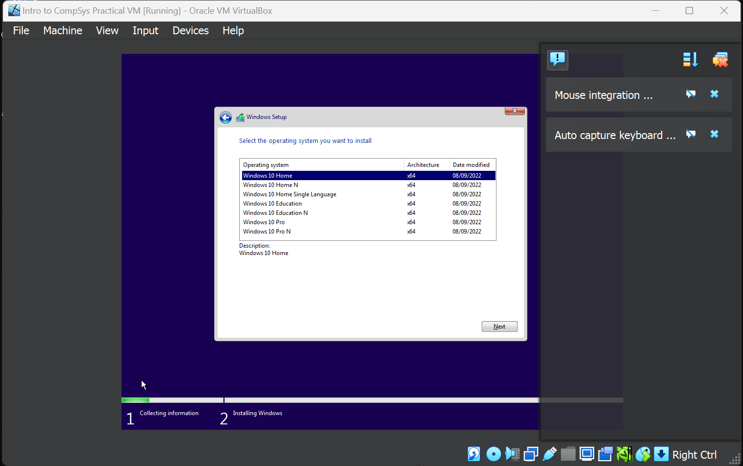
Screenshot 20 – The Windows 10 Home version of the OS is selected.
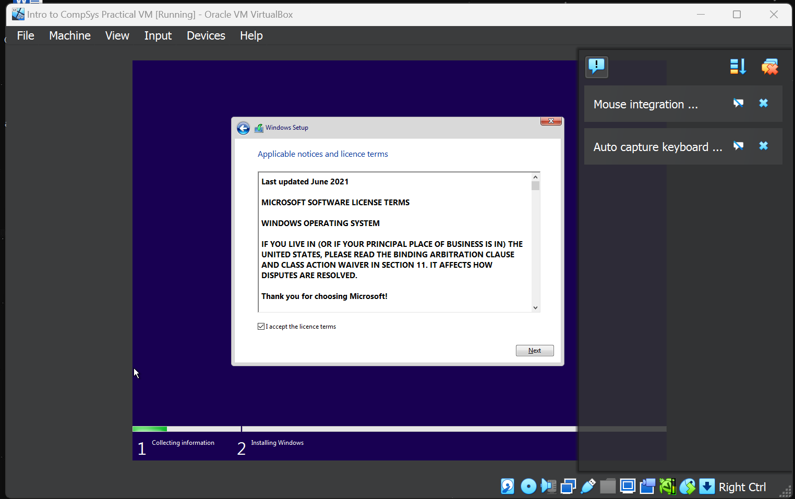
Screenshot 21 – A license terms and conditions screen is displayed. Next is clicked.
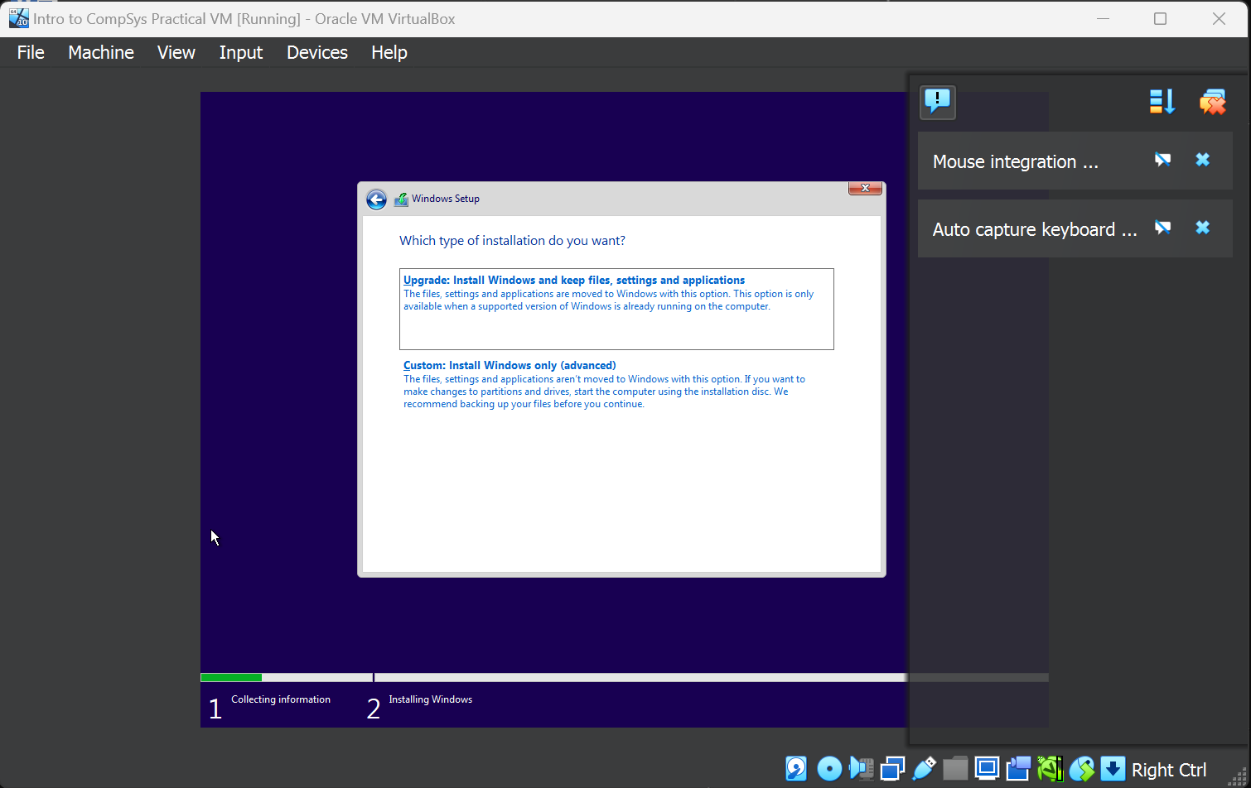
Screenshot 22 – A prompt for installation type is requested. The “Custom” button is clicked.
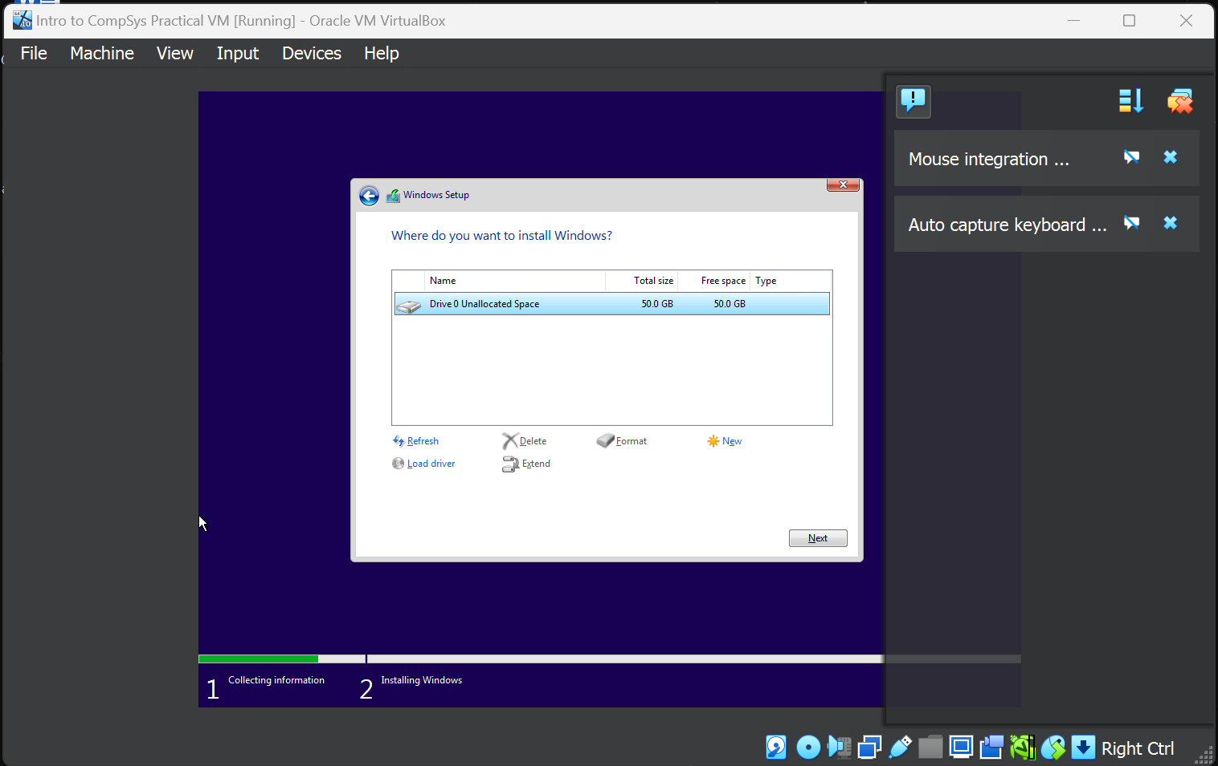
Screenshot 23 – The original storage space is selected for installation of the OS.
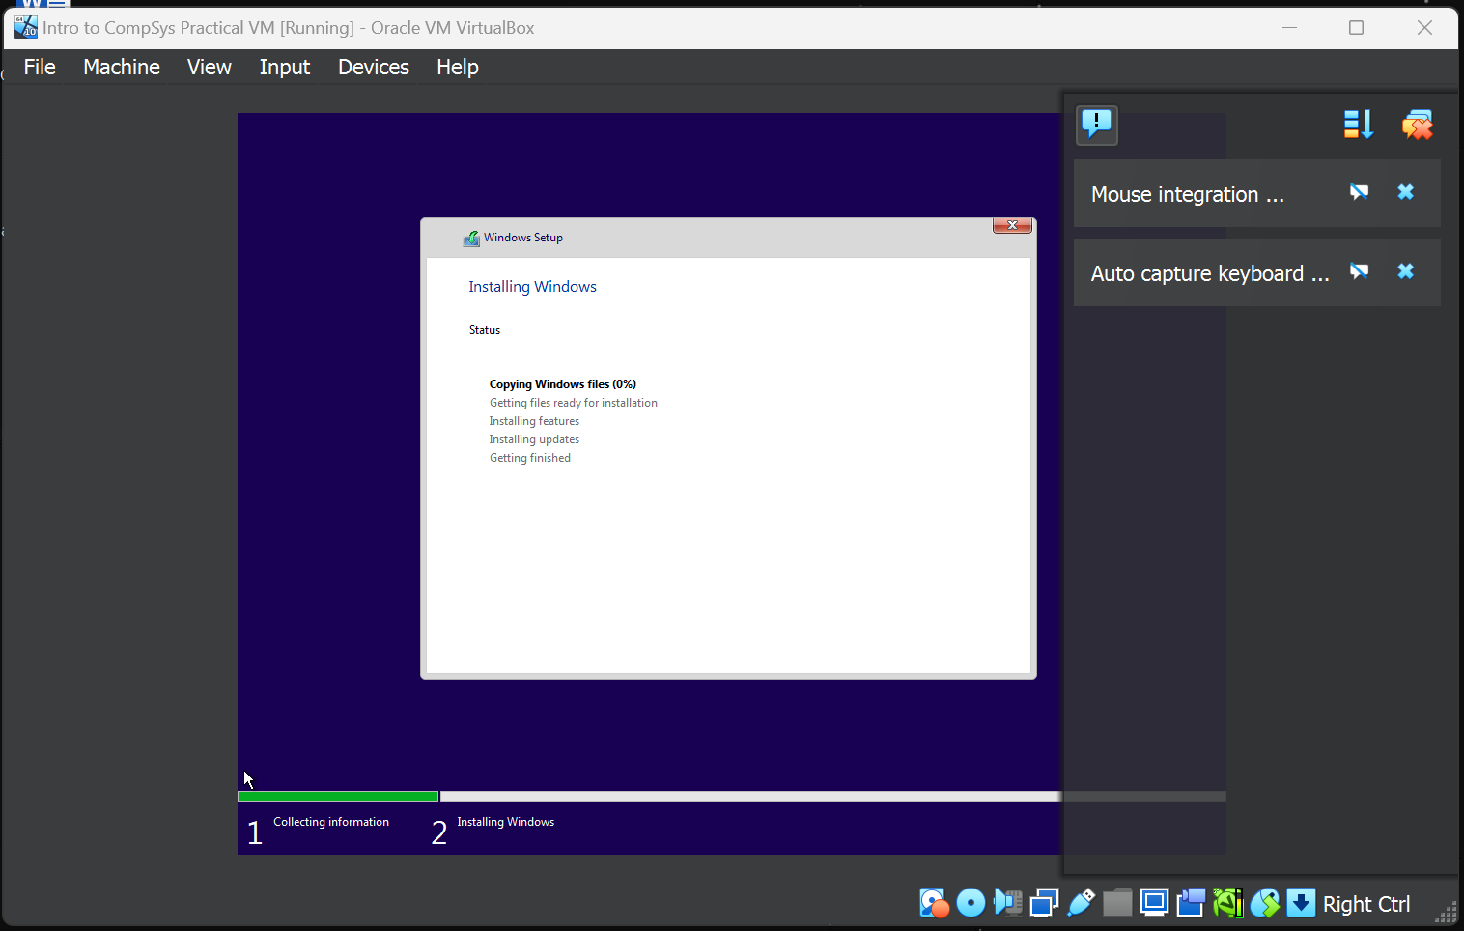
Screenshot 24 – The OS installation begins.
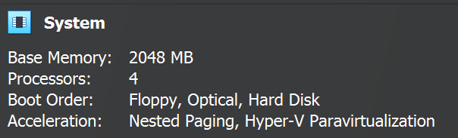
Screenshot 25 – After almost an hour of installation, it is halted en lieu of adding double the base memory and proessors.
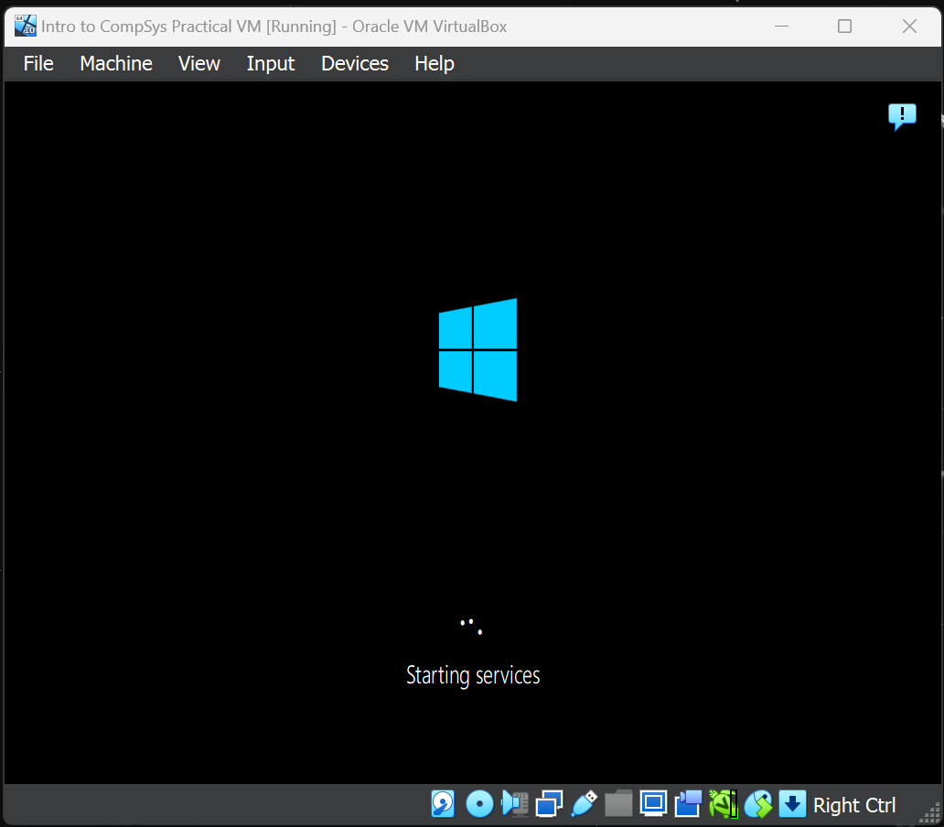
Screenshot 26 – Installation finishes, and further loading is commenced.
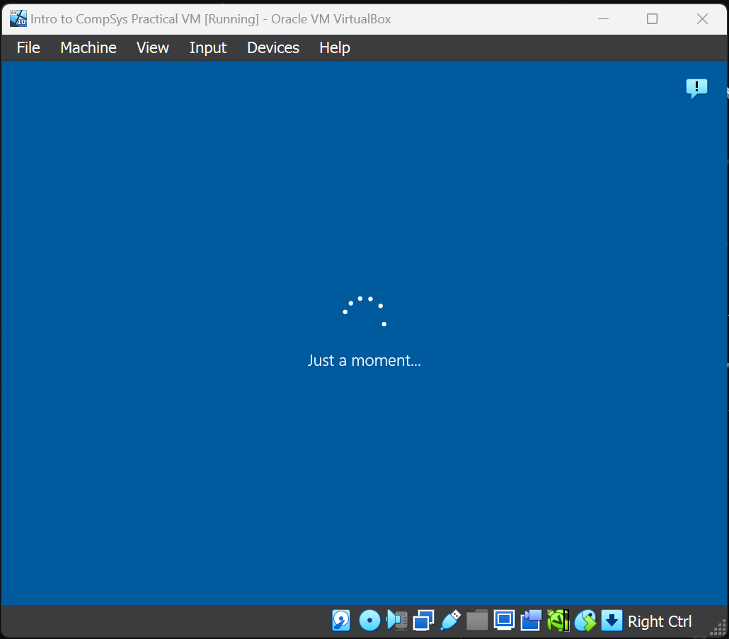
Screenshot 27 – Further loading.
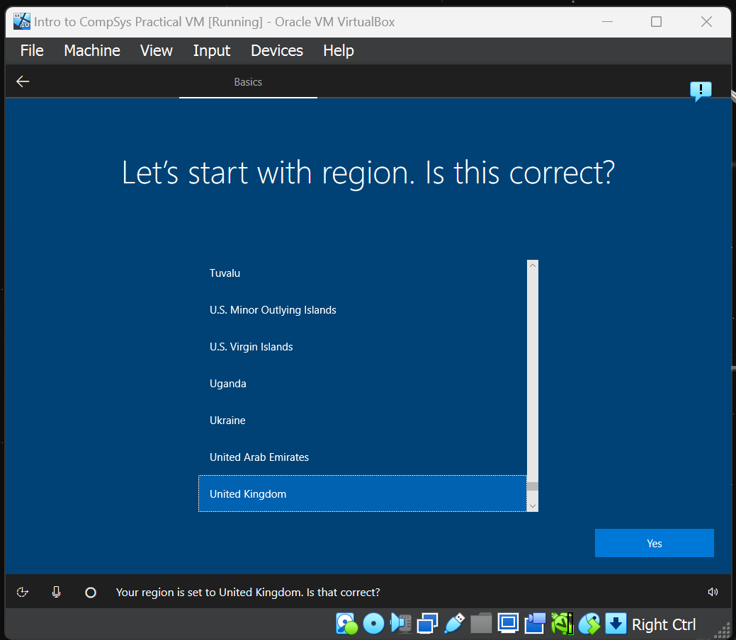
Screenshot 28 – Region is prompted. United Kingdom is selected.
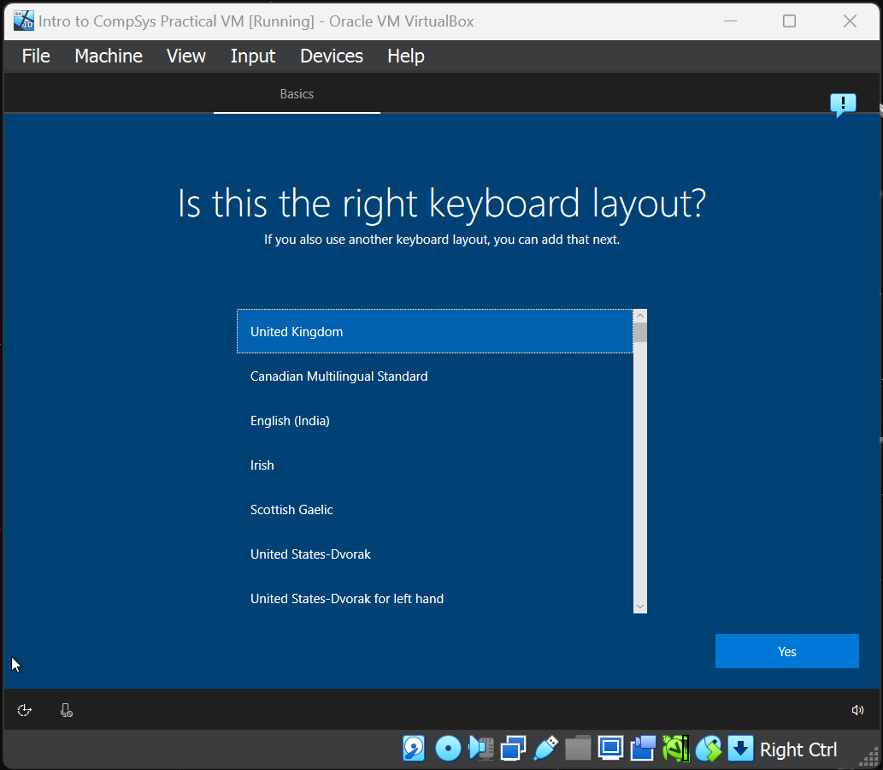
Screenshot 29 – Keyboard layout is prompted. United Kingdom selected again.
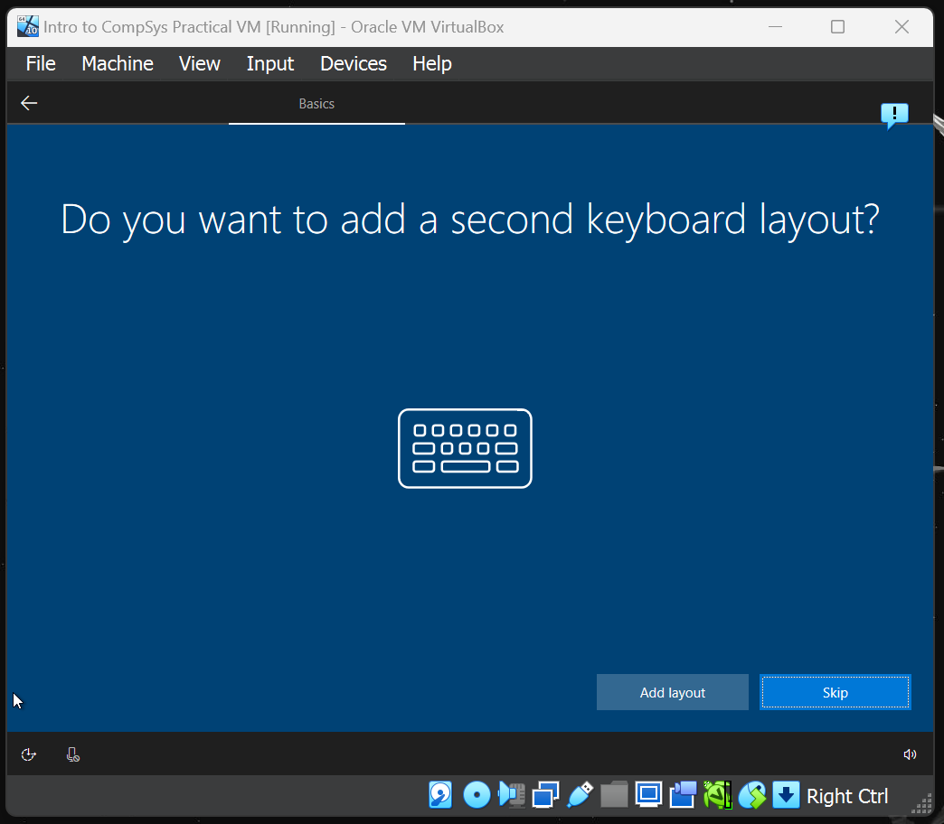
Screenshot 30 – User is prompted for a second keyboard layout, if desired. This is skipped.
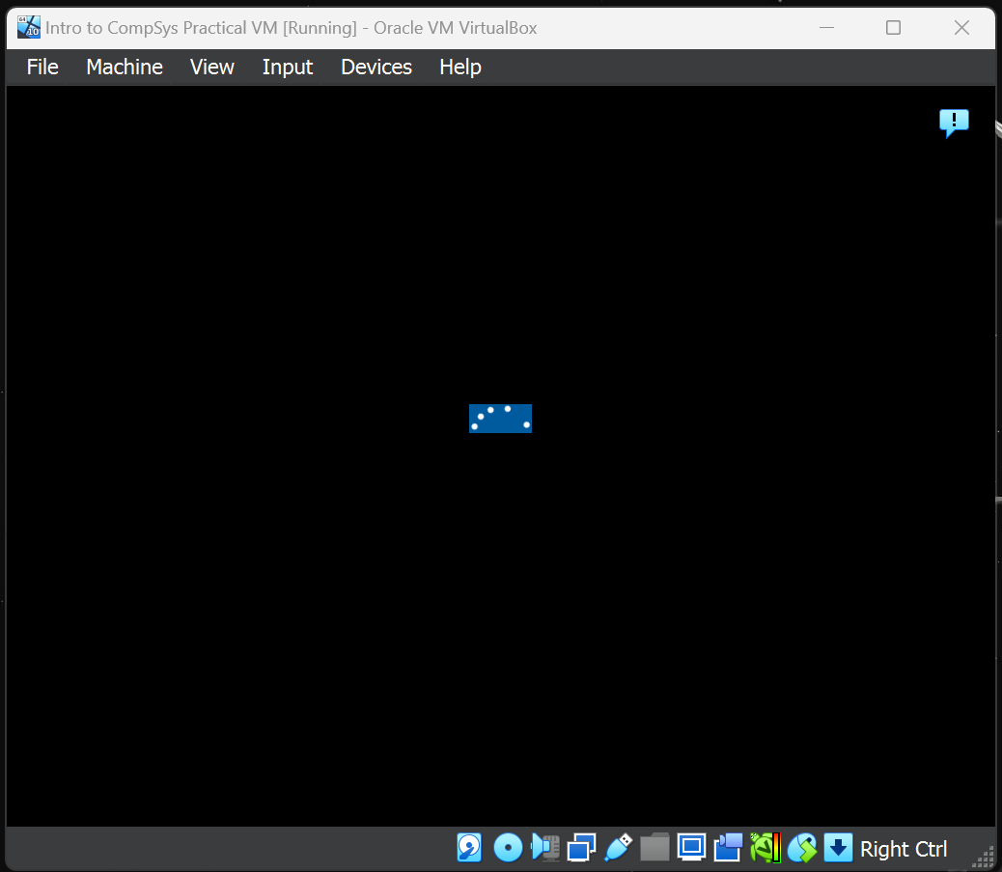
Screenshot 31 – Further loading.
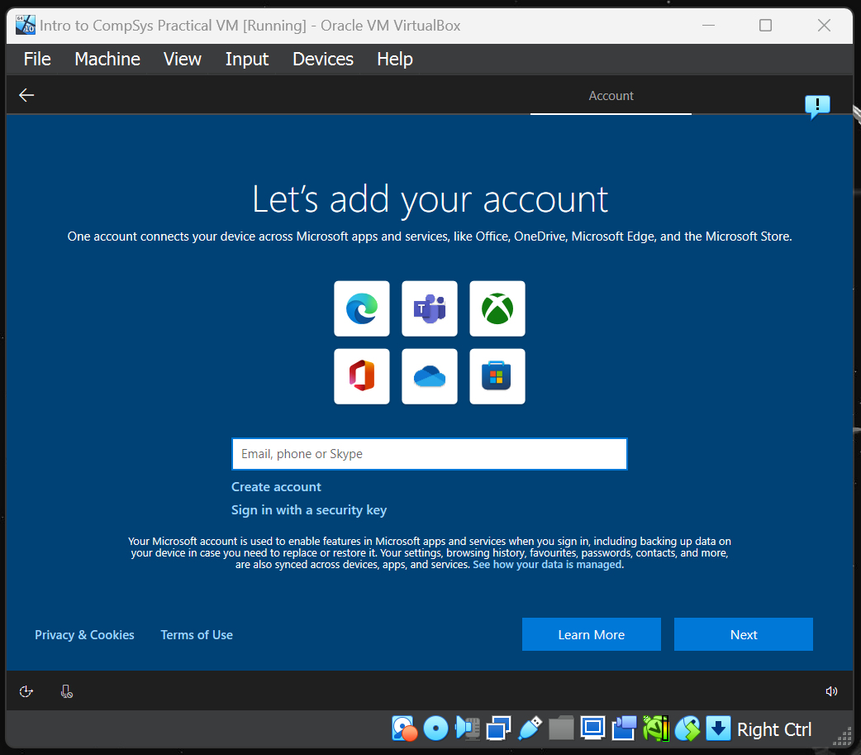
Screenshot 32 – A Microsoft account is requested.

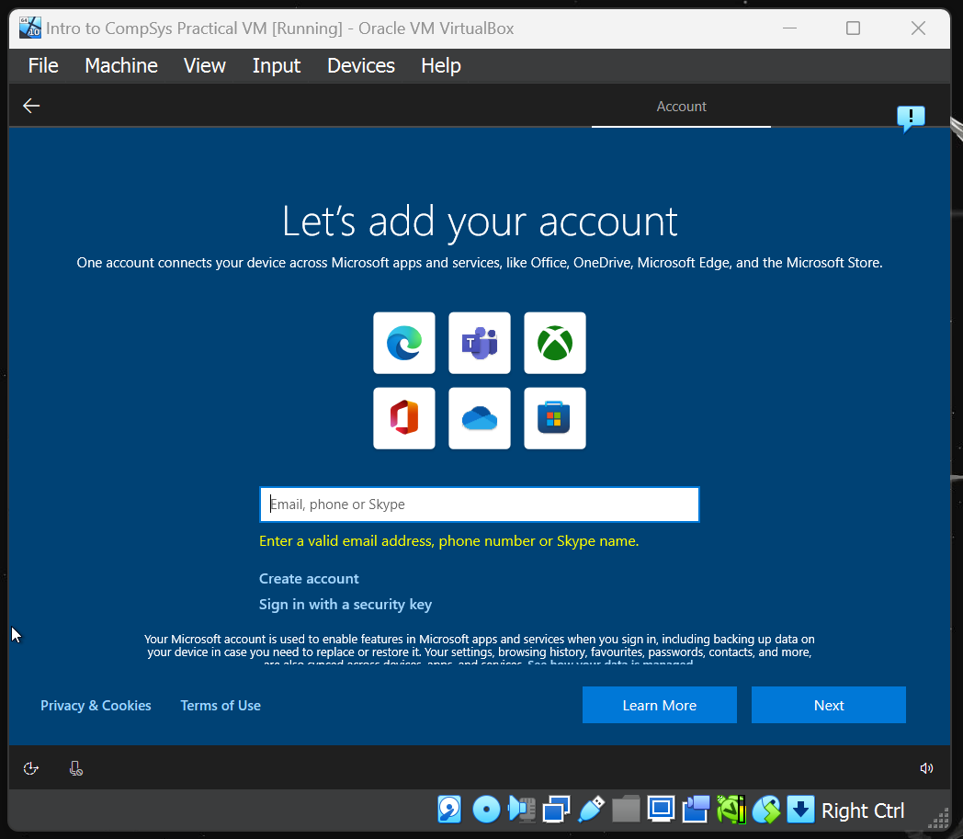
Screenshot 33 – Unfortunately, an email address, phone number or Skype name is required. A fake email (1234@gmail.com) is input.
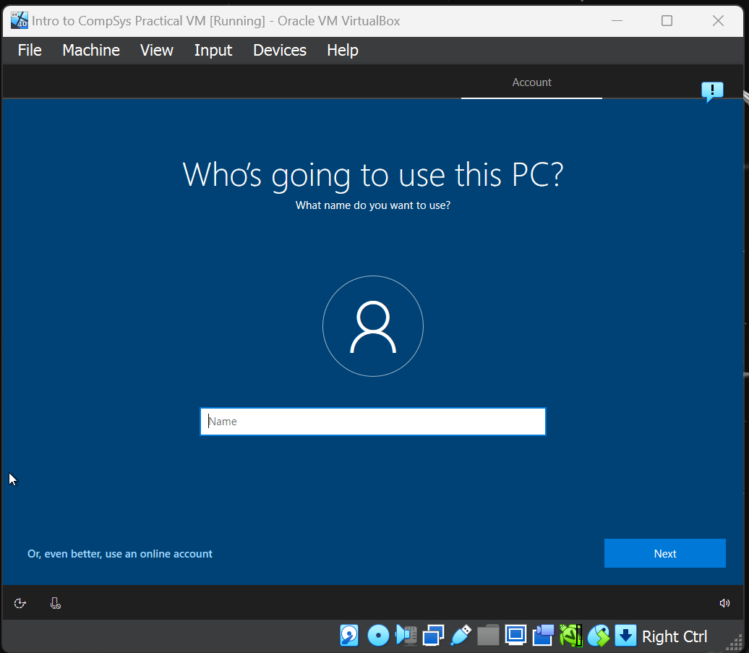
Screenshot 34 – A PC username is requested and input.
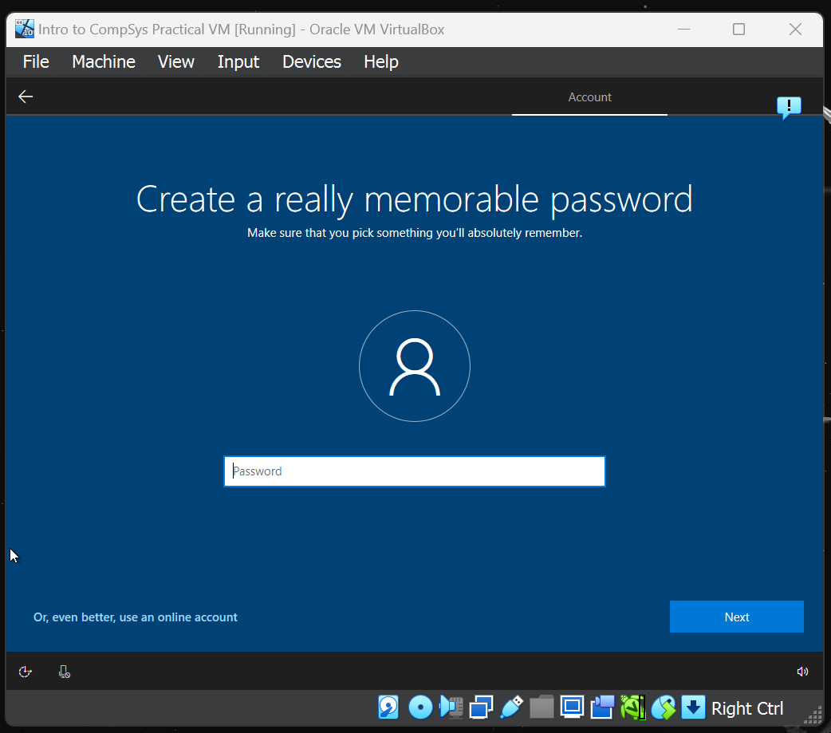
Screenshot 35 – A password is then requested. Upon inputting, the installation restarted the process from screenshot 27 onwards. This means that a full installation was not completed, however, if the process continued, presumably the VM would display a desktop, which would function like any other Windows 10 home desktop.
- Computer Networking Principles
Below is a brief introduction to computer networking principles, including coverage on network architecture, topologies, communication standards, and protocols.
3.1 Network Architecture

When discussing architecture, there are two main classifications to consider – Client/Server, and Peer-to-Peer. In the former, one or more servers act as and are referred to as hosts, and other computers, known as clients, request resources from these servers. Typically, these kinds of networks are used when a “dedicated server” is needed. These dedicated servers are used for specific tasks, enabling the performance of multiple operations over different servers. Examples of these include email servers, print servers, internet servers, and database servers.

The latter architecture, Peer-to-Peer, describes a small network of interconnected computers, typically connecting fewer than 10 individual systems. Each computer is called a “peer” and has equal responsibilities. They also have the capabilities to share data and hardware between each other. To this end, being relatively simple and inexpensive, a peer-to-peer network is ideal for home users and small businesses. Notably, peer-to-peer can also function over the internet, where users can access each other’s hard disks and exchange files directly over the internet. Because of this, this architecture subcategory is also known as a “file sharing network” – an example of which could be Bit Torrent, which through a client, allows a user to download and distribute files over the internet.

3.2 Network Topologies

Regardless of architecture, a network usually follows a typical layout. These usually follow three types – Star, Bus, and Ring topologies. The foremost option, star topology, connects all computers and devices on the network (nodes) to a central device, either a hub or a switch, forming a star around it. Usually, a hub is used to connect a network of personal computers together. A switch, on the other hand, can allow connections to multiple devices, manage ports, and manage Virtual Local Area Network (VLAN) security settings. Star topologies are ideal for their ease of node addition or removal, and should one node fail, the others can still operate normally. However, should the hub/switch fail, the network fails.

Next, a bus topology consists of a single central cable which connects the nodes together. In this way, the “bus” refers to the physical central cable, which connects and transmits data, instructions, and information in both directions. So, when a sending device transmits data along the bus, a receiving address is included to ensure the data is received by the proper devices. Bus topologies are often easy to install, and any nodes can be attached or detached without disrupting the rest on the network. Additionally, much like star topologies, should a node fail, it will not disrupt the other devices. However, the network is also dependent on the central backbone cable – should this fail, the other nodes will be unable to transmit or receive data.

Lastly, ring topologies describe a network connected by a cable which forms a closed loop, with every node arranged along the ring. Any data which is transmitted will travel between each node in one direction, until it reaches its intended destination. However, because each node is connected in a ring, if one device fails, the entire network fails, unlike the other two topologies.

3.3 Network Communication Standards and Protocols

Network communication standards define the guidelines that specify the ways a computer can access various mediums, insofar as to which they are attached, the types, and the speed of the medium, as developed and defined by the American National Standards Institute (ANSI) and the Institute of Electrical and Electronics Engineers (IEEE).

However, in referral to networking, this is often defined as a protocol, which outlines the characteristics of how two network devices communicate. To this end, a protocol may define data format, coding schemes, error handling, sequencing techniques, and so on. For example, Transmission Control Protocol/Internet Protocol (TCP/IP) is a network standard that defines how messages are routed from one end of a network to another, as well as ensuring data arrives correctly. It describes rules for dividing messages into smaller packets (a technique known as packet switching), of which each contains a receiving address, sequencing pattern, and regulating flow, allowing for data packets to be sent along the best route. Of note, all hosts on the internet follow these rules.

Of note, a receiving address is often a device’s unique Internet Protocol (IP) address, which is often temporarily assigned to it once it connects to a network by the Direct Host Configuration Protocol (DHCP) server. When a device connects to a network, it requests an IP address to the DHCP server, while also sending its MAC address (a device’s physical address, written in hexadecimal, usually a unique 6-byte address theoretically unique to the device’s network card). The DHCP server then allocates the device an IP address, making a note of this combined with the MAC address. After a pre-determined period, this pairing is wiped, and the device will need a new address. An IP address, specifically IPv4, is usually a 4-byte address, which appears as a dotted decimal number, like “192.168.1.1”. Each dot separates a byte.

Another communication standard could be ethernet, which specifies how devices connect to the internet. This standard specifies no central computer or network nodes should control when data can be transmitted. For example, when a node is connected to a network, it attempts to transmit data when it determines a network can receive communication. However, if two computers on an ethernet network attempt to send data at the same time, a collision will occur. This is most often seen on a bus topology’s backbone cable, where if multiple messages are sent along the same channel simultaneously, data collision can occur, and the message(s) become corrupted.

Alternatively, there is the token ring protocol, which specifies that nodes on a network share or pass a signal called a token (a series of bits which function like a ticket) in a pre-set order. When a computer or device on the network has a token, it can transmit data over the network. In this way, only a node that holds a token can send data, and tokens are released when receipt of the data is confirmed. Also of note, only one token may exist on a network at a time.

References
[1] “What is a virtual machine?,” VMware, 04-Aug-2022. [Online]. Available: https://www.vmware.com/topics/glossary/content/virtual-machine.html. [Accessed: 28-Apr-2023].
[2]

