Coexistent Perspectives ADAA7000 Owen Rees p148411

The role of the artist in the context of Space & Place
How does the art practice of JR explore and redefine space, in relation to Lefebvre’s spatial theories?

Abstract
This essay explores how the work of French artist JR engages with and challenges the spatial theories of Henri Lefebvre. It examines how JR, through collaborative projects with marginalized communities, creates a "third space" where participants become both subject and creator. By pasting large-scale photographic portraits in public spaces, JR disrupts the conceived and perceived notions of those spaces, subverting the intended use and power dynamics of urban environments. This empowers local voices and experiences, rewriting the narratives associated with those places.
The essay further discusses how JR's work, such as the "Portrait of a Generation" project, records and reimagines the rhythms and histories of a place, weaving new narratives into the collective memory. Even as his art erodes over time, the lingering social impact transforms the lived experience of those spaces. The role of the artist is positioned as a "professional see-er," one who can challenge preconceptions and foster empathy through the collaborative and site-specific nature of JR's practice.
In conclusion, the essay demonstrates how JR's art practice exemplifies the potential for contemporary art to redefine and reclaim spaces, giving voice to marginalized communities and creating global dialogues around social issues. The analysis of JR's work through the lens of Lefebvre's spatial theories provides insights into the transformative power of art in the public realm.

The role of the contemporary artist has and continues to be varied: for example, it allows the viewer to see and experience the world from a new and diverse point of view, it reflects on daily life and experience which stimulates thought and creates new ideas, challenges the normal and creates change, carries a message, and addresses current issues, intervening in everyday life. In terms of concepts of space and place, architects, geographers, sociologists, anthropologists, and philosophers have all been concerned with issues of conceptualising space and place, questioning power and social relationships, exploring cultural meaning and memory, and tackling problems of inclusion and exclusion.
The aim of this essay is to explore the relationship of the work of JR in the context of Lefebvre’s spatial triad. The essay has been organised in the following way; firstly, it will outline key aspects of Lefebvre’s spatial theories. It then explores how JR developed his practice as an artist. It will then discuss how he collaborates within a community, through his long running Portrait of a Generation project, redefining space as seen through the lens of Lefebvre. The next key area that will be considered is how JR transports one space to another place in the movement of his art across the Paris suburbs where his art would not normally be experienced and open to a wider audience. It is hoped that this exploration will show the ways in which the theories of space and place can be utilised in the practice of contemporary art and create change.
A physical space is defined by certain elements that people have given values to (Buchanan, 2018b). For example, a city is defined by criteria such as its size, location, population, infrastructure, and industry, but also by the subjective experiences perceived by the individuals within the city. These perceptions are shaped by the position of the individual within that society. Lefebvre’s Spatial Triad discusses three areas of space: the perceived, the conceived and the lived space (Lefebvre, 1991). These spaces overlap each other.
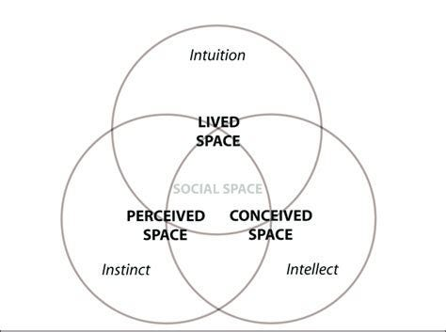
Figure 1 Lefebvre's Spacial Triad (Li, 2023)
Perceived space is our sensory experience of space. Conceived space is a mental or imagined representation of existing or planned spaces. Lived space includes how we experience life within a space through our actions, emotions, and influenced by past experiences.
JR is a contemporary French photographer, graffiti artist and fine artist. He uses public spaces and places as his canvas, creating large scale works. His art explores social issues and themes of place, identity and community (GALLERIACONTINUA, 2024). JR uses the physical landscape of city streets, buildings, vehicles, floors to arrange his art on in doing so JR repurposes architecture and the infrastructure of a place. Having found a camera in a Paris train station JR moved from graffiti to realising the power of photography. He printed black and white A4 copies of photographs he had taken of his friends and other graffiti artists, and pasted them around Paris, creating “Sidewalk Galleries” where he frames the images with bright coloured spray paint (Thompson and Remnant, 2015). This creates momentum in his craft. He began to travel, repeating the same process around the world. This could be seen as JRs first redefining of a place by the placement of his art. No longer is a blank wall just a wall, it becomes a gallery. The way an image is perceived is affected by the decisions about how and where it is positioned and displayed (Eckhard, 2015). This changes the experience of the space for the people who move through it, and with reference to Lefebvre’s spatial triad, the perceived, conceived and lived space are affected by this.
Graffiti artists move through cities and wider spaces leaving their marks on the urban landscape. It could be said that they are nomads because they move through the landscape freely. The spatial theories of Deleuze and Guattari build on those of Lefebvre (Buchanan and Lambert, 2005). According to Deleuze and Guattari (1987), nomads do not adhere to local rules and regulations. Graffiti artists deterritorialize a space by their actions and the marks that they leave. The graffiti artist leaves the striated space of the laws and restrictions of society and enters a smooth space of freedom and realisation, where that they can do what they want within that space. JR, being a graffiti artist, explored Paris as a youth. It gave him the idea of the city as an urban canvas for his artistic process (Thompson and Remnant, 2015). This experience has unrestricted him in his site-specific conceptions for his work and allowed him to challenge what defines an appropriate site for creating or displaying art in this way JR works outside the confines of a gallery space.
In his artwork JR explores and incorporates elements of ethnography to create large scale photographic works. Ethnography is a form of anthropological research involving directly observing and participating in the lives of a chosen group, typically from different ethnic backgrounds (Buchanan, 2018a). JR does this by placing himself in the community, having dialogues with the often-marginalised members of that community and recording this encounter (Eckhard, 2015). JR invites local individuals to collaborate and participate in the creative process. This creates a third space where all involved become subject and creator, giving voice to these people and the platform to express themselves. According to Grosz (cited in Green, 2001), the third hand occurs during artistic collaboration which helps the participants to step away from individual intention and to find a common theme. JR softens the boundaries between art and ethnography as he explores and experiences the social and historical fabric of the communities as he develops his collaborative praxis, creating a collaborative conceived space as with Lefebvre’s spatial triad. Here the practice of collaboration is an important part of JR’s method of working along with empowering communities through dialogue.
By moving purposefully through geographical spaces such as towns, cities and communities, JR can be seen as allowing himself to be guided by curiosity and intuition. This aligns with one of the central ideas in psychogeography: the concept of the dérive, (which is French for ‘to drift’) (Coverly, 2010). Psychogeography could be argued to be an intentional exploration of the spatial triad within urban spaces. Through this method, JR develops and discovers new perspectives and unexpected encounters within that space and the places he finds there. His art creates a map of the experiences of the people living within that community. Where he records and presents a subjective representation of that urban space that reflects the emotions, memories, and experiences of individuals, he creates a new map outside of traditional cartography. These psychological maps are highly personal to those areas and define the outcome of his art. By presenting this psychological map of the area through platforms such as media he redefines the physical and virtual map for anyone who encounters or visits this space. This has a global effect, changing the perception of this space and the experience within this place for those that encounter it.
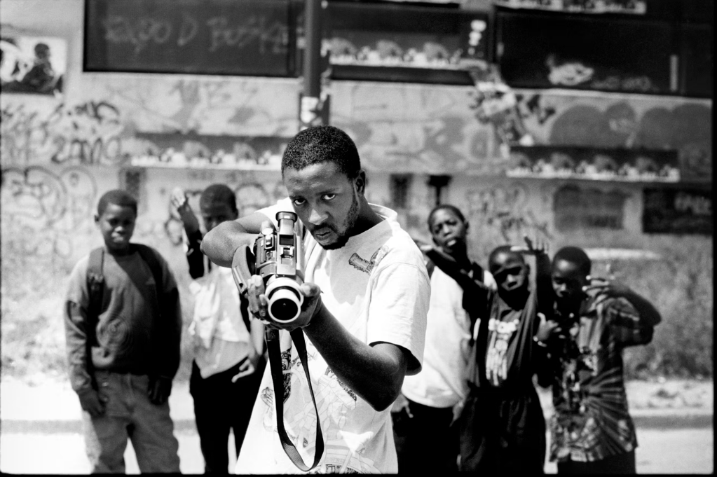
Figure 3 28 Millimeters, Portrait of a Generation, Hold-up, Ladj Ly by JR, Les Bosquets, Montfermeil, 2004 (JR, 2024a)
In 2004 JR set about again creating and placing art in venues where art would not be expected to be seen by anyone. His first exhibition Portrait of a Generation was held in the Parisian suburb of Montfermeil, to the East of the city, where, on the walls of Les Bosquets, in the ‘ghetto’ there, JR pasted up large scale photocopies of photos he had taken of its young residents whose images represented the struggles of the youth within that area (JR, 2024a). Following this, a year later in Montfermeil two local boys were killed in an electricity sub-station whilst hiding from police (JR, Ly and Cassel, 2006). The local community was in uproar and civil unrest turned into rioting, with the Minister of the Interior describing the rioters as ‘scum’ or in French ‘racaille’ on French media. After watching this JR was horrified by the reaction of the press and wanted to draw attention to the cause of the symptoms that the press were vilifying. Seeing his images from his previous project still on the walls becoming a backdrop for the riots frustrated and annoyed JR, as did the media coverage and bias over ‘out of control kids’ throwing molotovs (JR, 2024a). The media coverage hijacked the event and changed the perception of the place for people outside of the community. JR had already collaborated with these people and made friends there, and he felt that his role as an artist connected to this place was to help the inhabitants reclaim their space and discuss current issues (JR, 2024a). JR exemplifies how the role of the artist is to observe, and through that recontextualise an event.
Returning to this ‘ghetto’ JR joined up with his original collaborator Ladj Ly and started working with the community, taking full-frame photographic portraits using a 28mm lens of the local youths (JR, 2024a). JR requested them to pull scary faces to mock the medias portrayal of them. These images were pasted up on the walls of the community and further afield at night in the bourgeois bohemian areas of central Paris to avoid police attention. The authorities of the city quickly reacted to this action by removing the artwork as he had highjacked their space and created a place (JR, Ly and Cassel, 2006). This could be seen as the catalyst for JR’s continuing type of collaborative actions and the power this style of art has to draw attention to civil matters within and outside a community and the lived space of its inhabitants. This created a new meaning to the work and action as the Interior Minister had a few months earlier suggested cleaning out the banlieues or ‘ghetto’ with a Kärcher pressure washer as a metaphorical cleansing of the problem (JR, 2024a). Following this JR was invited to paste the artwork from ‘Portrait of a Generation’ on the hoardings around the Hotel de Ville in Paris, once the enemy of the authorities now being invited to utilize their space (JR, Ly and Cassel, 2006). Not only did these events draw attention to the subject matter, but it also brought this style of action and art to the mainstream.
In Portrait of a Generation, JR and his cohorts are transporting one place to another space, redefining that space by the placing of these images onto the architecture and creating a gallery in those newly defined places, this action affects all three of Lefebvre’s spatial triad (1991).The percieved space of city is changed by JR’s actions by the introduction of a new layer to the surfaces and material construct and visual field. This challenges and changes the concieved space by bringing a new meaning to the original design, and producing a gallery in the urban construct. This disrupts and changes the controlled space and unballances the authotiy of the dominent social and political power of that time. By design urban spaces were constructed to control and manipulate the inhabitants of them Lefebvre states "A conceived space is a place for the practices of social and political power; in essence, it is these spaces that are designed to manipulate those who exist within them" (Lefebvre, 1991, p. 222). JR bringing the images of the marginalised inhabitants of Les Bosquets to the heart of the city this changes the lived space and the functionality of that space as passers-by stop to look at these large-scale images and are, possibly, faced with a new narrative that these people are more than how they were described by the media depictions. By pasting up these images, JR firstly changes the objective space which then alters the subjective space and the experience of it. Here JR can be seen as actively participating in the production of space.
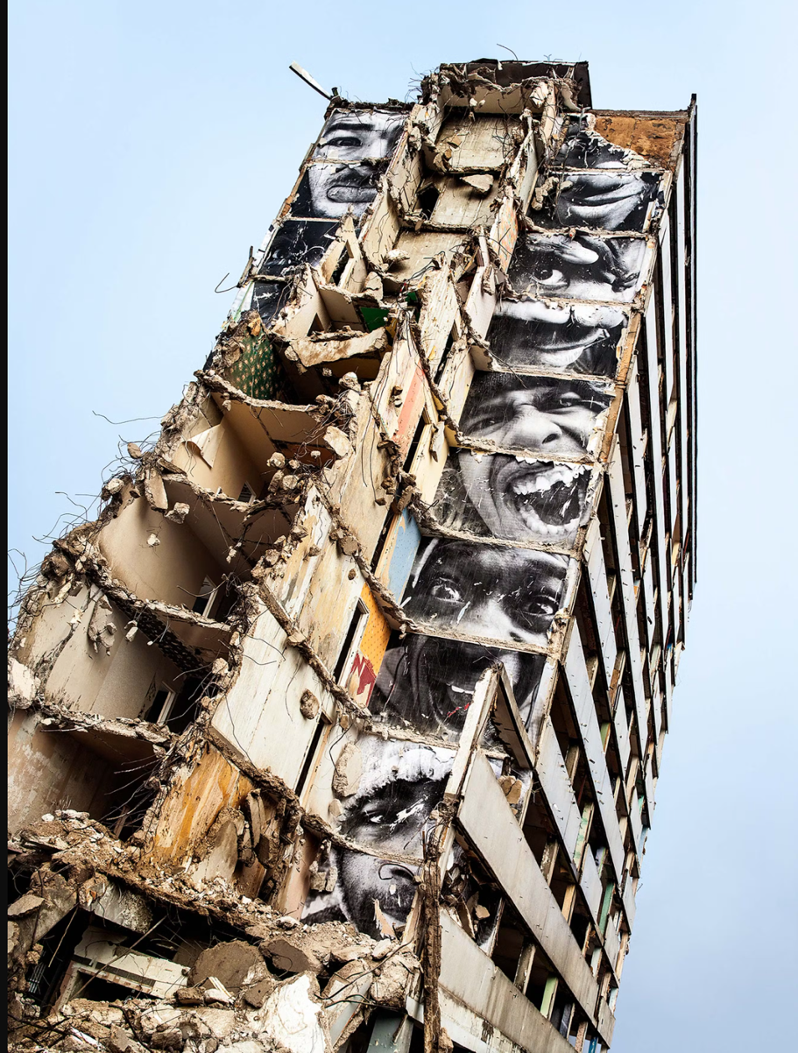
Figure 4 Portrait of a Generation – Destruction (JR, 2024b)
In 2013, JR returned to the place of the Portrait of a Generation project for a third time. The series of flats that were home to the subjects of his first exhibition were being demolished (JR, 2024b). JR pasted images of the Les Bosquets residents from his previous project inside the buildings despite not being able to secure official permission to do so. As the building was demolished, the interior of the building was revealed, and the staring faces of the former inhabitants looked out across a wasteland. The placement of these images within the midst of the demolition of the building gives them more power as they are dominant to the viewers at ground level. This act reclaimed the space for the inhabitants who were evicted. It also created another guerrilla gallery which redefines the space in the eyes of those who witnessed it. Even though this did not stop the demolition of the buildings, the art was recorded in photographs and in the hearts and minds of the people with a relationship to that space.
The pasted images between the floors of Les Bosquets alters the perceived space as the building is demolished and directly changes the perceived experience of that space. The conceived space of this building varies depending on the perspective of the individual. The urban planners would have conceived a plan for the future of the site. JR conceived how, as the building was being taken down, the separate images from each floor would be revealed and create a whole image from the faces. The former occupants conceived seeing their home as a demolition site, but JR’s art changed this conception to one of ownership and defiance as these faces stared out. This overlaps with the lived space, which becomes a gallery to all who saw it, directly affecting their experience and understanding of the place. JR re-affirms the identity of these people, where through the redevelopment of this area by a spatial fix as discussed by David Harvey, where capitalist powers seek new spaces for investment and provide temporary solutions to the ongoing crisis that capitalism has produced (Herod, 2019).
JR is changing the rhythm of a place by the placement of the artwork and interactions within that space. Like a conductor he changes the course of the rhythm. As with Lefebvre’s rhythm analysis (2004), he delves into the intricate interplay of space, time and everyday life within a place. Rhythms can nest with each other. JR as an artist has found a rhythm that works, and this rhythm has been repeated around the world in his various projects. This simple rhythm or formula is the foundation to his many works. The rhythm of the city is changed by JRs art, as people stop to observe and seek different perspectives on that art their usual movements through the city are disrupted, thus creating a new rhythm. Therefore, the role of JR as an artist is to tap into the rhythm of a place and disrupt and challenge it to create a lasting encounter.
JRs art becomes a part of the living landscape. The whole event and collaborative act of making his largescale projects becomes its own narrative. Recalled by those who were involved and those who observed the event. It gets woven into the local history of the place by being continuously recalled to those who follow, like the future generations. This oral history moves smoothly into the cultural history of the space creating a place or moment in time. They evolve through oral tradition, shaped by each storyteller as it moves in time. The creation of the art becomes a shared moment that unites a community, engaging people in a common goal and experience, giving ownership of their space, and place and pride in this project. Like a folk tale this experience reminds people of their cultural history. Seemingly, JR is writing into local history through his art, as it records and touches on the lives of this community and their experience.
JR’s art is not maintained and left to the elements; it erodes over time. The new rhythms created by the work also erodes and the original flow of the occupants of the city returns. However, the narrative of the event creates a social rhythm that continues to affect the collective memory of the place. As with Lefebvre’s (1991) Spatial Triad these three areas of space: the perceived, the conceived and the lived space, are affected by the presence and psychological effect of his art in situ, and the hidden narratives and social dynamics of his art. After Jr has left and the work exists, the narrative continues transcending his control. This aligns with Roland Barthes theory put forward in “The Death of the Author” (Gass, 1984). By embracing a collaborative process, he already hands over control working within the space of a third hand. The authorship becomes collective, and the community becomes both protagonist and curator (Wolfe, 2020). Beyond this, a third space is created when the viewer engages with the art and, as with Barthes’ theory, the seer transcends any possible original intent, and a new narrative is created. It could be said that JR’s art exemplifies the essence of “The Death of the Author.” His works transcend individual authorship, inviting viewers to connect directly and partake with the narratives and communities he portrays.
However, this goes broader as the art of JR is now exhibited around the world, outside of the communities where it was originally created (Thompson and Remnant, 2015). His powerful images are displayed in different arenas often challenging traditional construct of art spaces such as galleries, taking their potent meaning to a new audience. This audience brings their own lens to view this work through, often through a context outside of the original, and thus a new narrative and experience is created. In this instance the role of JR is to facilitate the delivery of this art to a global audience. As with Lefebvre’s Spatial Triad, the space and place this work is displayed takes on a new meaning outside of its original as the work changes the value and appearance of its site through the eyes of the viewer and the wider community.

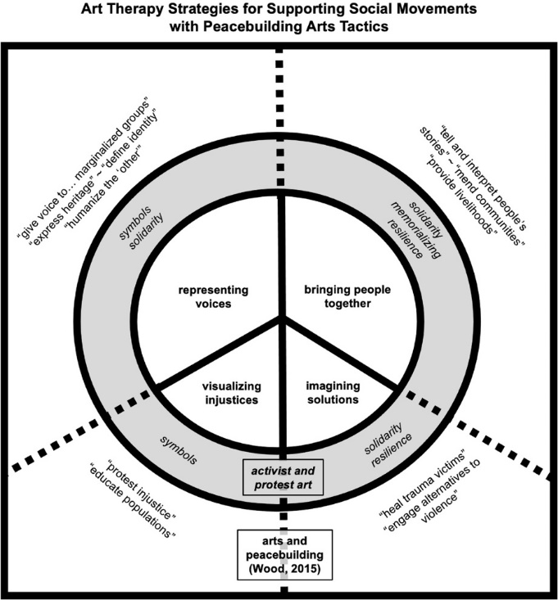
Figure 4 Art Therapy Strategies (Potash and Kalmanowitz, 2023)

Seeing is more than a physiological phenomenon… We see not only with our eyes but with all that we are and all that our culture is. The artist is a professional see-er (Potash and Kalmanowitz, 2023, p. 312).
JR’s art could be seen as a form of community-based art therapy. It fits with Wood’s framework for art therapy strategies toward peacebuilding strategies (Potash and Kalmanowitz, 2023) (see figure 4). JR deals with widespread problems that occur all around the world. He has focused on a wide range of political, social issues, inequalities and injustices within small communities and countries globally. His style of work encourages empathy and can be seen to challenge historical stereotypes that undermine equality and freedom of self-expression. In doing so he gives communities an amplified voice with a broader perspective on themselves and local issues, sharing the value of their experience. Not only does the work of JR change the individuals who participate in the creation of the work; The viewers of these pieces are challenged to reconsider preconceived perspectives and beliefs, and this opens up a new experience in which the complex realities of the human experience are understood and faced. Through this, his projects create a global community as people from different locales are unified through their participation in his projects.

In conclusion, it has been shown that the role of JR as an artist involves exploring social issues through art which he creates and displays in the urban space. This placement of art can be seen as highlighting, challenging and subverting the social and political construct of a place, this alters the conception of a space, the perception and lived experience of that newly reinvented place. This style of action or art has a broader effect as JR moves to other areas and deconstructs the hierarchy of the social construct by the placement of this art. By doing this, it is shown how the role of JR as an artist has been to tap into the rhythm of a space or place, creating change by harmonising in some and disrupting the status quo and altering the tempo of others.
This essay has shown how JR through collaboration within a social space has been able to create a new place, through dialogues within that community a common theme is found, this dialogue has been proved to create change within spaces where a creative place is found. This transcends into the local and wider narrative of these events as they are written into the history of places and spaces and the lives of the community there. These actions and events have been shown to unify the local and wider community. Here JR has been positioned as the facilitator of these interactions, by being curious JR conceives these projects within these places, by observing and immersing himself within that lived space JR’s actions are able to bring new perspectives to the conceived, perceived and lived space as shown in Lefebvre’s spatial triad.
Furthermore, this essay suggests that the role of JR is that of changing the conception of a gallery space by repurposing the architecture and infrastructure of a place. Here JR changes the physical space by placing art where it would not normally be expected to be seen creating a dialogue between the artwork and the environment. It has been discussed that the role of JR has been to look for the most effective ways to utilise space within certain places and to create new work. By doing this JR changes the lived experience of a place as in the context of Lefebvre’s spatial triad. He does so not only by the creation of new site-specific art, but through the repurposing and transportation of that art to other places where it again initially disrupts the status quo, but is later absorbed by that status quo altering what is acceptable within that space. JR’s work shows how art can create change by redefining spaces. Artists can learn from JR’s work that it is possible to address social issues and participate in a healing process.

References

Buchanan, I. (2018a) ‘ethnography’, in A Dictionary of Critical Theory. Oxford University Press. Available at: https://www.oxfordreference.com/display/10.1093/acref/9780198794790.001.0001/acref-9780198794790-e-232 (Accessed: 17 April 2024).
Buchanan, I. (2018b) ‘place’, in A Dictionary of Critical Theory. Oxford University Press. Available at: https://www.oxfordreference.com/display/10.1093/acref/9780198794790.001.0001/acref-9780198794790-e-781 (Accessed: 6 March 2024).
Buchanan, I. and Lambert, G. (2005) Deleuze and Space. University of Toronto Press.
Coverly, M. (2010) Psychogeography. Harpenden: Pocket Essentials.
Deleuze, G. and Guattari, F. (1987) A Thousand Plateaus: Capitalism and Schizophrenia. 2nd ed. edition. Minneapolis, Minn.: University of Minnesota Press.
Eckhard, P. (2015) ‘Urban Figures, Common Ground: JR and the Cultural Practices of Perception’, European journal of American studies, 10(3). Available at: https://doi.org/10.4000/ejas.11365.
GALLERIACONTINUA (2024) JR | Biography, Galleria Continua. Available at: http://www.galleriacontinua.com/artists/jr-258/biography (Accessed: 6 March 2024).
Gass, W.H. (1984) ‘The Death of the Author’, Salmagundi, (65), pp. 3–26.
Green, C. (2001) The third hand: collaboration in art from conceptualism to postmodernism. Minneapolis: University of Minnesota Press.
Herod, A. (2019) ‘Spatial Fix’, The Wiley Blackwell Encyclopedia of Urban and Regional Studies, pp. 1–2.
JR (2024a) JR - Portrait of a Generation, JR - Artist. Available at: https://www.jr-art.net/projects/portrait-of-a-generation (Accessed: 24 April 2024).
JR (2024b) JR - Portrait of a Generation - Destruction, JR - Artist. Available at: https://www.jr-art.net/projects/clichy---montfermeil (Accessed: 24 April 2024).
JR, Ly, L. and Cassel, V. (2006) 28 millimètres: Portrait d’une génération. Paris: ALTERNATIVES.
Lefebvre, H. (1991) The production of space. Oxford: Basil Blackwell.
Lefebvre, H. (2004) Rhythmanalysis space, time, and everyday life. London: Continuum (Athlone Contemporary European Thinkers). Available at: https://doi.org/10.5040/9781472547385.
Li, A. (2023) ‘Lefebvre’s dimensionality’, Medium, 26 September. Available at: https://medium.com/@wnsht1kll/9-26-lefebvres-dimensionality-ab8c28180476 (Accessed: 24 April 2024).
Potash, J.S. and Kalmanowitz, D.L. (2023) ‘Art Therapists as Activists in Social Movements’, Journal of Peacebuilding & Development, 18(3), pp. 310–328. Available at: https://doi.org/10.1177/15423166231193150.
Thompson, N. and Remnant, J. (2015) JR: Can Art Change the World? 1st edition. London New York: Phaidon Press.
Wolfe, S. (2020) ‘The Infiltrator: How French street artist JR puts his work amongst the people’, Artland Magazine, 22 October. Available at: https://magazine.artland.com/jr-the-french-streetartists-infiltrating-art/ (Accessed: 4 April 2024).

