Creative Practice 3 – Reflection

Video – (Double click icon to view)

Idea

My idea for the assignment consisted of a POV (Point of View) shot of either my own footage or stock footage of walking down path, then from around a corner a creature shows itself, and starts walking intimidatingly towards the camera. The ‘Cameraman’ backs away as the creature approaches and ends up turning around and running back to where they came from, but suddenly when they turn around a corner there is yet another creature standing over them. The special effects element will be the creature in the short video.

I have a path I have in mind if I am to go and film the video myself, but I will firstly research into any possible stock footage of what I want.

I created a production script and storyboard to go along with the video as part of my pre-production.

Production Script

EXT. Narrow Path – Day
Camera is moving down the path at a regular walking pace. Camera continues walking down the path until the end is in sight.
The camera stops and looks at the exit of the narrow path for a few seconds. (Camera zooms in) A creature walks around the corner and starts heading towards the camera (Camera zooms out - Added camera shake in post).
The camera backs away slowly until it turns around and starts heading back up the hill quickly (Added camera shakes in post).
Camera turns to look at the creature and sees it running. Turns back but theres another creature blocking the path (Camera pans up - Cuts to black).

Storyboard
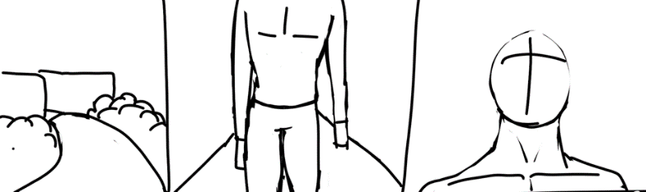
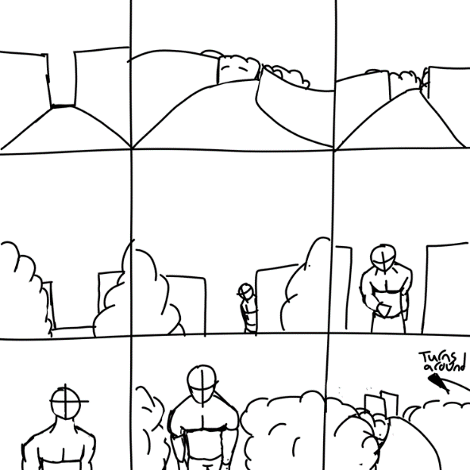

Model

For the creature I have found a free model online. I wanted it to be a humanoid creature, meaning bipedal so not to over complicate things. When looking for a model to use I looked through different websites for various styles of monsters. One website I looked at extensively was called ‘CGTrader’. It had a wide variety of models to choose from. After looking through this website I found that I could not use the models as there were not any Maya folders to download.

I changed my mind on the website, and decided on ‘Mixamo’, I found a model to use which is a ‘Mutant’ and found animations to go along with it. These animations are an Idle animation, a walking animation, a sprinting animation and a jumping animation. These will give variety to the movements so the video isn’t dull.

Process

When putting everything together I ran into a lot of issues. Firstly, the model. I thought I could bring the 3D model into After Effects, not knowing I couldn’t. I was stuck on this for awhile thinking there was a way to bring it in but finally realised after a lot of research that I could not. Secondly, the model I got ended up not working all that well, when I decided to save it as a video clip by rendering it out. The quality wasn’t the best and tracking it didn’t work either, therefore I decided to change the model I was using and instead of a 3D model I decided to use a green screen video clip. There weren’t any free monster clips to use though so I had to start over again when it came to the models.

I decided on using greenscreen dinosaur clips. I downloaded four clips, one being of a swarm of bats coming towards the camera to add a different effect to the video. I tracked the video again and set my tracking points. I made the tracking points into a solid and pre composed it. I removed the solid and in its place put in the clips of the dinosaurs. I changed the orientation so that the dinosaurs were visible. I once again ran into a problem. An error message kept coming up whenever I tried to use the camera tracker. The error message said ‘3D camera tracker layer size must match composition…’ I tried doing some research into this but the videos I watched did not give much support. Every time I tried testing to see if the tracking analysis worked it would take over 10 minutes to finish, just for it to pop up with the error message again. After this occurring multiple times I decided to start over once again.

After starting over I was then making good progress, deciding to only use one video for the background instead of two. This was due to all the errors/issues that were happening. Another reason was that the one clip was a minute in length to begin with, so I just stopped it almost halfway. This helped ease some of my concerns regarding tracking the other clip.

I then ran into yet another problem. My video started lagging and looping, it was doing this at an intense rate and I couldn’t get any work done as the tracking wouldn’t end as the video kept looping after four or so seconds of playing. This took some time researching to try and find a solution and thankfully I did. The solution was in the preview settings panel. I changed the resolution to ‘quarter’. It did solve the issue but the video is still fairly slow and I’m not sure on how I solve this.

Once I had both of my ground dinosaur clips finished for the tracking, I then moved on to bringing in the last two clips, which were significantly easier to work with. All I had to do was keylight it and situate it into the scene. For the pterodactyl clip I used the transform drop down to edit the scale and position to give it some more dynamic movement.

The next steps I took was to try and make the dinosaurs look as natural as possible. To do this I took to adding drop shadows to all the creatures. I edited them so that it fit with where they were situated, changing the distance, direction, and softness/opacity for each. I am happy with how the shadows came out overall, but the shadows on the grounded dinosaurs could use more work, though there weren’t many options to get the shadows how I wanted. I did try and play about with the colour correction for the two ground dinosaurs but struggled with understanding how to implement it in the way I visioned. I didn’t know how to change the colours to fit the environment, that is why the lighting, shadows, etc doesn’t fit as much as I would like it to. I also tried to change the hue/saturation, but that did not pan out due to my limited experience with my colour correction skills. I did do research on how I could blend objects into the environment with colour correction but the results were not what I needed/wanted.

Conclusion

Overall, I am proud of what I created during this assignment. I went through a significant amount of struggle in the creation process, having to change my idea in a lot of ways, also having to start over multiple times. Feeling incredibly stressed feeling as though I was not going to finish. And having many issues with the preview video stuttering, lagging and looping. With this assignment I also learnt a lot on using After Effects, that being the tracking process, keylighting, using drop shadows to immerse the imported scenes further and to an extent, colour correcting. I enjoyed the process when I began to see progress, once the majority of the issues were sorted.

Links

https://www.pexels.com/video/a-leafless-woodland-7107648/ - Video

https://pixabay.com/videos/dinosaur-prehistoric-realistic-83036/ - Green Screen Triceratops

https://pixabay.com/videos/dinosaur-spinosaurus-prehistoric-83174/ - Green Screen Spinosaurus

https://pixabay.com/videos/green-screen-bird-pterodactyl-114658/ - Green Screen Pterodactyl

https://pixabay.com/videos/halloween-bat-spooky-scary-night-52997/ - Green Screen Bats

