Assignment 2 Marketing Plan
Anda Suliteanu
2246204
Marketing Essentials BMIH4005
Scott James
Word Count 1256

Table of Contents

1.0 Introduction 3
2.0 Situation Analysis 3
2.1 SWOT Analysis 3
2.2 PESTLE Analysis 4
3.0 Objectives 5
3.1 SMART Objectives 5
4.0 Strategy 5
4.1 Business Strategy (Ansoff’s Matrix) 5
4.2 Changed Required to the Marketing Mix 6
5.0 Tactics 6
5.1 Revamping Communication Tactics 7
6.0 Action Plan 8
6.1 Gantt Chart 8
7.0 Control 8
8. Conclusion 9
9. Reference List 10
10.0 Appendix 12
10.1 Appendix 1: SWOT Analysis 12
10.2 Appendix 2:PESTLE Analysis 13
10.3 Appendix 3: Ansoff’s Matrix 14

1.0 Introduction
The Hilton Edinburgh Carlton, a 4-star hotel ensconced in Scotland's ancient Patrick Thomson Ltd. building, is the centrepiece of this marketing approach (Historic Hotels Worldwide, 2023). The approach, aimed at hotel management, uses Ansoff's grid to investigate options for development and innovation. It tries to uncover possibilities and difficulties to improve the hotel's posture via a detailed investigation of both the macro and micro environments. The plan intends to redefine guest experiences by using the 4Ps structure and Historical Hotels Worldwide membership, leveraging the appeal of the hotel's legacy while embracing current expectations.

2.0 Situation Analysis

2.1 SWOT Analysis
Strength | Weaknesses
- Historical Significance  - Prime Location  - Heritage Membership | - Ageing Infrastructure  - Evolving Guest Expectations
Opportunity | Threat
- Modernising Facilities  - Incorporating Tech  - Personalised Experiences | - Competitor Encroachment  - Changing Travel Trends  - Economic Uncertainty
Table 1: SWOT Analysis
The Hilton Edinburgh Carlton takes use of its historical importance, strategic location and heritage status. However, issues remain because of ageing infrastructure and changing visitor expectations (Historic Hotels Worldwide, 2023). Nonetheless, these issues provide opportunities for modernising buildings, integrating technology and providing personalised experiences. Threats such as rival invasion, changing travel preferences and economic uncertainty highlight the need for strategic adaptability.

2.2 PESTLE Analysis
Factors | Influence of factors
Political | This includes government actions, policies and stability that have an impact on hotel operations. Changes in rules, taxes, travel restrictions and visa policies have a direct impact on the industry's operation and foreign visitor traffic.
Economical | Economic factors have a big impact on the hotel industry. GDP growth, currency exchange rates, inflation rates and disposable income all have a direct influence on consumer expenditure on travel and lodging. The performance of an industry is intimately related to the general economic health of an area or nation.
Social | Demographic transitions, cultural upheavals and changing lifestyle choices all have a significant impact on the hotel sector. Understanding travel preferences, health awareness, demographic movements and cultural trends allows hotels to better personalise their offerings to suit the demands of their various guests.
Technological | Technological advancements are constantly reshaping the hospitality sector. To remain competitive, hotels must adopt online booking systems, IoT connectivity for guest convenience, automation in service delivery and rigorous data security measures.
Legal | It is vital to comply with numerous legal issues such as labour laws, health and safety rules, employment standards and consumer protection legislation. Adherence to these laws supports seamless operations and fosters visitor confidence.
Environmental | Sustainability practices have become more important as public awareness has grown. To lower their environmental imprint and attract environmentally aware travellers, hotels are progressively embracing eco-friendly programmes, establishing waste management systems and addressing the effect of climate change on tourism.
Table 2: PESTLE Analysis
(Source: Moliner et al., 2019; Chen et al., 2021; Nam et al., 2021; Alexandi and Murti, 2022)

3.0 Objectives

3.1 SMART Objectives
The main objective of the marketing plan is to increase overall visitor satisfaction by 15% within the next 12 months.
Specific | Measurable | Achievable | Relevant | Time Bound
Improve total visitor satisfaction | Increase the satisfaction measure by 15%. | Through focused service enhancements and increased visitor interaction | Consistent with the hotel's goal of improving guest experiences | Within 12 months, achieve
Table 3: SMART Objectives

4.0 Strategy

4.1 Business Strategy (Ansoff’s Matrix)
Market Development | Diversification
Expanding into new market segments by emphasising historical relevance and renovating the visitor experience. | Potentially developing wholly new services or markets outside hospitality, exploiting historical assets in novel ways.
Market Penetration | Product Development
Implementing promotional strategies highlighting historical relevance to attract current market groups and boost market share. | Introducing historically themed packages and reworking service offerings to correspond with the hotel's rich background.
Table 4: Ansoff’s Matrix

4.2 Changed Required to the Marketing Mix
Factors | Description
Product | Introduce historically themed packages, update service offerings to match the hotel's background, and potentially add historical excursions or themed events to improve visitor experiences.
Price | Adjust pricing methods to reflect enhanced value propositions in the historically themed packages or services, maybe providing bundled bargains or unique historical experiences at premium prices.
Place | Forge ties with local historical landmarks, allowing customers access or discounts, thus increasing the whole stay experience and establishing unique selling features.
Promotion | Emphasise the hotel's historical tale widely in marketing efforts across digital platforms, targeted commercials and cooperation with historical organisations or tourist boards.
Table 5: Marketing Mix
(Source: Tomislav and STIFANICH, 2020; Morrison, 2022; Prasad and Krishna, 2023)

5.0 Tactics
In addressing the difficulties highlighted in the situational assessment for Hilton Edinburgh Carlton, a thorough RACE (Research, Action, Communication, Evaluation) model will be implemented to boost communication techniques. Firstly, detailed research will assess the hotel's present communication efforts, evaluating social media existence, email marketing and Similarweb statistics to discover gaps and places for development (Bovsh, Rasulova and Hopkalo, 2021). The investigation may uncover significant problems, such as inconsistent communication across platforms, minimal interaction with historical characteristics or poor exploitation of internet channels to promote the hotel's legacy. To address these shortcomings, Hilton Edinburgh Carlton will begin a complex action plan.

5.1 Revamping Communication Tactics
Factors | Description
Content Enhancement | Hilton Edinburgh Carlton aspires to change its communication style by integrating historical themes with modern encounters. Crafting compelling content across social media, emails and the hotel's website, the emphasis is on a fascinating narrative that mixes the appeal of history with modern-day visitor expectations.
Interactive Campaigns | Interactive marketing involving historical quizzes, virtual tours and user-generated material will boost engagement and virality, enabling visitors to immerse themselves in the hotel's rich legacy. These activities are aimed at generating a feeling of engagement and sharing among audiences, increasing the hotel's narrative reach.
Strategic Partnerships | Strategic collaborations with local historical places and personalities will be exploited to promote the hotel's legacy narrative. Collaborations will broaden the hotel's reach to a larger audience, tapping into the authenticity and attraction of shared historical relevance.
Email Personalisation | Email customization will be a crucial tactic, personalising campaigns using historical information, unique bundles and customised messaging. This method seeks to captivate visitors by creating tailored experiences that match their interests and preferences.
Table 6: Communication Tactics
(Source: Kiselova, 2019; Agarwal, 2020; Kreh, 2022; Mandalia, 2023)

6.0 Action Plan

6.1 Gantt Chart
Marketing Activities | Week 1-2 | Week 3-4 | Week 5-6 | Week 7-8 | Week 9-10
Research Channels & Preferences
Develop Historical Content
Create Interactive Campaigns
Partner with Historical Sites & Influencers
Launch Personalized Emails & Implement Analytics
Table 7: Gantt Chart

7.0 Control
The assessment of achievement for Hilton Edinburgh Carlton's marketing campaigns will involve several key performance indicators (KPIs). Metrics will involve monitoring the inflow of new consumers, evaluating their interaction with historically related material and analysing how they turn into paying visitors. Additionally, the research will evaluate sentiment analysis using surveys or online conversation monitoring to determine favourable opinions regarding the brand. Ultimately, performance will be judged based on improved revenues attributable to the altered marketing methods, confirming the usefulness of the historical narrative in attracting and keeping visitors, developing a favourable brand image and generating financial development.

8. Conclusion
The marketing strategy for Hilton Edinburgh Carlton addresses issues in effectively blending historical tales with current guest expectations. Recommendations include improving content for an equitable appeal, ensuring interactive marketing engages with varied audiences, building strategic alliances and optimising individualised communication. The plan's success hinges on adjusting to growing tourist expectations while using the hotel's historical value to provide unique experiences. A unified approach blending history and contemporary will boost the company's position assuring a compelling combination that captivates and keeps visitors, establishing a good brand image and generating continuous growth.

9. Reference List
Agarwal, M., 2020. Importance of User Generated Content as a part of Social Media Marketing that drives Customer‟ s Brand Awareness and Purchase Intentions. The International journal of analytical and experimental modal analysis, 12(2), p.3071.
Alexandi, M.F. and Murti, P.P.I., 2022. The Political Economy of Household Expenditure in Indonesia. J. Islam. Econ, 14, pp.95-110.
Bovsh, L., Rasulova, А. and Hopkalo, L., 2021. Digital marketing of hotel business entities. Publishing House “Baltija Publishing”.
Chen, M.H., Wei, H., Wei, M., Huang, H. and Su, C.H.J., 2021. Modeling a green supply chain in the hotel industry: An evolutionary game theory approach. International Journal of Hospitality Management, 92, p.102716.
Historic Hotels Worldwide. 2023. Luxury Hotels In Edinburgh UK | Historic Hotel In Edinburgh. [Online] Available at: https://www.historichotels.org/hotels-resorts/hilton-edinburgh-carlton/history.php [Accessed 18 Nov. 2023].‌
Kiselova, H., 2019. Effective email marketing: an empirical study of the impact of personalized communication on customer engagement and purchase decisions (Master's thesis, Handelshøyskolen BI).
Kreh, D.B., 2022. Exploring Visitor Perceptions of Popular Culture Tourism in Sleepy Hollow, New York.
Mandalia, S., 2023. The role of the West Sumatra Indonesia tourism office in carrying out a communication strategy for the promotion of muslim-friendly tourism. Journal of Humanities and Tourism Research, 13(3), pp.557-570.
Moliner, M.Á., Monferrer, D., Estrada, M. and Rodríguez, R.M., 2019. Environmental sustainability and the hospitality customer experience: A study in tourist accommodation. Sustainability, 11(19), p.5279.
Morrison, A.M., 2022. Hospitality and travel marketing. Taylor & Francis.
Nam, K., Dutt, C.S., Chathoth, P., Daghfous, A. and Khan, M.S., 2021. The adoption of artificial intelligence and robotics in the hotel industry: prospects and challenges. Electronic Markets, 31, pp.553-574.
Prasad, B.R. and Krishna, S., 2023. Pricing The Value Proposition in Start-up Environment: A multi case study on start-up Pricing.
Tomislav, C.A.R. and STIFANICH, L.P., 2020. Mobile technology: a tool to increase hotel sales and revenue. Economics Business and Organization Research, pp.454-465.

10.0 Appendix

10.1 Appendix 1: SWOT Analysis
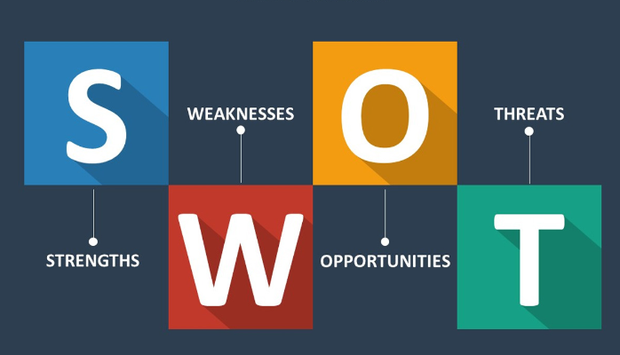

10.2 Appendix 2:PESTLE Analysis
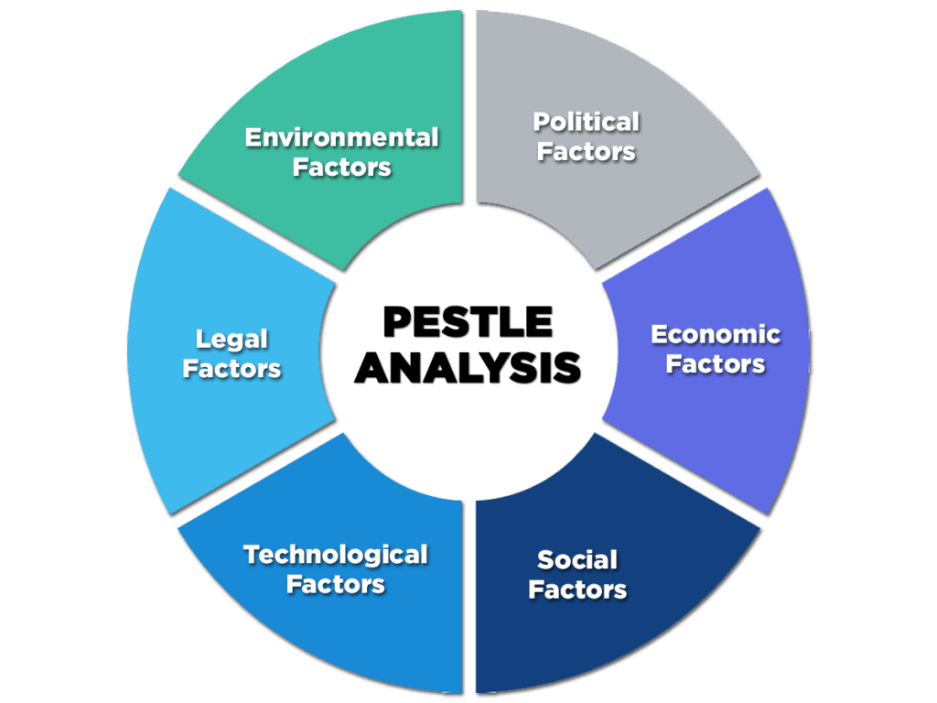

10.3 Appendix 3: Ansoff’s Matrix


