
UNIVERSITY OF WALES
TRINITY SAINT DAVID

HUMAN RESOURCE MANAGEMENT (LCMB7000)

ASSESSMENT – 1

Student Name : Parmod Kumar
Student No : 2229251

Table of Contents

Introduction 3
The Present situation in the UK’s Labour Market 3
Labour Market 3
Conditions of employment in the UK in recent times 4
Factors increasingly affecting the labour market of the UK 5
The changes occurring in the strategies of Human Resourcing in the Post Covid scenario and in the post-Brexit external environment 5
Human Resourcing Strategies in the Post Covid 5
Changes Emerging in Strategies of Human Resources post the Brexit’s external environment 8
Conclusion 10
References 12

Introduction
Constant monitoring of the labour market of a country helps the respective country in evaluating the proficiency of the labour or job market, and also in identifying the issues that are lowering the proficiency of the same. As per the study of Bell and Blanchflower, (2020), labours are an essential part of the production procedure of a firm, as a skilled and sufficient number of labours help in accomplishing the production demand of the firm which as a result increases the financial performance of a company and further of the respective country. The UK labour market is encountering several issues as a consequence of the exit of that of the UK from the European Union which is known as Brexit, and the upheaval of covid-19 in the past few years. The study will focus on explaining the current scenario of the labour market related to the UK. The focus will be given on explaining the condition related to employment associated with the UK in recent times. The discussion will be made regarding the key components related to the labour market. The concentration will be given on describing the variation that has taken place in the tactics related to human resources after COVID-19 and Brexit.
The deficiency of the labour or the job market of the UK is not only affecting several industries but also obstructing the financial development of the UK significantly (Katselidis, 2019). This specific assignment will be focusing on the labour market of the United Kingdom to analyse the current condition of the market. In addition to that, the increasing modifications in the human resourcing strategies to ensure maximum labour engagement in the post-Brexit and post covid era will also be mentioned in this study.

The Present Situation in the UK’s Labour Market

Labour Market
The workforce is vital for the owners to execute the target regarding their companies in the industry known as the labour market. The labour market mentions how in a particular economy the supply of and demand for labour is met (Escudero, 2023). It involves such individuals that are capable and willing to work and all available job opportunities in the market. This market of labour is determined and influenced by factors like technological advancements, education, demographics, training, government policies, and economic conditions. This equilibrium in the market is accomplished when labour demand in the industry equals the labour supply which results in optimum employment. This market is vital for determining multiple aspects such as wages, conditions of working, and productivity, which have an effect on the growth of economic and social welfare. As per corporatefinanceinstitute.com , (2023), the remarkable components related to the labour market are population related to the labour force, applicant pool applicant population and selected individuals.

Conditions of employment in the UK in recent times
As per May to July data 2021, the UK labour market is making a slow recovery from the COVID-19 pandemic, with the unemployment rate declining to 4.6% from a high of 5.1% in December 2020 (commonslibrary.parliament.com, 2023). Even after the continuous support from the government to the workers through the furlough scheme, some industries, such as hospitality, retail, and travel, have gone through a notable job loss (Wielgoszewska et al. 2023). On the contrary, other industries like technology, finance, and healthcare have experienced growth and a higher demand for the workforce. The future of the labour market in the UK remains uncertain due to the ongoing impact of the pandemic, potential changes in remote working, and the effects of Brexit.

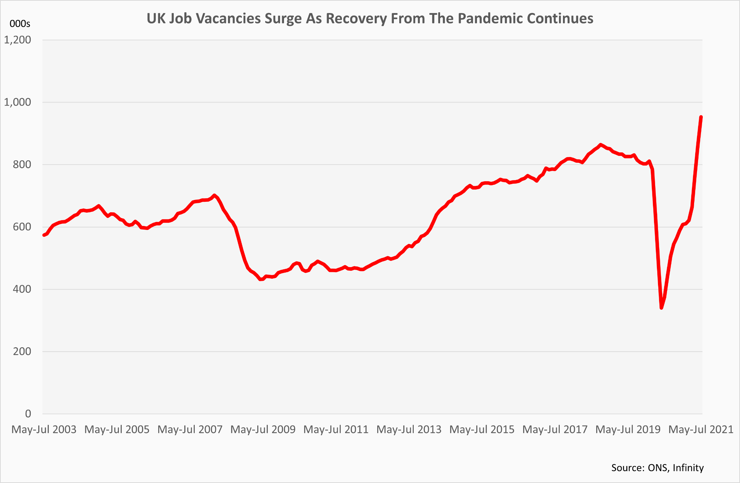
Figure 1: Positive surge in the UK’s employment market
[Source: Lumon, 2023]

Factors increasingly affecting the labour market of the UK
Several factors have influenced the labour market of the UK, beyond the commonly discussed effects of the Covid-19 pandemic and Brexit. For instance, Technological advancements have led to reformations in the skillsets vital for employees, which have led to a shift in labour demand for various industries. As per Portes and Springford, (2023), Quality education and training and the presence of such education and instructions will have an impact on the skillset and qualifications that the employees equip and their capacity to meet the demands for labour in the industry. The changes in government policies, like employment regulation, taxation, and societal welfare functions, affect this market. Economic conditions have multiple economic factors like growth of GDP, inflation, and rates of interest which affects the demand and supply of labour, wages, and the availability of job opportunities (Pizzinelli and Shibata, 2023). Globalization may impact the market for labour by generating job opportunities that are new in industries that are export-oriented which led to losses of jobs in markets that experience competition from abroad.
The labour market is a vital component of any economy as it determines wages, working conditions, and productivity. Although the UK's labour market is slowly recovering, the future remains uncertain. The government should take measures to support the affected industries and improve education and training programs to meet the changing market demands. A stable and sustainable labour market is crucial for the growth of the economy and the well-being of its people.

The changes occurring in the strategies of Human Resourcing in the Post Covid scenario and in the post-Brexit external environment

Human Resourcing Strategies in the Post Covid
In ways that were previously unthinkable, the covid pandemic has altered the workplace. A virtual office and remote employment required swift adaptation for many firms. The pandemic effect will continue to affect how work is done in the future even as vaccines become available and nations widen their borders. Organizations must review their human resource management plans in the post covid era to make sure they may continue to draw in and keep top people in this new setting. In this essay, we'll look at a few human resource management tactics that businesses in the post-COVID era should take into account.
Remote Employment
Organizations must adopt remote work as a long-term strategy since it has emerged as a crucial component of the new normal. Working remotely has several advantages, including lower overhead expenses, improved work-life balance and a larger talent pool. As per the views of Madero Gómez et al. (2020), the company's technology infrastructure must be strong enough to accommodate remote work and experts. To ensure that staff members can function well in a virtual environment, they must also provide the training they need. Also, the availability of a larger talent pool because remote employment eliminates the geographic restriction of geography. Companies have access to a more enormous variety of skills and knowledge by being able to hire people from anywhere in the world. Yet, working remotely may also have drawn back like isolation, poor communication, and trouble juggling work and personal obligations. Companies must help staff members manage their workloads, stay engaged, and preserve their mental health by offering services.
Consider the welfare of the workforce
On the mental and emotional well-being of the workforce, the pandemic has had a considerable effect. According to Donthu, and Gustafsson, (2020), Businesses must place a high priority on the welfare of their employees given the stress and uncertainty the pandemic has caused. This entails providing services for mental health, advocating for work-life balance, and fostering an environment at work that is encouraging and helpful. To meet the demands of employees and help them better manage their work-life balance, businesses should think about providing flexible work arrangements.
Prioritizing upgrading and retraining skills
A few abilities have become obsolete as a result of the pandemic’s acceleration of technological advancement. Businesses must emphasize reskilling and upskilling their people if they want to stay competitive in the post-COVID era. To do this, it is vital to identify the abilities that will be in demand in the future and to give people the resources and training they need to develop those skills (Yao and Azma, 2020). To assist employees in learning new skills, businesses might design training programmes, give online courses, and offer mentorship and coaching. Businesses may build a workforce that is more robust and flexible by investing in the development of their workers.
Put diversity, equity, inclusion
Inequalities and imbalances in our society have been brought to light by the pandemic. Businesses should put diversity, fairness, and inclusion as top priorities in their human resources strategies to promote a more just and equitable society. According to Purba, et al. (2021), this entails diversifying the workforce, fostering inclusivity and making sure that each employee is given respect and fair treatment. Companies may incorporate practices and policies that support diversity, such as utilizing blind rewriting procedures, offering training on unconscious prejudices, and establishing employee resource groups (Moore and Collins, 2021). Businesses may increase employee morale, encourage innovation and creativity, and draw in a larger pool of talent by fostering a more inclusive and varied work environment.

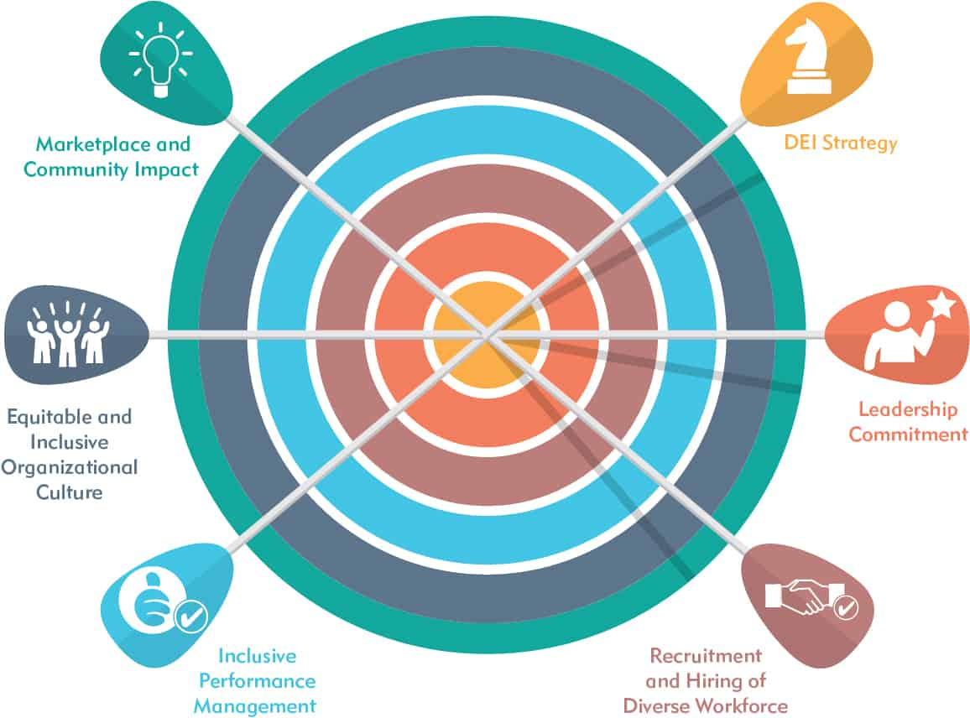

Figure 2: Diversity and Inclusion in the workplace
[Source: brighterstrategies, 2020]
Implement a data-driven strategy
Instead of relying on conjecture or gut feeling, human resource initiatives should be supported by data and research. Data can be used by businesses to pinpoint areas where they need to improve and to monitor the success of their human resource plans. According to Kerwin, (2023), companies can use employee engagement surveys to gauge employee satisfaction and pinpoint areas for development. Businesses may take better-informed decisions and make sure that their human resource plans are in line with their overall business objectives by using a data-driven strategy.
As per the vows of Hao, et al. (2020), for enterprises, the post-COVID era brings both new chances and problems. Businesses may produce a workforce that is more resilient and adaptable and can thrive in the post-COVID world by putting a strong emphasis on employee well-being, supporting remote work, reskilling and upskilling employees, prioritising diversity, equity, and inclusion, and adopting a data-driven approach.

Changes Emerging in Strategies of Human Resources post the Brexit’s external environment
According to Mitsakis, (2023), the UK’s withdrawal from the European Union, has resulted in the significant changes in the external environment affecting human resource management. These changes have necessitated new strategies to cope with the uncertainties and challenges brought about by Brexit. This research examines human resourcing strategy’s emerging changes post-Brexit in the UK.
Workforce Planning Strategies:
Planning ‘workforce effectively’ by businesses has become difficult due to Brexit. Many companies have had to re-evaluate their long-term plans and adapt to new market conditions. This has led to a need for more agile workforce planning strategies that can respond quickly to changes in demand and supply (Moradlou et al. 2022). Companies have had to invest in technology and data analytics to track their workforce’s skills, capabilities and productivity levels accurately.
Talent Acquisition Strategies:
This has caused problems for UK businesses to recruit and retain talented workers from the EU. Many EU citizens have left the UK due to uncertainty over their status and future opportunities. As a result, companies have been forced to turn to alternative sources of talent, including skilled workers from non-EU countries, older workers and workers with disabilities (Mitsakis et al. 2020). To attract and retain such talent, companies need to offer more working arrangements which can be considered as flexible, along with fruitful training and development opportunities and extensively inclusive workplace culture.
Leadership and Management Strategies:
Brexit has created a high level of uncertainty and complexity in the business environment. As a result, companies need to develop strong leadership and management strategies to navigate these challenges effectively (Roumpi et al. 2021). This includes investing in leadership development programs, mentoring, coaching and succession planning to ensure that companies have the right leaders in place to drive growth and innovation.
Compliance Strategies:
This has brought about significant changes to the UK’s legal and regulatory framework. As per the views of Cumming, (2020), companies need to ensure they comply with new immigration and employment laws to avoid costly fines and penalties. This has led to the need for new compliance strategies that incorporate regular audits and reviews of employment practices, documentation and reporting.
International Expansion Strategies:
This has created new opportunities for UK businesses to expand globally, particularly in emerging markets such as Asia and Africa. Companies need to develop international expansion strategies that are tailored to be specific needs of these markets. This includes understanding local employment laws, cultural differences and regulatory requirements.
Employee Engagement Strategies:
Brexit has also impacted employee engagement levels, with many workers feeling anxious and certain about their future in the UK. Companies need to invest in this strategies to foster a positive and supportive workplace culture (Kim et al. 2022). This includes regular communication, feedback, recognition, and rewards programs that help employees feel valued and motivated.
Digital Transformation Strategies:
Brexit has accelerated the need for digital transformation in many industries. Companies need to invest in technology and automation to improve their efficiency and productivity levels. This includes the adoption of cloud-based HR systems, digital recruitment platforms, and mobile workforce management tools.
Diversity and Inclusion Strategies:
This has created a climate of uncertainty and anxiety for many EU citizens working in the UK. Companies need to ensure that they maintain a diverse and inclusive workplace culture to retain their existing workforce and attract new talent (Cheikh et al. 2020). This includes developing diversity and inclusion strategies that promote equality, respect and opportunity for all employees, regardless of their nationality, race, gender, age, or disability.
Training and Development Strategies:
A need for new skills and capabilities in many industries has been created by Brexit. Companies majorly require investing in the training and development programs to help in the upskilling of their existing workforce and attract new talent. This includes developing bespoke training programs that address the specific needs of different employee groups, such as graduates, apprentices and older workers.
Employer Branding Strategies:
A highly competitive labour market in the UK has been created by Brexit. Companies need to differentiate themselves from their competitors to attract and retain top talent. This requires developing strong employer branding strategies that showcase their values, culture and commitment to employee development and well-being.
Sustainability Strategies:
A larger awareness of the need for sustainable business has been created by Brexit. Companies need to develop sustainability strategies that promote environmental responsibility, social welfare and economic growth .This includes developing strategies that reduce carbon emissions, minimize waste and promote sustainable supply chains.
Brexit has created a highly dynamic and challenging external environment for human resource management in the UK. Companies need to develop new strategies to adapt to these changes and remain competitive in the post-Brexit era (Martinescu et al. 2022). By developing and implementing these strategies, companies can ensure that they have the necessary skills, capabilities and workforce to succeed in the era.

Conclusion
It must be mentioned while concluding this assignment that the labour job market of the United Kingdom has encountered a significant decline due to a shortage of skilled labours in different business industries of the UK. Although the current state of the UK’s labour market denotes that the market is recently recovering from the consequences of covid 19 and Brexit issues, certain industries such as hospitality, retail, and travel are experiencing a labour shortage. Moreover, several factors such as proper education and training, policies, globalisation, and other major components are influencing the condition of the labour market. The assignment has been able to mention different modifications in the human resourcing strategies such as remote employment, the mental and emotional well-being of employees, and training of employees in the post covid era. Whereas, in the post-Brexit era, different human resourcing strategies such as talent acquisition, training, the inclusion of diversity, and many more have been implemented for retaining labours significantly. The study has discussed about the current scenario related to the labour market in the United Kingdom where the key components and the factors that are impacting the labour market have been explained. The focus has been provided in describing the variation that has taken place in the tactics related to the Human resource after COVID and the situation related to Brexit.

References
- Bell, D.N. and Blanchflower, D.G., (2020). US and UK labour markets before and during the Covid-19 crash. National Institute Economic Review, 252, pp.R52-R69.
- brighterstrategies.com, (2020). Available at: https://www.brighterstrategies.com/diversity-equity-inclusion-framework/. [Accessed on: 25.03.2023]
- commonslibrary.parliament.uk, (2023). Available at: https://commonslibrary.parliament.uk/research-briefings/cbp-8898/. [05.04.2023].
- corporatefinanceinstitute.com, (2023), economics/labor-market. Available at: https://corporatefinanceinstitute.com/resources/economics/labor-market/#:~:text=Components%20of%20the%20. [Accessed on: 05.04.2023].
- Cumming, D.J., Wood, G. and Zahra, S.A., (2020). Human resource management practices in the context of rising right‐wing populism. Human Resource Management Journal, 30(4), pp.525-536.
- Donthu, N. and Gustafsson, A., (2020). Effects of COVID-19 on business and research. Journal of business research, 117, pp.284-289.
- ElCheikh, M., Cojocaru, A., Theaker, M. and AlSheikh, D., (2020). Analyzing the effect of Brexit on the British construction industry using fuzzy sets theory. Frontiers in Built Environment, 6, p.8.
- Escudero, V., (2023). How Impact Evaluation is Shaping the Design of Labour Market Policies. In Global Labour in Distress, Volume II: Earnings,(In) decent Work and Institutions (pp. 567-575). Cham: Springer International Publishing.
- Hao, F., Xiao, Q. and Chon, K., (2020). COVID-19 and China’s hotel industry: Impacts, a disaster management framework, and post-pandemic agenda. International journal of hospitality management, 90, p.102636.
- Katselidis, I.A., (2019). Institutions, Policy and the Labour Market: The Contribution of the Old Institutional Economics. Economic Thought, 8(2), pp.13-30.
- Kerwin, S., 2023. Human Resource Management and Digital Technology. In The Routledge Handbook of Digital Sport Management (pp. 22-36). Routledge.
- Kim, S., Vaiman, V. and Sanders, K., (2022). Strategic human resource management in the era of environmental disruptions. Human Resource Management, 61(3), pp.283-293.
- Lumon.com, (2023). A Positive surge in the UK’s employment market Available at: https://www.lumonpay.com/business/insights/uk-labour-market-data-strong-as-expected-powell-to-speak-today. [Accessed on 20.03.3023]
- Madero Gómez, S., Ortiz Mendoza, O.E., Ramírez, J. and Olivas-Luján, M.R., (2020). Stress and myths related to the COVID-19 pandemic’s effects on remote work. Management Research: Journal of the Iberoamerican Academy of Management, 18(4), pp.401-420.
- Martinescu, E., Edwards, M.R., Leite, A.C., Randsley de Moura, G., Marques, A.G. and Abrams, D., (2022). The interactive effect of job skill level and citizenship status on job depression, work engagement and turnover intentions: A moderated mediation model in the context of macro‐level turbulence (of ‘Brexit’). Human Resource Management Journal.
- Mitsakis, F., (2023). Strategic human resource development in times of business and economic uncertainty: the case of Greek banks. European Journal of Training and Development, 47(1/2), pp.58-84.
- Mitsakis, F.V., (2020). Human resource development (HRD) resilience: a new ‘success element’of organizational resilience?. Human Resource Development International, 23(3), pp.321-328.
- Moore, H.L. and Collins, H., 2021. Rebuilding the post-Covid-19 economy through an industrial strategy that secures livelihoods. Social Sciences & Humanities Open, 3(1), p.100113.
- Moradlou, H., Fratocchi, L., Skipworth, H. and Ghadge, A., (2022). Post-Brexit back-shoring strategies: what UK manufacturing companies could learn from the past?. Production Planning & Control, 33(14), pp.1319-1336.
- Pizzinelli, C. and Shibata, I., (2023). Has covid-19 induced labor market mismatch? evidence from the us and the uk. Labour Economics, p.102329.
- Portes, J. and Springford, J., (2023). The Impact of the Post-Brexit Migration System on the UK Labour Market (No. 15883). Institute of Labor Economics (IZA).
- Purba, Y.T.S., Ariani, N. and Sumardjo, M., (2021). Management Strategy in the Process of Developing Human Resources in the Covid-19 Pandemic (Case Study: Pt. Pan Brothers, Tbk). Dinasti International Journal of Education Management And Social Science, 2(4), pp.687-698.
- Roumpi, D., (2021). Rethinking the strategic management of human resources: lessons learned from Covid-19 and the way forward in building resilience. International Journal of Organizational Analysis, (ahead-of-print).
- Wielgoszewska, B., Bryson, A., Costa Dias, M., Foliano, F., Joshi, H. and Wilkinson, D., (2023). Exploring the reasons for labour market gender inequality a year into the COVID-19 pandemic: evidence from the UK cohort studies. Longitudinal and Life Course Studies, pp.1-24.
Yao, X. and Azma, M., (2022). Do cloud-based enterprise resource planning systems affect the productivity of human resources in the COVID-19 era?. Kybernetes, 51(6), pp.1967-1990.

