WenQi ShangGuan 2124277
BMBM 6016 Strategic Marketing
Abstract
The report is an analysis and evaluation of the Wal-Mart Company, analyzing the problems as well as the strengths and weaknesses of the company through SWOT.
Strategic Marketing
Wal-Mart Company strategic marketing

Contents
Executive Summary 2
Introduction 2
SMART 2
SOSTAC 3
Strategic Marketing Objectives 4
Marketing Mix (7Ps) 5
SOSTAC 5
Situation 6
Objectives 6
Strategy 7
Tactics 7
Action 8
Control 9
Suggestion 9
Conclusion 10
References： 10

Executive Summary
Strategic marketing is a strategic development process that follows the laws of the market. Strategic marketing not only needs to consider the ever-changing market operating environment but also needs to consider meeting the needs of specific customer groups. Strategic marketing is a decision-making and implementation process that combines theory and practice. Process (Potter, N. 2012). It emphasizes the influence of competition in the same industry and the political, economic and cultural environment on the company. On the other hand, it requires the company's management and marketing personnel to use the company's existing resources and environment to make overall strategic planning for the company. These plans can help companies achieve specific strategic goals and missions (Josephson et al. 2016).

Introduction

SMART
The SMART analysis method refers to the five basic principles that the company should abide by when formulating strategic goals. These principles include: Specific. Specific means that when setting the company's strategic goals, the goals must be determined and must be specific requirements. The goal cannot be vague; Measurable, Measurable refers to the measurability of the strategic goal when setting the marketing strategy, and the strategic goal needs to be quantified into a specific value. For example, increasing sales by 1% is a specific quantitative goal, but becoming a successful company is not a good quantitative goal. There are too many factors involved in success (Hamlich, M. et al. (2020);
Attainable is the achievability of the goal. The strategic goal must meet the company's capabilities. Goals beyond the company's capabilities will not only waste the company's resources, but also make it difficult to achieve strategic goals（Darrell Zahorsky 2022）; Result means that goals should be results-oriented, strategic goals Although the implementation process is also an important procedure, the result will be the most important criterion for evaluating strategic goals (Liang, Y.-J. et al. 2016); Time is the effectiveness of strategic goals. Strategic goals need to be achieved within the specified time. Once the goal is completed beyond the expected time, it will bring real losses to the enterprise (Das, D. 2020).
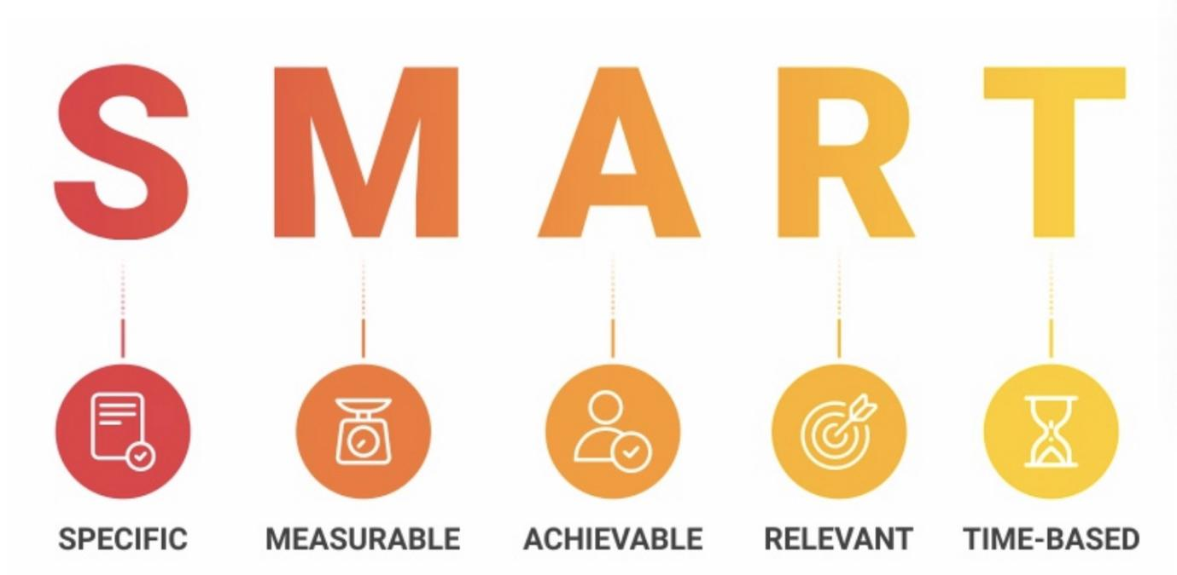

Bhat, A. (2018)

SOSTAC
The SOSTAC model is of great significance in market strategic planning. Using SOSTAC, managers can clearly establish strategic judgment and implementation of the company. The SOSTAC model is divided into six parts: Situation analysis, which analyzes the company's positioning and resources(Dave Chaffey. 2022), For example performance goals, customer needs. Objectives are goal setting, such as getting more consumers and getting more profits, which also includes where the company wants to go or what channels the company wants to achieve its goals(Jesi et al. 2021). Strategy is the company's strategy formulation. This part of the company needs to determine specific market segments and specific goals (Manna, M. 2023), and determine targeted solutions for the goals. Tactics is tactical selection. After the company has determined specific strategic goals, it will focus on this To achieve a strategic goal, the company needs to formulate a series of specific tactical action plans. As Sahartian side: these plans are usually very detailed, which is very helpful to achieve the strategic goal in stages(Sahartian et al. 2022). Action is an action plan. After the company has determined the large strategic plan and specific tactical actions, at this stage, the company will design goals and tactics into specific action plans(Martin Broadhurst 2022). Control is strategic evaluation and monitoring. Control requires the company's managers and executives to strictly follow the company's strategic and tactical plans. Strengthening evaluation and monitoring will help the company achieve its strategic goals(George et al. 2018).
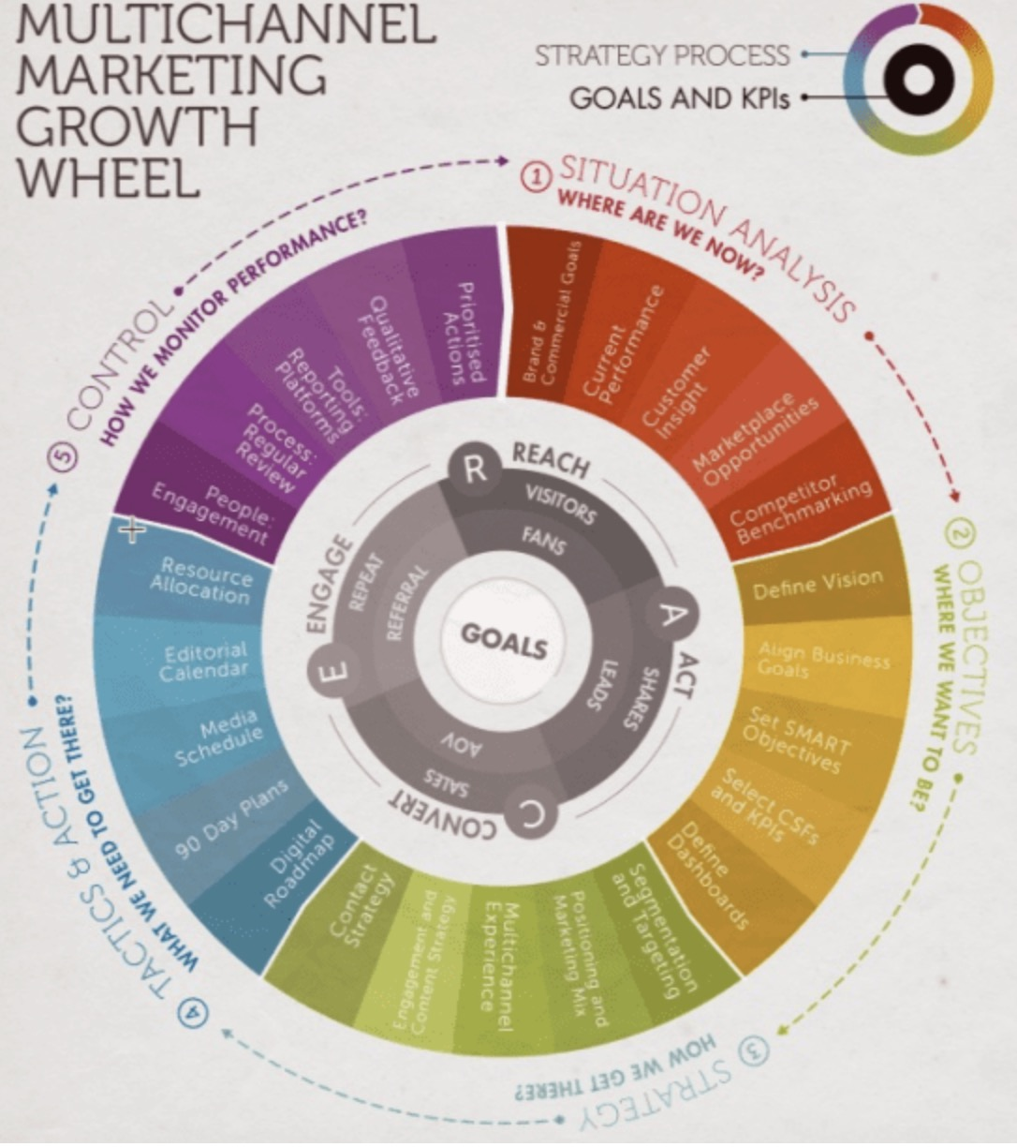
Chaffey, D. (2022)

Strategic Marketing Objectives
Wal-Mart's 2022 financial report for the Chinese market shows that Wal-Mart's sales in the Chinese market will increase by 13.5% in 2022, most of which will come from the increase in sales of meat products and processed foods. On the contrary, in China Wal-Mart’s sales in the fresh vegetables and fruits market fell by 5.8%, but at the same time, the overall sales of vegetables and fruits in the Chinese market showed an increasing trend. It can be seen that Wal-Mart’s sales of fresh vegetables and fruits There is a problem, and the management of Wal-Mart has noticed this problem. The company hopes to increase the sales of Wal-Mart in the vegetable and fruit market in 2023(Coelho, K. 2023). A survey shows that more than 30% of customers who go to the supermarket do not have a clear product they want to buy. As for fresh vegetables and fruits, this is one of their important choices (Christina Chen. 2020), Boost fruit and vegetable sales, which helps drive consumers to buy other supermarket products alongside fresh fruit and vegetables. In 2023, the management of Wal-Mart hopes to increase the sales of fresh vegetables and fruits in the Chinese market by 5%. This goal is feasible. The vegetable and fruit market in China is growing. People pay more attention to their health and are more willing to buy fresh vegetables and fruits. On the other hand, the increase in the sales of vegetables and fruits can increase the sales of other products as a whole by more than 1%, so the sales target of fresh vegetables and fruits will be increased by 5% (Tina. 2018), which is beneficial to the company as a whole. Sales performance is of great significance. The time to achieve this goal is the whole year of 2023, and the company will evaluate specific sales growth and sales plans every quarter.

Marketing Mix (7Ps)
Marketing mix is ​​a marketing tool, which includes seven specific aspects: product, price, promotion, location, personnel, packaging and process(McCarthy, E. J. 1964). Among them, the product is the most concerned thing for customers, and what the company's products or services can provide to customers (Gandolf, S. 2010) , In-depth understanding of customer needs, and using this information to support and deliver the value of products will be the direction that the company will focus on（Mulford, A. (2020). The price of a product will have a real impact on sales and sales. Attracting consumers with a low price or adopting a high price strategy to improve product quality are means to attract specific customers. Promotion and People are important considerations in marketing activities(Ivy, J. 2008). For example, discounts on fresh vegetables will significantly increase sales. On the other hand, people in different regions have significant differences in their demand for vegetables and fruits. For example, customers in northern China like to eat Chinese cabbage, while customers in southern China prefer Chinese cabbage. tomato. The enthusiasm and attitude of the sales staff also determine the customer's acceptance and desire to buy Wal-Mart products. Product packaging is also an important means for new customers. A beautiful and practical packaging can improve customer satisfaction. Process needs to consider the entire life cycle of product sales(Seyed et al. 2018).). The more specific the process, the smoother the sales and customer service staff can execute. Moreover, the sales staff can focus more on customers, which can be directly converted into personalized customers. Experience(Bitner et al.1981).
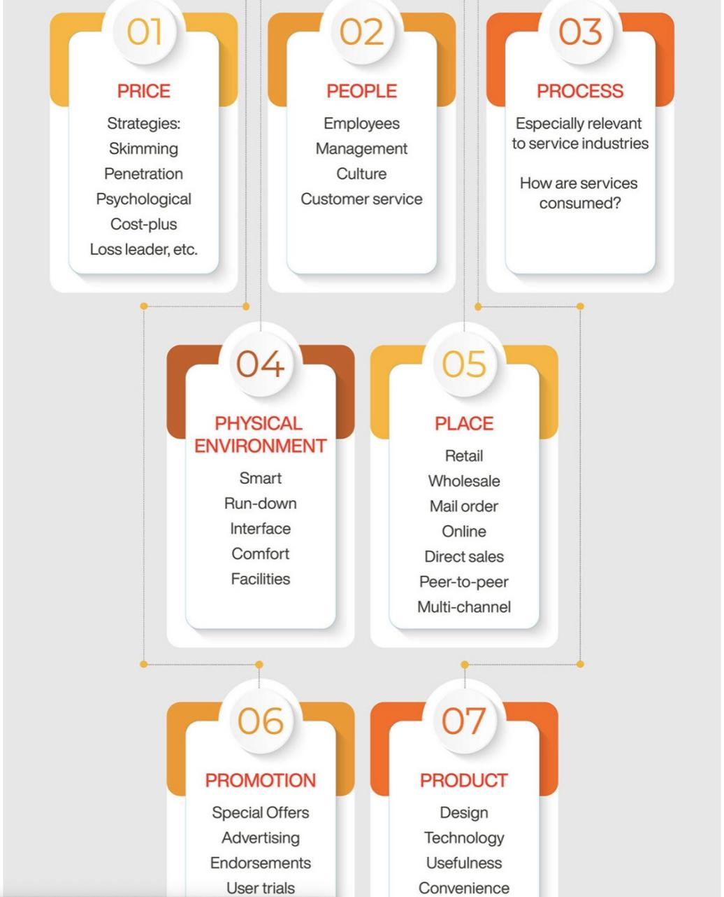

Team, O. (2023)

SOSTAC
After determining Wal-Mart's strategic marketing goals, this step will conduct a comprehensive analysis of Wal-Mart's strategic goals through the SOSTAC model. On the other hand, in order to formulate detailed strategic plans and implement strategies, Marketing Mix (7Ps) will be used in specific strategic plans and strategy implementation.

Situation
Wal-Mart is the largest supermarket chain group in the world. It has more than 10,000 supermarkets around the world and more than 2.2 million employees. Since Wal-Mart entered the Chinese market in 1996, Wal-Mart has more than 500 supermarkets in mainland China with more than 100,000 employees. And with 20,000 suppliers, Wal-Mart's market share in China exceeds 5% (Joe Wu. 2022).. At the same time, Wal-Mart has a high reputation in China, and Chinese consumers have a very high degree of recognition and acceptance of the brand and quality of Wal-Mart supermarkets. These advantages allow Wal-Mart to take advantage of its popularity and supplier advantages when it promotes new products in China or seeks to expand the market share of a certain business. These advantages can help Wal-Mart save procurement costs, and consumers are willing to go to Wal-Mart to try new product. Wal-Mart Supermarket has a huge store. By transforming the existing store or removing some unpopular products, this can bring more usable space for selling vegetables and fruits. On the other hand, Wal-Mart has A strong supply guarantee system, which not only includes high-quality vegetable and fruit suppliers, but also includes Wal-Mart’s advantages in cold chain transportation(Newegg.2022). Wal-Mart China has its own cold chain transportation fleet, which can ensure that the supermarket can provide consumers with more Fresh vegetables and fruits.

Objectives
In realizing Wal-Mart's strategic goal in the Chinese market, planning can be carried out through five dimensions.
In terms of sales, supermarkets should be based on security and quality, or they can help supermarkets retain existing customer groups. On the other hand, providing customers with more diversified choices of vegetables and fruits, such as higher-end fresh vegetables, can develop new user groups. While providing high-end vegetables, Wal-Mart will arrange dedicated sales staff to provide one-on-one service to customers, introducing the best time to eat vegetables and cooking techniques. Some specific fruit brands, such as Musang King durian, are very popular among high-end customers, and salespeople who specialize in communication skills will also increase fruit sales, which will increase the turnover of Wal-Mart supermarkets in vegetables and fruits.

Strategy
Strategy provides a basis for the macro strategic goals of Wal-Mart Supermarket. Wal-Mart's strategic goal in the Chinese market in 2023 is to increase the market share of supermarkets in the fresh fruit and vegetable market, increasing the market share by 5%, which will help increase sales of other commodities more than 1%. This macro goal is not just to increase the market share of fruits and vegetables, but to substantially increase the market share of fruits and vegetables without affecting the sales or sales growth of other commodities. This requires that Wal-Mart cannot Make substantial adjustments to the product structure of existing supermarkets or the layout of stores, or promote sales and promotion through other methods such as improving services and product quality.

Tactics
Tactics decided on a specific plan of action. Under the condition of ensuring the strategy, he took specific measures to achieve Wal-Mart's goal of increasing the market share of vegetable and fruit sales by 5% in 2023 in China. Under this tactic, Wal-Mart supermarkets need to increase their requirements for suppliers to ensure that suppliers choose the freshest vegetables and fruits. On the other hand, Walmart China must ensure a smooth supply chain, because the transportation process of vegetables and fruits will consume a lot of time, which will seriously affect the quality of vegetables and fruits, especially for high-end fruits, such as durian or other high-priced foods. Fruit art should be transported by special vehicles and trucks on special transport channels. This can ensure the taste and freshness of vegetables and fruits to the greatest extent, and these strategies are based on utilizing the existing Wal-Mart suppliers and supply chain system, which will not bring negative effects to the sales of other commodities Influence.

Action
Action The details of tactics, and the specific implementation of tactics to each action. For example, in order to improve the sales experience in the vegetable and fruit area, Wal-Mart has specially set up a sales assistant position. This assistant will only be responsible for the introduction and promotion of the vegetable and fruit area. He will tell customers the specific methods of solving vegetables and the best use of fruits Time, and the promoters will assist customers to choose fruits and vegetables, which will greatly increase the user experience and user favorability, and the increase in user favorability will increase the user's desire to buy and attract new users. This is a specific behavior to achieve the strategic goal of Wal-Mart's sales growth. On the other hand, supermarkets need to improve the transportation efficiency of the supply chain. For example, the average transportation time of Wal-Mart in the Chinese market is 2.3 days, while the average transportation time of Lihong Supermarket among the regional supermarkets is 1.98 days(Xu rongchong. 2022). There is still room for further improvement in the efficiency of fruit transportation. Adding more drivers or vehicles can help reduce Wal-Mart's transportation time and further increase the freshness of fruits and vegetables.

Control
Control is an important procedure to ensure the implementation of strategic goals. Control needs to evaluate the key performance indicators of the enterprise
For example, Wal-Mart China's goal of increasing the market share of vegetables and fruits is 5%, which means that the market share growth of the supermarket should reach 1.25% every quarter, and the market share growth should reach more than 0.4% every month. Managers should evaluate the company's strategic marketing goals on a monthly and quarterly basis. On the other hand, tactical actions should also be evaluated, such as evaluating customer satisfaction with supermarket fresh fruit and vegetable sales every month. Part of it can be done through questionnaires. The average transportation time of logistics is calculated by the company's transportation department and reviewed by the management department. The average transportation time for fresh vegetables and fruits should be reduced to less than two days.

Suggestion
Wal-Mart China's strategic marketing goal is to increase the market share of fresh vegetables and fruits by 5%, but this does not mean that the company's tactics and actions will remain unchanged when this goal is achieved. If the company does not achieve the strategic goals in the stage, the consensus should be to adjust the tactics and action plan, for example, the overall transportation time has not decreased, which means that the company should consider changing the management personnel of the transportation system, and set a stricter time Require.

Conclusion
The use of the SMART model can help us quickly determine the marketing strategy goals in China. At the same time, the SOSTAC model can help the company systematically analyze, the location of the company, the advantages and resources of the company, and use these advantages and resources to formulate specific strategies. Scope, this strategic scope includes Wal-Mart, China's fresh vegetables and fruit sales market share increased by 5%. In order to achieve this strategic goal, Walmart China needs to improve the quality of suppliers and increase the number of service personnel, On the other hand, reducing the transportation time of vegetables and fruits, these tactical Marketing Mixes help Walmart China achieve its strategic goals.

References：

Bhat, A. (2018) SMART Objectives and Goals: Definition, Characteristics and Examples | QuestionPro, QuestionPro. Available at: https://www.questionpro.com/blog/smart-objectives-and-goals/ (Accessed: 15 May 2023).

Bitner, M. J. and Booms, H. (1981). Marketing Strategies and Organization: Structure for Service Firms. In Donnelly, J. H. and George, W. R. (Eds). Marketing of Services, Conference Proceedings. Chicago, IL. American Marketing Association. p. 47- 52.

Christina Chen. 2020. In 2020, Walmart fresh food grew rapidly, and O2O fresh fruits increased several times in 100 days Page 20 | International Fruit and Vegetable Report (2023). Available at: https://m.guojiguoshu.com/article/5821?page=19 (Accessed: 15 May 2023).

Coelho, K. (2023) 10 Marketing Objective Examples To Guide and Focus Your Strategy, Impactplus.com. Available at: https://www.impactplus.com/blog/marketing-objectives-examples (Accessed: 15 May 2023).

Darrell Zahorsky. 2022. 5 Elements of a SMART Business Goal (2023). Available at: https://www.thebalancemoney.com/elements-of-a-smart-business-goal-2951530 (Accessed: 15 May 2023).

Dave Chaffey. 2022. SOSTAC® marketing plan model definition - What is? - Digital marketing Glossary (2023). Available at: https://www.davechaffey.com/digital-marketing-glossary/sostac-marketing-plan-model/ (Accessed: 15 May 2023).

SOSTAC marketing planning model guide | Smart Insights, Smart Insights. Available at: https://www.smartinsights.com/digital-marketing-strategy/sostac-model/ (Accessed: 15 May 2023).

Das, D. (2020). In pursuit of being smart? A critical analysis of India's smart cities endeavor. Urban geography, 41 (1), pp.55–78. [Online]. Available at: doi:10.1080/02723638.2019.1646049.

George Semonian, Tamer Abdel latif and Shereen Abdel Maqsoud. (2018). The basics of marketing strategy on social media. Majallat al-ʻimārah wa-al-funūn wa-al-ʻulūm al-insānīyah, 3 (12-1), pp.132–148. [Online]. Available at: doi:10.12816/0047866.

Gandolf, S. (2010) The Seven 7 Ps of Marketing- The Marketing Mix, Healthcare Success. Available at: https://healthcaresuccess.com/blog/medical-advertising-agency/the-7-ps-of-marketing.html (Accessed: 15 May 2023).

Hamlich, M. et al. (2020). Smart applications and data analysis : third International Conference, SADASC 2020, Marrakesh, Morocco, June 25-26, 2020, Proceedings / Mohamed Hamlich, Ladjel Bellatreche, Anirban Mondal, Carlos Ordonez (eds.). Cham: Springer.

Seyed Javad Ghazi Mirsaeed, Nadia Motamedi and Matin Shahivand. (2018). Comparing the Marketing between the Libraries of Tehran and Shahid Beheshti Medical Sciences Universities based on 7Ps Marketing Model in 2017. Payavard salamat, 12 (4), pp.324–333.

McCarthy, E. J. (1964). Basic Marketing. Richard D. Irwin. Homewood, IL.

Manna, M. (2023) Chapter 10 – SOSTAC Framework: Developing Marketing Plan -, Super Heuristics. Available at: https://www.superheuristics.com/learnmarketing/developing-marketing-plan-sostac-framework/ (Accessed: 15 May 2023).

Ivy, J. (2008). A new higher education marketing mix: the 7Ps for MBA marketing. International journal of educational management, 22 (4), pp.288–299. [Online]. Available at: doi:10.1108/09513540810875635.

Mulford, A. (2020). Repurposing the 7Ps. British dental journal, 228 (11), pp.810–811. [Online]. Available at: doi:10.1038/s41415-020-1724-2.

Sahartian, O., Ayouvi Poerna Wardhanie and Sri Hariani Eko Wulandari. (2022). STRATEGI DIGITAL MARKETING INSTAGRAM MENGGUNAKAN FRAMEWORK SOSTAC GUNA MENINGKATKAN OMZET CONSUMER GOODS MADU. JSiI (Jurnal Sistem Informasi), 9 (2), pp.141–149. [Online]. Available at: doi:10.30656/jsii.v9i2.5049.

Team, O. (2023) What are the 7 Ps of marketing?, Online Manipal. Available at: https://www.onlinemanipal.com/blogs/what-are-the-seven-ps-of-marketing (Accessed: 15 May 2023).

Tina. 2018. Walmart's 2017 performance hit a new high, and the future will be more intelligent omni-channel retail | International Fruit and Vegetable Report (2023). Available at: https://m.guojiguoshu.com/article/3907 (Accessed: 15 May 2023).

Jesi Irwanto, Wahyuning Murniati and Anisatul Fauziyah. (2021). Optimization of Digital Marketing Strategy with Implementation of SOSTAC Method. IJEBD (International Journal of Entrepreneurship and Business Development), 4 (6). [Online]. Available at: doi:10.29138/ijebd.v4i6.1532.

Joe Wu. 2022. Walmart's 2022 Q1 performance report: total revenue of $141.6 billion, growth of 7.2% in the Chinese market (2022). Available at: https://letschuhai.com/wal-mart-sam-market-finance-china-revenue (Accessed: 15 May 2023).

Josephson, B. W., Johnson, J. L. and Mariadoss, B. J. (2016). Strategic marketing ambidexterity: antecedents and financial consequences. Journal of the Academy of Marketing Science, 44 (4), pp.539–554. [Online]. Available at: doi:10.1007/s11747-015-0438-5.

Liang, Y.-J. et al. (2016). SMART: Statistical Metabolomics AnalysisAn R Tool. Analytical chemistry (Washington), 88 (12), pp.6334–6341. [Online]. Available at: doi:10.1021/acs.analchem.6b00603.

Martin Broadhurst. 2022. SOSTAC Plan: How to Develop a Killer Digital Marketing Plan (2023). Available at: https://broadhurst.digital/blog/sostac-killer-digital-marketing-plan (Accessed: 15 May 2023).

Newegg.2022. About Walmart China on Cross-border EC Platform - Cross-border for Business (2023). Available at: https://www.wweishang.com/article/1953.html (Accessed: 15 May 2023).
Potter, N. (2012). Strategic Marketing. Facet Publishing.

Xu rongchong. 2022. Interpretation of the logistics supply chain system of Yonghui Supermarket (2023). Available at: https://zhuanlan.zhihu.com/p/475543907 (Accessed: 15 May 2023).

