  ERNST & Young  “How do internal and external factors including COVID-19 affect or influence organisation’s quality systems and controls for customers and how the organisation can deal with the new situation and achieve its business objectives by developing and maintaining good customer relationships?” | Understanding and Engaging in the Customer Experience  Lecturer: Hossein Shokri  Module: BMSW5103  Student: Andrei Alexandru Agopian  

Table of Contents
Introduction 2
EY Company Background 2
Key Marketing Strategies 4
Maslow’s Hierarchy of Needs 4
Transaction and Relationship Marketing 4
Segmentation 4
Strategy at EY 4
Understanding What the Company Offers 5
Product and Service Strategies 5
Classification of Consumer Products 5
Product Lifecycle 5
EY’s Proposal 5
Understanding the Customers 6
Data and Security 6
SERVQUAL 6
Customer Expectations 6
Consumer Behaviour 6
Customer Lifecycle 6
Achieving Business Objectives in Less-Than-Optimal Circumstances 7
Internal and External Factors 7
Value Creation 7
The 4Is of Customer Engagement 7
Closing the Gaps 7
Critical Evaluation of Correct CRM Implementation 8
The Implementation Process 8
Strategic Goals 8
Ethical Considerations 8
Vision and Process 8
Conclusion 9
References 10
Appendices 11

Introduction

The aim of this paper is to analyse the impact of internal and external factors on an organisation’s relationship with its customers, how it can be improved and how COVID fits in the greater picture. For this purpose, the company chosen is EY, an accountancy and consultancy firm, with its origins dating back more than 100 years. This choice was made in virtue of the resilience the company has shown over the years, being able to survive, in one form or another, through two World Wars, several severe market crashes and an overwhelming technological development, that has placed other business on the extinction map.
To further our purpose, we analyse various market strategies and what EY implements within their ranks, followed by what is currently seen as a healthy strategy for achieving business objectives in less-than-optimal circumstances and how this company fits within that pattern. We confidently state that the optimal strategy revolves around client relationship management and we continue by outlining the steps necessary for achieving it at a high standard, in parallel with how EY implements it.
The findings will attempt to support the idea that EY is above its competition during these trying times and will emerge in a better position, thanks to its ability to embrace new technology rapidly, flexibility in business model and strong bond with the customers (Ostrenga et al, 1992).

EY Company Background

They are called The Big Four in the professional service industry, four companies that completely dominate the industry. Among them is Ernst & Young, a provider of ideas and solutions in the field of consultancy and accountancy that has a global reach. It was born out of the merger in 1989 of the third largest accounting firm, Ernst & Whinney with the sixth biggest one, Arthur Young. At its inception, the newly formed company provided tax advice and audit services for multinational giants, continuing to expand into providing management consulting in our current times. Among other attributes, Ernst & Young, handles IT services as well as offering legal advice.
Despite being popular as EY since 1989, the company’s history spans for more than 100 years, starting in Cleveland, Ohio, as the partnership between two brothers, Alwin C. Ernst and his big brother, Theodore C. Ernst, which continued to grow and add partners until it reached the level mentioned above. The Young in EY comes from Arthur Young and his brother Stuart, who founded their company in 1896 and took advantage of the high demand of accountants at the beginning of the century (Young, 1948).
To quote a few of the accolades the company boasts, in 2020 it was polled as America’s Best Employer, ranked 98th as World’s Most Valuable Brand, 73rd Best Employer for Diversity, 51st Best Employer for Women, 138th Best Employer for New Graduates, and Best Management Consulting Firm – according to Forbes.
As we are experiencing a worldwide pandemic in the form of COVID19, the accounting industry could not have escaped unscathed. Between them, the Big Four have over 75000 employees who had to quickly embrace technology and move from a face-to-face interaction to a virtual one, whilst working from home. This change pushed 75% of employees to adopt and adapt to a new type of technology, according to a survey provided by Deloitte (Ford and Bornstein, 2010).

Key Marketing Strategies

Maslow’s Hierarchy of Needs
In 1943, Abraham Maslow with his psychological paper “A Theory of Human Motivation”, proposed that humans are driven to accomplish something in base of a pyramidal desire of fulfilling specific needs. Although the psychologist never used a pyramid or a triangle to describe these needs, he did attribute to them a certain weight in base of the percentage they occupy in human lives (Boone and Kurtz, 2014). The most important of them are physiological, followed by safety, social, esteem and self-actualization. From there it became an important tool in psychology and business, and it helps negotiate the interactions between employer and employee, business, and customer, as well as the interactions between businesses themselves. To expand on the above, at the bottom of the pyramid, the most acute needs, are physiological, which relates to breathing, eating, drinking water, sleeping and all the major factors that maintain one’s homeostasis. The next layer is dedicated to safety, the preservation of the integrity of one’s body, relatives, property, and resources, followed by a smaller layer that comprises of need of social interaction, dedicated to love and belonging. The fourth layer is esteem/self-esteem, and is a cumulation of respect, confidence, and achievement. At the very top, Maslow places self-actualization, which is explained as morality, creativity, spontaneity, ability to solve problems and acceptance of truth (Peelen and Beltman. 2013).
Before Maslow, we have Aristotle and the “seven causes of human action”. These are an important strategy, particularly when it comes to dealing with the customers. An aspect of promoting a product or a service is the ability to illicit a response on the consumer’s part. To curate Aristotle’s reasons for human actions into marketing we have:
1. Chance – humans act with randomness, therefore, use clear messages and specific instructions.
2. Nature – humans are conditioned by their own make up or their environment, position your product/service in such a way as not to contradict those.
3. Compulsion – humans need to satisfy a need with the purpose of instant gratification, ensure that systems are in place to facilitate such a desire.
4. Habit – we act according to preestablished patterns, ensure the repeat purchase or be ready to slowly divert the consumer’s attention from a competitor to you.
5. Reason – which can be either rational or irrational, but both related to emotions: can your product appeal to that?
6. Passion – again an emotional cause, but it relates to developing a brand image that connects to the client over an extended period.
7. Desire – is born from a subconscious emotion and it involves a deep understanding of what a customer needs or wants.

Transaction and Relationship Marketing
Lastly, we are going to examine two marketing theories that are strictly linked to customer-business interaction: the transactional model and the relationship model. Whilst they contrast by the duration of the interaction, a transactional model being short-term whilst the relationship one long-term, they both focus on the common goal of pushing the product. The transactional model is based on the 4Ps (product, price, placement, and promotion) and aims at achieving the sale quickly, being supported by strong supply chains and appealing discounts. On the other hand, in the relationship model, the strategy is focused on retention of pre-existing customers, supported by frequent interaction between seller and consumer and various rewards systems. They are not mutually exclusive, and we notice a pattern of companies trying to expand from transactional to relational, this hybrid system taking place when once the purchase was done at a transactional level, the company dedicates a department to pursuing future interactions. It could be stated that if a company sells a variety of products, it will act on a transactional level, however, when it comes to selling itself, it is relational (Hooley and Saunders, 1993).
From what we have discussed above, correlated with the statistics offered by Forbes, we see EY as an adept of the PESO model. Their adherence to media promotion – due to the nature of their business as well – is eloquent firstly from their strong internet presence. Unlike most companies, EY, has a dedicated career website (“https://www.ey.com/en_gl/careers/rebuild-your-working-world”) that helps prospect employees find the right path for them. This is done by free online webinars, articles, and expert interviews. Facebook is also a hunting ground for them in the attempt of securing new talent, with various interactive posts, that gradually reveal information about the company, whilst keeping the user engaged. On Twitter, the company is looking at reaching a different type of audience, thus showing understanding of tailoring your message to the audience, their adverts aiming at bringing more diversity within their ranks. Another focus of EY is their own website, where they constantly update and publish articles, in a fruitful attempt of expanding their connection with their existing customers and firmly planting themselves as an authority in the consultancy field (Buttle and Maklan, 2015).

Segmentation
Another important marketing theory is segmentation, which divides consumers by geography, everyone’s purchasing behaviour will be influenced by the region they live in, the district, country or climate, psychology (lifestyle, personality, values, interests), behaviour – one’s perception or belief, spending pattern, the way they use a product -, and profile, which is a totality of information regarding age, gender, race, religion, occupation, and all other socio-economic aspects. As EY has a global presence, this proves the need for this type of insight, as well as an efficient implementation of it (Payne and Frow, 2013).

Strategy at EY
They are a company that thoroughly understands the customer-centric model of doing business, coupled with a close focus on how technology reshapes the service environment, thus being at the forefront of any future transformation in the field. As per their numerous informative articles, EY values diversity and adaptation and manages to place themselves as a leader in the service industry.

Understanding What the Company Offers

Product and Service Strategies
The word product refers to a cumulation of tangible assets, interactions, and attributes aimed at satisfying a consumer’s needs. Based on the strategy a company embraces in selling their product, we have a few strategies emerging, one of which being quality. By this is meant a constant effort of enhancing one’s product in terms of durability, performance, capability of maximally meeting customer’s demands. The assessment criteria here is a comparison to industry leaders, or, if the company in question is in the global leading position, comparison to a previous version of the same product. When the product does not have a physical aspect, quality is measured in base of its perception and rapport with the client (Kotler and Armstrong, 2012).

Classification of Consumer Products
Where goods and generally physical items can be easily classified based on shape, scope, size, and many other features, when it comes to services, the classification is a lot more fluid, revolving around an attempt to understand the nature of service, the relationship between company and client, flexibility and customization, demand, and supply levels, and means of delivering the service (Keillor, 2007).

Product Lifecycle
A product, be that goods or services, will go through several existential stages, from its inception to its discontinuance. Initially, a product will find itself in the introductory phase, characterized by teething problems where it seeks its place on the market, but will also bring something new on offer. After this, the product moves into the growth phase, where sales and volume increase, followed by the maturity phase, where the product reaches its peak sales figures and availability satisfies all customers. Finally, a product enters its decline stage, where the need it used to satisfy becomes obsolete, and demand dries up (Kotler and Keller, 2016).

EY’s Proposal
As a company that has been around for more than a century, products at EY exist in all the above lifecycles, however, being reliant on the consumer centric model, the need to innovate and customise, is much higher for EY than other non-service-based company.
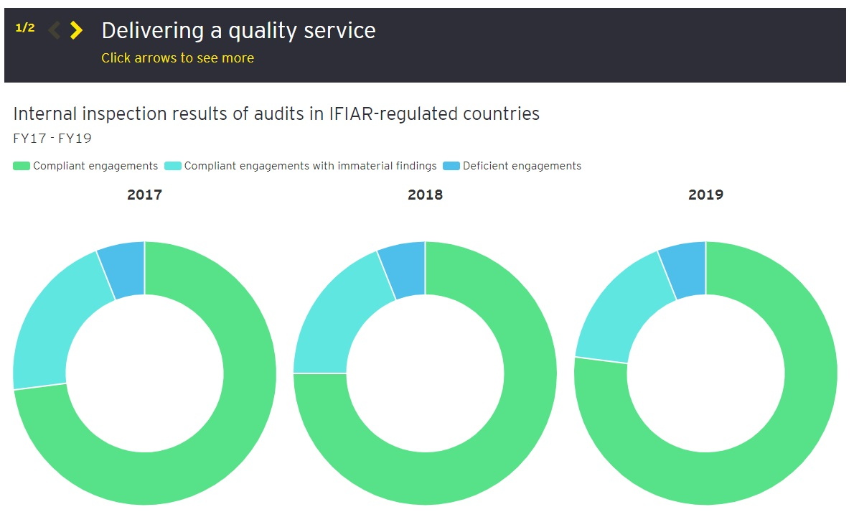
Figure 1: Delivering a quality service from EY’s website.

Understanding the Customers

Data and Security
Understanding customers comes from knowing them, and that in its turn comes from the amount of data a company manages to collect about them. When it comes to this aspect, a company must have a heightened awareness of what the legal boundaries are. EY takes this a step further than the average high street company or reseller. First off, their highly specialized team upholds and understand the latest legal requirements, but beyond that, they turned data collection and security into a product they offer (Baltzan and Philips, 2012).

SERVQUAL
To achieve a healthy bond with its customers, EY needs to provide value, and that is best done by following the SERQUAL model, also known as RATER. Designed initially for service firms and retailers, this model has five areas of focus: reliability, assurance, tangibles, empathy, and responsiveness. As COVID hit, the tangibles aspect – physical locations and in person interactions – shrunk, however EY must remain reliable – deliver timely a high standard of service, responsive – ensure communication is efficient and on time, assuasive – have a soothing effect through its employees, and empathetic – tailored approach to each customer. Overall, the two-part 22-point questionnaire, should strengthen CRM and determine how well EY is performing against the competition, by understanding what a customer sees as an ideal service and how the company is rated in their eyes (Kale, 2014).

Customer Expectations
Another aspect of understanding customers and managing the interaction with them efficiently, is knowing what they expect from the business. This is described as the trifecta between quality, cost, and time of a product – in EY’s case, service. For a company to remain successful it is of utmost importance to score top marks in all three categories.

Consumer Behaviour
Knowing a client’s behaviour is a more modern aspect of managing the interaction a business has with them, borrowing from psychology and sociology, and attempts to predict and outline patterns based on personal factors and external influences.
By constantly improving their products and by remaining present throughout the COVID19 lockdown phase, EY manages to position themselves as an opinion leader in their field. This in turn makes potential and existing customers more likely to turn to them when things will return to normal and the need for multidisciplinary services will expand (Solomon et al, 2016).

Customer Lifecycle
Same as products, customers have a lifecycle, a six-stage evolution they go through when engaging in a purchase. Initially, we have “awareness”, client becomes aware of the brand (something social media influencers make a living out of), then they move into “engagement” – a less mentioned step on its own traditionally – a stage where they begin seeking out the company’s promotional content to gather more information, a step with a stronger emphasis when the purchase is of a significant value. The stage that is entirely dedicated to research is “evaluation”. Here a potential customer will knock on a company’s door and start asking more about a specific product and put it in balance with what the competitors have to offer. Stage four is “purchase”, the point of decision finality, where a company can cure the approach they have to the customer, strictly limited to a transactional model or setting the foundation for a relationship. The next stage refers to “product and support experience”, and as Vala Afshar, Chief Digital Evangelist at Salesforce, explains it is “six to seven times more expensive attracting a new customer than keeping them” therefore this stage is the make it or break it point. According to “2018 State of Global Customer Service Report” released by Microsoft, 76% of consumers evaluate customer service as the truest measure of how valued they are by a company, and 97% claim is the deciding factor when it comes to whether they should stick with or leave a certain business. The final stage of the consumer’s lifecycle is “bonding”. This is the point where a good company nurture the relationship it has formed with the client and could reinitiate the cycle by convincing the customer to purchase again, and to promote their products to his/her peers (Schiffman and Wisenblit, 2015).

Achieving Business Objectives in Less-Than-Optimal Circumstances

Internal and External Factors
To better understand the path an organisation must follow to strive for greatness in the post-COVID era, we must analyse what it currently does well, where it could improve, what avenues will there be open for it and what might threaten its very existence. For this purpose, we are going to look at a SWOT analysis, a method often encountered in top organisations when it comes to evaluating their current position in the business environment and what the future strategy will be.
When it comes to EY’s strengths, they derive from its workforce, the company assembles groups of highly skilled individuals, driven by their own career progression and ambitions, which are constantly subjected to further trainings and development programs. By careful investments and a well thought spending pattern, the company also achieves a good return on capital expenditure, fact shown by the numerous successful new projects, as well as diversification of income streams. To further add on the company’s strength is a mature and experienced sales team, again with a focus on constant updating itself, capable of thoroughly explaining to the customer how to maximise the benefits of the offered service. Beyond its vast brand portfolio and successful product innovation, EY has a healthy distribution network making the most of the available market. All the above contribute to achieving high levels of customer satisfaction and conversion (Sakao and Lindahl, 2009).
In terms of issues the company should address, we are going to mention the gaps in product range which makes them more susceptible to competition from new players in the market, issue that would be best resolved by enhancing communication between the sales department and those responsible for product innovation. And when it comes to latter, EY weakness lies in a smaller budget allocated to R&D, in contrast to the industry’s norm. Also, the company’s spending aversion makes it slower at putting in places new technologies which would help with its expansion goals and geographical diversity of areas present that it is inhabiting. By contrast, the company spends a lot on new training new employees, due to high attrition levels.
When it comes to opportunities, EY should focus on the fact that technology bridges a gap between itself and competitors with a larger market share, therefore providing an avenue worth exploring. A new mentality focused on a better, greener planet is growing, which will in turn lead to more regulations, thus prompting the need for new products. This, alongside more cooperation between countries in a stable economic climate, leads to a market expansion characterized by customers willing to spend more. Lastly, EY’s opportunities are born from its readily available capital and that gives it the freedom to invest and diversify in new projects.
In terms of threats, the company is facing intense competition, be that from existing mature companies as well as start-ups. This is mainly because the market has provided a reliable and healthy return on investment, which made it attractive to an ever-growing number of players. Also, due to its business model, EY lacks consistency when it comes to delivering profitability as it cannot rely on a constant stream of new products. The company fluctuates between high and low numbers correlated to their innovation, which then may pose a risk when expanding during a low season.
The downside of the SWOT analysis is that it looks at individual details when describing a company and that dilutes the bigger picture. There are scenarios where strengths, weaknesses, opportunities, and threats can interchange, as one might say about new companies that threat the status quo, but at the same time they could be a great investment opportunity. The point to drive home from the above discussion is that EY must take in account the fluidity of the situation, whereas SWOT is mainly good at presenting a snapshot of it.

Value Creation
Currently and in the future, companies will be faced with a great financial strain, and that will make them highly reluctant to allocate their budget for acquisitions, unless those acquisitions can generate a significant and real return. The focus of a company will be on value creation, that is in understanding the customer’s needs and marketplace requirements, from there, creating a customer-oriented marketing strategy, deliver a better product and building a two-way advantageous relationship with prospective clients (Urban et al, 1987).

The 4Is of Customer Engagement
For successful navigation of testing times, a company must be able to engage its customers, be that on a cognitive level (brand awareness and company accolades), on an emotional one (providing an enjoyable experience, enhancing their senses), on a behavioural one (online metrics provided by website interaction, newsletter feedback), or on a social level (turning a customer into a brand ambassador and enlisting his/her social media interaction). The above detailed engagement is described by four metrics, namely, involvement, interaction, intimacy, and influence (Kotler and Keller, 2016).

Closing the Gaps
As with most interactions, there is still room for improvement, and that space – the gaps – is defined as the difference between what a customer expects to receive and what he/she perceive as having received. This manifests on five distinct levels, the first one being caused by a management’s inability to perceive the customer’s expectation, as it would be the case of a phone manufacturing company where the customer wants a cheaper and same quality phone, yet the company puts out a newer more efficient model that is far more expensive. Starting from this example, the company might correctly perceive the consumer’s requirements, but it does not impose a performance standard for itself, thus promising a cheaper phone but on a time scale unsuitable for the customer – gap number two: management perception and service-quality specification. Thirdly, there is a gap between service-quality specification and service delivery where a company attempts to create cheap and quality products, thus giving conflicting information to its employees and under-delivering to its customers. A fourth area to be improved if a company is to ensure success, is the gap between service delivery and external communication, where for instance a hotel posts professional pictures of their room that do not match reality. Lastly, a company must remain aware of the message it conveys with its actions – gap between perceived and expected service -, where a company may increase its fees for a service because that service engulfs another and that overall lowers the operating costs, but the customer may see it as a simple price increase and a reduction in service provided (Buttle and Maklan, 2015).

Critical Evaluation of Correct CRM Implementation

The Implementation Process
CRM is an acronym for Customer Relationship Management and is divided in three distinct branches: operational, collaborative, and analytical. To frame the term within a definition it can be a daunting task, because for as many perceptions of an ideal service there are, there is a distinct image of what CRM should be. In academia it is seen as a precursor to business strategy development, an information technology tool, and a communication strategy method. When we are addressing operational CRM, we are looking at the processes designed to improve efficiency and accuracy in our client interactions – how fast and how clear is my message to the client. On the other hand, collaborative CRM, deals with the above-mentioned processes in determining what means are at its disposal to facilitate communication. The analytical CRM occupies the space of understanding who is a company trying to sell to, and it includes customer profiles, reports, systems of segmentation, and all the relevant data collection involved therein.

Strategic Goals
In the previous lines it was observed how impactful and multifaceted the relationship with customers can be, further on, we will try and assess the critical stages in developing this bond. At the forefront of a model divided in 10 stages we have customer interaction and behaviour tracking. The in-person interactions have become scarce, due to technological growth and current pandemic, hence why there is a heightened focus on what happens online: we went from business dinners to Zoom calls and FaceTime, and that severely limits our ability to connect on an emotional level or to have an inkling of how we are perceived. For this purpose, CRM software is used, a tool that gathers data and creates customer profiles, all within the legal boundaries, respecting the Data Protection Act and GDPR requirements. Once we have achieved success in our information collection stage, we can move onto retention and repeat purchase via rewards and loyalty programmes. From Tesco to Starbucks and beyond, almost all companies use this strategy, creating a sort of digital currency (points, cashback, vouchers, private sale, event access) that entices an existing customer to remain loyal to the brand. To improve further CRM communication is key – putting the customer at the centre of the company’s intentions – and above all, an important step, is tailoring that communication to the individual. By changing a promotional email from “Dear Sir” to “Hi John!” a company moves into the inner circle of a customer and any message is seen as an advice from an old friend or family member, rather than a sales pitch. Also, it is crucial for a business to understand that its message must be clear and specific, people are more prone to respond to a call to action when the instructions are clear. The next focus should be on maintenance of the processes highlighted above: is the information I hold about the customer still accurate, has the profile been updated, and if so when was the last time that this happened? Image plays an important factor in CRM too, and so does a company’s relationship with its stakeholders: bad communication with the investors leads to bad press, and that in turn leads to reluctant spenders. Another major aspect of good CRM is correct identification of the relationship with each customer – think segmentation, thus the need for spending tier creation, frequency of contact, means of communication, and above all reducing the robot effect when interacting with the customer. You cannot have CRM without a fully integrated customer service team and their role should be addressing every issue that may occur. For this purpose, a company must ensure the team benefits from up-to-date training, required tools and good inter-departmental communication. Another duty a company must fulfil to ensure positive CRM is the creation and publishing of original content, be that through whitepapers, tutorials, or case studies. This method promotes the company as an important voice in their field and makes them more appealing to prospective clients. One of the last measurement tools in the CRM kit comes from giving an employee power to decide and independence over their area. By doing so, an employee can provide a better suited approach to a client and he/she can modulate their sales pitch to better fit with the customer. As with most things, there is a lot to learn from those that do things better than you, and that brings us to our final point: for quality CRM to happen, look at big brands in the field and learn from them, create partnerships, and expand on the existing knowledge.
The adherence to the stages above at EY is done religiously and that is one of their key drivers for success. However, by analysing them one by one we risk losing sight of the bigger picture. With EY, CRM starts with good and happy employees: plentiful paid apprenticeship opportunities, with salaries starting on the higher threshold compared to industry standards, upwards mobility, benefits packages, and most importantly empowerment and autonomy. This leads to exact customer relationship identification, which coupled with customer service integration, puts EY at the very top in most polls, be those conducted on behalf of employees, as well as for customers. One other strong feature the company has is constant quality content creation through its website, that in turn, establishes it as an authority in the consulting and accounting domain. They have the most professional and updated website out of the Big Four, as can be seen from the images below, as well as a smart approach to the content they publish: EY’s content seems tailored around answering the question “how can your life be better with the knowledge we have?” rather than a standardised company presentation. Also, the company has the most comprehensive guide when it comes to dealing with the COVID19 crisis, with articles and programmes spanning over a variety of topics – here they are answering the question “what is your biggest concern at the moment and how can our skillset supplement your efforts?”.

Ethical Considerations
Globalisation has led to people becoming more aware of their impact on the environment, and that in turn, reflects on their buying choices, where companies that have a lacklustre CSR policy are doomed to fade in the past. When a company positions itself in line with a customer’s core values and beliefs, it becomes an integral part of that person’s life and spending pattern. At EY, the need for sustainable product development and manufacturing is minimal since they are a service-oriented company, however, they have a strong focus on giving back to the world and offsetting their carbon footprint, through a program called EY Ripples, where they team up with impact entrepreneurs to bring clean and affordable energy to families in Sierra Leone, provide medical care in rural Chile, or safe sanitation in Kenya and India.
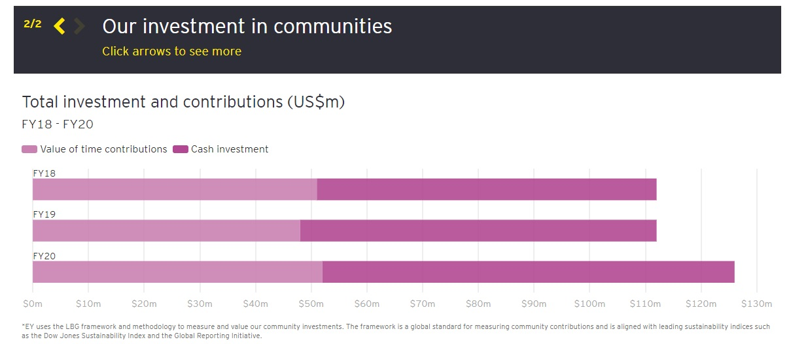
Figure 2: Investing in communities from EY’s website.

Vision and Process
In their own words, EY are driven by “future-mindedness, integrity, respect, and teamwork” and are a company that states that “the Transformative Age belongs to those who can reshape their performance, reimagine their ecosystem and reinvent themselves to drive growth”. Cumulated with a constant customer engagement, sustainable development, supported by an almost unbeatable track record in performance, and backed by more than 270000 experienced professionals in over 100 countries, EY has all the attributes to adapt and innovate in the face of COVID19, beyond that, has the potential of emerging a bigger and better company.
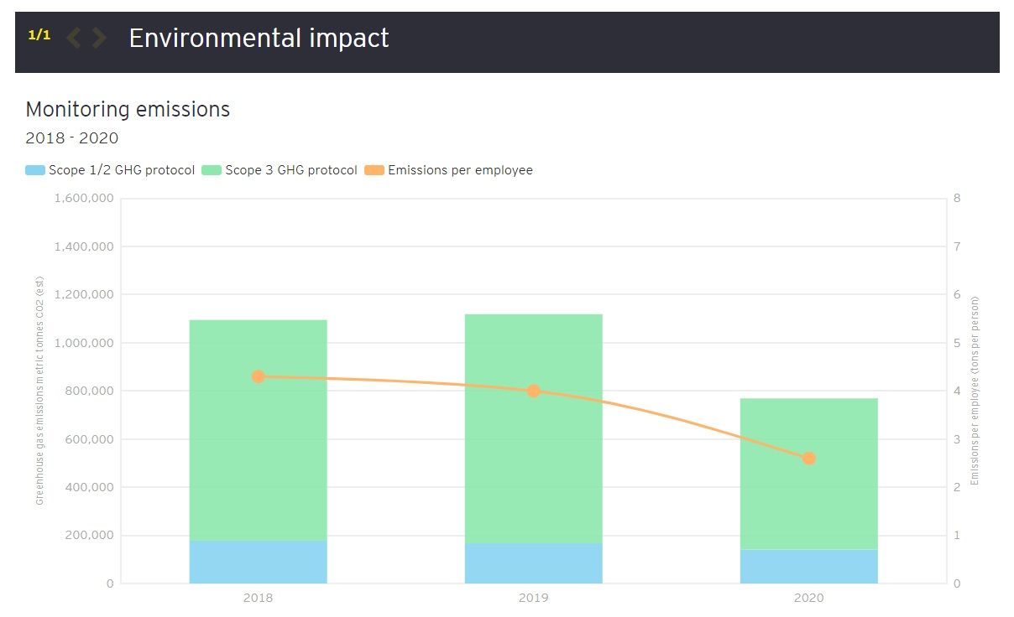
Figure 3: Environmental impact from EY’s website

Conclusion

When a company surpasses 100 years of constant growth, marked by an unbeatable track record, it makes them a sure winner at navigating the murky waters the global economy was thrown into. Coupled with excellent CRM, EY is on a decisive path to emerging out of the current situation in a better position than it was initially. The fact that they were able to understand that COVID19 is new, but at the same time the issues it brought about could be seen as something that companies have experienced before (possible reduction of customers, fewer physical locations, shrinking revenue, heightened health and safety awareness, the risk of rising isolationist policies, new government regulations, etc.), makes the company in itself an answer to the question “how do internal and external factors including COVID19 affect or influence organisation’s quality systems and controls for customers and how the organisation can deal with the new situation and achieve its business objectives by developing and maintaining good customer relationships?”.

References

Baltzan, P. & Philips, A., 2012. M: Information Systems. 1 st. Boston: McGraw Hill Higher Education.
Boone, L E. & Kurtz, D L., 2014. Contemporary Marketing. 16 ed. Mason, OH: Cengage Learning.
Brodie, R., Hollebeek, L. and Conduit, J., 2015. Customer Engagement: Contemporary Issues and Challenges. 1st ed. Abingdon: Routledge.
Buttle, F. & Maklan, S., 2015. Customer Relationship Management: Concepts and Technologies. 3 ed. Abingdon, Oxon: Routledge.
Chorafas, D., 2001. Integrating ERP, CRM, Supply Chain Management and Smart Materials. 1st ed. Boca Raton: CRC Press.
Eid, R. and Eid, R., 2013. Managing Customer Trust, Satisfaction, And Loyalty Through Information Communication Technologies. 1st ed. Hershey, PA: IGI Global.
Ferrell, O. C. & Hartline, M. D., 2014. Marketing Strategy: Text and Cases. 6 ed. Mason, OH: South-Western, Cengage Learning.
Ferrell, O. C. & Hartline, M. D., 2014. Marketing Strategy: Text and Cases. 6 ed. Mason, OH: South-Western, Cengage Learning.
Fjermestad, J. and Romano, N., 2006. Electronic Customer Relationship Management. 1st ed. New York: M.E. Sharpe.
Fogel, D. S., 2016. Strategic Sustainability: A Natural Environmental Lens on Organizations and Management. 1 ed. New York: Routledge.
Ford, B., Bornstein, j. and Pruitt, P., 2010. The Ernst & Young Business Plan Guide. 3rd ed. Toronto: John Wiley & Sons.

Ginty, M., Vaccarello, L. and Leake, W., 2012. Complete B2B Online Marketing. 1st ed. Hoboken, N.J.: J. Wiley & Sons.
Hooley, G. and Saunders, J., 1993. Competitive Positioning: The Key to Marketing Strategy. 2nd ed. Pennsylvania: Prentice Hall.
Kalbach, J., 2018. Customer journey maps. 1st Ed. O'Reilly Media.
Kale, V., 2014. Implementing SAP (R) CRM. 1st ed. Cleveland: CRC Press.
Keillor, B., 2007. Marketing in the 21St Century. Westport, Conn.: Praeger.
Kotler, P. & Armstrong, G., 2012. Principles of Marketing. 14 ed. New Jersey: Pearson Prentice Hall.
Kotler, P. & Keller, K. L., 2016. Marketing Management. 15 ed. Essex: Pearson Education Limited.
Kotler, P., Armstrong, G., Harris, L. C. & Piercy, N., 2013. Principles of Marketing. 6 ed. Essex: Pearson Education Limited.
Motiwalla, L F. & Thompson, J., 2012. Enterprise Systems for Management. 2 ed. Harlow: Pearson.
Ostrenga, M., Ozan, T., McIlhattan, R. and Harwood, M., 1992. The Ernst & Young Guide to Total Cost Management. 1st ed. New Jersey: John Wiley & Sons.
Payne, A. & Frow, P., 2013. Strategic Customer Management: Integrating Relationship Marketing and CRM. Cambridge: Cambridge University Press.
Peelen, E. & Beltman, R., 2013. Customer Relationship Management. 2 ed. Harlow: Pearson Education Limited.
Sakao, T. and Lindahl, M., 2009. Introduction to Product/Service-System Design. London: Springer-Verlag.
Schiffman, L. G. & Wisenblit, J., 2015. Consumer Behavior. 11 ed. Essex: Pearson Education Limited.
Solomon, M. R., Bamossy, G. J., Askegaard, S. & Hogg, M. K., 2016. Consumer Behaviour: A European Perspective. 6 ed. Harlow: Pearson Education Limited.
Urban, G., Hauser, J. and Dholakia, N., 1987. Essentials of New Product Management. 1st ed. Englewood Cliffs, N.J.: Prentice-Hall.
Young, A., 1948. Arthur Young and The Business He Founded. 1st ed. New York: Privately printed.
Weber, M., 2019. Three Key Marketing Strategies: What We Can Learn from Instagram's Enormous Success. 1st ed. Seattle: Independently Published.

Appendices
- Annual reporting in 2017/18: demonstrating purpose, creating value; available at : assets.ey.com › ey-com › en_uk › topics › assurance
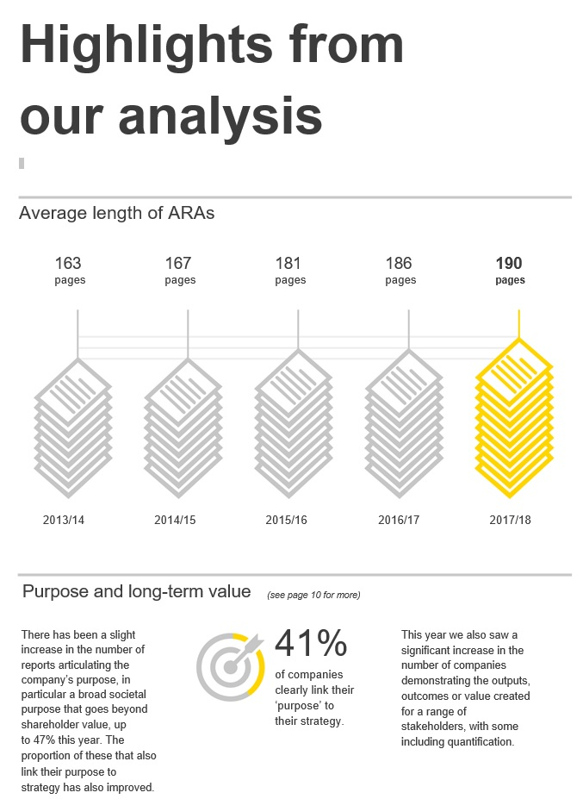
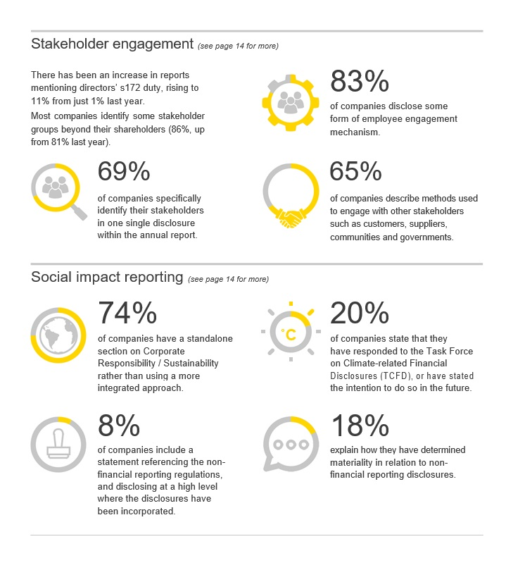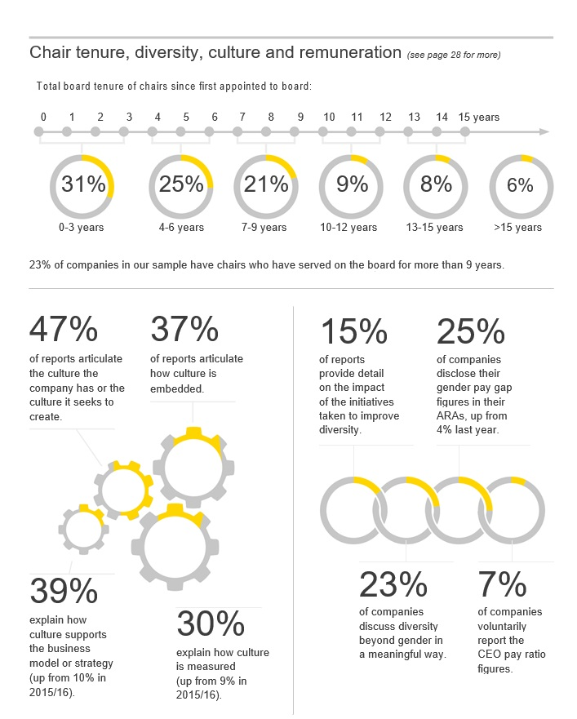

- EY UK Revenue and Remuneration from company’s website:
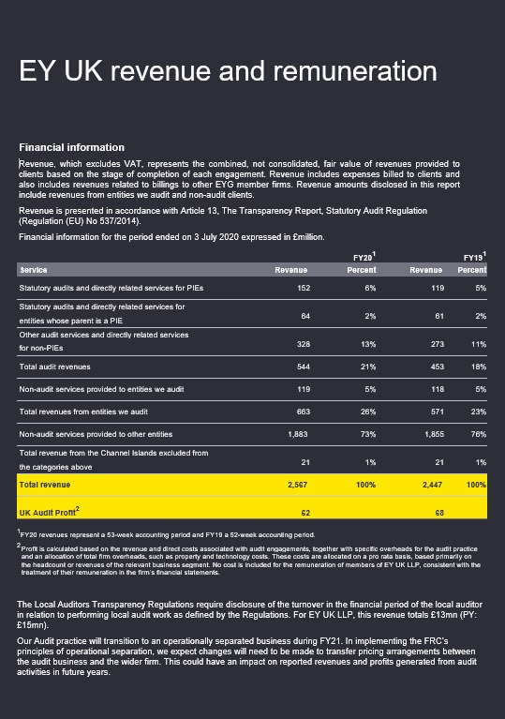

- EY Audit Quality Inspection available at: https://www.ey.com/en_us/assurance/audit-quality-report-2020?WT.mc_id=10811887&AA.tsrc=paidsearch&s_kwcid=AL!10073!3!475924495408!b!!g!!%2Baudit%20%2Bquality&gclid=Cj0KCQiA2af-BRDzARIsAIVQUOcdmvG6UfLlmBV6rU9waJicN7T9KJopR2kgs2LQYZS_7I7EkxPKZYsaAsm9EALw_wcB
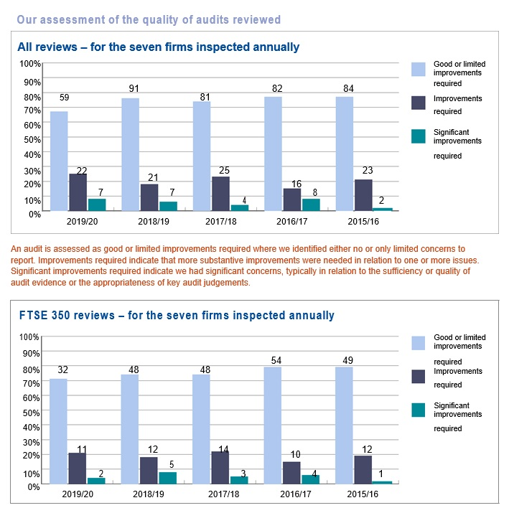

- EY Transparency Report available at: https://assets.ey.com/content/dam/ey-sites/ey-com/en_mt/transparency-reports/ey-malta-transparency-report-2019.pdf


