Cultural Sensitivity and Adaptation for German Guests: A Hotel Handbook

Module name / code: Cultural Awareness /BMIH 5003
Student Name: Florin Ciolacu
Word count: 1072
Lecturer: Rodrigo F. Aquilera
Executive Summary
Executive Summary This report explores the critical role of cultural intelligence and sensitivity in improving hotel guest service for international visitors, with a specific focus on German tourists. The report identifies key cultural differences, customs, and behaviors of German guests, and suggests practical measures for hotel personnel to enhance their guest service. The recommendations offered aim to improve the hospitality experience for German guests, promoting cultural understanding and respectful interactions.

Table of Contents:

- Introduction
- The Importance of Cultural Intelligence and Sensitivity
- Understanding German Culture: Customs and Etiquette
- Guest Service Implications for German Guests
- Do's and Don'ts for Hotel Staff
- Recommendations
- Summary
- References

1. Introduction
As the world becomes more interconnected, the hospitality industry stands at the forefront of this global convergence. It serves individuals from diverse cultural backgrounds, making cultural intelligence and sensitivity non-negotiable competencies in this industry. By understanding and respecting various cultural norms and practices, hoteliers can offer superior service that feels personalised and respectful to their guests, improving overall satisfaction and securing guest loyalty (Livermore, 2011).
This report concentrates on understanding Germany - a country with a rich cultural heritage and specific social customs and norms. It aims to arm international hotel staff with the requisite knowledge and tools to offer culturally sensitive service to guests from Germany.
The report begins with a critical evaluation of cultural intelligence and sensitivity in hotel personnel. It then delves into the distinctive cultural norms, values, and requirements of guests from Germany. Following this, we discuss how hotel departments/functions can adapt their service delivery to meet these requirements. For them to comply, a 'Do's and Don'ts' table is included as a briefing document for hotel staff.
The underlying objective is to underscore the importance of cultural intelligence as a cornerstone of superior guest service, equipping hotel staff with the skills to create a more culturally attuned and gratifying hotel experience for guests from Germany.
. 

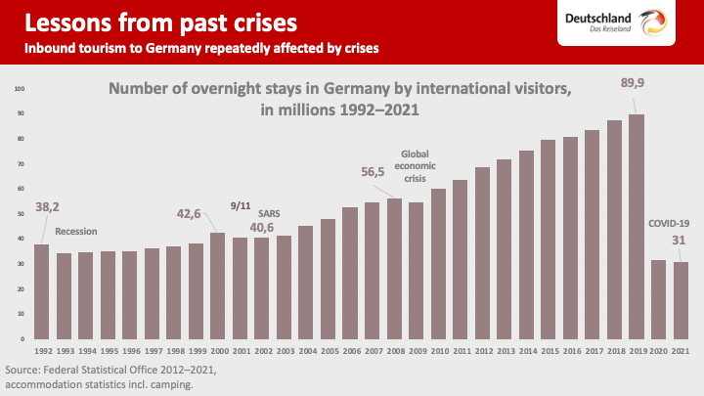





2. Cultural Intelligence and Sensitivity in Hospitality
Cultural intelligence (CQ) and sensitivity play a pivotal role in the hospitality industry. Essentially, cultural intelligence refers to the ability to adapt and function effectively in culturally diverse settings (Earley & Ang, 2003). In the context of hospitality, this means understanding, respecting, and appropriately responding to cultural differences that arise when interacting with guests from around the globe.
Cultural sensitivity complements this by encapsulating an awareness, acknowledgement, and respect for cultural differences. It involves recognising the nuances in various cultures and adapting one's behaviour to these distinctions. For hotel staff, displaying cultural sensitivity can significantly enhance the guest experience by creating an environment of mutual respect and understanding.
In the era of global travel, cultural intelligence and sensitivity become even more critical. International guests come with cultural norms and expectations, which can influence their perception of service quality and their overall stay experience. As such, hotel personnel must equip themselves with the necessary cultural knowledge and skills to meet these expectations and deliver superiorSeveral cross-cultural communication theories and models further underscore the importance of cultural intelligence and sensitivity
. Hall's high context and low context cultures theory (Hall, 1976), for instance, helps us understand how communication varies across cultures. Applying this understanding to a hospitality setting, we can better anticipate and navigate the diverse communication styles of international guests.
3. Understanding German Culture: Customs and Etiquette
Germany, with its rich historical legacy and multifaceted cultural tapestry, is characterised by a distinct culture of formality, punctuality, and an appreciation for privacy, directness, and efficiency. Understanding these cultural characteristics is key to effectively catering to German guests and ensuring their satisfaction with the hospitality experience.
Formality is a prevalent aspect of German culture, often seen in the way Germans communicate and interact with each other. In professional settings, this manifests as a preference for formal salutations and using last names when addressing individuals unless specified otherwise. This respect for formality extends to their expectations of hospitality service, with German guests likely to appreciate staff who approach courteously and professionally.

Punctuality, synonymous with reliability in German culture, is another critical factor. Timeliness in service delivery can strongly influence German guests' perception of service quality. Whether it's prompt room service or punctual shuttle services, timely delivery aligns with their cultural norms and is likely to be highly valued.
Directness and honesty are also deeply ingrained in the German communication style. Germans often value detailed information and clear, explicit instructions. Therefore, when communicating with German guests, hotel staff should strive for clarity and directness, avoiding ambiguity and evasive language.
Privacy is another vital aspect of German culture. Germans generally appreciate personal space and solitude. Understanding this cultural preference can guide hotel staff to ensure that German guests' privacy is respected, whether in room service, housekeeping, or other interactions.
Moreover, efficiency is highly esteemed in Germany. As such, German guests will likely appreciate quick and efficient service, emphasising getting the task done effectively and with minimal fuss.
In sum, understanding these customs and etiquette of German culture can equip hotel staff with the knowledge to tailor their service delivery, thereby enhancing the guest experience for visitors from Germany.

4. Guest Service Implications for German Guests Understanding these cultural norms can help hotel personnel tailor their service delivery. Receptionists should greet German guests formally and ensure prompt check-in and check-out procedures.
Room service and housekeeping staff need to respect guests' privacy and ensure efficient service. Similarly, restaurant staff should be prompt in taking orders and serving meals.

5. Do's and Don'ts for Hotel Staff
Do's | Don'ts
Greet formally | Address by the first name without permission
Respect privacy | Intrude personal space
Be punctual | Be late with services
Communicate clearly and directly | Use vague or ambiguous language

6. Recommendations
- Implement Cultural Sensitivity Training: Hotel management should consider implementing cultural sensitivity training programs for staff members. These programs should focus on understanding German cultural norms and preferences such as formality, punctuality, privacy, and direct communication. The training can equip staff with the knowledge and skills to offer tailored services that resonate with German guests.
- Introduce a Feedback Mechanism: To facilitate continuous improvement in service delivery, a feedback mechanism should be instituted. This can involve post-stay surveys or feedback forms, specifically designed to understand the experiences and expectations of German guests. The feedback collected can provide invaluable insights and can be used to make informed changes to service delivery protocols and procedures.

7. Summary
This report has emphasized the importance of cultural intelligence and sensitivity in the hospitality sector, particularly when catering to international guests. In the case of guests from Germany, understanding their cultural norms surrounding formality, punctuality, direct communication, privacy, and efficiency is crucial. Hotel staff must adapt their service delivery to accommodate these specific cultural preferences. To achieve this, it's recommended that hotels provide cultural sensitivity training programs focusing on German customs and implement a feedback mechanism for continuous service improvement. By respecting and valuing the cultural nuances of German guests, hotels can significantly enhance their guest service experience.

References:

- Earley, P. C., & Ang, S. (2003). Cultural intelligence: Individual interactions across cultures. Stanford University Press.
- Hall, E. T. (1976). Beyond culture. Anchor Press.
- Hofstede, G. (1984). Culture's consequences: International differences in work-related values. Sage.
- Lewis, R. D. (2006). When cultures collide: Leading across cultures. Nicholas Brealey International.
- Thomas, D. C., & Inkson, K. (2009). Cultural Intelligence: Living and Working Globally. Berrett-Koehler Publishers.
- "Germany - Language, Culture, Customs and Etiquette." (n.d.). Retrieved from Commisceo Global: https://www.commisceoglobal.com/country-guides/germany-guide
- "German Business Culture." (n.d.). Retrieved from Expatica: https://www.expatica.com/de/working/employment-basics/german-business-culture-101098/
- "Germany - The People." (n.d.). Retrieved from Culture Crossing: http://guide.culturecrossing.net/basics_business_student_details.php?Id=4&CID=82
- "Tourism in Germany – travel, breaks, holidays." (n.d.). Retrieved from Germany Travel: https://www.germany.travel/en/index.html

