

Portfolio: Elements 1-4

Module: Marketing Management

Apple Smart Desk Ecosystem brand extension

Module code: LCMB7024

Words: 2505

Student Name:Maheshwari Mehta
Student ID: 2531264

Lecturer Name: Mustakkima Afrin

Table of Contents
1. Introduction 3
Element 2: STDP Analysis for the brand extension 3
2.1 Segmentation 3
2.2 Targeting 4
2.3 Differentiation 5
2.4 Positioning 6
Element 3: Marketing Mix 7
3.1 Product 7
3.2 Price 8
3.3 Place 9
3.4 Promotion 9
3.5 People 10
3.6 Process 10
3.7 Physical Evidence 10
Element 4: Reflection 11
4.1 Experience developing the brand extension 11
4.2 Experience preparing and delivering the poster presentation 11
4.3 Key skills, knowledge, and insights 11
4.4 Enhancing approach and performance in similar future projects 12
5. Conclusion 12
References 13
Appendix (Element 1): Poster 15

1. Introduction
In this report, the experience of the Apple Smart Desk Ecosystem brand extension development (referred to in the Appendix) will be evaluated. The STDP analysis and marketing mix will demonstrate the detailed aspects of the brand extension strategy suggested for Apple. It will examine the skills, knowledge, and insights that were acquired and evaluate their role in personal and professional development.

Element 2: STDP Analysis for the brand extension

2.1 Segmentation
Segmentation Variable | Key Market Segment | Description
Geographic | Urban, developed, and emerging economies, such as the US, UK, India, Singapore | The focus of this extension will be on metropolitan regions with a high rate of hybrid work, digital infrastructure, and demand for smart workspace products
Demographic | Professionals, entrepreneurs, and students, aged 20–45 years, with high disposable income | It will target people who can afford premium products and need technologically advanced working conditions to be productive and multitasking
Psychographic | Tech-savvy, innovation-driven, design-conscious individuals | This product development appeals to consumers, who prefer seamless integration, minimalistic design, brand prestige, and augmented productivity using advanced technology
Behavioural | Loyal Apple users, early adopters, and productivity-focused consumers | It includes consumers who are loyal to the Apple ecosystem, those who constantly upgrade their devices, and want to get convenient and built-in online experiences in their daily working life
Table 1: Segmentation for the brand extension
(Source: Self-developed; idea from Apple, 2024)
Apple Smart Desk Ecosystem, AppleDesk is aimed at urban markets of developed and emerging economies where hybrid work is common. Professionals, entrepreneurs, and high-disposable-income students, 20-45 years old, should be interested in this brand extension. The segment also consists of loyal Apple users, who are keen on integrated digital ecosystems. Individuals who adopt smart technology early, as well as those who are interested in convenience and high-quality workspace solutions, will be interested in this. These segments are very active, brand-savvy, and ready to spend money on products that can help improve performance, organisation, and general work-life experience.

2.2 Targeting
The main consumer of the AppleDesk is a well-established follower of the Apple system of products who is an urban, business-oriented, and creative person aged 25-45 years. These users usually possess several Apple products like MacBooks, iPads, and iPhones. They appreciate having a seamless flow of their work. They are average and high-income earners and thus can afford high-quality solutions that will improve their lives and work quality. These consumers are very tech-savvy, efficient, convenient, and aesthetics driven. They like simple free-space surroundings and like products that are quite practical and yet have some sophisticated design. This will align with the diffusion of innovation theory as the target consumers can be early adopters for the innovative solution (DRI Staff, 2025). They should be efficient in adapting new technology and are interested in brand reputation along with seamless user experience. They are also eco-friendly, which is in line with the sustainability program of Apple. The AppleDesk will be a useful extension of their work and life, which is hard to resist.
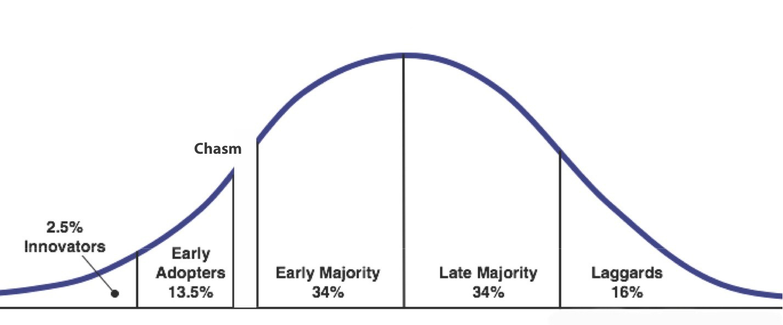
Figure 1: Diffusion of Innovation theory
(DRI Staff, 2025)

2.3 Differentiation
Apple can differentiate itself from the direct competitors, like IKEA, Samsung, and Microsoft, in terms of the AppleDesk. Although IKEA has provided intelligent solutions to furniture, its products are rather affordable and modular instead of being technologically integrated (IKEA, 2022). In comparison, Apple will offer a premium, all-in-one workstation that is easily aligned with its electronics to establish a single digital experience. In terms of innovation, Samsung is offering connected smart devices in the home appliances field (Samsung, 2026). However, it does not offer a unified, desk-focused ecosystem. Microsoft provides the customers with software solutions, including Surface devices (Microsoft, 2025). However, it does not focus on physical workspace infrastructure with the hardware-software synergy. Herman Miller and Google are two of the indirect competitors of Apple in this aspect of brand extension. Herman Miller sells high-quality ergonomic office chairs, which are oriented more toward comfort than on technological connectivity (Herman Miller, 2026). Google sells smart home systems as well as covers workspace improvement (Google Store, 2025). They both do not offer a fully integrated system, which resembles Apple's Smart Desk Ecosystem to users. Differentiation of Apple is the ability to integrate hardware, software, and services into one end-to-end intuitive platform, which improves workflow efficiency and improves user experience.

2.4 Positioning
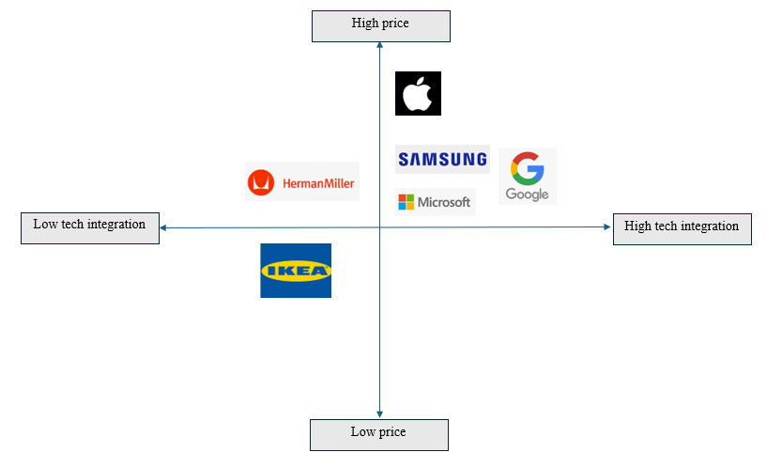
Figure 2: Positioning Map
(Source: Self-developed)
The positioning of the Smart Desk Ecosystem by Apple is based on the concept of an advanced, one-stop smart workspace tool that is unique and convenient by positioning itself as a premium product targeted at technologically advanced professionals (Apple, 2024). It is placed to be more than a piece of furniture or technology but is a lifestyle improvement. This brand extension product will connect technology with a convenient lifestyle. Such positioning is one that not only makes it stand out among the fragmented competitor proposals but also enhances the quality of the Apple ecosystem, which is a compelling value proposition to its customers and investors alike. AppleDesk is at the upper-right quadrant, which means that it has high technological integration and high price. It separates itself by way of flawless ecosystem connectivity and high quality of design. The position that Apple holds is an empty niche of luxury, design and integration of deep tech, which forms a strong competitive edge.

Element 3: Marketing Mix

3.1 Product
Apple Smart Desk Ecosystem will be a luxury, all-in-one workspace system that brings the Apple system to the real world. The product integrates the services, hardware, and software with in-built wireless charging areas, touch-based user interface, and synchronization with Apple products (Apple, 2024). Strategically, it corresponds to product differentiation and lock-in within an ecosystem, whereby the value is created due to interoperability and not single-purpose technology. The AppleDesk promotes productivity in contrast to traditional desks because it minimizes device fragmentation. Its simplicity and usability, as mirrored by its design philosophy echoes the Apple design philosophy, which further supports brand consistency. Sustainability elements to the product include energy-efficient elements and recyclable materials, which align with the increasing consumer preference for environmentally friendly innovation (Apple, 2025). The product approach helps the brand extension by building upon the core competencies of Apple, which are innovation, design, and integration into the ecosystem, and adapting to the changing demands of hybrid employees.
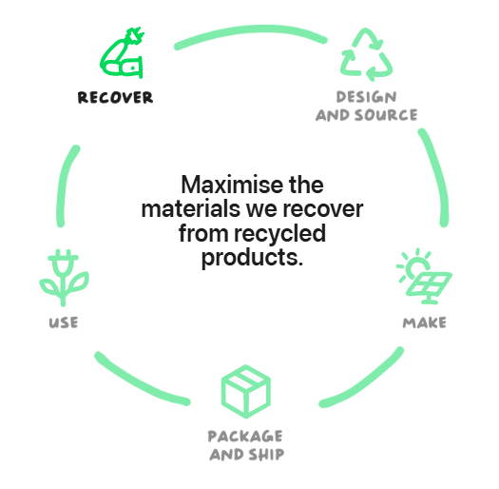
Figure 3: Apple’s sustainability initiatives
(Source: Apple, 2025)

3.2 Price
The AppleDesk is priced using the premium pricing model, which is aligned with the current market positioning of Apple. In this matter, Apple evidently follows the strategy to set a high price point, establishing a stronger perception of exclusivity and quality (Hong, 2025). It aims at the high-end professionals and their loyalty to the brand who can afford the costly workspace solutions. This is supported by the fact that the product has unique integration features, better design, and brand equity. Also, Apple has an opportunity to implement tiered pricing models by providing varying prices with the difference in features to increase the range of market accessibility without reducing brand status. Strategically, the high pricing helps to differentiate the brand and provides a sign of leadership in innovation (Bataineh, Sánchez‐Sellero and Ayad, 2024). It also enables Apple to have large margins as research and development costs are recovered. This will probably reduce the mass-market penetration, but it will reinforce the positioning of Apple as a luxury technology supplier and guarantee that its general brand extension strategy is aligned with the strategy.

3.3 Place
The AppleDesk will focus on existing direct-to-consumer platforms of Apple as its distribution platforms. This selective distribution approach guarantees the quality of brand experience, presentation of products, and interaction with customers (Angelina and Nurlinda, 2023). Apple Stores will offer a vivid experience where a customer can see the AppleDesk physically, which is very important in a high-involvement product. Also, the online channels are convenient and have a global coverage, which is especially significant to professionals in the city. Another entry option that Apple can pursue is into B2B markets, including co-working spaces and corporate offices, with the assistance of retailers of premium office furniture and corporate partners. This mixed distribution model is between intensive and selective distribution models, with exclusivity and accessibility (Seifert et al., 2023). Apple is able to do this by using its established retail infrastructure to maintain uniformity in the customer experience, and it also provides it with the ability to aid the entry of this new product range.

3.4 Promotion
The marketing communications (IMC) that will be incorporated in the promotion plan will be digital marketing, experience campaigns, and influencer programs (Rehman, Gulzar and Aslam, 2022). Product launch events, social media campaigns, and targeted advertisements can be used by Apple to create anticipation and awareness. Messaging will be emphasized in the demonstrations that highlight the smooth integration of devices and benefits in terms of productivity. Credibility and reach will be enhanced through influencer marketing, particularly among the technologically working population and art communities. The storytelling style of Apple, which focuses on lifestyle change rather than on technical details, will appeal to the target audience greatly (Apple, 2024). Moreover, the perceived value can be confirmed by content marketing that provides actual application cases. This marketing mix is aligned with the differentiation and emotional branding strategy, and the AppleDesk is a revolution in workspace solutions. Through its ability to consistently create and deliver on its brand promise, Apple is able to build on customer engagement as well as investor trust in the brand extension.

3.5 People
The workers have a very important role to play in the provision of the AppleDesk experience, especially with the highly trained Apple retail employees and customer care services. The employees will be considered as brand ambassadors, who will take customers through the features of the products and show their integration capabilities. This aligns with relationship marketing where individualised contacts lead to customer satisfaction and customer retention (Rane, Choudhary and Rane, 2023). Apple has always focused on training so that they can be able to convey the value proposition of the product, which forms the gap between technology and user experience. Besides, the sales services, such as installation facilities and technical training, will be necessary after sales of a product as intricate as this one. Apple has invested in human resources and service delivery, which makes the customer experience smooth, and on the same note, with a premium brand image.

3.6 Process
The process aspect is aimed at providing an effective and easy customer experience, from purchase to consumption. Apple can adopt an efficient purchasing mechanism using its online and offline platforms, such as customisation and delivery/installation services on demand. The ability to integrate with Apple ID and existing devices means a fast and simple setup will be achieved and will help to overcome the adoption barrier (Apple Inc., 2026). This is in line with service blueprinting and customer journey optimisation strategies that are based on convenience and efficiency.

3.7 Physical Evidence
The physical evidence plays an important role in supporting the premium position of the AppleDesk. The retail outlets, product packaging, and even the design of the desk used by Apple also add to the brand perception (Apple, 2024). Elegant, minimalist design, quality materials, and a user-friendly interface can be taken as clear physical evidence of Apple, which pursues excellence. Credibility and trust are further promoted through in-store displays where the customers get to interact with the product (Rehman, Gulzar and Aslam, 2022). Also, digital interfaces, user manuals, and customer care websites are consistent in design and usability. Through its coherence and quality physical presence, Apple reinforces the perceived value of AppleDesk and promotes the effectiveness of the brand extension strategy.

Element 4: Reflection

4.1 Experience developing the brand extension
The process of coming up with the Apple Smart Desk Ecosystem brand extension was an interesting and informative experience that enhanced my knowledge about strategic marketing and innovation. It also forced me to be critical of how an already existing brand can be developed into a new product line without losing the essence of the brand. I also got to understand the significance of matching product features with brand values, especially in the design, integration, and user experience. It also helped in my skill of putting theoretical frameworks, including those of market segmentation and the marketing mix, into practice.

4.2 Experience preparing and delivering the poster presentation
My poster presentation creation and presentation as well contributed to my development of skills that allow me to present a complicated concept in a clear and concise way with the help of a visual format in a way that can be easily understood. I had to be keen with the choice of vital information in a manner that would make the material not only informative to the audience, but interesting as well. This improved my skills in visual communication, layout designing and addressing the audience. Another advantage of the presentation to me was in terms of confidence in my capabilities regarding speaking in front of people, since I had to be capable of expressing my ideas and responding to questions. The experience has highlighted the importance of being explicit, organized, and communicating a story when selling a business idea, especially when one wants to persuade investors, not forgetting prospective customers.

4.3 Key skills, knowledge, and insights
During the process, I was in a position to acquire a lot of information regarding consumer behaviour, market trends that are coming up, and how innovation can be employed to sustain a competitive edge. I got to know the value of how a brand could generate value by adjusting to evolving customer demands such as the need to offer smart, integrated, and sustainable solutions. My research skills were also tested when I was able to analyze the information on the issue and apply it to support my arguments. The experiences have also contributed greatly to my personal and professional development since they have equipped me with transferable skills such as critical thinking, problem solving, creativity, and effective communication skills that are inevitable in marketing and professions that involve business.

4.4 Enhancing approach and performance in similar future projects
I need to be more proactive for extensive research so that I can use more perspectives, including consumer comments and industry knowledge. In this matter, I will also try to enhance my designing and technical skills that can properly sharpen my creativity. It would be possible to constantly improve by asking peers and mentors to provide feedback during the process. The more iterative and reflective approach will enable me to optimize the quality of my work and improve my performance in general in a comparable academic and work project.

5. Conclusion
Conclusively, this report shows that the brand extension process can help the brand to develop strategic solutions and marketing initiatives to meet the requirements of the target consumer base. Such a brand extension strategy will help Apple to be more innovative and perform better in the marketplace as a tech company.

References
Angelina, J. and Nurlinda, R.A., (2023). The influence of brand experience and brand personality on brand loyalty through brand love. Jurnal Scientia, 12(03), pp.2677-2693. https://pdfs.semanticscholar.org/5897/7506ab2d75c65bde4425de966e15301ebd79.pdf
Apple (2024). Apple empowers developers and fuels innovation with new tools and resources. [online] Apple Newsroom. Available at: https://www.apple.com/in/newsroom/2024/06/apple-empowers-developers-and-fuels-innovation-with-new-tools-and-resources/ [Accessed 28 Mar. 2026].
Apple (2025). Environment: We’ve reduced our emissions by over 60%. [online] Apple. Available at: https://www.apple.com/in/environment/ [Accessed 28 Mar. 2026].
Apple Inc. (2026). Apple Account – Official Apple Support. [online] Apple.com. Available at: https://support.apple.com/en-in/apple-account [Accessed 28 Mar. 2026].
Bataineh, M.J., Sánchez‐Sellero, P. and Ayad, F., (2024). Green is the new black: How research and development and green innovation provide businesses a competitive edge. Business Strategy and the Environment, 33(2), pp.1004-1023. https://doi.org/10.1002/bse.3533
DRI Staff (2025). Chasm Theory Development: The Complete History. [online] Diffusion Research Institute. Available at: https://diffusion-research.org/research_articles/chasm-theory-development/ [Accessed 28 Mar. 2026].
Google Store (2025). Google Nest Smart Home. [online] Google Store. Available at: https://store.google.com/category/connected_home?hl=en-US [Accessed 28 Mar. 2026].
Herman Miller (2026). Herman Miller - Modern Furniture for the Office and Home. [online] Hermanmiller.com. Available at: https://www.hermanmiller.com/en_in/ [Accessed 28 Mar. 2026].
Hong, T.K., (2025). Leveraging Internal Capabilities for Competitive Advantage: A Case Study of Apple Inc. https://www.researchgate.net/profile/Kwan-Hong-Tan/publication/391347739_Leveraging_Internal_Capabilities_for_Competitive_Advantage_A_Case_Study_of_Apple_Inc/links/68139cf9df0e3f544f5040fa/Leveraging-Internal-Capabilities-for-Competitive-Advantage-A-Case-Study-of-Apple-Inc.pdf
IKEA (2022). IKEA Launches New AI-powered, Digital Experience. [online] Ikea.com. Available at: https://www.ikea.com/us/en/newsroom/corporate-news/ikea-launches-new-ai-powered-digital-experience-empowering-customers-to-create-lifelike-room-designs-pub58c94890/ [Accessed 28 Mar. 2026].
Microsoft (2025). Boost Productivity with Surface and AI | Microsoft Surface. [online] Surface. Available at: https://www.microsoft.com/en-us/surface/do-more-with-surface/boost-productivity-with-surface-and-ai [Accessed 28 Mar. 2026].
Rane, N., Choudhary, S. and Rane, J., (2023). Hyper-personalization for enhancing customer loyalty and satisfaction in Customer Relationship Management (CRM) systems. Available at SSRN 4641044. https://papers.ssrn.com/sol3/Delivery.cfm?abstractid=4641044
Rehman, S.U., Gulzar, R. and Aslam, W., (2022). Developing the integrated marketing communication (imc) through social media (sm): the modern marketing communication approach. Sage Open, 12(2), p.21582440221099936. https://journals.sagepub.com/doi/pdf/10.1177/21582440221099936
Samsung (2026). Smart home with Samsung SmartThings | Samsung India. [online] Samsung India. Available at: https://www.samsung.com/in/smartthings/?srsltid=AfmBOoqk-9X6BBoA1kTp7BQ-nq1Jx_vxbc8S5XlpA0rH-sVBXAdaGDbF [Accessed 28 Mar. 2026].
Seifert, R., Otten, C., Clement, M., Albers, S. and Kleinen, O., (2023). Exclusivity strategies for digital products across digital and physical markets. Journal of the Academy of Marketing Science, 51(2), pp.245-265. https://link.springer.com/content/pdf/10.1007/s11747-022-00897-0.pdf

Appendix (Element 1): Poster

