BMSK4005
Reflective review of learning journey
Nicola brain 0811898

Introduction
My reflective review of my learning journey
This report will undertake a reflective review of my learning journey through personal development when looking to establish a career in management. This will include demonstrating knowledge and understanding of the learning process; support the narrative and conclusions with academic research, extracts, theories and models. To identify develop needs there will be a completed and detailed SWOT analysis on myself, three learning styles questionnaires that apply to me and finally will apply the GO MAD framework for myself. This will help me understand my starting position. This paper will identify barriers to my learning and development and how they were overcome, discussing what support is available. When addressing the development needs this report will discuss what learning and development options and interventions are available considering learning preferences, support mechanisms are available to me, a prepared PDP to achieve key learning objectives for myself, finally the monitoring development for myself. I have identified that there are many ways in which people learn.
.

A SWOT analysis is an incredibly simple yet powerful tool to help you develop your business strategy, whether you’re building a start up or guiding an existing company. SWOT stands for strengths, weaknesses, opportunities and threats; Strengths and weaknesses are internal to your company things that you have some control over and can change, opportunities and threats are external you can take advantage of opportunities and protect against threats.
Parsons, Noah (5th April 2018) https://www.liveplan.com/blog/what-is-a-swot-analysis-and-how-to-do-it-right-with-examples/

Strengths | Weaknesses
Team work skills | Confidence
Customer service | Close minded
Good listener | Negative
Communication skills
Opportunities | Threats
Meeting new people | Children
Driven | Travel
Improve knowledge

One strength about me is my good teamwork skills, an example of this is in my work environment, working with many people and leading the new employees’ teamwork is an essential skill. This skill is vital and valuable skill to have because being a manager requires good social skills. Another strength is my excellent customer service skills this skill is required in my field of work in order to achieve happy customers and a positive environment. The next strength I possess is being a good listener, this is a positive skill in a leader because it allows them to better improve their environment by taking on and listening to other people’s views and opinions. Then time management skills positively corelate with being a good leader and tie in to my learning journey because it allows me to properly assess how to prioritise my time and always be punctual to important events. Finally, my communication skills are a major component in my career goals and my learning journey because it has and will allow me to meet new people; broaden my audiences and develop my understanding of different environments.
My first weakness is my confidence, the lack of confidence in my studying puts me at a disadvantage in myself and in my environments; this makes it more difficult for to succeed in my chosen fields. The lack of confidence makes it hard for me to strive in my education and discourages me trying new things. My second weakness is my close mindedness this is challenging because it makes new situations harder to understand and develop in. This could be harmful to my education because I feel that my grades will never improve. Finally, I am very negative towards my education, linking with my other weaknesses I feel that I am not achieving my full potential.
One opportunity this will bring me is meeting new people this will be a positive experience because it will develop my understanding of different social cultures and therefore will impact my ability to lead. This course will allow me to become more driven, helping me get where I need to be to achieve my full potential; a strong drive will push me to improve and develop my education.
Primarily my children are the biggest threat to my education, the requirements of being a working mum takes crucial time away from my education, when I could be developing my studying I have to be accommodating to my children’s needs. However, I will turn this into an opportunity to become focused on achieving my goals. 58% of single moms have attended college or have at least a bachelor’s degree, and 32% earn $40,000+. Johnson, Emma October 6th (2017) https://www.wealthysinglemommy.com/single-mom-statistics/

My first learning style questionnaire is aimed to find my preferred learning style, the results to this questionnaire was that I am a reflective and pragmatist. Reflective learning is “learning derives from our experiences and can be constantly updated through the process of recording and thinking about the experiences we have.” University of Kent, June, (2012) https://www.kent.ac.uk/learning/PDP-and-employability/pdp/reflective.html. With a high score of 14, it is clear this is a learning style that is prominent in my education, showing that experiences are what drives my learning and pushes my education. A reflective learner sits back and thinks about what it is they are learning, they don’t rush in to deciding, this is a learning style that relates to me because I like to be shown what to do and learn from that, sitting back and reflecting on what was shown to me.
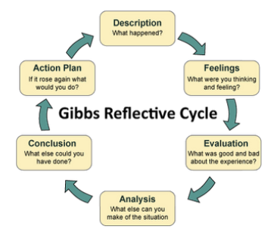
University of Kent, June, (2012) https://www.kent.ac.uk/learning/PDP-and-employability/pdp/reflective.html

“Pragmatists care about what works in the real world.” Skills you need https://www.skillsyouneed.com/learn/learning-styles.html this applies to me because I am very world oriented, in my experience a lot of my successes have been built off thoughts about relevance and practise. They are essentially practical, down to earth people who like making practical decisions and solving problems.
My next questionnaire was on personal effectiveness, I scored high in focused energy and situational responsiveness. With a score of 18 out of 20 I am clearly very focused. This will be a benefit to my study’s because I will be focused and dedicated on completing my assignments and presentations in the upcoming year. I had a low score of 12 out of 20 in competitive motivation this will be a downfall in my goal to be in a position of management so I will need to work on this.

Another questionnaire was the VARK questionnaire, there are many ways of learning and people all learn in different ways, I learnt that I am a kinesthetics learner which I would have to agree strongly with, I would much prefer to be shown how to do something rather than be handed a book because I feel I would learn more by what was being done rather than what was being said.

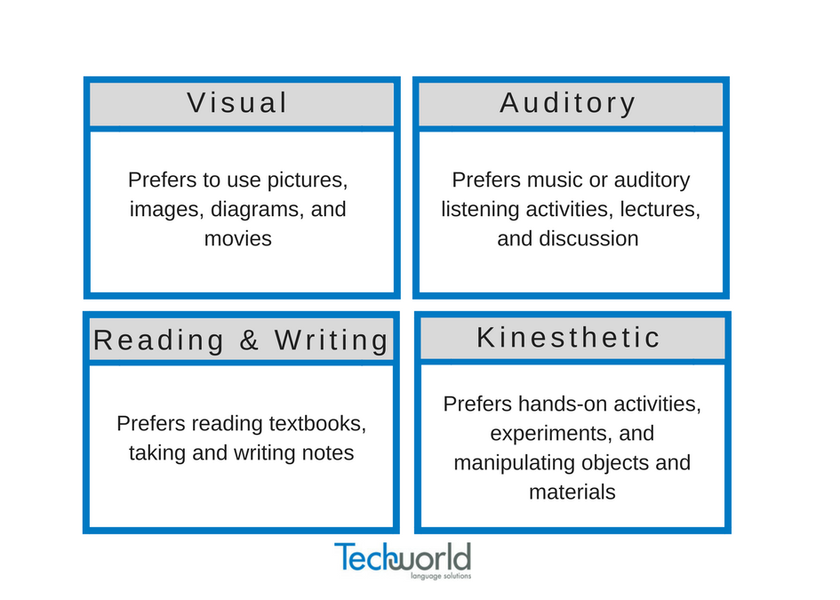

Honey and mumford was another learning style learned there is an ACTIVIST learner a THEORIST a PRAGAMIST and a REFLECTOR learner. An activist will involve themselves fully, thrive on the challenges are openminded. A theorist thinks things through step by step they tend to be perfectionist and think in a logical way. A pragamist are more practical and likes trying out new ideas; and sometimes respond to problems as a challenge. Then there’s the reflector I believe this is my learning style a reflector likes to stand back and observe, thinking about things before making their own points.

As the founding director of Thinkon Global, Andy Gilbert has been the driven force behind the values driven company he founded in 1996 and known, until recently, as go MAD thinking, which is now used by hundreds of thousands of people across the world. October 23 (2015) http://chriscooper.co.uk/radio-show/thinking-the-high-performance-way-with-andy-gilbert/

Making my goal smart it must be
SPECIFIC: What exactly you want to have completed?
MEASURABLE: How will you know whether you have completed it or not?
ACHEIVABLE: Are you likely to be able to achieve this goal/complete this work?
REALISTIC…in the timescale you have allocated? Or resourced: Do you have sufficient resources available to you?
TIME-BASED: By when do you want to have completed this? The shorter the timescale, the more precise you should be. Morgan, P, (2017 page 38) The business students guide to study and employability, London: Sage publications Ltd.

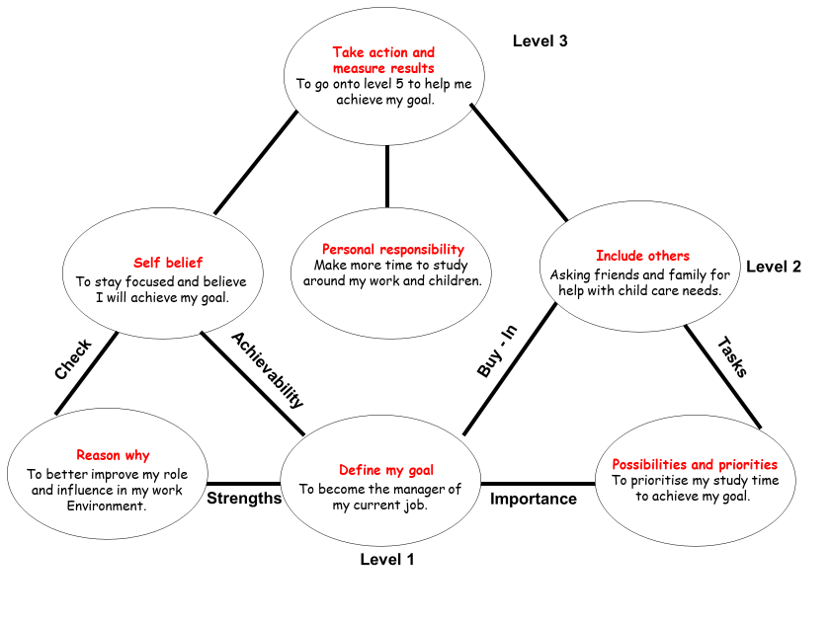

To achieve my goal of becoming a manager in my current job in two years’ time I will need to prioritise my time for studying and ask family and friends if any help is needed with childcare to focus on the aspects of my course that I feel the weakest in to therefore better increase my chances of getting the results I need. Taking action by studying hard will determine my results and end in success.

A personal development plan is an action plan that gets you from where you are right now to where you want to be in the future. This can incorporate learning hard skills (like project management skills) as well as soft skills (like active listening). February 8 (2013) http://www.smartselfdevelopmentplan.com/what-is-a-personal-development-plan

Personal development plan
Development  objective | Specific actions | Barriers and how they will be removed | Support required | How I will know when I have achieved the objective
Make more time for university work. | Set myself at least an hour a day for reading and studying. | Will have to manage time around work and child commitments. | Ask family and friends for help if needed with childcare. | When I’m on track with all my assignments and having good results.
To complete this course by January 2020 | Get all assignments and homework done on time. | Confidence and not understanding being a barrier, will visit the library and use resources. | Asking tutors for help if needed with assignments. | 2020 when the course ends.

A personal development plan identifies where I am now and where I want to be in the future it will help me improve on my own self-awareness. To increase my self-awareness I will also write down key plans and priorities, will ask at for regular feedback at work which will also help with my confidence. It helps establish your aims and recognise your strengths and weaknesses and will identify any need for improvement. However, in order to research your long-term goal, short term goals must also be completed in the process. Rolfe amber https://www.reed.co.uk/career-advice/personal-development-planning-what-you-need-to-know/
In order to achieve my goal of making more time for studying which will then help me complete my course by January 2020, I will set aside time everyday to complete work and assignments, in order to do this, I will have to overcome the barrier of my home commitments I will do this by asking friends and family for support.

CONCLUSION
overall my learning journey has been informative and useful for future goals, I have discovered my learning style preferences, my strengths and weaknesses and how to achieve my goals. All of this will be applied to my future aspirations and be effectively put to good use. My SWOT analysis as highlighted my strengths and weaknesses; I have discovered to effectively transfer my weaknesses into strengths and open possible future opportunities. Although, my learning journey can be a struggle with my confidence and a busy home schedule I feel that coming out of this experience I will be a much stronger and confident individual and a much more effective leader.

References

https://www.liveplan.com/blog/what-is-a-swot-analysis-and-how-to-do-it-right-with-examples/
https://www.wealthysinglemommy.com/single-mom-statistics/
https://www.kent.ac.uk/learning/PDP-and-employability/pdp/reflective.html
https://www.skillsyouneed.com/learn/learning-styles.html
http://chriscooper.co.uk/radio-show/thinking-the-high-performance-way-with-andy-gilbert/
. Morgan, P, (2017 page 38) The business students guide to study and employability, London: Sage publications Ltd.
http://www.smartselfdevelopmentplan.com/what-is-a-personal-development-plan
Rolfe amber https://www.reed.co.uk/career-advice/personal-development-planning-what-you-need-to-know/

