Michael Leather 2218482
Assignment 3
Task
Describe in 1000 words what the 1959 photograph of Jovanka Broz in Addis Ababa tells us about the Cold War history?
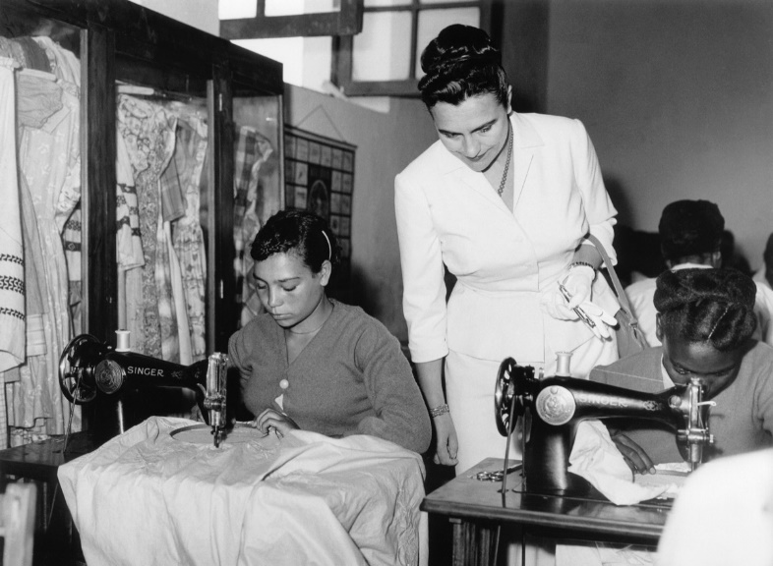

Although there is not much written about Jovanka Broz, she was the wife of Josip Broz Tito, the President of the State of Yugoslavia. She was 30 years his junior when they married in 1952, although Josip was young for his years and this discrepancy in ages was not unusual among southern Slavs. They were of similar background, coming from peasant beginnings and she proved herself to be the right qualities to be Josip’s consort and accompany him on his travels. She accompanied him many times and used to compile information on the customs and history of the countries they were to visit.¹
Jovanka’s presence, or more correctly, her accompaniment of the Yugoslav President to Addis Ababa in 1959 was part of the ongoing development by Tito of Yugoslavia’s foreign policy of developing relationships with the ‘3rd world’ countries during the period of de – colonisation and non - alignment movement that developed after the 2nd World War.
Josip Broz Tito came to power in Yugoslavia at the end of the 2nd World War, having proved himself during it to emerge as the leader of the Partisans and reuniting Yugoslavia as a federal republic. It was always Tito’s objective to establish a new state and protect it in the cold war world. He needed peace and stability to make his changes in a world that was being dominated by the 2 super powers and those that aligned with them. Tito wanted to protect Yugoslavia’s interests abroad and for that he needed stability. ²
Tito was a confirmed communist all through is life. Growing up from a peasant background, he followed the teachings of Lenin and Marx and in his 20’s secretly formed the Yugoslav communist party. He was even jailed for 5 years for his outspoken views, and was a staunch supporter of Stalin. However, in 1948, there was a falling out with the Central Committee of the USSR following accusatory letters from Stalin, which led to Yugoslavia’s expulsion from the Communist Information Bureau (Cominform). This heightened tensions between the 2 countries resulting in border tensions between Yugoslavia and the surrounding Soviet Bloc countries. Stalin ordered the Hungarian Army to mobilise on the Yugoslav border with the intention of invading. Had this happened, it is believed that Yugoslavia would have been lost; however, Stalin Hesitated, hoping that Tito would capitulate and stand down. Tito did not as he had a different interpretation of the doctrines of Lenin / Marx where the workers did in fact hold the power and control of their own destiny, an ethos he never forgot. This period led to isolation for Yugoslavia in a bipolar world as the surrounding countries of the Soviet Bloc ceased trading with them.
Tito turned to the west in 1950 when communist China entered the Korean War. Backed by the USSR, the West, in particular the USA saw this as a decoy by the USSR with their real intention being the possible intervention into Yugoslavia. Because of its Strategic position, Tito and Yugoslavia managed to get the West, again in particular the USA, to invest in arms and economic aid to such an extent that they were able to build up defences to a scale that they averted invasion and economic collapse and famine. “From 1950 to 1955, Yugoslavia received more than $700 million in economic aid and close to $1 billion in military aid.”³. Reconciliation came in 1956, 2 years after the death of Stalin.
Despite this western intervention, Tito resisted the pressure to join the newly forming North Atlantic Treaty Organisation, (NATO), and describes the relationship as a marriage of convenience. Tito did not want to be reliant on either of the ‘Super Powers’ and therefore embarking on a search for allies outside of these 2.
This period of time was also seeing the decolonisation and non - alignment of countries in Africa and Asia from their Imperial Masters, India being one of the 1st in 1947. This was an opportunity for the smaller European countries to form mutual non alignment pacts with others than those that aligned with the East or West.
The alliance with India did not bear fruit until 1954 as after the war and up to 1950, India still saw Yugoslavia as part of the Soviet Bloc and after this time could not comprehend their independence from the Western Bloc having received such substantial aid in the ensuing period. In fact, so low did India give to the initial alliance with Yugoslavia, that their diplomatic relations were dealt with the Indian Ambassador to Rome!!
The 2nd Italian – Ethiopian wars, (3 Oct 1935 – 5 May 1936), helped the formation of economic alliances Ethiopia and Yugoslavia. The Balkan Pact at the time (Greece, Turkey and Yugoslavia) had taken up the defence of Ethiopia’s independence and integrity, pressing for the strict observance of the League of Nations’ Pact. Add this to Yugoslavia’s issues with Italy over Trieste after the 2nd World War, it was easy to see why these 2 countries found common ground.⁴
Tito was becoming recognised as a very astute charismatic leader, feted by numerous well known world leaders and it was with these skills that he embarked on his travels to get other countries to align with Yugoslavia. In these exchanges between the participating countries, Yugoslavia were seen to send their experts to aid these countries such as port construction in Syria, Hydroelectric power stations in India and factories in Argentina. In 1961, in Belgrade, a Conference of Non - Aligned Nations was held, (the 1st of 2), and was attended by 25 heads of State. This established a neutral 3rd World order to take its place alongside the Free West and the Communist Bloc, as well as setting Yugoslavia into becoming the leading nation in an international movement that encompassed half the nations in the world, and whilst this Non alignment Movement, (NAM), did not become a world powerful force to stand alongside the world powers, it established Yugoslavia as a prominent nation in the world order.⁵

Bibliography
- Auty, Phyllis., Tito: A Biography, 1970, p288, Longman Group Limited
- Auty, Phyllis., Tito: A Biography, 1970, p246, Longman Group Limited
- Journal of Cold War Studies. No Bargaining Chips, No Sphere of Interest, 2014, Vol 16 (1), pp 146-179, MIT Press
- James, Mark. Betts, Paul., Socialism Goes Global, The Soviet Union and Eastern Europe in the Age of Decolonisation, CH 1 Berlin to Ababas, 2022, Oxford University Press
- Josip Broz Tito: The Rebel Communist. (Television Programme) A & E Television Works. 36 minutes. 1998

