

ANALYSING THE INFLUENCE OF DIGITAL MARKETING ON CONSUMER PERCEPTIONS AND ACTIONS WITHIN THE UK’S MOBILE TECHNOLOGY SECTOR

STUDENT NAME: SUFIYANHUSEN NAJIRHUSEN PATEL
STUDENT ID: 2309266
PROGRAMME: MBA – INTERNATIONAL BUSINESS
MODULE CODE: LCMB7020
ASSIGNMENT TITLE: DISSERTATION

Master’s Degrees by Examination and Dissertation
Declaration Form.

I SUFIYANHUSEN NAJIRHUSEN PATEL, declare that this dissertation has been composed by myself, that the work contained herein is entirely my own except where explicitly stated otherwise in the text, and that this work has not been submitted for any other degree or qualification, in whole or in part, except as specified.

Signature: SUFIYANHUSEN PATEL
Date: 01/10/2024

ACKNOWLEDGEMENT
I, hereby thank to all my family members and friends for lending their support while I was working on this research. It was of immense help that enabled me to complete this research in a successful way. A special thanks to my tutor and my university for letting me work on this project, providing me with the opportunity to understand and work on this topic.

ABSTRACT
Purpose: The research intended to assess the effect of digital marketing on consumer attitudes and behaviour in the mobile industry in UK. The study reflects its significance by conducting the present research on the contribution of digital marketing and its influence on consumer behaviour and attitudes toward purchasing products from mobile companies in UK.
Methods: The study with the help of primary methods and statistical analysis to present the online survey data gained in-depth knowledge about the selected research phenomenon more accurately and appropriately. It surveyed 50 marketing professionals with 12 close ended questions. The collected data were analysed using SPSS software that derived descriptive statistics, regression, chi-square test and Pearson correlation.
Findings: The results provide an understanding of the influence of consumer perception and their actions towards the digital marketing technique in the UK for the mobile technology sector. Through the SPSS analysis process, it is evident that there remains a correlation between the dependent and the independent variables. The results have shown that digital marketing needs to be undertaken by market practitioners to engage customers, however by seeing consumers’ actions. It has been found that consumer perception and their actions have a significant relationship over the digital marketing taking place in UK mobile technology.
Implications: The scholars or academic researcher who are willing to conduct research on a closer background can enrich their knowledge through the results of this study. Decision makers or marketing managers of mobile companies could gain profound knowledge about digital marketing and its influence on consumers’ perception. They could take suggestions from the findings of this study to maximise their potential in digital marketing efficiency.

Table of Contents
Chapter 1: Introduction 9
1.1 Background of the Research 9
1.2 Research Problem 10
1.3 Research Significance 12
1.4 Aims, objectives, and Research Questions 13
Aim 13
Objectives 13
Research Questions 13
1.5 Dissertation Outline 13
1.6 Theoretical Framework 15
Chapter 2: Literature Review 17
2.1 Introduction 17
2.2 Key Concepts 17
2.2.1 Digital Marketing 17
2.2.2 Consumer behaviour 17
2.2.3 User-generated content 18
2.3 Contribution of Digital Marketing to the UK Mobile Industry 19
2.4 Current digital marketing strategies practiced in the UK mobile industry 20
2.5 Opportunities with digital marketing in the context of the UK mobile industry 22
2.6 Challenges of digital marketing in the context of the UK mobile industry 24
2.7 Impact of influencer-generated Content on consumer behaviour and Attitude in the Context of the mobile industry 25
2.8 Theoretical underpinning 26
2.8.1 RACE model 26
2.8.2 Technology Acceptance Model 27
2.9 Literature Gap 28
2.10 Conceptual framework 29
2.11 Summary 31
Chapter 3: Methodology 32
3.1 Introduction 32
3.2 Research Philosophy 32
3.3 Research Approach 33
3.4 Research Design 33
3.5 Research Strategy 34
3.6 Research choice 35
3.7 Data Collection Method 36
3.8 Sample Size and Sampling Method 37
3.9 Data Analysis Method 38
3.10 Ethical Context 39
3.11 Research Limitation 40
3.12 Summary 40
Chapter 4: Research Findings 41
4.1. Introduction 41
4.2. Research variables and Hypotheses development 41
4.2.1. Research variables 41
4.2.2 Hypotheses Between Research Variables 41
4.3. Statistical analysis 42
4.3.1. Descriptive Statistics 42
4.3.2. Demographic Analysis 42
4.3.2.1. Correlation Analysis 45
4.3.2.2. Regression Analysis 47
4.4. Supported Hypotheses of this research 50
4.5. Summary 51
Chapter 5: Discussion 52
5.1 Introduction 52
5.2 Discussion of the results 52
5.3 Theoretical Contributions 55
5.4 Managerial Implications 56
5.5 Summary 56
Chapter 6: Conclusions and Recommendations 57
6.1 Conclusion 57
6.2 Linking with Objectives 57
6.3 Limitations and Future Research 59
6.4 Recommendations 59
6.5 Practical Implications 60
References 61
Appendix: Survey Questions 70

List of Figures
Figure 1.1: Influential of digital marketing channels on the buying decision of consumers 9
Figure 1.2: Increase in Social media advertising spending 11
Figure 1.3: Influence of social media marketing on purchase intention of customers 12
Figure 1.4: Dissertation Structure 14
Figure 2.1: Influential factors to consumer behavioural intentions 20
Figure 2.2: Contribution of digital marketing to business 21
Figure 2.3: RACE model 27
Figure 2.4: Conceptual framework 30
Figure 4.1: Descriptive statistics of the selected data 42
Figure 4.2: Statistics of the age group of the selected sample 43
Figure 4.3: Pie-Chart depicting the age group of the chosen sample 44
Figure 4.4: Demographic statistics representing the gender of the sample 44
Figure 4.5: Pie chart depicting the gender classification percentage. 45
Figure 4.6: Results of correlation analysis 46
Figure 4.7: R-squared value of the given model 47
Figure 4.8: ANOVA table for the given table. 48
Figure 4.9: VIF statistics and presence of collinearity 49
Figure 4.10: Collinearity diagnostic table 49
List of Tables
Table 4.1. Hypothesis Summary 51

Chapter 1: Introduction

1.1 Background of the Research
With the advent of modern technologies, business entities across the globe have perceived the need for modern marketing or promotional activities to conveniently promote their brands, services, or products in front of the target audience. According to Kurdi et al. (2022), in the contemporary and dynamic business trends, companies are found to shift from their conventional or traditional marketing approach to digital marketing practices to maintain business competitiveness and a strong customer base. Reflecting on Figure 1, the authors mentioned that eWOM (Electronic Word of Mouth) mediates in digital marketing channels such as email marketing, online marketing, social media, and websites that directly influence consumers' buying decisions. Nazarov (2020) showed similar perspectives to Kurdi et al. (2022) depicting that companies across the present business environment have devoted huge amounts of capital to establish digital relationships with their target and potential consumers. The author mentioned that consumer behaviour (CB) is often influenced by social status culture, product, price, fashion, reference group, communication, and others. Hence, digital marketing is found to play a crucial role in influencing CB and their purchase decision by maintaining a strong communication flow through digital platforms.
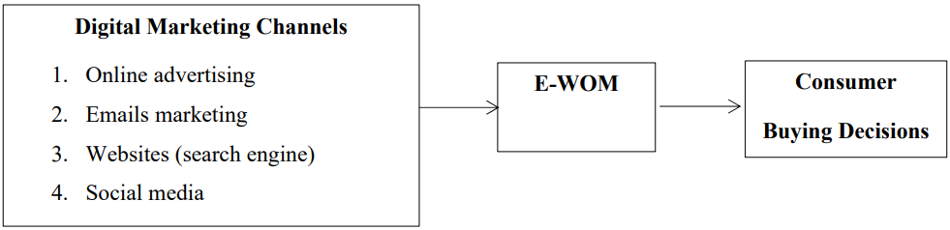

Figure 1.1: Influential of digital marketing channels on the buying decision of consumers
(Source: Kurdi et al., 2022)
In this present era, the internet has created enormous opportunities for business organisations to exploit the benefits of digital marketing practices. Al-Azzam and Al-Mizeed (2021) mentioned that with the help of different digital marketing channels businesses can effectively promote their brands, services, and products to the target audience, and at the same time, they can attract a wider range of customers, enhancing business Return on Investment (ROI) as well. The authors also added, that starting with email marketing, online advertising, mobile marketing, and social media platforms, consumer spending experience can be determined in real-time and convince customers to make purchases from specific brands successfully. Nam and Kannan (2020) in this regard underlined a report by Boston Consulting Group mentioning that within 2022, around 3 billion customers within the emerging market were the online customers which were expected to make around a $4 trillion purchase through online platforms. In this context, the author underlined the need for multinational organisations across the globe to design a strong digital marketing plan to understand the differences in socioeconomic, privacy, and cross-cultural factors that directly influence the customer buying journey. Thus, it can be asserted that digital marketing can be one of the major sources for organisations to improve customer perceptions towards brands and their engagement that positively drive consistent and long-term business growth.

1.2 Research Problem
Changing CB, lack of content quality, budget constraints, privacy, market competition, and others are the key challenges associated with the integration of digital marketing strategy. Failure to address these existing and potential challenges can negatively impact consumer perceptions and brand value to the respective market (Suleiman et al., 2020). Despite these challenges, the demand and popularity of digital marketing has been increasing dramatically. Reflecting on the following figure, it is identified that social media advertising spending across the globe has witnessed significant growth, predicting its increased growth to 355.8 billion USD within 2028 (Statista, 2024). In this regard, one of the key significance of carrying out the present study is to investigate the digital marketing methods that are considered by mobile companies in the UK. The contribution of digital marketing for mobile companies to drive their competitive edge in the UK is being addressed critically in the present research as well.
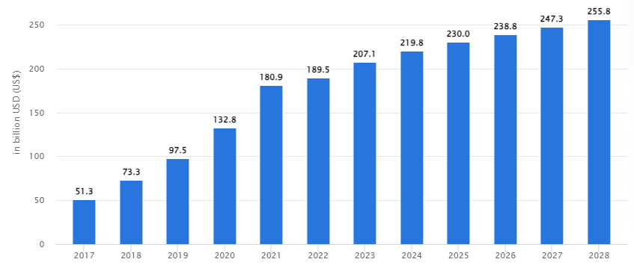

Figure 1.2: Increase in Social media advertising spending
(Source: Statista, 2024)
Successful marketing has a significant contribution to the accomplishment of long-term organisational success, customer engagement, and profitability within the respective market. Manzoor et al. (2020) asserted that social media platforms like YouTube, Facebook, Instagram, and others encourage consumers to post product reviews and their perceptions towards specific brands that influence customers who intend to make purchases like mobile phones. Thus, in line with this evidence, it can be mentioned that conducting the present research supports the purpose of gaining deeper insight into the digital marketing strategies considered by brands, specifically operating in the mobile industry in the UK to maintain their brand value, competitiveness, and long-term growth.
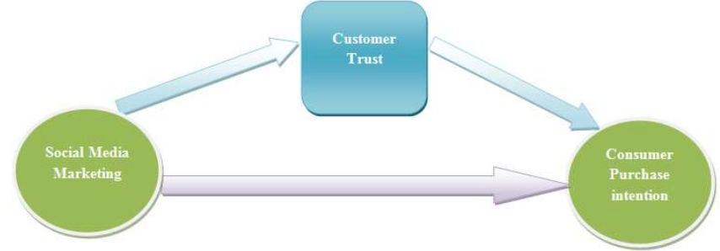

Figure 1.3: Influence of social media marketing on purchase intention of customers
(Source: Manzoor et al., 2020)
Reflecting on the present research area it can be mentioned that conducting the present research helps to gain insight into the areas associated with digital marketing approaches followed by the implication of the identified issue. Other than this it also helps to understand the way each digital marketing channel contributes to influencing consumer action and perceptions strategically in relation to the UK mobile industry.

1.3 Research Significance
The majority of the companies operating in the mobile industry have perceived the benefits that they can obtain with the help of digital marketing. Fondevila-Gascón et al. (2020) in this regard mentioned the effectiveness of social media marketing considered by mobile telephony manufacturers to influence the CB. The authors underlined the fact that different social networking sites such as Instagram, Twitter, Facebook, YouTube, and others are utilised by global mobile companies such as BQ, Xiaomi, Samsung, and Apple in terms of promoting their brands, services, and product ranges. Thus, the significance of conducting the present research is to gain deeper insight into the contribution of digital marketing to influencing consumer behaviour and attitudes toward purchasing products from mobile companies. Apart from this, conducting the present research helps to demonstrate the way companies operating in the mobile industry have been utilising the benefits and features of digital marketing to influence perceptions of their target audience followed by their market popularity and competitiveness.

1.4 Aims, objectives, and Research Questions

Aim
The main aim of this research is to assess the effect of digital marketing on consumer attitudes and behaviour in the Mobile Industry.

Objectives
- To investigate the different digital marketing strategies considered by companies operating in UK mobile technology industry
- To explore the opportunities as well as challenges witnessed by UK mobile technology companies with digital marketing
- To highlight the influence of digital marketing on consumer perception and behaviour.

Research Questions
RQ 1: What are the different digital marketing strategies considered by companies operating in the UK mobile technology industry?
RQ 2: What are the opportunities as well as challenges witnessed by UK mobile technology companies with digital marketing?
RQ 3: How do generated content and digital marketing influence consumer behaviour and attitude

1.5 Dissertation Outline
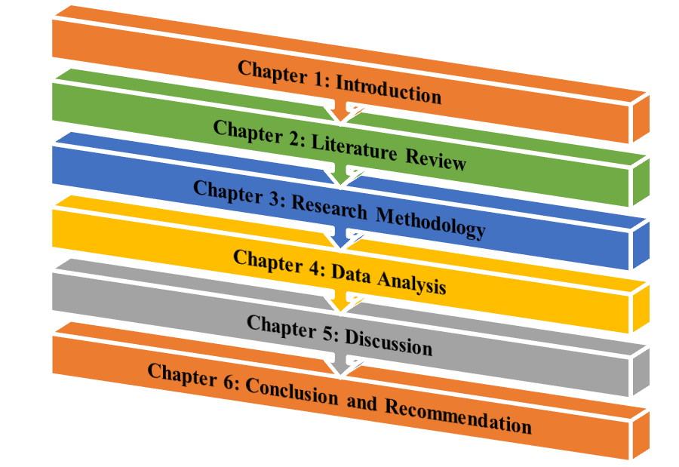

Figure 1.4: Dissertation Structure
(Source: Self-created)
Reflecting on Figure 5, the present dissertation is divided into six distinct chapters and the outline of each chapter is as follows:
Chapter 1: Introduction
This chapter has provided a brief outline of the background of the selected research area followed by the significance behind conducting this research critically. Apart from this, the research aim, objectives, and research question have also been highlighted based on which throughout investigation has been made.
Chapter 2: Literature Review
This chapter includes evidence obtained from different author’s perspectives that they have portrayed on similar topics. A comparison of each author's perspectives has been made by interlinking with suitable theoretical concepts and based on identified gaps in the existing literature conceptual framework has been developed.
Chapter 3: Research Methodology
This chapter offers a critical analysis of the selection of each methodological approach considered for collecting the required data. As this study includes primary quantitative data, a detailed illustration of the data collection process is included in this section.
Chapter 4: Data Analysis
This section includes numerical data that are being obtained from the primary qualitative data collection process and data interpretation to generate meaningful information from the statistical analysis.
Chapter 5: Discussion
This chapter includes a comparison of the authors' perspectives obtained from the literature review section with the statistical evidence obtained from primary quantitative data.
Chapter 6: Conclusion and Recommendation
This chapter includes an overall summarisation of the research findings followed by research limitations based on which future research scope and recommendations in relation to identified issues have been demonstrated.

1.6 Theoretical Framework
In the context of the present research, the RACE model and Technology Acceptance Model are being followed to perform a critical analysis of the selected research areas. The RACE model is considered a strategic framework that includes four marketing stages Research, Act, Convert, and Engage respectively (Masrianto et al., 2022). Consideration of this model concept supports gaining insight into the way mobile companies can increase the effectiveness of online marketing strategically to influence consumer perceptions.
In the context of the Technology Acceptance Model, it helps to determine the factors that digital marketing includes to influence perceptions of consumers towards specific brands operating in the UK mobile industry. This model concept helps to understand the way digital marketing can support mobile companies to understand the way target customers utilise or accept specific products, brands, or services (Camilleri and Falzon, 2021). Hence, both of the selected theoretical frameworks have supported the present research to generate more critical and meaningful insight into the selected research area.

Chapter 2: Literature Review

2.1 Introduction
The advent of technology has dramatically changed the way business organisations operating in the mobile technology sector have been carrying out their marketing and promotional activities. Thus, in the following segment, a critical and detailed evaluation of the selected research area is presented by considering the perspectives of different authors on similar research areas. A critical investigation of the research areas is being made by interlinking the research context with suitable theoretical concepts. A comparison of authors' perspectives followed by the gaps identified in the existing selected literature is identified in the following section to develop a conceptual framework.

2.2 Key Concepts

2.2.1 Digital Marketing
Digital marketing techniques have evolved significantly with the majority of businesses around the world utilising the internet and technology to share necessary information with potential consumers. The rapid increase in the use of the internet prompted the business to shift to a digital marketing medium that influenced the lifestyle of the common people. It helped form a closer relationship with the consumers and helped sustain the competitive nature of the business (Nuseir and Aljumah, 2020). The availability of the internet and smartphones provided the flexibility to consumers to access social media, websites, and other suitable platforms where businesses promote their content. It is also reflected in the accessibility to the consumers, which makes the marketing process effective for the companies. The businesses are taking support from the influencers and are investing in developing content that is relevant to the present market scenario (Chaffey and Ellis-Chadwick, 2019). For example, Nuseir and Aljumah, (2020), observed that in the US there are over $60 million being invested by businesses in developing digital marketing content, signifying its importance. Therefore, it shows that digital marketing has become significantly important for businesses and has improved the business reach to the consumers. Its contribution to the development of consumer behaviour is understood in the following section.

2.2.2 Consumer behaviour
Businesses are constantly developing their promotional process and content and it has a significant influence on consumer behaviour. The process of advertising on the most successful is found to be successful in entertaining the mindset of the consumers, which is crucial for the company's success. It prompted the business to conduct a market survey and understand the perception of the consumers, which plays a pivotal role in designing the advertisement (Sanchez-Sabate, and Sabaté, 2019). This highlights the reason that modern businesses are constantly seeing marketing changes, which promotes the desire of the business to fulfil consumer requirements. For instance, Bala and Verma (2018) with the help of a critical literature survey observed that electronic word-of-mouth or E-WOM is one of the potential techniques to spread the vision to the consumers. The identification of the right marketing channel has a major influence in generating the right result for the business. Now, E-WOM is further influenced through influential marketing or celebrity endorsement which fulfils the entertainment factors (Nuseir and Aljumah, 2020). The contribution of the customers in prompting the services of the business cannot be ignored in the modern era.

2.2.3 User-generated content
The previous section talks about the contribution of the consumers and this contribution is termed as the user-generated content. It is the unpaid service or the information posted by the consumers that results in the business promoting their services (Bala and Verma, 2018). Many businesses often rely on user-generated content to promote their services, while it influences the mindset of the consumers as well. Müller and Christandl, (2019) use secondary information to highlight that even though businesses are constantly working to promote their content, eventually consumer behaviour changes heavily with the content placed by other consumers on social media platforms. As the consumers review, any information placed in the online market related to the use of resources influences decision-making. For example, a person waving a negative comment about a product instantly gets affected by the negative vision. Even with technology, the user-generated content provides a summary of the vision of the other users. Hence, user-generated content affects consumer mindset. In contrast to the above observation, consumer reliance on user-generated content makes it an important factor in the promotion of businesses. Hence, businesses are concerned about user-generated content which are being put up on social media and internet platforms. In line with the thought process, Agarwal, (2020) also observed that social media interaction is critical for businesses to promote their services. The quality of feedback is considered important by most consumers because that improves the overall performance in the long run. Hence, user-generated content plays an important role in the digital marketing process.

2.3 Contribution of Digital Marketing to the UK Mobile Industry
The digital marketing process has proved to have a greater influence on the business in improving its overall position. Every industry has to find ways to promote its services, which varies with industrial requirements. Similarly, the UK mobile industry has to find ways to use the digital marketing process appropriately. Now that mobile is one of the essential services individuals need, its requirement varies with age. The vision is in line with the outcome observed by Al-Azzam and Al-Mizeed, (2021) who identified that digital marketing techniques also vary with consumer requirements. Now, one product is promoted in different ways to address the requirements of different consumer segments. The requirement of school or college goers to that of a working professional varies and thus, digital marketers have to adjust based on its requirements. The UK mobile market has been successful in addressing the requirements of consumers through digital marketing techniques. For example, it is identified that marketers invested 15.6 million pounds to promote their services and products digitally (Statista Research Department, 2023). The reason for making such a huge investment is because of its necessity and effectiveness in the promotion of its services. The consumers are influenced by the contents and the businesses are experiencing positive outcomes through the services.
The mobile industry is not only improving business-to-customer conversation but also using digital marketing techniques to improve business-to-business conversation. The resources are only as good as they fulfil the requirements of the consumers (Al-Azzam and Al-Mizeed, (2021). For example, the E-WOM technique improves the business reputation and encourages a positive relationship with its suppliers and it contributes to about an average income of 185 million pounds for industries operating in the UK (Statista Research Department, 2023). It signifies the impact of digital marketing on developing relationships with both consumers and other businesses.
The marketing strategy of Motorola, one of the mobile manufacturers of the UK industry depicted sophistication in its digital presence. Strategic use of online advertisement, SEO optimisation, and content marketing promoted the brand efficiently in the UK market. With over 15 million followers on Facebook and around 241000 followers on Instagram, the company showed the importance of SEO optimisation by focusing on keywords that are popular in the UK market to maintain a proper digital presence (The Brand Hopper, 2024). Similarly, Apple also succeeded in its marketing process, with a ‘less is more’ approach and has over 13000 followers on Facebook in the UK (Stroud, 2023). It depicts that digital marketing strategy is about understanding consumer's mindset to promote the services.

2.4 Current digital marketing strategies practiced in the UK mobile industry
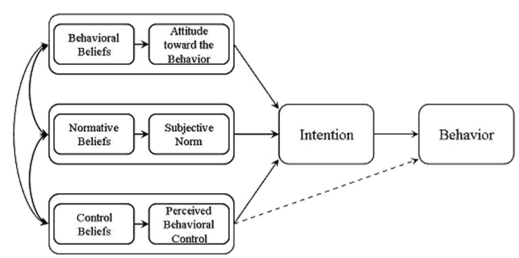

Figure 2.1: Influential factors to consumer behavioural intentions
(Source: Ajzen, 2018)
Understanding consumer behaviour and consumer psychology are considered two crucial aspects of the present dynamic business environment to maintain organisational growth and competitiveness within the target market. Presenting secondary qualitative data, Ajzen (2018) identified that the purchase decision of consumers is influenced by factors such as behavioural beliefs, normative beliefs, and control beliefs (Refer to Figure 5). These factors can further be influenced and understood with the integration of digital marketing strategies, increasing business opportunities to foster market growth and brand recognition. Supporting this evidence, Omar and Atteya (2020) underlined that email marketing has a significant and positive influence on the purchase decision of the target audience. Reflecting on the Egyptian market and presenting primary quantitative data based on an online questionnaire with a sample of 213, the authors identified the emergence of different digital marketing channels dynamically changing consumer purchase decisions. For example, email marketing is an effective strategic approach that has the potential to create a value of $38 with a spend of $1, increasing 3,800% ROI to the respective business (Omar and Atteya, 2020). In line with these above authors' perspectives, it can be articulated that Digital marketing supports companies to increase their sales values, customer acquisition, brand awareness, and others that help in maintaining long-term business stability and continuous growth (Refer to Figure 5).
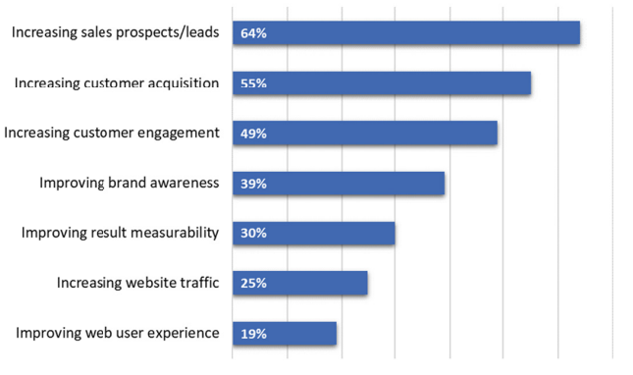

Figure 2.2: Contribution of digital marketing to business
(Source: Omar and Atteya, 2020)
Influencer marketing is identified as another digital marketing approach for brands operating in the mobile technology sector to gain attention from the target audience by increasing customer engagement. Lou and Yuan (2019) in this regard mentioned social media influencers as one of the key drivers for companies to influence perceptions of customers. With the help of primary quantitative data and online surveys among the users of social media, the authors mentioned that influencer-generated content has the potential to generate trust and affect the interest of the target audience towards specific brands. Supporting these authors' perspectives, Minarso, Natalia, and Saleh (2024) underlined the celebrity endorsement strategy by Samsung to promote their brands, products and services through social media platforms. Presenting secondary qualitative data, the authors underlined celebrity endorsement practices supporting Samsung to improve and strengthen their brand image and build trust among the target audience while advertising their products through social media platforms.
In the majority of cases, it is identified that consumers these days are more influenced by the lifestyle and the product information shared by their preferred celebrity on social media. Thus, interacting with target audiences and promoting brands on social media through popular celebrities supports mobile companies in enhancing their brand recognition and influencing perceptions of the target audience through strong and customer-centric influencers or celebrity-generated content (Hughes, Swaminathan, and Brooks, 2019). Though the existing literature has portrayed current digital marketing strategies utilised by mobile companies, it failed to consider a case example of the UK mobile industry, creating gaps in the existing literature in terms of the present research area.

2.5 Opportunities with digital marketing in the context of the UK mobile industry
The emergence of modern technology has changed the way consumers make purchases of their required products. To understand the perspectives and preferences of the target audience, companies operating across the mobile technology industry have been integrating digital marketing strategies. For example, with the help of a primary quantitative method, and explanatory survey with a sample of 100, Ittaqullah, Madjid, and Suleman (2020) mentioned that content shared on mobile marketing shaped the customer intention and their perspectives while purchasing a specific brand. This signifies the opportunities that digital marketing brings for mobile companies to promote their products and brands successfully attracting customers that enhance sales values and customer loyalty as well.
Digitalisation or integration of digital technology in marketing practices brings opportunities for companies to improve communication interfaces with channel partners, suppliers, and customers. Based on primary quantitative data and a survey with a sample of 167 international firms Wang (2020) identified that the usage of digital marketing creates opportunities for organisations to retain customers and maintain market competitiveness over their competitors accurately. Similarly, Khizar et al. (2020) underlined the opportunities that the mobile technology brand Samsung obtained through digital marketing to influence their target audience. With the help of primary quantitative data and a survey with a sample of 450, the authors underlined that the usage of social media platforms such as LinkedIn, Instagram, Facebook, YouTube, and others has increased dramatically and customers are more reliant on the content shared on these platforms.
Highlighting the case of Samsung, Khizar et al. (2020) underlined that building a strong presence on social media platforms helps brands like Samsung to understand the perception of their target audience toward their offerings. At the same time, reviews for Samsung products shared by customers also influence customers who intend to purchase smartphones (Khizar et al., 2020). Reflecting on these author’s perspectives it can be highlighted that digital marketing channels like social media bring significant opportunities for mobile technology brands to strengthen their global brand recognition.
With the advent of technology, improvement of digital marketing approach has been perceived with the help of emerging technologies such as Virtual Reality, Augmented Reality, Extended Reality, and others to improve customer purchase journey. For example, Soni et al. (2022) in this regard mentioned the demand for integrating Extended Reality (XR) in social media marketing in terms of influencing consumer perception significantly with the help of secondary qualitative data and a case study of OnePlus. The authors underlined the smartphone manufacturer OnePlus launched its popular Oneplus Nord segments at an AR event, offering opportunities for users to interact with the launched products virtually. Apart from this, while promoting products on Instagram, Oneplus integrates XR which supports the target audience to visualise virtual rendering of their offered OnePlus products in 3D helping to attract customers and gain strong customer engagement influencing positively their market popularity (Soni et al. 2022). Hence, it can be mentioned that mobile technology companies have been taking benefits through digital marketing channels to gain customer attention and long-term organisational growth.
Therefore, the considered literature for this section portrayed cases of different mobile technologies followed by their digital marketing opportunities. However, evidence for the UK mobile technology sector or companies or opportunities that identified mobile brands that were obtained while marketing in the UK digitally has not been addressed, creating limitations to the existing literature.

2.6 Challenges of digital marketing in the context of the UK mobile industry
Companies operating in the mobile industry are found to be taking enormous amounts of opportunities with the growing popularity of digital marketing channels. Kumar and Mittal (2020) with the help of secondary qualitative data mentioned that online or digital marketing allows marketers to maintain personalised content for their target audience and at the same time, brands can interact with a wider group of audience in real-time. On the contrary, the authors also made contradictory points highlighting key challenges associated with digital marketing. The authors mentioned privacy regarding user information, security, and the development of non-intrusive promotions are key challenges restricting companies from influencing target audiences positively towards brands. Apart from this, inaccurate or inappropriate product information is also found to be a commonly identifiable challenge for digital marketers, minimising operational efficiency and customer trust with brands.
Negative e-WOM is identified as another significant challenge that impacts negatively on brand repositioning and market popularity. Dwivedi et al. (2021) in this regard mentioned that in recent times, with the growing popularity of social media usage, people are more actively participating in sharing their opinions, and reviews on specific events, or specific products they purchased from popular brands. With the help of a secondary qualitative study, the authors identified through different digital platforms, complaints or negative reviews on specific smartphones offered by specific brands can reach millions of social media users across the globe.
Higher levels of negative reviews on specific mobile brands or their offered products can create negative perceptions towards those mobile brands, declining their brand popularity to the target market as well. Supporting this evidence Hayes et al. (2021) with the help of primary data and an online survey with a sample size of 112 revealed privacy as one of the major concerns for marketers that negatively influence customer perspective in terms of online promotional activities. In line with these author's perspectives, it can be underlined that privacy, non-intrusive promotions, inappropriate information, and others are the key challenges that can have a negative impact on brands that engage primarily in digital marketing.
Digital marketing has brought a significant amount of opportunities for companies to drive their business growth, brand recognition, and market popularity. With the help of primary data followed by an online questionnaire with a sample size of 128 participants, Aiolfi, Bellini, and Pellegrini (2021) underlined the popularity of data-driven digital advertising across the globe. For example, the demand and spending value on digital marketing increased by 2.4% in 2020 compared with the value in 2019, reaching 332.84 billion dollars in market value, reflecting its growing popularity across the global business environment (Aiolfi, Bellini, and Pellegrini, 2021). On the contrary, Aiolfi, Bellini, and Pellegrini (2021) underlined privacy concerns as major issues that bring negative consumer perception, creating complexities for brands to build customer trust as well. In line with these authors' perspectives, it can be articulated that failure to address the underlined challenges can minimise the opportunities for mobile companies to influence customer perception positively towards brands. These articles have offered a general overview of the risk of digital marketing, instead of focusing on challenges witnessed by mobile companies in the UK, creating gaps in the literature in relation to the present study.

2.7 Impact of influencer-generated Content on consumer behaviour and Attitude in the Context of the mobile industry
In this dynamic and highly competitive business environment, online reviews, or online content are found to play a significant role for both companies and consumers. Purchase decisions and perceptions of consumers are directly influenced by the content or the online reviews shared on different digital media platforms. With the help of primary quantitative data and an online survey with 300 Instagram users, Puspitasari and Aruan (2023) identified the contribution of influencer-generated content on purchase decisions. For example, the authors underlined around 92% of online viewers consider online reviews primarily for references while 93% of consumers make their purchase decision based on the reviews they obtained online. This has created urgency for the organisation specifically operating in the mobile industry to involve influencer-generated content to gain attention from a large number of audiences.
It is identified that influencers who constantly promote or share product reviews on social media platforms can influence their followers' purchase decisions with the help of their popularity and credibility. Supporting this evidence, Venciute et al. (2023) with the help of primary quantitative data and performing surveys with a sample of 7500 individuals claimed that influencer marketing can be considered as a strategic approach to social media marketing practices to increase brand awareness and brand image significantly. The authors also added, with the help of influencer marketing companies, to select the most popular influencer or celebrity, making them engage with their followers on social media to promote offerings of specific brands. Similar perspectives have been drawn by Mishra and Ashfaq (2023) in the context of influence-generated content effective for influencing customer perceptions. Based on primary as well as secondary data and performing surveys with a sample of 358 the authors asserted that the majority of the survey respondents agreed that they preferred online reviews followed by product reviews before making any purchase decision. In line with these authors' perspectives, it can be underlined that as customers are more influenced by the content shared by celebrities or social media influencers, it creates opportunities for mobile companies to influence customer perceptions with the help of strong and active influencer-generated content while promoting online.
The demand and the execution of customers across the globe, specifically for purchasing mobile phones have been changing dramatically over the past few years. It becomes difficult for brands operating across the mobile technology industry to understand and cater to the needs of customers with digital marketing. Masuda, Han, and Lee (2022) in this regard with the help of primary quantitative data and a survey with a sample of 313 mentioned the need for mobile brands to integrate influencer-generated content in digital marketing practices. The authors added, that with the help of influencer-generated content, brands can build strong relationships with target customers, driving overall organisational growth and brand popularity. Hence, it can be mentioned that influencer-generated content has a pivotal role for mobile companies to influence consumer perception and their attitude towards mobile brands. However, the existing literature lacked in portraying evidence for UK mobile companies and their strategy through influencer-generated content marketing, creating gaps in the literature.

2.8 Theoretical underpinning

2.8.1 RACE model
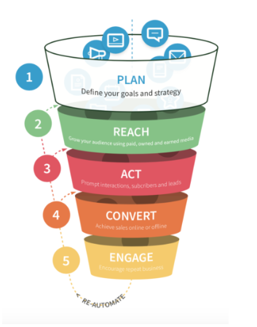

Figure 2.3: RACE model
(Source: Chaffey, 2023)
The RACE model can be considered as one of the strategic frameworks that is being introduced to support digital marketers to manage as well as plan their respective marketing activities in a structured and sequential manner based on four specific stages, Reach, Action, Conversion, and Engage (Chaffey, 2023). In the context of the present research area, the application of the RACE framework can support mobile brands to shape and streamline the overall purchasing journey of their target audience. In the majority of the cases, it is identified that due to a lack of knowledge of consumer preferences, companies failed to develop strategic digital marketing practices, minimising their chance to drive brand recognition across the market. One of the primary benefits that can be obtained with the application of the RACE model is that it can help tailor marketing strategies for companies to accomplish the preferences and needs of the target audience (Chaffey, 2023). On the contrary, the application of this framework is found to be time-consuming and may create complexities for taking prompt actions to build strategic marketing approaches to bring benefits by identifying the needs of the target audience. However, these drawbacks can be mitigated with the application of the TAM framework that has been underlined in the following section.

2.8.2 Technology Acceptance Model
Interlinking the concept of the Technology Acceptance Model in this context can be underlined as the application of this concept can support gaining insight into the factors that can have a significant impact on the digital marketing approach (Abbas and Mehmood, 2021). Compared with the concept of the RACE Model, the TAM model illustrates the way individual or specific population groups accept certain products or services with time. Consideration of the TAM model helps to gain insight into the causal relationship between the user beliefs and behaviours, while the RACE model only focuses on tailoring the marketing strategies to cater to consumer needs. This forms a strength of the TAM model in relation to the present research integration which helps in gaining insight into consumer beliefs and behaviours towards digital marketing approaches (Abbas and Mehmood, 2021). The TAM model concept may be overlooked in explaining the issue that influences consumers to accept certain services or purchase their products, which can be considered a major disadvantage of the model. However, it can be mentioned that with the help of the TAM model, companies can successfully implement strategic marketing approaches through different digital marketing channels by understanding the beliefs and perspectives of the target audience accurately.

2.9 Literature Gap
In relation to the above evidence, it is identified that the adoption and investment rate in digital marketing has witnessed significant growth perceiving its benefits in influencing consumer perceptions positively. However, for example, the perspectives of authors such as Müller and Christandl, (2019), Agarwal (2020), and Al-Azzam and Al-Mizeed, (2021) reflected a general overview of the contribution of digital marketing to the mobile industry followed by its impact in customer purchase decision or behaviour. On the other hand, Omar and Atteya (2020), Lou and Yuan (2019), Ittaqullah, Madjid, and Suleman (2020), and Dwivedi et al. (2021) underlined the opportunities and contribution of digital marketing on business performance and customer preferences by interlinking with digital marketing approaches such as social media marketing, email marketing, WOM, eWOM, and others. For each of these existing literature, limited evidence has been noticed in the context of digital marketing investment by mobile companies operating in the UK mobile technology industry. The primary understanding from this literature depicts that consumers use a digital platform to express their feelings which is a dependable source of promoting the services. This research wants to explore the way, the digital marketing process is getting influenced by fluctuating consumer behaviour. In other words, the research wants to interlink the existence of interrelationship existing between digital marketing and consumer perception and actions. The way these two factors are dependent on each other is explored in this research, which is a new way of looking at the digital marketing process that can be used by various marketers. Hence, these sources or existing literature uncover further research areas in identifying the way integration of digital marketing influences consumer action and perceptions while they make purchases from mobile technology companies in the UK. Hence, conducting this research is going to address the existing literature gap by generating outcomes about the contribution of digital marketing on consumer action and perceptions by considering the UK mobile technology sector.

2.10 Conceptual framework
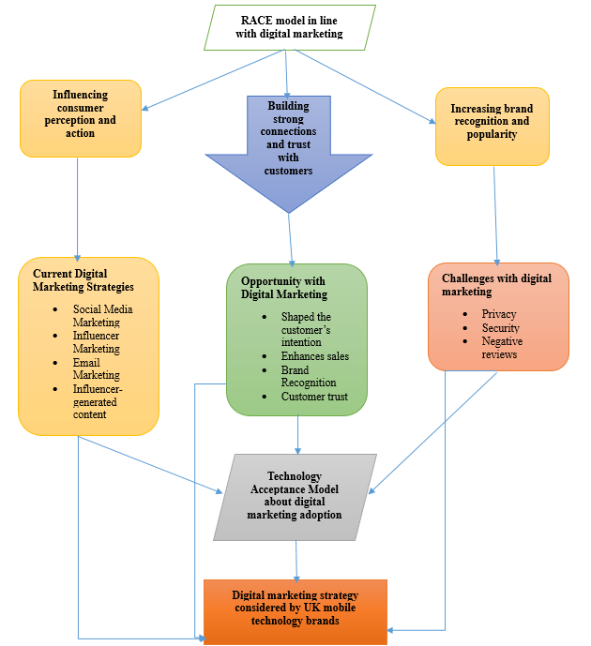

Figure 2.4: Conceptual framework
(Source: Self-created)
The development of a strong and strategic conceptual framework supports to determination of the areas that the considered research area is going to be covered. In the context of the underlined conceptual framework detailed illustration about the areas and the aspects that the present research has been covered. It provides a visual representation to show the way research goals can be accomplished by addressing different associated areas highlighted in Figure 8. In relation to the present research, consumer perceptions and actions have been considered as independent variables while digital marketing in the UK's mobile technology sector has been considered as dependent variables to carry out the present research critically and logically.

2.11 Summary
Based on the overall evidence presented in the earlier section based on the considered existing literature, it can be mentioned that the adoption of digital marketing and its associated channels creates opportunities as well as challenges to influence consumer perceptions. It is identified that companies operating across the mobile industry perceive features of digital marketing to influence customer purchases positively, increasing brand recognition and popularity within the target market. Thus, in the next adjacent chapter, a critical analysis of the methodological approach that has been considered to collect relevant research data is going to be presented.

Chapter 3: Methodology

3.1 Introduction
Research methodology acts as a systematic plan offering a logical path for researchers to conduct specific research activities successfully by attaining research goals. In relation to the present research analysing the influence of digital marketing on customer perception followed by actions within the UK's mobile technology sectors required to select a strategic methodological approach. Hence, the following section is going to present a detailed overview and justification behind the selection of each methodological approach to conduct the present study successfully.

3.2 Research Philosophy
Selecting a philosophical approach or research paradigm is one of the crucial stages in research as it helps to form suitable research questions. Saliya (2023) in this regard mentioned that the research paradigm reflects a set of techniques, assumptions, values, and beliefs that guide the logical execution of a specific investigation or research. Based on the perspectives of Saliya (2023) it is seen that the philosophical paradigm of research is associated with three philosophical approaches such as realism, interpretivism, and positivism respectively. About the requirements followed by characteristics of the present research, a positivist philosophical approach is being considered for carrying out the present investigation on the effect of digital marketing on customer behaviour and attitudes successfully.
The positivist philosophical approach is found to focus on exploring factual knowledge about specific phenomena with the help of statistical evaluation and observation. The present research is going to focus primarily on investigating the impact of digital marketing on consumer behaviour and attitude, which requires statistical evidence followed by real-time data in relation to the UK mobile technology sector. In this regard, consideration of the positivist philosophical approach serves as effective to present evidence based on actual observation (Park, Konge, and Artino Jr, 2020). Based on the empirical evidence, observations, and measurements, positivist philosophy helps maintain the reliability and objectivity of the research. Apart from this, offering opportunities to discover patterns of customer behaviour in relation to digital marketing, positivism philosophy helps to gain insight into the causal relationship that persisted between digital marketing, and customer behaviour in the context of the UK mobile technology sector (Maretha, 2023). With the help of factual data, positivism philosophy also supports the present research to obtain an in-depth understanding of the global marketplace context. Thus, the selection of the mentioned philosophical approach is effective in terms of driving fruitful research outcomes by generating answers to each predefined research question.

3.3 Research Approach
Successful selection of suitable approaches for specific research helps to address research issues or problems critically and appropriately. Based on the perspectives in the research approach drawn by Casula, Rangarajan, and Shields (2021) research approach supports obtaining scientifically sound research outcomes by offering a detailed systematic plan that helps to manage each of the research required activities systematically and effectively. Depending on the present research values, a deductive research approach is being considered instead of an inductive approach to evaluate the aspects of digital marketing and its contribution to consumer behaviour and attitude by considering the case of the UK mobile technology industry.
With the development of theoretical hypotheses, the integration of deductive research approaches supports the present research to explore the statistical evidence with the theoretical aspects. Based on the evidence presented by Okoli (2023) in the context of the research approach, it can be mentioned that the application of the deductive approach for the present research helps to define variables followed by concepts that influenced customer behaviour, customer perceptions, and digital marketing appropriately. Apart from this, it helps to present research-relevant information quantitatively, increasing opportunities to obtain research success by accomplishing predefined goals. In the present research, the application of the deductive approach helps in maintaining logical flow throughout the quantitative data representation process, creating opportunities for driving favourable research outcomes. Hence, the selection of the mentioned research approach is appropriate for the present research in terms of driving research success logically.

3.4 Research Design
One of the primary roles of research design is to maintain the reliability and validity of the overall research findings. Muzari, Shava, and Shonhiwa (2022) mentioned that research design helps to strengthen the research methods that are appropriate for the subject matter and enhances the chance for the accomplishment of research objectives by addressing predefined research questions. The author underlined the primary purpose of selecting an appropriate research design is to execute research activities correctly, reducing the risk of scope deviation in the research process. Among the three critical research designs such as exploratory, explanatory, and descriptive, the present research has followed a descriptive design throughout its execution process.
The descriptive design illustrates the specific research methods that are being utilised to determine as well as try the characteristics of specific research phenomena or selected populations. For instance, the application of descriptive design helps in visualisation the preferences and influence of digital marketing on customer behaviour statistically, specifically while they try to avail services from companies operating in UK mobile technology operators.
The pattern of digital marketing considered by marketers in the mobile technology industry can be determined easily and accurately with the application of descriptive research design. Also, it enhances the chance to gain knowledge about the effectiveness of digital marketing in understanding customer perceptions and their attitudes toward mobile technology companies. Based on the perspectives drawn by Siedlecki (2020), the application of descriptive design in the present research supports generating statistical outcomes that maximise the chance of maintaining data accuracy throughout the data representation process. As the present research is going to collect data through a statistical approach, descriptive design helps to collect data from a wider range of population groups, which helps to gain an understanding of digital marketing influence on customer behaviour and attitude accurately. Hence, the selection of a descriptive design for the present research is ideal for analysing statistical data appropriately.

3.5 Research Strategy
Research strategy is found to be another segment in research that illustrates the approaches through which answers or solutions to predefined questions can be formed. Zou and Xu, (2023) in this regard mentioned that research strategy supports determining appropriate methods for collecting required data followed by the procedure for analysing those data critically. In relation to the present research, the quantitative survey is being considered as the research strategy for accomplishing the proposed research aim successfully.
Consumer perceptions and their choice towards a specific brand are found to be based on the marketing approaches considered by companies for their brands, products, or services promotion. In this regard, collecting statistical or quantitative evidence is found to be effective in terms of determining the actual influence of digital marketing on consumer action and their perceptions, specifically while they make choices for brands operating in the mobile technology sector (Mohajan, 2020). In this regard, the help of quantitative survey strategy helps to gain data from a large number of population groups and supports the analysis of the opinions of each participant from different types of behavioural patterns. This strategic approach supports gaining insight in real time, maximising the chance of obtaining fruitful results. In this regard, the application of quantitative surveys in the present research supports the identification of the way marketers of mobile technology companies consider digital marketing strategies to understand the perceptions of their target audience (Strijker, Bosworth, and Bouter, 2020). Apart from this, this methodological strategy also helps in finding and analysing perceptions of customers engaged with mobile technology companies which enhances the chance to make the most suitable and optimal conclusion.

3.6 Research choice
Overall methodological choice is found to influence the research process followed by its outcome. Nanthagopan (2021) mentioned that multimethod, mono-method, and mixed-method are the three types of research choices, and considering any of these three choices supports sequentially conducting research activities. In the context of the present study, mono-quantitative has been selected to generate quantifiable and statistical data with the help of a survey process.
Determining the influence of digital marketing on customer perception in relation to the UK mobile technology sector requires a singular form of evidence which is the way digital marketing shapes consumer perceptions. In this regard, the consideration of a mono-method for collecting required data is found to be effective for the present research as it supports the collection of high-quality information in real time (Lindemann and Stolz, 2021). Apart from this, as the present research is going to consider the perspectives of customers to identify how they are influenced by digital marketing performed by the UK mobile technology sector, a mono-quantitative method is found to be effective in gaining clear insight into the selected research phenomenon. This research choice also supports to study of the selected research area rigorously and enhances the chance of gaining unanticipated phenomena more accurately and systematically. Mono-method for this study also helped to maintain a consistent and focused research approach that enhances the chance to explore the predefined research questions extensively.

3.7 Data Collection Method
In research, data collection plays a significant role in terms of supporting researchers to collect the most suitable and relevant information to generate optimal solutions for identified research problems. According to the study of Taherdoost (2021), with the help of a suitable method, researchers can effectively collect relevant information to draw meaningful information attaining the predefined research aim. Among primary and secondary methods, the present research has considered primary methods for collecting data from first-hand sources or experiences.
Considering primary data to conduct any research work relied on offering data accuracy and research relevance. Mazhar et al., (2021) in this regard mentioned that after defining the specific research, the responsibility for collecting relevant data is found to be initiated by the researchers. In the context of the present research, it is seen that marketers are finding it difficult to determine the appropriate digital marketing approaches to influence the perception of the customers due to the rapid changes in customer purchasing behaviour and patterns. The majority of the data presented by the authors such as Lou and Yuan (2019), Ittaqullah, Madjid, and Suleman (2020), Wang (2020), Khizar et al. (2020), and others are based on the primary data. Influenced by these methodological choices considered by the underlined authors the present research has also selected a primary method and performed online surveys to collect real-time evidence.
The survey was conducted by utilising Google Forms and forming 12 closed-ended questions that were distributed among 50 marketing professionals or executives from different mobile technology companies across the country UK. Each participant is selected from different job positions such as marketing manager, SEO (Search Engine Optimisation) Specialist, social media manager, email marketing manager, content marketing manager, and Graphic Designer is being considered to obtain a wider view of the selected research area. The overall online survey process was conducted for around 15 minutes and collected the required first-hand information relevant to the present research study. Though the survey method may take longer to collect all the relevant information through human participation, it is identified as a cost-effective method to gain the most relevant and accurate data, ensuring data authenticity and reliability. Thus, it can be mentioned that with the help of primary data and survey methods, a clear view from the selected participants has been determined about the way digital marketing continuously shapes the perspectives and actions of customers, specifically in the context of the UK mobile technology industry.

3.8 Sample Size and Sampling Method
The selection of an appropriate sampling strategy and sample size supports research to become more cost-effective as well as efficient, generating extensive knowledge about specific phenomena. According to the view of Campbell et al. (2020), the sampling method helps to save time for the researcher to collect required information from a specific population group, enhancing the chance of driving accurate research outcomes. This, in turn, enhances the chance of obtaining a quicker research outcome by addressing each of the research questions and the study phenomenon.
In the context of the present study, the primary data has been collected by considering a sample of 100 participants working as marketing professionals or executives within the UK mobile technology industry. Based on the perspectives of Pandey and Pandey (2021), with the help of selecting an accurate sample size, more accurate and fruitful research outcomes can be formed. Hence, with the help of the considered sample size, the way digital marketing influences customer perceptions in recent times can be determined more accurately and systematically. Apart from this, selecting the mentioned sample also helps to generalise the collected data and develop the most optimal research outcome.

3.9 Data Analysis Method
After the collection of required research evidence based on the selected methodological approaches and sample size as highlighted earlier, interpreting those data and presenting those first-hand experiences sequentially is critical to drive research success. Reflecting on the information shared by Peck, Short, and Olsen, (2020), data analysis is one of the most crucial and complex parts that helps in forming the overall research content and data more accurately and effectively. In the majority of the cases it is identified that lack of focus on determining a suitable analysis strategy, fruitful outcome may not be obtained. That negatively impacts the outcome of the research as well. As the present research is going to collect quantitative data from the online survey, statistical analysis is being performed to present each of the collected data critically.
Relying on statistical analysis methods helps to gain extensive insight into the selected research area based on which informed research decisions can be made. In the context of the present research, statistical analysis helps to identify the pattern of changing customer perceptions towards brands with the emergence of digital marketing popularity in UK mobile technology sectors (Siedlecki, 2020). This method also helps to determine the correlation between digital marketing and customer perceptions followed by their action accurately with the help of the visual representation process.
Based on the statistical method, the present research has considered descriptive statistics to interpret and analyse each of the collected data in a narrative format. Using descriptive statistics for the present research helps to reduce the complexities of data analysis and enhances the chance to gain meaningful information from a wide range of data sets. For analysis and representing all the collected quantitative data visually, Microsoft Excel is being considered. Using Microsoft Excel for the present research allows us to present each of the analysed data with a high level of graphical or visual summaries, patterns, and trends. This, in turn, helps in gaining an understanding of the way digital marketing has been radically reshaping the precautions and actions of customers for mobile technology companies.
For instance, presenting data with the help of Excel helped to determine the perspectives of the considered participants of digital marketing and their thoughts regarding the way customers invest or make choices while purchasing sprouts from specific mobile technology companies. Apart from this, in order to validate each of the obtained first-hand data, a comparison between the collected quantitative evidence with the evidence drawn by the authors in the literature review has been performed (Al-Ababneh, 2020). This approach helped to make clear arguments regarding the selected study area from a wider perspective, enhancing the chance of obtaining research success. Thus, the selection of the mentioned statistical approaches is effective in determining the role of digital marketing in influencing the perspectives of the customers for selecting the right brands to purchase preferred products from different mobile technology companies in the UK.

3.10 Ethical Context
Research ethics is necessary while working with research activities, specifically for primary research to ensure the protection of the considered human participants. Integrity, confidentiality, anonymity, trust, and others are found to be the key research principles that researchers need to prioritise in terms of developing high-quality research work. On the other hand, it can be mentioned that maintaining research ethics reflects the concerns in upholding the respective values of respect, integrity, and honesty to pursue the required scientific knowledge (Chandler, Cover, and Fitzpatrick, 2022). Throughout the present research, each of the ethical guidelines has been followed to prevent the occurrences of any data discrepancies or ethical errors.
As the present research is completely based on primary methods and human participation has been considered, thus, informed consent has been obtained from the involved participants to ensure that their participation was voluntary. Privacy and confidentiality are the two major concerns and issues while conducting research activities based on primary methods (Kang and Hwang, 2023). In order to maintain the confidentiality of the selected participants, a consent form has been shared before the execution of the survey process and ensures no personal data has been utilised to conduct the present study. On the other hand, in order to maintain the privacy of the collected data, all the collected evidence has been stored securely in University OneDrive. This helps in preventing the accessibility of the collected data by third parties, maintaining ethical research approaches.

3.11 Research Limitation
Identification of research limitations is effective for determining the loophole in the present research and enhances the chance for identifying the areas in which future research could be extended. As the present research has been completely based on primary methods and quantitative data, some limitations have been identified that may create difficulties in obtaining accurate and generalised results. As the present research considers human participation to collect their perspectives on the selected research, thus, challenges in terms of obtaining inconsistent and incomplete data can be generated due to data distortion errors or contradictions. One of the major limitations that have been found with primary data is time-consuming challenges, specifically with smaller sample sizes as the present research considers. This may lead to the occurrence of extrapolations of the presented data, minimising the chance of obtaining the reliability of the research outcome.

3.12 Summary
In the context evidence highlighted throughout the present choate, it reflects the needs and effectiveness of selecting suitable methodological approaches to drive research success. From the discussion, it is identified that the selected philosophical approaches help the present research to present factual data about the influence digital marketing has on consumer action and their perspectives in the context of mobile technology companies in the UK. Apart from this, with the help of primary methods and statistical analysis to present the online survey data helps to gain in-depth knowledge about the selected research phenomenon more accurately and appropriately. Each of the methodological choices also supports maintaining data integrity, reliability, and validity throughout the research process. Hence, based on the methodological choice, the presentation of the data that has been collected is going to be underlined in the next chapters.

Chapter 4: Research Findings

4.1. Introduction
This section highlights information on the analysis conducted on the data collected from 100 respondents. The analysis involves a simple descriptive understanding of the collected information along with the correlation and regression analysis to test the relevance of the hypothesis constructed. The model constructed involves the use of different variables such as consumer perception, actions and digital marketing within the UK mobile technology sector and the relationship that exists between them. The basis of this understanding is to provide an understanding of the way the digital market in the UK mobile technology sector influences consumer perception and their actions.

4.2. Research variables and Hypotheses development

4.2.1. Research variables
The variables of this research have been listed below:
IV1: Consumer perceptions
IV2: Consumer actions
DV: Digital marketing in the UK's mobile technology sector

4.2.2 Hypotheses Between Research Variables
The hypotheses of this research have been divided into the null hypothesis, which describes no connection between a DV and IV, and the alternative hypothesis which signifies a connection between a DV and IV.
Hypotheses between DV and IV1
H0: There is no connection between digital marketing in the UK’s mobile technology sector and consumer perception.
H1: Digital marketing in the UK’s mobile technology sector is dependent on consumer perceptions.
Hypotheses between IV1 and DV
H0: There is no connection between digital marketing in the UK’s mobile technology sector and consumer actions.
H1: Digital marketing in the UK’s mobile technology sector is dependent on consumer actions.

4.3. Statistical analysis

4.3.1. Descriptive Statistics
This descriptive statistic provides an overview of the selected data that provides basic information on the dependent and independent variables.
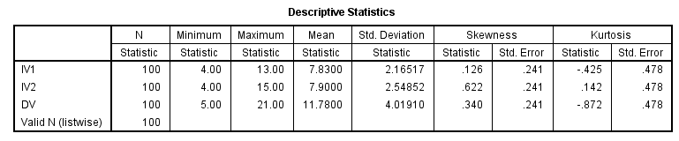

Figure 4.1: Descriptive statistics of the selected data
(Source: Imported from SPSS analysis)
The descriptive information provides information highlighting the average of responses obtained for both the independent and dependent variables. The descriptive statistic result also showcases the information on variability within the dataset, which includes the information on the standard deviation (Abulela and Harwell, 2020). Here, the standard deviation values are found to be high as for the three variables the standard deviation values are higher than 2. It means that the values for each variable are not stacked together. Instead, it is variable, depicting the fact that the mean value does not necessarily describe the given situation effectively.

4.3.2. Demographic Analysis
The demographic analysis involves the understanding of the characteristics of the population undertaken for this analysis (Abulela and Harwell, 2020). The characteristics of the population describe a lot about the possible results and are directly connected with the statistical output and describe the quality of output obtained for this analysis.
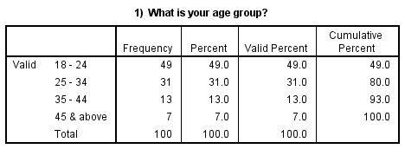

Figure 4.2: Statistics of the age group of the selected sample
(Source: Imported from SPSS analysis)
The age group denotes that the maximum selected sample of 49 personnel belongs to the age group of 18-24 years. Another 31 personnel of the selected sample belong to the age group of 25-34 years, while only 13 belong to the age group of 35-44 and 7 personnel are aged 45 years and above. This understanding denotes that the maximum sample space belongs to youth and young adults. They are prone to the use of technology and have a better judgement on technological aspects. Hence, it can be said that the consumer perception towards the digital market in the UK is likely to experience a higher probability towards accurate consumer perception.
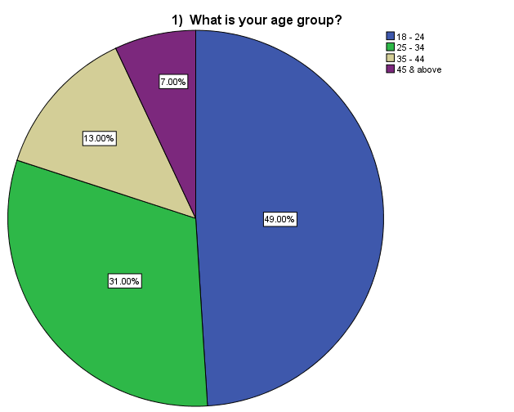

Figure 4.3: Pie-Chart depicting the age group of the chosen sample
(Source: Imported from SPSS analysis)
The pie chart describes the percentage of sample space falling on a particular age group. As observed from the earlier description, 49% of the sample belongs to the age group of 18-24 years and 31% of the overall population belongs to the age group of 25-34 years. This showcases that a higher percentage of the sample population belongs to the young adult group.
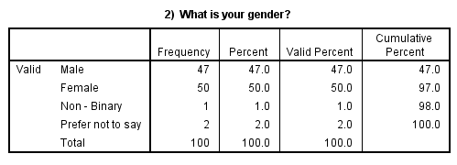

Figure 4.4: Demographic statistics representing the gender of the sample
(Source: Imported from SPSS analysis)
The gender representation also affects the result of an analysis. This is because the perception of a particular scenario differs with gender. In this scenario, the gender is evenly distributed between male and female employees. It shows that the result does not involve gender biasedness. The sample includes 47 male participants and 50 female participants. Hence, the chances of experiencing gender biasedness affecting the test result are low.

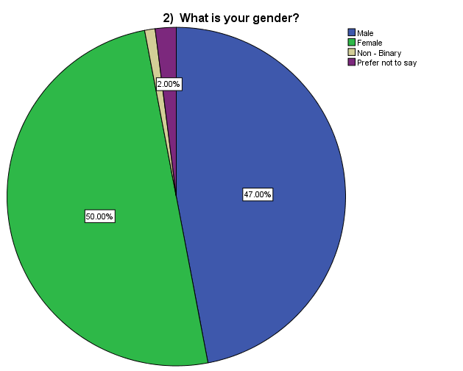

Figure 4.5: Pie chart depicting the gender classification percentage.
(Source: Imported from SPSS analysis)
The pie chart depicts similar information in the given scenario that showcases the distribution of gender is equal. 47% are male participants and 50% are female participants. Hence, it depicts that the presence of biased output is minimal in this context.

4.3.2.1. Correlation Analysis
The purpose of correlation analysis was to understand whether two variables or more variables of this research are correlated or not. The Pearson correlation method has been followed for the correlation test, and as per the study of Li and Gospodarik (2022), this correlation analysis method is one of the most effective methods to test whether two or more research variables are correlated. The value range of the Pearson correlation method is from -1 to +1, and the lower limit signifies a total negative correlation between two or more research variables, and the upper limit describes a total positive correlation (Jebarathinam et al. 2020). In addition, a Pearson correlation value of 0 means two research variables do not correlate.
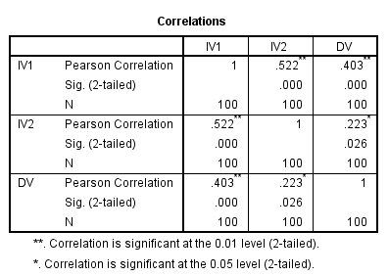

Figure 4.6: Results of correlation analysis
(Source: Imported from SPSS analysis)
In Figure 4.6, it can be seen that the Pearson correlation value between IV1 and DV is .403** and it is within the supported range. This value signifies there is a moderately positive correlation between IV1 and DV at 0.05 significant level as any Pearson correlation value from 0.4 to 0.8 describes a moderately positive correlation between two research variables. Hence, it can be stated that consumer perceptions have a moderately positive correlation with digital marketing in the UK’s mobile technology sector. Thus, consumer perception can be considered a significant predictor or determinant of the application of digital marketing in the UK’s mobile technology sector. On the other hand, the .223* Pearson correlation value between IV2 and DV signifies a weak positive correlation which is significant at 0.01 level. Therefore, consumer actions have a comparatively weaker relationship with digital marketing in the UK’s mobile technology sector.
Further, the correlation between the research variables is statistically significant at 0.01 and 0.05 significance level, which means the correlation between the research variables occurred due to specific reasons and not due to sampling error. Both the Significance or Sig values of IV1 (0.000) and IV2 (0.026) are within the threshold limit of 0.05 or 5% circuit (Kwak, 2023). Hence, the relationship between the variables is statistically valid.

4.3.2.2. Regression Analysis
The regression analysis method is constructed to develop an understanding of the relationship that exists between the dependent and the independent variable. The quality of the relationship that exists between the two variables is understood and most importantly, it provides an idea of the level of influence that the independent variable provides to the dependent variable (Lee, 2022). It would showcase that the constructed model is valid and will provide similar results under any given scenario. A higher level of randomness or error percentage would question the validity of the chosen model and it would ensure the need for further analysis in the future.
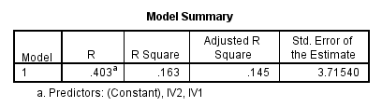

Figure 4.7: R-squared value of the given model
(Source: Imported from SPSS analysis)
The above table represents the R and the R² values obtained from the analysis of the chosen model. The R² value depicts the goodness of fit of the given model. It means that the data collected is accurate and is successful in providing the necessary information that is relevant to the given model (Onyutha, 2020). In this scenario, the R² value is found to be 0.163, which is quite low. It describes that the chosen data does not specifically describe the model. The value signifies that only 16% of the variability of the targetted variable is explained through this regression model. In simpler terms, the model fails to explain the movement of the variable's rationale behind its movement. The adjusted R² value is 0.145 depicting that only 14% of the variability is explained by the presence of other multiple variables. While it is true that the model does not significantly explain the variability within the model, it can still define the relationship between the chosen variables. It only represents that the data points are spread out within the given model and the presence of noise is high. It describes that the consumer perception and the actions are highly random and it is difficult to make accurate predictions of its existence in the model.
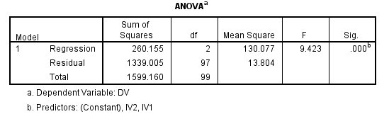

Figure 4.8: ANOVA table for the given table.
(Source: Imported from SPSS analysis)
The above table describes the presence of significance between the two variables. In the above table, the significant value is found to be 0.000, which is less than 0.05 describing that as high as 95% of probability of the occurrence of the given event. It showcases that despite the presence of higher noise, the model shows higher predictability and the changes in the dependent variable is described by change in the independent variables. Now, from the above table, it is also observed that the F-value is provided and it describes the presence of group means by the variance within the groups. In this instance, the F-value is found to be 9.43 signifies that the difference of the group means is similar in comparison to the natural variation. It means that the mean value after the regression analysis of the chosen groups does not differ from the mean value within the groups during its original state (Lee, 2022). This describes the presence of the linear movement of the variables that are accurately described by the chosen model.
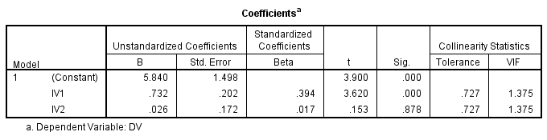

Figure 4.9: VIF statistics and presence of collinearity
(Source: Imported from SPSS analysis)
The presence of multicollinearity is a major issue in a model. The presence of this problem signifies that it is going to be difficult to make accurate predictions from the given model and as the independent variable gets affected by the movement of another independent variable, it is difficult to generate a reliable solution. It is detected by the VIF or variance inflation factor and the value is found to be 1.375. The VIF value has to be greater than 3 to ensure the presence of multicollinearity (Shrestha, 2020). In this scenario, it is seen that the presence of multicollinearity is low as the values are less than 3. Therefore, it can be said that in this given situation, the independent variables are not related. It signifies that the outcome of the given model is reliable and the predicted outcome can be deemed as accurate. It is an important aspect of the model that describes that customer perception and customer actions are two different elements and are not interrelated. The customer actions are not always driven by their perception and vice versa. It denotes that the consumer perception and actions in this model are likely to influence the marketing process followed in the UK.
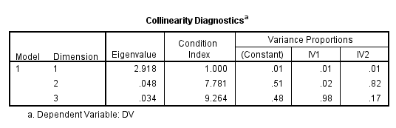

Figure 4.10: Collinearity diagnostic table
(Source: Imported from SPSS analysis)
It has already been established the presence of multicollinearity is minimal. The above table of collinearity diagnostic represents the degree of presence of standard error in the model, which would then establish that the estimates are unstable. Hence, the collinearity diagnostic analysis is important to validate the model. To validate the collinearity diagnostic table, the condition index is first considered. The condition index also indicates the multicollinearity problems, with a value greater than 15 indicating the presence of the problem (Shrestha, 2020). In this instance, it is observed that the value for 3 dimensions is less than 15, signifying the multicollinearity problem does not exist in this model.
Now, if variance proportion values are considered, the values get importance if the condition index is found to be extremely high. The understanding of these values again indicates that the independent variables are not correlated. The establishment of this understanding convincingly indicates that consumer perception and their actions are not correlated. Based on this model, the consumer's perception and actions are likely to influence the dependent variable which is digital marketing in the UK mobile technology.
Through all the statistical tests, it has been observed that consumer perception and their actions have a significant relationship over the digital marketing taking place in UK mobile technology. The understanding goes in line with the RACE model as depicted in the literature understanding where it is essential to engage people to ensure that the message reaches the desired personnel. Therefore, to engage the consumers, digital marketers must understand the movement of the consumers. The way consumer reacts to a situation and respond to stimuli forms the basis for the understanding of the marketer (Chaffey, 2023). It helps them to formulate their marketing strategy that is perceived to be successful in the market. Hence, the relationship that is observed can be considered to be valid and most importantly, the marketing operations benefit from this understanding.

4.4. Supported Hypotheses of this research
Based on the above analysis, the hypotheses tested are found to be significant and the summary of the hypotheses tested are stated below.
Hypothesis | Description | Significance
H1: Accepted | Digital marketing in the UK’s mobile technology sector is dependent on consumer perceptions. | 0.000
H1: Accepted | Digital marketing in the UK’s mobile technology sector is dependent on consumer actions. | 0.000

Table 4.1. Hypothesis Summary
(Source: Self-Created)
The null hypothesis was rejected on both occasions and the alternative hypothesis was accepted as stated in the table above.

4.5. Summary
The analysis provides an understanding of the influence of consumer perception and their actions towards the digital marketing technique in the UK for the mobile technology sector. Through the SPSS analysis process, this section highlighted that there remains a moderately weak correlation between the dependent and the independent variables. It is further accumulated through the regression analysis, where it was observed that a significant relationship exists between the two variables. The demographic analysis depicts that the analysis is biased because a higher percentage of the sample belongs to young adults. It means that the understanding obtained specifically highlights the perception of digital marketers towards young adult consumers, who are perceived to use mobile technologies more. The following section draws a line between these research findings and the literature understanding for a better understanding of the present situation.

Chapter 5: Discussion

5.1 Introduction
This chapter presents the critical interpretation of the results derived in previous section. Discussion of results is one of the important aspects in research which gives the reader a view by linking the results, research questions and insights derived in literature and research background. The chapter has intended to provide research significance and relevance of the results by critically analysing them with other author’s opinions and arguments. Huge contradiction of results with previous studies often shows a weaker significance of the research results and this chapter aims to justify the outcomes by critical interpretation and thorough discussion. This section also gives a snapshot of the theoretical contributions of the research and the importance of results from managerial perspective. The significance of the results along with a new dimension to the solution of research problem.

5.2 Discussion of the results
The results with descriptive statistics have established the relation between DV and IV1 and IV2 which helped in interpretation of the responses. The responses derived from 100 participants has highlighted that digital marketing on consumer perceptions and actions have significant contribution. The results pointed that standard deviation for the three variables are pointed high indicating that the variables are largely spread and this indicates the three variables are not stacked together. In this context, in the literature based on the study conducted by Nuseir and Aljumah, (2020) highlights that digital marketing has become significantly important for businesses and has improved the business reach to the consumers. Moreover, literature introspection revealed with the study of Sanchez-Sabate, and Sabaté, (2019) the process of advertising on the most successful is found to be successful in entertaining the mindset of the consumers, which is crucial for the company's success. It encourages businesses to conduct a market survey and understand the perception of the consumers, which plays a pivotal role in designing the advertisement. Moreover, the introspection has a link with the results because the results are not biassed and presence of biased output is minimal because opinions responses were almost equally in terms of male and female respondents.
The results have revealed that Pearson correlation value between DV and IV1 is 0.403 which shows a positive corelation and is within supported range. This interprets that digital marketing and consumers’ perceptions has a positive relationship in the mobile technology industry of UK. Similar concept introspected in the literature based on the study of Hughes, Swaminathan, and Brooks (2019) that consumers nowadays are more influenced by product information shared on social media which follows the approach of interaction with target audiences and promoting brands on social media leading to influence on consumer perceptions. On a close note, it is explored in literature from the study of Omar and Atteya (2020), email marketing which is a type of digital marketing is an effective approach to influence consumers’ perception because email marketing dynamically changes consumers’ perceptions. In congruence with these opinions, the results become more relevant because from the Pearson correlation test the value between DV and IV1 is 0.403 which is statistically significant at 0.05 level as it lies within the range of 0.4 to 0.8.
On the other hand, the Pearson test done, for finding the relationship between DV and IV2 has derived the value of 0.223 and this shows a weak corelation between digital marketing and consumers’ actions. Based on the observations of Sanchez-Sabate, and Sabaté (2019) business constantly develops their promotional process to influence consumer behaviour which includes actions as a part. Therefore, a similarity between the research results and literature is evaluated. Moreover, the results establish the outcomes because it highlights the weak correlation between DV and IV2 at a 0.01 level of significance. Moreover, this weak correlation can be acknowledged by revealing when the strategic framework of RACE model cannot be applied because often digital marketing creates complexities for businesses which could promptly not influence consumers’ actions.
The study conducted regression analysis test to understand the relationship that exists between the dependent and two of the independent variables. In this context, R² value is 0.163 and the data collected is accurate and is successful in providing the necessary information. This value is very low and it fails to examine the movement between the variables. Despite this it is also evident that data re highly spread within the given model indicating consumer perceptions and actions being highly random and is difficult to make accurate predictions of its existence in model. However, it is reviewed in literature based on the study of Puspitasari and Aruan (2023) influencer generated content which is a form of digital marketing helps in engaging huge number of audience and their perceptions get influenced. Besides this, another evidence reviewed in literature based on the study of Venciute et al. (2023) that influencer marketing engages the followers on social media by influencing their perceptions through various promotional offerings. Link with these opinions from the two authors it can be said that customer perceptions and actions are influenced by digital marketing because digital marketing includes opportunities like content generation, promote offerings and interact with customers.
The results have also presented the significance between the two variables. The significant value is found to be 0.000, which is less than 0.05 and indicating high as 95% of probability of the occurrence of the given event. It showcases that despite the presence of higher noise, the model shows higher predictability and the changes in the dependent variable is described by change in the independent variables. On a similar note, it is reviewed in the literature Khizar et al. (2020) underlined the opportunities of mobile technology brand Samsung which has gained a wide audience engagement through digital marketing to influence their target audience. It is shown that with engagement in various social media platforms like LinkedIn, Instagram, Facebook, YouTube, and others has helped to engage more customers and customers are more reliant on the content shared on these platforms.
The multicollinearity issue has also been tested because presence of this problem makes difficult to signify the accurate predictions. From the research results it is found that VIF value is 1.375 and this nullifies the presence of multicollinerity issue because multicollinearity issue is found when it the value is greater than 3. Lack of multicollinerity indicated that the independent variables are highly statistically significant and correlated. This further indicates that the research results do not weakens the power of the regression model. In this context, it is established that both the independent variables i.e. consumers’ perceptions and consumers’ actions do not have strong correlations. This further leads to the understanding that consumers ’actions are not always driven by consumers’ perceptions and vice versa. On the same coin, the opinion of Sanchez-Sabate, and Sabaté (2019) explored in literature has shown advertising process is successful approach to influence consumers’ mindset. This notes that consumer perceptions changes about a brand seeing its advertisements, however they always do not act accordingly. Moreover, it is review in previous sections based on the study of Bala and Verma (2018) that E-WOM technique, a type of digital marketing technique influences consumers’ perceptions and identification of right channel is required to influence consumes’ perception, however there is no such link between customer perceptions and consumers’ actions. On the other hand, Dwivedi et al. (2021) highlighted the negative impact which has been taken a look in the literature review shown that the easy way without restrictions, individuals post negative reviews which are often fake and this negatively influences consumers’ perceptions.
Based on these opinions, the results of this research can be linked through the collinearity diagnostic value which is 3 and the variance proportion value index has been extremely low. On this aspect it is found that that consumer perception and their actions are not correlated and both the independent variables are likely to have influence and connection with dependent variables. Through all the statistical tests, it has been observed that consumer perception and their actions have a significant relationship over the digital marketing taking place in UK mobile technology. This has been also been the opinion of several authors that are explored in literature review. For example, the study of Omar and Atteya (2020) reviewed in literature underlined that email marketing has a significant and positive influence on the purchase decision of the target audience. Similarly, from the study of Lou and Yuan (2019) it is inspected in literature social media influencers (i.e. influencer marketing) as one of the key drivers for companies to influence perceptions of customers. Therefore, from this critical interpretation it can said that results are significant and relevant because as such no huge contradictory results is achieved. Moreover, when linked with the insights explored in literature the results have been proved to consistent because digital marketing initiatives by mobile brands has a significant influence on consumer perceptions and actions. The interpretation has tied up the research questions by giving thorough explanation and evaluation of results seeing its congruence with past studies.

5.3 Theoretical Contributions
Considering the similar opinions from previous studies the research results have confirmed that digital technology is dependent on consumers’ actions in the UK mobile technology industry. The study has expanded the knowledge by bridging the gap in previous studies and confirmed that the existing limited evidence regarding digital marketing in UK mobile technology industry. The results support the observation that digital marketing and consumers’ actions have a positive correlation based on the evidence of Pearson correlation value0.403. This finding has confirmed that consumer perceptions and actions are significant predator of digital marketing strategies taken by UK mobile technology sector. This could be an attribution for the market practitioners in mobile technology industry to keep a strong eye on consumer action and perceptions to follow digital marketing initiatives. The results of this study indicates that digital marketing initiatives can be considered because consumers ‘perceptions towards digital marketing in UK has a positive impact. Moreover, in line with RACE model and TAM model the research results further expanded the existing theoretical base and highlighted that how consumers perceive technological initiatives to company and their actions makes brands follow digital marketing strategies.

5.4 Managerial Implications
The results of this present research offer valuable insights for the brands working in mobile technology sector in consideration with consumers’ perceptions and actions. The decision makes and marketing managers of mobile technology industry could get a broader knowledge from the research results that could be beneficial for business operations. The paper extends the existing knowledge that consumer actions and perceptions can be an influential factor for consideration of digital marketing initiatives. The study is important for managers and market practitioners that consumers’ perceptions being a significant predictor of digital marketing initiatives and market practitioners can follow this concept and take initiatives to encourage digital marketing.

5.5 Summary
The chapter has critically evaluated the results and has revealed that the findings have a link with the insights explored in past studies. The research questions have also been tied up with the results and the results are established with the conclusion that digital marketing in UK mobile technology industry is dependent on consumer actions. It has been observed that consumer perception and their actions have a significant relationship over the digital marketing taking place in UK mobile technology. The study has been able to keep line with the previous research and established the findings stating that digital marketing needs to be undertaken by market practitioners to engage customers, however by seeing consumers’ actions. Therefore, to engage the consumers, digital marketers must understand the movement of the consumers.

Chapter 6: Conclusions and Recommendations

6.1 Conclusion
The study has focused on analysing the influence of digital marketing on consumer perceptions and actions within the mobile technology sector in UK. The study intended to analyse this aspect and for this, four research objectives was set which helped to move step-by step and reach to a fruitful outcome. It has analysed that there exists a strong influence of digital marketing on consumer perceptions because majority of mobile companies in UK have received benefits from this marketing strategy. The survey responses analysed through descriptive statistics has highlighted there exists a positive correlation between DV and IV indicating that digital marketing influence on consumer perceptions and actions is positive. The study highlighted that consumer perceptions and actions though have a weak intercorrelation, however, both the variables have a strong positive correlation with the dependent variable. The research has shown that emergence of different digital marketing channels dynamically changes consumer purchase decisions which reflects its influence on consumer perceptions and actions.
Consumers are more influenced through email marketing, influencer marketing because these digital marketing techniques interacts more with consumers, provides lucrative contents that makes consumers more engaged. Additionally, the research also has revealed the opportunities and challenges related to digital marketing. The study has shown that integration of digital technology in business operations provides opportunities for companies to improve communication interfaces with channel partners, suppliers, and customers. The challenges that are evident from this study are privacy concern, negative E-WOM and non-intrusive promotions.

6.2 Linking with Objectives
In link with first research objective, the study has found different types of digital marketing strategies used in UK mobile technology industry. It is identified email marketing as a type and this digital marketing technique significantly influences consumers decisions of purchase. Email marketing is also supportive for creating value to the business and digital marketing further articulates in supporting companies to increase their sales value and brand awareness. Influencer marketing is another technique that is identified in the literature which has a strong influence over consumers’ perceptions and actions because the ability to interact with customers on social media sites encourages consumer engagement and brand recognition. The results also have shown that both independent variables have a positive corelation with digital marketing which is a dependent variable. The value has been also proven for ANOVA results and the significant value bring 0.000 the outcomes indicate changes in DVs has a significant relation with changes in IVs. This summarisation of the explored insights acknowledges first research objective and also answers the first research question with an extension of scope in compared to existing studies.
In link with second research objective the study has focussed on understanding the opportunities and challenges related to digital marketing for UK mobile technology industry. The study has highlighted that holding the hands of digital marketing, the way of purchase, influencing consumers have changed a lot and revealed that through mobile marketing customer intentions are shaped by the shared contents which also promotes the brands. The results revealed that consumer perception towards the digital market in the UK is likely to experience a higher probability towards accurate consumer perception. It has ben noted that mobile brands like Samsung, OnePlus have been successful after integration of digital marketing techniques. The study has highlighted that Samsung dramatically show increase in consumer engagement and OnePlus through 3D support, gained more customers. The challenges highlighted in the study mainly revolves around security concern, privacy regarding information, negative E-WOM, ability to negative comments easily on social media, high negative reviews and non-intrusive promotions by brands. These are the key challenges that can have a negative impact on brands that engage primarily in digital marketing. The synopsis of this conjecture acknowledges second research objective and provides answer of the second research question.
In link with third objective the study has found that digital marketing initiatives have influence on consumer perceptions and actions in the UK mobile technology industry. From the literature it is evident that digital marketing has ben successful to meet consumer requirements successfully by the mobile companies. They attract consumers by the contents provided in digital mode which influences consumers’ perceptions and actions. It is also noted that in digital marketing, integration of social media is a part where consumers freely post their experiences and feelings. Positive reviews create positive E-WOM that in turn is helpful for influencing perceptions of consumers to a wider extent. The results in this context have revealed that DV and both the IVs have positive correlation by getting test results from Pearson correlation tests. The regression analysis has helped the research to measure R² value which depicted the goodness of fit model because the value is 0.163. Though the value of R² and adjusted R² cannot clearly mentioned the definition between chosen variables, however it described that consumer perception and the actions are highly random which creates difficulty to predict accurately about the model. ANOVA test also revealed the interconnection between the variables to be significant and this makes the results confirmed with the findings from previous studies. It highlights that digital marketing has an impact on consumer perceptions and actions in the UK mobile technology industry. The synopsis of this conjecture acknowledges third research objective and provides answer of the third research question.

6.3 Limitations and Future Research
The study has some limitations despite its potential findings and this provides avenue for future research. The study collected data with the UK consumers and this limits the generalisation of the findings. Future research could extend it scope by focusing on a cross-cultural study that could cross-validate the results. The study has only conducted primary quantitative research with focus on surveying marketing professionals which limits the study to include textual and in-depth interpretation, instead it only analyses the research through lenses of numbers and statistics. This indicates a scope for future research where managers’ perception can be taken by conducting interview with changing the method from primary quantitative to mixed method i.e. focus on both quantitative and qualitative method. Owing to the growth of mobile technology industry in UK, the study could focus on understanding the market trends evident in this industry based on which consumers’ perceptions and actions is understood.

6.4 Recommendations
- The research suggests to build a strong brand image on social networking sites that could optimise marketing for their brands and focus making your brand on social media that could engage more consumers (Forbes, 2024).
- The research also suggests that mobile technology brands can diversify the advertisements and spend across various channels and focus on creating contents that aligns with the values (Forbes, 2024).
- The mobile brands are suggested to examine the intent data of audience because understanding the audience and fuelling campaign efforts across all stages of consumers’ journey provides quality data (Forbes, 2024). This provides the brand with the ability to increase media efficiency and foster digital marketing by understanding consumers’ perceptions
- Companies are also suggested to use feedback tools to know customer better so that 0improve the undertaken digital marketing initiatives. This helps to understand better about consumer sentiments and their actions regarding products and services

6.5 Practical Implications
The study provides valuable insights in practical field because reflecting on this study could help mobile companies to take some suggestive measures that could be beneficial for the brands. The scholars or academic researcher who are willing to conduct research on a closer background can enrich their knowledge through the results of this study. Decision makers or marketing managers of mobile companies could gain profound knowledge about digital marketing and its influence on consumers’ perception. They could take suggestions from the findings of this study to maximise their potential in digital marketing efficiency. The recommendations provided here could be roadmap for the companies to consider following any of the suggestions that can ensure positive outcome holding hands of digital marketing.

References
Abbas, A. and Mehmood, K. (2021) ‘Understanding digital marketing adoption in India: integrated by technology acceptance model (TAM) and theory of planned behaviour (TPB) framework’, Journal of Management Sciences, 8(2), pp. 70-87. Available at: https://doi.org/10.20547/jms.2014.2108206
Abulela, M.A. and Harwell, M.M. (2020) ‘Data Analysis: Strengthening Inferences in Quantitative Education Studies Conducted by Novice Researchers’, Educational Sciences: Theory and Practice, 20(1), pp.59-78. Doi: 10.12738/jestp.2020.1.005
Agarwal, M. (2020) ‘Importance of User Generated Content as a part of Social Media Marketing that drives Customer‟ s Brand Awareness and Purchase Intentions’, The International journal of analytical and experimental modal analysis, 12(2), p. 3071. Available at: http://dx.doi.org/10.13140/RG.2.2.33503.61609
Aiolfi, S., Bellini, S. and Pellegrini, D. (2021) ‘Data-driven digital advertising: benefits and risks of online behavioural advertising’, International Journal of Retail & Distribution Management, 49(7), pp. 1089-1110. Available at: https://doi.org/10.1108/IJRDM-10-2020-0410
Ajzen, I. (2018) ‘Consumer attitudes and behavior’, In Handbook of consumer psychology (pp. 529-552). Routledge. Available at: https://www.researchgate.net/profile/Icek-Ajzen/publication/264000611_Consumer_attitudes_and_behavior/links/0a85e53c7d49b08fb6000000/Consumer-attitudes-and-behavior.pdf (Accessed: 29 June 2024)
Al-Ababneh, M. (2020) Linking ontology, epistemology and research methodology. Science & Philosophy, 8(1), pp. 75-91. Available at: 10.23756/sp.v8i1.500
Al-Azzam, A.F. and Al-Mizeed, K. (2021) ‘The effect of digital marketing on purchasing decisions: A case study in Jordan’, The Journal of Asian Finance, Economics, and Business, 8(5), pp. 455-463. Available at: 10.13106/jafeb.2021.vol8.no5.0455
Al-Azzam, A.F. and Al-Mizeed, K. (2021) ‘The effect of digital marketing on purchasing decisions: A case study in Jordan’, The Journal of Asian Finance, Economics, and Business, 8(5), pp. 455-463. Available at: https://10.13106/jafeb.2021.vol8.no5.0455
Bala, M. and Verma, D. (2018) ‘A Critical Review of Digital Marketing’, International Journal of Management, IT & Engineering, 8(10), pp. 321-339. Available at: https://www.academia.edu/download/57617823/IJMRA-14610.pdf (Accessed: 29 June 2024)
Bos, J. (2020) Research ethics for students in the social sciences (p. 287). Berlin: Springer Nature.
Camilleri, M.A. and Falzon, L. (2021) ‘Understanding motivations to use online streaming services: integrating the technology acceptance model (TAM) and the uses and gratifications theory (UGT)’, Spanish Journal of Marketing-ESIC, 25(2), pp. 217-238. Available at: http://dx.doi.org/10.1108/SJME-04-2020-0074
Campbell, S., Greenwood, M., Prior, S., Shearer, T., Walkem, K., Young, S., Bywaters, D., and Walker, K. (2020) 'Purposive sampling: complex or simple? Research case examples', Journal of research in Nursing, 25(8), pp. 652-661. Available at: https://doi.org/10.1177/1744987120927206
Casula, M., Rangarajan, N. and Shields, P. (2021) ‘The potential of working hypotheses for deductive exploratory research’, Quality & Quantity, 55(5), pp. 1703-1725. Available at: https://doi.org/10.1007/s11135-020-01072-9
Chaffey, D. (2023) RACE marketing model. Available at: https://www.davechaffey.com/digital-marketing-glossary/race-marketing-planning-model/. (Accessed: 29 June 2024)
Chaffey, D. and Ellis-Chadwick, F. (2019) Digital marketing. London: Pearson uk.
Chandler, A., Cover, R. and Fitzpatrick, S.J. (2022) ‘Critical suicide studies, between methodology and ethics: Introduction’, Health, 26(1), pp. 3-9. Available at: https://doi.org/10.1177/13634593211061638
Dwivedi, Y.K., Ismagilova, E., Hughes, D.L., Carlson, J., Filieri, R., Jacobson, J., Jain, V., Karjaluoto, H., Kefi, H., Krishen, A.S. and Kumar, V. (2021) ‘Setting the future of digital and social media marketing research: Perspectives and research propositions’, International journal of information management, 59, p. 102168. Available at: https://doi.org/10.1016/j.ijinfomgt.2020.102168
Fondevila-Gascón, J.F., Polo-López, M., Rom-Rodríguez, J. and Mir-Bernal, P. (2020) ‘Social media influence on consumer behavior: The case of mobile telephony manufacturers’, Sustainability, 12(4), p. 1506. Available at: http://dx.doi.org/10.3390/su12041506
Forbes (2024). Council Post: 14 Ways For Companies To Improve Digital And Mobile Marketing In 2021. Forbes. [online] 12 Aug. Available at: https://www.forbes.com/councils/forbesagencycouncil/2021/06/22/14-ways-for-companies-to-improve-digital-and-mobile-marketing-in-2021/ [Accessed 27 Sep. 2024].
Hayes, J.L., Brinson, N.H., Bott, G.J. and Moeller, C.M. (2021) ‘The influence of consumer–brand relationship on the personalised advertising privacy calculus in social media’, Journal of Interactive Marketing, 55(1), pp. 16-30. Available at: https://doi.org/10.1016/j.intmar.2021.01.001
Hughes, C., Swaminathan, V. and Brooks, G. (2019) ‘Driving brand engagement through online social influencers: An empirical investigation of sponsored blogging campaigns. Journal of marketing, 83(5), pp. 78-96. Available at: https://ora.ox.ac.uk/objects/uuid:daba943b-e18e-4790-8dd8-b5fb1f79bbb9/download_file?safe_filename=Driving%2BBrand%2BEngagement.pdf&file_format=application%2Fpdf&type_of_work=Journal+article (Accessed: 29 June 2024)
Ittaqullah, N., Madjid, R. and Suleman, N.R. (2020) ‘The effects of mobile marketing, discount, and lifestyle on consumers’ impulse buying behavior in online marketplace’, International Journal of Scientific and Technology Research, 9(3), pp. 1569-1577. Available at: https://www.researchgate.net/profile/Nursaban-Suleman/publication/343905917_The-Effects-Of-Mobile-Marketing-Discount-And-Lifestyle-On-Consumers-Impulse-Buying-Behavior-In-Online-Marketplace_2019pdf/data/5f477ed992851c6cfde61ed2/The-Effects-Of-Mobile-Marketing-Discount-And-Lifestyle-On-Consumers-Impulse-Buying-Behavior-In-Online-Marketplace-2019.pdf (Accessed: 29 June 2024)
Jebarathinam, C., Home, D. and Sinha, U. (2020) ‘Pearson correlation coefficient as a measure for certifying and quantifying high-dimensional entanglement’, Physical Review A, 101(2), p.022112. Available at: https://doi.org/10.1103/PhysRevA.101.022112
Kamkankaew, P., Sribenjachot, S., Wongmahatlek, J., Phattarowas, V. and Khumwongpin, S. (2022) ‘Reconsidering the mystery of digital marketing strategy in the technological environment: Opportunities and challenges in digital consumer behaviour’, International Journal of Sociologies and Anthropologies Science Reviews, 2(4), pp. 43-60. Available at: https://doi.org/10.14456/jsasr.2022.29
Kang, E. and Hwang, H.J. (2023) ‘The importance of anonymity and confidentiality for conducting survey research’, Journal of Research adn Publication Ethics, 4(1), pp. 1-7. Available at: http://dx.doi.org/10.15722/jrpe.4.1.202303.1
Khizar, H.M.U., Yaqub, R.M.S., Javed, T. and Mahmood, S. (2020) ‘Social Media Marketing and Committed Customer: Analysing the Underlying Role of Customer Commitment in Developing Country Context’, Journal of Business and Social Review in Emerging Economies, 6(4), pp. 1543-1560. Available at: http://dx.doi.org/10.26710/jbsee.v6i4.1503
Kumar, V. and Mittal, S. (2020) ‘Mobile marketing campaigns: practices, challenges and opportunities’, International Journal of Business Innovation and Research, 21(4), pp. 523-539. Available at: http://dx.doi.org/10.1504/IJBIR.2020.105996
Kurdi, B., Alshurideh, M., Akour, I., Alzoubi, H., Obeidat, B. and Alhamad, A. (2022) ‘The role of digital marketing channels on consumer buying decisions through eWOM in the Jordanian markets’, International Journal of Data and Network Science, 6(4), pp. 1175-1186. Available at: http://m.growingscience.com/ijds/Vol6/ijdns_2022_93.pdf (Accessed: 29 June 2024)
Kwak, S. (2023) ‘Are Only p-values less than 0.05 significant? A p-value greater than 0.05 is also significant!’, Journal of Lipid and Atherosclerosis, 12(2), p.89. Available at: https://doi.org/10.12997%2Fjla.2023.12.2.89
Lee, S.W. (2022) ‘Regression analysis for continuous independent variables in medical research: statistical standard and guideline of Life Cycle Committee’, Life cycle, 2. Doi: https://doi.org/10.54724/lc.2022.e3
Li, R. and Gospodarik, C.G. (2022) ‘The impact of digital economy on economic growth based on pearson correlation test analysis’, In International Conference on Cognitive based Information Processing and Applications (CIPA 2021) Volume 2 (pp. 19-27). Springer Singapore. Available at: https://doi.org/10.1007/978-981-16-5854-9_3
Lindemann, A. and Stolz, J. (2021) ‘Teaching mixed methods: Using the Titanic datasets to teach mixed methods data analysis’, Methodology, 17(3), pp. 231-249. Available at: https://doi.org/10.5964/meth.4241
Lou, C. and Yuan, S., (2019), Influencer marketing: How message value and credibility affect consumer trust of branded content on social media. Journal of interactive advertising, 19(1), pp.58-73. Available at: https://doi.org/10.1080/15252019.2018.1533501
Manzoor, U., Baig, S.A., Hashim, M. and Sami, A. (2020) ‘Impact of social media marketing on consumer’s purchase intentions: the mediating role of customer trust’, International Journal of Entrepreneurial Research, 3(2), pp. 41-48. Available at: 10.31580/ijer.v3i2.1386
Maretha, C. (2023) ‘Positivism in Philosophical Studies’, Journal of Innovation in Teaching and Instructional Media, 3(3), pp. 124-138. Available at: https://doi.org/10.52690/jitim.v3i3.716
Masrianto, A., Hartoyo, H., Hubeis, A.V.S. and Hasanah, N. (2022) ‘Digital marketing utilization index for evaluating and improving company digital marketing capability’, Journal of Open Innovation: Technology, Market, and Complexity, 8(3), p. 153. Available at: https://doi.org/10.3390/joitmc8030153
Masuda, H., Han, S.H. and Lee, J. (2022) ‘Impacts of influencer attributes on purchase intentions in social media influencer marketing: Mediating roles of characterizations’, Technological Forecasting and Social Change, 174, p. 121246. Available at: https://doi.org/10.1016/j.techfore.2021.121246
Mazhar, S. A., Anjum, R., Anwar, A. I., and Khan, A. A. (2021) ‘Methods of data collection: A fundamental tool of research’, Journal of Integrated Community Health (ISSN 2319-9113), 10(1), pp. 6-10. Available at: https://doi.org/10.24321/2319.9113.202101
Minarso, M.F., Natalia, I. and Saleh, M.Z. (2024) ‘The Phenomenon Of Celebrity Endorsement For Samsung's Brand Image And Consumer Trust’, WANARGI: Jurnal Manajemen Dan Akuntansi, 1(2), pp. 129-134. Available at: https://doi.org/XX..XXXXX/wanargi
Mishra, S. and Ashfaq, R. (2023) ‘Influencer Impact: Examining the Effect of Influencers on Consumer Behavior and Purchase’, Traditional Journal of Multidisciplinary Sciences, 1(01), pp. 55-72. Available at: https://ojs.traditionaljournaloflaw.com/index.php/TJMS/article/download/86/40 (Accessed: 29 June 2024)
Mohajan, H.K. (2020) ‘Quantitative research: A successful investigation in natural and social sciences’, Journal of Economic Development, Environment and People, 9(4), pp. 50-79. Available at: https://mpra.ub.uni-muenchen.de/105149/ (Accessed: 7 August 2024)
Müller, J. and Christandl, F., (2019), ‘Content is king–But who is the king of kings? The effect of content marketing, sponsored content & user-generated content on brand responses’, Computers in human behavior, 96, pp. 46-55. Available at: https://doi.org/10.1016/j.chb.2019.02.006
Muzari, T., Shava, G.N. and Shonhiwa, S. (2022) ‘Qualitative research paradigm, a key research design for educational researchers, processes and procedures: A theoretical overview’, Indiana Journal of Humanities and Social Sciences, 3(1), pp. 14-20. Available at: https://indianapublications.com/Journals/IJHSS (Accessed: 7 August 2024)
Nam, H. and Kannan, P.K. (2020) ‘Digital environment in global markets: Cross-cultural implications for evolving customer journeys’, Journal of International Marketing, 28(1), pp. 28-47. Available at: https://doi.org/10.1177/1069031X19898767
Nanthagopan, Y. (2021) ‘Review and comparison of multi-method and mixed method application in research studies’, Journal of Advanced Research, 2(3), pp. 55-78. Available at: 10.15421/192119
Nazarov, A.D. (2020, December) ‘Impact of Digital Marketing on the Buying Behavior of Consumer’, In 2nd International Scientific and Practical Conference on Digital Economy (ISCDE 2020) (pp. 364-367). Atlantis Press. Available at: https://www.atlantis-press.com/article/125947778.pdf (Accessed: 29 June 2024)
Nuseir, M.T. and Aljumah, A., (2020), ‘The role of digital marketing in business performance with the moderating effect of environment factors among SMEs of UAE’, International Journal of Innovation, Creativity and Change, 11(3), pp. 310-324. Available at: https://www.researchgate.net/profile/Mohammed-Nuseir/publication/340874998_The_role_of_digital_marketing_in_business_performance_with_the_moderating_effect_of_environmental_factors_among_SMEs_of_UAE_International_Journal_of_Innovation_Creativity_and_Change_wwwijiccnet_Volume/links/5eb4716c299bf1287f750cf0/The-role-of-digital-marketing-in-business-performance-with-the-moderating-effect-of-environmental-factors-among-SMEs-of-UAE-International-Journal-of-Innovation-Creativity-and-Change-wwwijiccnet-Volum.pdf (Accessed: 29 June 2024)
Okoli, C. (2023) ‘Inductive, abductive and deductive theorising’, International Journal of Management Concepts and Philosophy, 16(3), pp. 302-316. Available at: https://www.researchgate.net/profile/Chitu-Okoli/publication/372054290_Inductive_abductive_and_deductive_theorising/links/6554de88b86a1d521be6d07a/Inductive-abductive-and-deductive-theorising.pdf (Accessed: 7 August 2024)
Omar, A.M. and Atteya, N., (2020), The impact of digital marketing on consumer buying decision process in the Egyptian market. International Journal of Business and Management, 15(7), p. 120. Available at: https://pdfs.semanticscholar.org/f13b/13728c0776036fa31f35c6badcf220b28b98.pdf (Accessed: 29 June 2024)
Onyutha, C. (2020), ‘From R-squared to coefficient of model accuracy for assessing" goodness-of-fits"’, Geoscientific Model Development Discussions, 2020, pp.1-25. Doi: https://doi.org/10.5194/gmd-2020-51
Pandey, P. and Pandey, M.M. (2021) Research methodology tools and techniques. Bridge Center.
Park, Y.S., Konge, L. and Artino Jr, A.R. (2020) ‘The positivism paradigm of research’, Academic medicine, 95(5), pp. 690-694. Available at: 10.1097/ACM.0000000000003093
Peck, R., Short, T. and Olsen, C. (2020) Introduction to statistics and data analysis. Boston: Cengage Learning.
Puspitasari, A.V. and Aruan, D.T.H. (2023) ‘The effects of user-generated reviews versus influencer-generated reviews on consumer purchase intention’, Journal of Management Applications, 21(2), pp. 404-417. Available at: http://dx.doi.org/10.21776/ub.j
Saliya, C.A. (2023) ‘Research Philosophy: Paradigms, world views, perspectives, and theories’, In Social Research Methodology and Publishing Results: A Guide to Non-Native English Speakers (pp. 35-51). IGI Global. Available at: https://orcid.org/0000-0002-9239-1648 (Accessed: 7 August 2024)
Sanchez-Sabate, R. and Sabaté, J. (2019), ‘Consumer attitudes towards environmental concerns of meat consumption: A systematic review’, International journal of environmental research and public health, 16(7), p. 1220. Available at: http://dx.doi.org/10.3390/ijerph16071220
Shrestha, N. (2020), ‘Detecting multicollinearity in regression analysis’, American Journal of Applied Mathematics and Statistics, 8(2), pp.39-42. Doi: 10.12691/ajams-8-2-1
Siedlecki, S.L. (2020) ‘Understanding descriptive research designs and methods. Clinical Nurse Specialist, 34(1), pp. 8-12. Available at: 10.1097/NUR.0000000000000493
Soni, S., Shukla, K., Yadav, U. and Ahluwalia, H.S. (2022) ‘Virtual Reality in Social Media Marketing: The New Age Potential’ In Multimedia Computing Systems and Virtual Reality (pp. 79-97). CRC Press. Available at: http://dx.doi.org/10.1201/9781003196686-4
Statista (2024) Digital Advertising – Worldwide. Available at: https://www.statista.com/outlook/dmo/digital-advertising/worldwide#ad-spending (Accessed: 29 June 2024)
Statista Research Department (2023) Digital marketing in the United Kingdom (UK) - statistics & facts. Available at: https://www.statista.com/topics/4019/digital-marketing-in-the-uk/#editorsPicks (Accessed: 29 June 2024)
Strijker, D., Bosworth, G. and Bouter, G. (2020) ‘Research methods in rural studies: Qualitative, quantitative and mixed methods’, Journal of Rural Studies, 78, pp. 262-270. Available at: https://doi.org/10.1016/j.jrurstud.2020.06.007
Stroud, S., (2023). Apple’s Social Media: The Tech Giant’s Marketing. (Accessed 5 August 2024).
Suleiman, M.I., Muhammad, N.B., Yahaya, I.S., Adamu, M.A. and Sabo, A.U. (2020). Benefits and challenges: for marketing strategies on-line. European Journal of Molecular & Clinical Medicine, 7(3), pp. 164-179. Available at: https://www.academia.edu/download/92549423/article_1505_57afb6807136e8f18c9a30f183a73179.pdf (Accessed: 29 June 2024)
Taherdoost, H. (2021) 'Data collection methods and tools for research; a step-by-step guide to choose data collection technique for academic and business research projects', International Journal of Academic Research in Management (IJARM), 10(1), pp. 10-38. Available at: https://hal.science/hal-03741847 (Accessed: 7 August 2024)
The Brand Hopper (2024) Exploring Motorola’s Detailed Marketing Strategies. Available at: https://thebrandhopper.com/2024/07/07/exploring-marketing-strategies-of-motorola/#:~:text=Motorola%20maintains%20a%20robust%20digital,potential%20customers%20across%20the%20internet. (Accessed: 29 June 2024)
Venciute, D., Mackeviciene, I., Kuslys, M. and Correia, R.F. (2023) ‘The role of influencer–follower congruence in the relationship between influencer marketing and purchase behaviour’, Journal of Retailing and Consumer Services, 75, p. 103506. Available at: https://doi.org/10.1016/j.jretconser.2023.103506
Wang, F. (2020) ‘Digital marketing capabilities in international firms: a relational perspective’, International Marketing Review, 37(3), pp. 559-577. Available at: https://doi.org/10.1108/IMR-04-2018-0128
Zou, P.X. and Xu, X. (2023) Research methodology and strategy: theory and practice. Hoboken: John Wiley & Sons.

Participation Consent Form
University of Wales Trinity Saint David (c


 | Participant Identification Number:
PARTICIPATION CONSENT FORM
(for researcher to fill)
Project Title:
Name of Researcher: |  | Name of Supervisor:
Email of Researcher: _________@student.uwtsd.ac.uk
Aim of Research:

(for participant to fill) |  |  |  |  | YES |  | NO
1 | I confirm that I have read and understood the information sheet dated _________ for the above study.
2 | I understand there are no material benefits for participating.
2 | I have had the opportunity to consider the information, ask questions and have had these answered satisfactorily.
3 | I understand that my participation is voluntary and that I am free to withdraw at any time, without giving any reason.
4 | I understand that any information given by me may be used in future reports, articles or presentations by the researcher.
5 | I consent for my name and title to be used within this study.
 | Where applicable, I understand that my details will not be anonymous.
6 | I agree to be recorded (audio and/or audio-visual video).
7 | I agree to take part in the above study.
Researcher’s Name (Print) |  |  | Signature |  | Date
Participant’s Name (Print) |  |  | Signature |  | Date

You may decline to participate in this study. You may end your participation in this study at any time. All data generated from this or any interview will remain confidential. For more information, please view the university’s Research and Data Management Policy.

When completed please email a copy to the below address to be kept on the file of the researcher and retain a copy for yourself.

Subject Title: [NAME OF PARTICIPANT] – Participant Consent Form
Email: _________@student.uwtsd.ac.uk

Appendix: Survey Questions

1. What is your age group?
- 18-24
- 25-34
- 35-44
2. What is your gender?
- Male
- Female
- Prefer not to say
3. How often do you encounter digital marketing content (ads, social media posts, emails) related to mobile technology?
- Daily
- Weekly
- Monthly
- Rarely
4. Which digital platforms do you primarily use to learn about new mobile technology products? (Select all that apply)
- Social media (e.g., Facebook, Instagram, Twitter)
- Search Engines (e.g., Google)
- Email Newsletters
- Company Websites
- Online Forums and Reviews
5. How influential are digital advertisements in your decision to purchase a new mobile device?
- Very Influential
- Somewhat Influential
- Neutral
- Slightly Influential
6. How often do you rely on influencer reviews or recommendations when considering a mobile technology purchase?
- Always
- Often
- Sometimes
- Rarely
7. Which type of digital content most impacts your perception of a mobile technology brand? (Select all that apply)
- Video Reviews
- Blog Posts
- Social Media Posts
- Online Ads
- Email Campaigns
8. How does digital marketing affect your perception of mobile technology brands' reliability and innovation?
- Significantly Improves
- Somewhat Improves
- Neutral
- Somewhat Worsens
9. Have you ever purchased a mobile device primarily due to digital marketing efforts (ads, influencer recommendations, social media)?
- Yes
- No
10. How much do you trust the information provided through digital marketing when it comes to mobile technology?
- Completely Trust
- Somewhat Trust
- Neutral
- Somewhat Distrust
11. How important are online consumer reviews in your decision-making process for purchasing mobile technology?
- Extremely Important
- Very Important
- Moderately Important
- Slightly Important
12. Compared to traditional marketing (TV, print), how effective do you find digital marketing in shaping your opinions about mobile technology?
- Much More Effective
- More Effective
- Equally Effective
- Less Effective
13. Do you agree that the digital marketing is helpful to review and compare the different mobile products in order to make the right purchase decision?
- Highly agree
- Agree
- Neither agree, nor disagree
- Disagree
- Highly disagree
14. Do you agree that sometimes digital marketing of mobile phone led to impulsive buying decision?
- Highly agree
- Agree
- Neither agree, nor disagree
- Disagree
- Highly disagree
15. Do you agree that the comment and engagement on the influencers’ post need to be reviewed before making buying decision for mobile?
- Highly agree
- Agree
- Neither agree, nor disagree
- Disagree
- Highly disagree

