
Module name: Strategic Management
Module code: LCMB7003
Title: Strategic Management Analysis of Tesla Inc.
Lecturer: Balendran Kandasamy
Student Name: ABHI PATEL
Student ID: 2503794
Words: 5074

Table of Contents
1. Organisational Context and Overview 3
2. External and Internal Environment Analysis 4
2.1 External Environment Analysis (PESTEL) 4
2.2 Internal Environment Analysis (VRIO Framework) 7
3. CSR and Sustainability Objectives 9
4. Comprehensive and holistic view of the organisation 10
4.1 Balanced Scorecard Analysis 10
4.1.1 Financial Perspective 10
4.1.2 Customer Perspective 10
4.1.3 Internal Business Processes 11
4.1.4 Learning and Growth Perspective 11
5. Strategic Choices and Implementation 12
5.1 Business-Level Strategy 12
5.2 Corporate-Level Strategy 13
5.3 Strategy Implementation and Change Management 13
6. Strategic Evaluation and Recommendations 14
6.1 SWOT Analysis 14
6.2 Ansoff Matrix Analysis 15
6.3 Strategic Recommendations 16
7. Reflective Account (Gibbs Reflective Cycle) 17
References List 21

1. Organisational Context and Overview
Tesla Inc. is a transnational motor vehicle and clean energy corporation based in Austin, Texas, the United States. It was established in 2003 by Martin Eberhard, a software engineer, and Marc Tarpenning, who are the engineers, and Elon Musk became a key investor and the chief executive officer. The main mission of Tesla is to hasten the process of switching the world to sustainable energy sources by creating electric vehicles, energy storage systems, and solar power technologies (Ghar, 2025).
Tesla first became known with the presentation of the Tesla Roadster in 2008, proving that electric cars could compete with traditional vehicles with internal combustion engines in terms of performance and design. Since that time, Tesla has increased its product range to cover the popular models of the Model S, the Model 3, the Model X, and the Model Y. Tesla is also manufacturing renewable energy, such as solar panels, solar roofs, and large-scale battery storage systems (Lu, 2024).
Tesla is a leader in the fast-evolving international EV market preconditioned by a focus on environmental issues and laws and the attack of innovations in the field of battery, charging infrastructure, and vehicle software integration (Malik et al., 2025). Tesla is increasingly encountering competition in the market from both existing car manufacturers and the new companies that produce EVs. The major competitors are BYD, Volkswagen, Ford, General Motors, and Rivian, which invest in electric vehicle technologies to a significant extent. The market competition has become even stiffer with government policies and incentives encouraging the use of EVs (He and Hao, 2023). Nevertheless, the Tesla company leads in terms of its competitive advantages, including technological innovation, an integrated environment of vehicles and software, a network of superchargers across the entire world, and giant Gigafactories in the United States, China, and Europe, which allow it to grow globally very fast (Pares et al., 2024). All in all, the competitiveness of Tesla in the changing EV market is based on its high innovation, practical focus on sustainability, and technological leadership.
This report is a critical analysis of the strategic management of Tesla in the fast-changing electric automobile industry. It also analyzes the external and internal environment through strategic frameworks to determine the major challenges, opportunities, and competitive advantages with a view to suggesting strategies to maintain Tesla's competitiveness in the long run.

2. External and Internal Environment Analysis

2.1 External Environment Analysis (PESTEL)
Strategic management is dependent on external environmental analysis. The PESTEL model considers the aspects of politics, economics, social, technology, environment, and law that influence the performance and organisational strategic decision-making (Qadir et al., 2024).
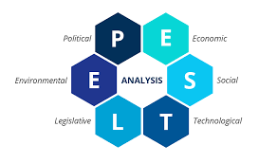
Figure 1: PESTEL analysis
(Sources: Ormston, 2025)
Political Factors: Government policies are important in facilitating the adoption of electric vehicles (EVs) and clean energy transitions. The federal government introduced a new tax credit, the Clean Vehicle Credit, which offers up to $7,500 tax credits to purchase a new EV after 2023, as part of the Inflation Reduction Act, and would get people to abandon traditional vehicles and move to electric mobility (IRS, 2023b). Moreover, in 2024, the number of states in the U.S. with additional incentives and rebates to purchase an EV increased to 27, increasing the demand to buy EVs and enhancing the development of such a business like Tesla (IEA, 2025). Investment in renewable energy projects and charging infrastructure is also a part of the political support of sustainable transportation technologies. The efforts by the government to cut carbon emissions have helped Tesla grow favourably. Nevertheless, the political uncertainties, including the trade disagreements, international tariffs, and other regulations, can also have an impact on the strategic functioning of the company and its international growth.
Economic Factors: The economic factors play a great role in the behaviour and demand of customers in the electric vehicle market. The U.S. The EV market consists of 2024 valued at $98.9billion and 2025 projected to $122 billion, suggesting a fast rate of growing industries and good chances of Tesla to increase its market share (Fortune Business Insights, 2025). Moreover, the inflation rate in the U.S. was approximately 2.4% in early 2026, which is an indicator of steady economic times that favor consumers to spend their money on high-value commodities like electric cars (Trading Economics, 2025). Still, the economic issues related to the supply chain disruptions, the increase in the prices of the raw materials, and the global economic instability may influence the costs of production and profit in the EV industry. Tesla, therefore, needs to be able to change its strategic operations in response to the fluctuating economic conditions.
Social Factors: Electric vehicle (EV) adoption is largely dependent on consumer attitudes and social trends. The growing environmental awareness and the issues of climate change are the factors that have stimulated consumers to explore their sustainable transportation options. In the USA, EVs made about 8% of all new car sales in 2024, which points to the increased acceptance of electric mobility (John, 2025). Moreover, questionnaires conducted in 2025 revealed that approximately 50% of Americans would be willing to buy an EV, which is positive evidence of the growing popularity of a sustainable car, yet other variables, like the price of the vehicle, the availability of charging solutions, and the range anxiety, continue to impact consumer behavior (Osaka, 2025). The company has exploited these social trends in order to make its vehicles technologically superior, environmentally friendly, and innovative products. The firm has been able to access environmentally conscious consumers due to its strong brand image and sustainability-based mission.
Technological Factors: One of the greatest sources of competitive advantage in the electric vehicle market is technological innovation. Blistering development of battery technology, artificial intelligence, and charging infrastructure has substantially changed the car industry. The U.S. Energy Information Administration undertakes monitoring of the electric and hybrid car sales and found that the electric and hybrid cars accounted 18.7% of light-duty vehicle sales in the U.S. in the second quarter of 2024, wherein the electric and hybrid cars in the U.S. are gaining more use (EIA, 2024). The given technological change emphasizes the increasing role of innovation in the sphere of automotive. Tesla has established a dominant role in technological development by investing in battery development, self-driving technology, and connecting cars to the Internet. The invention of superior battery technologies at the company has enhanced vehicle performance, minimized production costs, and increased the driving range. Moreover, Tesla has autonomous driving technology and over-the-air software updates as another competitive edge since it improves the functionality of the vehicle and user experience. The sustained technological innovation is hence a central strategic focus of Tesla in sustaining the top position in the EV industry.
Environmental Factors: One of the most significant factors that led to the development of the electric vehicle market is environmental sustainability. Environmental protection and mitigation of climate change have become the main concern among governments, organisations, and consumers. The United States has the highest rate of greenhouse emissions in the transport industry, which is estimated to be about 28-29% of the overall emissions, necessitating cleaner means of transportation (US EPA, 2025). The total greenhouse gas emissions in the U.S. were around 6343 million metric tons of CO₂ equivalent, which is another indicator of the urgency to cut carbon emissions. Electric cars provide a feasible remedy that can help lower the pollution in the environment by eradicating tailpipe emissions and enhancing the adoption of renewable energy. The strategic direction of sustainability adopted by Tesla is in line with the global environmental objectives, and this aspect has made the company associated with a high reputation as an innovator in clean energy.
Legal Factors: The law and regulatory systems play a major role in the growth and implementation of electric cars. Governments have implemented numerous policies to promote EVs and increase the number of charging points. As an example, the Alternative Fuel Vehicle Refueling Property Tax Credit offers tax credits to install EV charging stations prior to July 2026, which will facilitate the creation of charging stations in the United States (IRS, 2023a). There are also EV tax incentives in the Inflation Reduction Act, which enable those who are eligible to get up to $7,500 per vehicle through 2032 (Electrification Coalition, 2025). Such legal incentives provide Tesla with a favourable market environment, as they motivate consumers to buy electric cars, as well as promote the development of EV infrastructure. But Tesla also has to meet a number of regulatory requirements concerning the safety of vehicles, as well as environmental protection, and autonomous driving technologies.

2.2 Internal Environment Analysis (VRIO Framework)
Internal analysis ascertains the resources and capabilities of the organisation to identify sustainable competitive advantage. The VRIO model (Value, Rarity, Imitability, Organisation) determines the existence of competitive resources that can make Tesla competitive in the long term (Lu, 2024).
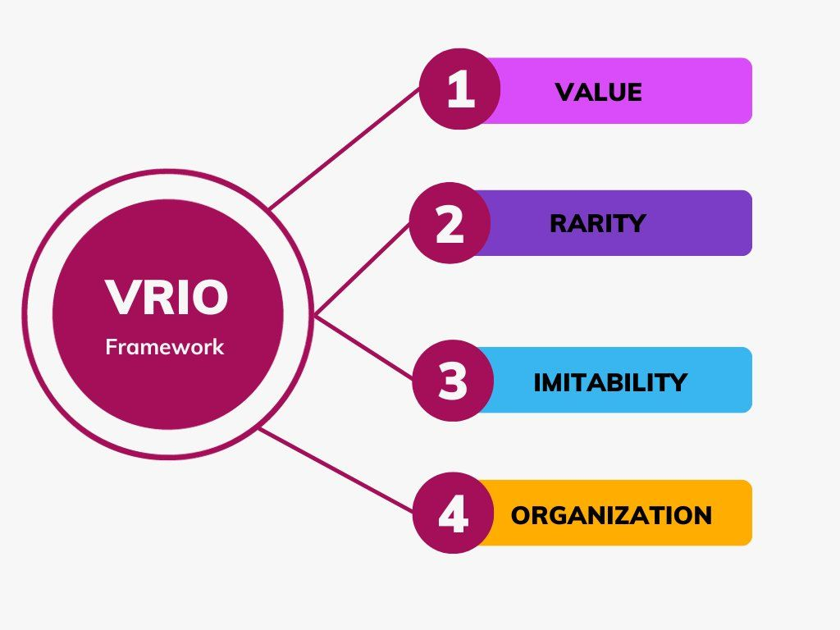
Figure 2: VRIO model
(Source: Solutions Hub, 2023)
Valuable Resources: Tesla has several resources that are of value in enhancing its strategic position. Its superior battery technology and energy storage system allow it to drive further and be more efficient due to the constant investment in research and development that lowers the cost of production and adds value to the product (Malik et al., 2025). Besides, Tesla has a worldwide network of superchargers that offers high-speed charging services that enhance customer convenience and increase EV adoption (Pares et al., 2024). Moreover, the practice of artificial intelligence and autonomous driving technologies implemented by Tesla makes users' experience more enjoyable, and it makes the company stand out compared to conventional automotive producers.
Rare Resources: Tesla has several strategic resources that are rare, and this enhances its competitive advantage. Its vertically integrated production system, which includes battery production, vehicle assembly, and software development, is rare among conventional automotive producers. Tesla is in control of several levels of the value chain through this form of integration, enhancing the efficiency of operations and technological alignment (Ghar, 2025). Also, Tesla has created a powerful international brand related to innovation, sustainability, and high performance. Such a reputation boosts loyalty among customers to the Tesla brand, as well as boosting demand to buy Tesla cars in the global market, which strengthens the business.
Imitability: The competitive advantage of Tesla is hard to imitate by its rivals because of its up-to-date technological skills, developed knowledge base, and significant investments in research and development. Such aspects pose severe entry barriers in the electric vehicle market. As an illustration, battery manufacturing technologies and ecosystems of software by Tesla demand expertise and significant capital investments, and imitation is difficult (He and Hao, 2023). Moreover, the organisational culture of Tesla, based on innovation, allows unstoppable experimentation and quick product development, which allows the company to launch new technologies more quickly than most traditional automotive producers.
Organisational Support: The last aspect of the VRIO framework is to determine whether the organisation is organised to capitalise on its strategic resources. The Tesla model is highly innovative and technologically advanced in its organisational structure. It also has a huge investment in research and development, especially in battery technology, autonomous driving systems, and renewable energy solutions (Lachmanen, 2025). Also, the Tesla global presence of Gigafactories in the United States, China, and Europe facilitates mass production, economies of scale, and successful quality control, enhancing the capacity of the company to leverage its strategic position to the max.
Tesla has valuable, rare, and difficult to imitate resources, generally combined with strong organisational support, which give the company a sustainable competitive advantage in the electric vehicle industry.

3. CSR and Sustainability Objectives
Sustainability programs and corporate social responsibility (CSR) have also become a significant part of business strategies in the contemporary world. In the case of Tesla, sustainability is not necessarily a complementary activity but the core of the mission and strategic vision of a company. The goal of Tesla to speed up the worldwide shift to renewable energy indicates its readiness to find solutions to environmental issues and generate value in the business in the long term (Lachmanen, 2025).
The creation of electric vehicles with zero tailpipe emissions is one of the major sustainability activities at Tesla. Conventional internal combustion engines are one of the main causes of carbon emissions in the world, especially in the transport industry. The United States Environmental Protection Agency asserts that transportation is the largest contributor to greenhouse gas emissions in the United States, with the proportion of transportation-related emissions being 28-29 percent of the total emissions in the nation (US EPA, 2025). The electric vehicles by Tesla are thus very important in curbing environmental pollution and climate change mitigation.
Tesla has increased sustainability measures by adding solar panels, solar roofs, and energy storage systems, which will help the company generate renewable energy and lessen its reliance on fossil fuels. Besides environmental efforts, the CSR strategy covers attempts to enhance the sustainability of the supply chain and ethical sourcing. The company has also put in place measures so that there is responsible sourcing of essential raw materials employed in manufacturing the batteries, such as lithium and cobalt. Moreover, Tesla is also spending on employee growth and workplace innovation, and this factor leads to organisational productivity and business sustainability.
The sustainability initiative embedded in its fundamental business model makes Tesla stronger in terms of brand image and positioning its strategic intentions in accordance with the global environmental agenda.

4. Comprehensive and holistic view of the organisation

4.1 Balanced Scorecard Analysis
The Balanced Scorecard was formulated by Kaplan and Norton (1992), and it assesses the performance of organisations based on financial and non-financial measurements in four perspectives, which include financial, customer, internal processes, and learning and growth.

4.1.1 Financial Perspective
Financially, Tesla is expected to experience a sustainable increase in revenues with a sustained profitability level. The EV market has grown swiftly on a global scale, producing tremendous opportunities that Tesla can seize to expand its market share. Fortune Business Insights estimates that the U.S. market of electric vehicles was expected to be valued at $98.9 billion in 2024 and will further increase to $122 billion in 2025, showing that the industry is growing well (Fortune Business Insights, 2025). The main financial goals of Tesla are to enhance production capacity, sales growth across the globe, and cost-effectiveness. The key performance indicators (KPIs) can consist of the growth rates of revenues, operating profitability, and the ROI. Moreover, Tesla targets the maximization of supply chain effectiveness, minimization of production expenses with the help of technological inventions, and enhanced financial stability over the long term in all global markets.

4.1.2 Customer Perspective
Customer satisfaction and brand loyalty are critical sources of competitiveness at Tesla. Tesla has achieved a good brand image in terms of innovation, sustainability, and technological development. The vehicles manufactured by the company have become well known for having good performance, safety features, and autonomous driving abilities. The last several years have shown an increase in the market demand for electric vehicles. Placing electric vehicles in 2024 contributed to about 8% of new vehicle sales in the United States, as the number of consumers who accept EV technology grows (John, 2025). The capability of Tesla to provide customers with innovative products that match their expectations is important in ensuring customer satisfaction remains high. Moreover, it is also important to mention that the Tesla charging system is growing, and software improvements increase customer experience, providing a solid brand loyalty and customer trust over time and anywhere in the world.

4.1.3 Internal Business Processes
Operational excellence and competitive advantage are impossible without effective internal processes. The vertically integrated production model enables Tesla to manage several steps of the manufacturing process, such as battery production, vehicle assembly, and software development. The efficient production processes and supply chain management have allowed Tesla to expand its manufacturing processes at a very high rate. Moreover, Tesla's emphasis on automation and high-tech production technologies contributes to enhancing productivity and decreasing the cost of production. Moreover, the constant gains in the manufacturing processes and the integration of digital supply chains allow Tesla to increase the flexibility of its operations, enhance the quality control, and promote the further growth of global production to an appropriate scale.

4.1.4 Learning and Growth Perspective
The learning and growth view concentrates on organisational innovation, growth of the employees, and technology. To retain its leadership role in the electric vehicle market, Tesla puts a lot of money into research and development. Innovation is one of the major aspects of the Tesla strategy, especially when it comes to battery, artificial intelligence, and renewable energy solutions. The constant education and technological advances enable Tesla to launch new products and upscale the current technologies, guaranteeing organisational growth in the long term. Additionally, Tesla fosters an effective culture of innovation by motivating the development of skills, cross-functional working, and trying new ideas among employees, which will help speed up the technological breakthrough and strategic growth.

5. Strategic Choices and Implementation
The strategic decisions define the manner in which organisations compete in their industries and maintain a competitive advantage in the long run. These decisions entail making suitable strategies that match organisational resources with the external market opportunities and threats. The strategic decision-making in the Tesla case is related to both the business level, within which the company has to compete on the electric vehicle market, and the corporate level, on which larger organisational growth and diversification strategies are worked out. These strategies must be well implemented to ensure Tesla leads the dynamic EV market.

5.1 Business-Level Strategy
At the business level, Tesla has been using a differentiation strategy, which involves producing special products that provide high value to customers. Differentiation is an aspect that enables companies to compete based on innovations, product quality, and technological superiority, and not just on price. Tesla also stands out with superior engineering, software, and performance electric vehicle design.
The incorporation of high-technological features, such as self-driving capabilities, artificial intelligence, and over-the-air updates to the software, should be listed among the most important differentiating aspects of Tesla. These qualities enable Tesla cars to continuously enhance their performance and capabilities even after the customer acquisition, thus giving the customers a changing perception of technology. Also, Tesla has invested in battery development that has allowed the company to create vehicles with a longer range and quicker charge time than a number of competitors (Lu, 2024).
Tesla has diversified, as well, in the brand position. The company has positioned itself as a high-quality technology-based car manufacturer, with a blend of environmental sustainability, high performance, and modern design. Tesla has managed to build a good brand image with excellent product attributes and by concentrating on innovation that attracts environmentally conscious customers, in addition to those who appreciate technology. This distinction allows Tesla to set higher prices and have high demand in the world.

5.2 Corporate-Level Strategy
Diversification and international expansion are some of the strategies that Tesla has implemented at the corporate level. Diversification entails diversifying business operations to new product lines that would complement the core competence of the organisation. Besides electric vehicles, Tesla has pursued other business ventures to produce renewable energy products, including solar panels, solar roofs, and energy storage systems, including Powerwall and Megapack batteries. These goods are in line with the larger goal of Tesla, which is to hasten the worldwide change towards sustainable energy.
Another significant strategy of the corporate level is international expansion. Tesla has also opened manufacturing factories in various countries, so that it can have more production capacity and get into the international markets better. Gigafactories in China and Germany have enabled Tesla to cut costs in logistics, increase the efficiency of its supply chain, and better address the demand of the regional market (Pares et al., 2024). Another way that Tesla improves its competitive edge over other multinational automotive corporations is through the expansion of manufacturing operations to international levels.

5.3 Strategy Implementation and Change Management
Effective implementation of strategies needs good organisational leadership and the capability to face dynamic change. Tesla has been very adaptive with the introduction of new technologies, improved manufacturing processes, and constant modification of its products. The fact that Tesla vehicles are technologically competitive in the long run is due to the company's inability to provide frequent software updates and technological improvements. The disruptive leadership of Tesla team leader, Elon Musk, contributes to the disruption and the continued leadership of Tesla in the electric vehicles sector in the world.

6. Strategic Evaluation and Recommendations
SWOT and Ansoff assess the competitiveness and opportunities of Tesla to grow in the future.

6.1 SWOT Analysis
SWOT analysis is the assessment of the Strengths, Weaknesses, Opportunities, and Threats that an organisation faces, enabling the business to know how the internal capabilities respond to environmental conditions.

Figure 3: SWOT analysis
(Sources: Taylor, 2024)
Strengths: The core competencies of Tesla are a good brand name, technological predominance, and a combined system of vehicles, software, and charging stations.
Weaknesses: Tesla is experiencing difficulties associated with the high cost of production and reliance on raw materials that are of high priority in the production of batteries.
Opportunities: The shift of the world to electric mobility has huge growth prospects. In the future, EV adoption is likely to rise due to government incentives and environmental policies (Qadir et al., 2024).
Threats: The threat of increasing competition by established automotive manufacturers and new start-ups in the field of EV has a significant impact on the market share of Tesla.

6.2 Ansoff Matrix Analysis
Ansoff Matrix is a strategic analysis tool that helps in the analysis of the possible growth strategies on the basis of products and markets. The business strategy of Tesla can be analyzed in the light of four growth strategies, which are recognized in this model.
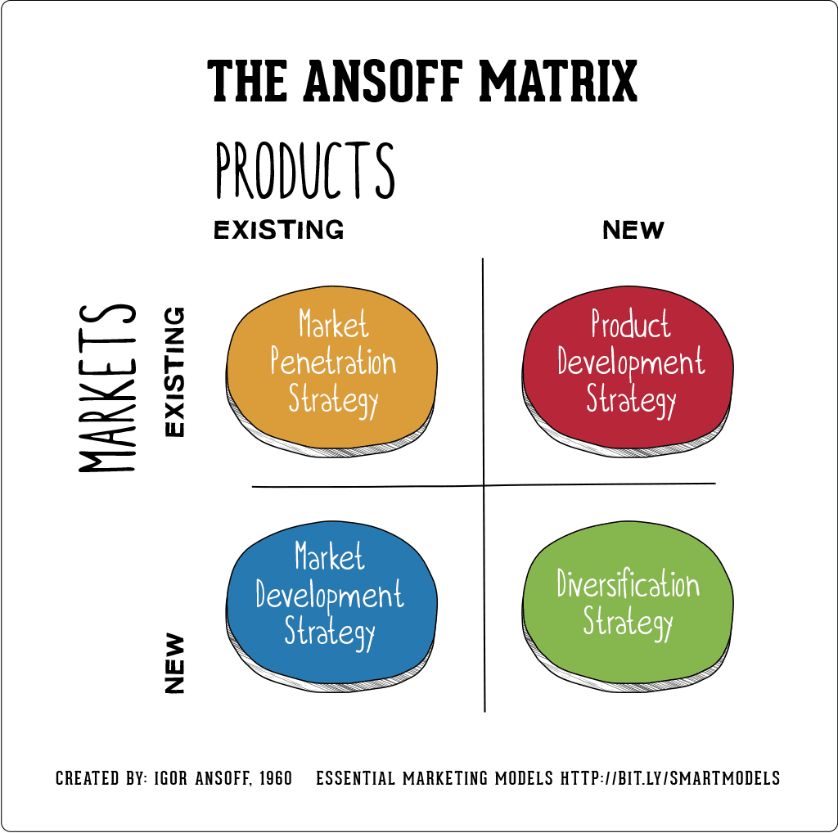
Figure 4: Ansoff matrix
(Source: Hanlon, 2021)
Market Penetration: Market penetration is aimed at boosting sales in the current markets with the current products. Tesla aims to consolidate its market by increasing production capacity and the affordability of its electric cars. Through the increase in efficiency in production and the minimization of manufacturing expenses, Tesla wants to appeal to a larger customer base and gain market share in the existing markets.
Market Development: Another market development approach that Tesla takes is to expand into new geographic areas where there is an increasing demand for electric vehicles. The developing economies and emerging markets are the new opportunities for EV adoption because governments implement new sustainability policies and invest in infrastructure.
Product Development: One of the elements of Tesla's strategy is to continuously innovate its products. The company also delivers new vehicle models and technology, such as battery performance, autonomous driving, and software integration features, regularly. The innovations enable Tesla to retain its technological leadership in the EV industry.
Diversification: Lastly, Tesla has engaged in diversification to go beyond the manufacture of vehicles into other renewable energy activities like solar energy products and battery storage systems. The diversification strategy is an addition to the main business of Tesla, and it contributes to the overall mission of powering the world towards a sustainable future.

6.3 Strategic Recommendations
According to the performed strategic analysis using the PESTEL framework, VRIO analysis, Balanced Scorecard, and strategic evaluation models, multiple recommendations may be made to increase the capabilities of Tesla to sustain a competitive advantage in the global electric vehicles sector in the long term.
- Increase in Global Volume of Production: Increase Gigafactories around the world to enhance productivity and resiliency in supply.
- Investment in Next-Generation Battery Technology: Invest in new generation batteries that will enhance efficiency, performance, durability, and manufacturing cost reduction.
- Ensuring the Charging Infrastructure: The expansion of charging infrastructure and the development of EVs all over the world are necessary to grow the use of EVs and consumer trust.
- Improving Sustainability in Supply Chains: Recycling to create a sustainable supply chain of batteries, enhance ethical sourcing, and transparency.
- Further Development of Autonomous Driving Technology: Invest in an autonomous AI business that enhances the safety, innovation, and mobility services.

7. Reflective Account (Gibbs Reflective Cycle)
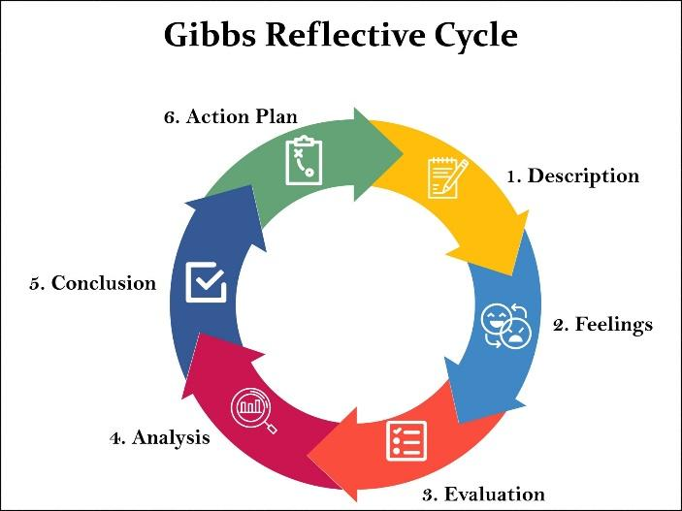
Figure 5: Gibbs reflective model
(Source: McLeod, 2025)
Description: This section is a contemplation of the research, analysis, and preparation process that took place on the strategic management analysis of Tesla Inc. The assignment aimed to critically analyse the strategic management practices at Tesla by using different strategic frameworks, including the PESTEL analysis, VRIO analysis, Balanced Scorecard, SWOT analysis, and the Ansoff Matrix. The research procedure entailed the collection of both academic and industry-based data regarding the activities of Tesla, the electric vehicle market, and the macroeconomic forces affecting the company in general.
To complete the assignment, the initial step included finding an adequate organisation where there was enough available data to carry out strategic analysis. Tesla was chosen due to the fact that it is in a highly dynamic industry with high rates of technological change, environmental pressure, and government policy in support of electric vehicles. The next step after selection of the organisation was to gather data using academic journals, industry reports, government sources, or market analysis to formulate the overall picture of the strategic environment around Tesla.
In the research phase, some critical aspects were addressed, including the government incentives for electric vehicles, technological advances in battery systems, consumer perception towards electric vehicles, and the environmental regulatory laws of the automotive industry. Once adequate information was gathered, the next step was to apply the strategic frameworks as needed by the assignment brief. They were analysed by each of the frameworks on various facets of the Tesla strategy, such as the external environmental factors, internal organisational capabilities, performance indicators, and future growth opportunities.
The last stage of the process was to combine the results of each framework into a consistent strategic analysis and generate recommendations for the further strategic development of Tesla.
Feelings: When I started the assignment, I was interested and a bit intimidated by the complexity of the analysis of such a large world organisation as Tesla. The electric vehicle business encompasses numerous interrelated variables, such as technological advancement, environmental policies, consumer behaviour, and economic status in the world. At first sight, it was difficult to put these various elements into a clear and systematic analysis.
Nevertheless, towards the end of the research process, I started to be more confident about my ability to use strategic management frameworks to analyse the business environment of Tesla. Structured frameworks like PESTEL and VRIO made it easier to simplify the complicated information and enabled me to divide the external and internal factors into more efficient categories. This data organization simplified the analysis of large volumes of data and the discovery of major strategic concerns that had an impact on the company.
I was also inspired upon learning that strategic management theories taught in the module had a direct application to an actual organisation. The assignment was interesting and thought-provoking to conduct due to the innovative approaches and sustainability efforts of Tesla.
Evaluation: In general, the process of research and analysis was positive on a number of occasions. The use of several reliable sources, such as academic journals, government reports, and industry publications, was one of the strengths of the process. This enabled the analysis to be based on sound and valid data and evidence, and enhanced the quality of the strategic assessment.
One more advantage was the use of various strategic management models, which helped to gain more profound insights into the competitive environment of Tesla. Indicatively, the PESTEL analysis was used in determining macro-environmental factors like government incentives, technological innovations, and environmental issues, which affect the electric vehicle market. On the same note, the VRIO framework offered useful information about the internal resources and capabilities of Tesla, discussing the contribution of technological innovation and brand reputation to the company's competitive advantage.
Nevertheless, certain obstacles during the research also existed. The second challenge was the high amount of information to deal with regarding Tesla and the electric vehicle market. Since Tesla is a well-researched company, it was required to thoroughly assess the sources and pick the most applicable information for the analysis. Also, certain information in the industry is dynamic and is quickly changing with the changes in technology and market conditions, and this demands that the most current and reliable sources be carefully selected.
Analysis: The evaluation of the process of the assignment shows the significance of the frameworks of analytical systematization of strategic management research. It would have been hard to structure and decipher the various complex factors that affect the strategic environment of Tesla without frameworks like PESTEL, VRIO, and SWOT.
The assignment also revealed the importance of organisations keeping abreast with environmental pressure. Some of the key drivers that influence the strategic decisions taken by Tesla are the government policies that encourage the use of electric vehicles, environmental issues of greenhouse gas emissions, and technological advancement. The analysis supported the notion that organisations that achieve success need to match the internal capabilities to the external opportunities to maintain a competitive advantage.
The other important lesson of the assignment was to realize the significance of innovation and sustainability in the strategic management of today. Tesla's attention to clean energy technologies and its sophisticated auto systems demonstrates how firms can gain a competitive advantage when dealing with global issues like climate change.
Conclusion: To sum up, the strategic management analysis has gone a long way in enhancing my knowledge on the application of theoretical frameworks to real-life organisations. The assignment served to build my research skills on independent research, analyse complex business contexts, and acceptance or refusal of organisational strategies based on academic models.
The case study of Tesla was also helpful in understanding the strategic issues and opportunities in the electric vehicle market. In the process, I learnt more about the role of innovation, sustainability, and government policy in organisational strategy.
Action Plan: When working on my academic projects in the future, I will continue improving my research and analytical abilities by studying other models of strategic management and applying them to various organisations and industries. Another area that I would like to enhance is my critical writing skills as far as academic literature is concerned, and my skill in blending theoretical knowledge and practical business in the world.
Moreover, I am going to improve my time management and information assessment abilities so that I can process huge volumes of research information more effectively. The enhancements would aid in improving my skills in carrying out in-depth strategic analysis both in academia and in the workplace.

References List
Eia (2024). U.S. share of electric and hybrid vehicle sales increased in the second quarter of 2024 - U.S. Energy Information Administration (EIA). [online] Eia.gov. Available at: https://www.eia.gov/todayinenergy/detail.php?id=62924&.
Electrification Coalition (2025). Inflation Reduction Act Impacts on Electric Vehicles. [online] Electrification Coalition. Available at: https://electrificationcoalition.org/work/federal-ev-policy/inflation-reduction-act/? [Accessed 12 Mar. 2026].
Fortunebusinessinsights (2025). US Electric Vehicle Market Size, Share, Trends | Growth [2032]. [online] Fortunebusinessinsights.com. Available at: https://www.fortunebusinessinsights.com/u-s-electric-vehicle-market-106396? [Accessed 12 Mar. 2026].
Ghar, S. (2025). Tesla’s International Business Strategy. SSRN Electronic Journal. [online] doi:https://doi.org/10.2139/ssrn.5258192.
Hanlon, A. (2021). The Ansoff Model. [online] Smart Insights. Available at: https://www.smartinsights.com/marketing-planning/create-a-marketing-plan/ansoff-model/.
He, W. and Hao, X. (2023). Competition and welfare effects of introducing new products into the new energy vehicle market: Empirical evidence from Tesla’s entry into the Chinese market. Transportation Research Part A: Policy and Practice, [online] 174(103730), p.103730. doi:https://doi.org/10.1016/j.tra.2023.103730.
IEA (2025). Trends in electric car markets – Global EV Outlook 2025 – Analysis - IEA. [online] IEA. Available at: https://www.iea.org/reports/global-ev-outlook-2025/trends-in-electric-car-markets-2?.
IRS (2023a). Clean vehicle tax credits | Internal Revenue Service. [online] Irs.gov. Available at: https://www.irs.gov/clean-vehicle-tax-credits?.
IRS (2023b). Credits for new clean vehicles purchased in 2023 or after | Internal Revenue Service. [online] Irs.gov. Available at: https://www.irs.gov/credits-deductions/credits-for-new-clean-vehicles-purchased-in-2023-or-after?.
John, A.S. (2025). The US electric vehicle industry is collateral damage in Trump’s escalating trade war. [online] AP News. Available at: https://apnews.com/article/trump-tariffs-electric-vehicles-automakers-a106cce5b6acbf5d14ad1e583e301b50.
Kaplan, R.S. and Norton, D. (1992). The Balanced Scorecard: Measures that Drive Performance. [online] Hbs.edu. Available at: https://www.hbs.edu/faculty/Pages/item.aspx?num=9161.
Lachmanen, R.D. (2025). A Systematic Review of Tesla’s Innovations Towards Environmental Sustainability. International Journal of Innovative Science and Research Technology, [online] p.1221. doi:https://doi.org/10.38124/ijisrt/25dec864.
Lu, S. (2024). Overcoming obstacles of Tesla: Strategies for problem-solving. Highlights in Business Economics and Management, [online] 40, pp.514–519. doi:https://doi.org/10.54097/cw7ssm33.
Malik, M.A.I., Kalam, M.A., Ikram, A., Zeeshan, S., and Raza Zahidi, S.Q. (2025). Energy transition towards electric vehicle technology: Recent advancements. Energy Reports, 13, pp.2958–2996. doi:https://doi.org/10.1016/j.egyr.2025.02.029.
McLeod, S. (2025). Gibbs Reflective Cycle. [online] Simply Psychology. Available at: https://www.simplypsychology.org/gibbs-reflective-cycle.html.
Ormston, A. (2025). PESTLE Analysis: A Guide to Understanding Market Influences. [online] B2B International. Available at: https://www.b2binternational.com/2025/04/03/pestle-analysis/.
Osaka, S. (2025). Americans are losing interest in EVs. And it’s not just about Elon Musk. [online] The Washington Post. Available at: https://www.washingtonpost.com/climate-environment/2025/04/08/electric-vehicles-sales-us/? [Accessed 12 Mar. 2026].
Pares, F., Busch, P., Chandra, M., and Tal, G. (2024). Shifting Manufacturing: Electric Vehicle Supply Strategy using the Model for International EV Trade. Journal of Cleaner Production, [online] p.144357. doi:https://doi.org/10.1016/j.jclepro.2024.144357.
Qadir, S.A., Ahmad, F., Al-Wahedi, A.M.A.B., Iqbal, A. and Ali, A. (2024). Navigating the Complex Realities of Electric Vehicle adoption: a Comprehensive Study of Government strategies, policies, and Incentives. Energy Strategy Reviews, [online] 53(53), pp.101379–101379. Available at: https://www.sciencedirect.com/science/article/pii/S2211467X24000865.
Solutions Hub (2023). EPAM SolutionsHub | Software Solutions for Digital Business. [online] solutionshub.epam.com. Available at: https://solutionshub.epam.com/blog/post/vrio-analysis.
Taylor, I. (2024). A SWOT Analysis Template For The Overwhelmed Marketer. [online] QuestionPro. Available at: https://www.questionpro.com/blog/a-swot-analysis-template-for-the-overwhelmed-marketer/.
Trading Economics (2025). United States Inflation Rate. [online] Trading Economics website. Available at: https://tradingeconomics.com/united-states/inflation-cpi.
US EPA (2025). Transportation Sector Emissions. [online] US EPA. Available at: https://www.epa.gov/ghgemissions/transportation-sector-emissions?.

