Student Name: Nasir Hossain

student ID: 2211492
teacher name: christian felicas
uwtsd - university of wales trinity saint davies
learning in the digital era / e – portfolio

Table of Contents
Introduction 3
Importance of Academic Writing (Task 2) 3
Definition 4
Importance of Academic Writing 4
Turnitin Screenshot: 5
Enhancing Quality Writing Through Critical Analysis (Task 3) 6
Definition 6
Significance of Critical Analysis for Quality Work 6
Exploring Sense of Place and Identity (Task 4) 7
Conclusion 10
References 12

Introduction
This introduction section of this report template acts as an introductory overview and sets the context for the tasks that follow in the e-portfolio (Bailey, 2018). It presents a concise overview of the document's overall purpose and structure, emphasizing the significance of the tasks that will be tackled (Bailey, 2018).
The main purpose of this e-portfolio is to exhibit the author's understanding of academic writing, critical analysis, and concepts of sense of place and identity. This knowledge is fundamental in an academic setting and plays a vital role in both academic achievements and personal growth. So the first section of this report will delve into the significance of academic writing and its impact on scholarly communication, knowledge dissemination, and intellectual growth. The author intends to enrich the comprehension of academic work expectations and standards by examining the importance of academic writing. In the following segment, the author will delve into the significance of critical analysis in academic writing. In the last section, the author will explore the concept of a sense of place and identity by discussing their significance in understanding human experiences. This task involved creating a video presentation to present these concepts. Overall this report template used here serves as the cornerstone for undertaking the upcoming tasks in this e-portfolio.

Importance of Academic Writing (Task 2)
The initial segment of the report delves into the essence of academic writing as an imperative proficiency for scholarly pursuits (Swales and Feak, 2022). The significance of academic writing lies in its ability to articulate complex ideas, substantiated with appropriate evidence. Moreover, maintaining conformity with disciplinary standards and acquiring expertise in academic writing is indispensable for active participation in scholarly discussions, contributing to existing knowledge and demonstrating comprehension of the subject matter (Harrison, 2017). Integrating this section into report templates recognizes the indispensable role played by academic writing in intellectual and academic endeavours.

Definition
Academic writing is a different and specialized form of writing used in educational and scholarly settings (Bailey, 2018). Such writing is characterized by its formal style, logical structure, and evidence-based approach. This type of writing covers a broad spectrum of genres such as research papers, reports, dissertations, and essays. Scholars from various fields understand and recognise the importance of academic writing for effective communication within the academic setting.

Importance of Academic Writing
Swales and Feak (2022) highlighted the significance of academic writing as an important tool that helps to construct and share knowledge within the academic community. It provides researchers with an opportunity to contribute their findings to the existing body of knowledge, engage in critical discourse, and contribute to their respective fields. In such cases, scholars follow specific conventions of academic writing as they always make sure of precision, clarity, and credibility in their scholarly works (Swales and Feak, 2022).
Besides this, Harrison (2017) stated that academic writing is very crucial in terms of developing critical thinking skills. As in the process of academic writing, individuals are required to involve in the process of researching, analyzing, and synthesizing information, this helps them to develop their unique ability to evaluate various evidences more critically along with well-reasoned arguments (Harrison, 2017). Academic writing encourages individuals to challenge assumptions and develop logical arguments constantly in their writing by employing critical thinking exercises (Harrison, 2017).
Moreover, Willetts (2017) stated that the ability to write effectively in an academic setting is critical for personal and professional development. This skill is highly valued in various fields, including academia, research, and other professional settings. Effective writing allows for the clear communication of complex ideas, influencing decision-making, and establishing credibility (Willetts, 2017).
In sum, academic writing goes beyond just conveying information it serves as a tool for constructing knowledge, developing critical thinking skills, and promoting professional growth. It also makes it easy to exchange ideas and contributes to the advancement of knowledge at the same time ensures clarity and precision in academic discourse. Engaging in academic writing sharpens analytical and communication skills which as a result helps individuals to have success both within academia and beyond its borders.

Turnitin Screenshot:
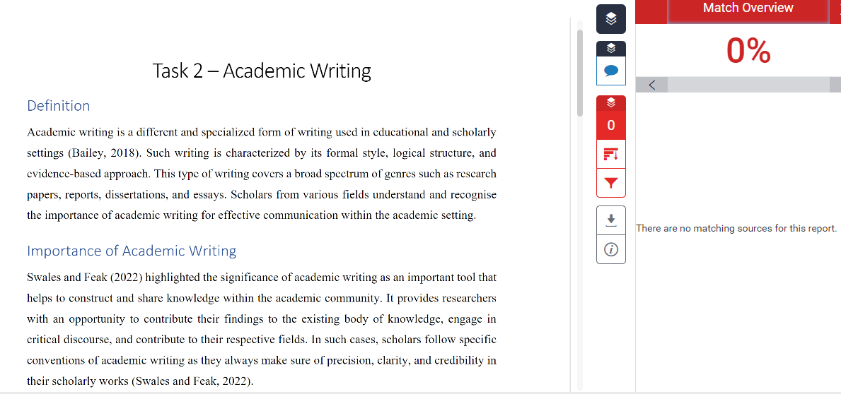

As shown in the above screenshot of my task 2 Turnitin submission, obtaining a 0% similarity score on Turnitin is a clear indication of my commitment to academic integrity and the originality of my work. This score confirmed that my document is unique and does not contain any similarities with existing sources in the Turnitin database and which also means that I have appropriately paraphrased and given credit to all information and ideas from the sources I used (Barberena-Cerda & Parnther, 2022). To stay in such a score in the future, I plan on implementing effective paraphrasing techniques at the same time meticulously citing and referencing all sources used. Additionally, I will conduct extensive research and integrate various perspectives to enhance the quality and uniqueness of my work. Moreover, regular self-reviewing and proofreading will help identify any unintentional similarities or errors before submission while ensuring the authenticity and integrity of my academic writing (Barberena-Cerda & Parnther, 2022).

Enhancing Quality Writing Through Critical Analysis (Task 3)
In this section, the author stresses the importance of critical analysis in academic report writing and its impact on improving the quality of work produced. According to Samanhudi & Linse (2019), critical analysis is a tool that individuals can use to evaluate and synthesize information from different sources to comprehend the subject matter. This process enables writers to assess the credibility and validity of research findings, identify weaknesses and strengths in arguments, and provide well-researched recommendations (Bailey, 2018). In academic report writing, critical analysis plays a crucial role in promoting evidence-based reasoning, contributing to thorough research, and improving overall work quality, as highlighted in this section.

Definition
The act of critically analyzing is a vital component within the framework of academic report writing as it allows individuals to delve deeper than a superficial understanding and engage in a comprehensive evaluation of different concepts, justifications, proof, and viewpoints (Cottrell, 2013). This method involves meticulously and systematically assessing, interpreting, and consolidating data to formulate astute and well-substantiated judgments regarding a given subject matter (Swales & Feak, 2022). By diligently conducting a critical analysis of the content they are producing, individuals can elevate the calibre of their academic output in various ways.

Significance of Critical Analysis for Quality Work
Critical analysis provides an opportunity to have an all-inclusive understanding of the topic being investigated. This includes breaking down complex ideas into various parts at the same time examining relationships and identifying underlying assumptions. Such a process helps researchers and students gain a deeper understanding of the subject matter and develop more strong and sophisticated arguments (Bailey, 2018). According to Swales and Feak (2022), critical analysis assists researchers and students in moving beyond a mere description of a writing to a higher level of analysis which as a result makes sure a quality work.
In the case of academic writing, the significance of critical analysis is so higher it is needless to mention. The critical analysis develops intellectual rigour and objectivity among individuals as such skill allows them to evaluate the credibility, reliability, and validity of various types of sources used in a work (Cottrell, 2013). So as a result, the work they produce is well-equipped with high-quality evidence. Samanhudi & Linse (2019) stated that critical analysis helps students identify biases, logical fallacies, and weaknesses in arguments so they can construct a more robust academic report.
Moreover, critical analysis fosters originality and independent thinking among students and researchers by challenging established ideas and assumptions at the same time exploring different viewpoints (Bailey, 2018). Through this process of questioning, individuals can develop unique insights that contribute to knowledge generation. Critical analysis also encourages researchers to go deeper into the interpretation of information beyond surface-level understanding (Swales & Feak, 2022). This helps individuals to develop their perspectives at the same time contributes to the broader academic discourse.
Overall integrating critical analysis into academic report writing is crucial for producing impactful work grounded in well-supported arguments and evidence. Researchers contribute significantly towards knowledge development in their respective fields by engaging in the process of critical thinking as it requires the process of evaluation and questioning assumptions with pieces of evidence.

Exploring Sense of Place and Identity (Task 4)
This section of the report is about the topic of exploring one's sense of place and identity. This concept holds great significance in comprehending human experiences and cultural contexts (Rieh, 2020). Through an examination of these concepts, this section aims to shed light on their impact on individual and collective identities, sense of belonging, and cultural expressions. It emphasizes the need to recognize and comprehend how a sense of place and identity interrelate. By engaging with these ideas, individuals can gain insights into the complexity behind human experiences and how our sense of place and identity shapes our understanding of the world around us.
Video Link: Put your video link here…..

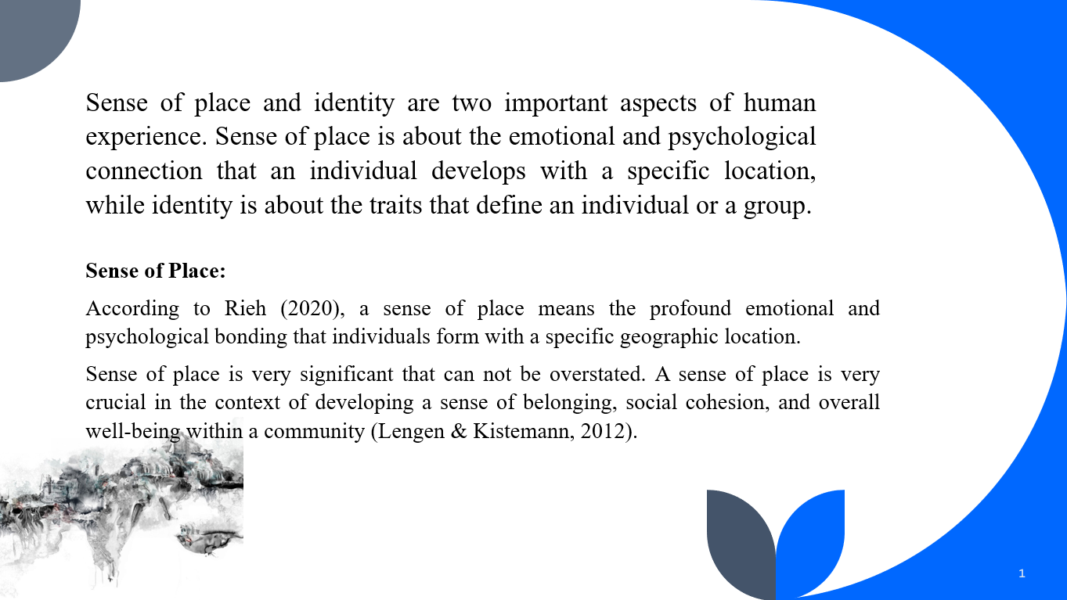
Take my greetings! In this video presentation, I am going to explore two intriguing concepts namely sense of place and identity, and how these concepts impact on wider individual and community levels.
Sense of place and identity are two important aspects of human experience. Sense of place is about the emotional and psychological connection that an individual develops with a specific location, while identity is about the traits that define an individual or a group.
Sense of Place:
Let’s start with the concept of a sense of place! According to Rieh (2020), a sense of place means the profound emotional and psychological bonding that individuals form with a specific geographic location. Such connection goes beyond the physical attributes of that location and includes components like meanings, memories, and various experiences linked with that location.
Sense of place is very significant that can not be overstated. A sense of place is very crucial in the context of developing a sense of belonging, social cohesion, and overall well-being within a community (Lengen & Kistemann, 2012). This enhances and strengthens the ties of individuals with their environment and as a result, contributes to preserving cultural heritage and environmental stewardship. Communities can create more meaningful connections with other individuals at the same time can preserve their historical roots, just by cultivating a sense of place (Lengen & Kistemann, 2012).
Identity
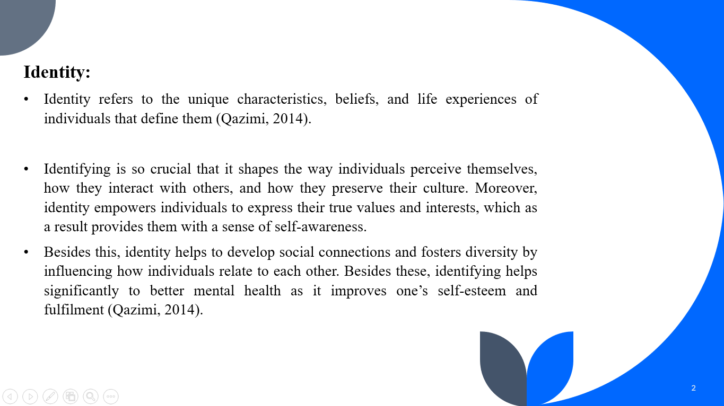
Another key concept: Identity! Identity refers to the unique characteristics, beliefs, and life experiences of individuals that define them (Qazimi, 2014). Identifying is so crucial that it shapes the way individuals perceive themselves, how they interact with others, and how they preserve their culture. Moreover, identity empowers individuals to express their true values and interests, which as a result provides them with a sense of self-awareness. Besides this, identity helps to develop social connections and fosters diversity by influencing how individuals relate to each other. Besides these, identifying helps significantly to better mental health as it improves one’s self-esteem and fulfilment (Qazimi, 2014). Overall, recognizing the importance of identity helps both society and individuals to develop a strong sense of self at the same time promote harmony and acceptance in society.
Connection Between Identity and Sense of Place
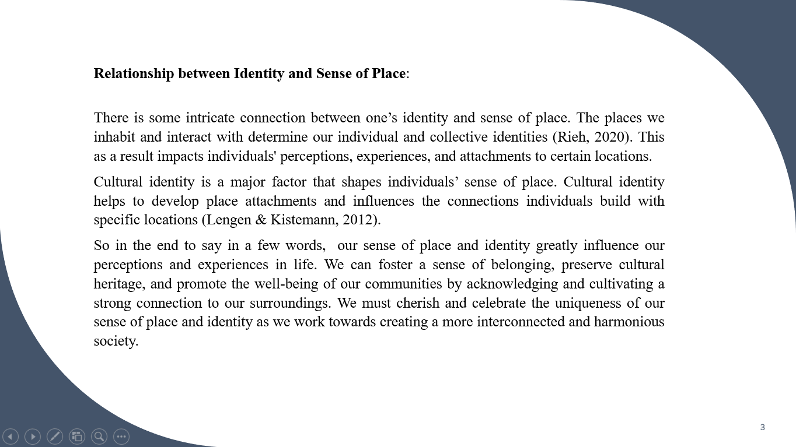
There is some intricate connection between one’s identity and sense of place. The places we inhabit and interact with determine our individual and collective identities (Rieh, 2020). This as a result impacts individuals' perceptions, experiences, and attachments to certain locations.
Cultural identity is a major factor that shapes individuals’ sense of place. Cultural identity helps to develop place attachments and influences the connections individuals build with specific locations (Lengen & Kistemann, 2012).
So in the end to say in a few words, our sense of place and identity greatly influence our perceptions and experiences in life. We can foster a sense of belonging, preserve cultural heritage, and promote the well-being of our communities by acknowledging and cultivating a strong connection to our surroundings. We must cherish and celebrate the uniqueness of our sense of place and identity as we work towards creating a more interconnected and harmonious society.

Conclusion
In conclusion, this report template offered a comprehensive framework for holding e-portfolio tasks of the module and mostly emphasized the importance of academic writing, and critical analysis for quality work, and explored two related concepts namely a sense of place and identity. As the report started with academic writing, with enough evidence, it is clear that academic writing is a crucial skill that helps with effective communication, knowledge development, and critical thinking skill in the context of academic settings. In the following heading, the author has explored the role of critical analysis in academic writing to have quality work and highlighted how it improves the quality of academic work by promoting thorough research, evidence-based reasoning, and informed insights. Moreover, exploring our sense of place and identity has deepened our comprehension of how geography influences individuals and cultures. Overall this report template provided an all-encompassing overview of these tasks at the same time showcased growth and proficiency in these vital areas.

References
Bailey, S. (2018) Academic writing: A handbook for international students. London: Routledge.
Barberena-Cerda, A. and Parnther, C. (2022) ‘Promoting academic integrity and admonishing academic misconduct’, Promoting Academic Integrity [Preprint]. doi:10.4135/9781071888421.
Cottrell, S. (2013) Critical thinking skills: Developing effective analysis and Argument. New York: Palgrave Macmillan.
Harrison, R. (2017) Academic writing and critical thinking. London: Canford Publishing.
Lengen, C. and Kistemann, T. (2012) ‘Sense of place and place identity’, Health &amp; Place, 18(5), pp. 1162–1171. doi:10.1016/j.healthplace.2012.01.012.
Qazimi, S. (2014) ‘Sense of place and place identity’, European Journal of Social Sciences Education and Research, 1(1), p. 306. doi:10.26417/ejser.v1i1.p306-310.
Rieh, S.-Y. (2020) ‘Sense of place’, Creating a Sense of Place in School Environments, pp. 7–19. doi:10.4324/9780429441332-2.
Samanhudi, U. and Linse, C. (2019) ‘Critical thinking-related challenges to academic writing: A case of Indonesian postgraduate students at a UK university’, Lingua Cultura, 13(2), p. 107. doi:10.21512/lc.v13i1.5122.
Swales, J.M. and Feak, C.B. (2022) Academic writing for graduate students: Essential Tasks and skills. Ann Arbor: The University of Michigan Press.
Willetts, D. (2017) ‘The student academic experience’, A University Education [Preprint]. doi:10.1093/oso/9780198767268.003.0014.

