
Skills for the Workplace
Module Assignment Submission
Student Name: | Pachita Gabriela Buliga
Student Number: | 1813644
Module leader: | Cristopher Mafuva
Module No: | BMSK-4002
Module Title: | Effective Team Working and Communication
Assessment No: | 1

Table of Contents

1.0 Introduction 3
2.0 Importance of Communication in a Retail Store 3
3.0 Types of Communication at Specsavers 4
4.0 Barriers to Communication at Specsavers 5
5.0 Different Models of Communication 6
6.0 Model of Communication within the Workplace 7
7.0 How communication & performance of employees can be improved 8
8.0 Conclusion 8
9.0 References 9

1.0 Introduction
Communication is essential for every organization’s success. Workplace communication is what determines the success and failure of an organization to reach their desired gaols and daily outcomes. Communication is the means of sending or receiving information (Youtube, 2019). Workplace communication is the means of sending and receiving information in a workplace setting when different methods and tools are used for both internal and external communication. A proper communication use of proper words, phrases, emotions, body language and eye contract. There are many types of employees who perform well at communicating in the workplace and they are successful at achieving their outcome. These types of employees are liked by the manager as they can put their trust to achieve a certain goal when needed. There are some other types of employees who are introvert type in nature and does not communicate well with other. Although they might possess some other types of skills such as technical skills, analysing skills and strategic skills that adds value to them. According to Belbin, (2012) No matter whether an employee is an introvert or an extrovert, it is always expected than an employee should be able to work well with others in a team and use effective methods of communication within the workplace.
This report will discuss about how employees perform at communication in the workplace. I would share my experience for working in an organization and the communication skills and strategies used inside the organization. I have been working at Specsavers for more than a year as a supervisor of their store. Specsavers. Specsavers Optical Group Ltd is a British optical retail chain, operating globally. The chain offers optician services for eyesight testing and sells glasses, sunglasses, and contact lenses and it also sells hearing aids (Specsaverscouk, 2019). Working here gave me a lot of knowledge and learned more about employability skills which will be beneficial for my future. Apart from that I learned how to communicate well with others and how all the employees manage communication by using different models, tools and strategies.

2.0 Importance of Communication in a Retail Store
Internal communication important for all types of business but specially in retail stores it is much more important as the way employees communicate internally will directly reflect towards the customers. According to Dalley & Burton (2010), communication creates a general image in the customers mind by the way the employees internally communicate and a good communicate skills and behaviour will surely motivate the customers to get a proper service from that retail employees who works there. In todays market, one bad experience of the customer will take away many more customers to the doorsteps of the competitors.
A brand promise is a type of communication that is done by many popular brands and it is implemented by the retail employees. Therefore, it is important to fulfil brand promises and communicate with clients with accurate and clear message so that the brand promise can be kept. This is where effective communication plays the role and does help the organization to achieve their goals.
It is important to work Collaboratory in retail stores so that all customers can get the same type of services from the employees. With effectively communicate skills and methods, employees will be able to stay in touch with each other regarding latest updates and news of their products and work as a team serve the client in an effective manner (Adair, 2009).

3.0 Types of Communication at Specsavers
At Specsavers, there are different types of communication that are followed by the employees while working in the organization which is explained with more details below:
3.1 Oral Communication: The most common type of communication is the oral communication that happened at Specsavers. As it was a retail shop where I worked, so there are many customers who visited out stores to purchase something or get tested depending on their needed. It is the oral face to face communication which al the employees had to did to communicate effectively with the customers. Sometimes oral communication can be done without face to face for example providing customer support over the phone. As customer service was one of the most important job for the employees so facing different customers and providing them service with verbal communication was our daily job requirement.
3.2 Written Communication: Written communication was another type of communication that the employees did every day. When customers set an appointment to visited then we had to send an email confirming the date and time of the appointment which was done by the employees. When customers get tested for their eye problems, then we provide a written document of the report which clearly explains the problems and suggested solution for the eye problem. Sometime we needed to communicate with other retail store and even our headquarters and this could be done by written communication. Therefore, this type of communication was essential for a retail store of Specsavers where I work for more than a year.
3.3 Interpersonal Communication: This type of communication is also known as nonverbal communication which is also done by every employee in every organization. At Specsavers we had to strictly follow the interpersonal communication as we provide service to customer face to face. Some good skills in interpersonal communication will help to provide a positive and better service to the customers. The smile, the body language of reassurance, the listening ability are all non-verbal type of communications. As the employees at Specsavers has to provide in store services so we need to focus on that to provide ultimate satisfaction to the customers.

4.0 Barriers to Communication at Specsavers
As I worked at Specsavers as a supervisor, I was able to learn the communication barriers in the organization that created communication issues and conflicts with others and cause problem with effective internal communication. The barriers to communication are minimal but needs to be taken care immediately. Some of the barriers to communication at the retail store are given below:
Cultural differences are ones of the biggest change for effective in store communication. The employees who work at the store comes from different cultures and their way of communication is different from one another. Sometimes it takes time to get along with the environment of the workplace and this creates a barrier for effective communication.
Language difference can be another barrier to communication. Customers might have different accent so does the employees. It crates difficulty while communicating internally and also with the customers who come to visit the store. This cause unfamiliar situation and might create a bad experience for the customers which is difficult to solve as language difference will always exist.
Another barrier to effective communication is lack of interest for active listening. This can be caused due to boredom and lack of interest to work due to personal issues. When active listening is not happening then one employee will not be able to accurately communicate with another and it can happen as well with the customers. When employees are not actively listening then the customer can easily understand that and this will create a negative impression inside the mind of the customers (Lumenlearningcom, 2019).

5.0 Different Models of Communication

- Claude Shannon and also Warren Weaver Model (Communicationtheoryorg, 2011)
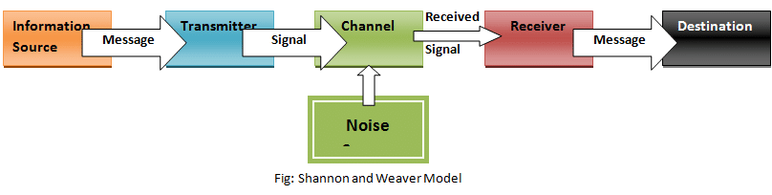

- Schramm’s Model (Ipfsio, 2019)
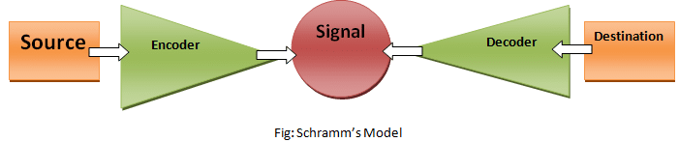

- The Rileys Model (Ipfsio, 2019)
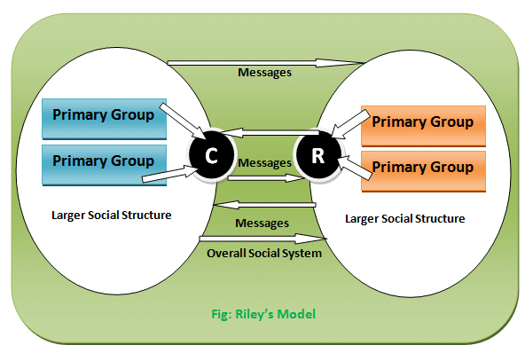

6.0 Model of Communication within the Workplace
Shannon Weaver model of communication was created in 1948 when Claude Elwood Shannon wrote an article “A Mathematical Theory of Communication” in Bell System Technical Journal with Warren Weaver (Communicationtheoryorg, 2011). Although this method of communication is seen as one of the best one compared to other models of communications but it has few criticisms as well. This model can be applied more for interpersonal communication compared to group communication. This model always misinterprets the human nature of communicating with others (Youtube, 2019).
6.1 Sender- It is the person who sends to message to a recipient. In case of our retail store, a sender can be the employee or the customer who sends the message and expects the receiver to receive the message.
6.2 Encoder- It is the sender who uses machine which converts messages into binary data. When sender has some message in mind then the sender encodes the message inside and delivers it to the receiver.
6.3 Channel- It is the medium that is used to send a message to another person or group of people. Channel can be through face to face, telephone, email, written and many more. The mode that is used for the channel of communication will decide the effectiveness of the message (Communicationtheoryorg, 2011). At Specsavers it is the face to face verbal communication channel that is used to deliver the message from sender to receiver.
6.4 Decoder- It is the receiver that converts the signals or binary data into messages that can be interpreted by the receiver. When a customer asks for something then it ia decoded by the receiver to get a clearer meaning of the message.
6.5 Receiver- Receiver is the person who receives the message that is sent by the sender. In our retail store communication, the message that is sent by the customer is receiver by the employees who acts as the receiver.
6.6 Noise- Noise is the physical disruptions that does not allow the actual message to be sent from the sender to the receiver. Examples of noise can be environment, peoples that can create physical disturbances (Youtube, 2019). In retail stores when many customers visit and communicate with the employees, it creates noise for others while communication and cause disruptions.

7.0 How communication & performance of employees can be improved
With proper training is communication, employees will become more skilled at communicating. For a retail store like Specsavers, it is important for the employees to get trained when they join the organization. This will help them to learn new skills and provide better customer service. In this way their communication skills will improve and they will be better at communicating both with colleagues and the customers visiting the store which will improve the productivity as well.
Incentivize Employees can be another method to reward and motivate to be more efficient and communicate effectively with others. This will also help to improve their work productivity as well. In a retail store communication plays a vital role and when an employee is self-motivated then he or she can achieve what is required to perform well in a job.
Providing feedback can be another method that can improve the communication skills and productivity of the employees. The managers in the store can look after the employees and analyze their strength and weaknesses. After that the management can talk in person with that employees regarding the lacking in communication and suggest ways to improve them. This will result in better communication and also make them more productive at work.

8.0 Conclusion
Communication is important for every organization and for a retail store like Specsavers it is the most important as effective communication skills are required to do workplace communication also to provide service to the client who visits the store every day. Barriers to communication will exist in every organization and it needs to be taken care within very short time to solve misunderstandings and communication issues in the organization. To properly communicate and solve workplace communication issues, organization should provide trainings to the employees specially in a service-based retail chain where customer service is daily requirement in the job role. With proper communication, motivation and teamwork, workplace communication and productivity of employees can be improved.

9.0 References
- Adair, J.E. (2009) Effective Teambuilding: How to make a winning team. London: Pan Books
- Belbin, M.R. (2012) Team roles at work. 2nd edn. Oxford: Butterworth-Heinemann.
- Communicationtheoryorg. 2011. Communication Theory. [Online]. [17 April 2019]. Available from: https://www.communicationtheory.org/shannon-and-weaver-model-of-communication/
- Communication in the 21st Century: Is It What You Say, Not How You Say It? | Vivian Ta | TEDxUTA, Video File, Available from: https://www.youtube.com/watch?v=laDnZ_FWyhM [18 April, 2019].
- Dalley, D., and Burton, L. Developing your Influencing Skills: How to influence people by increasing your credibility, trustworthiness and communication skills (2010) Universe of Learning Ltd.
- Ipfsio. 2019. Ipfsio. [Online]. [17 April 2019]. Available from: https://ipfs.io/ipfs/QmXoypizjW3WknFiJnKLwHCnL72vedxjQkDDP1mXWo6uco/wiki/Models_of_communication.html
- Lumenlearningcom. 2019. Lumenlearningcom. [Online]. [17 April 2019]. Available from: https://courses.lumenlearning.com/boundless-communications/chapter/understanding-listening/
- Specsaverscouk. 2019. Specsaverscouk. [Online]. [17 April 2019]. Available from: https://www.specsavers.co.uk/
- Transmission Model of Communication: Shannon and Weaver, Video File, Available from: < https://www.youtube.com/watch?v=OY1JsGFZprc> [18 April, 2019]

