Rochester Castle, Source Commentary
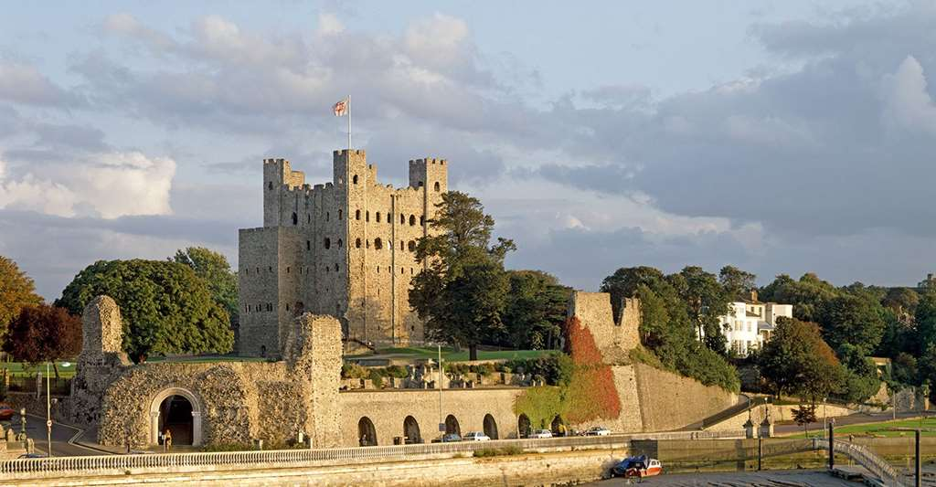
Figure 1.English Heritage, Rochester Castle, https://www.english-heritage.org.uk/visit/places/rochester-castle/ [accessed 9th March 2025].

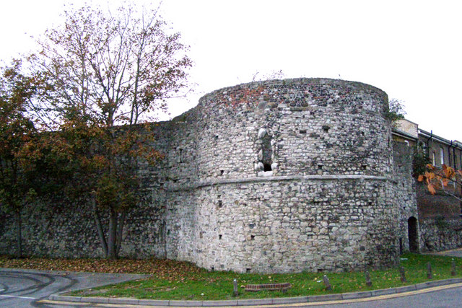
Rochester is a historic and strategic city situated upon a large cape near the mouth of the River Medway in Kent. The castle at Rochester is one of the most iconic pieces of Romanesque architecture in England, a tall and domineering in the local landscape, is equally strategically positioned, rising from a rocky base, high above the river, with a clear view of the surrounding area. its well-preserved ruins are a testament to its esteemed architects. The fortification at Rochester appears to have had several stages, the current build is likely from between 1123-1139. However it is likely the area has held fortifications from at least the Roman period. This source commentary will attempt to cover this earlier period however, in order to remain focused, this commentary will prioritise those fortifications built during the Norman period, and will ignore the later history of the building after King Johns gruelling siege of 1215. This commentary will look at the physical lifetime and functions of Rochester castle to greater understand the fortification as both a defensive building, a bishops residence, and a feat of high Romanesque architecture.
Figure 2. North-east tower of Rochester’s city wall. Castellogy, Rochester City Walls, https://castellogy.com/sites/sites-south-east/rochester-city-walls [accessed 9th March 2025].

The city of Rochester is positioned along the great Roman way from London to Canterbury. The cities rectangular form, the cruciform arrangement of its main streets, with its 4 gates opposite each other, not to mention the name Rochester itself, all point to its Roman origin. The Roman fortifications likely composed of a wall and a ditch. It is not until the early medieval period where clear mentions of a defined fortification are to be found. A church and monastery to St Andrew preceded the castle, and the bishopric was given lands and donations from the hands of succeeding Anglo-Saxon rulers. The historian Bede, describing the Synod held in Hertford during in 670, mentions Putta, as Bishop of the castle in West Kent, called Rochester. Later, in Offas charter, 788, a castle is mentioned, again referring to the bishopric, “Episcopium Castelli quod nominatur Hrofescester.” Whilst clearly demonstrating the presence of fortifications at Rochester, these descriptions also show how at this time, the bishopric and the castle were held together, conveying the concept of spiritual and military unity in the city of St Andrew. Interestingly, this connection to either the bishopric of Rochester, or the archbishopric of Canterbury, remains important for much of the castles later history.

In the time elapsing from 855 to the castles next mention, the monastery was further enriched by 6 Anglo-Saxon princes. In 1066, William of Normandy invaded England, and after defeating Harold Godwinson at Hastings, he moved up the coast to Dover, stopping at Canterbury before making his way to London fortifying at every step he came to. Sitting upon the great Roman way between Canterbury and London, Rochester would have been an important steppingstone in Williams conquest. Orderic Vitalis would later claim that it was England’s failure to adopt castles that hastened William’s victory, so a fortified position like Rochester was important to subdue. When encountering English strongholds such as Rochester, the usual custom for the Normans, was to erect a keep upon the mound, and to surround it with a strong curtain wall, built upon the scarp of the existing ditch. Thus, we can assume that the first Norman castle at Rochester may have utilised the Saxon features in such a way. This was a practical move for construction; however, it also emphasised the re-founding of traditional English centres under their new Norman command. Furthermore, building on not just a Saxon fortress but within a Roman walled city, the Normans further painted themselves as the roman conquerors on whom they modelled themselves. themselves on. It is also possible that the original Norman structure was built in the years following the conquest by Odo of Bayeux; certainly, it was in the bishops’ hands by 1087, when after the failed rebellion of Robert Curthose, Odo and his garrison of 500 men were forced to surrender the castle to William II.

It is between William’s accession in 1087 and the death of Lanfranc in 1089, when it is recorded that Gundulf, Bishop of Rochester built a stone castle at Rochester for the price of £66 in exchange for Haddenham manor. A highly renowned Norman architect, credited also with rebuilding Rochester Cathedral, it is local tradition that the current castle, well within his expertise, was also the work of Gundulf. This however is disproved by the very fact Gundulf’s structure was built on a budget of just £66. Putting that sum into perspective, the repairs to Rochester castle after John’s siege in 1215 cost £500. The only likely remaining features of Gundulf’s stone castle, are parts of the curtain wall. The grand and iconic keep of Rochester castle, owes its design to another.

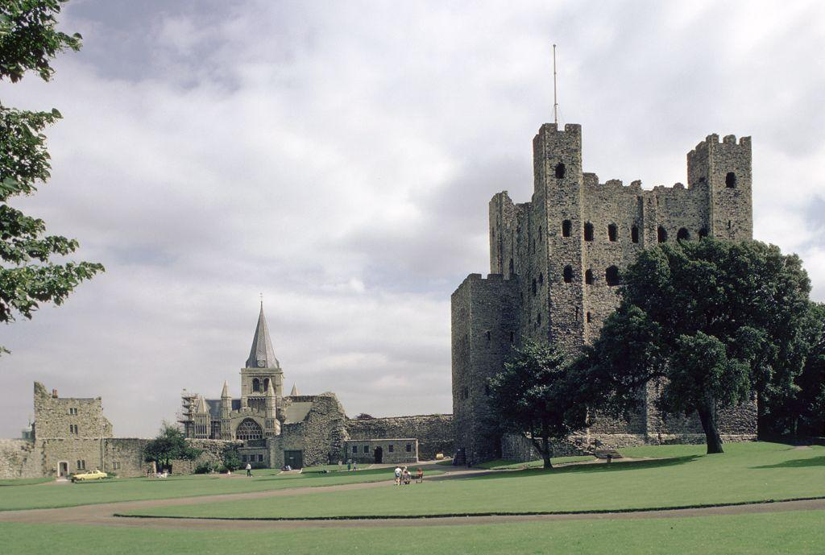
In a chronicle written by Gervase, a contemporary to Archbishop William de Corbeuil, it is recorded that at the archbishop’s instigation, Henry I gave and confirmed the castle and city of Rochester to the church of Canterbury, and to William, who built an extremely beautiful tower. This is corroborated by Florence of Worcester, who writes that along with being granted the city in 1126, William was also granted permission to build within it a defence or tower such as he liked. Thus in 1126, the castles connection to the see of Rochester was severed as it became a part of the see of Canterbury. The modern keep was likely built during the archbishop’s residency in Rochester castle, between 1123 and 1126.
Figure 3. Rochester Castle, JSTOR https://jstor.org/stable/community.14671394 [Accessed 9 Mar. 2025].

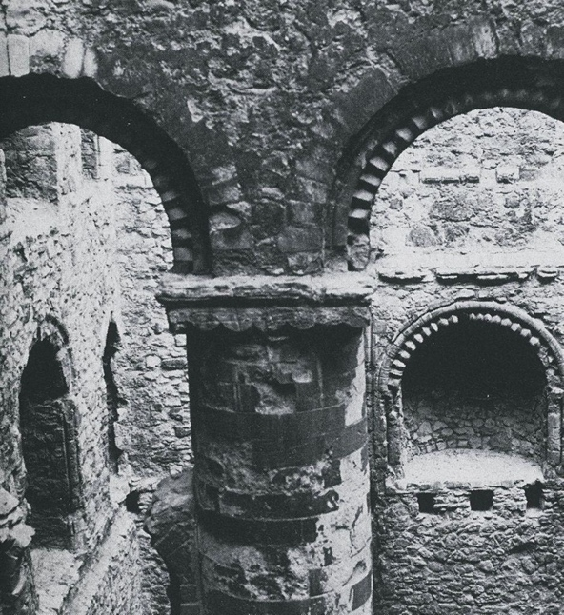
The castle William constructed was of coursed ragstone rubble, with Caen dressings. And it remains a masterpiece of Romanesque architecture and art, an incredible showcase of Norman skill, and arguably the most striking timeless landmark of the city. Functioning as the archbishop’s residence, it displays, like in Anglo-Saxon times, the unity and might of spiritual and military power. The castle would undergo repairs in 1166-1170 and was again strengthened from 1173-1174 and 1191-1205. However, it would undergo its most gruelling test of endurance in 1215, when John besieged the castle which the Barnwell annalist tells us was defended by 95 of the barons strongest knights. Much like centuries prior when William II pried the fortress from the hands of Odo. Johns first move was to cut off the routes by which the defenders could receive aid, the siege proceeded with a day and night bombardment from all sides with his ‘five throwing machines’ until only the keep remained. ‘And because it was an ancient and solid work, it resisted the onslaught.’ Sending in his sappers, John undermined and collapsed half of the keep; however still the occupants were able to defend from the other side, as Barnwell tells us: ‘Such was the structure of the keep that one part was divided from the other by a solid stone wall.’ After John finally took Rochester castle, the repairs reportedly cost him £500. The account of the siege from Barnwell gives us unique insight into the castles defensive capabilities, but also of the fortress and its defender’s epic reputation at the time, and how its fall sowed panic within the ranks of the baronial forces.
Figure 4. Rochester: Rochester Castle Keep Int.: 2nd/3rd Story Level View through Arcaded Cross-Wall. 1127. JSTOR, https://jstor.org/stable/community.13552881. [Accessed 9 Mar. 2025].

Rochester castle bears the marks of many architects over its long history. And has fulfilled many functions. Castles and churches were the instruments with which the conquest uprooted and replaced the English aristocracy and church. The first Norman structures were such instruments, rebuilding entirely the Anglo-Saxon structures. They were both practical and symbolic tools of conquest. Later iterations would display the spiritual and military power of the bishopric of Rochester and the archbishopric of Canterbury. The 12th century keeps grandeur symbolic of Archbishop Williams power, yet also his artistry. Rochester remained a powerful and strategic, defensive fortress. Its many iterations and repairs are testament enough to this fact. However, its most important function is still held to this day, as it remains an image of striking power and beauty.

Bibliography
- Reginald A. Brown, The Normans (Woodbridge, Suffolk: Boydell & Brewer, 1984).
- George T. Clark, ‘Rochester Castle’, The Archaeological Journal. [Periodical], 32.10 (1875), 205–28 https://doi.org/10.1080/00665983.1875.10851679.
- Elizabeth S. Hallam (ed.) The Plantagenet Chronicles (London: Weidenfeld & Nicolson, 1986).
- Charles Henry Hartshorne, ‘Rochester Castle’, The Archaeological Journal. [Periodical], 20.14 (1863), 205–23 https://doi.org/10.1080/00665983.1863.10851250.
- Leonie V. Hicks, A Short History of the Normans (London: Bloomsbury Publishing, 2016).
- Derek F. Renn, Norman Castles in Britain, 2nd ed. (London: J. Baker, 1973).

George T. Clark, ‘Rochester Castle’, The Archaeological Journal. [Periodical], 32.10 (1875), 205–28 https://doi.org/10.1080/00665983.1875.10851679 (p. 205).
Charles Henry Hartshorne, ‘Rochester Castle’, The Archaeological Journal. [Periodical], 20.14 (1863), 205–23 https://doi.org/10.1080/00665983.1863.10851250 (p. 211).
Clark, ‘Rochester Castle’, p. 207.
Derek F. Renn, Norman Castles in Britain, 2nd ed. (London: J. Baker, 1973) p. 303.
Clark, ‘Rochester Castle’, p. 205.
Ibid, p. 207.
Ibid.
Hartshorne, ‘Rochester Castle’, pp. 205-206.
Ibid. p. 206.
Ibid.
Ibid.
Ibid.
Renn, Norman Castles in Britain, p. 28.
Ibid, p. 27.
Clark, ‘Rochester Castle’, p. 206.
The ways in which the Normans painted themselves as Roman successors, see: Leonie V. Hicks, A Short History of the Normans (London: Bloomsbury Publishing, 2016) pp. 58-67.
Renn, Norman Castles in Britain, p. 28.
Hartshorne, ‘Rochester Castle’, pp. 207-08.
Renn, Norman Castles in England, p. 299.
Hartshorne, ‘Rochester Castle’, p. 210.
Ibid.
Renn, Norman Castles in Britain, p. 303.
Ibid, p. 34.
Hartshorne, ‘Rochester Castle’, p. 211.
Ibid.
Ibid.
Renn, Norman Castles in Britain, p. 299.
Clark, ‘Rochester Castle’, p. 206.
Elizabeth S. Hallam (ed.) The Plantagenet Chronicles (London: Weidenfeld & Nicolson, 1986). p. 314.
Hartshorne, ‘Rochester Castle’, p. 208.
Hallam, The Plantagenet Chronicles, p. 314.
Hallam, The Plantagenet Chronicles, p. 316.
Renn, Norman Castles in Britain, p. 303.
Hallam, The Plantagenet Chronicles, p. 316.
Reginald A. Brown, The Normans (Woodbridge, Suffolk: Boydell & Brewer, 1984) p. 71.

