

Assessment 1 – Reading Task Template
Upload your photo of your A3 in-class notes here:
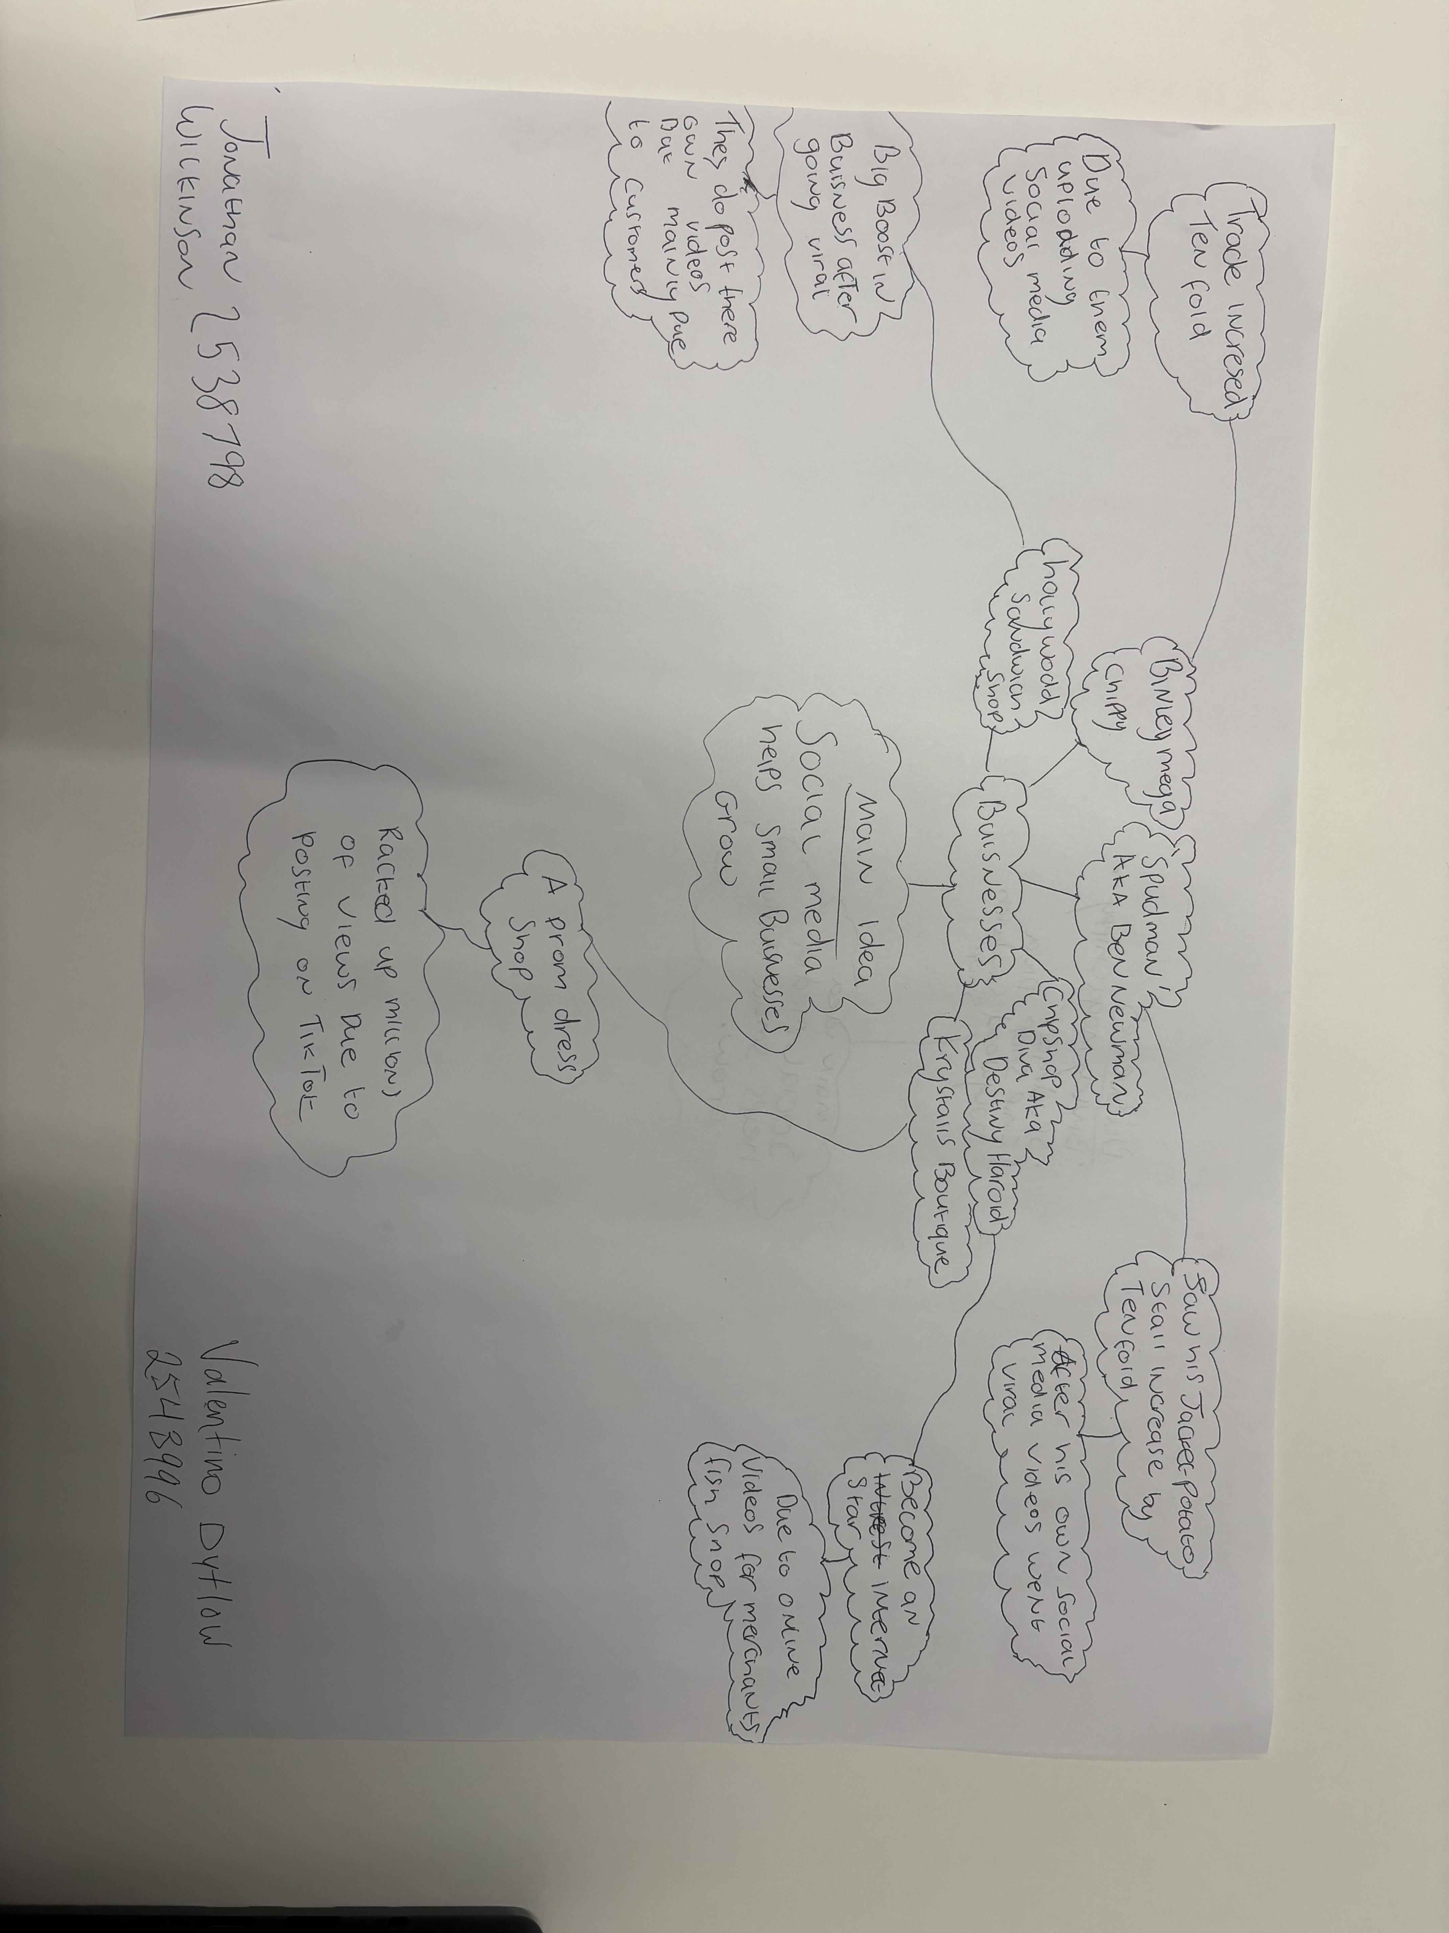

1. Answer these questions using the sentence starters below

a. What is the main idea of the text?
The main idea of the text is that social media is helping small business to grow to larger business.

b. What are two key points?
One key point can be the main idea, that social media is helping small business to grow.
Another key point is that promoting through social media can help you interact with your customers and customers understand you, so they feel like they are part of the family.

c. What part of the text did you find most important? Why?
The most important part is understanding the main idea.
The reason why is because if you can successfully identify the main idea and it is clear then you can take what information you want from the article while still understanding the target of what the article is trying to achieve.

d. Was anything unclear or difficult to understand?
There wasn’t anything that was unclear or too difficult to understand in my opinion.

e. How did your group help you understand the text better?
My group didn’t really help me understand better, although they did provide different outlooks and points of view which we reflected and discussed.

2. One sentence reflection

Question: What did you find challenging about this task?

The thing I found most challenging about this task was learning how to identify the main idea.

