Marketing Fundamentals

By: Ioan-Alexandru Sas
Lecturer’s name: Tushara Balendran
Module number: (LCBB4004)
Student number: 2213949



Apple and the impact of Covid-19 that affected the whole organization

Table of Contents
Table of Contents
Table of Contents 3
Introduction 4
Definition of Marketing 5
Apple marketing mix 6
Product 6
Price 6
Promotion 6
Place 6
Packaging 6
Positioning 7
People 7
Apple Macro Environment 8
Porter Five Forces 9
1. Supplier Power 9
2. Buyer Power 9
3. Competitive Rivalry 9
4. Threat of Substitution 9
5. Threat of New Entrants 9
Apple SWOT Analysis 10
Strengths 10
Weaknesses 10
Opportunities 10
Threats 10
Impact of Covid-19 on Apple 11
Segmentation, Targeting and Positioning of Apple 12
Segmentation 12
Targeting 12
Positioning 12
Conclusion 13
Reference list 14

Introduction

Apple Inc., an American multinational technology company headquartered in Cupertino, California, designs, develops, sells consumer electronics, computer software, and online services. It is considered one of the Big Five companies in the U.S. information technology industry, along with Amazon, Google, Microsoft, and Facebook. Apple was founded by Steve Jobs, Steve Wozniak, and Ronald Wayne in 1976 to develop and sell personal computers. It has since expanded to include consumer electronics, such as the iPod, iPhone, iPad, Apple Watch, and Apple T.V. The company also offers its software and services, such as the macOS and iOS operating systems, the iTunes media player, the Safari web browser, and the Apple Music streaming service. Apple has become one of the world's most valuable companies and is widely recognized for its innovative products and services.
Apple Inc. is currently one of the most valuable companies in the world, with an estimated market capitalization of $2.2 trillion as of April 2021. Apple has had a remarkable run over the past decade, as its stock price has more than quadrupled since 2011. The company's success is primarily attributed to its focus on innovation, which has enabled it to create popular products such as the iPhone, iPad, and Mac computers.

Definition of Marketing

Marketing is the process of planning and executing the conception, pricing, promotion, and distribution of ideas, goods, and services to create exchanges that satisfy individual and organizational goals. It is the art of creating, communicating, and delivering value to customers, clients, partners, and society. It is a process that involves researching, analyzing, and understanding the needs and wants of target markets, as well as developing, positioning, and promoting the right product, service, or idea to the right target market. Marketing involves identifying potential customers, understanding their needs and preferences, developing a product or service to meet those needs and preferences, pricing the product or service, and promoting it to the target market. It also includes sales, customer service, and customer relationship management. Marketing is a critical component of any business, as it helps to create and maintain customer relationships and promote and increase sales.

Apple Marketing Mix

Apple marketing mix and the 7ps in a more extended, more detailed version The Marketing Mix, often referred to as the 4Ps, is a tool businesses use to help define their marketing strategy. It consists of four components: Product, Price, Promotion, and Place. However, a fifth "P" has been added to the mix in recent years: People. This article will explore the 7Ps of the Marketing Mix and how they can be applied to Apple Inc.

Product: The first P in the Marketing Mix is Product. Apple Inc. offers various products, including hardware, software, and services. Apple takes great pride in their products, which are designed to be innovative, high-quality, and easy to use. Apple's products are designed to stand out from their competitors and provide customers with an experience that is second to none.

Price: The second P in the Marketing Mix is Price. Apple Inc. is known for its premium prices, which reflect the quality of its products. Apple's pricing strategy is designed to attract a wide range of customers, from budget-conscious shoppers to high-end buyers. Apple also offers a variety of financing options to make its products more accessible to customers.

Promotion: Apple's third-party promotion involves partnering with other companies to promote its products and services. This includes partnerships with other technology companies, app developers, content providers, and retailers. Apple has also partnered with media companies to create exclusive content and offers, such as Apple Music, Apple TV+, and Apple Arcade. Additionally, Apple has worked with retailers to offer special deals and discounts on its products. Finally, they have partnered with app developers to promote their apps in the App Store and create marketing campaigns.

Place: Apple's marketing mix place strategy is focused on their retail stores, online stores, and third-party retailers. Apple has stores in more than 20 countries and regions, and its online store is available in more than 40 countries and regions. Additionally, Apple products are available through a variety of third-party retailers, such as Argos and Currys and P.C. World. Apple also has a presence in many countries through their Apple Store app, which allows customers to buy products and access customer service.

Packaging: Apple's marketing mix packaging includes a variety of packaging options, such as retail packaging, product packaging, and promotional packaging. Retail packaging includes the packaging used to display and transport products in retail stores. Product packaging includes the packaging used to protect, store, and ship products directly to customers. Promotional packaging includes packaging used to promote and advertise products. Apple also uses promotional packaging to introduce new products and services or to promote sales and discounts. Apple also uses packaging to create a unique and unified visual identity for its products.

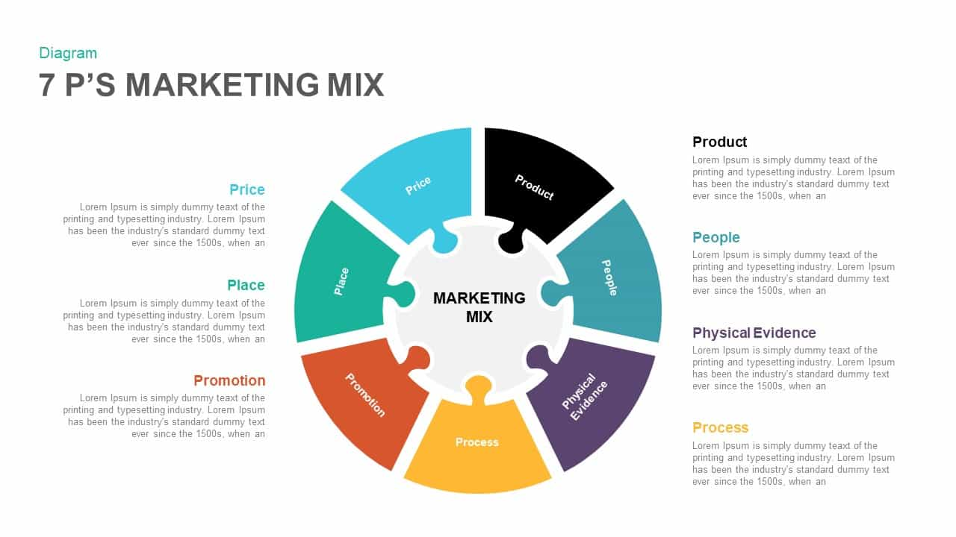
Positioning:
Apple's marketing strategy is focused on providing premium products and services. Apple's products are typically priced at a premium compared to their competitors, and they position themselves as offering a unique user experience with their products. Apple also leverages their brand recognition and reputation further to differentiate its products from other products on the market. Additionally, Apple's marketing strategy emphasizes using digital channels to reach its customers, such as its website, App Store, and iTunes Store. Apple also works to ensure that its products are available in multiple locations, such as retail stores and online, to ensure customers have access to their products.

People:
Apple's marketing mix's people element focuses on providing a great customer experience. They employ highly skilled salespeople and customer service representatives who are knowledgeable about their products and services. They also have a strong presence in the education market, providing educators and students with the tools they need to get the most out of their technology. Additionally, Apple sponsors events, conferences and other activities to build customer relationships. They also have a large base of loyal customers who will continue to purchase their products due to the quality and reliability of the brand.

Apple Macro Environment

Apple Inc's macro environment consists of the major external and uncontrollable factors that influence its strategic decision-making, performance, and its overall direction. The macro environment is typically divided into six main factors: demographic, economic, natural, technological, political, and cultural. Demographic: This refers to the population's makeup, including age, gender, education, income, and occupation. Economic: This refers to the current economic conditions of the market, including the overall health of the economy, economic trends, monetary policies, and interest rates. Natural: This refers to the environment, including climate change, resource availability, and pollution. Technological: This refers to technological advances and their impact on the market. It includes the development of new products and services, as well as the pace of technological change. Political: This refers to the regulations and laws that govern the market. It includes the political climate, government policies, and trade agreements. Cultural: This refers to the population's shared beliefs, values, and attitudes. It includes religious beliefs, consumer attitudes, and ethical standards.

The COVID-19 pandemic has had a significant impact on Apple's macro environment. The pandemic has disrupted global supply chains, disrupting Apple's production and manufacturing operations. This has resulted in Apple adjusting its production processes and supply chain to meet new health and safety regulations. In addition, the pandemic has caused a shift away from physical stores to online shopping to adhere to social distancing guidelines. This has directly impacted Apple's retail operations, as many of their stores had to close temporarily and those that remained open had to implement social distancing measures. The pandemic has also had a significant impact on the global economy, which has caused a decrease in consumer spending. This has caused a decrease in demand for Apple's products, resulting in reduced sales. Finally, the pandemic has caused a shift in consumer behaviour, with more people turning to technology to stay connected. This has increased demand for products such as iPhones, iPads, and Macs as people rely on them to stay connected and work from home.

Porters Five Forces

1. Supplier Power: Apple has one of the most potent supplier networks in the world. Their suppliers are typically large and well-established companies with strong bargaining power. Apple also has exclusive contracts with some of these suppliers, which allows them to maintain their competitive edge in the marketplace. Apple has also been able to negotiate better terms with suppliers, such as lower prices on components, due to its large size and market presence.
2. Buyer Power: Buyers have strong bargaining power regarding Apple products. Apple products are highly sought after, allowing buyers to negotiate better terms regarding pricing and other terms of the deal. However, Apple has maintained its premium prices by offering superior products and services, so buyers are usually willing to pay the extra price.
3. Competitive Rivalry: Apple faces high competition from other tech companies such as Microsoft, Samsung and Google. These companies are often able to offer comparable products at lower prices. Apple also has to contend with the threat of new entrants into the market and the possibility of existing rivals introducing new products or services that could make Apple's offerings less attractive.
4. Threat of Substitution: Apple products have a loyal user base, but there is always the threat of consumers switching to other products or services. Apple must remain innovative to keep its customers loyal and ensure that its products remain attractive.
5. Threat of New Entrants: The entry barrier for new competitors into the tech market could be higher due to the availability of open-source software and the low cost of entry for hardware. New entrants can quickly develop and launch products that compete with Apple's offerings. Therefore, Apple must continue to innovate to stay ahead of the competition.

Apple SWOT Analysis

Strengths
1. Apple is one of the most innovative companies in the world. It has consistently been at the forefront of technology, and its products are often seen as trendsetters.
2. Apple has a strong brand image. It has consistently been ranked as one of the most valuable brands in the world.
3. Apple has an extensive retail network. It has physical stores in most major countries, and its online store is one of the largest in the world.
4. Apple has a solid financial position. It has a large cash reserve, and its profits have increased recently.
5. Apple has a large customer base. Its products appeal to many customers, from casual users to professionals.

Weaknesses
1. Apple products are often seen as expensive compared to competitors. This limits the potential customer base.
2. Apple’s operating system, iOS, is not compatible with many third-party applications and services.
3. Apple has a limited presence in the enterprise market. Its products are less widely adopted in this market compared to competitors.
4. Apple is heavily dependent on the success of its flagship products. If these products fail to perform, it could significantly impact the company.
5. Apple's products are often seen as challenging to use. This can be off-putting to some users and could limit the potential customer base.

Opportunities
1. Apple could expand its presence in the enterprise market by developing more enterprise-focused products and services.
2. Apple could expand its retail presence by opening more physical stores in new markets.
3. Apple could develop affordable products to reach a broader customer base.
4. Apple could develop new product lines to diversify its revenue streams.
5. Apple could develop new technologies and services to increase customer loyalty.

Threats
1. Competition from other tech companies is increasing. Companies such as Samsung, Microsoft, and Google compete for market share in the tech industry.
2. The threat of new entrants is also increasing. New companies are entering the market with innovative products and services.
3. The threat of substitute products is also increasing. Consumers have more options, which could lead to lower sales for Apple.
4. Apple’s products are vulnerable to security threats. Hackers are constantly trying to find vulnerabilities in Apple’s products, which could lead to data breaches.
5. Apple is heavily reliant on its supply chain. If a major supplier goes out of business, it could significantly impact Apple's operations.

Impact of Covid-19 on Apple

The COVID-19 pandemic has significantly impacted Apple, Inc., one of the world's largest technology companies. The global economic slowdown has impacted the company's revenue, and its supply chain has experienced significant disruption due to the pandemic. In the first quarter of 2020, Apple reported a year-over-year revenue decline of 8% due to the economic slowdown caused by the pandemic. The company's iPhone sales were particularly affected, with a 12% decrease compared to the previous year. Apple's services revenue was also affected, although the decline was not as steep, with a 5% decrease. Apple's supply chain has also been affected by COVID-19. The company has encountered difficulties shipping products from China, with shipments delayed by six weeks.
Additionally, Apple's production lines in China have been impacted by the pandemic, with some factories shut down due to health and safety concerns. Apple has also had to adjust its retail stores due to the pandemic. All its stores in the U.S. and some other countries were closed for some time, and the company has implemented new safety protocols for its stores.

Segmentation, Targeting and Positioning of Apple

Segmentation:
Apple Inc.'s target market can be divided into four primary segments: 1. Young Professionals: Professionals aged between 18 and 35 who are tech-savvy and have a higher purchasing power. These consumers are the primary target market for Apple Inc.'s products.
2. Business Professionals: Professionals aged between 35 and 55 who are tech-savvy and use Apple products for their business needs.
3. Educators: Professionals aged between 18 and 55 who are tech-savvy and use Apple products in educational settings.
4. General Consumers: Consumers aged between 18 and 55 who are tech-savvy and use Apple products for personal use.

Targeting:
Apple Inc.’s target market can be further divided into two main subgroups:
1. High-Income Consumers: Consumers with a high purchasing power are willing to pay for the higher quality of Apple products.
2. Mid-Income Consumers: Consumers with a limited budget are still willing to pay for the quality of Apple products.

Positioning:
Apple Inc. positions itself as an innovative and reliable brand that offers quality products and services. Apple Inc.'s products are known for their cutting-edge technology, sleek design, and user-friendly interfaces. The company also positions itself as a leader in the tech industry, with a wide range of products and services that cater to various needs and lifestyles. The company also emphasizes its commitment to customer service, with easy-to-use customer support systems and helpful tutorials.

Conclusion

The impact of Covid-19 on Apple has been both positive and negative. On the positive side, Apple's stock price has remained relatively stable throughout the pandemic. Its services revenue continues to grow as more people rely on digital services like iCloud and Apple Music during social distancing. Apple's new products and services, such as the Apple Watch and AirPods, have also seen an increase in sales as consumers look for new ways to stay connected.

On the negative side, Apple's global supply chain has been disrupted, causing delays in producing new products and difficulty obtaining components. This has impacted Apple's ability to meet customer demand. Additionally, Apple has had to close many of its retail stores, which has impacted its ability to promote and sell its products. Finally, Apple's an advertising and marketing spending has decreased significantly due to the pandemic, further limiting its ability to generate revenue. Although the pandemic has negatively impacted Apple, the company is still performing well and is well-positioned to continue to be successful in the future.

Reference list

Investopedia. (2021). How COVID-Affects Apple (AAPL). Retrieved from https://www.investopedia.com/how-covid-affects-apple-aapl-5198334

Apple (2020) Apple’s Covid-19 Response. [online] Available at: https://www.apple.com/uk/newsroom/2020/03/apples-covid-19-response/
[Accessed 11 Dec 2022].

Bloomberg. (2022). Apple’s (AAPL) Covid Effects: Supply Snags, Masking and Office Return Delays. Retrieved from https://www.bloomberg.com/news/newsletters/2022-05-22/apple-s-aapl-covid-effects-supply-snags-masking-and-office-return-delays-l3hcqjug

The Guardian (2022) Apple quarterly earnings: Covid sales surge past expectations [online]. Available at: https://www.theguardian.com/technology/2021/apr/28/apple-quarterly-earnings-covid-sales [Accessed 11 Dec 2021].

PESTLEAnalysis.com (2022). Apple SWOT Analysis. Available at: https://pestleanalysis.com/apple-swot-analysis/
[Accessed 11 Dec 2022].

Investingport (2021). Apple Inc Segmentation, Targeting and Positioning. [online] Available at: https://www.investingport.com/apple-inc-segmentation-targeting-and-positioning/
[Accessed 13 Dec 2022].

Research Methodology.net. (n.d.). Apple 7Ps of Marketing. [online] Available at: https://research-methodology.net/apple-7ps-of-marketing/
[Accessed 15 Dec 2022].

Lamontagne, C. (2020). Exploring the Six Components of Apple's Macro Environment. Vocal. Media. Retrieved from https://vocal.media/journal/exploring-the-six-components-of-apple-s-macro-environment

Internet Corporation. (2019). Apple Inc. Five Forces Analysis (Porter’s Model) Case Study. Panmure Institute. Retrieved from https://panmore.com/apple-inc-five-forces-analysis-porters-model-case-study

Investopedia. (2022). Marketing. Retrieved from https://www.investopedia.com/terms/m/marketing.asp

